Supplementary Materials for

Enhanced Electrochemical Stability by Alkyldiammonium in Dion-Jacobson Perovskite Towards Ultrastable Light-Emitting Diodes
Kwanho Ngai¹, Qi Wei³, Zefeng Chen¹, Xinlu Guo¹, Minchao Qin⁴, Fangyan Xie⁵, Christopher Chang Sing Chan⁶, Guichuan Xing³, Xinhu Lu⁴, Jian Chen⁵, Kam Sing Wong⁶, Jianbin Xu^{1†}, Mingzhu Long^{1, 2†}

Affiliations
1 Department of Electronic Engineering, The Chinese University of Hong Kong, Shatin, New Territories, 999077, Hong Kong.
² Guangdong Provincial Key Laboratory of Optical Information Materials and Technology, Institute of Electronic Paper Displays, South China Academy of Advanced Optoelectronics, South China Normal University, Guangzhou, 510006, China.
³ Joint Key Laboratory of the Ministry of Education, Institute of Applied Physics and Materials Engineering, University of Macau, Macao SAR 999078
⁴ Department of Physics, The Chinese University of Hong Kong, Shatin, New Territories, 999077, Hong Kong.
⁵ State Key Laboratory of Optoelectronic Materials and Technologies, Sun Yat-sen University, Guangzhou, Guangdong, 510275, P. R. China.
⁶ Department of Physics, Hong Kong University of Science and Technology, Clear Water Bay, Hong Kong, China
†E-mail: †E-mail: mzlong@cuhk.edu.hk, jbxu@ee.cuhk.edu.hk

This file includes:
- Supplementary Fig. 1. GIWAXS patterns of DJ thin films.
- Supplementary Fig. 2. XRD patterns of BDA-DJ thin films.
- Supplementary Fig. 3. PL characterization of DJ thin films.
- Supplementary Fig. 4. Device structure and cross section image.
- Supplementary Fig. 5. Current density-voltage and radiance-voltage curves.
- Supplementary Fig. 6. SEM images of BDA-DJ perovskite with different n values.
- Supplementary Fig. 7. TEM images of 1.8FA n=5 thin film.
- Supplementary Fig. 8. Histogram of the peak EQE values.
- Supplementary Fig. 9. XRD and SEM images of the 1.8FA n=5 DJ films with PA addition.
- Supplementary Fig. 10. Carrier dynamics of BDA-DJ thin films.
- Supplementary Fig. 11. Voltage tendency as a function of time under current of 100 mA cm⁻².
- Supplementary Fig. 12. EL performances of 3D-PeLEDs based on FAPbI₃.
- Supplementary Fig. 13. EQE tendency during 10000 times of ON-OFF switching.
- Supplementary Fig. 14. Degraded Au electrode.
- Supplementary Fig. 15. Temperature dependent conductivity of perovskite thin films.
- Supplementary Fig. 16. The EQE and radiance values from forward and reverse voltage scans.
- Supplementary Fig. 17. The degradation process BDA-DJ film under electric stress.
- Supplementary Fig. 18. XPS spectra of iodide from different etching times of BDA-PeLEDs.
- Supplementary Fig. 19. XPS spectra of Pb at different etching times.
- Supplementary Fig. 20. Thermal stability.
- Supplementary Table 1. Performance summary of near-infrared PeLEDs.

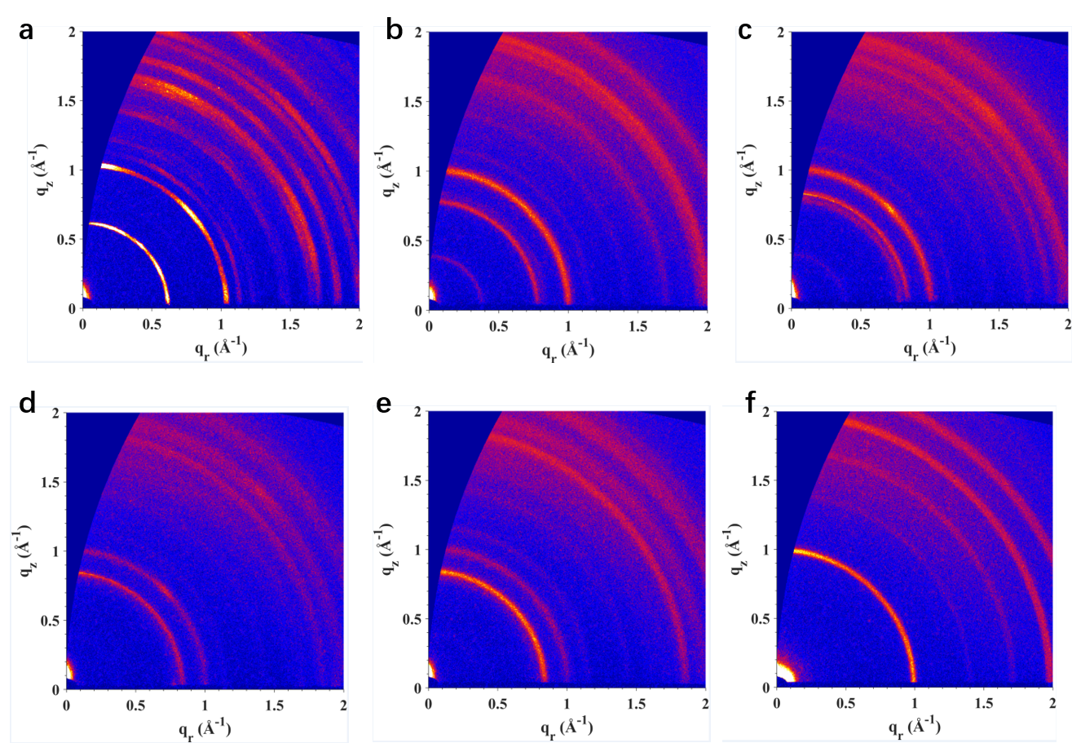
Supplementary Fig. 1. GIWAXS patterns of DJ thin film. (a-f) GIWAXS patterns of DJ thin films with n values of 1-6, respectively.
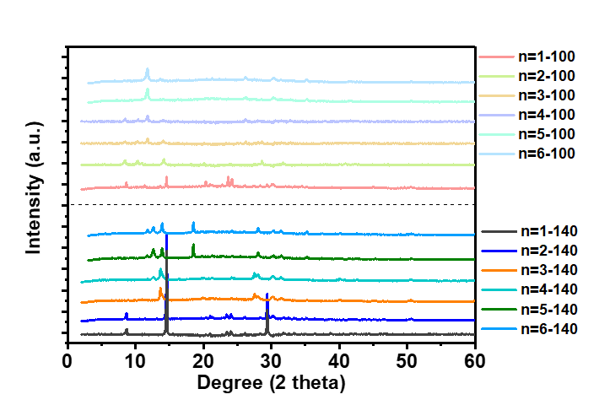
Supplementary Fig. 2. XRD patterns of BDA-DJ thin films. XRD patterns of the BDAFA_{n-1}Pb_{n}I_{3n+1} DJ thin films with different n values (n=1-6) after annealing at 100 and 140 °C, respectively. High annealing temperature 140 °C can significantly optimize the crystallinity.

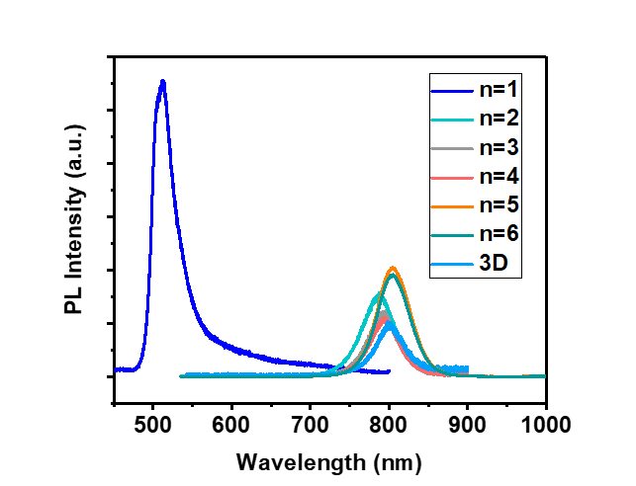
Supplementary Fig. 3. PL characterization of DJ thin films. PL spectra of the BDAFA_{n-1}Pb_{n}I_{3n+1} DJ thin films with different n values after annealing at 140 °C. PL peak positions of BDAFA_{n-1}Pb_{n}I_{3n+1} perovskite thin films after annealing at 140 °C shift to 788 nm, 791 nm, 794 nm for n=2, 3 and 4 DJ phases, and to 801 nm for n=5 and n=6 films, respectively. The PL peak position for FAPbI₃ is 803 nm.

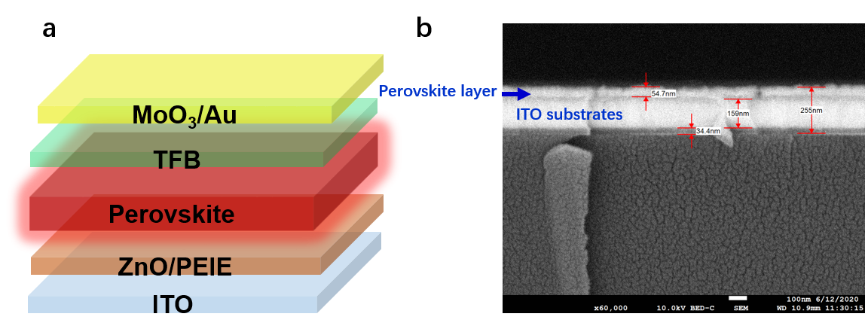
Supplementary Fig. 4. Device structure and cross section image. (a) Configuration of PeLED structure (ITO/ZnO/PEIE/Perovskite emitting layer/TFB/MoO₃/Au) (b) Cross sectional SEM image of the structure ITO/ZnO/PEIE/perovskite layer. The thickness of the perovskite layer is around 55 nm.

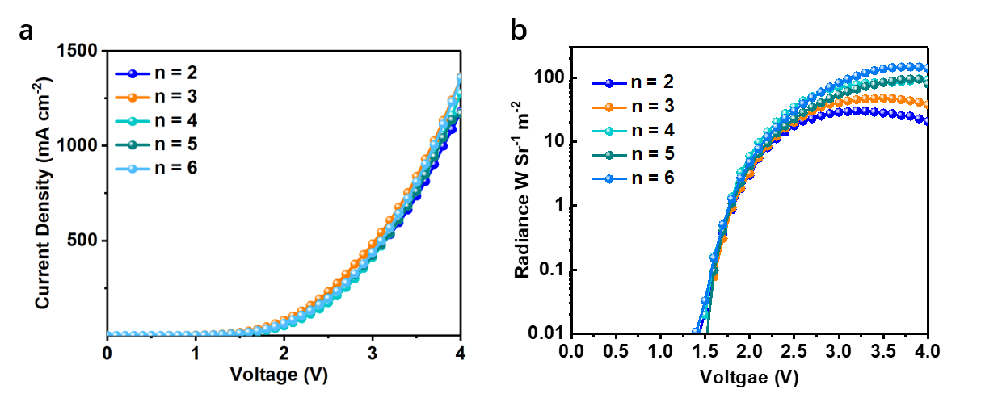
Supplementary Fig. 5. Current density-voltage and radiance-voltage curves. (a) Current density-voltage curves and (b) radiance-current density curves for PeLED samples with different-n DJ thin films. Voltage-current density curves of BDA-PeLEDs with different n values (n=2-6) are compared.
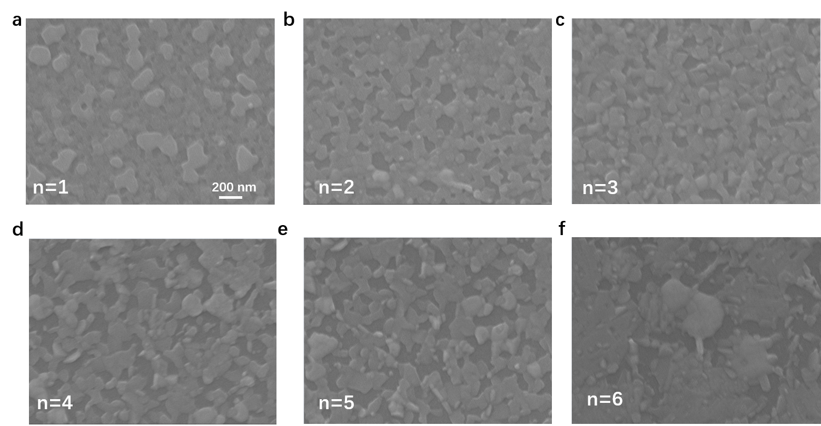

Supplementary Fig. 6. SEM images of BDA-DJ perovskite with different n values. Scanning electron microscopy (SEM) images of BDA-DJ perovskite thin films of n=1-6, respectively. The SEM images of the BDA-DJ thin films deposited on ZnO/PEIE surface show that the n=1 DJ film is much more compact than n=2-6 thin films, but there is not any observed EL performance for the n=1 BDA-PeLEDs.

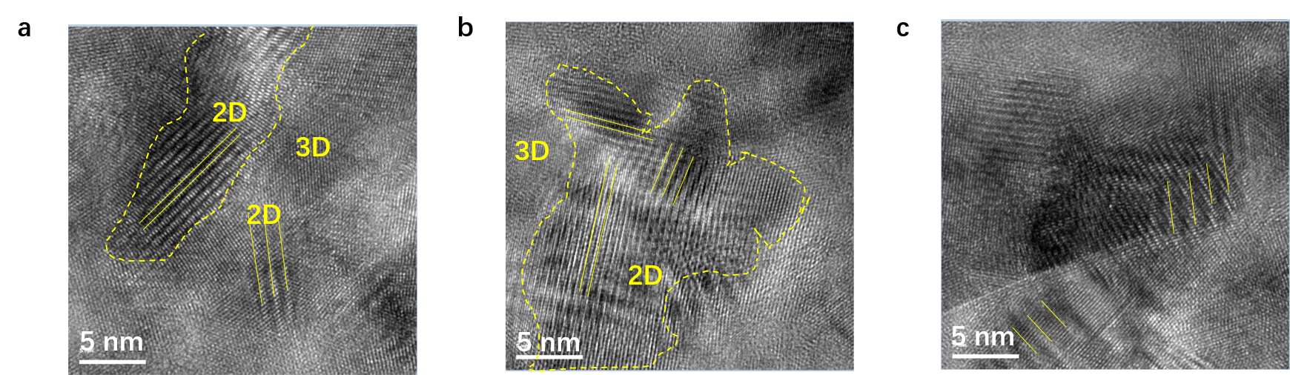

Supplementary Fig. 7. (a-c) TEM images of 1.8FA n=5 thin film.
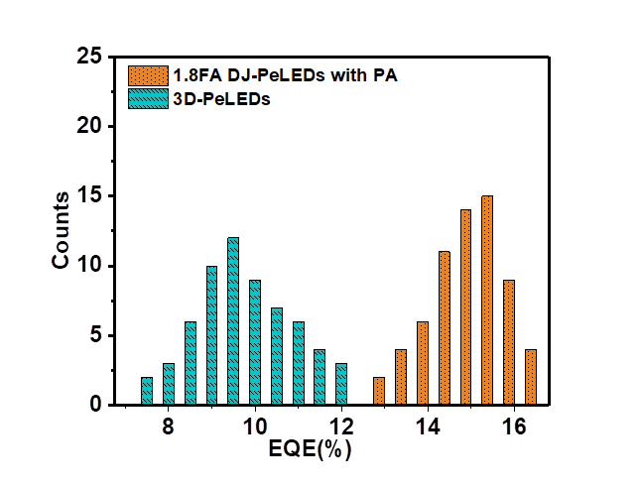
Supplementary Fig. 8. Histogram of the peak EQE values for the champion 1.8FA BDA-PeLEDs with PA addition (65 devices) and control 3D-PeLEDs devices (62 devices).
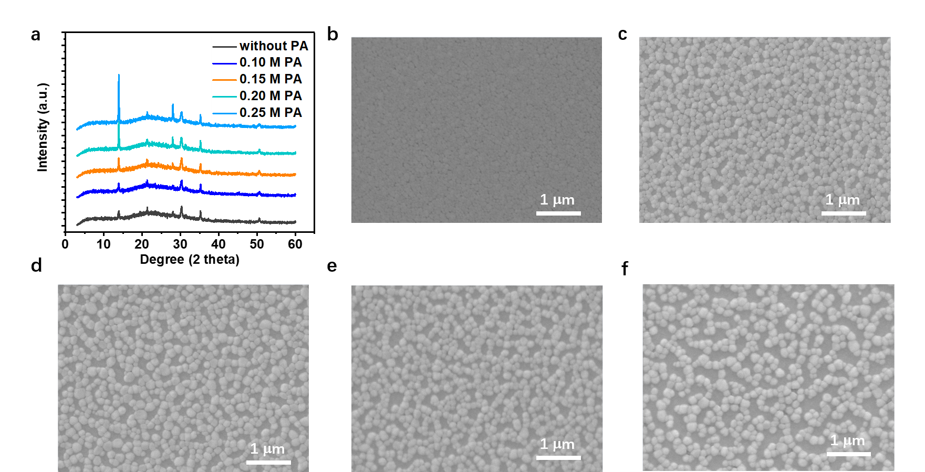

Supplementary Fig. 9. (a) XRD patterns and (b-f) SEM images of the 1.8FA n=5 DJ thin films with different amount of PA addition.
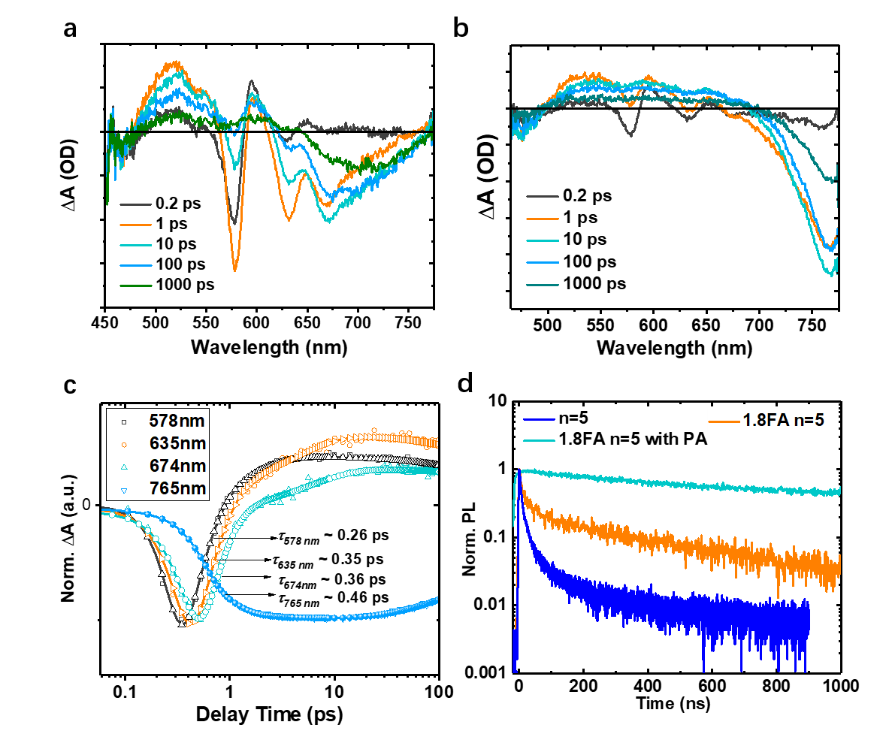
Supplementary Fig. 10. Carrier dynamics of BDA-DJ thin films. TA spectra of 1.8 FA n=5 without (a) and with (b) PA DJ thin films. (c) Normalized bleaching kinetics at 578 nm, 635 nm, 674 nm and 765 nm (excitation wavelength of 400 nm and excitation intensity of 1.1 μJ cm⁻²). (d) TRPL results of the n=5, 1.8 FA n=5 thin films without/with PA addition.

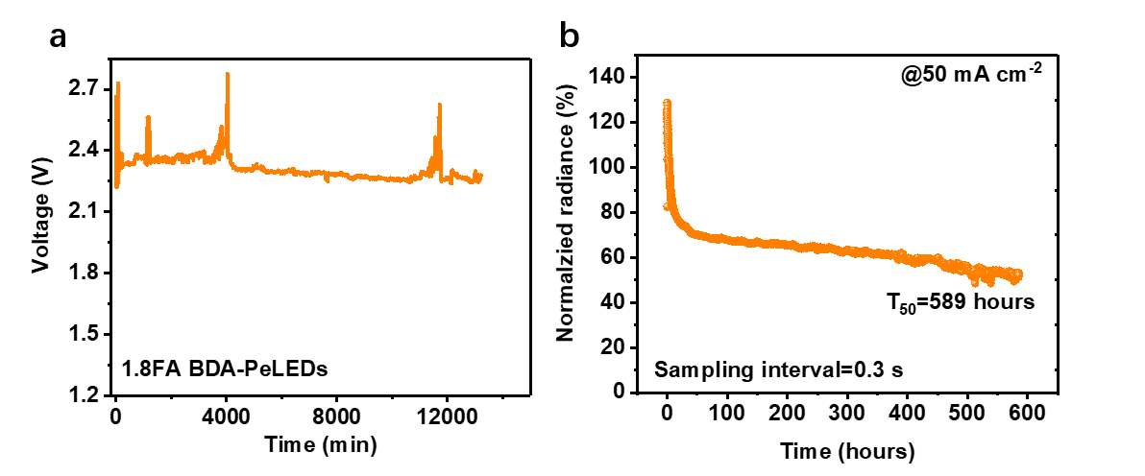
Supplementary Fig. 11. (a) Voltage tendency as a function of time under constant current of 100 mA cm⁻². (b) Radiance tracking under a constant current of 50 mA cm⁻² (sampling interval is 0.3 s). T₅₀ is 589 h.

Supplementary Table 1. Performance summary of the reported near-infrared PeLEDs.
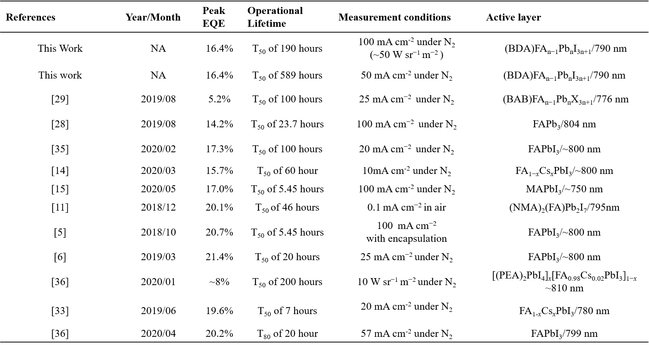

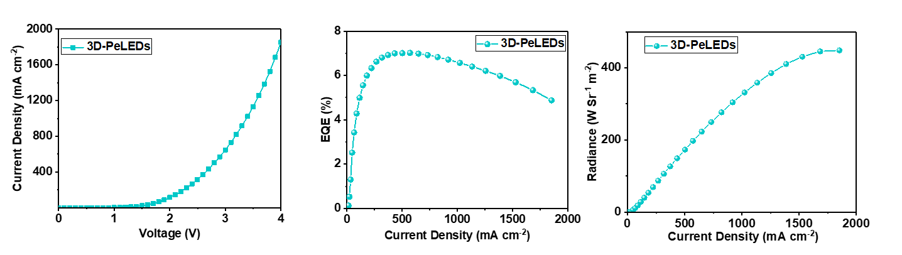
Supplementary Fig. 12. EL performances of 3D-PeLEDs based on FAPbI₃. Current density-voltage curve, EQE-current density curve and radiance-current density curve of 3D FAPbI₃ based PeLED with FA to Pb ratio of 1.8. The current density is much larger at 4 V than that of BDA-PeLEDs. The maximum EQE is 7.0% at current density of 432 mA cm⁻² and radiance reaches to the highest at current density of 1860 mA cm⁻².

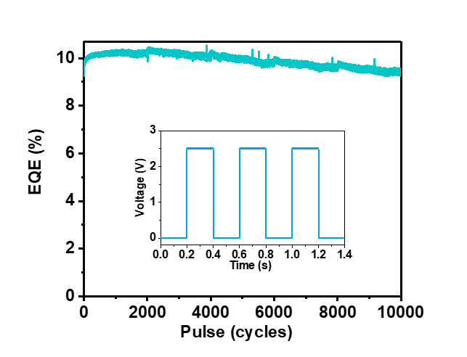
Supplementary Fig. 13. EQE tendency during 10000 times of ON-OFF switching. EQE tracking curve during 10000 times of turning on-off under a periodic pulse of 2.5 V. The pulse curve is shown in the inset with periodic time of 0.4 s.

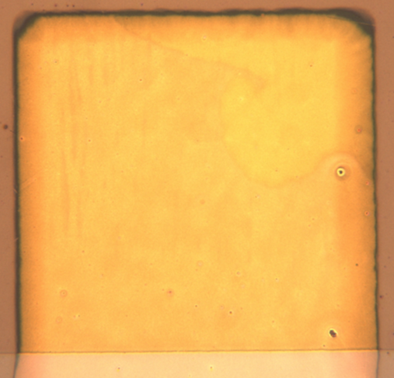
Supplementary Fig. 14. Degraded Au electrode. Degraded Au electrode (area of 1.5 mm×2 mm) of 3D FAPbI₃ PeLEDs with complete EQE loss after operation under a constant current density of 100 mA cm⁻²

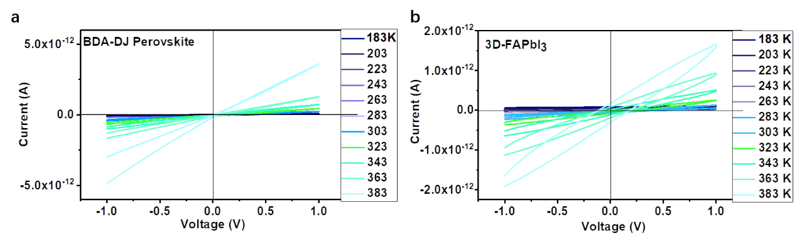
Supplementary Fig. 15. Temperature dependent conductivity of perovskite thin films. Temperature dependent current-voltage curves with temperature ranging from 183 K to 383 K under both forward and backward voltage scanning. The slightly larger current density for BDA-DJ perovskite thin film than that of 3D FAPbI₃ indicates high carrier mobility despite the incorporation of insulating bulky cation.

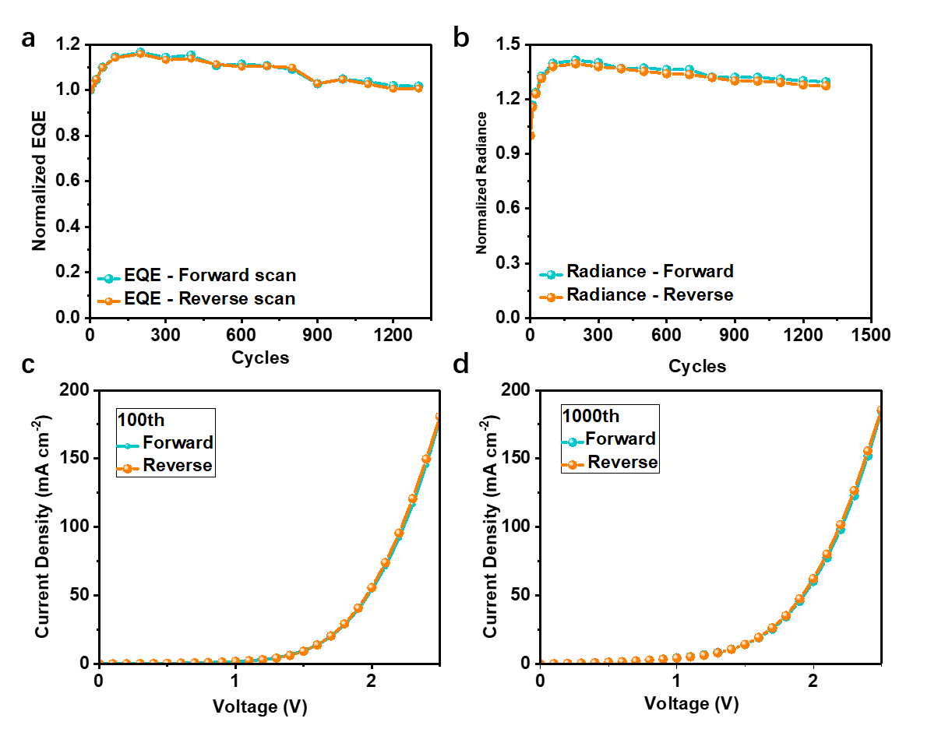

Supplementary Fig. 16. The EQE and radiance values from forward and reverse voltage scans. The tendency of EQE (a) and radiance (b) during the repeated forward and reverse voltage scans (total of 1300 scan cycles). Current density-voltage curves for the 100th scan (c) and 1000th scan (d). The EQE and radiance values obtained from the forward and reverse forward scan do not show any difference.

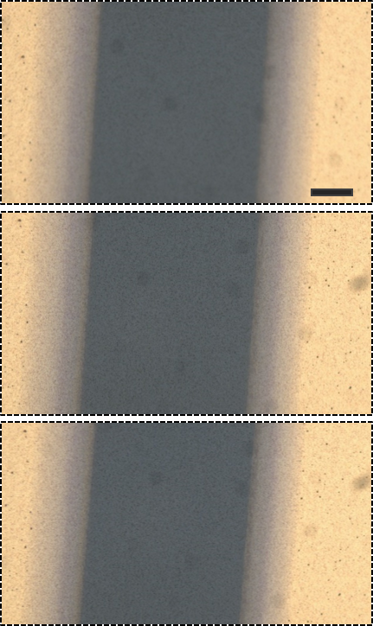
Supplementary Fig. 17. Degradation process of BDA-DJ perovskite thin film under electric stress. The channel length is 80 μm and electric field is 35 V (0.44 V μm⁻¹). The three figures present the perovskite thin film after bias time of 0, 15 min and 30 min (from top to bottom), respectively. Scale bar is 20 μm.

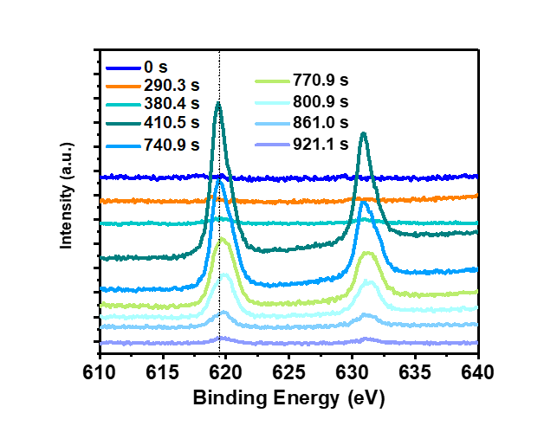
Supplementary Fig. 18. XPS spectra of iodide from different etching times of BDA-PeLEDs. Different etching times represent different depths and layers of the device, with 0 s and 290.3 s representing the iodide in Au electrode, 380.4 s representing TFB organic layer, 410.5 sand 740.9 s representing perovskite layer, 800.9 s, 861.0 s and 921.1 s representing ZnO layer.
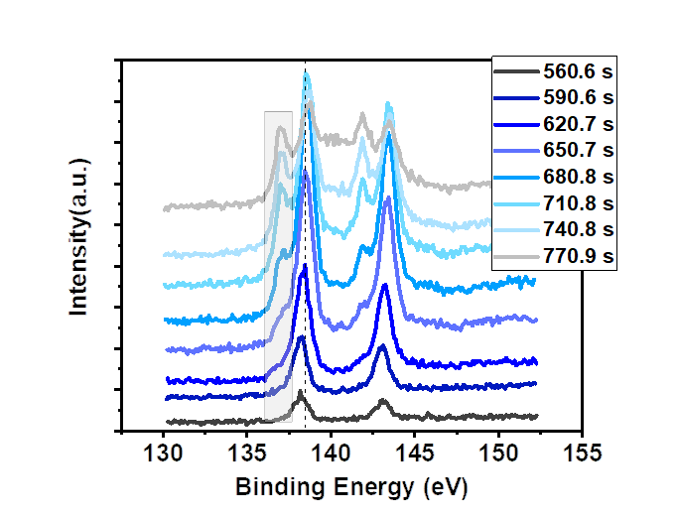
Supplementary Fig. 19. XPS spectra of Pb at different etching times. With the increase of etching time, the intensity of Pb⁰ is gradually increased, which can be attributed to the increased decomposition near the interface between perovskite and ZnO layer.
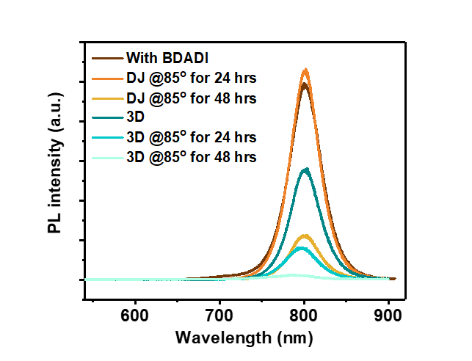
Supplementary Fig. 20. Thermal stability. Thermal stability comparison at 85 °C of BDA-DJ and 3D-FAPbI₃ perovskite materials deposited on ZnO/PEIE surface. Despite FAPbI₃ has an excellent thermal stability, it decomposes after storing at 85 °C for 24 h.

