Vaporization enthalpy estimations of a series of licit and illicit drugs
Supporting Information:
1. Equations used to adjust vaporization enthalpies for changes in temperature [S1]ª
Vaporization Enthalpy/kJ⋅mol⁻¹: ΔlgH(298 K) = ΔlgH(Tm/K) + [10.58 + 0.26⋅Cpl(298 K)]⋅[ ΔΤ]/1000a (S1)
Sublimation Enthalpy/kJ⋅mol⁻¹:
ΔcrgH(298 K) = ΔcrgH(Tm/K) + [0.75 + 0.15⋅Cpcr(298 K)]⋅[ ΔΤ]/1000 (S2)
Table S1A. Hydrocarbon and functional group values used in evaluation of heat capacities in
J.K⁻¹.mol⁻¹ at T = 298 K used in conjunction with Eqs. (S1) and (S2) [S2]
Hydrocarbon Functional Groups |  | G Symbols | Γ(l) | Γ(cr)
Primary sp³ carbon |  | CH₃- | 34.9 | 36.6
Secondary sp³ carbon |  | -CH₂- | 31.9 | 26.9
Tertiary sp³ carbon |  | >CH- | 22.4 | 9.0
Quaternary sp³ carbon |  | >C< | 14 | -4.9
Secondary sp²carbon |  | =CH₂ | 25.8 | 46
Tertiary sp² carbon |  | =CH- | 27.8 | 21.4
Quaternary sp² carbon |  | =C< | 21.7 | 6.9
Cyclic Group Values |  |  | Γ(l) | Γ(cr)
Cyclic secondary sp³ carbon |  | >C_{(c)}H₂ | 25.5 | 24.6
Cyclic tertiary sp³ carbon |  | >C_{(c)}H- | 17.4 | 11.7
Cyclic quaternary sp³ carbon |  | >C_{(c)}< | 13.9 | 6.1
Cyclic tertiary sp² carbon |  | =C_{(c)}H- | 22.8 | 18
Cyclic quaternary sp² carbon |  | =C_{(c)}< | 17.7 | 6.6
Aromatic Group Values |  |  | Γ(l) | Γ(cr)
Tertiary aromatic sp² carbon |  | =C_{a}H- | 21.8 | 17.5
Quaternary aromatic sp² carbon ^{b} |  | =C_{a}< | 15.3 | 8.5
Cyclic Functional Groups | Γ(l) Γ(cr)
Cyclic ether -O_{(c)}- 23 10.3
Cyclic tert-amine -N_{c}< 17.8 2.1
Table S1B
Acyclic Group Values [S1] Γ(l) Γ(cr)
Alcohol OH 58.7 22.7
Phenols O_{p}H 74.9 23.2
Ether O(C)₂ 28 18.5
Ester -CO₂- 63.9 42.2
Amine -NH₂ 59.2 23.5
ª The uncertainty associated with temperature adjustments is 20% of the adjustment

Table S2. Group values from Guthrie and Taylor [S3] unless noted otherwise (kJ⋅mol⁻¹) ª
Group | Group Value | (±) |  | Group | Group Value |  | (±)
CH₃(X) ^{b} | 5.69 | ±0.04 | C_{B}(H) |  |  | 5.61 | ±0.08
CH₂(C)₂ | 5.06 | ±0.04 | C_{B}(C) |  |  | 4.64 | ±0.21
CH₂(C)(C_{d}) | 5.61 | ±1.17 | C_{B}(C_{B})^{j} |  |  | 4.64 | ±0.21
CH₂(C_{d})₂ (5) ^{c} | 6.1 | ±0.6 | C_{B}(C_{d}) ^{j} |  |  | 4.64 | ±0.21
CH₂(C)(C_{B}) | 3.31 | ±0.75 | C_{B}(O) |  |  | 4.64 | ±0.21
CH₂(C_{d})(C_{B}) ^{d} | 4.46 | ±1.0 | C_{B}(N) |  |  | 9.58 | ±1.05
CH₂(C)(CO) | 1.55 | ±0.54 | C_{d}H(N) ^{k} |  |  | 9.58 | ±1.05
CH₂(C)(O) | 3.51 | ±0.21 | CO(NH)(C)₂ (5) ^{l} |  |  | 51.1 | ±0.80
CH₂(C_{d})(O) ^{e} (4) | 4.25 | ±0.58 | CO(C)₂ |  |  | 20.0 | ±0.63
CH₂(C)(N) | 1.8 | ±0.54 | CO(C)(O) |  |  | 18.6 | ±1.84
CH₂(O)₂ | 0.59 | ±2.90 | O(CO)(C) |  |  | 2.68 | ±1.84
CH(C)₃ | 3.05 | ±0.13 | O(C)₂ |  |  | 8.37 | ±0.33
CH(C)₂(C_{d}) (9) ^{f} | 2.7 | ±0.63 | (CO)(O)(C) |  |  | 18.6 | ±1.84
CH(C)₂(C_{B}) | 1.00 | ±1.00 | OH(CO) |  |  | 26.5 | ±10.2
CH(C)₂(CO) | −0.75 | ±0.84 | O_{p}H_{Hos} (14) ^{m} |  |  | 26.2 | ±1.9
CH(C)₂(O) | 0.0 | ±0.63 | O_{p}H_{p/sos} (16) ^{n} |  |  | 20.4 | ±1.4
CH(C)₂(N) | −1.84 | ±0.79 | O_{p}H_{tos} (4) º |  |  | 18.0 | ±0.8
C(C)₂(C_{d})(O) ^{g} | −1.38 | ±1.15 | O_{p}H_{qos} (3) ^{p} |  |  | 15.8 | ±1.1
C(C)₃(C_{d}) | −1.21 | ±1.17 | O_{p}H_{dpos} (4) ^{q} |  |  | 14.8 | ±1.6
C(C)₃C_{B} | −2.4 | ±1.7 ^{c} | O_{p}H_{oes} (6) ^{r} |  |  | 13.4 | ±2.0
C(C)₃(O) | −1.55 | ±1.13 | 1◦; 2◦ −ΟΗ |  |  | 32.7 | ±4.4
C(C)₃(CO) | −4.22 | ±0.75 | 3◦ −OH |  |  | 31.0 | ±2.1
C(C)₄ | 0.34 | ±0.34 | OH···O (intra) |  |  | −10.3 | ±0.75
C_{d}H₂ | 4.18 | ±1.5 | O_{p}H…O (intra) ^{s} |  |  | −7.0 | ±2.4
C_{d}H(C) | 5.15 | ±1.1 | N(C)₃ |  |  | 12.0 | ±1.7
C_{d}H(C_{B}) (4) ^{h} | 5.15 | ±1.1 | NH(C)₂; |  |  | 15.5 | ±1.05
C_{d}H(C_{d}) (6) ^{i} C_{d}C(C_{d}) (2)^{i} | 6.0 | ±0.4 | NH(C_{B})(C_{d}) ^{t} |  |  | 14.0 | ±2.5
C_{d}(C)₂ | 4.85 | ±1.17 | NH(C_{B})₂, ^{t} NH(C_{d})₂ ^{t} |  |  | 14.0 | ±2.5
C_{d}(C)C_{B}) (2) ^{j} | 4.85 | ±1.17 | NH₂(C) |  |  | 18.1 | ±0.63
ª New group values added to reference [S4] are identified by the number of entries included in parenthesis or by footnotes; additional details are provided in the SI, Tables S4-S7 and the section on validation, pp; all other values are from [S3]. ^{b} X = C, O, N, CO,… ^{c} SeeTable S4, this work. ^{d} An average of the values for CH₂(C)(C_{B}) and CH₂(C)(C_{d}). ^{e} See SI of [S4], Tables S8. ^{f} See Table S5. ^{h} See SI of [S4], Table S9. ^{i} An average of the values of a C(C)₃(O) and C(C)₃(C_{d}). ^{j} For validation see pg. S11. ^{k} For validation see SI, pp. S6-S7. ^{l} See Table S7. ^{m-r} Value for a phenolic hydroxide in various environments. ^{m} Value for a phenolic hydroxide with adjacent ortho hydrogens. ^{n}Value for a phenolic hydroxide adjacent to a single ortho methyl/n- alkyl carbon substituent º Value for a phenolic hydroxide encumbered by a single ortho tertiary carbon substituent. ^{p} Value for a phenolic hydroxide adjacent to a single ortho quaternary alkyl substituent. ^{q} Value for a phenolic hydroxide doubly substituted by adjacent primary ortho methyl/n-alkyl substituents. ^{r} Value for a phenolic hydroxide ortho to a single ether oxygen containing either a methyl or n-alkyl substituent; see Table S16, ref. [S4] ^{s} The difference between the group values for a O_{p}H_{oes} and O_{p}H_{p/sos} is taken as the value for intramolecular hydrogen bonding in ortho phenolic ethers. in 5 and 6 membered rings, -7.0 kJ⋅mol⁻¹. ^{t} See section 3C, pp S6-S7.

Section 1. Vaporization enthalpies and temperature adjustments of the materials used below
Table S3. Vaporization Enthalpies at T = 298.15 K. Temperature adjustments of vaporization enthalpies using equation 2 and the constants of Table S1ª
 | Δ_{l}^{g}H(T_{m})  kJ⋅mol⁻¹ | T_{m}/K | Cp(l)(298 K)  J⋅mol⁻¹K⁻¹ | ΔCpΔT  kJ⋅mol⁻¹ | ΔlgH(298 K) kJ⋅mol⁻¹ | Ref
Ethylamine | 29.1  28.9 | 281  275 | 126.2 | −0.74  −1.0 | 28.4  27.9  28.1±0.3 | [S5]  [S6]  avg
cis 1,3-Pentadiene |  |  |  |  | 28.3 | [S7]
trans 1,3-Pentadiene |  |  |  |  | 27.8 | [S7]
2-Methyl-1,3-butadiene |  |  |  |  | 26.4 | [S7]
1,3-Cyclopentadiene |  |  |  |  | 28.4±0.3 | [S8]
1,4-Pentadiene |  |  |  |  | 25.2 | [S7]
Methyl butanoate |  |  |  |  | 39.4  40.3  40.6  40.1±0.6 | [S9]  [S10]  [S11]  avg
2,3-Dimethyl-1,3-butadiene | 31.6 | 288 | 177 | -0.57 | 31.0 | [S7]
Benzene |  | 298 |  |  | 33.8±0.1 | [S12]
1,3-Cyclohexadiene | 32.4 | 308 | 142.2 | 0.47±0.1 | 32.9 | [S13]
1,4-Cyclohexadiene | 33.9 | 308 | 142.2 | 0.47±0.1 | 34.4 | [S13]
1,3-Hexadiene | 30.2 | 309 | 176 | 0.61 | 32.4 | [S13]
trans 1,4-Hexadiene | 30.2 | 313 | 176 | 0.84±0.16 | 31.0 | [S13]
trans trans 2,4-Hexadiene | 33.2 | 308 | 181 | 0.57 | 33.8 | [S13]
cis 1,3,5-Hexatriene | 33.3 | 314 | 162.8 | 0.8 | 34.1 | [S13]
Triethylamine | 34.8 | 298 |  |  | 34.8 | [S14]
2,4-Dimethylpyrrole | 54.5 | 298 |  |  | 54.5 | [S15]
2,5-Dimethylpyrrole | 56.3 | 298 |  |  | 56.3 | [S15]
1,3,5-Cycloheptatriene | 38.7 | 298 |  |  | 38.7 | [S16]
Ethyl isovalerate | 44.5 | 282 | 253.6 | -1.24 | 43.3 | [S6]
Cyclooctatetraene | 43.1 | 298 |  |  | 43.1 | [S17]
Methyl benzoate | 51.1 | 360 | 223.1 | 4.24±0.8 | 55.3 | [S18]
α-Methylstyrene | 48.6 | 298 |  |  | 48.6 | [S19]
1,2-Dihydronaphthalene | 54.8 | 298 |  |  | 54.8 | [S19]
1,4-Dihydronaphthalene | 54.2 | 298 |  |  | 54.2 | [S20]
1,3-Divinylbenzene | 48.3 | 320 | 215 | 1.45±0.3 | 49.8±0.3 | [S6]
Myristicin | 61.2 | 383 | 331 | 8.2±2.4 | 69.4±2.4 | [S21]
ª Most data were taken from the two compendia . References refer to the original work.

Section 2. Evaluation of new group values
Table S4. Evaluation of a group value for a CH₂(C_{d})₂; values in kJ⋅mol⁻¹
 | Δ_{l}^{g}H(298 K) | ΔlgH(298 K) – CH₂(C_{d})₂ | CH₂(C_{d})₂
Cyclopentadiene | 28.4 | 28.4 − ( 2⋅(C_{d}(H)(C_{d}) + 2⋅C_{d}H(C)) (28.4 − 2⋅(6.0 +5.15)) | 5.68
1,4-Pentadiene | 25.2 | [25.2 − 2⋅C_{d}H₂ − 2⋅C_{d}H(C)]  [25.2 − (2⋅4.18 + 2⋅5.15)] | 6.54
1,4-Cyclohexadiene | 34.4 | (34.4 – [4⋅C_{d}H(C)])/2  (34.4 – [4⋅5.15 ])/2 | 6.9
trans 1,4-Hexadiene | 31.0 | (31.0 – [CH₃(C) + 3⋅C_{d}H(C) + C_{d}H₂]  (31.0 – (5.69 + 3⋅5.15 + 4.18) | 5.7
1,3,5-Cycloheptatriene | 38.7 | (38.7 – [2⋅C_{d}H(C) + CH₂(C_{d})₂])/4  (38.7 – [2⋅5.15 +6.4]) | 5.5
 |  | CH₂(C_{d})₂ | (6.1±0.6)
Table S5. Evaluation of a group value for a CH(C)₂(C_{d}) [S7]
 | Δ_{l}^{g}H(298 K)  kJ⋅mol⁻¹ | ΔlgH(298 K)(lit) − CH(C)₂C_{d} | CH(C)₂C_{d}
3-Methyl-1-butene | 23.9 | [23.9 − 2⋅[CH₃(C) +C_{d}H₂ + C_{d}H(C)] (23.9 − 2⋅(5.69 + 4.18 + 5.15) | 3.19
3-Methyl-1-pentene | 28.6 | [28.6 − [CH₃(C) +C_{d}H₂ + C_{d}H(C) + CH₂(C)₂]  [28.6 − [5.69 + 4.18 + 5.15 + 5.06] | 2.83
trans 4-Methyl- 2-pentene | 30 | 30 − 3⋅[CH₃(C) + 2⋅C_{d}H(C)]  30 − 3⋅[5.69 + 2⋅5.15] | 2.63
3-Methyl-1- hexene | 34.3 | 34.3 − [2⋅CH₃(C) + C_{d}H₂ + C_{d}H(C)+ 2⋅CH₂(C)₂]  34.3 − [2⋅5.69 + 4.18 + 5.15 + 2⋅5.06] | 3.47
cis 4-Methyl-2-hexene | 34.7 | 34.7 − [3⋅CH₃(C) + 2⋅C_{d}H(C)+ CH₂(C)₂]]  34.7 − [3⋅5.69 + 2⋅5.15 + 5.06] | 2.27
trans 4-Methyl-2-hexene | 34.7 | 34.7 − [3⋅CH₃(C) + 2⋅C_{d}H(C)+ CH₂(C)₂]  34.7 − [3⋅5.69 + 2⋅5.15 + 5.06] | 2.27
2,4-Dimethyl-pent-2-ene | 34.3 | 34.3 − [4⋅CH₃(C) + 2⋅C_{d}(C) ₂+ C_{d}H(C)]  34.3 − 4⋅5.69 + 4.85 + 5.15 | 1.54
3-Ethyl-1-pentene | 34.3 | 34.3 − [2⋅CH₃(C) + C_{d}H₂ + C_{d}H(C)+ 2⋅CH₂(C)₂  34.3 − [2⋅5.69 + 4.18 + 5.15 + 2⋅5.06] | 3.47
(d)-Limonene [S22] | 49.3 | 49.3− 2⋅CH₃(C) + C_{d}H₂ + C_{d}H(C)+ 2⋅CH₂(C)(C_{d}) + 2⋅C_{d}(C)₂ + CH₂(C)₂]  49.3− [2⋅5.69 + 4.18 + 5.15 + 2⋅5.61 + 2⋅4.85  + 5.06] | 2.61
 |  | CH(C)₂C_{d} | 2.7±0.63
Table S6A. Evaluation of a group value for a (C_{d}H(C_{d}); C_{d}C(C_{d}); values in kJ⋅mol⁻¹
 | Δ_{l}^{g}H(298 K) | Δ_{l}^{g}H(298 K) − C_{d}(H)(C_{d}) | C_{d}(H)(C_{d})
cis-1,3-Pentadiene | 28.3 | (28.3 – (CH₃(C) + C_{d}H₂ + C_{d}H(C)))/2  (28.3 – (5.69 + 4.18 + 5.15))/2 | 6.64
trans-1,3-Pentadiene | 27.8 | (27.8 – (CH₃(C) + C_{d}H₂ + C_{d}H(C))/2  (27.8 – (5.69 + 4.18 + 5.15))/2 | 6.4
1,3-Cyclohexadiene | 32.9 | (32.9 – (2⋅CH₂(C)(C_{d}) + 2⋅C_{d}H(C)))/2  (32.9 – (2⋅5.61 + 2⋅5.15))/2 | 5.7
1,3,5-Hexadiene | 34.1 | (34.1 – (2⋅C_{d}H₂)/4  (34.1 – 2⋅(4.18))/4 | 6.4
1,3-Hexadiene | 32.4 | [32.4– (CH₃(C) + CH₂(C)(C_{d}) + C_{d}H(C) + C_{d}H₂]/2  [32.4 – (5.69 + 5.61 + 5.15 + 4.18)]/2 | 5.9
trans, trans  2,4-hexadiene | 33.2 | 33.2 – (2⋅CH₃(C)+ 2⋅C_{d}H(C))/2  (33.2 – (2⋅5.69 +2⋅5.15)/2 | 5.8
Evaluation of a group value for a C_{d}C(C_{d}); values in kJ⋅mol⁻¹
Table S6B |  | Δ_{l}^{g}H(298 K) − C_{d}(C)(C_{d}) | C_{d}(C)(C_{d})
2-Methyl-1,3-  butadiene | 26.4 | 26.4 – [CH₃(C) + 2⋅C_{d}H₂ + C_{d}H(C_{d}))  26.4 – (5.69 + 2⋅4.18 +6.0) | 6.35
2,3-Dimethyl-1,3-butadiene | 31.6 | [31.6 – 2⋅(CH₃(C) + 2⋅C_{d}H₂)]/2  [31.6 – 2⋅(5.69 + 4.18)] | 5.9
 |  | C_{d}H(C_{d}); C_{d}(C)(C_{d})/ kJ⋅mol⁻¹ | 6.0±0.4

Table S7. Evaluation of a group value for a secondary amide linkage; values in kJ⋅mol⁻¹ [S23]
 | Δ_{l}^{g}H(298 K) | ΔlgH(298 K) – CO(NH)(C) ₂ |  | -(CO)NH-
N-Methylacetamide | 61.1±0.2 |  | 2 CH₃(C)  (11.4±0.08) | 49.7
N-Ethylacetamide | 64.8±0.2 |  | 2⋅CH₃(C) + CH₂(C)(N)  (11.4±0.08) + (1.8±0.54) = (13.2) | 51.6
N-Propylacetamide ^{b} | 69.5±0.3 |  | 2⋅CH₃(C) + CH₂(C)₂ + CH₂(C)(N)  (11.4±0.08) + (5.06±0.04) + (1.8±0.54) = 18.2 | 51.3
N-Butylacetamide | 75±0.4 |  | 2⋅CH₃(C) + 2⋅CH₂(C)₂ + CH₂(C)(N)  (11.4±0.08) + (10.1±0.08) (1.8±0.54) = 23.3 | 51.7
N-Isopropylacetamide | 66.4±0.6 |  | 3⋅CH₃(C) +CH(C)₂(N)  (17.1±0.12) + (-1.84) = 15.2 | 51.2
 |  | CONH(C)₂ |  | (51.1±0.8) ^{c}
ª Average of 61.5 and 61.9 [S23]. ^{b} Average of 69.1 [S23] and 69.8 [S24]. ^{c} ( ±) 1σ.

Section 3. Validation of the use of existing group values for related functional groups

3A Approximate numerical equivalency has been assumed for the following groups (in bold):
C_{B}(C) ≈ C_{B}(C_{d})) ≈ C_{B}(C_{B}) = (4.64±0.21);
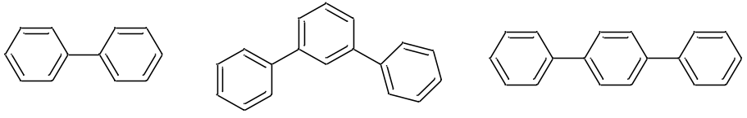
Figure S1.
Biphenyl-d₁₀: 10⋅C_{B}(H) + 2⋅C_{B}(C_{B})
Δ_{l}^{g}H(298 K) = [10⋅(5.61±0.08) + (2⋅(4.64±.21)] = (65.4±0.9); Lit. (64.5±1.6) kJ⋅mol⁻¹ [S25]

m-Terphenyl: 10⋅C_{B}(H) + 2⋅C_{B}(C_{B})
Δ_{l}^{g}H(298 K) = [14⋅(5.61±0.08) + (4⋅(4.64±.21)] = (97.1±1.4); Lit. (96.4±4.5) kJ⋅mol⁻¹[S25]

p-Terphenyl: 14⋅C_{B}(H) + 4⋅C_{B}(C_{B})
Δ_{l}^{g}H(298 K) = 14⋅(5.61±0.08) + (4⋅(4.64±.21) = (97.1±1.4); Lit. (100.6±4.5) [S25]

3B. C_{d}H(C) ≈ C_{d}H(C_{B}) = (5.15±1.13); C_{d}(C)₂≈ C_{d}(C)(C_{B}) = (4.85±1.17),
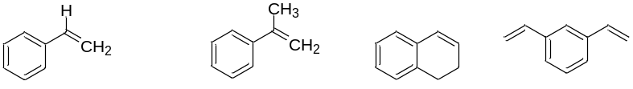
Figure S2.
Styrene: 5⋅C_{B}(H) + C_{B}(C_{d}) + C_{d}H(C_{B}) + C_{d}H₂
Δ_{l}^{g}H(298 K) = 5⋅(5.61±0.08) + (4.64±0.21) + (5.15±1.13) + (4.18±1.5)
Δ_{l}^{g}H(298 K) = (42.0±1.9) kJ⋅mol⁻¹; 43.5±0.4 [S26]

α-Methylstyrene: 5⋅C_{B}(H) + C_{B}(C_{d}) + C_{d}(C)(C_{B}) + C_{d}H₂ + CH₃(C)
Δ_{l}^{g}H(298 K) = 5⋅(5.61±0.08) + (4.64±0.21) + (4.85±1.17) + (4.18±1.5) + (5.69±0.04)
Δ_{l}^{g}H(298 K) = (47.4±2.0) kJ⋅mol⁻¹; (48.9±0.3) [S19]

1,2-Dihydronaphthalene: 4⋅C_{B}(H) + C_{B}(C_{d}) + C_{B}(C) + C_{d}(H)(C_{B}) + C_{d}H(C) + CH₂(C)(C_{d})
+ CH₂(C)(C_{B})
Δ_{l}^{g}H(298 K) = 4⋅(5.61±0.08) + 2⋅(4.64±0.21) + 2⋅(5.15±1.1) + (5.61±1.17) + (3.31±0.75)
Δ_{l}^{g}H(298 K) = (50.9±2.7) kJ⋅mol⁻¹; lit. (51.9 ± 0.4)

1,3-Divinylbenzene: 4⋅C_{B}(H) + 2⋅C_{B}(C_{d}) +2⋅C_{d}(C_{B}) +2⋅C_{d}(H₂)
Δ_{l}^{g}H(298 K) = 4⋅(5.61±0.08) + 2⋅(4.64±0.21) + 2⋅(5.15±1.1) + 2⋅(4.18±1.5)
Δ_{l}^{g}H(298 K) = (50.4±3.8) kJ⋅mol⁻¹; lit. (49.8 ± 0.4)
3C. NH(C_{B})₂ ≈ NH(C_{d})(C_{B}) ≈ NH(C_{d})₂; C_{B}(N) ≈ C_{d}H(N) ≈ C_{d}(C)(N)

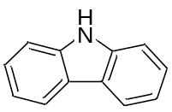

Figure S3. Carbazole

Carbazole: 8⋅C_{B}(H) + 2⋅C_{B}(C_{B}) + 2⋅C_{B}(N) + NH(C_{B})₂
Δ_{l}^{g}H(298 K)/ kJ⋅mol⁻¹ = (87.3±0.1) [S27, S28]
NH(C_{B})₂ = (87.3±0.1) − 8⋅(5.61±0.08) + 2⋅(4.64±0.21) + 2⋅(9.58±1.05)
NH(C_{B})₂ = (14.0±2.2) kJ⋅mol⁻¹
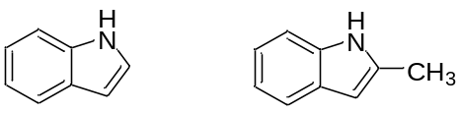
Figure S4. Indole 2-Methylindole

Indole: 4⋅C_{B}(H) + C_{B}(C_{d}) + C_{B}(N) + C_{d}(H)(N) + C_{d}(H)(C_{B}) + NH(C_{B})(C_{d})
Δ_{l}^{g}H(298 K) = 4(5.61±0.08) + (4.64±0.21) + 2(9.58±1.05) + (5.15±1.1) + (14.0±2.2)
Δ_{l}^{g}H(298 K) = (65.4±3.3) lit. (65.3±0.6) [S27]

2-Methylindole: CH₃(C) + 4⋅C_{B}(H) + C_{B}(C_{d}) + C_{B}(N) + C_{d}(C)(N) + C_{d}(H)(C_{B}) + NH(C_{B})(C_{d})
Δ_{l}^{g}H(298 K) = (5.69±0.04) + 4⋅(5.61±0.08) + (4.64±0.21) + 2⋅(9.58±1.05) + (5.15±1.1) + (14.0±2.2)
Δ_{l}^{g}H(298 K) = (71.1±3.1) lit. (72.7±0.4) [S33]

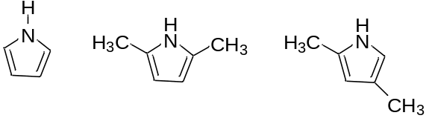
Figure 5. A series of pyrroles

Pyrrole: Δ_{l}^{g}H(298 K) =45.2 [S29]
Δ_{l}^{g}H(298 K) = 2⋅C_{d}H(C_{d}) + (C_{d}(C)(N)] + NH(C_{d})₂;
Δ_{l}^{g}H(298 K) = 2⋅(6.0±0.4)+ (9.58±1.05)] + (14.0±2.2) = (45.2±3.1) kJ⋅mol⁻¹

2,5-Dimethylpyrrole: Δ_{l}^{g}H(298 K) = 56.3 kJ⋅mol⁻¹ [S15]
Δ_{l}^{g}H(298 K) = 2⋅CH₃(C) +C_{d}H(C_{d}) + (C_{d}(C)(N)] +NH(C_{d})₂;
Δ_{l}^{g}H(298 K) = 2⋅(5.69±0.04) + (6.0±0.4)+ (9.58±1.05) +(14.0±2.2)] = (56.5±3.1) kJ⋅mol⁻¹

2,4-Dimethylpyrrole: Δ_{l}^{g}H(298 K) = 54.5 kJ⋅mol⁻¹ [S15]
Δ_{l}^{g}H(298 K) = 2⋅CH₃(C) + C_{d}H(C_{d}) + C_{d}(C)(C_{d})+ C_{d}(C)(N) + C_{d}H(N) + NH(C_{d})₂;
Δ_{l}^{g}H(298 K) = 2⋅(5.69±0.04)+ 2⋅(6.0±0.4)+2⋅(9.58±1.05) + (14.0±2.2) = (56.5±3.1) kJ⋅mol⁻¹

Section S4. Evaluations by SA of the two synthons cited in Table 1 (manuscript)
Table S8A. Ethyldimethylamine from Triethylamine by SA
Compound | Δ_{l}^{g}H(298K) |  | (±) |  | No. |  | Value | (±)²
Triethylamine ª | 34.8 | 0.2 |  | 1 |  | 34.8 |  | 0.04
CH₂(C)(N) | -1.8 | 0.54 |  | 2 |  | -3.6 |  | 0.29
Ethyldimethylamine: Δ_{l}^{g}H(298 K)/ kJ⋅mol⁻¹ (31.2±0.6)
ª [S14]
Table S8B. Methyl isovalerate from Ethyl isovalerate
Compound | Δ_{l}^{g}H(298K) |  | (±) |  | (±)²
Ethyl isovalerate [S6] | 43.3 | 0.3 |  | .09
CH₂(C)(O) | -3.51 | 0.21 |  | 0.044
Methyl isovalerate: Δ_{l}^{g}H(298 K)/ kJ⋅mol⁻¹ (39.8±0.4)

A comparison of vaporization enthalpy of MDMA from evaluated from 3,4,5-TMT and from 5-Methylbenzodioxole
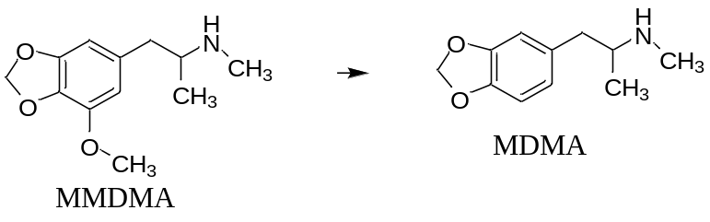
Figure 6. SA of MDMA from MMDMA
Table S9. SA of MDMA derived from 3,4,5-TMT
 | Δ_{l}^{g}H(298 ) (±) (±)²
MMDMAª | 89.5 | 3.0 | 9
C_{B}(H) | 5.61 | 0.08 | 0.006
C_{B}(O) | -4.64 | 0.21 | 0.044
CH₃(C) | -5.69 | 0.04 | 0.002
O(C)₂ | -8.37 | 0.33 | 0.109
MDMA: Δ_{l}^{g}H(298 )/kJ⋅mol⁻¹ (76.4±3.0)
ª MMDMA from Table 12 using 3,4,5-TMT
MDMA (from 5-methylbenzodioxole): Δ_{l}^{g}H_{m}(298.15K)/kJ⋅mol⁻¹ = (77.5±1.4) (from Table 10)
MDMA (from 3,4,5-TMT): Δ_{l}^{g}H_{m}(298.15K)/kJ⋅mol⁻¹ = (76.5±3.0) (from Table S9)

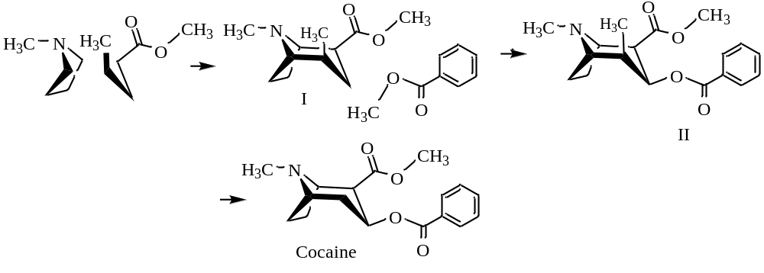
Figure S6. SA of Cocaine using methylpentanoate

Table S10. Formation of intermediate I Table S11. Formation of intermediate II and cocaine
Syn/Grp | Value | (±) | (±)² |  | Syn/Grp | Value | (±) | No. | (±)²
N-Methyl pyrrolidine | 34.2 | 0.7 | 0.49 |  | (I) | 66.3 | 1.9 | 1 | 3.61
Methyl pentanoate | 43.72 | 0.5 | 0.25 |  | Methyl benzoate | 55.6 | 0.1 | 1 | 0.01
CH(C)₃ | 3.05 | 0.13 | 0.017 |  | CH₃(C) | -5.69 | 0.04 | 1 | 0.002
CH₂C₂ | -5.06 | 0.04 | 0.002 |  | CH(C)₂(O) | 0 | 0.63 | 1 | 0.40
CH(C)₂(N) | -1.84 | 0.54 | 0.292 |  | CH₂(C)₂ | -5.06 | 0.04 | 1 | 0.002
CH₂(C)(N) | -1.8 | 0.79 | 0.624 |  | II/ kJ⋅mol⁻¹ | (111.2±2.0)
CH(C)₂(N) | -1.84 | 0.54 | 0.292 |  | II (±)² | 111.2 | 2.0 | 1 | 4.0
CH₂(C) (N) | -1.8 | 0.79 | 0.624 |  | CH₂C₂ | 5.06 | 0.04 | 1 | 0.002
CH(C)₂(CO) | -0.75 | 0.84 | 0.706 |  | CH₃(C) | -5.69 | 0.04 | 1 | 0.002
CH₂(C)(CO) | -1.55 | 0.54 | 0.292 |  | CH(C)₃ | -3.05 | 0.13 | 1 | 0.018
(I): Δ_{l}^{g}H(298 K)/ kJ⋅mol⁻¹ 66.3±1.9 |  |  |  |  | Cocaine: Δ_{l}^{g}H(298 K)/kJ⋅mol⁻¹ 107.5±2.0
The same value is evaluated if the benzoate ester is attached on a carbon at the ethylene bridge
Fusion Enthalpy of Cocaine:  Δ_{cr}^{g}H(304 K)/kJ⋅mol⁻¹: 112.6 [S34]; T_{fus} /K = 371  Δ_{l}^{g}H(298 K)/kJ⋅mol⁻¹: 105.0±2.0; 105.5±3.7 |  | Cp(298 K)  J⋅mol⁻¹⋅K⁻¹
Cp(cr) | =3*24.6+4*11.7+2*36.6+2*42.2+5*17.5+8.5+2.1 | 376.3
Cp(l) | =3*25.5+4*17.4+2*34.9+2*63.9+5*21.8+15.3+17.8 | 485.8

ΔlgH(371 K) = ΔlgH(298 K) + [10.58 + 0.26⋅Cpl(298 K)]⋅[ ΔΤ]/1000 (S1)
ΔlgH(371 K) = (105.3±2.9) + [10.58 + 0.26⋅485.8][ 298.15 – 371]/1000 = (95.3±3.5)
ΔcrgH(T_{fus} /K) = ΔcrgH(Tm/K) + [0.75 + 0.15⋅Cpcr(298 K)]⋅[ ΔΤ]/1000 (S2) ΔcrgH(371K) = 112.6 + [0.75 + 0.15⋅376.3][304 − 371]/1000 = (108.8±0.8) kJ⋅mol⁻¹
ΔcrlH(T_{fus} /K) = ΔcrgH(T_{fus} /K) - ΔlgH(T_{fus} /K)
ΔcrylH(T_{fus} /K) ≈ (108.8±0.8) - (95.3±3.5) = (13.5±3.6) kJ⋅mol⁻¹
Section S5. Evaluation of the licit and elicit drugs by group additivity
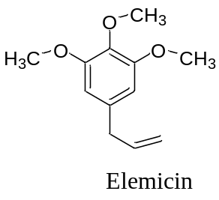
Table S12. Evaluation of elemicin by group additivity
Group | Value | (±) | No. |  | (±)² | Mass | T_{mass}
CH₃(C) | 5.69 | 0.04 | 3 | 17.1 | 0.014 | 15 | 45
O(C)₂ | 8.37 | 0.33 | 3 | 25.1 | 0.980 | 16 | 48
C_{B}(H) | 5.61 | 0.08 | 2 | 11.2 | 0.026 | 13 | 26
C_{B}(O) | 4.64 | 0.21 | 3 | 13.9 | 0.397 | 12 | 36
C_{B}(C) | 4.64 | 0.21 | 1 | 4.64 | 0.044 | 12 | 12
CH₂(C_{d})(C_{B}) | 4.46 | 1.0 | 1 | 4.46 | 1.0 | 16 | 16
C_{d}H(C) | 5.15 | 1.1 | 1 | 5.15 | 0.292 | 14 | 14
C_{d}H₂ | 4.18 | 1.5 | 1 | 4.18 | 2.25 | 14 | 14
Elemicin: | Δ_{l}^{g}H_{m}(298.15 K)/kJ⋅mol⁻¹ |  |  | (85.8±2.4) |  | MW | 208
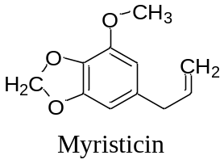
Table S13. Evaluation of myristicin by group additivity
Group | Value | (±) | No. | Total value | (±)² | Mass | T_{mass}
CH₃(C) | 5.69 | 0.04 | 1 | 5.69 | 0.002 | 15 | 15
CH₂(C_{d})(C_{B}) | 4.46 | 1.0 | 1 | 4.46 | 1.0 | 14 | 14
C_{d}H₂ | 4.18 | 1.50 | 1 | 4.18 | 2.25 | 14 | 14
C_{d}H(C) | 5.15 | 1.1 | 1 | 5.15 | 1.21 | 13 | 13
C_{B}(H) | 5.61 | 0.21 | 2 | 11.2 | 0.80 | 13 | 26
C_{B}(C) | 4.64 | 0.21 | 1 | 4.64 | 0.044 | 12 | 12
C_{B}(O) | 4.64 | 0.21 | 3 | 13.9 | 0.040 | 12 | 36
O(C)₂ | 8.37 | 0.33 | 3 | 25.1 | 0.98 | 16 | 48
CH₂(O)₂ | 0.59 | 2.90 | 1 | 0.59 | 8.41 | 14 | 14
Myristicin: | Δ_{l}^{g}H_{m}(298.15 K)/kJ⋅mol⁻¹ (75.0±3.8) |  |  |  |  | 192
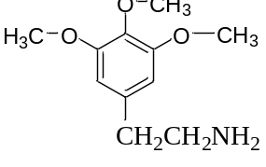
Mescaline
Table S14. Evaluation of mescaline by group additivity
Group | Value | (±) | No | Total | (±)² | Mass | T_{mass}
CH₃(C) | 5.69 | 0.04 | 3 | 17.1 | 0.014 | 15 | 45
O(C)₂ | 8.37 | 0.33 | 3 | 25.1 | 0.980 | 16 | 48
CB(H) | 5.61 | 0.08 | 2 | 11.2 | 0.256 | 13 | 26
CB(O) | 4.64 | 0.21 | 3 | 13.9 | 0.397 | 12 | 36
CB(C) | 4.64 | 0.21 | 1 | 4.64 | 0.044 | 12 | 12
NH₂(C) | 18.1 | 0.63 | 1 | 18.1 | 0.397 | 16 | 16
CH₂(C)(N) | 1.8 | 0.54 | 1 | 1.8 | 0.292 | 14 | 14
CH₂(C)(C_{B}) | 3.31 | 0.75 | 1 | 3.31 | 0.563 | 14 | 14
Mescaline | Δ_{l}^{g}H_{m}(298.15 K)/kJ⋅mol⁻¹ |  |  | (95.2±1.6) |  |  | 211

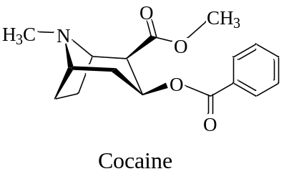
Table S15. Vaporization enthalpy of cocaine by group additivity
Group | Value | (±) | No | Group  Mass | (±)² | Mass | T_{mass}
CH3(X)ª | 5.69 | 0.04 | 2 | 11.38 | 0.006 | 15 | 30
CH2(C)2 | 5.06 | 0.04 | 3 | 15.18 | 0.014 | 14 | 42
CH(C)2(O) | 0 | 0.63 | 1 | 0 | 0.400 | 13 | 13
CH(C)2(N) | -1.84 | 0.79 | 2 | -3.68 | 2.496 | 13 | 26
N(C)3 | 12 | 1.7 | 1 | 12 | 2.890 | 14 | 14
CB(H) | 5.61 | 0.08 | 5 | 28.05 | 0.160 | 13 | 65
CB(C) | 4.64 | 0.21 | 1 | 4.64 | 0.044 | 12 | 12
CH(C)2(CO) | -0.75 | 0.84 | 1 | -0.75 | 0.706 | 13 | 13
CO(O)(C) | 18.6 | 1.84 | 2 | 37.2 | 13.54 | 28 | 56
O(CO)(C) | 2.68 | 1.84 | 2 | 5.36 | 12.96 | 16 | 32
Cocaine: ΔlgH(298 K)/ kJ⋅mol⁻¹ |  |  |  | (109.4±5.8) |  | MW | 303
ª X = C, N.
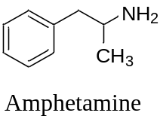
Table S16. Evaluation of Amphetamine by group additivity
Group | Value | (±) | No | Group  Mass | Total | (±)² | Mass
C_{B}(H) | 5.61 | 0.08 | 5 | 13 | 28.05 | 0.16 | 65
C_{B}(C) | 4.64 | 0.21 | 1 | 12 | 4.64 | 0.04 | 12
CH₃(C) ª | 5.69 | 0.04 | 1 | 15 | 5.69 | 0.002 | 15
CH₂(C)(C_{B}) | 3.31 | 0.75 | 1 | 14 | 3.31 | 0.56 | 14
NH₂(C) | 18.1 | 0.63 | 1 | 16 | 18.1 | 1.05 | 16
CH(C)₂(N) | -1.84 | 0.79 | 1 | 13 | -1.84 | 0.62 | 13
Amphetamine: ª |  | Δ_{l}^{g}H_{m}(298.15K)/kJ⋅mol⁻¹ |  |  | (58.0±1.3) |  | 135
ª Lit. (58.2±2.7 kJ⋅mol⁻¹) [S30]; SA: (58.9 ±0.8)

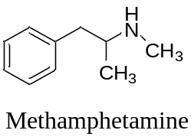
Table S17. Evaluation of Methamphetamine by group additivity
Group | Value | (±) | No | Group  Mass | Total | (±)² | Mass
C_{B}(H) | 5.61 | 0.08 | 5 | 13 | 28.05 | 0.16 | 65
C_{B}(C) | 4.64 | 0.21 | 1 | 12 | 4.64 | 0.04 | 12
CH₃(X) ª | 5.69 | 0.04 | 2 | 15 | 11.38 | 0.006 | 30
CH₂(C)(C_{B}) | 3.31 | 0.75 | 1 | 14 | 3.31 | 0.56 | 14
NH(C)₂ | 15.5 | 1.05 | 1 | 15 | 15.5 | 1.05 | 15
CH(C)₂(N) | -1.84 | 0.79 | 1 | 13 | -1.84 | 0.62 | 13
Methamphetamine:^{b} |  | Δ_{l}^{g}H_{m}(298.15K)/kJ⋅mol⁻¹ |  |  | (61.0±1.6) |  | 149
ª X= C, N. ^{b} Lit. (58.7±4.3) kJ⋅mol⁻¹ [S31]

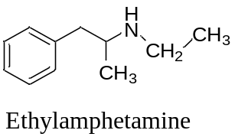
Table 18. Evaluation of N-Ethylamphetamine by group additivity
Group | Value | (±) | No | Group  Mass | Total | (±)² | Mass
C_{B}(H) | 5.61 | 0.08 | 5 | 13 | 28.05 | 0.16 | 65
C_{B}(C) | 4.64 | 0.21 | 1 | 12 | 4.64 | 0.04 | 12
CH₃(X) | 5.69 | 0.04 | 2 | 15 | 11.38 | 0.006 | 30
CH₂(C)(C_{B}) | 3.31 | 0.75 | 1 | 14 | 3.31 | 0.56 | 14
NH(C)₂ | 15.5 | 1.05 | 1 | 15 | 15.5 | 1.10 | 15
CH₂(C)(N) | 1.8 | 0.54 | 1 | 14 | 1.8 | 0.29 | 14
CH(C)₂(N) | -1.84 | 0.79 | 1 | 13 | -1.84 | 0.62 | 13
Ethylamphetamine ª: |  | Δ_{l}^{g}H_{m}(298.15K)/kJ⋅mol⁻¹ |  |  | (62.8±1.7) |  | 163
ª Δ_{l}^{g}H_{m}(298.15K)/kJ⋅mol⁻¹: (62.4±4.4) [S32]
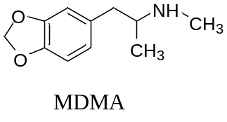
Table S19. Evaluation of MDMA by group additivity
Group | Value | (±) | No | Mass | Total value | (±)² | T_{mass}
CH₃(X) b | 5.69 | 0.04 | 2 | 15 | 11.38 | 0.006 | 30
CH₂(C)(C_{B}) | 3.31 | 0.75 | 1 | 14 | 3.31 | 0.56 | 14
CH(C)₂(N) | -1.84 | 0.79 | 1 | 13 | -1.84 | 0.621 | 13
C_{B}(H) | 5.61 | 0.08 | 3 | 13 | 16.83 | 0.058 | 39
C_{B}(C) | 4.64 | 0.21 | 1 | 12 | 4.64 | 0.044 | 12
C_{B}(O) | 4.64 | 0.21 | 2 | 12 | 9.28 | 0.0441 | 24
NH(C)₂ | 15.5 | 1.05 | 1 | 15 | 15.5 | 1.103 | 15
CH₂(O)₂ | 0.59 | 2.90 | 1 | 14 | 0.59 | 8.33 | 14
O(C)₂ | 8.37 | 0.33 | 2 | 16 | 16.74 | 0.44 | 32
MDMA: ΔlgH(298 K)/ kJ⋅mol⁻¹ (76.4±3.4) MW |  |  |  |  |  |  | 193

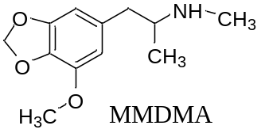
Table S20. Evaluation of MMDMA by group additivity
Group | Value | (±) | No | Mass | Total value | (±)² | T_{mass}
CH₃(X) ^{b} | 5.69 | 0.04 | 3 | 15 | 17.1 | 0.014 | 30
CH₂(C)(C_{B}) | 3.31 | 0.75 | 1 | 14 | 3.31 | 0.56 | 14
CH(C)₂(N) | -1.84 | 0.79 | 1 | 13 | -1.84 | 0.621 | 13
C_{B}(H) | 5.61 | 0.08 | 2 | 13 | 11.2 | 0.060 | 39
C_{B}(C) | 4.64 | 0.21 | 1 | 12 | 4.64 | 0.044 | 12
C_{B}(O) | 4.64 | 0.21 | 3 | 12 | 13.9 | 0.0441 | 24
NH(C)₂ | 15.5 | 1.05 | 1 | 15 | 15.5 | 1.05 | 15
CH₂(O)₂ | 0.59 | 2.90 | 1 | 14 | 0.59 | 8.4 | 14
O(C)₂ | 8.37 | 0.33 | 3 | 16 | 25.11 | 1.0 | 48
MMDMA: ΔlgH(298 K)/kJ⋅mol⁻¹ |  |  | 16 |  | 89.5±3.5 |  | 223
^{b}X= C, N, O
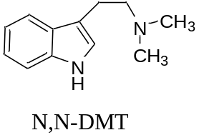
Table S21. Evaluation of N,N- dimethyltryptamine by group additivity
Group | Value | (±) | No | Group  Mass | Total |  | (±)² | Mass
CH₃C | 5.69 | 0.04 | 2 | 15 | 11.38 |  | 0.0064 | 30
C_{B}(H) | 5.61 | 0.08 | 4 | 13 | 22.44 |  | 0.1024 | 52
C_{B}(C_{d}) | 4.64 | 0.21 | 1 | 12 | 4.64 |  | 0.0441 | 12
C_{B}(N) | 9.85 | 1.05 | 1 | 12 | 9.85 |  | 1.1025 | 12
C_{d}H(N) | 9.85 | 1.05 | 1 | 13 | 9.85 |  | 1.1025 | 13
C_{d}(C)C_{B}) | 4.85 | 1.17 | 1 | 12 | 5.15 |  | 1.21 | 12
CH₂(C)(Cd) | 5.61 | 1.17 | 1 | 14 | 5.61 |  | 1.3689 | 14
CH₂C)(N) | 1.8 | 0.54 | 1 | 14 | 1.8 |  | 0.2916 | 14
NH(C_{B})(C_{d}) | 14 | 2.5 | 1 | 15 | 14 |  | 6.25 | 15
N(C)₃ | 12 | 1.7 | 1 | 14 | 12 |  | 2.89 | 14
N,N- Dimethyltryptamine: Δ_{l}^{g}H_{m}(298.15K)/kJ⋅mol⁻¹ |  |  |  |  |  | (96.4±3.8) |  | 188

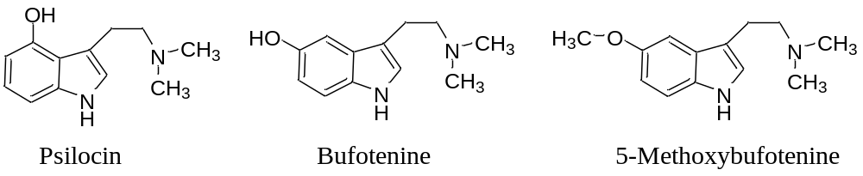
Table S22. Evaluation of psilocin, bufotenine and 5-methoxybufotenine by group additivity
Group | Value | (±) | No. | Group  Mass | Total | (±)² | Mass |  | No. |  | Total | (±)² | Mass
CH₃C | 5.69 | 0.04 | 2 | 15 | 11.38 | 0.006 | 30 |  | 3 |  | 17.1 | 0.014 | 45
C_{B}(H) | 5.61 | 0.08 | 3 | 13 | 16.83 | 0.058 | 39 |  | 3 |  | 16.8 | 0.056 | 39
C_{B}(C_{d}) | 4.64 | 0.21 | 1 | 12 | 4.64 | 0.044 | 12 |  | 1 |  | 4.64 | 0.0441 | 12
C_{B}(O) | 4.64 | 0.21 | 1 | 12 | 4.64 | 0.044 | 12 |  | 1 |  | 4.64 | 0.044 | 12
O(C)₂ | 8.37 | 0.33 |  | 16 |  |  |  |  | 1 |  | 8.37 | 0.109 | 16
N(C)₃ | 12 | 1.7 | 1 | 14 | 12 | 2.89 | 14 |  | 1 |  | 12 | 2.89 | 14
C_{B}(N) | 9.85 | 1.05 | 1 | 12 | 9.85 | 1.103 | 12 |  | 1 |  | 9.85 | 1.10 | 12
O_{p}H_{HOS} | 26.2 | 1.9 | 1 | 17 | 26.2 | 3.61 | 17
C_{d}H(N) | 9.85 | 1.05 | 1 | 13 | 9.85 | 1.103 | 13 |  | 1 |  | 9.85 | 1.10 | 13
CH₂(C)(Cd) | 5.61 | 1.17 | 1 | 14 | 5.61 | 1.37 | 14 |  | 1 |  | 5.61 | 1.37 | 14
CH₂(C)(N) | 1.8 | 0.54 | 1 | 14 | 1.8 | 0.292 | 14 |  | 1 |  | 1.8 | 0.292 | 14
C_{d}(C)C_{B}) | 4.85 | 1.17 | 1 | 12 | 5.15 | 1.1 | 12 |  | 1 |  | 5.15 | 1.21 | 12
NH(C_{B})(C_{d}) | 14.0 | 2.5 | 1 | 15 | 14.0 | 6.25 | 15 |  | 1 |  | 14 | 6.25 | 15
5-Methoxybufotenine: Δ_{l}^{g}H_{m}(298.15K)/kJ⋅mol⁻¹ (109.5±3.8) 218
Psilocin/Bufotonin: Δ_{l}^{g}H_{m}(298.15K)/kJ⋅mol⁻¹(121.7±4.2)

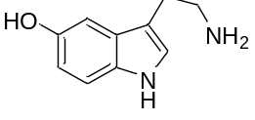
Table S23. Evaluation of seratonin by group additivity
Group | Value | (±) | No. | Group  Mass | Total | (±)² | Mass
C_{B}(H) | 5.61 | 0.08 | 3 | 13 | 16.83 | 0.058 | 39
C_{B}(C_{d}) | 4.64 | 0.21 | 1 | 12 | 4.64 | 0.045 | 12
C_{B}(O) | 4.64 | 0.21 | 1 | 12 | 4.64 | 0.044 | 12
C_{B}(N) | 9.58 | 1.05 | 1 | 12 | 9.58 | 1.10 | 12
C_{d}H(N) | 9.58 | 1.05 | 1 | 13 | 9.58 | 1.10 | 13
OH_{HOS} | 26.2 | 1.90 | 1 | 17 | 26.2 | 3.61 | 17
CH₂(C)(N) | 1.8 | 0.54 | 1 | 14 | 1.80 | 0.292 | 14
NH(C_{B})(C_{d}) | 14.0 | 2.5 | 1 | 15 | 14.0 | 2.5 | 15
NH₂(C) | 18.1 | 0.63 | 1 | 16 | 18.1 | 0.40 | 16
CH₂(C)(C_{d}) | 5.61 | 1.17 | 1 | 14 | 5.61 | 1.37 | 14
C_{d}(C)(C_{B}) | 4.85 | 1.17 | 1 | 12 | 5.15 | 1.21 | 12
Seratonin: Δ_{l}^{g}H_{m}(298.15K)/kJ⋅mol⁻¹ |  |  |  |  | (115.8±3.9) |  | 176
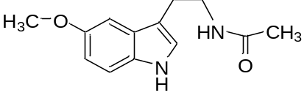
Table S24. Evaluation of melatonin by group additivity
Group | Value | (±) | No. | Group  Mass | Total | (±)² | Mass
CH₃(C) | 5.69 | 0.04 | 2 | 15 | 11.4 | 0.0064 | 30
(CO)NH(C) ₂ | 51.1 | 0.8 | 1 | 43 | 51.1 | 0.64 | 43
CH₂(C)(N) | 1.80 | 0.54 | 1 | 14 | 1.80 | 0.62 | 14
CH₂(C)(C_{d}) | 5.61 | 1.17 | 1 | 14 | 5.61 | 1.37 | 14
C_{d}(C)C_{B}) | 4.85 | 1.17 | 1 | 12 | 5.15 | 1.21 | 12
C_{d}H(N) | 9.85 | 1.05 | 1 | 13 | 9.85 | 1.10 | 13
NH(C_{B})(C_{d}) | 14.0 | 2.5 | 1 | 15 | 14.0 | 6.25 | 15
C_{B}(N) | 9.85 | 1.05 | 1 | 12 | 9.85 | 1.10 | 12
C_{B}(H) | 5.61 | 0.08 | 3 | 13 | 16.8 | 0.058 | 39
C_{B}(C) | 4.64 | 0.21 | 1 | 12 | 4.64 | 0.044 | 12
C_{B}(O) | 4.64 | 0.21 | 1 | 12 | 4.64 | 0.044 | 12
O(C)₂ | 8.37 | 0.33 | 1 | 16 | 8.37 | 0.11 | 16
Melatonin: Δ_{l}^{g}H_{m}(298.15K)/kJ⋅mol⁻¹ |  |  |  |  | (142.9±3.5) |  | 232

Table 25. A summary of the vaporization enthalpies evaluated by SA and GA
Drugs | SA |  | GA
Elemicin | 85.6±1.6 |  | 85.8±2.4
Myristicin | 74.8±3.3 |  | 75.0±3.8
Mescaline | 97.7±1.0 |  | 95.2±1.6
Cocaine | 105.0±2.0 |  | 109.4±5.8
Amphetamine | 58.9±0.9 |  | 58.0±1.3
Methamphetamine | 61.2±0.8 |  | 61.0±1.6
N-Ethylamphetamine | 63.6±0.8 |  | 62.8±1.7
MDMA | 77.5±1.4 |  | 76.4±3.4
MDMA | 76.4±3.0 |  | 76.4±3.4
MMDMA | 89.5±3.0 |  | 89.5±3.5
N,N-Dimethyltryptamine | 96.1±2.2 |  | 96.4±3.8
Psilocin | ≈121.4±2.9 |  | ≈121.7±4.2
Bufotenine | ≈121.4±2.9 |  | ≈121.7±4.2
5-Methoxybufotenine | ≈109.2±2.8 |  | ≈109.5±3.8
Seratonin | ≈118.2±2.8 |  | ≈115.8±3.9
Melatonin | ≈ 142.8±2.2 |  | ≈142.9±3.5

Section 6 Non-regiospecific Synthetic Analyses
Mescaline
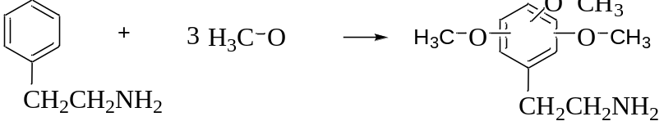
2-Phenethylamine | 57.6 | 1.5 | 1 | 57.6 | 2.25
CH₃ | 5.69 | 0.04 | 3 | 17.07 | 0.014
O(C)₂ | 8.37 | 0.33 | 3 | 25.11 | 0.980
C_{B}(O) | 4.64 | 0.21 | 3 | 13.92 | 0.397
C_{B}(H) | -5.61 | 0.08 | 3 | -16.83 | 0.058
Δ_{l}^{g}H_{m}(298.15K)/kJ⋅mol⁻¹ (96.9±1.9)

- References
[S1] Acree Jr. W, Chickos JS. (2016) Phase Transition Enthalpy Measurements of Organic and Organometallic Compounds. Sublimation, Vaporization and Fusion Enthalpies From 1880 to 2015. Part 1. C₁-C₁₀; J Phys Chem Ref Data 45: 033101 (1- 565). (2017) Part 2. C₁₁-C₁₉₂. J Phys Chem Ref Data 46: 012104 (1-532).
[S2] Chickos J, (2023) An update on liquid heat capacity estimations of cyclic organic compounds by group additivity and their application in estimations of complex molecules by synthetic and retrosynthetic analysis. J Chem Thermodyn 182;107039:1-12. https://doi.org/10.1016/j.jct.2023.107039.
[S3] Guthrie JP, Taylor KF (1983) Additivity methods for estimating heat of vaporization of organic compounds. J Can Chem 61:602–607.
[S4] JS Chickos, (2026) Estimation of the vaporization enthalpies of codeine (C) and morphine (M) by correlation gas chromatography using alcohols as standards. A comparison to the values of a series of opioids including C and M evaluated by synthetic analysis and group additivity. Struct Chem
[S5] Bittrich HJ, Kauer E, Kraft M, Schoeppe G, Soell W, Ullrich A, (1962) J Prakt Chem 17:250.
[S6] Stull DR , (1947) Ind Eng Chem 39:517.
[S7] Wilhoit RC, Zwolinski BJ, “Handbook of vapor pressures and heats of vaporization of hydrocarbons and related compounds,” in API 44-TRC Publications in Science and Engineering. API, College Station, TX, 1971
[S8] Hull HS, Reid AF, Turnbull AG, (1965) Aust J Chem 18:249.
[S9] Agafonova LE, Varushchenko RM, Druzhinina AI, Polyakova OV, (2012) J Chem Thermodyn 47:120.
[S10] Verevkin SP, Emel’yanenko VN, (2008) Fluid Phase Equilib 266:64.
[S11] van Genderen ACG, van Miltenburg JC, Blok JG, van Bommel M J, van Ekeren PJ, K. van den Berg GJ, Oonk HAJ, (2002) Fluid Phase Equilib 202: 109.
[S12] Svoboda V, Vesely F, Holub R, Pick, (1973) J Collect Czech Chem Commun 38:3539.
[S13] Letcher, TM, and F. Marsicano F, (1974) J Chem Thermodyn 6:509.
[S14] Majer V. Svoboda V, Koubek J, Pick J, (1979) J Collect Czech Chem Commun 44:3521.
[S15] Chirico D, Kazakov AF, (2018) J Chem Thermodyn 116:213 (2018).
[S16] Finke HL, Scott DW, Gross ME, Messerly JF, Waddington G, (1956) J Am Chem Soc 78:5469.
[S17] Scot DW, Gross ME, Oliver GD, Huffman HM, (1949) J Am Chem Soc 71:1634.
[S18] Steele WV, Chirico RD, Cowell AB, Knipmeyer SE, Nguyen A, J. Chem. Eng. Data 47, 667 (2002).
[S19] Verevkin SP, Thermochim. Acta 326, 17 (1999).
[S20] Steele WV, Chirico RD, Knipmeyer SE, Nguyen A, (1997) J Chem Eng Data 42:1008.
[S21] R. M. Stephenson and S. Malanowski, Handbook of the Thermodynamics of Organic Compounds (Elsevier, NewYork, 1987).
[S22] limonene Stejfa VC, Fulem M, Ruzicka KVC, Cervinka C, (2014) J Chem Thermodyn 79:280.
[S23] Zaitseva KV, Varfolomeev MA, Verevkin SP, (2019) J. Mol. Liq. 293:111453.
[S24] Starzewski P, Wadso I, Zielenkiewicz W, (1984) Enthalpies of vaporization of some N alkylamides at 298.15 K, (1984) J Chem Thermodyn 16:331.
[S25] Acree W, Chickos J. (2022) J. Phys. Chem. Ref. Data 51:043101.
https://doi.org/10.1063/5.0081916
[S26] Pitzer KS, Guttman L , Westrum, Jr. EF, (1946) J Am Chem Soc 68:2209.
[S27] Verevkin SP, Emel’yanenko VN, Pimerzin AA, Vishnevskay EE, (2011) J. Phys. Chem. A 115:12271.
[S28] Sivaraman A, Martin RJ, Kobayashi R, (1983) Fluid Phase Equilib. 12:175.
[S29] Scott, DW, Berg WT, Hossenlopp IA, Hubbard WN, Messerly JF, Todd SS, Douslin DR, McCullough JP, Waddington G, (1967) J. Phys. Chem. 71, 2263–2270.
[S30] Thornton M, Chickos J, Garist IV, Varfolomeev MA, Svetlov A, Verevkin SP, (2013) J Chem Eng Data 58:2018.
[S31] Thornton M, Gobble C, Chickos J. (2014) The vaporization enthalpy and vapor pressure of S (+)-methamphetamine at T = 298.15 K by correlation gas chromatography. J Chem Eng Data 73:51.
[S32] Chickos, JS, (2021) The vaporization Enthalpy and Vapor pressure of (±) N-Ethyl Amphetamine by Correlation gas Chromatography. Molecules 26:3809.
[S33] Chirico RD, Paulechka E, Bazyleva A, Kazakov AF. (2018) Thermodynamic properties of 2-methylindole: experimental and computational results for gas-phase entropy and enthalpy of formation., pubmed.ncbi.nlm,nih.giv/39534676. doi: 10.1016/j.jct.2018.05.029.
[S34] Lawrence AH, Elias L, M. Authier-Martin M. (1984) Determination of amphetamine, cocaine, and heroin vapour pressures using a dynamic gas blending system and gas chromatographic analysis. Can. J. Chem. 62:1886.

