Supplementary Materials

1. Raw data for 80 yr old male, 70 kg, 170 cm
Time to CeT  (sec) | Peak Cp  Cp limited  (µg·mL⁻¹) | Peak Cp  Infusion limited  (µg·mL⁻¹) | Dose 15 min  Cp limited  (mg) | 15 min Dose  Infusion limited  (mg)
250 | 14.1 | 14.1 | 168 | 168
284 | 8.1 | 11.4 | 166 | 165
318 | 6.7 | 9.6 | 164 | 163
352 | 6.0 | 8.3 | 163 | 160
387 | 5.4 | 7.4 | 161 | 158
421 | 5.0 | 6.7 | 159 | 156
455 | 4.7 | 6.2 | 158 | 154
489 | 4.5 | 5.8 | 157 | 152
523 | 4.3 | 5.4 | 156 | 150
558 | 4.2 | 5.1 | 154 | 148
592 | 4.0 | 4.9 | 153 | 147
626 | 3.9 | 4.7 | 152 | 145
660 | 3.8 | 4.5 | 151 | 143
695 | 3.7 | 4.4 | 150 | 142
729 | 3.7 | 4.3 | 149 | 140
763 | 3.6 | 4.2 | 149 | 139
797 | 3.5 | 4.1 | 148 | 138
832 | 3.5 | 4.0 | 147 | 136
866 | 3.4 | 3.9 | 146 | 135
900 | 3.4 | 3.9 | 145 | 134

2. Varying demographics
Simulation of the 3 induction strategies (standard Ce targeting, Ce targeting with peak Cp limit and Ce targeting with maximum infusion rate limit) were repeated for older patients with a spectrum of different demographics (high BMI, low BMI, female). Plots corresponding to Figure 1 and 2 of the original manuscript were produced for each simulated patient with varied parameters. Similar trends were found in each case, supporting the in silico generalisability of main conclusions of this study.

2.1 High BMI – 80 yr old male, 120 kg, 170 cm
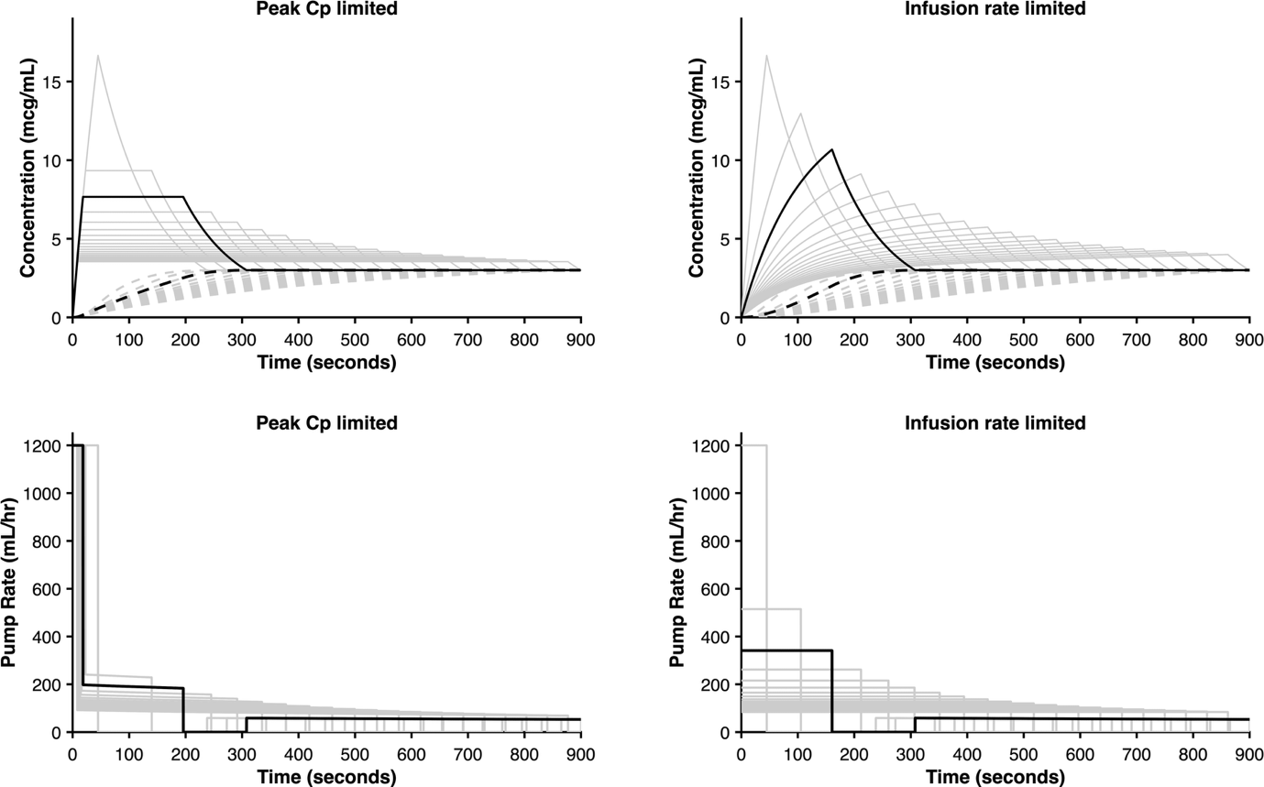
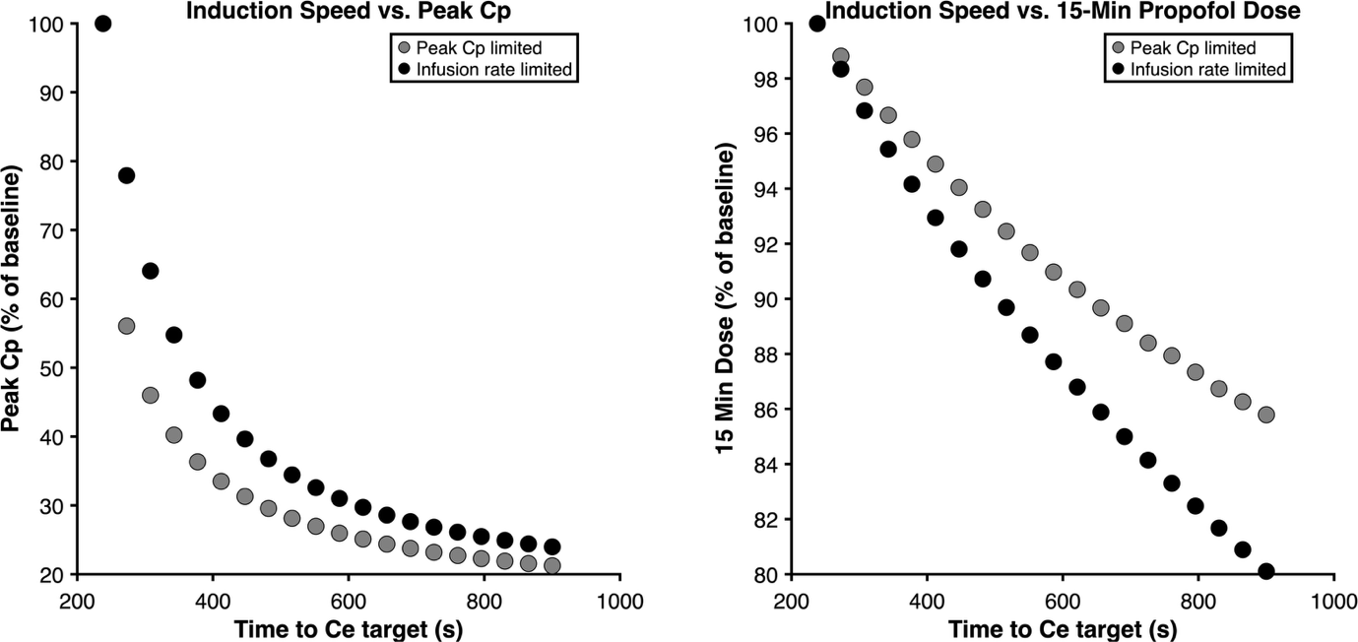
2.2 Underweight – 80 yr old male, 40 kg, 170 cm
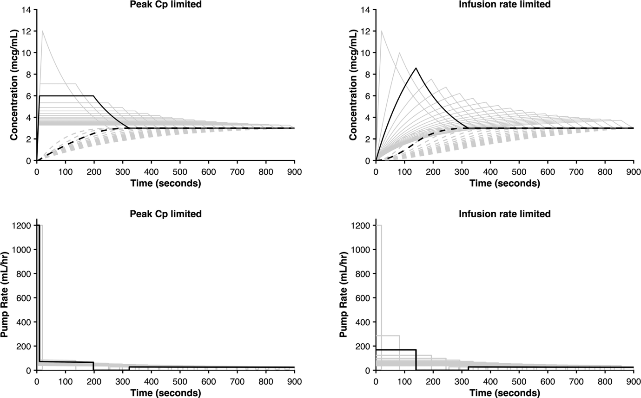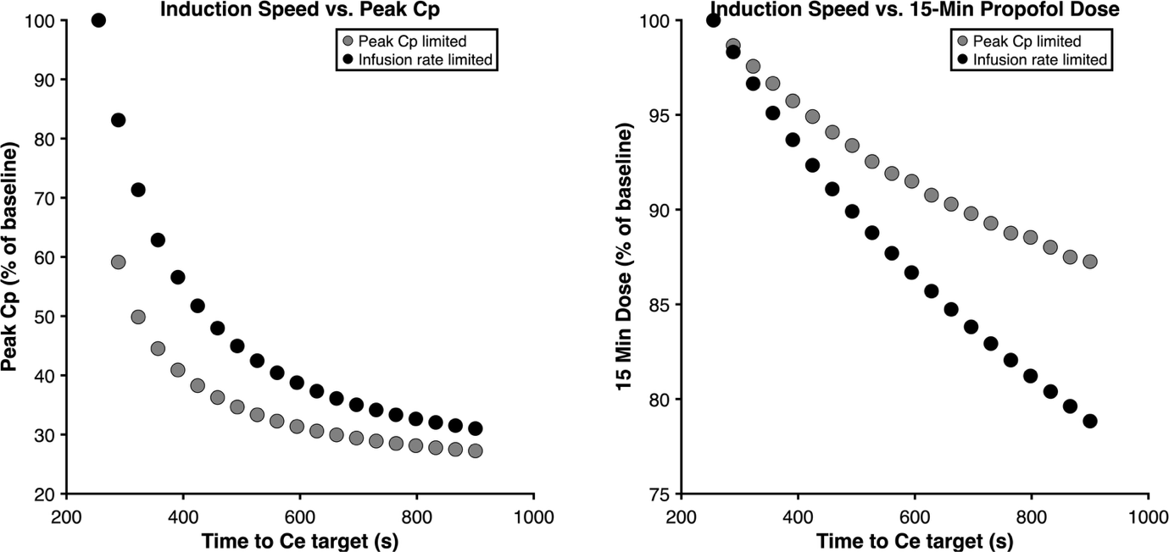

2.3 Female sex - 80 yr old female, 70 kg, 170 cm
