Supplementary Information for
Global assessment of marine CO₂ removal efficiency in the coastal ocean
Yinghuan Xie^{1,2}, Paul Spence^{1,2,3}, Stuart Corney^{1,2} and Lennart T. Bach¹
1 Institute for Marine and Antarctic Studies, University of Tasmania, Hobart, Australia
2 Australian Antarctic Partnership Program, University of Tasmania, Hobart, Australia
3 Australian Centres of Excellence for Antarctic Science and Our Future Oceans and 21st Century Weather, University of Tasmania, Hobart, Australia
Corresponding author: Y. Xie (yinghuan.xie@utas.edu.au)

Table of Contents
Supplementary Text 1: Computational cost relative to conventional modelling 2
Supplementary Text 2: Definition of absorber height 3
Supplementary Text 3: 3
Supplementary Fig. 1 | Time evolution of four-season mean coastal mCDR efficiency. 4
Supplementary Fig. 2 |Coastal mCDR efficiency at year-1 and 10 for different seasons. 5
Supplementary Fig. 3 | Dominant attribution of coastal mCDR efficiency for different seasons. 6
Supplementary Fig. 4 | Sensitivity of absorber-approach efficiency error to the gamma scaling and mixed layer depth clip. 7
Supplementary Fig. 5 | Sensitivity of mCDR efficiency calculated with the absorber approach to the number of absorbers used to assess mCDR efficiency. 8

Supplementary Text 1: Computational cost relative to conventional modelling
We estimated the market-rate replacement cost of ACCESS-OM2 simulations using published model-performance data and benchmarked HPC pricing. Kiss et al. (2020) report that ACCESS-OM2 requires approximately 118 CPU-hours per simulated year at 1° resolution and 118,000 CPU-hours per simulated year at 0.1° resolution. For a 10-year simulation, this corresponds to 1,180 and 1,180,000 CPU-hours, respectively. We converted CPU-hours to monetary cost using published HPC/cloud benchmark rates from Dancheva et al. (2024), who report approximately USD 0.027–0.053 per core-hour for comparable academic supercomputing and cloud-HPC resources. This gives an indicative replacement cost of approximately USD 30–60 for a 10-year 1° simulation and USD 30,000–60,000 for a 10-year 0.1° simulation.
Relative to conventional model mCDR simulations, the computational advantage of the absorber approach depends on resolution (Supplementary Fig. 6). At 1° resolution with monthly forcing, the method is lightweight: CESM2 and ACCESS-OM2 experiments required median costs of only 0.19-0.26 Processor Element (PE, i.e., CPU core) h site⁻¹ yr⁻¹ with 3,000-10,000 absorbers per site, low enough for desktop-scale sensitivity tests while still giving median speed-up factors of 435-5,000 relative to comparable conventional simulations ^{15,16}. Across configurations, the along-trajectory PYCO2SYS and mCDR efficiency calculations added negligible cost compared with Lagrangian absorber tracking and sampling. At 0.1° resolution, the calculation becomes supercomputer-scale because the daily eddy-permitting fields and particle advection are substantially larger, requiring a median cost of 16.9 PE h site⁻¹ yr⁻¹ for the 112-site benchmark experiment with typically 3,000 absorbers per site. However, this still corresponds to a median 7,000-fold reduction in cost relative to an equivalent 0.1° conventional simulation ¹⁵, while providing the best agreement with conventional model estimates (Fig. 2f). For the dense global coastal application, the computational saving is even more decisive: sampling 170,798 coastal sites (including 21,227 north pole sites not used in the research) with 31 absorbers per site required a median cost of only 0.02 PE h site⁻¹ yr⁻¹, equivalent to a median 5,040,000 -fold speed-up relative to the conventional 0.1° simulations. Even when normalized to 3,000 absorbers per site, the inferred median cost remains only 1.93 PE h site⁻¹ yr⁻¹, equivalent to a median 5.21 x 10⁴-fold speed-up. Thus, the 1° implementation enables low-cost screening, whereas the 0.1° implementation makes globally dense, conventional model-consistent coastal mCDR assessment computationally feasible. Compared with the 112-site sensitivity tests, the 170,798-site main experiment achieved higher single-absorber tracking efficiency, and therefore a larger overall median speed-up factor.

Supplementary Text 2: Definition of absorber height
The virtual-absorber release depth, Z_{release}, was 2.3 m for both 1° and 0.1° ACCESS-OM2, corresponding to the uppermost and second-uppermost model layers, respectively. For 1° CESM2, which has a thicker uppermost layer, half of the absorbers were released at 5 m and the other half at 7 m, giving a mean release depth of 6 m. To define the vertical extent of each virtual absorber, we assign it a geometric height, h_{absorber}. We treat the release depth as the absorber’s vertical centre. Assuming that the absorber extends downward from the sea surface, its geometric height is therefore h_{absorber} = 2Z_{release}.

Supplementary Text 3:
For each trajectory i and time step t, mixed-layer depth in the 0.1° daily experiments constrained to the inclusive range 50–1000 m to avoid excessively strong air-sea exchange under very shallow mixed layers while limiting anomalously deep mixed-layer values:
$H_{i,t}= min(1000,max(50,{mldepth }_{i,t​}))$ (Supplementary Equation 1)
Specifically, the 50 m lower bound compensates for differences between our mixed-layer shuffling scheme and tracer mixing in conventional models. Sensitivity tests showed that this threshold produced mCDR efficiencies most consistent with the conventional model results (Supplementary Fig. 6). For the 1° monthly experiments, the lower bound of the mixed-layer depth was deepened to 100 m to further reduce the risk that absorbers perform unrealistically large air-sea CO₂ exchange along shallow trajectories in coarse, low-frequency fields (Supplementary Fig. 4).

Supplementary Figure 1: Time evolution of four-season mean coastal mCDR efficiency.
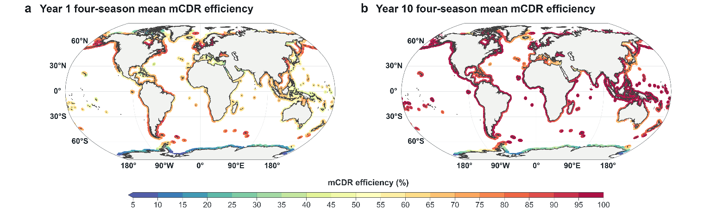
Four-season mean mCDR efficiency after 1 and 10 years. The year 10 plot shown here is the same as in Fig. 3a and shown to facilitate comparison with year 1 mCDR efficiency. All coloured data is averaged by data points in coastal bins using a 100 km coastal mask. For each 100 km coastal mask, regions within 185 km of the coast were coloured on global maps for better visibility.

Supplementary Figure 2: Coastal mCDR efficiency at year-1 and 10 for different seasons.
(a-d) January, April, July and October efficiency in year 1. (e-h) The same release months in year 10. All coloured data is averaged by data points in coastal bins using a 100 km coastal mask. For each 100 km coastal mask, regions within 185 km of the coast were coloured on global maps for better visibility.

Supplementary Figure 3: Dominant attribution of coastal mCDR efficiency for different seasons.
Dominant attribution for January, April, July and October 10-year efficiency. All coloured data is averaged by data points in coastal bins using a 100 km coastal mask. For each 100 km coastal mask, regions within 185 km of the coast were coloured on global maps for better visibility.

Supplementary Figure 4: Sensitivity of absorber-approach efficiency error to the gamma scaling and mixed layer depth clip.
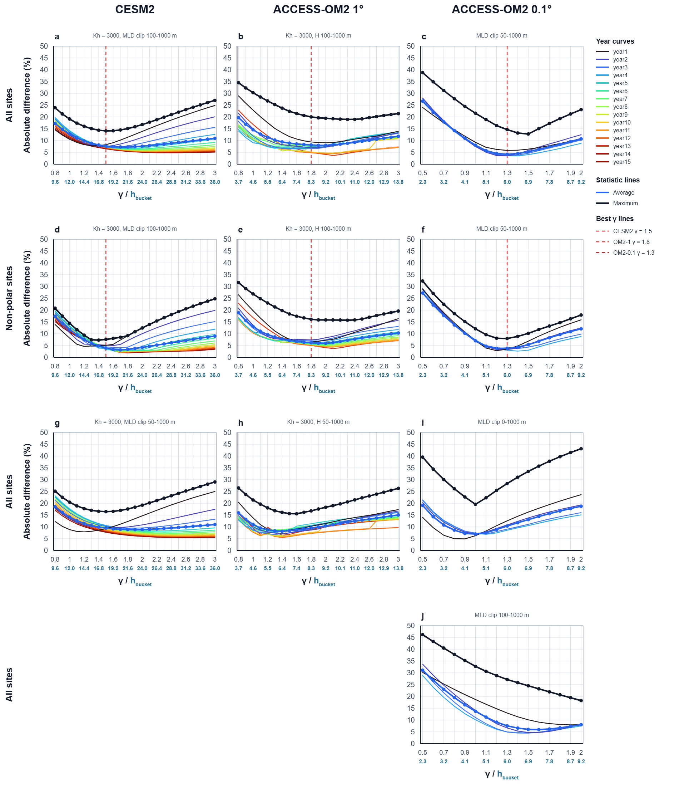
Absolute difference between absorber-approach and conventional-model mCDR efficiency as a function of the gamma scaling for CESM2 1°, ACCESS-OM2 1° and ACCESS-OM2 0.1° benchmark configurations. Coloured curves show simulation years 1-15, while the blue and black summary lines indicate the across-year average and maximum errors, respectively. Dashed red lines mark the selected gamma guides for each configuration: CESM2 1° = 1.5, ACCESS-OM2 1° = 1.8 and ACCESS-OM2 0.1° = 1.3. Panels a-c include all benchmark sites; panels d-f repeat the comparison after excluding polar bands or sites, where sea-ice and high-latitude circulation errors can dominate the mismatch with online simulations. Panels g-j test sensitivity to alternative mixed-layer-depth or absorber-height clipping choices.

Supplementary Figure 5: Sensitivity of mCDR efficiency calculated with the absorber approach to the number of absorbers used to assess mCDR efficiency.
(a) Comparison over the 14-month window for different numbers of absorbers (ranging from 6-3100) seeded at the 100 randomly selected test sites. (b) Same as in (a) but for a 10-year time window and only for seeding of 6 to 31 absorbers. The half width of the 95% confidence intervals were calculated from four-release mean efficiency estimates.
