Phage display-derived TCR-T cells targeting KRASG12V and CTAG1B suppress colorectal and esophageal tumors

Obed B. Amissah^{1,2,3┼}, Wenfang Chen^{3┼}, Belinda E. Baiden⁴, Rajesh Basnet³, Zhiyuan Li³*, Gloria B. Kim^{1,2}*
¹Department of Physiology and Biomedical Engineering, Mayo Clinic Arizona, Scottsdale, AZ, USA.
²Department of Immunology, Mayo Clinic Arizona, Scottsdale, AZ, USA.
³Guangzhou Institutes of Biomedicine and Health, Chinese Academy of Sciences, Guangzhou, Guangdong, China.
⁴College of Health Sciences, Kwame Nkrumah University of Science and Technology, Kumasi, Ghana.
┼These authors contributed equally.
*Correspondence: Zhiyuan Li li_zhiyuan@gibh.ac
Gloria B. Kim kim.gloria2@mayo.edu

Supplementary Table 1. Cell lines, culture conditions, and Research Resource Identifiers used in this study
Cell line/cell source | Cell type/origin | RRID | Growth medium | Experimental use
ECA109 | Human esophageal carcinoma | CVCL_6898 | RPMI 1640 + 10% FBS | CTAG1B-specific TCR-T functional assays; esophageal cancer xenograft model
KYSE180 | Human esophageal carcinoma | CVCL_1349 | RPMI 1640 + 10% FBS | CTAG1B-specific TCR-T tumor-recognition assays
SW480 | Human colorectal carcinoma | CVCL_0546 | DMEM + 10% FBS | KRASG12V-specific TCR-T functional assays; colorectal cancer xenograft model
T2 | Human lymphoblastoid/T-B hybrid cell line | CVCL_2211 | RPMI 1640 + 10% FBS | Peptide-pulsed target cells for CTAG1B-specific TCR-T assays
T2/HLA-A*11:01 | HLA-A*02:01-knockout T2 derivative stably expressing HLA-A*11:01 | Parental: CVCL_2211* | RPMI 1640 + 10% FBS | Peptide-pulsed target cells for KRASG12V-specific TCR-T assays
CCD-841CoN | Human colon-derived epithelial cells | CVCL_2871 | EMEM + 10% FBS | Normal-cell reactivity assessment
Het-1A | Human esophageal epithelial cells | CVCL_3702 | BEGM | Normal-cell reactivity assessment
293T | Human embryonic kidney-derived cells | CVCL_0063 | DMEM + 10% FBS | Lentiviral production
293T/HLA-A*02:01 | 293T/HLA-A*02:01 | 293T/HLA-A*02:01 | 293T/HLA-A*02:01 | Normal-cell/off-target reactivity assessment
293T/HLA-A*11:01 | 293T/HLA-A*11:01 | 293T/HLA-A*11:01 | 293T/HLA-A*11:01 | Normal-cell/off-target reactivity assessment
J.RT3-T3.5 | Human T cell line | CVCL_1316 | RPMI 1640 + 10% FBS | Lentiviral titration
PBMC-1 | Independent peripheral blood mononuclear cells from healthy donor 1 | N/A | RPMI 1640 + 10% FBS | Normal-cell/off-target reactivity assessment (independent donor; not used for TCR-T cell generation)
PBMC-2 | Independent peripheral blood mononuclear cells from healthy donor 2 | N/A | RPMI 1640 + 10% FBS | Normal-cell/off-target reactivity assessment (independent donor; not used for TCR-T cell generation)
Primary human T cells | Peripheral blood-derived human T cells | N/A | RPMI 1640 + 10% FBS | TCR-T cell generation and functional studies
All cells were maintained at 37 °C, 5% CO₂. Unless otherwise specified, growth media were supplemented with 10% fetal bovine serum and 1% penicillin/streptomycin. Cell lines were routinely tested for mycoplasma contamination and were generally used within five passages after thawing; no cell line was used beyond passage 10.

Supplementary Table 2. Antigen and HLA characteristics of target and control cell lines used in this study
Cell line | CTAG1B expression | KRASG12V mutant status | HLA-A*02:01 | HLA-A*11:01 | Characterization or basis
ECA109 | + | − | + | ND | Previous NY-ESO-1 paper; engineered derivative
KYSE180 | + | − | − | ND | Previous Cellular Immunology paper
SW480 | − | + | + | + | Previous Cellular Immunology paper + current study
T2 | ND | ND | + | ND | Previous studies
T2/HLA-A*11:01 | ND | ND | − (CRISPR KO) | + (engineered) | Engineered derivative
CCD-841CoN | − | − | Your current data | Your current data | Current study
Het-1A | − | − | + | − | Current study
293T/HLA-A*02:01 | ND* | ND* | + (engineered) | ND* | Stable lentiviral expression
293T/HLA-A*11:01 | ND* | ND* | ND* | + (engineered) | Stable lentiviral expression
+, detected; −, not detected; ND, not determined. CTAG1B expression was assessed by RT-PCR using RNA-derived cDNA. KRASG12V status was assessed by mutation-specific PCR or RT-PCR, as applicable. HLA-A*02:01 and HLA-A*11:01 were assessed by allele-specific PCR or flow cytometry, as applicable. Where indicated, HLA-positive derivatives were generated by stable lentiviral expression of the corresponding HLA allele. T2/HLA-A*11:01 is an HLA-A*02:01-knockout T2 derivative engineered to express HLA-A*11:01 and was provided by the originating laboratory. Previously characterized cell-line profiles were based on our earlier studies, whereas normal-cell profiles were assessed in the present study.
Supplementary Table 3. Peptides and pHLA complexes used for TCR selection and specificity assessment
Peptide/antigen | Peptide sequence | Residue positions | HLA restriction | Designation | Experimental application
CTAG1B | SLLMWITQC | 157-165 | HLA-A*02:01 | Cognate | TCR selection and specificity assessment
KRASG12V | VVGAVGVGK | 8-16 | HLA-A*11:01 | Cognate | TCR selection and specificity assessment
CTAG1B | SISSCLQQL | 148-156 | HLA-A*11:01 | Non-cognate/control | Specificity assessment
AFP | FMNKFIYEI | 158-166 | HLA-A*02:01 | Non-cognate/control | Specificity assessment
CTAG1B, cancer/testis antigen 1B; KRASG12V, KRAS glycine-to-valine substitution at codon 12; AFP, alpha-fetoprotein; HLA, human leukocyte antigen; pHLA, peptide-HLA complex. Cognate pHLA complexes correspond to the antigen-HLA complexes used for selection of the respective TCR candidates. Non-cognate pHLA complexes were used as specificity controls. Synthetic peptides were purchased from GenScript, and the corresponding pHLA complexes were prepared in-house using the indicated peptides and HLA molecules as described in the Materials and Methods.
Supplementary Table 4. Antibodies and detection reagents used for flow cytometry and immunofluorescence
Target/reagent | Clone# or Cat# | Supplier | Application
Human CD3 | Clone# OKT3 | BioLegend | Flow cytometry
Human CD8 | Clone# SK1 | BioLegend | Flow cytometry
Mouse TCRβ | Clone# H57-597 | BioLegend | Detection of transgenic TCR expression by flow cytometry
Human CD69 | Clone# FN50 | BioLegend | Flow cytometry
Human CD25 | Clone# BC96 | BioLegend | Flow cytometry
Human PD-1 | Clone# EH12.2H7 | BioLegend | Flow cytometry
Alexa Fluor 594 anti-human CD8a Antibody | Clone# C8/144B | BioLegend | Tumor immunofluorescence
DAPI | Cat# 62248 | ThermoFisher Scientific | Nuclear counterstaining for immunofluorescence
HLA-A2 | Clone# BB7.2 | BioLegend | HLA characterization by flow cytometry
Anti-M13 | Cat# 11973-MM05T-H | SinoBiological | Phage ELISA
CD, cluster of differentiation; DAPI, 4′,6-diamidino-2-phenylindole; PD-1, programmed cell death protein 1; TCRβ, T cell receptor β chain; HLA, human leukocyte antigen; N/A, not applicable. Murine TCRβ-specific staining was used to distinguish expression of the introduced TCR from endogenous human TCR expression. Where applicable, fluorophore-conjugated antibody variants were selected according to the requirements of individual flow-cytometry panels.

Supplementary Table 5. Lentiviral plasmids used in this study
Plasmid | Purpose | Encoded component(s) | Source
pLTV-mC | Transfer plasmid | TCR transgenes | In-house
pMD2.G | Envelope plasmid | VSV-G | Addgene plasmid #12259
pMDLg/pRRE | Packaging plasmid | Gag/Pol | Addgene plasmid #12251
pRSV-Rev | Packaging plasmid | Rev | Addgene plasmid #12253
VSV-G, vesicular stomatitis virus glycoprotein G. pLTV-mC was used as the lentiviral transfer vector for expression of the selected TCR transgenes. pMD2.G, pMDLg/pRRE, and pRSV-Rev were used for lentiviral particle production.

Supplementary Table 6. TRAV and TRBV gene identities of selected antigen-specific TCR candidates
TCR Candidate | Target antigen | αTCR V-gene | αTCR J-gene | Closest βTCR V-gene | Closest βTCR J-gene | βTCR D-gene
TCR-A5 | KRASG12V | TRAV17*01 F | TRAJ40*01 F | TRBV5-4*02 (F) | TRBJ1-1*01 F | TRBD1*01 F
TCR-A24 | KRASG12V | TRAV21*02 (F) | TRAJ32*02 F | TRBV5-4*01 F | TRBJ2-3*01 F | TRBD1*01 F
TCR-B14 | KRASG12V | TRAV12-2*03 (F) | TRAJ43*01 F | TRBV7-9*06 (F) | TRBJ1-1*01 F | TRBD1*01 F
TCR-C18 | CTAG1B | TRAV21*02 (F) | TRAJ29*01 F | TRBV6-5*01 F | TRBJ2-6*01 F | -
TCR-C19 | CTAG1B | TRAV21*02 (F) | TRAJ6*01 F | TRBV6-1*01 F | TRBJ2-7*01 F | TRBD1*01 F
TCR-D15 | CTAG1B | TRAV6*02 (F) | TRAJ29*01 F | TRBV19*03 (F) | TRBJ2-7*01 F | TRBD1*01 F
CTAG1B, cancer/testis antigen 1B; KRASG12V, KRAS glycine-to-valine substitution at codon 12; TCR, T cell receptor; TRAV, T cell receptor α-chain variable gene; TRAJ, T cell receptor α-chain joining gene; TRBV, T cell receptor β-chain variable gene; TRBJ, T cell receptor β-chain joining gene. The table reports TCR variable and joining gene identities for the TCR candidates advanced to in vivo evaluation.

Supplementary Figures
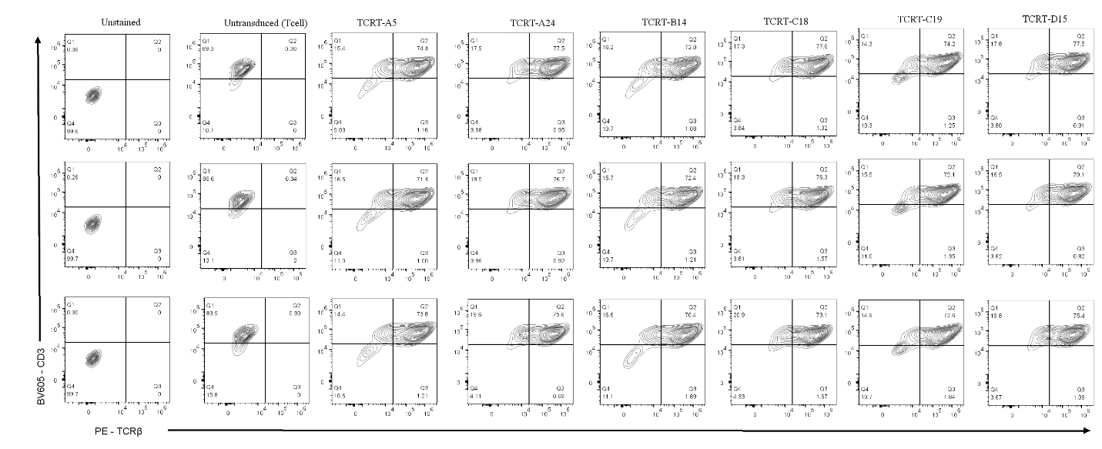
Figure S1. Expression of introduced TCRs in expanded TCR-T cells. Representative flow-cytometry plots showing TCR expression in untransduced T cells and the indicated TCR-T cell products following expansion. Live singlet cells were stained with anti-human CD3 (clone OKT3) and murine TCRβ (clone H57-597) to identify T cells expressing the introduced TCR. Unstained cells (pooled TCR-T cells and untransduced T cells) were included as staining controls. Three independent replicates generated from the same donor are shown for each TCR-T cell product and the untransduced T cell control.
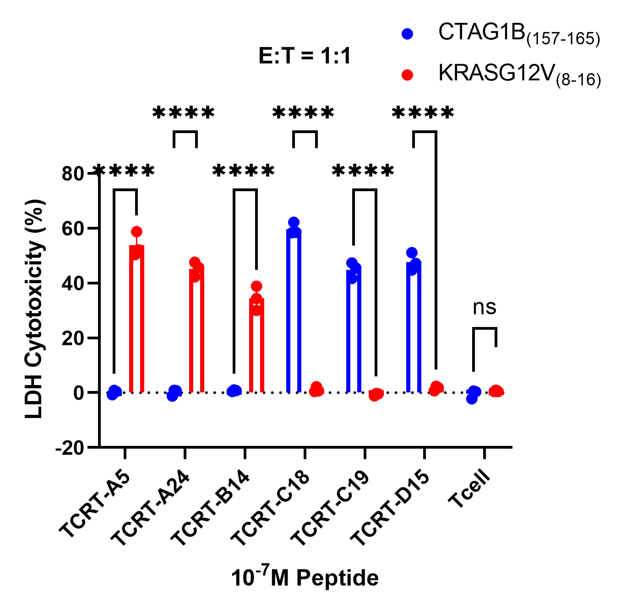
Figure S2. Antigen-specific cytotoxicity of selected TCR-T cells against peptide-pulsed target cells. LDH-based cytotoxicity of the indicated TCR-T cells against HLA-appropriate T2 target cells pulsed with 10⁻⁷ M CTAG1B₍₁₅₇₋₁₆₅₎ or KRASG12V₍₈₋₁₆₎ peptide at an effector-to-target (E:T) ratio of 1:1. Untransduced T cells were included as a control. Data are presented as mean ± SD from three independent experiments. Statistical significance was assessed by two-way ANOVA followed by Sidak’s multiple-comparisons test. ****P < 0.0001; ns, not significant.
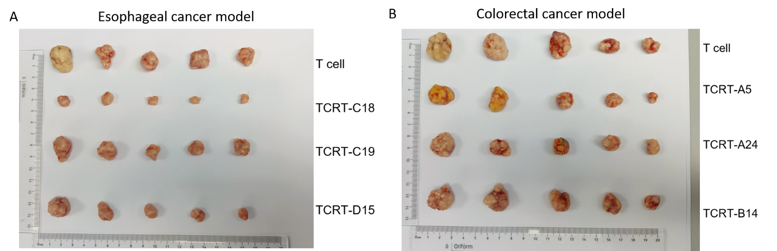
Figure S3. Gross appearance of resected tumors following TCR-T cell treatment in esophageal and colorectal cancer xenograft models. Representative images of tumors resected at the study endpoint from mice bearing (A) esophageal cancer or (B) colorectal cancer xenografts following treatment with the indicated TCR-T cells or control T cells. Tumors were arranged according to treatment group for gross comparison. Rulers are shown for scale.

