Supplementary data

CYANIDIN 3-GLUCOSIDE IS A SELECTIVE INHIBITOR OF HEPATIC BILIRUBIN UPTAKE

Paola Pelizzo¹, Marco Stebel¹*, Nevenka Medic¹*, Paola Sist¹, Andreja Vanzo², Andrea Anesi³, Urska Vrhovsek³, Federica Tramer¹, Sabina Passamonti^{1§}

¹Department of Life Sciences, University of Trieste, Italy
2 Agricultural Institute of Slovenia, Ljubljana, Slovenia
3 Edmund Mach Foundation, San Michele all’Adige, Italy
* These authors contributed equally
§ Corresponding author

Table of contents
Abbreviations 2
Supplementary methods 2
Isolated perfused rat liver 2
Viability tests on isolated perfused rat liver 2
Hepatic bilirubin uptake: assumptions 3
HUG-based fluorometric assay of bilirubin and bilirubin glucuronide 3
Supporting information 5
Table S1. Hepatic membrane transporters for bilirubin and bilirubin glucuronide (A) and their substrates/inhibitors (B) 5
Table S2. Analysis of anthocyanins and taurocholate by UHPLC-ESI-MS/MS 7
Scheme S1. Chemical structures of three anthocyanins 7
Supplementary results 8
Fig. S1. Determination of biomarkers of liver viability in the hepatic perfusion effluent. 8
Fig. S2. Fluorometric assay of bilirubin (A) and bilirubin glucuronide (B). 10
Fig. S3. Analysis of bilirubin peaks triggered by the co-injection of bilirubin with cyanidin 3-glucoside 12
Fig. S4. Analysis of bilirubin peaks triggered by the co-injection of bilirubin with cyanidin 3-glucoside or pravastatin 13
Fig. S5. The reciprocal influence of cyanidin 3-glucoside and bilirubin on the bilirubin peak size 14
Fig. S6. The effect of cyanidin 3-glucoside, malvidin 3-glucoside, and peonidin 3-glucoside on the hepatic uptake of bilirubin 16
Fig. S7. The effect of estradiol-17 beta-glucuronide and pravastatin on the hepatic uptake of bilirubin or bilirubin glucuronide 17
Fig. S8. The effect of pravastatin on the sinusoidal reuptake of bilirubin glucuronide 20
Fig. S9. The effects of indomethacin and ketoprofen of the sinusoidal reuptake of bilirubin glucuronide 21
Fig. S10. The quantitative effect of taurocholate of the sinusoidal reuptake of bilirubin glucuronide 22
Fig. S11. The effects of physiological concentrations of cyanidin 3-glucoside and taurocholate on the hepatic uptake of bilirubin and bilirubin glucuronide 24
References 27

Abbreviations
BR, bilirubin; BRG, bilirubin glucuronide; C3G, cyanidin 3-glucoside; E17G, estradiol-17 beta-glucuronide; M3G, malvidin 3-glucoside; P3G, peonidin 3-glucoside; PRV, pravastatin; TC, taurocholate.

Supplementary methods

Isolated perfused rat liver
The isolated perfused rat liver was chosen because the hepatic architecture supporting the vectorial hepatobiliary transport processes is preserved [1]. Isolated livers were prepared from Wistar rats (200-290 g) following a standard procedure [2] with modifications as described in a protocol [3]. Surgical procedures were performed between 11 am and 1 pm. Only female rats were used, as in previous work on the transport activity of bilitranslocase in vitro [4] [5]. Livers were isolated from the general circulation by intraportal perfusion of 110 mL of Hank's buffered saline solution (HBSS) at a flow rate of 6 mL min⁻¹ and a temperature of 37°C. The outflow from the liver was collected via a catheter inserted into the posthepatic segment of the inferior vena cava via the right atrium. When the effluent from the liver was free of blood, we replaced HBSS with phosphate-buffered saline, pH 7.4 (PBS), as this was compatible with the analysis of BR. The perfusion PBS was without serum albumin to avoid variable equilibria of the BR -albumin complex [6] and contained 2.5 mM glucose, 2 mM pyruvate and 0.2 mM lactate. Perfusion was performed without oxygenation to prevent the formation of oxygen free radicals and redox reactions with bilirubin [7] and anthocyanins [8]. It is known that short-term ischemia has no effect on the structural [9] and metabolic integrity of the organ [10]. The perfusion fluid was anoxic but not ischemic because glucose and the unequal pyruvate/lactate pair ensured both substrate-level phosphorylation and a "clamped" cellular NAD⁺/NADH + H⁺ ratio. Once the need for oxygen delivery to the liver was overcome, perfusion flow was maintained at 0.9 mL min⁻¹ g⁻¹ liver weight (6 mL min⁻¹), which is within the range that ensures normal portal pressure and perfusion flow in the isolated rat liver [11], and is close to physiological portal blood flow in the rat (1.25 mL min⁻¹ g⁻¹ liver weight) [12]. These conditions preserve the sinusoidal endothelium from shear stress [13], which can trigger the release of hepatic enzymes [14]. The bile duct was not cannulated, as recommended, to avoid accidental cholestasis and its unpredictable influence on the kinetics of hepatic BR uptake [15].

Viability tests on isolated perfused rat liver
The tests were performed as described in detail [3]. Liver perfusion effluent was assayed for a marker of membrane lipid oxidation (malondialdehyde), which was undetectable in contrast to oxygenated liver perfusion [14]. There was no apparent membrane permeabilization (ATP release) or cytolysis (LDH release) (Suppl. Fig. 1A), and the microcirculation was preserved, as assessed by recovery of a bovine serum albumin bolus (Suppl. Fig. 1B). The liver showed a constant release of taurocholate (Suppl. Fig. 1C), which was not affected by the portal injection of BR, C3G, or E17G.

Hepatic bilirubin uptake: assumptions
According to data from isolated perfused rat liver [16][17], > 50% of an intra-portal bolus of 10 nmol BR is expected to be taken up, resulting in recovery of the remaining fraction in hepatic venous effluent. Variations may occur if the liver loses its ability to absorb bilirubin, as has been observed in the perfused liver of endotoxemic rats [18], or its ability to capture BR by intracellular conjugation, as has been observed in the Gunn rat, which carries an inherited bilirubin-UDP-glucuronosyl transferase deficiency [19], or eventually loses its ability to keep intracellular BRG concentration low by biliary excretion, as is the case in the Eisai rat, which carries a genetic defect in Mrp2 function [20].
If the transport of BR from the sinusoid into the hepatocyte is mediated by one or more sinusoidal membrane transporters, the membrane permeability to BR can be reduced by specific reversible inhibitors at appropriate concentrations. This would be evident in a transient increase in the concentration of BR in hepatic venous effluent. The target transporters and the compounds tested for possible inhibition of sinusoidal uptake of BR are listed in Suppl. Table 1.

The general experimental design for testing hepatic bilirubin uptake
Because the focus of this study was to characterize the pharmacology of hepatic single-pass BR uptake, which occurs in < 0.5 min [16][17], we administered small intraportal BR boli, each corresponding to approximately 3.6% of the dose (38.5 nmol g⁻¹ liver) that would be taken up by the liver at half-maximal rate [16]. Up to 12 repeated BR boli (0.2 mL; 0.05 mM in PBS:DMSO, 80:20 vol/vol) were injected into the portal vein using a 1 mL syringe connected to a port of the cannula inserted into the portal vein. Thus, BR boli were administered under constant perfusion flow. After each bolus, ten fractions (0.35 mL) of hepatic venous effluent were collected in Eppendorf tubes at 4 seconds/fraction intervals. Thereafter, the effluent was collected in bulk (3.5 mL) for 40 seconds. During this time, the 1-mL syringe was prepared for delivery of the next BR bolus and collection of hepatic venous outflow continued. The entire test took approximately 25 minutes. Known inhibitors/substrates of hepatic sinusoidal transporters were injected or co-injected with BR in the same vehicles as above at the concentrations indicated in Table 2 and in the captions. See protocol [3] for further details.

HUG-based fluorometric assay of bilirubin and bilirubin glucuronide
The BR assay was performed using the HUG fluorometric assay [21]. 96-well plates (Nunc) containing 0.010 mL HUG (0.4 mg/mL) were used. A freshly prepared BR standard solution (0-0.05 mM in PBS:DMSO, 97:3, vol/vol; 0.2 mL) was used to calibrate the fluorescence of the HUG-BR complex, which was recorded in a multiplate reader (Synergy H1; BioTek Winooski, VT) at λ_{ex} = 485 nm and λ_{em} = 528 nm, yielding a lower limit of detection LoD = 0.74 nM and a lower limit of quantification LoQ = 2.25 nM (n=40) (Suppl. Fig. 2). Controls were performed to evaluate the potential interference of molecules co-injected with BR by adding them to serially diluted standard solutions of BR (Suppl. Fig. 2). Immediately after collection, fractions of hepatic venous effluent (0.2 mL) were transferred to the multi-well plates containing HUG (0.4 mg/mL) to prevent decay of trace amounts of BR in the perfusion solution. The covered multi-well plate was incubated at T = 25°C for 1 hour and the emission fluorescence was recorded. Then, BRG present in the same samples was analyzed by adding 0.01 mL (8 IU) of β-glucuronidase (Sigma) to each well, including the wells containing the standard solutions BR, and keeping the plate at T = 25°C. Emission fluorescence was recorded 2 hours later as described above. The multiwell plate was stored covered at 4°C overnight and the fluorescence was recorded again (Suppl. Fig. 2). The value of the last reading represents the total bilirubin concentration (BR + BRG) and allows the calculation of the BRG concentration. See protocol [3] for further details.

Analysis of anthocyanins and taurocholate
C3G and peonidin 3-glucoside (P3G) in perfusion effluent were analyzed using HPLC-DAD
[22]. Samples (0.1 mL) were mixed with methanol (0.1 mL) and stored at -20°C. At the time of analysis, samples were acidified with 1 µL of 70% perchloric acid, filtered through a 0.22 µ PDVF filter (Millipore Corporation, MA, USA) and injected directly into a Purospher C18 column (250x4.6 mm, 5 µm; Merck, Darmstadt, Germany) with a Purospher C18 guard column (4x4 mm, 5 µm) on an 1100 HPLC-DAD (Agilent Technologies, Palo Alto, USA). Anthocyanins were detected and quantified using a slightly modified method as described in
[22]. The mobile phase consisted of 0.3% perchloric acid in Milli-Q water (phase A) and 100% methanol (phase B). The separation was carried out at T = 35 °C. Linear gradient conditions started at 28.5% B, reached 42% B in 25 min, then 100% B in 1 min, and remained at 100% B for 3 min. The column was equilibrated for 6 min before each analysis. The flow rate was 0.55 mL min-1 and the injection volume was 70 µl. UV-Vis spectra were recorded from 200 to 700 nm. Identification of the peaks was based on both the retention times and the UV-Vis spectra of the pure reference compounds. Quantification of C3G and P3G was based on the peak areas at λ=520 nm and concentrations were estimated using the external standard method.
An Ultra High Performance Liquid Chromatography-ElectroSpray Ionization-tandem mass spectrometry method (UHPLC-ESI-MS /MS) was used for the simultaneous analysis of taurocholate, C3G, and P3G in the perfusion effluent fractions. Samples (0.18 mL) were added to a 96-well plate together with 0.02 mL of 1 ppm taurocholate-d5 in methanol and mixed on an Eppendorf shaker (Eppendorf, Milan, Italy) at 300 rpm for 5 min. Calibration curves (15 points) were prepared in methanol by serial dilution of the mother solution (5 ppm taurocholate, 1.5 ppm taurocholate-d₅, and 2.5 ppm of both C3G and P3G). Analyses were performed using a AB Sciex 6500+ triple quadrupole coupled to a Shimadzu LC-30AD pump (Ab Sciex, Milan, Italy). Chromatographic separation was performed on Acquity Premier HSST3 2.1 x 150 mm (1.8 µm particle size) (Waters, Milan, Italy). The mobile phase was 0.1% formic acid, either in water (phase A) or acetonitrile (phase B). The linear gradient at a constant flow of 0.4 mL/min started at 20% B and reached 100% B at 2 min. It was continued for 1.30 min, then the column was re-equilibrated at the original conditions The total analysis time was 5.80 minutes. ESI was run in positive ion mode to detect cyanidin, C3G, peonidin and P3G and in negative mode to detect taurocholate and taurocholate-d₅. The curtain gas (CUR) was set at 35 PSI, the ion source (IS) gas 1 and 2 were set at 45 and 55 PSI, respectively; CUR and IS were air; collision gas was nitrogen. The source temperature was 400°C; the ion spray voltage was 5500 V in positive ion mode and 4500 V in negative ion mode. Compound-dependent parameters, such as Declustering Potential (DP), Entrance Potential (EP), Collision Energy (CE), and Collision-cell exit potential (CXP), were determined by direct infusion of the pure standard. Analytical details can be found in Suppl. Table 2.

Supporting information

Table S1. Hepatic membrane transporters for bilirubin and bilirubin glucuronide (A) and their substrates/inhibitors (B)

Table S1A. Sinusoidal membrane transporters of bilirubin and bilirubin glucuronide considered in this study. Codes are given by: Transporter Classification Database (TCDB), the Rat Genome Database (RGD), the Mouse Genome Database (MGI), and the HUGO Gene Nomenclature Committee (HGNC).
Acronym | Organisms | Names and Synonyms | TCDB | RGD/  MGI/ HGNC | Bilirubin interaction Ref
BTL | Rat, human | Bilitranslocase. Bilirubin transporter | 2.A.65.1.1 |  | BR binding [23]; BR transport [24]
Oatp1a1 | Mouse, rat, human | Organic anion-transporting polypeptide 1a1. Solute carrier organic anion transporter family, member 1a1; Oatp1, Oatp1a1, Slc21a1. | 2.A.60.1.1 | Slco1a1, SLCO1A2 | BRG transport [25]
Oatp1b2 | Mouse, rat, human | Organic anion-transporting polypeptide 1b2. OATP2; Oatp4; lst-1; OATP-C; mlst-1; Oatp1b2; Slc21a6; Slc21a10 |  | Slco1b2, SLCO1B1, SLCO1B3, | BR transport [26][27]; BRG transport [27][25]
Oat2 | Mouse, rat, human | Organic anion transporter 2. Novel liver transporter. Slc22a7 | 2.A.1.19.25 | Slc22a7, SLC22A7 | BR binding [28]
Mrp3 | Mouse, rat, human | Multidrug resistance protein 3. ABCC3. | 3.A.1.208.9 | ABCC3 | BRG transport [29]

Table S1B. List of compounds and targeted hepatic membrane transporters. Compounds delivered as single-pass intra-portal boli are coded according to the Chemical Entities of Biological Interest (ChEBI) dictionary. Targeted hepatic membrane transporters (rat orthologues, unless otherwise specified) are named by their acronyms. (*) Bilirubin (mono- or di-)glucuronide is the endogenous product of the reaction catalysed by UGT1A1. n.a., not administered, but detected in the perfusion effluent.
Compound | [Compound] in the bolus (mM) | nmol injected | Target sinusoidal transporter | Target biliary Efflux transporter
Bilirubin  CHEBI:16990 | 0.05 | 10 | INFLUX: BTL (Ki = 2 nM) [30][23][31]  EFFLUX: Unknown | Bcrp (mouse) and another unknown transporter [32]
Cyanidin 3-glucoside CHEBI:28426 | 0.5-2 | 100-400 | INFLUX: BTL (K_{i} = 5.8 µM) [33] [34]  EFFLUX: Unknown | Bcrp (human) [35]
Pravastatin  CHEBI:63618 | 6 | 1200 | INFLUX: Oatp2 (K_{m} = 37.5 µM) [36]; Oat (IC₅₀ = 0.5 mM)[37]. Not Ntcp [38]. Not BTL [5]. OATP1B1 (human) [39].  EFFLUX: Unknown | Mrp2 (K_{m} = 6 µM) [40];  Bsep (0.8 mM) [41]; Bcrp (mouse) (K_{m} = 4.8 µM)[42]
Estradiol-17 beta-glucuronide  CHEBI:791 | 1 | 200 | INFLUX: Oatp1, Oatp2 (K_{m} = 3 µM), and Oatp3 (K_{m} = 39 µM) [43] [44]. Not Ntcp [45]. Not BTL [5].  EFFLUX: Mrp3 (K_{m} = 33 µM) [46] or (K_{m}= 67 µM) [47] | Mrp2 (K_{m} = 4.8 µM) [48]  Bcrp (human; K_{i} or K_{m} not determined) [49]
Indomethacin  CHEBI:49662 | 1 | 200 | INFLUX: Oat2 (Slc22A7, K_{m} = 0.37 µM) [50]; OATP1B1, OATP1B3, OATP2B1 (human; 11, 38, and 130 µM) [39]; OSTα-OSTβ (Slc51) [51]; OATP2B1 (human; 2.14 and 16.9 µM [52]). Not BTL [5].  EFFLUX: Mrp3 (K_{i} = 60 µM) [53] | Mrp2 (human, activator) [54]
Ketoprofen  CHEBI:6128 | 1 | 200 | INFLUX: Oat2 (K_{m} = 3.3 µM) [50]. Not BTL [5].  EFFLUX: Unknown | Unknown
trans-resveratrol  CHEBI:45713 | 2 | 400 | INFLUX: OATP1B1, OATP1B3, OATP2B1 (human; K_{m}= 0-90 µM)[55]. Not BTL [5].  EFFLUX: Mrp3 (not a substrate, unless conjugated) [56] | Unknown
Taurocholate  CHEBI:36257 | 0.2-2 | 40-400 | INFLUX: Ntcp (K_{m}=10.5 µM) and Oatp1 (K_{m}=19.4 µM) [57]; OSTα-OSTβ (Slc51) (>10 mM) [58]. Not BTL [5].  EFFLUX: Mrp3 (Ki=74 µM) [46] | Bsep (K_{m}=5.3 µM) [59]
Bilirubin glucuronide (*) | n.a. | n.a. | INFLUX: OATP1B1 (human; Monoglucuronosyl bilirubin, K_{m} = 0.1 µM; bisglucuronosyl bilirubin, K_{m} = 0.28 µM) [27]  EFFLUX: Mrp3 (human; K_{i} or K_{m} not determined) [29] | Mrp2 (K_{m}=0.5-0.8 µM) [60]; Bcrp1 (K_{i} or K_{m} not determined) [32]; other unknown transporter [32].

Table S2. Analysis of anthocyanins and taurocholate by UHPLC-ESI-MS/MS

Table S2. Analysis of anthocyanins and taurocholate by UHPLC-ESI-MS/MS. Q1: parent m/z in Dalton (Da); Q3: daughter m/z; RT: retention time (min); LOD: Limit of Detection; LOQ: Limit of Quantitation.
Q1 (Da) | Q3  (Da) | RT (min) | ID | Type | LOD (mg/L) | LOQ (mg/L)
449.3 | 287.1 | 1.10 | Cyanidin-3-O-glucoside | Quantifier ion | <0.00061 | 0.00061
449.3 | 212.9 | 1.10 | Cyanidin-3-O-glucoside | Qualifier ion | 0.00061 | 0.0012
287.1 | 137.2 | 1.60 | Cyanidin | Quantifier ion | 0.0048 | 0.0097
287.1 | 213.0 | 1.60 | Cyanidin | Qualifier ion | 0.0195 | 0.0390
463.3 | 301.1 | 1.30 | Peondin-3-O-glucoside | Quantifier ion | <0.00061 | 0.00061
463.3 | 286.0 | 1.30 | Peondin-3-O-glucoside | Qualifier ion | 0.00061 | 0.0012
301.1 | 201.1 | 1.78 | Peonidin | Quantifier ion | 0.0024 | 0.0048
301.1 | 286.2 | 1.78 | Peonidin | Qualifier ion | 0.0390 | 0.0781
514.3 | 514.3 | 2.60 | Taurocholic acid | Quantifier ion | <0.0012 | 0.0012
514.3 | 80.0 | 2.60 | Taurocholic acid | Qualifier ion | <0.0012 | 0.0012
519.3 | 80.0 | 2.55 | Taurocholic acid-d₅ | Quantifier ion | 0.0006 | 0.00244
519.3 | 124.1 | 2.55 | Taurocholic acid-d₅ | Qualifier ion | 0.0006 | 0.00244

Scheme S1. Chemical structures of three anthocyanins

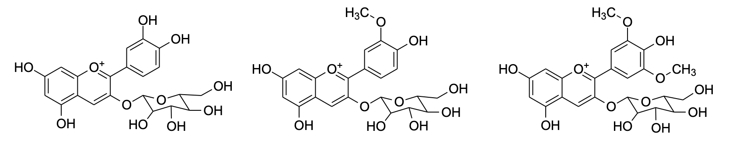
Malvidin 3-glucoside
M3G
Peonidin 3-glucoside
P3G
Cyanidin 3-glucoside
C3G

Scheme S1. Chemical structure of three anthocyanins. Structures were drawn by the free version of ChemDraw (https://chemdrawdirect.perkinelmer.cloud/js/sample/index.html). The chemical analogies with bromosulfophthalein are discussed in [33].

Supplementary results

Fig. S1. Determination of biomarkers of liver viability in the hepatic perfusion effluent.

A
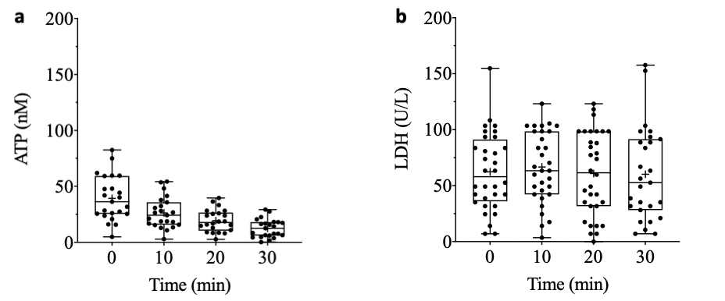

B
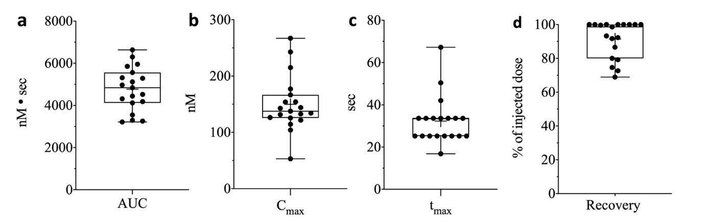

C
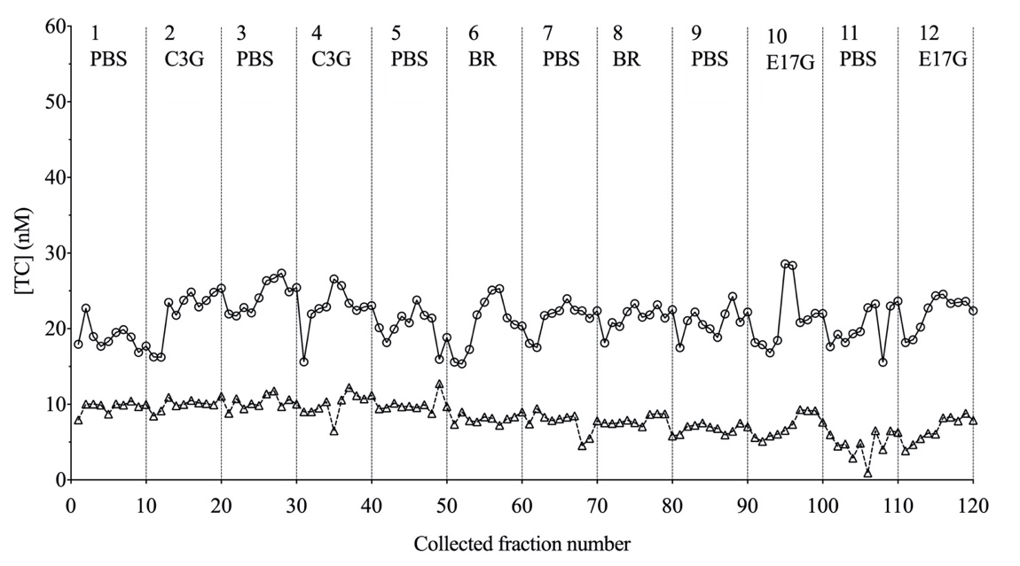

Fig. S1. Determination of biomarkers of liver viability in the hepatic venous effluent of isolated perfused rat livers. (A) Analysis of ATP and LDH. Box plots of ATP concentrations (liver n = 27) (a) and LDH activity (liver n = 32 (b), detected in 4 inter-boli fractions collected along tests of hepatic uptake of BR. Reference values ATP: 10-100 nM in rat hepatoma cells [61]; LDH: 30 IU L⁻¹ [62]. (B) Analysis of serum albumin peaks. Box plots of BSA-FITC peak descriptors, resulting from the injection of a 0.2 mL-bolus of 5.15 mg L⁻¹ BSA containing 3 % (w:w) BSA-FITC. (a) Peak size. (b) Peak height. (c) Time to reach the peak. d Recovery. Mean values and SD (liver n = 19) are: AUC = 4777 ± 1036 nM • sec; C_{max} = 149.8 ± 49.2 nM; t_{max} = 32.3 ± 11.3 sec; Recovery = 91.5 ± 10.9 %. (C) Analysis of taurocholate. Concentration of taurocholate (TC) in the venous effluent of two isolated perfused rat livers (circles and triangles), following sequential boli of PBS solution, without or with 0.010 mM cyanidin 3-glucoside (C3G), 0.05 mM bilirubin (BR), or 1 mM estradiol-17 beta-glucuronide (E17G).

Fig. S2. Fluorometric assay of bilirubin (A) and bilirubin glucuronide (B).

A
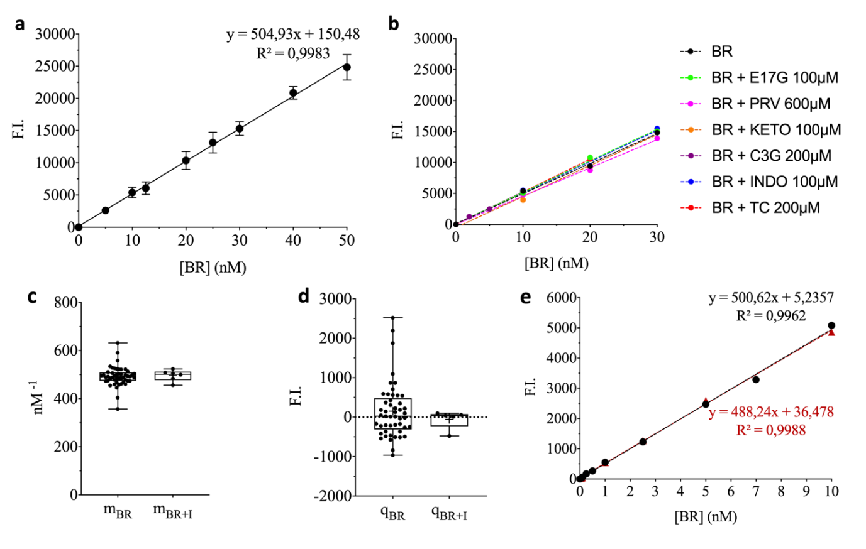
Fig. S2A. Fluorometric assay of bilirubin. (A) Calibration of bilirubin-dependent HUG fluorescence emission. HUG (0.4 mg/mL; 6.62 µM; 66.2 pmoles in 0.01 mL) was allowed to bind bilirubin (BR) at different concentrations at 25°C for 1 h. Fluorescence intensity (F.I.) of each BR concentration was recorded at λ_{ex}= 485 nm and λ_{em}=528 nm in quadruplicate and averaged. The graph shows data (means ± SD) of 40 independent calibration curves, fitted by linear regression analysis (y = 504.93 x - 150.48; R² = 0.9983; LoD = 0.74 nM. LoQ = 2.25 nM). (B) Interference tests. Calibration curves were performed either in the absence or in the presence of inhibitors: 0.1 mM estradiol-17 beta-glucuronide (E17G); 0.1 mM Indomethacin (INDO) or Ketoprofen (KETO); 0.2 mM cyanidin 3-glucoside (C3G) or taurocholate (TC); 0.6 mM Pravastatin (PRV). (C-D) Box plot analysis of regression coefficients (m) and y-intercepts (q) obtained with BR standard solutions (m_{BR}, q_{BR}) and BR standard solutions supplemented with the inhibitors (m_{BR+I}, q_{BR+I}). Means and SD are: m_{BR} = 492.6 ± 40.88 nM⁻¹; q_{BR} = 151.2 ± 697.8 F.I. units (n = 40); m_{BR+I} = 498.4 ± 25.29 nM⁻¹; q_{BR+I} = -54.17 ± 238 F.I. units (n = 6). (E) Comparison test. Calibration curves were performed in either PBS buffer (black) or perfusion buffer (PBS with 2.5 mM glucose, 2 mM pyruvate, and 0.2 mM lactate) (red).

B
a b
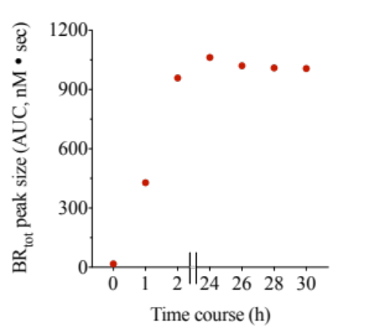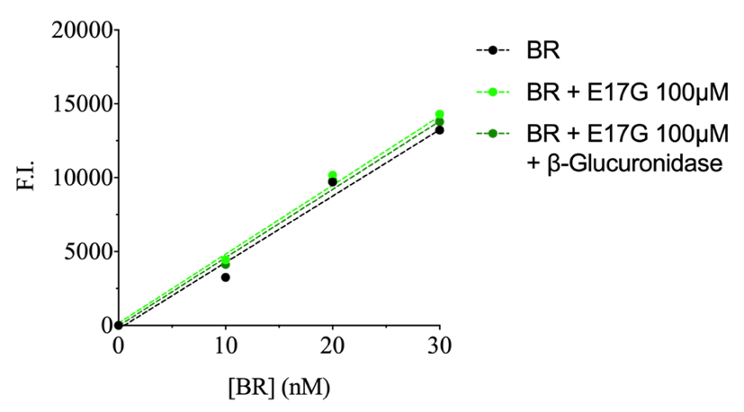

Fig. S2B. Fluorometric assay of bilirubin glucuronide. (A) Time course of bilirubin glucuronide hydrolysis. β-glucuronidase-induced increase of BR in the perfusion effluent. Fractions were collected after intra-portal co-injection of a bolus containing of 10 nmol bilirubin (BR) and 200 nmol estradiol-17 beta-glucuronide (E17G). Samples (0.2 mL) were incubated with 0.01 mL (8 IU) β-Glucuronidase on a multi-well plate at T = 25°C for 2h. Thereafter, the multi-well plate was stored covered at 4°C overnight and fluorescence was recorded again. (B) Effect of estradiol-17 beta-glucuronide hydrolysis on the bilirubin calibration curve. Samples (0.2 mL) containing different bilirubin (BR) concentrations dissolved in PBS, without (black) and with 0.1 mM estradiol-17 beta-glucuronide (dark and light green). A series of BR concentrations with E17G was supplemented with 0.01 mL (8 IU) β-Glucuronidase. The multi-well plate was incubated at T = 25°C for 2h. Fluorescence intensity was recorded at λ_{ex}= 485 nm and λ_{em}=528 nm in quadruplicate and average data were fitted by linear regression analysis. Equations: y= 449.6x – 237.9 (BR); y = 466.3x + 164.8 (BR + E17G); y = 461.9x – 30.23 (BR + E17G + β-Glucuronidase).

Fig. S3. Analysis of bilirubin peaks triggered by the co-injection of bilirubin with cyanidin 3-glucoside

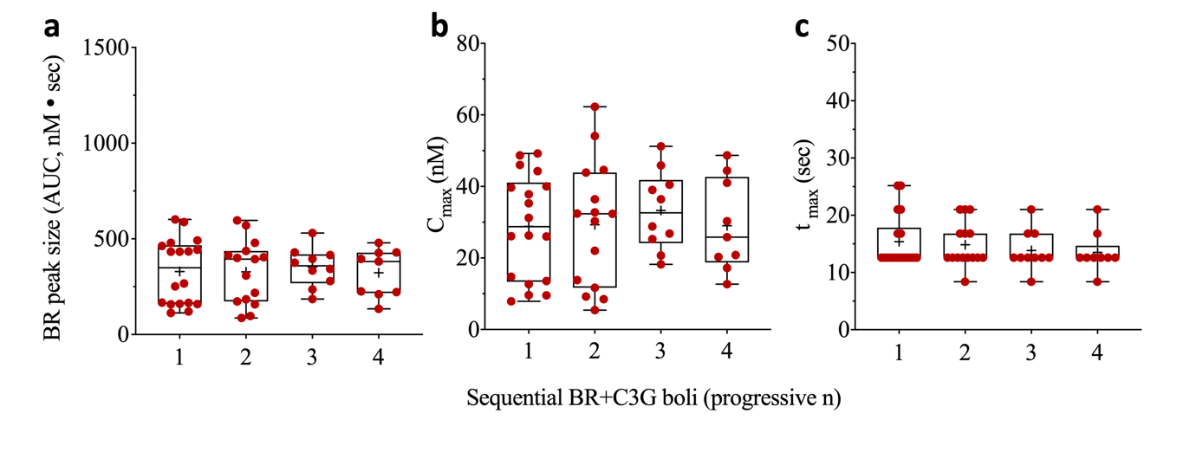
Fig. S3. Bilirubin peaks in the hepatic venous effluent resulting from repeated intra-portal boli of bilirubin and cyanidin 3-glucoside. Box plots of bilirubin (BR) peak descriptors: (A) area (AUC), (B) height (C_{max}), and (C) time to reach C_{max} (T_{max}). BR peaks resulted from sequential boli of 0.05 mM BR and 2 mM cyanidin 3-glucoside (C3G) (livers: n = 18 for 1st bolus; n = 15 for 2nd bolus; n = 10 for 3rd bolus; n = 9 for 4th bolus).

Fig. S4. Analysis of bilirubin peaks triggered by the co-injection of bilirubin with cyanidin 3-glucoside or pravastatin

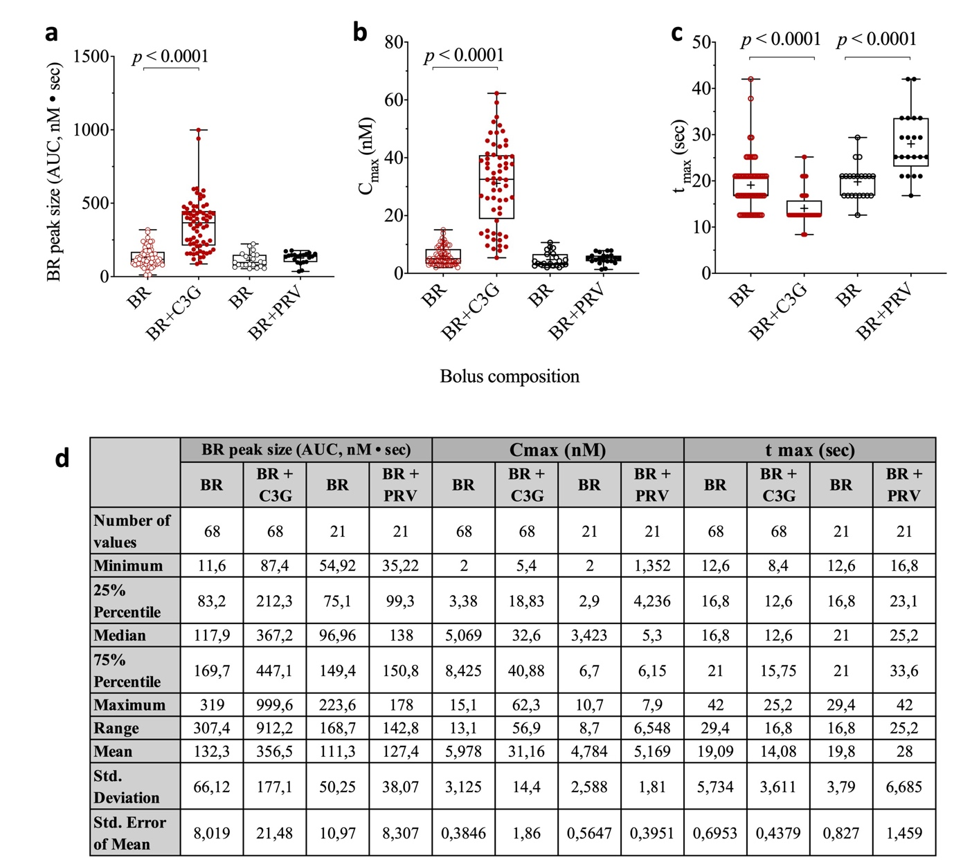

Fig. S4. The effect of cyanidin 3-glucoside or pravastatin on BR peaks in the hepatic venous effluent. Box plots of bilirubin (BR) peak descriptors: (A) areas (AUC), (B) heights (C_{max}), and (C) time to reach C_{max} (T_{max}). BR peaks resulted from boli of 0.05 mM BR without (empty symbols) or with either 2 mM cyanidin 3-glucoside (C3G) (livers, n = 21; peak areas, n = 68) or 6 mM pravastatin (PRV) (closed symbols) (livers, n = 6; peak areas, n = 21). (D) Descriptive table of the peak parameter statistics.

Fig. S5. The reciprocal influence of cyanidin 3-glucoside and bilirubin on the bilirubin peak size

A
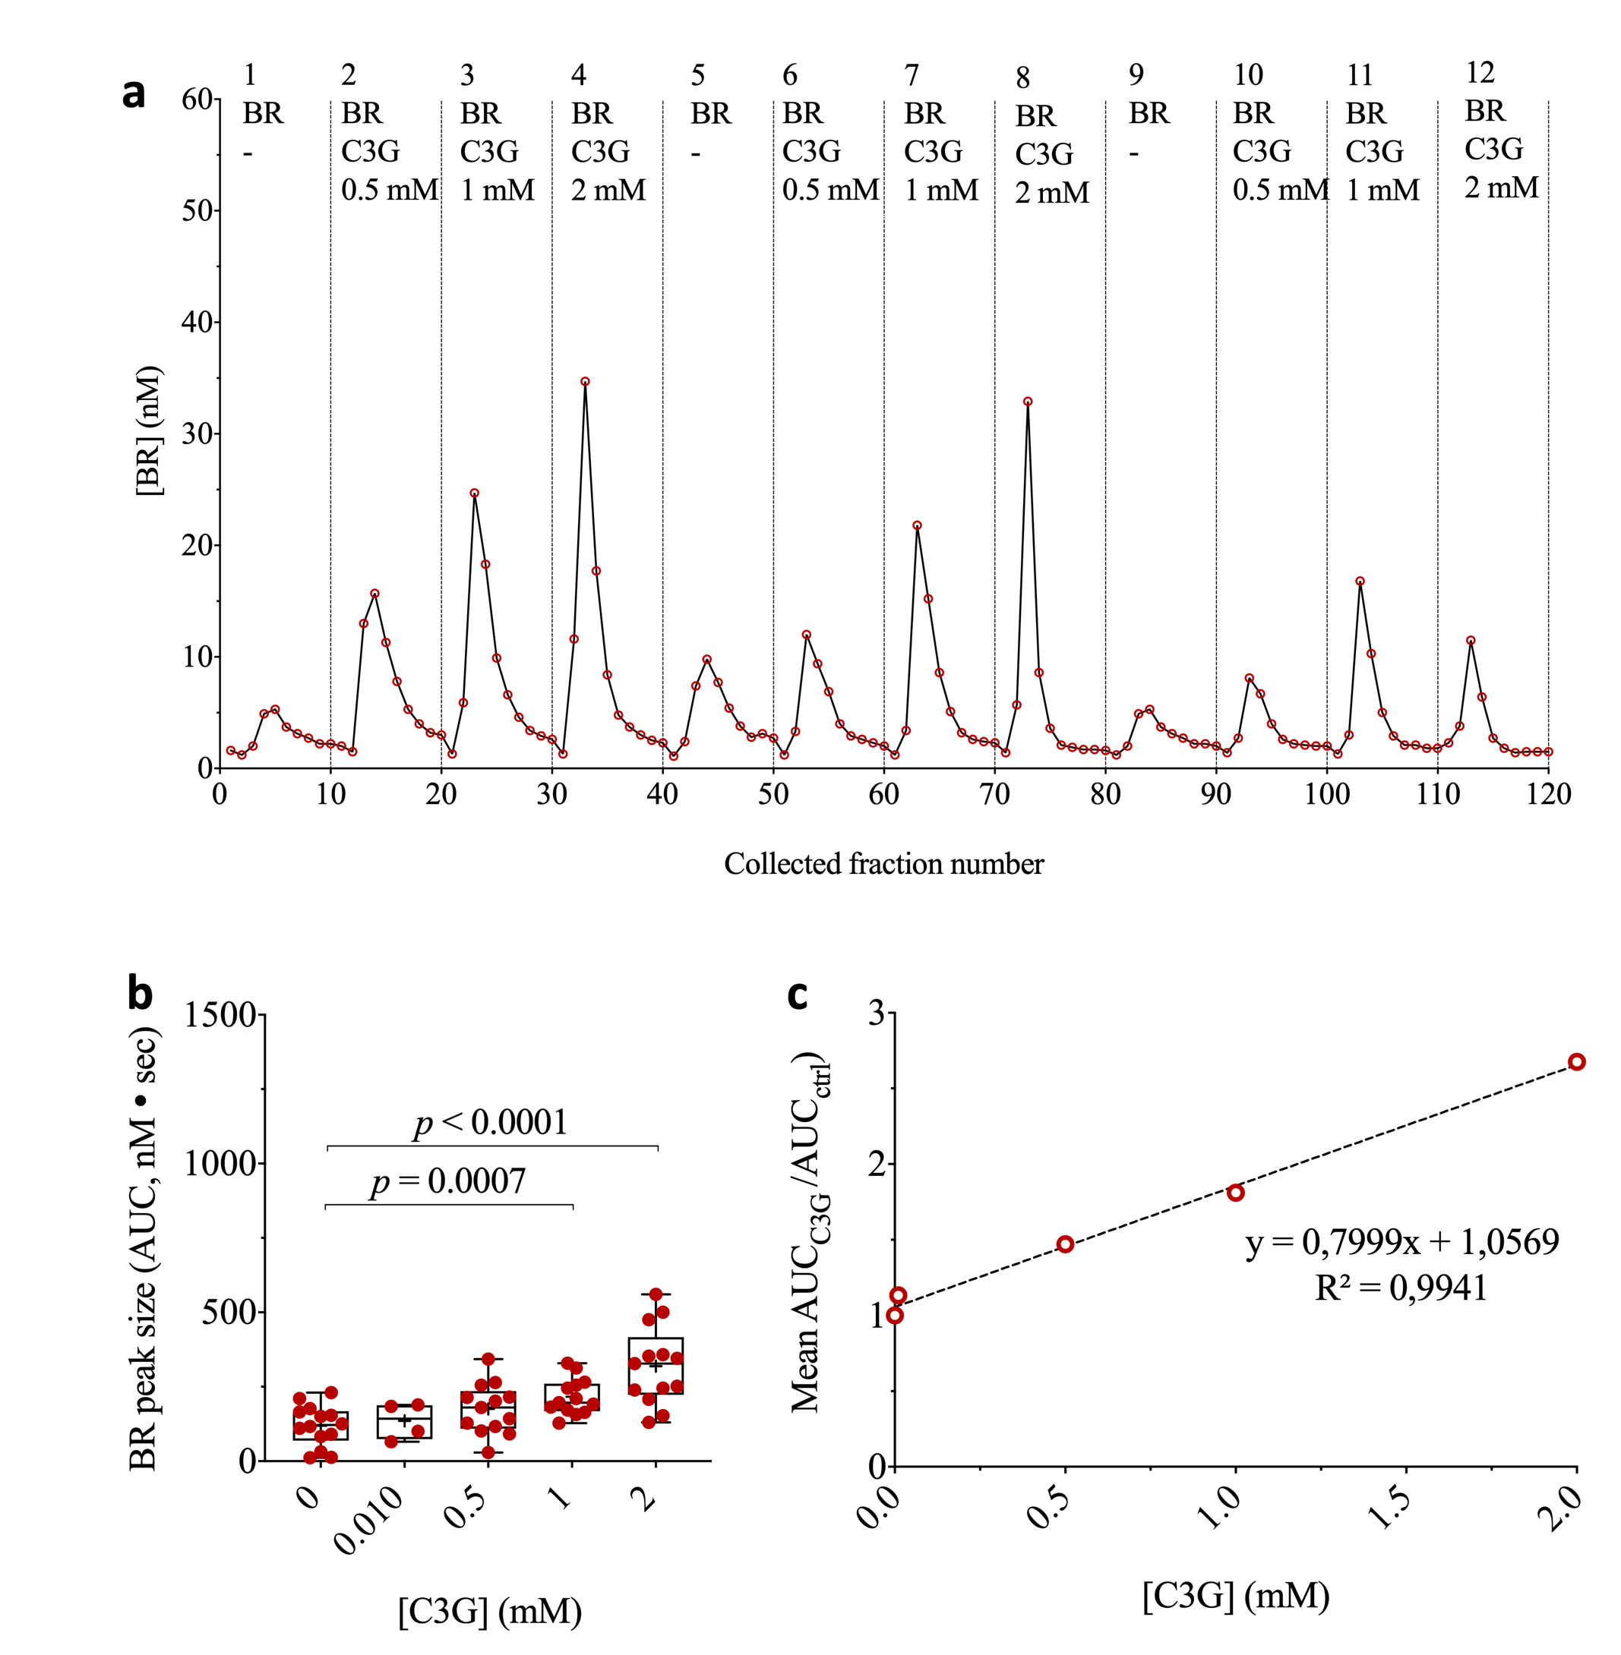
Fig. S5A. The dose-dependent effect of cyanidin 3-glucoside on hepatic uptake of bilirubin. (A) Concentration of bilirubin (BR) in the venous effluent of one representative isolated perfused rat liver, following sequential boli of 0.05 mM BR without or with increasing cyanidin 3-glucoside (C3G) concentrations. (B) Box plots of BR peak areas resulting from co-injection of BR with different C3G concentrations (livers, n = 7; peak areas/group: 0 mM, n = 14; 0.010 mM, n = 4; 0.5 mM, n = 13; 1 mM, n = 13; 2 mM, n = 13). (C) The dependence of the BR peak size on C3G concentration in the bolus of 0.05 mM BR.

COMMENT: In this set of 3 experiments, increasing concentrations of C3G were tested in the BR boli in the same liver, yielding a linear dose-response up to 2 mM C3G.

B
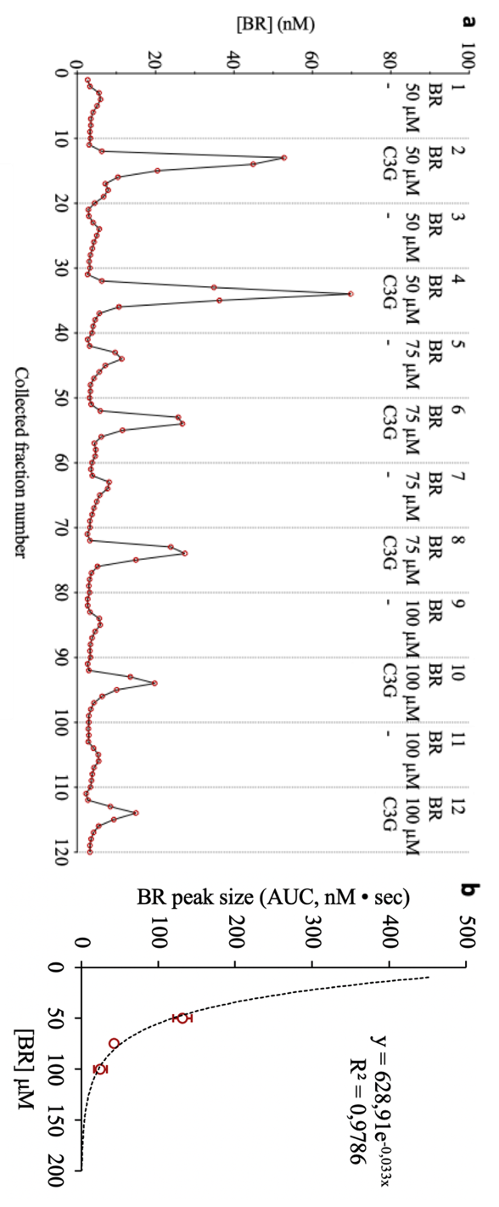

Fig. S5B The effect of cyanidin 3-glucoside on the hepatic uptake of different bilirubin doses. (A) Concentrations of bilirubin (BR) in the venous effluent of a representative isolated perfused rat liver, following sequential intra-portal boli (0.2 mL) of 0.05, 0.75, 0.1 mM BR, without and with 2 mM cyanidin 3-glucoside (C3G). (B) Dependence of the BR peak size on the BR concentration in the bolus.

COMMENT : In this single experiment, increasing concentrations of BR were injected along with the same C3G dose, resulting in BR peaks whose AUC decreased as a nonlinear function of BR concentration. The curve fitted to the data shows that small changes in BR bolus concentrations of 0.05 mM resulted in large changes in BR peak areas, providing evidence for the variable effect size of C3G (see Fig. 1C).

Fig. S6. The effect of cyanidin 3-glucoside, malvidin 3-glucoside, and peonidin 3-glucoside on the hepatic uptake of bilirubin
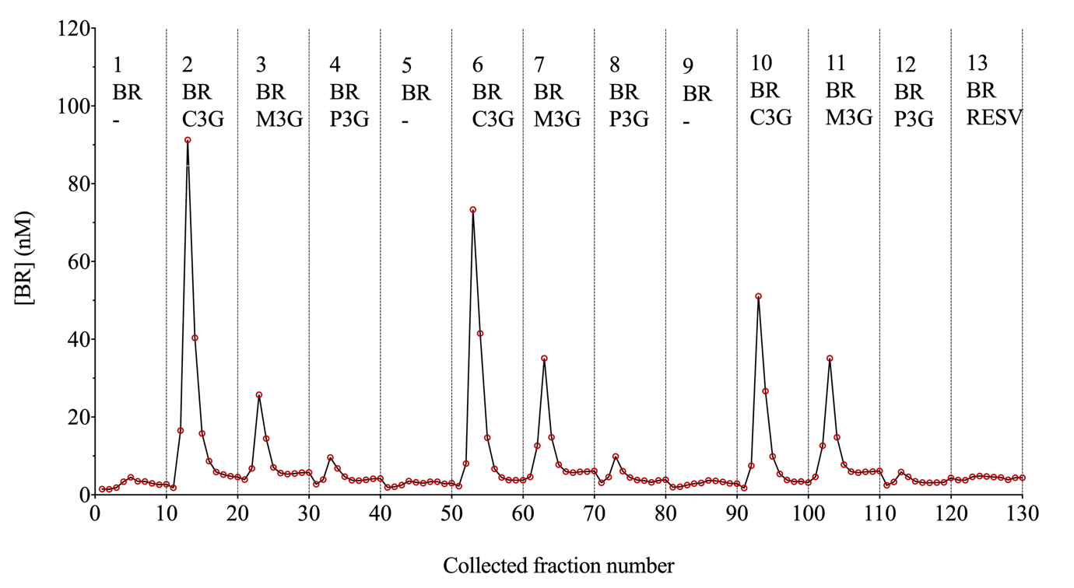

Fig. S6. The effect of cyanidin 3-glucoside, malvidin 3-glucoside, and peonidin 3-glucoside on the hepatic uptake of bilirubin. Concentration of bilirubin in the venous effluent of an isolated perfused rat liver, following sequential boli (0.2 mL) of 0.05 mM BR without or with 2 mM cyanidin 3-glucoside (C3G), malvidin 3-glucoside (M3G), peonidin 3-glucoside (P3G), or trans-resveratrol (RESV).

COMMENT : P3G and M3G are the most potent anthocyanins inhibiting the transport activity of bilitranslocase in rat liver plasma membrane vesicles (K_{i} = 1.8 and 1.4 µM, respectively) [33]. Therefore, they were expected to act like C3G. Indeed, M3G showed the same effect on the uptake of BR as C3G, albeit with lower efficacy (AUC_{C3G}/AUC_{M3G} = 1.70). On the contrary, P3G was essentially inactive on BR uptake. Assuming that the transporter targeted by anthocyanins in intact liver and in plasma membrane vesicles is the same, the differential effect of P3G in the two preparations could be due to the property of P3G to bind the transporter only at the intracellular vestibule of the transport site, which is obviously inaccessible in the intact organ but accessible in vesicles, which are randomly oriented to the medium (right-side out and inside out). If this were the case, we would have to infer that the BR transporter is bidirectional, at least with the BSP substrate. With the last bolus, we co-injected BR with trans-resveratrol, a molecule that is inactive in the electrogenic BSP transport assay of bilitranslocase activity in vesicles [5] and in this preparation.

Fig. S7. The effect of estradiol-17 beta-glucuronide and pravastatin on the hepatic uptake of bilirubin or bilirubin glucuronide
A
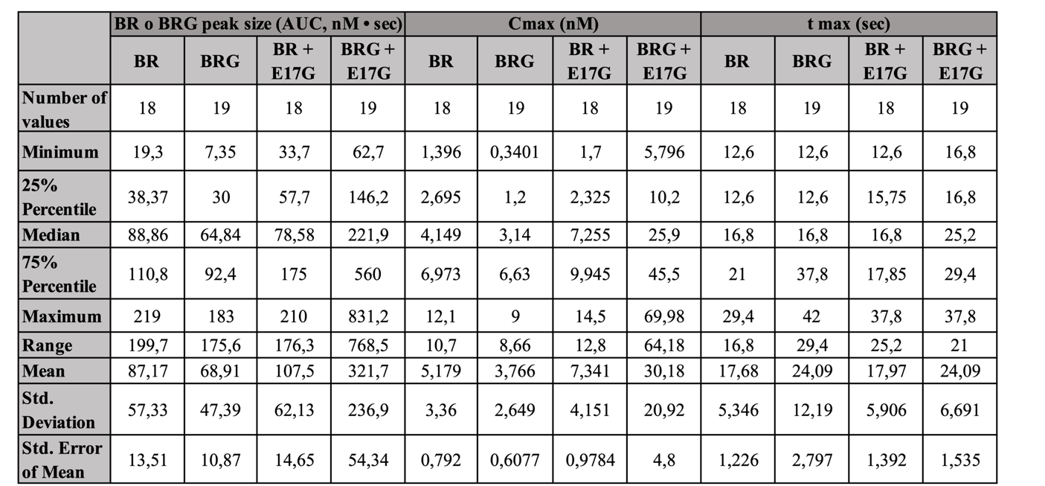
Fig S7A. The effect of cyanidin 3-glucoside and estradiol-17 beta-glucuronide on the hepatic uptake of bilirubin or bilirubin glucuronide. Descriptive table of the peak parameter statistics.

B
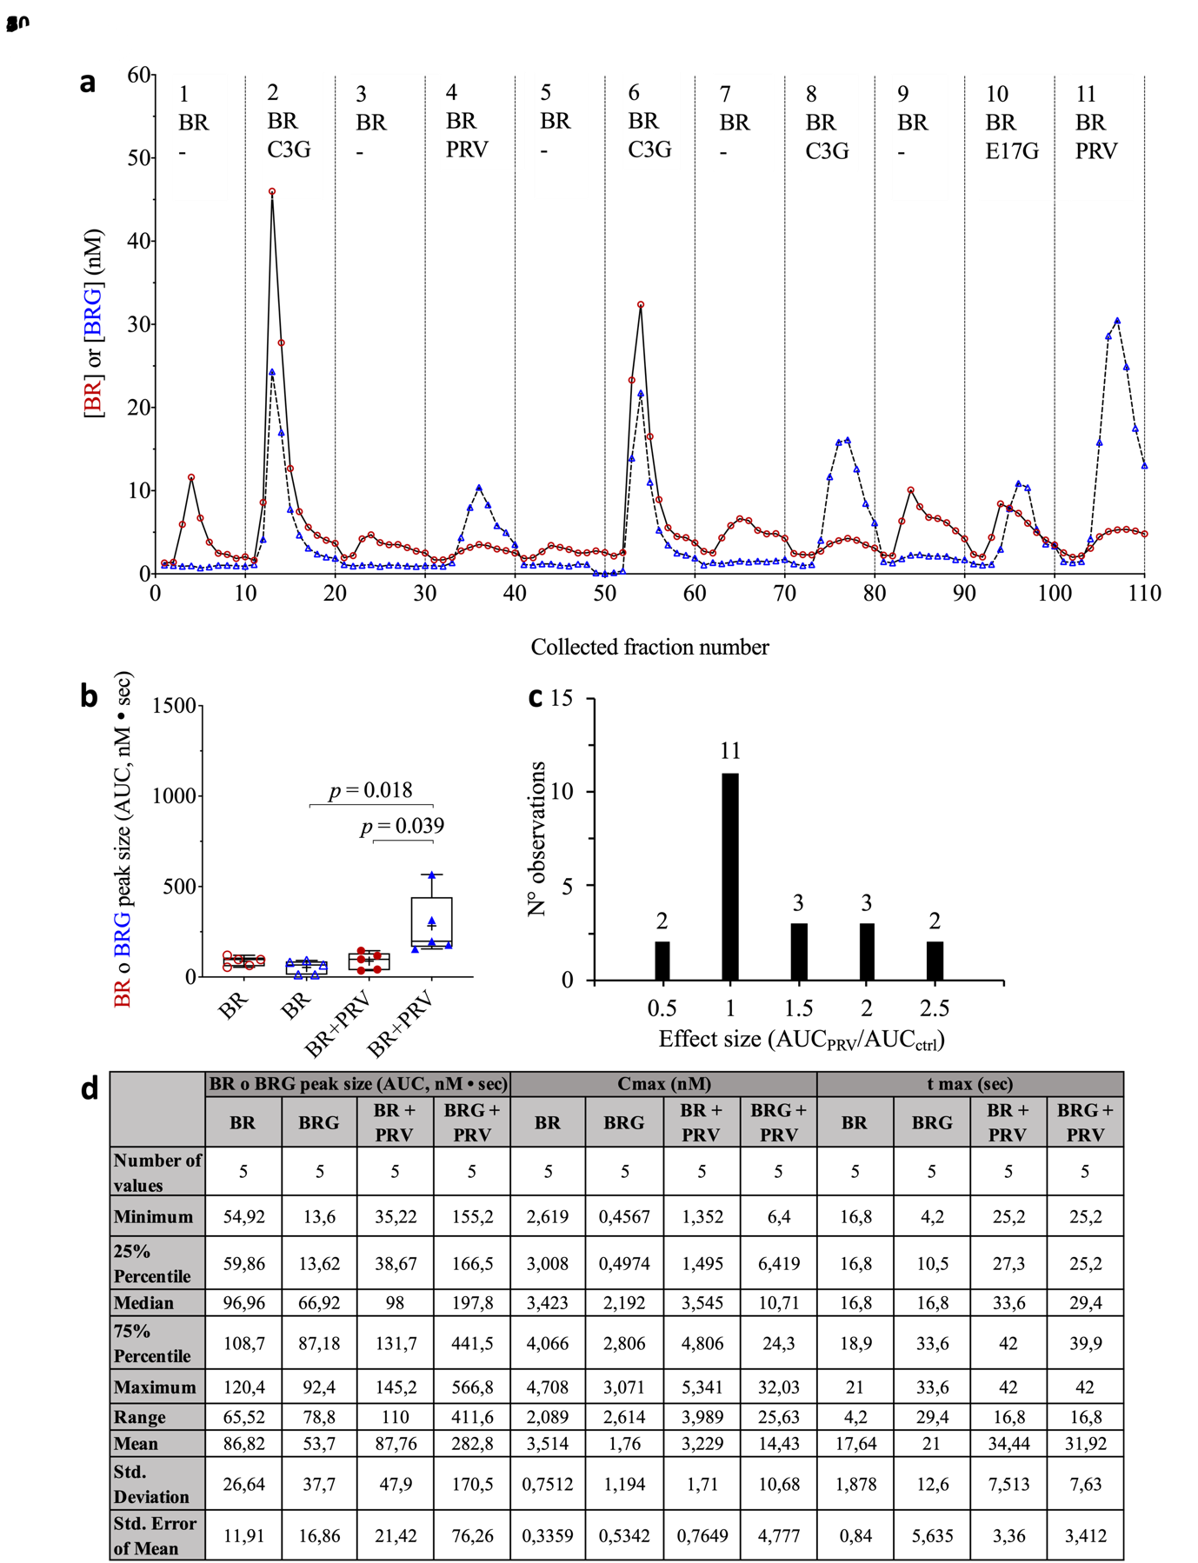

Fig S7B. The effect of cyanidin 3-glucoside and pravastatin on the hepatic uptake of bilirubin or bilirubin glucuronide. (A) Concentrations of bilirubin and bilirubin glucuronide in the venous effluent of a representative isolated perfused rat liver, following sequential boli of 0.05 mM BR without or with either 2 mM cyanidin 3-glucoside (C3G) or 6 mM pravastatin (PRV); bilirubin (BR) in red and bilirubin glucuronide (BRG) in blue. (B) Box plots of peak areas of either BR (in red) or BRG (in blue), resulting from boli of 0.05 mM BR without (empty symbols) or with 6 mM C3G (closed symbols) (n livers = 2, n peak areas = 5). (C) Frequency analysis of the effect size of PRV inhibition of hepatic BR uptake. The effect size is calculated as ratio of each peak area resulting from co-injection of BR with PRV (AUC_{PRV}) vs respective control BR peak area (AUC_{Ctrl}). (D) Peak parameter statistics.

Fig. S8. The effect of pravastatin on the sinusoidal reuptake of bilirubin glucuronide

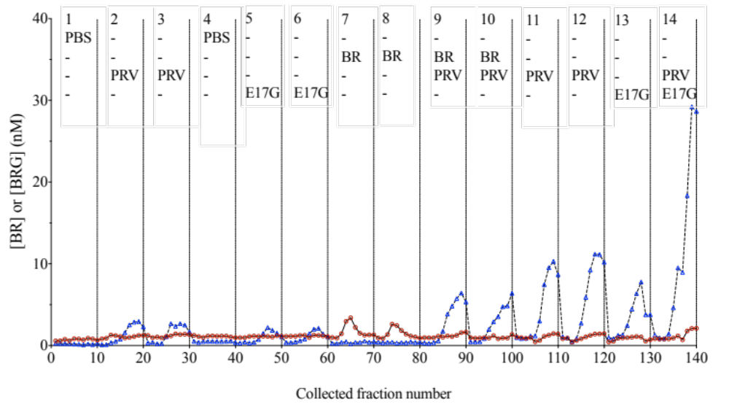
Fig. S8. The effects of pravastatin and estradiol-17 beta-glucuronide on hepatic uptake of bilirubin and bilirubin glucuronide. Concentrations of bilirubin (BR, in red) and bilirubin glucuronide (BRG, in blue) in the venous effluent of one representative isolated perfused rat liver. Boli of 6 mM pravastatin (PRV) were injected alone (boli 2-3), before exposing the liver to BR. After two BR boli (0.05 mM; boli 7-8), PRV boli (6 mM) were injected with BR (0.05 mM; boli 9-10) or alone (boli 11-12). Boli of 1 mM estradiol-17 beta-glucuronide (E17G) were injected alone or with PRV (6 mM).

Fig. S9. The effects of indomethacin and ketoprofen of the sinusoidal reuptake of bilirubin glucuronide

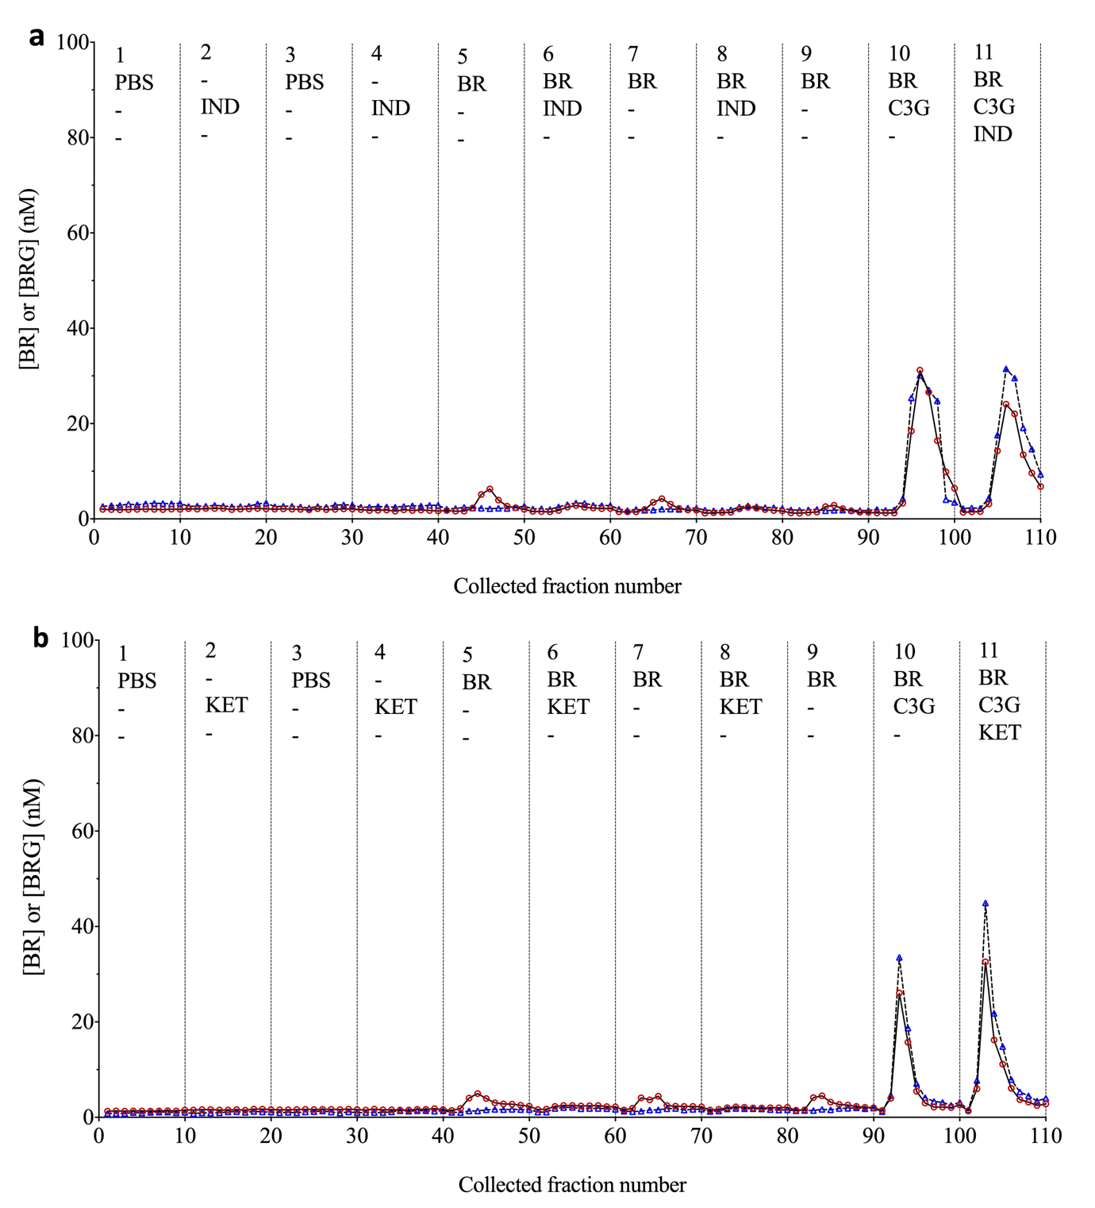
Fig. S9. The effects of indomethacin and ketoprofen on hepatic uptake of bilirubin and bilirubin glucuronide. Concentrations of bilirubin (BR, in red) and BRG (blue triangles) in the venous effluent of a representative isolated perfused rat liver. Boli of 1 mM indomethacin (A) or 1 mM ketoprofen (B) were injected alone (boli 2, 4), or with 0.05 mM BR (boli 6, 8), or with both 0.05 mM BR and 2 mM C3G (bolus 11); bolus 10 is 0.05 mM BR with 2 mM C3G, as a control of BR uptake.

Fig. S10. The quantitative effect of taurocholate of the sinusoidal reuptake of bilirubin glucuronide

A
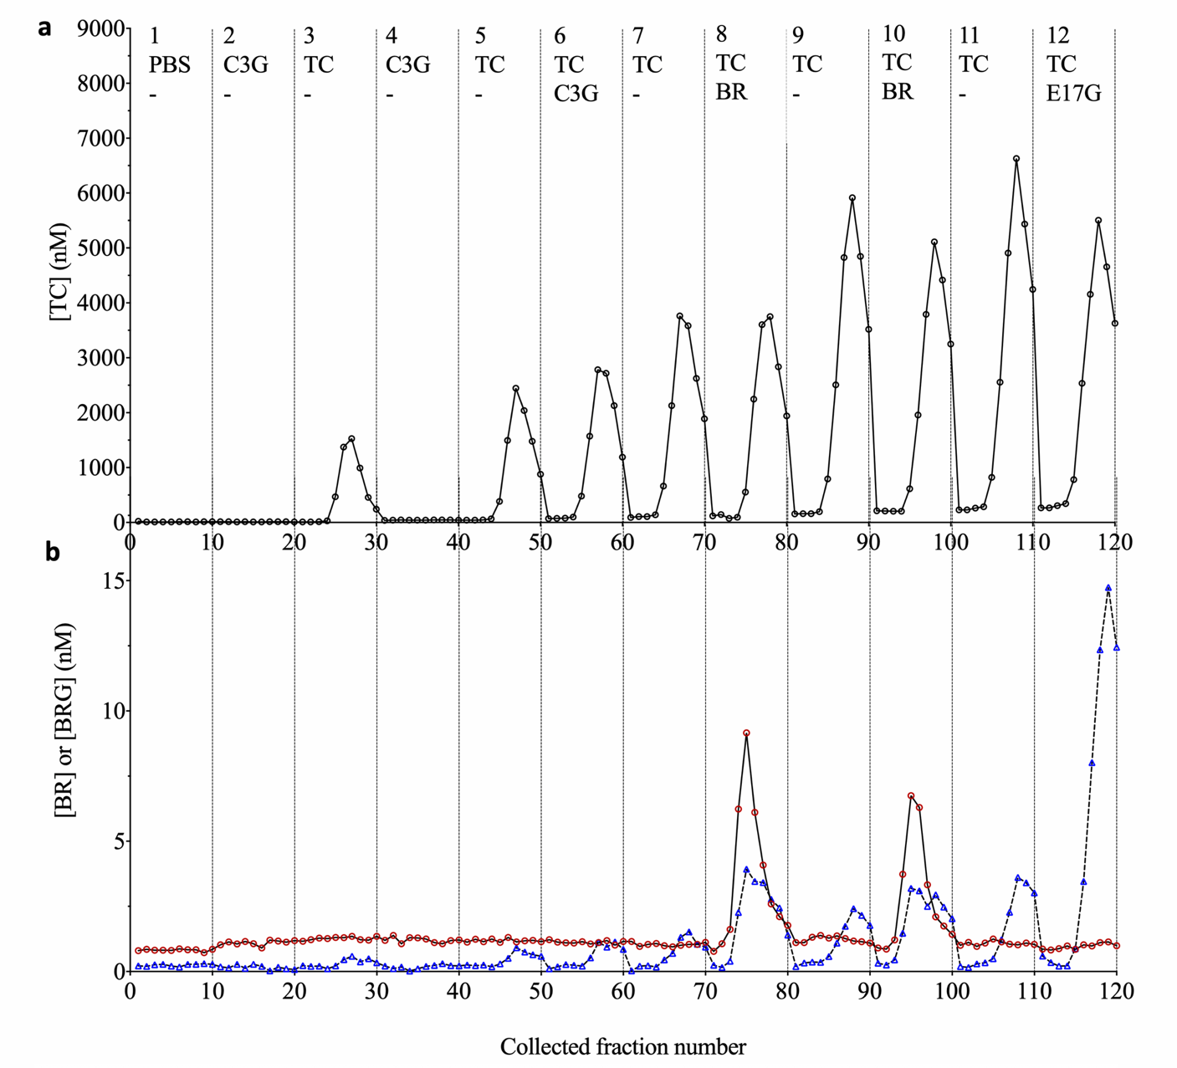

Fig. S10A The effects of sequential boli of taurocholate on bilirubin glucuronide in the perfusion effluent. A representative isolated perfused rat liver was tested with boli (0.2 mL) of 2 mM TC alone (boli 3, 5, 7, 9 and 11) or 2 mM TC with 2 mM C3G (bolus 6), or 2 mM TC with 0.05 mM bilirubin (BR) (bolus 8 and 10), or 2 mM TC with 1 mM estradiol-17 beta-glucuronide (E17G). Boli 1 (PBS solution) and 2 (2 mM C3G) were injected to assess the basal concentrations of TC, BR and BRG. The effluent of the perfusion was analysed for (A) Concentrations of taurocholate (TC) or (B) Concentrations of bilirubin and bilirubin glucuronide (BR, red; BRG, blue).

B
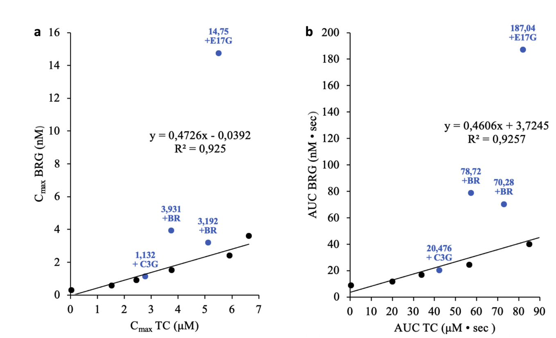

Fig. S10B Correlation between taurocholate and bilirubin glucuronide in the perfusion effluent. Correlation of Cmax (a) or AUC (b) of Bilirubin glucuronide vs taurocholate.

Fig. S11. The effects of physiological concentrations of cyanidin 3-glucoside and taurocholate on the hepatic uptake of bilirubin and bilirubin glucuronide
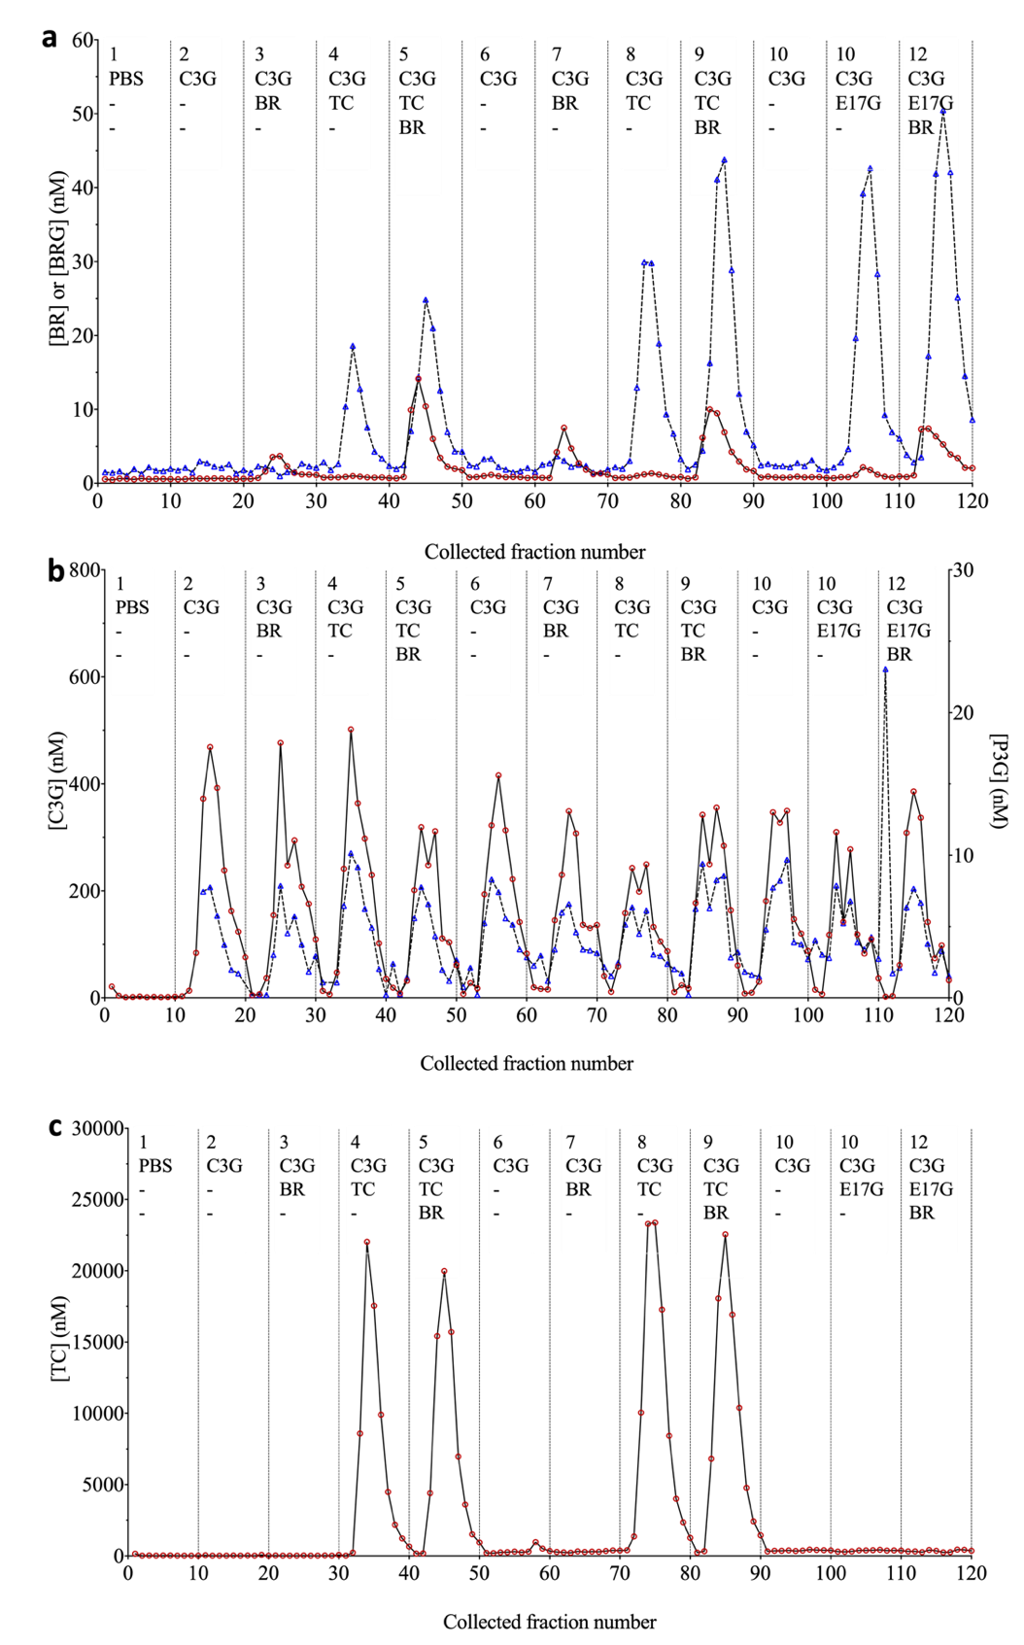
Fig. S11 The effects of cyanidin 3-glucoside and taurocholate on the hepatic uptake of bilirubin and bilirubin glucuronide. An isolated perfused rat liver was tested with intraportal injection of boli (0.2 mL) containing: PBS solution (bolus 1); 0.01 mM (2 nmol) cyanidin 3-glucoside (C3G) alone (boli 2, 6, and 10), or with 0.05 mM BR (10 nmol; boli 3 and 7), or with 2 mM taurocholate (TC) (400 nmol; boli 4 and 8), or with both 0.05 mM BR (10 nmol) and 2 mM TC (400 nmol). The perfusion effluent was analysed to simultaneously determine: (a) Concentrations of bilirubin and bilirubin glucuronide (BR, in red; BRG, in blue); (b) Concentrations of cyanidin 3-glucoside and peonidin 3-glucoside (C3G, in red; P3G, in blue); (c) Concentrations of taurocholate (TC).

This experiment has been performed on two livers.

Descriptive statistics of basal concentrations of the analysed compounds in the effluent fractions 2-9, in 2 livers. Fractions 1 were removed because they contained abnormally high values of TC.

Basal concentrations | BR (nM) | BRG (nM) | C3G (nM) | TC (nM)
Number of values | 16 | 16 | 16 | 16
Minimum | 0.4 | 0.4 | 0 | 13.9
25% Percentile | 0.6 | 0.5 | 0 | 18.5
Median | 0.9 | 0.9 | 0.6 | 28.2
75% Percentile | 1.3 | 1.7 | 1.8 | 36.9
Maximum | 1.5 | 2.2 | 4 | 69.9
Range | 1 | 1.2 | 4 | 56
Mean | 0.9 | 1.1 | 1 | 32.3
Std. Deviation | 0.4 | 0.6 | 1.2 | 16.7
Std. Error of Mean | 0.1 | 0.2 | 0.3 | 4.3

Descriptive statistics of peak parameters. Number of values refers on the total number of peaks obtained in 2 experiments.

AUC | BR (nM • sec) | BRG (nM • sec) | C3G (nM • sec) | TC (nM • sec)
Number of values | 4 | 4 | 6 | 8
Minimum | 16.56 | 17.22 | 535.3 | 66.57
25% Percentile | 18.75 | 18.35 | 1125 | 69.71
Median | 35.7 | 25.74 | 1592 | 82.05
75% Percentile | 47.04 | 30.14 | 1751 | 90.69
Maximum | 47.36 | 30.26 | 1897 | 112.9
Range | 30.8 | 13.04 | 1362 | 46.33
Mean | 33.83 | 24.74 | 1440 | 83.3
Std. Deviation | 15.32 | 6.36 | 481.3 | 15.01
Std. Error of Mean | 7.659 | 3.18 | 196.5 | 5.307

Cmax | BR (nM) | BRG (nM) | C3G (μM) | TC (μM)
Number of values | 4 | 4 | 6 | 8
Minimum | 3.693 | 2.676 | 0.247 | 19.98
25% Percentile | 4.648 | 2.933 | 0.3243 | 21.02
Median | 10.92 | 7.748 | 0.4105 | 22.31
75% Percentile | 15.38 | 13.57 | 0.546 | 23.74
Maximum | 15.73 | 14.16 | 0.777 | 36.48
Range | 12.04 | 11.48 | 0.53 | 16.5
Mean | 10.32 | 8.083 | 0.444 | 23.83
Std. Deviation | 5.69 | 5.747 | 0.1797 | 5.266
Std. Error of Mean | 2.845 | 2.873 | 0.07336 | 1.862

tmax | BR (sec) | BRG (sec) | C3G (sec) | TC (sec)
Number of values | 4 | 4 | 6 | 8
Minimum | 12 | 12 | 20 | 16
25% Percentile | 12 | 12 | 20 | 17
Median | 14 | 12 | 22 | 20
75% Percentile | 19 | 27 | 25 | 20
Maximum | 20 | 32 | 28 | 24
Range | 8 | 20 | 8 | 8
Mean | 15 | 17 | 22.67 | 19.5
Std. Deviation | 3.83 | 10 | 3.266 | 2.563
Std. Error of Mean | 1.915 | 5 | 1.333 | 0.9063

The integrity of the liver is evident in the controlled uptake of BR and BRG
Livers released endogenous BR in the sinusoid, which occurred in the very first fractions of all experiments (1.2 ± 0.5 nM, n=24). This could be due to the efflux of the intracellular "mobile" BR, i.e. the protein-free fraction [63]. Conversely, livers were able to absorb repeated boli of 10 nmol BR almost completely, with a residual amount of BR (0.13%, n=68) recovered in the liver perfusion effluent. Simultaneous injection of C3G with BR had considerable effects on the occurrence of BR in the effluent (Fig. 1), but had a negligible effect on the uptake balance, as the proportion of BR recovered in the effluent increased to only 0.36% (n = 68), demonstrating an overwhelming driving force for the uptake of BR from the sinusoid.
This result arises from the combination of the biophysical properties of BR membrane transport, the geometric property of this model, and perfusion flow rate. BR diffusion across the sinusoidal membrane of the hepatocyte is a rapid, transporter-mediated process, as shown by pharmacokinetic observations in the rat [64], later demonstrations in cultured hepatocytes exposed to nM BR in an albumin-free buffer where an anti-bilitranslocase antibody blocked uptake [24], and the data obtained in this study.
The vascular volume of the rat liver is approximately 5% of the liver volume [65], so the volume in which BR could be distributed exceeds the volume of the portal vein bed by 2 orders of magnitude. Therefore, the fraction of the injected BR that should be recovered in the venous effluent at the equilibrium must be a few percent of the injected dose. Finally, the relatively low perfusion flow rate contributed to the quasi-total extraction of BR, as this parameter is directly dependent on flow [66]. Other factors contribute to the driving force for BR uptake, including the intracellular association of BR and BRG with glutathione S-transferase (Ligandin) [63] and the rapid BR glucuronidation to BRG, which implies, in turn that the liver has sufficient availability of UDP-glucuronic acid.
Livers exhibited a basal net release of BRG that remained essentially unchanged by repeated administrations of BR. This resulted from efflux via an uncharacterized efflux pathway that appeared to be independent of Mrp3 (since it was not inhibited by E17G) or other sinusoidal membrane transporters targeted by the inhibitors used. Importantly, hepatic reuptake of BRG occurred, as demonstrated by specific transient inhibition by E17G, pravastatin, and taurocholate. Thus, in the isolated organ, we reproduced the phenomenon of sinusoidal reuptake of BRG previously described in knockout mice with defective expression of Oatp
[25][67]. Overall, we consider BRG hopping in the isolated liver preparations as evidence of their viability and functional capacity.

References
1. Stieger B, Mahdi ZM: Model systems for studying the role of canalicular efflux transporters in drug-induced cholestatic liver disease. J Pharm Sci 2017, 106:2295–2301.
2. Bessems M, ’t Hart NA, Tolba R, Doorschodt BM, Leuvenink HGD, Ploeg RJ, Minor T, van Gulik TM: The isolated perfused rat liver: standardization of a time-honoured model. Lab Anim 2006, 40:236–246.
3. Stebel M, Medic N, Pelizzo P, Sist P, Tramer F, Passamonti S: Protocol for the Study of Hepatic Bilirubin Uptake in the Isolated Perfused Rat Liver. 2021.
4. Passamonti S, Tramer F, Petrussa E, Braidot E, Vianello A: Electrogenic bromosulfalein transport in isolated membrane vesicles: implementation in both animal and plant preparations for the study of flavonoid transporters. Methods Mol Biol 2010, 643:307–335.
5. Zuperl S, Fornasaro S, Novic M, Passamonti S: Experimental determination and prediction of bilitranslocase transport activity. Anal Chim Acta 2011, 705:322–333.
6. Bowman CM, Benet LZ: An examination of protein binding and protein-facilitated uptake relating to in vitro-in vivo extrapolation. Eur J Pharm Sci 2018, 123:502–514.
7. Asad SF, Singh S, Ahmad A, Khan NU, Hadi SM: Prooxidant and antioxidant activities of bilirubin and its metabolic precursor biliverdin: a structure–activity study. Chem Biol Interact 2001, 137:59–74.
8. Yamasaki H, Uefuji H, Sakihama Y: Bleaching of the Red Anthocyanin Induced by Superoxide Radical. Arch Biochem Biophys 1996, 332:183–186.
9. González-Flecha B, Cutrin JC, Boveris A: Time course and mechanism of oxidative stress and tissue damage in rat liver subjected to in vivo ischemia-reperfusion. J Clin Invest 1993, 91:456–464.
10. Chan TS, Cassim S, Raymond V-A, Gottschalk S, Merlen G, Zwingmann C, Lapierre P, Darby P, Mazer CD, Bilodeau M: Upregulation of Krebs cycle and anaerobic glycolysis activity early after onset of liver ischemia. PLoS One 2018, 13:e0199177.
11. Sherman IA, Dlugosz JA, Barker F, Sadeghi FM, Pang KS: Dynamics of arterial and portal venous flow interactions in perfused rat liver: an intravital microscopic study. Am J Physiol Liver Physiol 1996, 271:G201–G210.
12. Daemen MJ, Thijssen HH, van Essen H, Vervoort-Peters HT, Prinzen FW, Struyker Boudier HA, Smits JF: Liver blood flow measurement in the rat. The electromagnetic versus the microsphere and the clearance methods. J Pharmacol Methods 1989, 21:287–297.
13. Wolkoff AW, Johansen KL, Goeser T: The isolated perfused rat liver: preparation and application. Anal Biochem 1987, 167:1–14.
14. Díaz-Juárez JA, Hernández-Muñoz R: Rat Liver Enzyme Release Depends on Blood Flow-Bearing Physical Forces Acting in Endothelium Glycocalyx rather than on Liver Damage. Oxid Med Cell Longev 2017, 2017:1360565.
15. Kato K, Hasegawa Y, Iwata K, Ichikawa T, Yahara T, Tsuji S, Sugiura M, Yamaguchi J-I: Recommendation to Exclude Bile-Duct-Cannulated Rats with Hyperbilirubinemia for Proper Conduct of Biliary Drug Excretion Studies. Drug Metab Dispos 2016, 44:1180–1183.
16. Paumgartner G, Reichen J: Kinetics of hepatic uptake of unconjugated bilirubin. Clin Sci Mol Med 1976, 51:169–176.
17. Stollman YR, Gartner U, Theilmann L, Ohmi N, Wolkoff AW: Hepatic bilirubin uptake in the isolated perfused rat liver is not facilitated by albumin binding. J Clin Invest 1983, 72:718–723.
18. Roelofsen H, van der Veere CN, Ottenhoff R, Schoemaker B, Jansen PL, Oude Elferink RP: Decreased bilirubin transport in the perfused liver of endotoxemic rats. Gastroenterology 1994, 107:1075–1084.
19. Chowdhury JR, Jansen PL, Fischberg EB, Daniller A, Arias IM: Hepatic conversion of bilirubin monoglucuronide to diglucuronide in uridine diphosphate-glucuronyl transferase-deficient man and rat by bilirubin glucuronoside glucuronosyltransferase. J Clin Invest 1978, 62:191–196.
20. Hirouchi M, Suzuki H, Sugiyama Y: Treatment of hyperbilirubinemia in Eisai hyperbilirubinemic rat by transfecting human MRP2/ABCC2 gene. Pharm Res 2005, 22:661–666.
21. Bandiera A, Corich L, Tommasi S, De Bortoli M, Pelizzo P, Stebel M, Paladin D, Passamonti S: Human elastin-like polypeptides as a versatile platform for exploitation of ultrasensitive bilirubin detection by UnaG. Biotechnol Bioeng 2020, 117:354–361.
22. Vanzo A, Terdoslavich M, Brandoni A, Torres AM, Vrhovsek U, Passamonti S: Uptake of grape anthocyanins into the rat kidney and the involvement of bilitranslocase. Mol Nutr Food Res 2008, 52:1106–1116.
23. Battiston L, Passamonti S, Macagno A, Sottocasa GL: The bilirubin-binding motif of bilitranslocase and its relation to conserved motifs in ancient biliproteins. Biochem Biophys Res Commun 1998, 247:687–692.
24. Passamonti S, Terdoslavich M, Margon A, Cocolo A, Medic N, Micali F, Decorti G, Franko M: Uptake of bilirubin into HepG2 cells assayed by thermal lens spectroscopy: Function of bilitranslocase. FEBS J 2005, 272:5522–5535.
25. van de Steeg E, Wagenaar E, van der Kruijssen CMM, Burggraaff JEC, de Waart DR, Elferink RPJO, Kenworthy KE, Schinkel AH: Organic anion transporting polypeptide 1a/1b–knockout mice provide insights into hepatic handling of bilirubin, bile acids, and drugs. J Clin Invest 2010, 120:2942.
26. Briz O, Serrano MA, MacIas RIR, Gonzalez-Gallego J, Marin JJG: Role of organic anion-transporting polypeptides, OATP-A, OATP-C and OATP-8, in the human placenta-maternal liver tandem excretory pathway for foetal bilirubin. Biochem J 2003, 371(Pt 3):897–905.
27. Cui Y, König J, Leier I, Buchholz U, Keppler D: Hepatic Uptake of Bilirubin and its Conjugates by the Human Organic Anion Transporter SLC21A6. J Biol Chem 2001, 276:9626–9630.
28. Dragojević J, Mihaljević I, Popović M, Smital T: Zebrafish (Danio rerio) Oat1 and Oat3 transporters and their interaction with physiological compounds. Comp Biochem Physiol Part B Biochem Mol Biol 2019:110309.
29. Lee Y-MA, Cui Y, König J, Risch A, Jäger B, Drings P, Bartsch H, Keppler D, Nies AT: Identification and functional characterization of the natural variant MRP3-Arg1297His of human multidrug resistance protein 3 (MRP3/ABCC3). Pharmacogenetics 2004, 14.
30. Passamonti S, Battiston L, Sottocasa GL: Arylsulfonylation of bilitranslocase in plasma membranes from rat liver enables to discriminate between natural and artificial substrates. Biochim Biophys Acta - Biomembr 1997, 1323:130–136.
31. Passamonti S, Battiston L, Sottocasa GL: On the mechanism of bilitranslocase transport inactivation by phenylmethylsulphonyl fluoride. Mol Membr Biol 1999, 16:167–172.
32. Vlaming MLH, Pala Z, van Esch A, Wagenaar E, de Waart DR, van de Wetering K, van der Kruijssen CMM, Oude Elferink RPJ, van Tellingen O, Schinkel AH: Functionally Overlapping Roles of Abcg2 (Bcrp1) and Abcc2 (Mrp2) in the Elimination of Methotrexate and Its Main Toxic Metabolite 7-Hydroxymethotrexate. Clin Cancer Res 2009, 15:3084 LP – 3093.
33. Passamonti S, Vrhovsek U, Mattivi F: The interaction of anthocyanins with bilitranslocase. Biochem Biophys Res Commun 2002, 296:631–636.
34. Passamonti S, Vanzo A, Vrhovsek U, Terdoslavich M, Cocolo A, Decorti G, Mattivi F: Hepatic uptake of grape anthocyanins and the role of bilitranslocase. In Food Research International. Volume 38; 2005:953–960.
35. Dreiseitel A, Oosterhuis B, Vukman K V, Schreier P, Oehme A, Locher S, Hajak G, Sand PG: Berry anthocyanins and anthocyanidins exhibit distinct affinities for the efflux transporters BCRP and MDR1. Br J Pharmacol 2009, 158:1942–1950.
36. Tokui T, Nakai D, Nakagomi R, Yawo H, Abe T, Sugiyama Y: Pravastatin, an HMG-CoA reductase inhibitor, is transported by rat organic anion transporting polypeptide, oatp2. Pharm Res 1999, 16:904–908.
37. Khamdang S, Takeda M, Shimoda M, Noshiro R, Narikawa S, Huang X-L, Enomoto A, Piyachaturawat P, Endou H: Interactions of human- and rat-organic anion transporters with pravastatin and cimetidine. J Pharmacol Sci 2004, 94:197–202.
38. Choi M-K, Shin HJ, Choi Y-L, Deng J-W, Shin J-G, Song I-S: Differential effect of genetic variants of Na+-taurocholate co-transporting polypeptide (NTCP) and organic anion-transporting polypeptide 1B1 (OATP1B1) on the uptake of HMG-CoA reductase inhibitors. Xenobiotica 2011, 41:24–34.
39. Karlgren M, Vildhede A, Norinder U, Wisniewski JR, Kimoto E, Lai Y, Haglund U, Artursson P: Classification of inhibitors of hepatic organic anion transporting polypeptides (OATPs): influence of protein expression on drug-drug interactions. J Med Chem 2012, 55:4740–4763.
40. Ellis LCJ, Hawksworth GM, Weaver RJ: ATP-dependent transport of statins by human and rat MRP2/Mrp2. Toxicol Appl Pharmacol 2013, 269:187–194.
41. Hirano M, Maeda K, Hayashi H, Kusuhara H, Sugiyama Y: Bile salt export pump (BSEP/ABCB11) can transport a nonbile acid substrate, pravastatin. J Pharmacol Exp Ther 2005, 314:876–882.
42. Hirano M, Maeda K, Matsushima S, Nozaki Y, Kusuhara H, Sugiyama Y: Involvement of BCRP (ABCG2) in the biliary excretion of pitavastatin. Mol Pharmacol 2005, 68:800–807.
43. Cattori V, Montfoort JE, Stieger B, Landmann L, Meijer DK, Winterhalter KH, Meier PJ, Hagenbuch B: Localization of organic anion transporting polypeptide 4 (Oatp4) in rat liver and comparison of its substrate specificity with Oatp1, Oatp2 and Oatp3. Pflügers Arch 2001, 443:188–195.
44. Kanai N, Lu R, Bao Y, Wolkoff AW, Vore M, Schuster VL: Estradiol 17 beta-D-glucuronide is a high-affinity substrate for oatp organic anion transporter. Am J Physiol 1996, 270(2 Pt 2):F326-31.
45. Grosser G, Müller SF, Kirstgen M, Döring B, Geyer J: Substrate Specificities and Inhibition Pattern of the Solute Carrier Family 10 Members NTCP, ASBT and SOAT . Frontiers in Molecular Biosciences 2021:430.
46. Akita H, Suzuki H, Hirohashi T, Takikawa H, Sugiyama Y: Transport activity of human MRP3 expressed in Sf9 cells: comparative studies with rat MRP3. Pharm Res 2002, 19:34–41.
47. Hirohashi T, Suzuki H, Sugiyama Y: Characterization of the transport properties of cloned rat multidrug resistance-associated protein 3 (MRP3). J Biol Chem 1999, 274:15181–15185.
48. Ninomiya M, Ito K, Horie T: FUNCTIONAL ANALYSIS OF DOG MULTIDRUG RESISTANCE-ASSOCIATED PROTEIN 2 (MRP2) IN COMPARISON WITH RAT MRP2. Drug Metab Dispos 2005, 33:225 LP – 232.
49. Blazquez AG, Briz O, Romero MR, Rosales R, Monte MJ, Vaquero J, Macias RIR, Cassio D, Marin JJG: Characterization of the role of ABCG2 as a bile acid transporter in liver and placenta. Mol Pharmacol 2012, 81:273–283.
50. Morita N, Kusuhara H, Sekine T, Endou H, Sugiyama Y: Functional characterization of rat organic anion transporter 2 in LLC-PK1 cells. J Pharmacol Exp Ther 2001, 298:1179–1184.
51. Seward DJ, Koh AS, Boyer JL, Ballatori N: Functional complementation between a novel mammalian polygenic transport complex and an evolutionarily ancient organic solute transporter, OSTalpha-OSTbeta. J Biol Chem 2003, 278:27473–27482.
52. Sato R, Akiyoshi T, Morita T, Katayama K, Yajima K, Kataoka H, Imaoka A, Ohtani H: Dual kinetics of OATP2B1: Inhibitory potency and pH-dependence of OATP2B1 inhibitors. Drug Metab Pharmacokinet 2021, 41:100416.
53. Lengyel G, Veres Z, Tugyi R, Vereczkey L, Molnár T, Glavinas H, Krajcsi P, Jemnitz K: Modulation of sinusoidal and canalicular elimination of bilirubin-glucuronides by rifampicin and other cholestatic drugs in a sandwich culture of rat hepatocytes. Hepatol Res 2008, 38.
54. Bodó A, Bakos É, Szeri F, Váradi A, Sarkadi B: Differential Modulation of the Human Liver Conjugate Transporters MRP2 and MRP3 by Bile Acids and Organic Anions*. J Biol Chem 2003, 278:23529–23537.
55. Riha J, Brenner S, Böhmdorfer M, Giessrigl B, Pignitter M, Schueller K, Thalhammer T, Stieger B, Somoza V, Szekeres T: Resveratrol and its major sulfated conjugates are substrates of organic anion transporting polypeptides (OATPs): Impact on growth of ZR‐75‐1 breast cancer cells. Mol Nutr Food Res 2014, 58:1830–1842.
56. van de Wetering K, Burkon A, Feddema W, Bot A, de Jonge H, Somoza V, Borst P: Intestinal breast cancer resistance protein (BCRP)/Bcrp1 and multidrug resistance protein 3 (MRP3)/Mrp3 are involved in the pharmacokinetics of resveratrol. Mol Pharmacol 2009, 75:876–885.
57. Hata S, Wang P, Eftychiou N, Ananthanarayanan M, Batta A, Salen G, Pang KS, Wolkoff AW: Substrate specificities of rat oatp1 and ntcp: implications for hepatic organic anion uptake. Am J Physiol Liver Physiol 2003, 285:G829–G839.
58. Suga T, Yamaguchi H, Ogura J, Mano N: Characterization of conjugated and unconjugated bile acid transport via human organic solute transporter α/β. Biochim Biophys Acta - Biomembr 2019, 1861:1023–1029.
59. Gerloff T, Stieger B, Hagenbuch B, Madon J, Landmann L, Roth J, Hofmann AF, Meier PJ: The sister of P-glycoprotein represents the canalicular bile salt export pump of mammalian liver. J Biol Chem 1998, 273:10046–10050.
60. Kamisako T, Leier I, Cui Y, Konig J, Buchholz U, Hummel-Eisenbeiss J, Keppler D: Transport of monoglucuronosyl and bisglucuronosyl bilirubin by recombinant human and rat multidrug resistance protein 2. Hepatology 1999, 30:485–490.
61. Lazarowski ER, Boucher RC, Harden TK: Mechanisms of release of nucleotides and integration of their action as P2X-and P2Y-receptor activating molecules. Mol Pharmacol 2003, 64:785–795.
62. Yang W, Benjamin IS, Sherwood R, Salisbury J, Alexander B: Effect of perfusate albumin on organ viability and vascular responses in the in vitro dual-perfused rat liver. J Pharmacol Toxicol Methods 2000, 43:225–231.
63. Levitt DG, Levitt MD: Quantitative assessment of the multiple processes responsible for bilirubin homeostasis in health and disease. Clin Exp Gastroenterol 2014, 7:307–28.
64. Scharschmidt BF, Waggoner JG, Berk PD: Hepatic organic anion uptake in the rat. J Clin Invest 1975, 56:1280–1292.
65. Masyuk T V, Ritman EL, LaRusso NF: Hepatic artery and portal vein remodeling in rat liver: vascular response to selective cholangiocyte proliferation. Am J Pathol 2003, 162:1175–1182.
66. Pries JM, Staples AB, Hanson RF: The effect of hepatic blood flow on taurocholate extraction by the isolated perfused rat liver. J Lab Clin Med 1981, 97:412–417.
67. van de Steeg E, Stránecký V, Hartmannová H, Nosková L, Hřebíček M, Wagenaar E, van Esch A, de Waart DR, Elferink RPJO, Kenworthy KE: Complete OATP1B1 and OATP1B3 deficiency causes human Rotor syndrome by interrupting conjugated bilirubin reuptake into the liver. J Clin Invest 2012, 122:519.

