A material-selective capture model predicts cargo-specific RNA-granule retention at active synapses

Ayberk Alp Gyunesh¹
¹University of Basel, Basel, Switzerland

* Correspondence: ayberkalp.gyunesh@stud.unibas.ch

Supplementary Information

This Supplementary Information provides the complete mathematical and computational specification of the Material-Selective Capture (MSC) model, together with its control variants, numerical validation, robustness analyses, and experimentally testable predictions. MSC is a coarse-grained stochastic model that examines whether compatibility between RNA-granule and postsynaptic condensate material states can provide cargo selectivity beyond activity-dependent synaptic eligibility. The Supplementary Information is organized into nine integrated Notes, followed by Supplementary Figure Legends, Supplementary Tables, Supplementary References, and a code and data availability statement.

Note titles
- Supplementary Note 1. Model variants, controls, and statistical comparisons
- Supplementary Note 2. Necessity of an identity-bearing variable for cargo-selective docking
- Supplementary Note 3. Material-state dynamics, robustness, and numerical validation
- Supplementary Note 4. Material-space construction, material mismatch, and anti-tautology logic

Supplementary Note 5. Sequence-anchored material coordinates and three-dataset evaluation of state-dependent capture
- Supplementary Note 6. Experimental predictions, falsification criteria, and model limitations
- Supplementary Note 7. Model architecture and encounter–docking–productive capture hierarchy
- Supplementary Note 8. Stochastic encounter and docking model
- Supplementary Note 9. Productive capture and synaptic-state dynamics

Supplementary Note 1. model variants, controls, and statistical comparisons
Five prespecified control variants were used to determine whether the outcomes of full MSC depended on multidimensional material compatibility, organized correspondence between cargo identity and material state, or consolidation-dependent material-memory feedback (see Fig. 3). Unless explicitly modified, all variants retained the same transport process, encounter definition, activity-tag dynamics, intrinsic productive-capacity framework, delayed payload, consolidation dynamics, simulation duration, parameter ranges and outcome definitions.
Model-variant overview: retained and disrupted MSC components.
Variant | Material geometry | Cargo–material mapping | Docking compatibility | Payload compatibility | 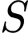-to-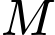 feedback | Question tested
Full MSC | First three axes | Authentic | Retained | Retained | Retained | Can material compatibility and feedback jointly generate selective, persistent capture?
Capture-only | First three axes | Authentic | Retained | Retained | Disabled | What does material-selective capture produce without persistent material-memory feedback?
Projected-1D | First axis | Authentic | Retained | Retained | Retained | Can one material coordinate reproduce the aggregate outcomes of multidimensional MSC?
Shuffled-material | First three axes | Permuted | Retained | Retained | Retained | Is cargo-to-material correspondence informative beyond the material-vector distribution itself?
Random-material | First three axes | Independent random vectors | Retained | Retained | Retained | What remains when model-used material states are independent of authentic cargo identity?
Activity-only | None | Not used by capture rules | Disabled | Disabled | Retained | Can activity and feedback reproduce the outcomes without granule-specific material compatibility?

Full MSC retained the authentic three-dimensional material representation at both the docking and productive-capture stages. Productive capture reinforced the consolidation state 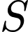, which in turn reinforced the material-memory tag 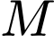, thereby increasing future docking competence while preserving material-dependent cargo selection. Capture-only retained material-selective docking, productive capture, delayed payload and consolidation dynamics, but disabled consolidation-dependent reinforcement of . The material-memory tag consequently did not contribute to the docking hazard. This variant isolated initial material-dependent selection from feedback-mediated stabilization of local capture competence. Projected-1D retained the authentic cargo-to-material mapping and the complete feedback pathway but calculated mismatch using only the first material coordinate. It was therefore a dimensionality control rather than a claim that biological material states are one-dimensional. Similar aggregate outcomes between projected-1D and full MSC would show that those outcomes alone do not establish a requirement for multidimensional material geometry. Shuffled-material preserved the complete set and multivariate distribution of material vectors but permuted their assignment across granule identities. It therefore tested whether the organized correspondence between authentic cargo identity and model-used material state was necessary. Random-material provided a stronger disruption by generating model-used material vectors independently of authentic identity. In both variants, the docking and productive-payload rules remained formally material dependent; what was disrupted was the biological organization of the material representation. Activity-only removed granule-specific material dependence by setting the docking and productive-payload compatibility factors to one. Spatial encounter, activity-dependent docking, intrinsic productive capacity, delayed reinforcement and -to- feedback remained active. This variant tested the central alternative explanation that activity and positive feedback can generate consolidation without solving the cargo-specificity problem. The control hierarchy therefore separated three questions: whether activity can generate capture, whether material compatibility improves cargo selection, and whether feedback stabilizes the consequences of selective capture.
Matched model comparisons
The primary comparison used 400 parameter-generating seeds per variant. Each parameter-generating seed defined one parameter realization that was shared across all six variants. Variant-specific deterministic simulation seeds were then used for granule initialization, transport and stochastic event sampling. Comparisons were therefore matched at the parameter-realization level but did not impose identical granule pools, trajectories or event histories across variants. Simulation-level outcomes were first calculated separately for each parameter-generating seed and variant. Full MSC was then compared with each control using within-seed differences. These comparisons included consolidation specificity, material-memory specificity, productive-capture enrichment, strong-granule docking enrichment and crosstalk. Parameter-generating seeds were treated as the independent units; individual encounters, synapses and time points within a simulation were not treated as independent replicates. Interpretation emphasized the direction and magnitude of paired effects and their uncertainty. The event-level logistic model in Fig. 2 served as a diagnostic test that simulated docking recovered the encoded positive effects of the activity tag and material-memory tag and the negative effect of material mismatch. It was not treated as an independently fitted mechanistic model.

Supplementary Note 2. Necessity of an identity-bearing variable for cargo-selective docking

Necessity of an identity-bearing variable for cargo-selective docking
We asked whether activity-dependent capture could, in principle, generate cargo enrichment without a variable that carries information about cargo identity. We show that, conditional on the granules that encounter a synapse, any identity-blind docking rule preserves the cargo composition of the encountered pool in distribution. Activity and cargo-independent feedback can alter the total amount of docking but cannot systematically enrich one cargo class beyond its local encountered availability. Material mismatch breaks this exchangeability in MSC by making docking probability granules–synapse-pair-specific. This result suggests the necessity of an identity-bearing capture variable for cargo-selective docking; it does not establish material mismatch as the unique possible biological implementation.

Model and encountered reference pool
Let index synapses, index granules, and 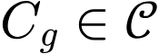 denote the cargo class of granules . The encounter gate is
The MSC docking hazard is
Here, 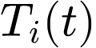 is the activity tag, 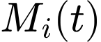 is the material-memory tag, and 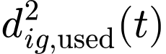 is the material mismatch supplied to the docking mechanism. If the hazard is constant during one simulation interval 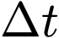, the exact finite-step docking probability is
where 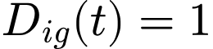 denotes a docking event during 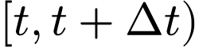 . The pre-event history 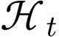​ includes previous activity, docking events, feedback, granule positions, material states, pending payloads, and current synaptic states. Conditioning on allows the argument below to remain valid within the complete dynamic feedback model. The appropriate reference distribution for cargo enrichment is the local encountered pool:
This reference separates docking-stage selectivity from cargo-dependent abundance, dendritic transport, microtubule entry, motor usage, or other processes that may already influence which granules become locally available.

Composition-preservation theorem
Theorem S2.1. Identity-blind docking preserves encountered cargo composition.
Fix synapse , time , and pre-event history . Assume that, conditional on encounter, docking is independent of cargo class:
Equivalently, assume that every represented cargo class has the same conditional docking probability,
for every 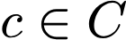 with 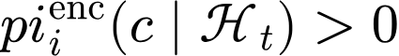. Then
Proof. Define
Bayes’ rule gives
Under the identity-blind assumption, the numerator is
By the law of total probability,
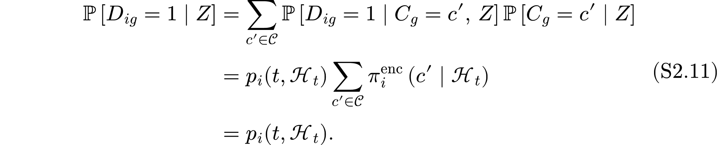
Equation S2.7 is an exact distributional statement. A finite simulation may show random deviations in empirical cargo fractions, but identity-blind docking cannot create systematic enrichment. Independence among docking events is not required for the composition result; the statement concerns the conditional distribution of cargo for a sampled docking event at fixed , , and .

Enrichment and crosstalk corollaries
Define cargo enrichment relative to the encountered pool as
Corollary S2.1. No enrichment under identity-blind docking.
For every represented cargo class,
Thus, activity and cargo-independent feedback may increase or decrease the total number of docking events, but they cannot systematically change the relative cargo composition of the docked pool.
If 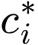​ denotes the intended cargo class for synapse , the conditional crosstalk probability under identity-blind docking is
For 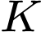 equiprobable encountered cargo classes, this reduces to
Increasing activity therefore raises the total amount of capture but does not, by itself, reduce the compositional crosstalk expected from the locally encountered pool.

Application to activity-only MSC
After removing material dependence, the activity-only MSC docking hazard is
The exact finite-timestep docking probability becomes
At fixed , , and Equation S2.17 is identical for all encountered granules. Theorem S2.1 therefore applies exactly, without requiring a small approximation. Activity and cargo-independent feedback can move the total docking probability from near zero toward saturation, but they cannot alter the relative cargo composition of the docked pool.
This establishes why activity-only capture may support postsynaptic consolidation while failing to solve the stricter problem of cargo-selective docking.

Material mismatch breaks exchangeability
Define the cargo-independent synapse factor
For two granules and 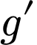 encountering the same synapse at the same time,
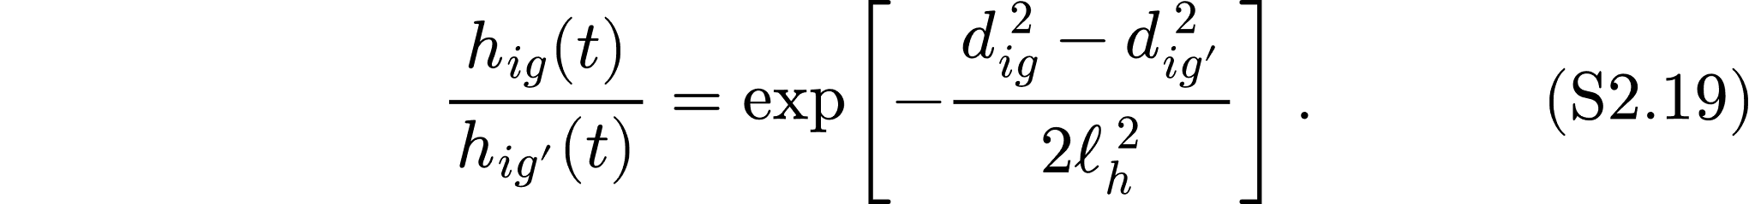
The activity- and feedback-dependent factors cancel exactly. They determine the overall capture competence of the synapse, whereas pair-specific mismatch determines relative cargo preference among encountered granules.

Writing 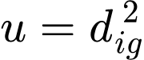​, the exact finite-timestep docking probability is
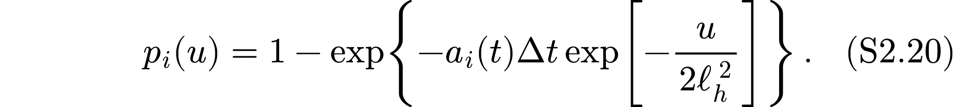
Define
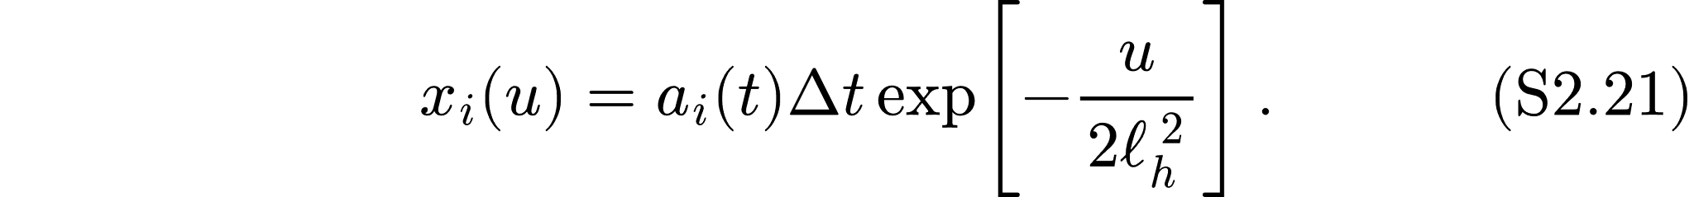
Then
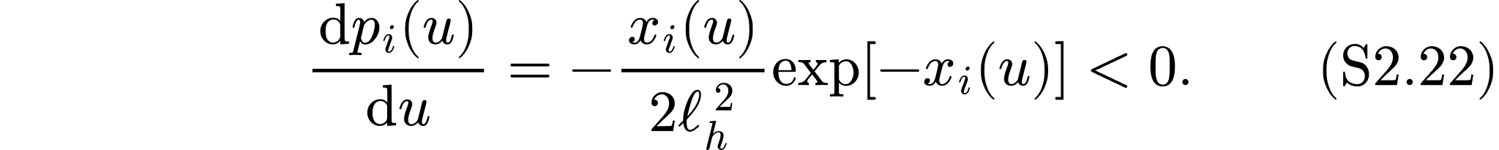
Thus, smaller material mismatch implies a larger exact finite-timestep docking probability, not merely a larger continuous-time hazard.

Exact selected-cargo distribution
Granules belonging to the same cargo class may have different material vectors and therefore different mismatch values. Define the mean docking probability for cargo class c within the encountered pool as

Bayes’ rule gives the exact finite-timestep selected-cargo distribution:

Consequently,
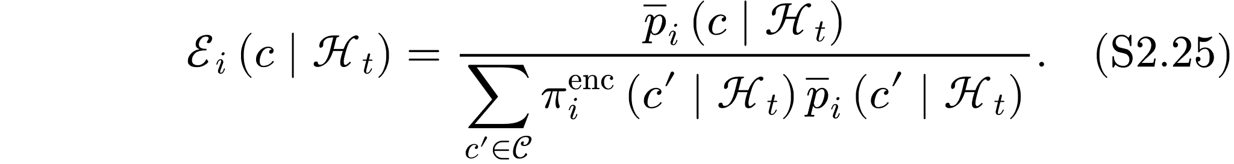
A cargo class is enriched if and only if its mean docking probability exceeds the encounter-pool mean:
Equation S2.26 provides the exact finite-timestep criterion for cargo enrichment.
When 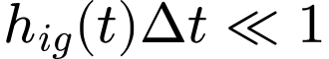,

The shared activity- and feedback-dependent factor then cancels from Equation S2.24, giving
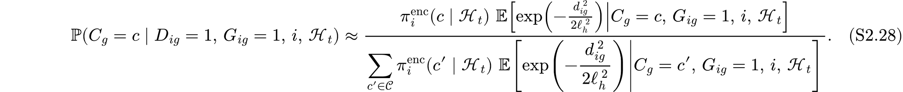

In the rare-event regime, the selected-cargo distribution is therefore proportional to encountered availability multiplied by mean material compatibility.

Scope and interpretation
The theorem proves that enrichment beyond encountered availability requires a docking variable carrying information about cargo identity. This variable need not be an explicit categorical cargo label. A continuous feature is identity-bearing whenever it covaries with cargo class and is used by the docking rule. Material mismatch is one such variable, but it is not the only possible biological implementation. Motor or adaptor identity, sequence-specific receptors, RNA-binding-protein interactions, RNA–RNA recognition, molecular modifications, or other pair-specific recognition channels could also break exchangeability. The result is pointwise in synapse, time, and pre-event history. Aggregating across synapses or histories can produce apparent compositional differences if cargo availability is correlated with context. Such differences reflect variation in the encountered reference pool and must not be interpreted as docking-stage enrichment without conditioning on encounter and context. The theorem concerns physical docking in the encounter–docking–productive-capture hierarchy. Extending the same result to productive capture requires all downstream terms to remain cargo-independent under the corresponding null model. In particular, cargo dependence in intrinsic productive capacity 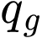​ can generate selective productivity after identity-blind docking. Docking-stage and productive-capture selectivity must therefore be analysed separately.

Supplementary Note 3 Material-state dynamics and robustness
The primary Material-Selective Capture (MSC) simulations treat the granule material vector 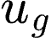​ and synaptic target vector 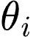​ as quasi-static during transport and capture. To test whether this assumption was load-bearing, we introduced time-dependent granule-material fluctuations, transcript-copy-number averaging, and activity-dependent movement of the postsynaptic target state.
Each granule material vector fluctuated around its birth coordinate 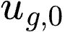​ according to the exact Ornstein–Uhlenbeck update
where 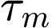​ is the material-relaxation time, 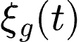 is a standard-normal random vector, and 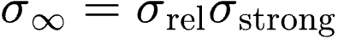 defines the stationary fluctuation amplitude relative to the within-class spread of the compatible granule population. The exact update preserves the specified stationary variance independently of ​. Drift stochasticity was drawn from a separate random-number stream, and the drift-disabled implementation was verified to be bit-identical to the original MSC simulation. Intrinsic productive capacity 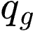​ remained fixed at granule birth, thereby separating persistent cargo identity from the instantaneous material state used during docking. This analysis therefore tests bounded fluctuations around an identity-bearing reference coordinate rather than complete loss or switching of material identity.
Material dynamics were expressed relative to the median granule–synapse encounter interval,
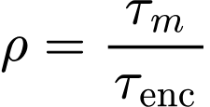
where 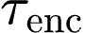​ was estimated separately for each parameter seed. Across 100 matched seeds, the median encounter interval was 14 s and ranged from 4 to 48 s. We evaluated 14 values of , from 0.003 to 300, at 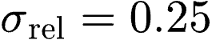, 0.5, and 1.0. Weak fluctuations preserved consolidation specificity near static MSC throughout the sweep. The minimum mean specificity was approximately 0.99 of static MSC at , 0.97 at 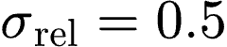, and 0.90 at 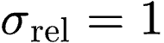. At the largest amplitude, the broad minimum occurred around 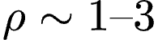, with an interpolated minimum near 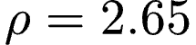, but no condition approached the random-material reference floor of 0.56 (Fig. S2A). The response therefore represents a bounded, non-monotonic sensitivity rather than a critical relaxation-time threshold. Material fluctuations affected different levels of the MSC hierarchy differently. Strong-granule enrichment at docking remained within approximately 1% of static MSC across the full sweep, whereas material-memory specificity declined to minima of approximately 0.98, 0.93, and 0.82 at increasing fluctuation amplitudes (Fig. S2B). The model therefore predicts that instantaneous compatibility filtering can remain functional while large material fluctuations weaken the temporal consistency of repeated productive capture needed to reinforce the material-memory tag 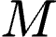. One parameter seed produced no active-synapse docking events, making docking enrichment undefined for that seed; Panel B therefore uses 99 finite seeds for docking selectivity and 100 seeds for material-memory specificity. Conditions in which the imposed material-relaxation time was shorter than the primary simulation timestep were conservatively flagged as timestep-unresolved. We therefore repeated the fast branch at half the original timestep for 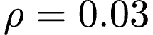, 0.1, 0.3, and 1.0. The half-timestep means were lower at the first three values, but paired half-minus-original differences were imprecise and their confidence intervals included zero at every tested (Fig. S2C). The dedicated refinement test therefore detected no statistically resolved systematic timestep effect, although uncertainty remained substantial in the fast-dynamics regime. The still-faster conditions 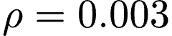 and 0.01 were not included in this refinement and remain conservatively marked as unresolved.

Copy number and PSD-target drift.
Neuronal mRNAs are frequently transported as single- or low-copy RNPs, although transcript-specific multimeric populations have also been reported (1,2). We tested 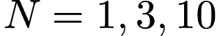 transcript copies per granule, with 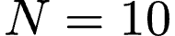 serving as an upper stress condition. Copy number reduced within-class material variation according to
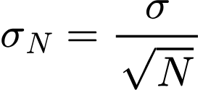
while the displacement of the weakly compatible population was held constant. This rule assumes independent transcript-level contributions and represents an upper-bound averaging model rather than an experimentally established biophysical law. Strong-granule enrichment decreased only slightly, from 1.329 at 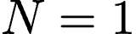 to 1.302 at 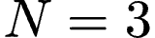 and 1.294 at (Fig. S2D). Mean consolidation specificity relative to was 1.090 at and 1.081 at , although seed-level ratios were heterogeneous and right-skewed (Fig. S2E). Copy-number averaging therefore did not impair MSC and produced a modest increase in mean consolidation specificity under the implemented assumption. We additionally allowed the synaptic target vector to move toward an activity-dependent reference state at rate 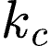​. Slow target movement was well tolerated: relative specificity remained approximately 1.00 for 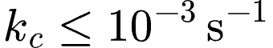. At the highest tested rate, 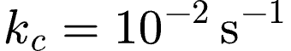, mean specificity decreased to 0.957, but its confidence interval reached the no-drift reference (Fig. S2F). The fastest target-remodelling regime therefore suggested a moderate reduction rather than a statistically resolved loss of specificity.

Supplementary Note 4. Material-space construction, material mismatch, and anti-tautology logic
Each granule was assigned an effective material vector 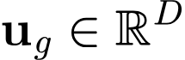, and each synapse was assigned a target material vector 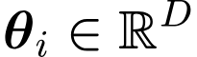. These vectors provide a coarse-grained representation of material-associated features that could arise from RNA sequence and structure, RBP composition, molecular multivalency, mobility or related condensate properties. They are dimensionless model variables rather than direct measurements of individual physical properties. Experimentally, corresponding material fingerprints could be estimated from independent measurements such as FRAP recovery, single-particle mobility, partitioning, relaxation dynamics and molecular composition, as discussed in Supplementary Note 6. The baseline model generated four coordinates for every granule and synapse. The first three coordinates formed the primary material space used by full MSC. The fourth, outcome-associated coordinate was excluded from the primary mismatch calculation to reduce circularity between material identity and downstream functional readouts. The projected-1D control used only the first coordinate. All material coordinates entered the current implementation with equal weight. For a selected set of axes 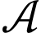, the normalized material mismatch between granule and synapse was
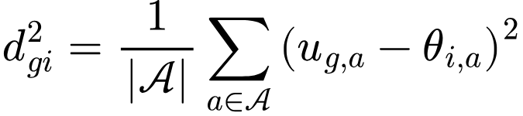
Lower 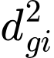​ denotes greater material compatibility. The full MSC, capture-only, shuffled-material and random-material variants used the first three axes, whereas the projected-1D variant used only the first axis. This definition is identical to the equal-weight form of the normalized weighted mismatch reported in the main Methods. Synaptic target vectors were sampled from a standard normal distribution, after which the target of the designated active synapse was set to the origin. Granules were generated from two overlapping populations: a relatively compatible population centred on the active target and a broader population displaced independently along each material coordinate. The compatible fraction, within-class variation and between-class displacement were sampled across the intervals in Supplementary Table S1. These distributions provide controlled heterogeneity in material space and should not be interpreted as two discrete biological RNP classes.
The model additionally assigned each granule an intrinsic productive capacity ​ from its authentic three-dimensional mismatch to the active-synapse target. This value was fixed when the granule pool was generated and was not recalculated when the material representation used by the capture mechanism was subsequently shuffled, randomized or allowed to fluctuate. The operational strong-granule label was assigned from the upper quantile of ​. Intrinsic productive capacity therefore represented authentic cargo quality, whereas material mismatch supplied to the capture rules determined whether that cargo was compatible docked and productively used. To test whether docking depended on the material representation supplied to the model rather than on an undeclared cargo label, we distinguished authentic and model-used material vectors. These defined
In full MSC and capture-only MSC, the authentic and model-used vectors were identical. In the shuffled-material variant, complete material vectors were permuted across granule identities, preserving their multivariate distribution while disrupting their correspondence to authentic cargo identity. In the random-material variant, model-used vectors were sampled independently from a zero-centred normal reference distribution with coordinate-wise standard deviation 1.25. In activity-only MSC, the material-compatibility factors were removed from the capture rules. A negative relationship between 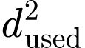 and docking is expected because model-used mismatch explicitly enters the docking mechanism. The anti-tautology analysis therefore asked whether authentic mismatch continued to predict docking after authentic and model-used material representations were separated. Event-level logistic models analysed 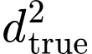 and separately and jointly while adjusting for the activity tag 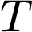, the material-memory tag where estimable, and simulation-seed effects.
After shuffling or randomization, only was supplied to the docking rule. Neither intrinsic productive capacity nor the strong-granule label independently entered the docking hazard. The intended implementation therefore predicts that , but not independently misaligned ​, should explain docking. Persistence of an authentic-mismatch effect after disruption of the cargo-to-material mapping would indicate an unintended pathway from cargo identity to docking. Conversely, loss of that association while the model-used mismatch effect remains supports the conclusion that simulated docking follows the material representation supplied to MSC rather than the original cargo label. This anti-tautology analysis validates the internal causal implementation of the model. A physical reading of this construction is available even though the present implementation does not use it. Both compartments are condensates: the postsynaptic density forms a multivalent scaffold condensate, and the transported RNP granule is itself a condensed phase. Whether an encountered granule remains associated with the PSD is therefore, in principle, a three-phase wetting problem governed by the granule/cytoplasm, PSD/cytoplasm and granule–PSD interfacial tensions, with the adhesion energy per unit contact area given by the Dupré relation . Material mismatch 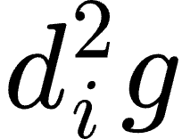 is best understood as a phenomenological stand-in for this interfacial cost, and the Gaussian docking kernel 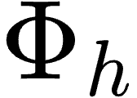 as the corresponding Boltzmann-like weight. This reading explains why compatibility is necessarily relational: W depends on both phases and their shared interface, never on either compartment alone. The mapping between 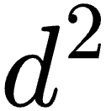 and measured interfacial tensions is not established here, and no such measurement currently exists for RNP–PSD pairs.

Supplementary Note 5. Sequence-anchored material coordinates and three-dataset evaluation of state-dependent capture
We asked whether transcript sequence features associated with condensate material properties could provide experimentally grounded inputs to Material-Selective Capture (MSC). We analysed three independent dendritic-versus-somatic datasets: Middleton (mouse, gene level), Perez (rat, gene level), and Tushev (rat, isoform level). A primary 3′UTR score combining G content and predicted rG4 density was mapped separately onto relaxation time (τ₂), elastic modulus, and mobile fraction, with fixed symmetric ME-like and WT-like anchors of ±0.83, ±0.44, and ±0.38. These mappings were specified independently of the localization outcomes. Simulations used 100 stochastic seeds for τ₂ and 30 seeds for the other two observables, and applied the same docking and productive-capture rules whose numerical implementation and selectivity benefit are validated separately in S1 and S5 Figs. Localized transcripts had higher primary G+rG4 scores than matched somatic transcripts in all three datasets (Fig. S4C): 0.32 z units (95% CI 0.19–0.45) for Middleton, 0.47 (0.31–0.65) for Perez, and 0.55 (0.41–0.70) for Tushev, all with Benjamini–Hochberg-adjusted q = 1.1 × 10⁻⁴. G content alone gave larger differences (0.48, 0.59, 0.81), and GC content the largest of all scores (0.55, 0.64, 1.01). Because G and GC content cannot be separated within 3′UTR sequence, the reproducible signal is best described as G/GC-associated compositional variation. Raw rG4 density was elevated only in the isoform-resolved Tushev dataset (0.29 z units; q = 7.0 × 10⁻⁴), consistent with feature sparsity: 91.4% of Perez 3′UTRs contained no strict rG4 motif versus 82.4% in Tushev, so the primary coordinate correlated with G content at Spearman ρ = 0.974 and 0.955. After adjustment for G content and log 3′UTR length, residual rG4 density showed no independent separation in any dataset. The 3′UTR-length control remained near zero after matching, and shuffled and random score controls were not significant anywhere after correction, with point estimates scattering between −0.15 and 0.16 z units. The reproducible sequence signal was therefore compositional and did not establish an rG4-specific contribution. When these scores were supplied to MSC, the model predicted a WT-like minus ME-like shift in relative capture preference (Fig 6D; Fig. S4D), largest along the τ₂ axis. For the primary coordinate, the shift in the log localized/soma rate ratio at physical docking was 0.046 (0.010–0.084), 0.067 (0.031–0.103), and 0.136 (0.098–0.178) for Middleton, Perez, and Tushev, rising at productive capture to 0.102 (0.044–0.166), 0.179 (0.117–0.246), and 0.226 (0.163–0.293), that is, increases of roughly 11%, 20%, and 25% in the productive-capture rate ratio. The direction was not confined to τ₂: at productive capture, the elastic-modulus and mobile-fraction mappings also reached significance in Perez (q = 0.043 and 0.045) and Tushev (q = 0.029 and 0.004), but not in Middleton. Shuffled mappings produced no consistent shift, for example 0.040 (−0.011 to 0.094; q = 0.24) in Perez and 0.001 (−0.038 to 0.038; q = 0.98) in Tushev at productive capture. The larger shifts at productive capture than at docking match the encounter–docking–productive capture hierarchy, in which the productive gate is the more selective of the two. Absolute preference fractions nonetheless remained close to 0.5, indicating relative state-dependent redistribution rather than universal enrichment: in Tushev at τ₂, localized preference moved from 0.457 to 0.509 for the primary coordinate and from 0.436 to 0.534 for G content, while the shuffled control stayed at 0.487 in both states. Two sensitivity analyses were performed on the frozen panels without repeating any simulation. Removing the 5% of pairs with the largest matching distance left every effect unchanged in sign and magnitude (for example 0.55 to 0.54 z units in Tushev). For the isoform-level dataset, where reconstructed 3′UTR length was capped at 5,000 nucleotides as a reconstruction-quality criterion applied before sequence scoring, repeating the analysis with a 10,000-nucleotide cap and without any cap gave identical estimates and retained all 250 pairs. Finally, because the PSD mapping is phenomenological, we varied the WT–ME separation from zero to twice its reference value: preferences were identical at zero separation, and across non-zero scalings authentic mappings produced predominantly positive shifts in all three datasets, largest in Tushev, whereas shuffled mappings were smaller and more variable (Fig. S4E). These results show that sequence-informed material coordinates generate reproducible, dataset-dependent capture shifts within MSC. They do not demonstrate that G-rich sequences determine granule material state or synaptic localization; testing that will require joint measurements of 3′UTR sequence, granule material properties, synaptic docking, and productive local translation.

Supplementary Note 6 experimental tests and falsification criteria

Material-Selective Capture predicts that synaptic activity determines when capture is permitted, whereas compatibility between RNA-granule and postsynaptic material states influences which encountered granules dock and become productive. The sensitivity analyses above further predict that encounter availability and activity-dependent docking primarily control whether consolidation emerges, whereas material-space organization controls the composition of captured cargo. Testing these predictions requires material-associated properties to be measured independently of capture. An in-vitro assay could combine RNP-like granules of defined RNA and RBP composition with reconstituted PSD condensates spanning controlled material states. FRAP, single-particle mobility, partitioning and relaxation measurements could define empirical material fingerprints for each compartment before their interaction is assessed.Interfacial characterization would be the most informative addition: contact-angle analysis of reconstituted PSD and RNP droplets in contact, combined with micropipette aspiration or optical-tweezer-induced fusion for the individual tensions, would convert the model's abstract mismatch coordinate into a measured adhesion energy. PSD (3–5) states could be perturbed through scaffold composition or Shank3 oligomerization, which has been shown to alter PSD-condensate elasticity, molecular exchange and network relaxation (3–5). MSC predicts a pair-specific relationship in which retention or interfacial dwell time depends on relative material compatibility, rather than one granule or PSD state being universally preferred. In cultured neurons, live RNP tracking could be combined with local spine stimulation, PSD labelling and a local translation reporter. Previous studies established that 3′UTRs can regulate neuronal RNA transport and activity-dependent synaptic recruitment, and that glutamate uncaging can induce RNA capture and translation at individual spines (6,7). Events should be separated into encounter, persistent docking and productive capture. Conditional on encounter, independently measured material mismatch should predict docking beyond activity, particle abundance and transport dynamics. Causal tests should compare 3′UTR or RBP perturbations that alter the measured granule material state with perturbations that alter dendritic targeting but leave material-associated observables approximately unchanged. RNA G content and G-quadruplex propensity provide candidate perturbations because they can modify condensate viscosity and molecular dynamics, although their effects on localization, stability and RBP binding must be measured separately (8). Orthogonal perturbation of the PSD material state should produce a granule-by-PSD interaction rather than a uniform change across all cargo classes. MSC would be weakened if material mismatch failed to predict docking after controlling for activity and encounter frequency, if PSD perturbations affected all cargo classes equally, or if docking followed sequence identity independently of measured material state.

Supplementary Note 7. Model architecture and simulation workflow
The Material-Selective Capture (MSC) model is a coarse-grained stochastic representation of RNA–protein granule transport, synaptic encounter, physical docking, productive capture, and delayed postsynaptic reinforcement. It was designed to test whether transient activity-dependent eligibility and material compatibility can jointly generate selective cargo retention at individual synapses. The model represents these processes through effective state variables and stochastic transition rules rather than explicit molecular binding reactions, condensate thermodynamics, or translation kinetics. MSC distinguishes three nested event classes. An encounter opportunity occurs when a granule–synapse pair lies within the capture radius during a simulation step. Conditional on encounter, physical docking is sampled from a continuous-time hazard controlled by the activity tag 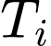​, material-memory tag 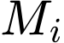, and material mismatch 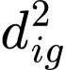​. Docked granules subsequently pass through a narrower compatibility-dependent productivity gate. Only productive-capture events enter the delayed-payload queue and subsequently reinforce the consolidation state 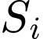​.
The conceptual causal sequence is
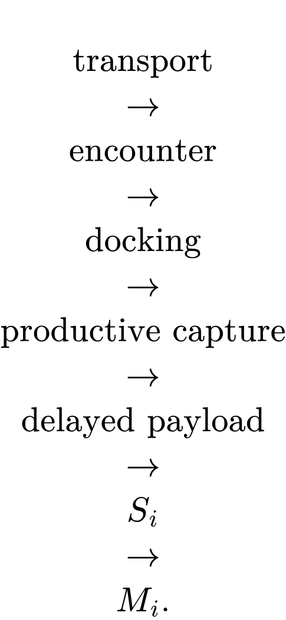
This sequence describes the causal organization of the model rather than the line-by-line numerical update order. The implemented update order, including delivery of previously queued payloads, state-variable integration, granule movement, encounter detection, and event sampling, is specified below and summarized in Fig 1. The activity tag determines when a synapse is capture-permissive but does not encode granule identity. Material mismatch determines which encountered granules are preferentially docked and productively used. Consolidation-dependent reinforcement of subsequently modifies future docking competence through the coupled pathway
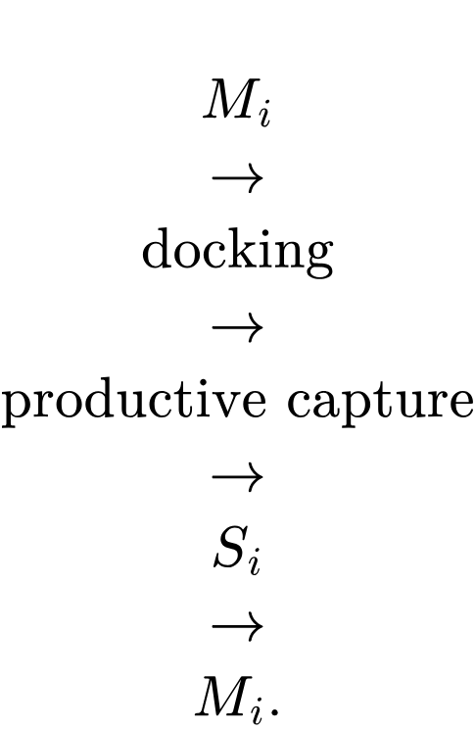
This feedback increases local capture competence but does not replace the material-compatibility filter. Consequently, activity, material selectivity, and feedback perform distinct roles: activity establishes eligibility, material mismatch provides cargo selectivity, and feedback stabilizes the consequences of previous productive capture.

Supplementary Note 8. stochastic encounter and docking model
The MSC model separates spatial encounters from physical docking. Granule transport first determines which granule–synapse pairs are spatially eligible. Conditional on encounter, the activity tag ​, material-memory tag 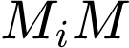, and model-used material mismatch 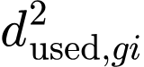 determine a continuous-time docking hazard. The hazard is then converted into a finite-step probability and sampled as a binary docking event.
Granule transport
The dendrite was represented as a one-dimensional domain of length 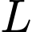. The 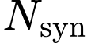​ synapses were positioned evenly within the domain, and granule positions were initialized independently from a uniform distribution over 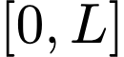.
Each granule moved according to a persistent drift–diffusion process:
where 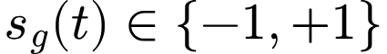 is the transport direction, v is the directed transport speed, and  is the effective diffusion coefficient. Following each movement update, the direction was reversed with probability 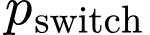 per timestep. Reflecting boundaries constrained all granules to ; a boundary crossing reflected the position into the domain and reversed the transport direction. This transport rule provides heterogeneous encounter opportunities but does not itself contain activity- or material-dependent targeting. Consequently, transport controls where and when capture can be attempted, whereas the subsequent docking rule determines whether an eligible encounter becomes a physical-docking event.

Encounter opportunities
For granule and synapse , the binary encounter gate was:
where is the encounter radius and 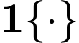 is the indicator function. An encounter opportunity was therefore defined as one eligible granule–synapse pair during one simulation timestep. A granule that remained within the encounter radius for several consecutive steps contributed multiple encounter opportunities. These observations represent repeated evaluations of the finite-step docking probability and should not be interpreted as independent granule–synapse contact episodes. The reported encounter-to-docking conversion therefore denotes the probability of a simulated docking transition per eligible granule–synapse pair-step, rather than the probability of docking per unique physical visit. Biologically, this transition is intended as a coarse-grained proxy for persistent spine-proximal retention or interfacial association, not as an explicit simulation of binding or dwell-time kinetics. Within the configured parameter ranges, neighbouring synaptic encounter zones did not overlap. A granule could therefore be spatially eligible for at most one synapse at a given timestep, and no additional competition rule was required to resolve simultaneous synaptic candidates.
Docking compatibility
For each eligible pair, the model calculated material mismatch from the material representation assigned to the corresponding model variant. The docking-compatibility factor was:
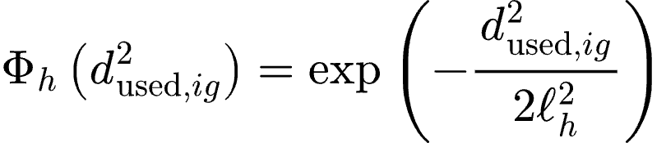
The Gaussian compatibility term is a phenomenological filter. It represents a graded decrease in docking competence with increasing material mismatch but is not intended as a microscopic thermodynamic potential or binding-energy calculation.

Continuous-time docking hazard
Conditional on encounter, the docking hazard was:
where 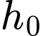​ is the basal docking hazard during an encounter, 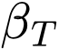​ determines the effect of the activity tag, and 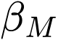 determines the effect of the material-memory tag. The encounter gate ensures that 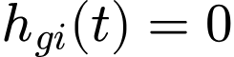 outside the synaptic capture region. Activity and material memory increase docking competence, whereas increasing material mismatch decreases the hazard through 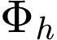​. In the implementation, the exponential activity-feedback term was capped at an exponent of 20 as a numerical safeguard. This bound was not approached within the configured parameter intervals and therefore did not affect the reported simulations. In capture-only MSC, feedback was disabled and ​ did not contribute to the docking hazard. The complete variant definitions are provided in Supplementary Note 1.
Finite-step event sampling
Assuming that the hazard remained constant during one timestep, the probability of at least one docking event was:
A sampled docking event was recorded but did not permanently remove or immobilize the granule. Granule movement continued during the next timestep, permitting repeated capture opportunities over the simulation. In the model docking should therefore be interpreted as a stochastic event-level transition representing stable capture at the resolution of the coarse-grained model, rather than an explicit simulation of a bound-state trajectory or molecular dwell time. Productive capture and delayed reinforcement were evaluated only after docking and are defined in Supplementary Note 9. When encounter-level observations were retained for diagnostic analyses, a maximum of 5,000 observations per simulation was stored using reservoir sampling. This procedure limited memory use while maintaining an approximately uniform sample of eligible pair-steps. It affected only the stored observation table and did not alter transport, docking, productive capture, or state dynamics. Binned and synapse-stratified validation analyses are shown in Fig. S1.

Supplementary Note 9. productive capture and synaptic-state dynamics
Physical docking did not necessarily produce a functional postsynaptic consequence. The model therefore applied a second compatibility-dependent filter after docking. Only productive-capture events entered the delayed-payload queue and subsequently reinforced the consolidation state ​. This separation permits frequent spatial encounters, rare physical docking and a distinct probability that a docked event becomes productive.
Productive capture
Each granule carried a fixed intrinsic productive capacity ​, defined from its authentic material identity as described in Supplementary Note 4. For a docking event involving granule and synapse , the effective payload was:
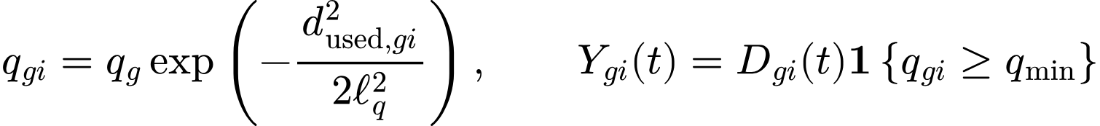
where 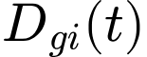 denotes physical docking, is the model-used material mismatch, 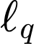​ is the productive-payload compatibility width, and 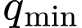​ is the productivity threshold. The binary variable 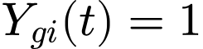 denotes productive capture.
The productive-payload width was narrower than the docking width, 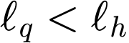. Productive capture therefore imposed a stricter compatibility requirement than physical docking. In activity-only MSC, the material-dependent exponential factor was set to one, so the effective payload was reduced to 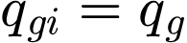​. The threshold is an operational model assumption rather than a molecularly derived discontinuity. Productive capture should likewise be interpreted as a coarse-grained transition linking docking to delayed functional reinforcement. It does not identify a specific molecular step such as granule fusion, mRNA release, translation initiation or protein incorporation.

Delayed-payload queue
When , an input of magnitude 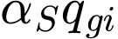 was scheduled for delivery to synapse after the translation delay 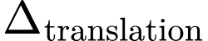. The delay represents the combined interval between capture and a measurable functional consequence, potentially including granule remodelling, transcript accessibility, translation initiation, reporter maturation, local trafficking and incorporation of the translated product. Computationally, delays were implemented using a pending-input queue. The delay in simulation steps was:
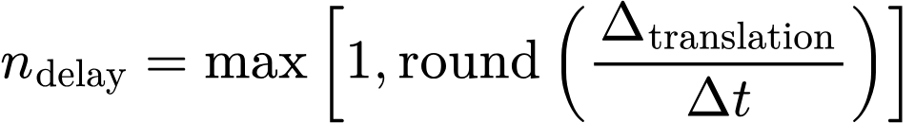
Productive events were added to the queue position 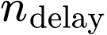 steps after docking. Events whose delivery time fell beyond the simulated observation period did not contribute to the reported late-state readouts.
Activity tag
The activity tag 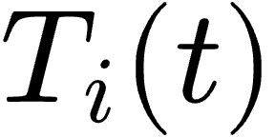 represented a transient capture-permissive state generated by recent synaptic activation. Its continuous-time dynamics were:
where 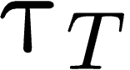 is the activity-tag decay timescale, 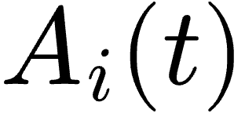 is the activation input to synapse i, which is non-zero only at the stimulation times defined by the protocol, 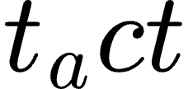 is an activation time, and 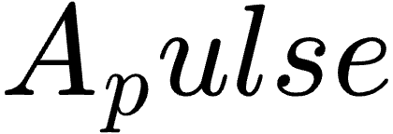 is the amplitude of a single activation pulse. The tag was capped at unity, so repeated stimulation within one decay interval saturated rather than accumulated without bound.In the stepped-drive protocol used for Fig 4,  was instead clamped to the current drive amplitude at every timestep for the stimulated synapse, so that each plateau held activity constant while all remaining state variables evolved normally.

Consolidation state
The consolidation state 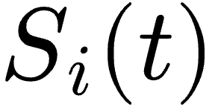 accumulated the delayed functional consequences of productive capture and decayed in their absence:
where 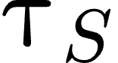 is the consolidation-state decay timescale,  is the set of productive-capture events at synapse 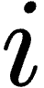, 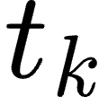 is the docking time of event k, Δ is the translation delay defined above, 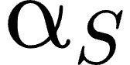 is the payload gain, 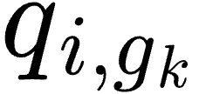 is the effective productive payload of event k, and 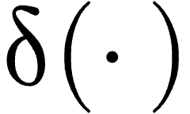 denotes an impulse at the delayed delivery time 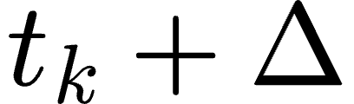. The consolidation state is an effective functional variable, not the concentration of a particular protein. It summarizes the accumulated consequences of productive capture and delayed local payload delivery. Repeated productive events can maintain or increase ​, whereas isolated events decay on the timescale 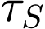​. Nonproductive docking events do not contribute to ​.
Material-memory tag
The material-memory tag represented a slower synaptic state through which prior productive capture modified subsequent docking competence:
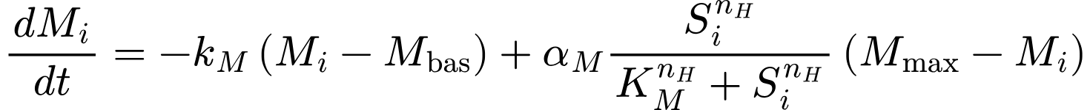
The first term relaxes toward the basal state 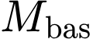 at rate 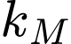​. The second term reinforces as a nonlinear function of the consolidation state. Here, 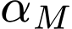 is the maximum reinforcement rate, 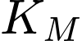​ is the half-activation level, 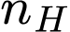 is the Hill coefficient, and ​ is the upper bound approached under sustained reinforcement. The material-memory tag is distinct from the synaptic target vector 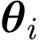​. In the baseline model, changes the overall docking competence of synapse through the coefficient , but it does not encode granule identity or move the synaptic target in material space. Material mismatch therefore remains necessary for cargo selectivity. Activity-dependent movement of was considered only as a separate robustness analysis in Supplementary Note 3.
The feedback loop is consequently
productive capture⟶ 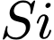 ⟶ 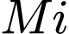 ​⟶increased future docking competence.
Because ​ increases general docking competence rather than encoding cargo identity, feedback cannot replace the material-compatibility filter. Instead, it stabilizes the local consequences of previous compatible productive capture. This architecture allows the model to generate threshold-like responses and history dependence without imposing an explicit binary state switch.
Discrete implementation
At initialization, 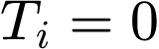, 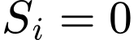, and , and the delayed-input queue was empty. During each simulation step, the previously scheduled payload was first delivered to ​. The consolidation state was then decayed, ​ was updated from the current value of , and the activity tag was decayed. Granule movement, encounter detection, docking and scheduling of new productive inputs were subsequently evaluated. The , , and states were clipped to 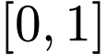 after their respective updates. The implementation used explicit finite-step updates with 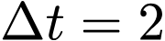 s. Timestep robustness was evaluated separately in the supplementary numerical controls. In capture-only MSC, consolidation-dependent reinforcement of was disabled and did not enter the docking hazard. The remaining productive-capture, delayed-payload and consolidation-state rules were retained. Complete variant definitions are provided in Supplementary Note 1.

Supplementary Table S1. sampled model parameters
Table S1. Parameter-sampling intervals for the Material-Selective Capture model.
The table reports the prespecified intervals from which 27 model parameters were independently sampled across stochastic parameter seeds. Continuous parameters were sampled from uniform distributions, whereas and were sampled as inclusive integers. Parameters classified as literature-motivated were constrained by experimentally reported timescales or biological processes where a defensible correspondence was available; this classification does not imply direct measurement or quantitative calibration of the model parameter. Parameters lacking a direct experimental equivalent were treated as phenomenological. Their intervals were selected to span plausible dynamical regimes, and the robustness of the principal MSC predictions across these intervals is evaluated by global and targeted sensitivity analyses in Fig. S3 Spatial quantities remain expressed in model-distance units and are not converted to physical units without an explicit spatial calibration.

No. | Code name | Symbol | Definition and units | Sampling interval | Calibration status | Interpretation and basis
1 | L | L | Length of the one-dimensional transport domain; model-distance units | 80–180 | Numerical design | Controls transport extent, derived granule number, inter-site spacing, and encounter supply. No conversion to micrometres is imposed.
2 | Nsyn | N_syn | Number of candidate capture sites distributed along the modeled domain; integer | 18–35 | Numerical design | Represents a reduced set of modeled capture sites, not all anatomical synapses or dendritic spines. Sampled as an inclusive integer.
3 | granule_density | g | Granule density per model-distance unit | 0.60–1.30 | Numerical design | Controls granule supply through N_gran = max[10, round(Lg)]. No direct experimental granule-density equivalence is claimed.
4 | v | v | Magnitude of directed granule drift; model-distance units s⁻¹ | 0.05–0.30 | Qualitatively literature-motivated; numerically phenomenological | Motivated by microtubule-dependent, bidirectional dendritic transport of RNA-containing granules. Because distance is uncalibrated, reported physical velocities motivate the process and timescale order but do not directly set this interval (9).
5 | D | D | Effective diffusion coefficient; model-distance units² s⁻¹ | 0.005–0.15 | Phenomenological | Coarse-grains diffusive, locally corralled, and unresolved stochastic motion in addition to directed drift. It is not interpreted as a measured molecular diffusion coefficient.
6 | pswitch | p_switch | Probability of reversing transport direction during one 2-s timestep | 0.002–0.040 per timestep | Qualitatively literature-motivated; numerically phenomenological | Motivated by bidirectional and saltatory dendritic RNP transport. The interval corresponds to approximate geometric mean persistence times of 50–1000 s, but is not directly fitted to reversal-time data (9).
7 | epsilon | ε | Encounter half-width around each modeled capture site; model-distance units | 0.20–0.80 | Geometrically motivated; uncalibrated | PSD dimensions motivate a spatially localized capture region. ε is a one-dimensional encounter half-width and is not equated with PSD radius or diameter; the interval remains small relative to modeled inter-site spacing (9–11).
8 | h0 | h₀ | Basal docking hazard during an eligible encounter; s⁻¹ | 0.0005–0.0025 | Phenomenological kinetic parameter | Controls encounter-to-docking conversion. At Δt = 2 s, the unmodulated per-step docking probability 1 − exp(−h₀Δt) is approximately 0.001–0.005.
9 | betaT | β_T | Activity-tag coefficient in the exponential docking hazard; dimensionless | 2.0–3.8 | Phenomenological | Effective activity gain controlling how strongly the transient eligibility tag increases docking hazard; no direct experimental coefficient is claimed.
10 | betaM | β_M | Material-memory coefficient in the exponential docking hazard; dimensionless | 1.0–3.0 | Phenomenological | Effective feedback gain controlling how strongly the material-memory state increases future docking competence; no direct experimental coefficient is claimed.
11 | ellh | ℓ_h | Width of the Gaussian material-compatibility kernel for docking; normalized material-space units | 1.0–2.2 | Phenomenological with qualitative molecular motivation | Defines the tolerance of physical docking to material mismatch. RNA composition and structure can tune condensate dynamics, motivating a graded compatibility term, but neither the Gaussian form nor this numerical interval is experimentally calibrated (8).
12 | ellqratio | ℓ_q/ℓ_h | Ratio of productive-payload selectivity width to docking selectivity width; dimensionless | 0.35–0.75 | Structural/phenomenological assumption | Enforces ℓ_q < ℓ_h, so productive capture is more selective than physical docking. This is a mechanistic hierarchy assumption rather than a directly measured ratio.
13 | alphaS | α_S | Gain converting compatibility-weighted productive payload into an increment of S; normalized S units per event | 0.025–0.080 | Phenomenological | Controls the effective postsynaptic reinforcement delivered by each productive event. S is an effective state, not a measured molecular concentration.
14 | qmin | q_min | Minimum compatibility-weighted payload required to classify a docked event as productive; normalized payload units | 0.10–0.25 | Operational/phenomenological | Defines the operational productivity threshold. It should not be interpreted as a molecularly discontinuous biochemical threshold.
15 | tauT | τ_T | Exponential decay time of the transient activity tag T; s | 900–3600 s (15–60 min) | Literature-constrained timescale | Synaptic tags are transient and decay over tens of minutes to hours. The model samples the earlier portion of the experimentally supported range (12,13).
16 | tauS | τ_S | Passive decay time of the consolidation state S; s | 1200–7200 s (20–120 min) | Literature-motivated effective timescale | Motivated by minute-to-hour persistence of activity-induced RNA retention and local translation. S is an effective functional state and is not directly identified with RNA or protein abundance (6).
17 | deltatranslation | Δ_translation | Delay between productive capture and delivery of reinforcement to S; s | 300–900 s (5–15 min) | Literature-motivated effective delay | Coarse-grains granule remodeling, RNA accessibility, translation initiation, reporter maturation, local trafficking, and functional incorporation. The interval is motivated by activity-induced RNA accumulation and local translation on approximately 10–15-min timescales (6).
18 | Mbas | M_bas | Basal level toward which the material-memory state relaxes; normalized state units | 0.02–0.12 | Phenomenological with qualitative PSD motivation | Provides a nonzero basal capture-competence state. Tunable and reversible PSD material organization motivates the state concept, but not this numerical interval (5).
19 | Mmax | M_max | Upper bound of the normalized material-memory state | 0.85–1.00 | Phenomenological saturation bound | Numerical upper bound on M under sustained reinforcement. PSD scaffold-network percolation motivates tunability and saturation qualitatively, not the value of M_max (5).
20 | kM | k_M | Relaxation rate of M toward M_bas; s⁻¹ | 0.00015–0.0012 s⁻¹ | Phenomenological slow-state rate | Corresponds to relaxation times 1/k_M of approximately 833–6667 s (14–111 min). No direct molecular identity or measured decay rate is assigned to M (5).
21 | alphaM | α_M | Maximum Hill-dependent reinforcement rate of M; s⁻¹ | 0.0015–0.010 s⁻¹ | Phenomenological feedback rate | Controls reinforcement of M by S. The reciprocal maximum-rate scale is approximately 100–667 s, but realized dynamics also depend on S, K_M, n_H, M_max, and k_M (5).
22 | KM | K_M | Value of S producing half-maximal Hill activation of M reinforcement; normalized S units | 0.40–0.65 | Phenomenological threshold | Sets the effective activation midpoint of the S-to-M feedback pathway; it is not identified with a measured biochemical dissociation constant.
23 | nhill | n_H | Hill coefficient governing feedback cooperativity; integer | 3–6 | Phenomenological cooperativity parameter | Produces graded threshold-like feedback and history dependence. A Hill term alone does not establish bistability or a specific molecular stoichiometry. Sampled as an inclusive integer.
24 | strongfraction | f_strong | Fraction of granules sampled from the relatively compatible material population | 0.35–0.60 | Phenomenological supply-composition parameter | Controls the composition of the synthetic heterogeneous granule pool. The two overlapping populations are not claimed to be discrete biological RNP classes.
25 | strongsigma | σ_strong | Standard deviation of each coordinate in the relatively compatible population; normalized material-space units | 0.18–0.42 | Phenomenological material-space heterogeneity | Controls within-population dispersion around the active-synapse target. No direct experimental variance is claimed.
26 | weakshift | Δ_weak | Absolute displacement of each coordinate in the less-compatible population; normalized material-space units | 1.2–2.4 | Phenomenological material-space separation | Controls separation between relatively compatible and less-compatible granules. The interval is an effective discrimination range, not a measured physical distance.
27 | weaksigma | σ_weak | Standard deviation of each coordinate in the less-compatible population; normalized material-space units | 0.65–1.10 | Phenomenological material-space heterogeneity | Controls heterogeneity of the less-compatible population. No direct experimental variance is claimed.
Table S1. Parameter-sampling intervals for the Material-Selective Capture model.

Supplementary Table S2. Fixed and derived quantities
Table S2. Fixed simulation settings and quantities derived from the sampled parameters.
The table reports simulation settings held constant across the baseline MSC simulations and quantities calculated deterministically from the sampled parameters in Table S1. Fixed settings define the numerical implementation, activation protocol, observation windows, and operational readout thresholds; they were not independently varied across parameter seeds. Derived quantities, including the number of granules 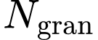 and productive-capture kernel width ​, were calculated from the sampled parameter set according to the rules specified below and therefore do not constitute additional free parameters. The baseline simulation duration was 3600 s, whereas the Figure 4 hysteresis protocol used a protocol-specific duration of 4200 s. Numerical resolution of the dynamic-material analysis was evaluated by timestep refinement in Fig. S2C , whereas sensitivity to the 27 sampled model parameters is reported in Fig. S3 .

Code name | Symbol | Code- value | Status and explanation
D_material | Dmaterial | 4 | Four material coordinates are generated for each granule and synapse. In the full MSC model, the code uses primary3, i.e., the first three axes, to compute d2; the fourth outcome-related axis is excluded from the primary mismatch calculation to reduce circularity.
dt | t | 2.0 s | Fixed integration timestep. Timestep resolution was evaluated for the dynamic-material analysis in S2C Fig.
T_total | Ttotal | 3600 s in the baseline configuration | Baseline duration specified in config_msc_feedback.yaml and DEFAULT_FIXED. The archived Figure 4 hysteresis parameter file uses 4200 s; this is a protocol-specific override and should be stated explicitly rather than treated as a contradiction.
activation_time | tact | 120 s | Time at which the activity pulse is applied.
activation_amp | A | 1.0 | Baseline activity-pulse amplitude. Figure 4 overrides/scans this input to generate ascending and descending hysteresis branches.
late_window | Tlate | 600 s | Final time window used to compute late-state readouts.
S_threshold | Sthr | 0.60 | Operational threshold for binary consolidation readouts; continuous S remains the primary state variable.
M_threshold | Mthr | 0.50 | Operational threshold for binary material-memory readouts; continuous M remains the primary state variable.
cargo_ell | ℓextcargo | 1.0 | Fixed width used to convert material mismatch to intrinsic granule productive capacity qg.
max_obs_per_run | — | 5000 | Maximum number of encounter-level observations retained per run by reservoir sampling; numerical/storage setting.
Derived Ngran | Ngran | max[10,round(Lg)] | Derived from sampled dendritic length and granule density; not independently sampled. Given the configured intervals, the theoretical range is approximately 48–234 granules before rounding and the lower safeguard.
Derived ell_q | ℓq | max[0.05,ℓh(ℓq/ℓh)] | Productive-payload kernel width derived from ell_h and ell_q_ratio; not independently sampled. The theoretical range from the configured intervals is 0.35–1.65 normalized material units.
Active synapse set | — | Central synapse by default | If no active-synapse list is supplied, the code activates Nsyn // 2.
Boundary condition | — | Reflecting at 0 and L | Granules crossing a dendritic boundary are reflected and reverse direction.
State bounds | — | T,S,M[0,1] | State variables are clipped to the unit interval after numerical updates.
Table S2. Fixed simulation settings and quantities derived from the sampled parameters.

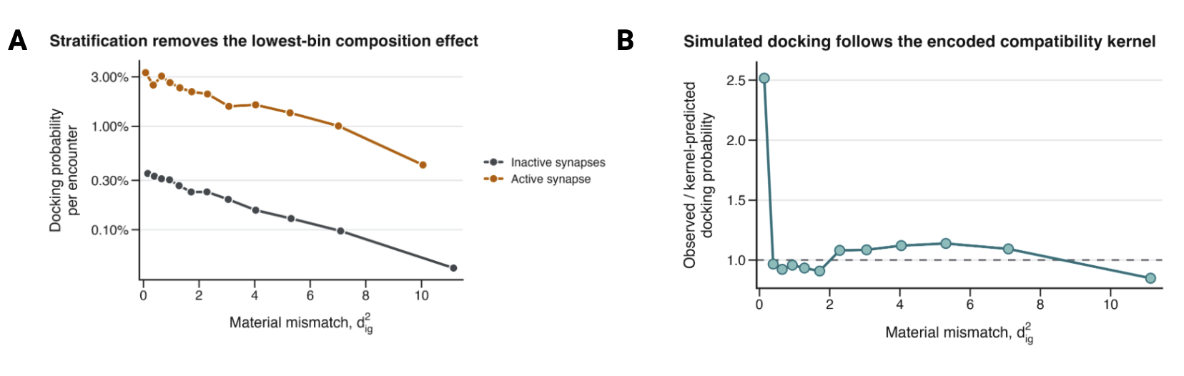

S1 Fig. Stratified and kernel-based validation of the MSC docking implementation.
(A) Docking probability per encounter opportunity as a function of model-used material mismatch 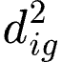​, stratified by synapse state. Both active and inactive synapses retain a monotonic decrease in docking probability with increasing mismatch. The active synapse shows a higher absolute docking probability because its activity tag 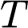 and material-memory tag 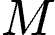 increase docking competence independently of material mismatch. The lowest-mismatch bin of the pooled Fig. 2A curve is enriched for active-synapse encounters; stratification therefore removes the corresponding composition effect. (B) Ratio of observed docking probability to the docking probability predicted from a log-linear fit across mismatch bins 2–12. Values near one indicate agreement between simulated event frequencies and the encoded Gaussian compatibility kernel. The first bin lies above the fitted kernel expectation because it contains a disproportionate contribution from active-synapse encounters.
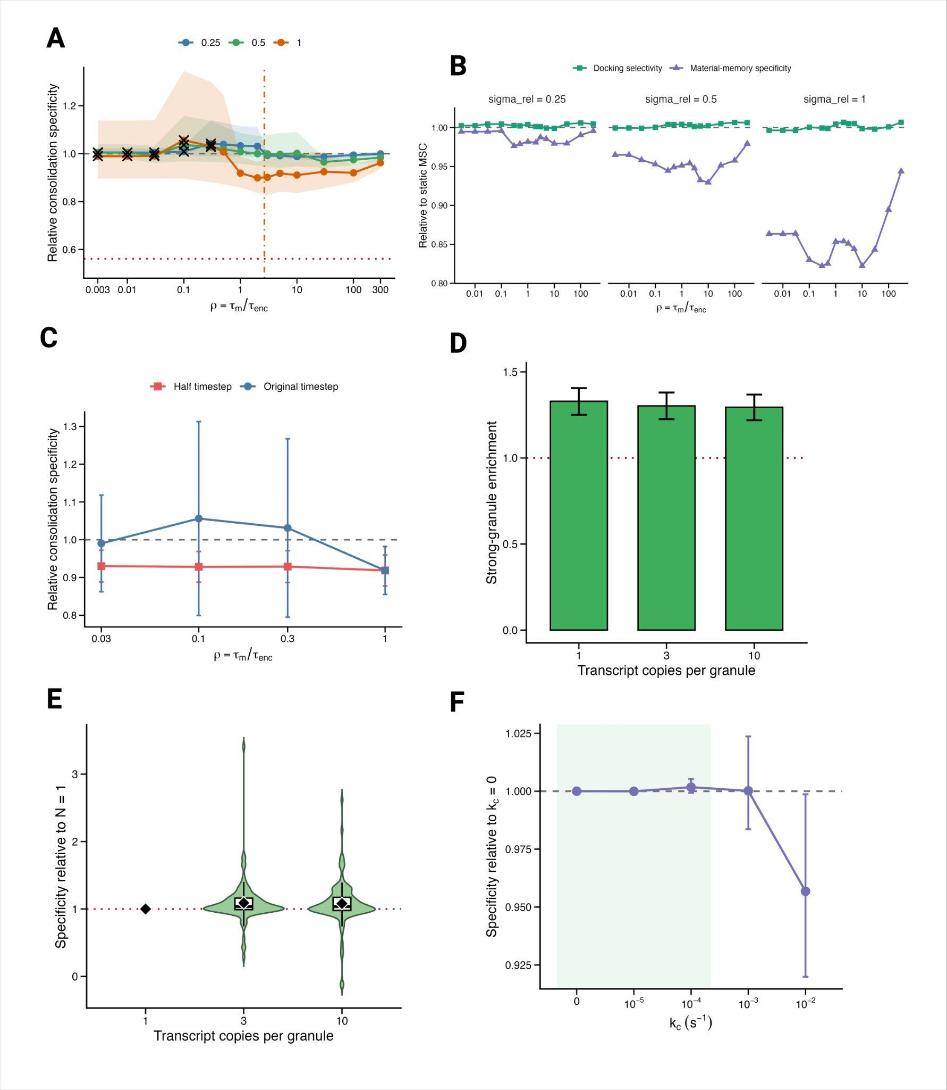

S2 Fig. Time-varying material states preserve MSC within a bounded dynamic regime.
(A) Consolidation specificity normalized within seed to static MSC across 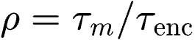​ at three stationary fluctuation amplitudes. Shading shows paired-bootstrap 95% confidence intervals; crosses mark conditions conservatively flagged as timestep-unresolved. Horizontal lines denote static MSC and the random-material floor; the vertical dot-dashed line marks the interpolated minimum for 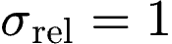. (B) Docking-stage strong-granule enrichment and material-memory specificity normalized to static MSC. (C) Timestep-refinement control at , comparing the original and half timesteps; error bars show approximate 95% intervals. (D) Strong-granule enrichment for 1, 3, or 10 transcript copies per granule under the 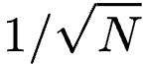 averaging assumption. (E) Paired within-seed consolidation specificity relative to 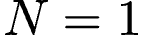; violins show seed distributions, boxes show medians and interquartile ranges, and diamonds indicate means. (F) Consolidation specificity under activity-dependent PSD-target drift, normalized within seed to 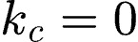; shading marks the low-drift regime. Panels A–E use 100 matched parameter seeds and panel F uses 50. Panel B docking enrichment uses 99 finite seeds because one seed produced no active-synapse docking events. Error bars in D and F show seed-bootstrap 95% confidence intervals
Global and targeted parameter sensitivity
The dynamic-material analyses tested whether time-dependent material states disrupted MSC under otherwise controlled parameter configurations. We next asked how the principal model outcomes varied across the complete prespecified parameter space. We sampled 500 parameter sets across all 27 parameters listed in Supplementary Table S1 and evaluated each parameter set using four stochastic replicates. Replicate-level outcomes were averaged within the parameter set before sensitivity estimation. Partial rank correlation coefficients quantified monotonic parameter–outcome associations while controlling for the remaining sampled parameters (Fig. S3A–C ). MSC outcomes varied across the sampled parameter space rather than emerging uniformly from every parameter combination. This variation followed the organization of the model. Consolidation specificity was most strongly associated with the activity-tag coefficient ​, basal docking hazard , activity-tag lifetime 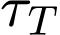​, encounter radius , and consolidation gain 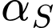, with PRCCs of 0.73, 0.67, 0.60, 0.59, and 0.48, respectively (Fig. S3A–C ). Granule density, the consolidation-state lifetime ​, and the material-memory coefficient produced additional positive associations. By contrast, dendritic length, synapse number, transport velocity, effective diffusion, direction-switching probability, and translation delay showed comparatively weak independent associations with consolidation specificity across their tested intervals. Parameters controlling material-space geometry preferentially affected captured-cargo composition. Broadening the docking-compatibility kernel through increasing 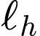​ reduced compatible-class enrichment, with a PRCC of −0.68, consistent with weaker material discrimination. Increasing the displacement of the incompatible granule population increased compatible-class enrichment and productive-payload enrichment, with PRCCs of 0.60 and 0.79, respectively. Productive-payload enrichment also increased with 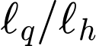, whereas increasing the within-class dispersion of the compatible population reduced productive enrichment. Thus, parameters controlling capture availability and reinforcement primarily determined whether consolidation developed, whereas material-space parameters more directly controlled which granules were preferentially captured. We next generated targeted one-parameter profiles to verify the direction and shape of selected global associations. All other parameters were held at a common reference configuration, and each parameter value was evaluated using 30 stochastic replicates. Increasing , ​, ​, and ​ increased consolidation and material-memory specificity across their prespecified intervals (Fig. S3D). Increasing the material-memory reinforcement rate ​ preferentially increased material-memory specificity, whereas increasing the material-memory relaxation rate ​ or Hill half-activation level ​ reduced it. Increasing ​ reduced productive-payload enrichment, while increasing increased it. The productivity threshold ​ produced comparatively small changes over its tested interval. Hill cooperativity revealed a trade-off between late-state specificity and history dependence. Under the transient-pulse protocol, increasing from 3 to 6 modestly reduced consolidation specificity and material-memory specificity (Fig. S3E). Under a sequential amplitude-step protocol, in which 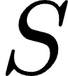 and 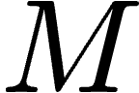 were carried over between activation steps, integrated branch separation increased from 0.31 to 0.46 for and from 0.23 to 0.45 for (Fig. S3F). Greater feedback cooperativity therefore strengthened history dependence without uniformly improving specificity under transient stimulation. Together, these analyses identify a bounded dynamical regime for Material-Selective Capture: selective consolidation requires sufficient encounter supply, activity-dependent docking, and productive reinforcement, whereas captured-cargo composition depends more directly on material-space organization and compatibility-filter width.Because several parameter intervals remain phenomenological, these associations should be interpreted as computational. More broadly, global and targeted sensitivity analyses showed that MSC outcomes varied across a bounded parameter regime, with encounter supply and activity-dependent docking primarily controlling consolidation magnitude and material-space parameters preferentially controlling captured-cargo composition (Fig. S3A–D).
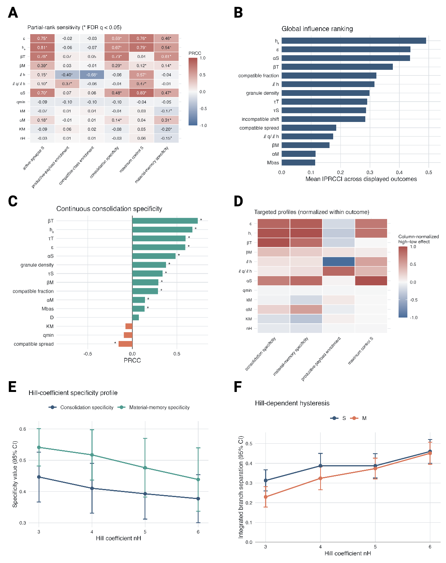
S3 Fig. . Global and targeted sensitivity analyses identify distinct control of consolidation, cargo composition, and history dependence.
(A) Partial rank correlation coefficients for selected model parameters and six MSC outcomes across 500 globally sampled parameter sets. Each parameter set was evaluated using four stochastic replicates, which were averaged before analysis. PRCCs estimate monotonic parameter–outcome associations while controlling for the remaining sampled parameters. Asterisks denote false-discovery-rate-adjusted 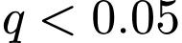. Positive and negative values indicate that increasing the parameter was associated with increasing and decreasing outcome values, respectively. (B) Global influence ranking calculated as the mean absolute PRCC across the six outcomes displayed in panel A. The 15 parameters with the highest mean absolute PRCC are shown.(C) Parameters with the strongest positive or negative PRCCs for continuous consolidation specificity. Consolidation specificity was most strongly and positively associated with the activity-tag coefficient 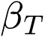​, basal docking hazard 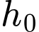, activity-tag lifetime ​, encounter radius , and consolidation gain ​. Asterisks denote false-discovery-rate-adjusted . (D) High-to-low endpoint effects from targeted one-parameter profiles, normalized separately within each outcome. Red indicates that the outcome increased between the lowest and highest tested parameter values, whereas blue indicates a decrease. Column-wise normalization permits comparison of effect directions but does not preserve absolute effect magnitudes across outcomes. Each parameter value was evaluated using 30 stochastic replicates. (E) Consolidation specificity and material-memory specificity across Hill coefficients 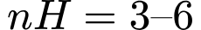 under the transient-pulse protocol. Points show means and error bars show 95% confidence intervals across 30 stochastic replicates per value. Increasing Hill cooperativity modestly reduced both late-state specificity measures under this protocol. (F) Integrated separation between the decreasing and increasing branches of a sequential amplitude-step protocol (activation pulses of increasing, then decreasing amplitude, with 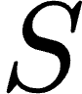 and 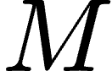 carried over between steps) for the consolidation state and material-memory tag . Positive values indicate persistence after prior exposure to stronger activity drive. Points show means and error bars show 95% confidence intervals across 15 replicates per Hill coefficient. Increasing 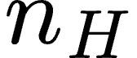 strengthened integrated history dependence for both states.
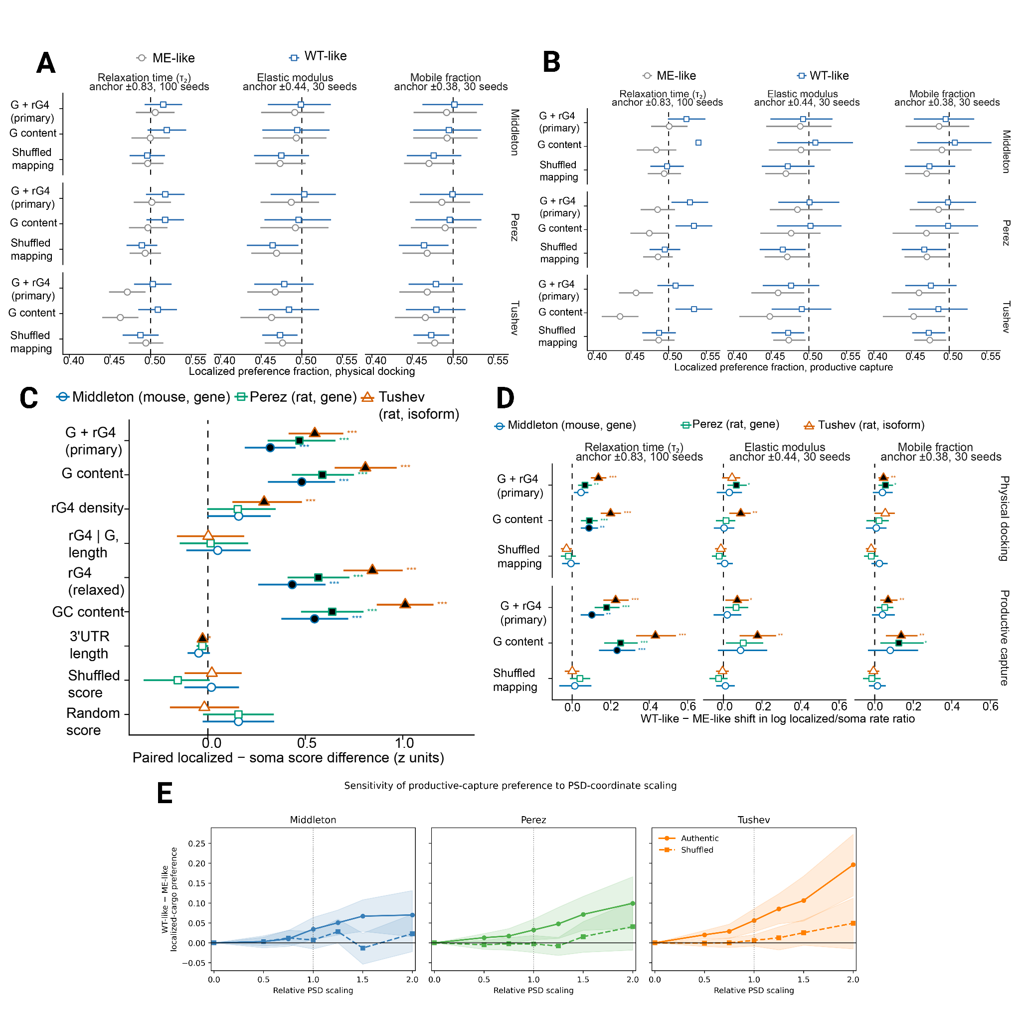
S4 Fig. Sequence-informed material states predict state-dependent capture of localized transcripts.
(A, B) Relative preference for localized transcripts under ME-like and WT-like postsynaptic states, at physical docking (A) and productive capture (B). Sequence-derived G+rG4 and G-content scores were mapped separately onto relaxation time (τ₂), elastic modulus, or mobile fraction; shuffled mappings served as identity-disrupted controls. (C) Paired sequence-score differences between localized and matched somatic transcripts in the Middleton, Perez, and Tushev datasets. Positive values indicate higher scores in localized transcripts. (D) WT-like minus ME-like shifts in the log localized/soma rate ratio, at both outcome stages. Positive values indicate greater relative capture of localized transcripts in the WT-like state. (E) Sensitivity of productive-capture preference to PSD-coordinate scaling. The WT–ME separation derived from relaxation time was varied from zero to twice the reference scaling, shown for authentic and shuffled transcript-to-coordinate mappings; the vertical dotted line marks the reference scaling. Dashed lines denote no preference (A, B), no localized–somatic difference (C), and no state-dependent shift (D, E). Points show means; error bars and shaded regions show 95% confidence intervals: seed bootstraps across 100 seeds for τ₂ and 30 seeds each for elastic modulus and mobile fraction (A, B, D), bootstraps across 250 matched pairs (C), and seed bootstraps across 30 matched parameter seeds (E). Filled symbols and asterisks in (C, D) denote Benjamini–Hochberg-adjusted significance: *q < 0.05, **q < 0.01, ***q < 0.001.

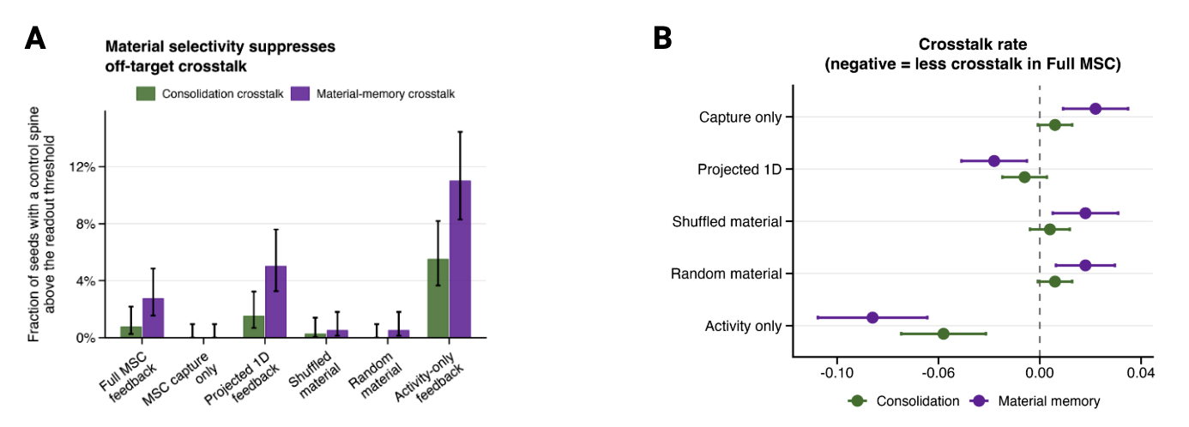

S5 Fig. Material-selective capture reduces off-target crosstalk across model variants.
(A) Fraction of parameter-generating seeds in which the maximum late-state value among inactive control synapses exceeded the prespecified consolidation or material-memory threshold. Bars show mean seed-level proportions and Wilson 95% confidence intervals across 400 matched parameter seeds. (B) Paired within-seed crosstalk differences, calculated as Full MSC minus the corresponding null model. Negative values indicate lower crosstalk in Full MSC. Relative to the activity-only model, Full MSC reduced consolidation crosstalk by 0.0475 and material-memory crosstalk by 0.0825. Points show mean paired differences and horizontal bars show approximate 95% confidence intervals across matched parameter seed.

References
1. Batish M, van den Bogaard P, Kramer FR, Tyagi S. Neuronal mRNAs travel singly into dendrites. Proc Natl Acad Sci U S A. 2012 Mar 20;109(12):4645–50.
2. Donlin-Asp PG, Polisseni C, Klimek R, Heckel A, Schuman EM. Differential regulation of local mRNA dynamics and translation following long-term potentiation and depression. Proc Natl Acad Sci U S A [Internet]. 2021 Mar 30;118(13). Available from: http://dx.doi.org/10.1073/pnas.2017578118
3. Zeng M, Shang Y, Araki Y, Guo T, Huganir RL, Zhang M. Phase Transition in Postsynaptic Densities Underlies Formation of Synaptic Complexes and Synaptic Plasticity. Cell. 2016 Aug 25;166(5):1163–75.e12.
4. Zeng M, Chen X, Guan D, Xu J, Wu H, Tong P, et al. Reconstituted Postsynaptic Density as a Molecular Platform for Understanding Synapse Formation and Plasticity. Cell. 2018 Aug 23;174(5):1172–87.e16.
5. Jia B, Shen Z, Zhu S, Huang J, Liao Z, Zhao S, et al. Shank3 oligomerization governs material properties of the postsynaptic density condensate and synaptic plasticity. Cell. 2025 Nov 13;188(23):6473–91.e21.
6. Yoon YJ, Wu B, Buxbaum AR, Das S, Tsai A, English BP, et al. Glutamate-induced RNA localization and translation in neurons. Proceedings of the National Academy of Sciences. 2016 Nov 1;113(44):E6877–86.
7. Bauer KE, Segura I, Gaspar I, Scheuss V, Illig C, Ammer G, et al. Live cell imaging reveals 3′-UTR dependent mRNA sorting to synapses. Nature Communications. 2019 July 18;10(1):3178.
8. Vidal Ceballos A, Geissmann A, Favaro DC, Deshpande P, Elbaum-Garfinkle S. RNA guanine content and G-quadruplex structure tune the phase behavior and material properties of biomolecular condensates. Sci Rep. 2025 Mar 18;15(1):9295.
9. Köhrmann M, Luo M, Kaether C, DesGroseillers L, Dotti CG, Kiebler MA. Microtubule-dependent recruitment of Staufen-green fluorescent protein into large RNA-containing granules and subsequent dendritic transport in living hippocampal neurons. Mol Biol Cell. 1999 Sept;10(9):2945–53.
10. Chen X, Vinade L, Leapman RD, Petersen JD, Nakagawa T, Phillips TM, et al. Mass of the postsynaptic density and enumeration of three key molecules. Proc Natl Acad Sci U S A. 2005 Aug 9;102(32):11551–6.
11. Chen X, Winters C, Azzam R, Li X, Galbraith JA, Leapman RD, et al. Organization of the core structure of the postsynaptic density. Proc Natl Acad Sci U S A. 2008 Mar 18;105(11):4453–8.
12. Redondo RL, Morris RGM. Making memories last: the synaptic tagging and capture hypothesis. Nature Reviews Neuroscience. 2010 Dec 20;12(1):17–30.
13. Frey U, Morris RGM. Synaptic tagging and long-term potentiation. Nature. 1997 Feb;385(6616):533–6.

