Supplementary Information

Fracture Mechanics and Self-Healing in Molecular Crystal Resonators for Lasing

Melchi Chosenyah,¹ Vuppu Vinay Pradeep,¹ Kapil Yadav,¹ Ankur Khapre,¹ Biswajit Kumar Barman,¹ Raghavaiah Pallepogu,² Rajadurai Chandrasekar^{1,🖂} (ORCID: 0000-0003-3527-3984)

¹Advanced Photonic Materials and Technology Laboratory, School of Chemistry and Centre for Nanotechnology, University of Hyderabad, Prof. C. R. Rao Road, Gachibowli, Hyderabad 500 046, Telangana (India)
E-mail: r.chandrasekar@uohyd.ac.in
²Department of Chemistry, School of Chemical Sciences, Central University of Karnataka, Kadaganchi, Aland Road, Kalaburagi - 585367, Karnataka, India.

S.No. | Content | Page No.
1 | Supplementary note. 1 Materials | 3
2 | Supplementary Fig. 1 The Hirshfeld surface analysis
3 | Supplementary Fig. 2 ORTEP diagram and face indexing of HDMAC crystal | 4
4 | Supplementary Table. 1 Crystallographic data of HDMAC single-crystal | 4
5 | Supplementary Fig. 3 Confocal and FL images of HDMAC microcrystals | 5
6 | Supplementary Fig. 4 Confocal optical microscopy setup | 5
7 | Supplementary Fig. 5 Self-healed HDMAC microcrystals | 6
8 | Supplementary Fig. 6 HDMAC microcrystal healing process | 6
9 | Supplementary Fig. 7 Single-crystal X-ray data of HDMAC microcrystal compared with macrocrystal | 6
10 | Supplementary Fig. 8 Translational movement of self-healed HDMAC microcrystal | 7
11 | Supplementary Fig. 9 Various self-healed microcrystals with different crack types | 8
12 | Supplementary Fig. 10 Optical comparison before and after healing | 8
13 | Supplementary Fig. 11 Comparison of self-healing efficiency | 10
14 | Supplementary Fig. 12-16 Self-healing efficiency of various crystals | 10-12
 | Supplementary note. 2 Calculation of missing unit cells at the misaligned interface
15 | Supplementary Fig. 17 Thickness-dependent optical modes of HDMAC microresonators | 13
16 | Supplementary Fig. 18 Background subtraction of the HDMAC microcrystal’s FL spectrum | 13
17 | Supplementary Fig. 19 Energy framework analysis | 14
18 | References | 14

Supplementary note 1: Materials
All solvents and chemicals (2-hydroxy acetophenone, 4-dimethylaminobenzaldehyde, and ethanol) were purchased from commercial sources (Sigma Aldrich and Merck). HPLC solvents were used for synthesis and self-assembly.

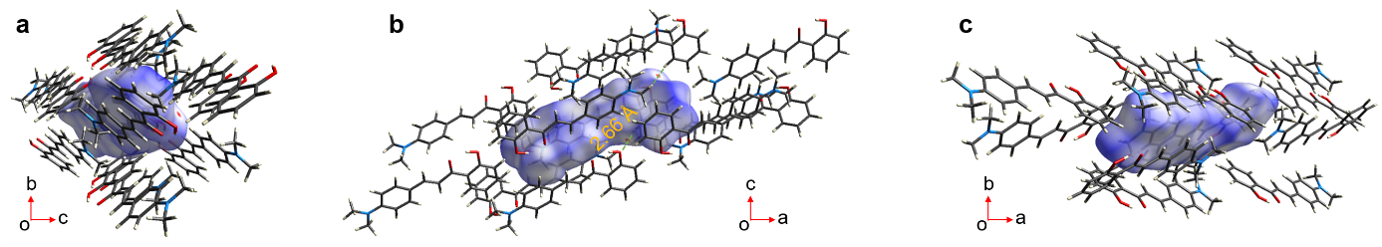
Supplementary Fig. 1 ⏐ The Hirshfeld Surface (HS) analyses. Three-dimensional view of the Hirshfeld surface plotted along a a-axis, b b-axis, and c c-axis over d_{norm} in the range -0.05 to 1.3757 a.u., showing the region of intermolecular H-bonding.
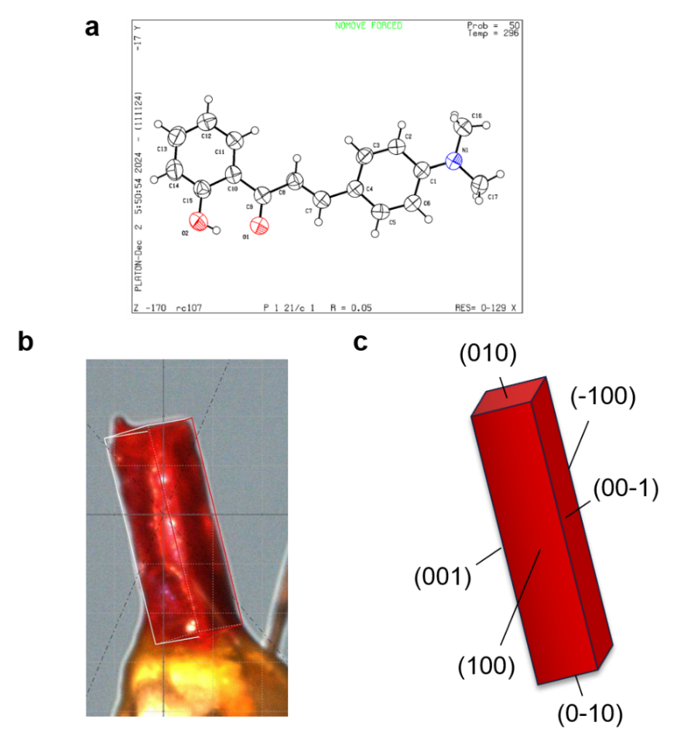
Supplementary Fig. 2 ⏐ ORTEP diagram and face indexing of HDMAC crystal. a ORTEP view of HDMAC with thermal ellipsoids shown at 50% probability. b Picture of the mounted HDMAC crystal and c graphical representation of indexed planes of HDMAC.

Supplementary Table. 1 ⏐ Crystallographic data of HDMAC single-crystal.
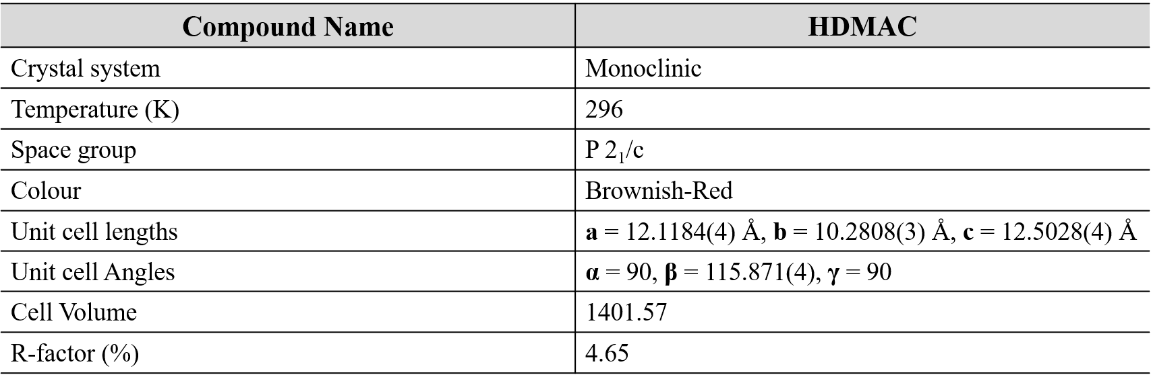
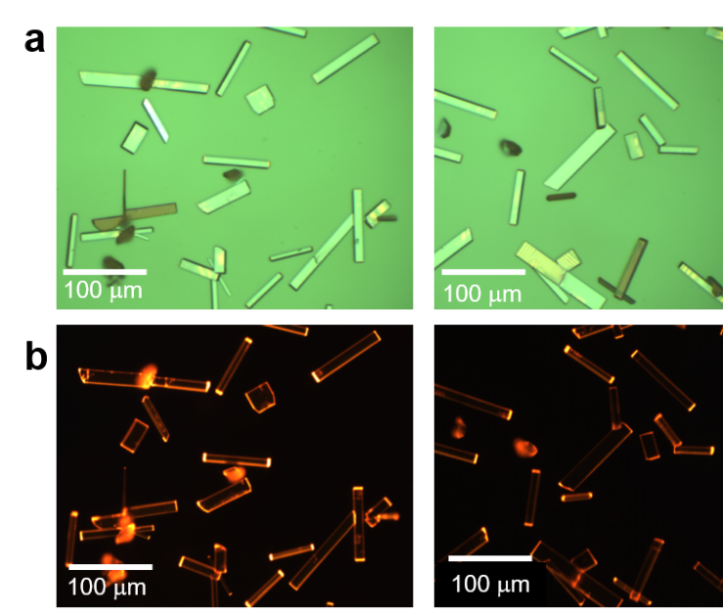
Supplementary Fig. 3 ⏐ HDMAC microcrystals. a Confocal optical microscopic and b FL images of the self-assembled HDMAC microcrystals.

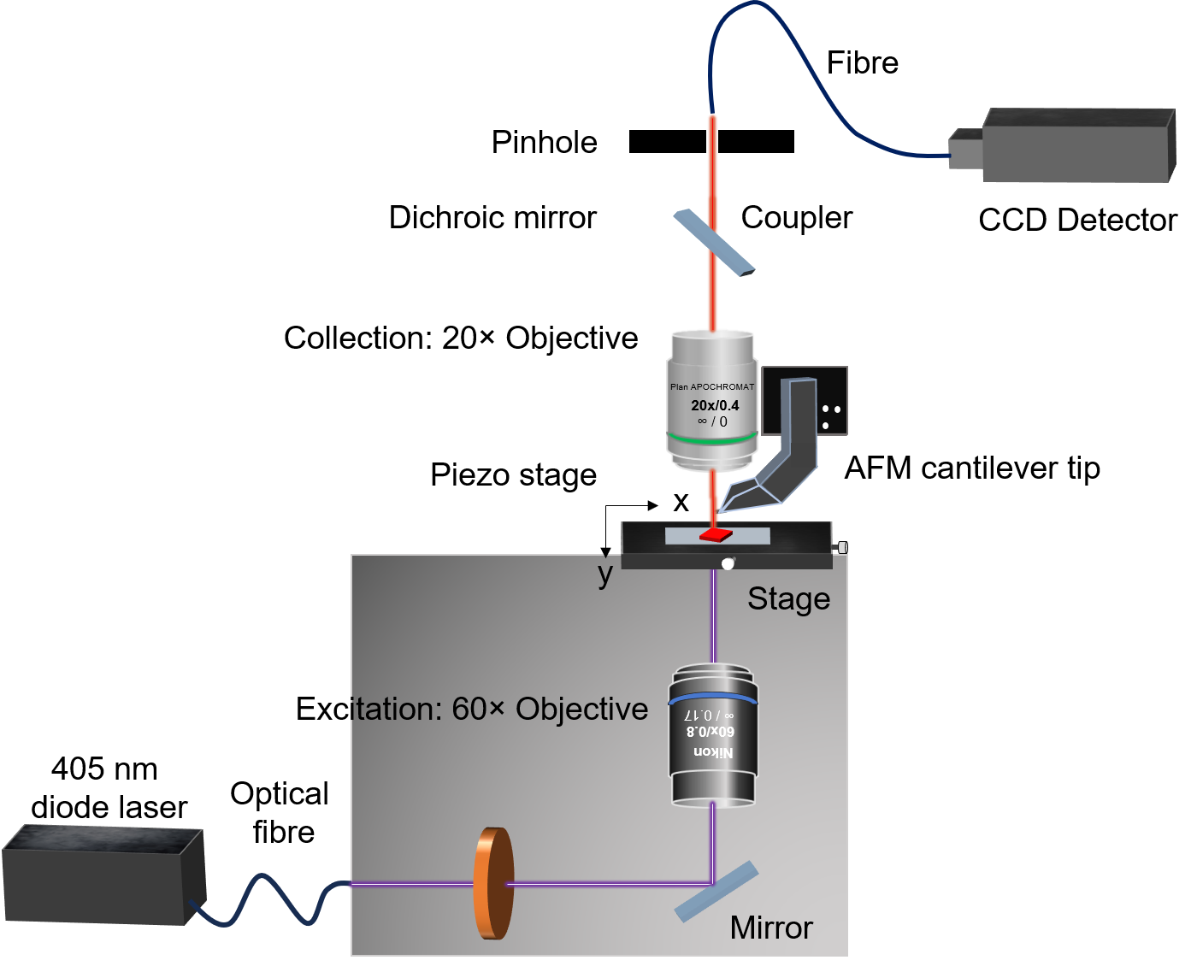
Supplementary Fig. 4 ⏐ Confocal optical microscopy setup. The experimental optical and mechanical micromanipulation Setup.
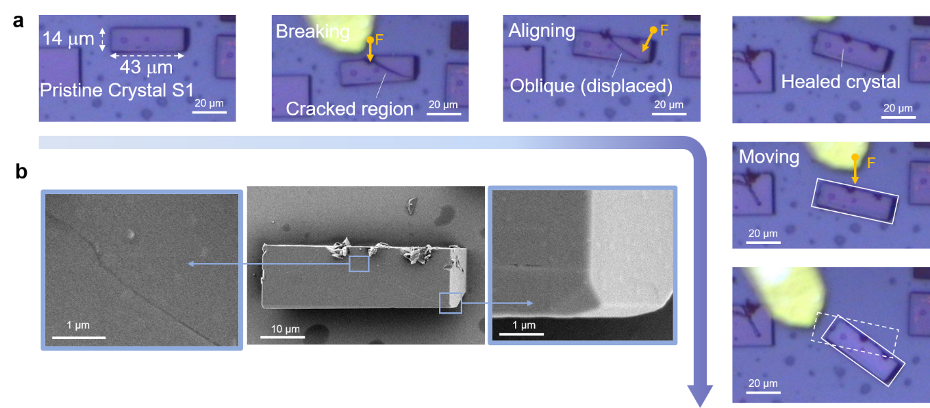
Supplementary Fig. 5 ⏐ Self-healed HDMAC microcrystal. a Confocal optical microscopic image of the self-healing process of microcrystal S1 and its translational movement b FESEM images of the self-healed microcrystal.
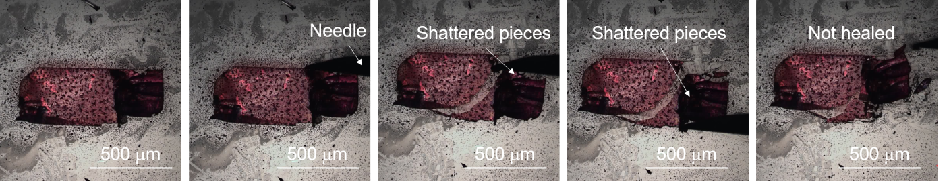
Supplementary Fig. 6 ⏐ Macrocrystal healing process. Optical image of self-healing process of macrocrystal of HDMAC. Crystal shattered when mechanical force is applied.
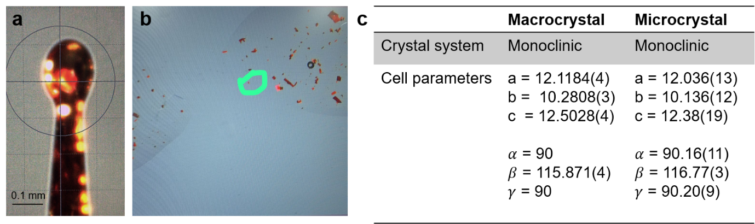
Supplementary Fig. 7 ⏐ Single-crystal X-ray data of HDAMC microcrystal. a Mounted HDMAC microcrystal (≈ 50 μm) for SXRD analysis. b Selected microcrystal under the optical microscope. c The comparison of crystallographic data obtained from macro and microcrystal of HDMAC.
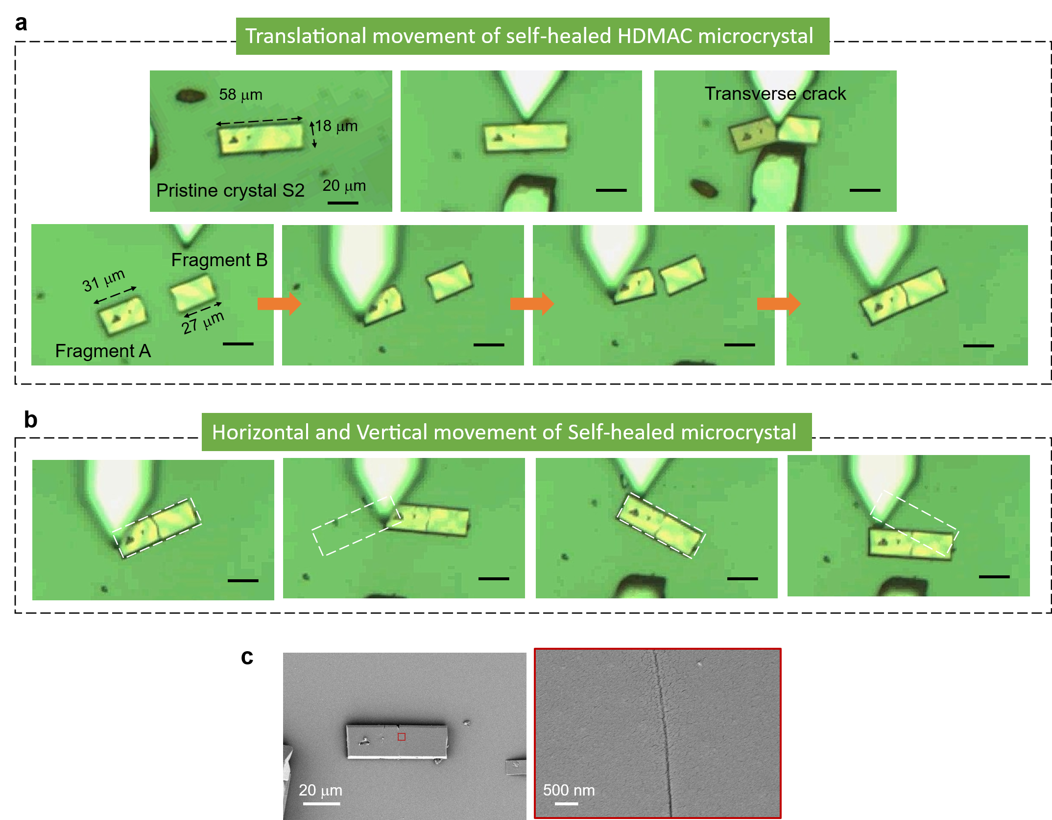
Supplementary Fig. 8 ⏐ Translational movement of self-healed HDMAC microcrystal. Sequential confocal optical microscopic images of a mechanophotonic-assisted self-healing in HDMAC microcrystal. b Horizontal and vertical movement of self-healed microcrystal. c FESEM images of self-healed microcrystal.
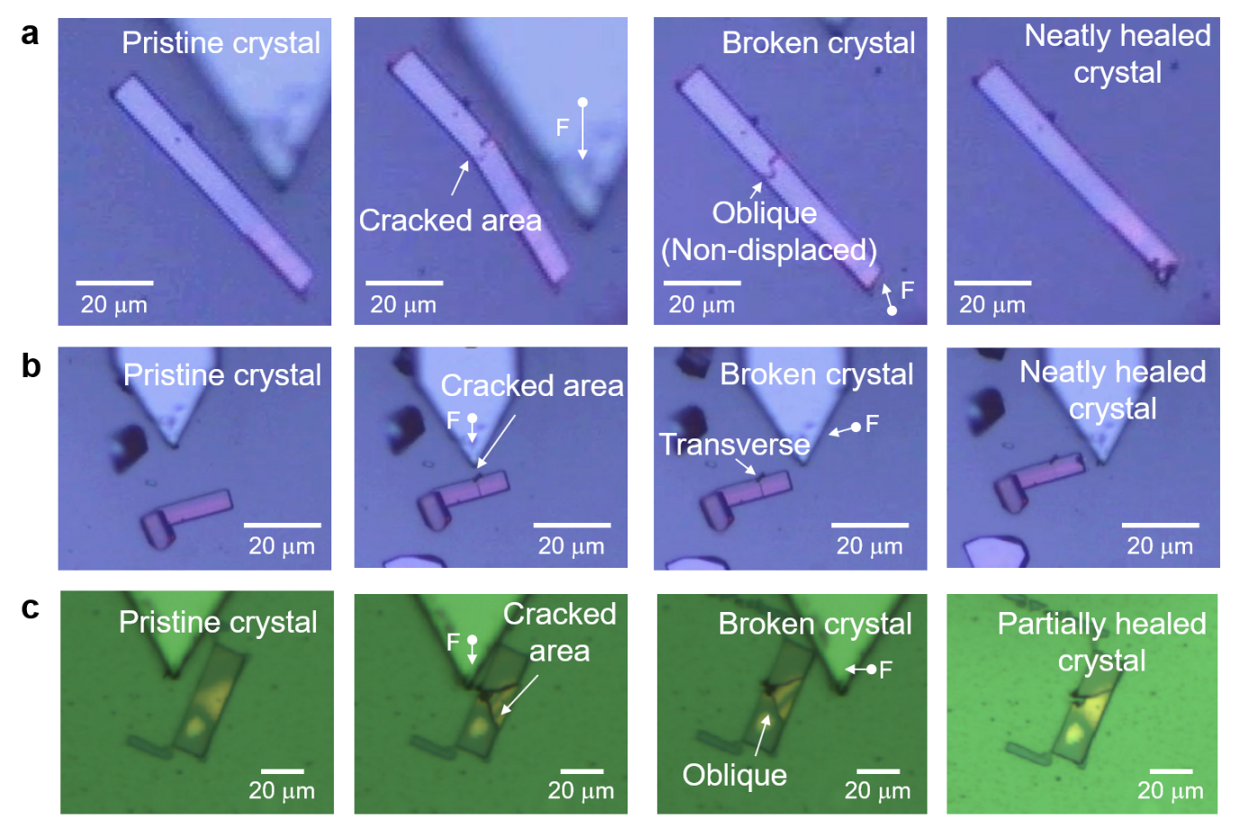
Supplementary Fig. 9 ⏐ Self-healed HDAMC microcrystals with different types of cracks. a-c Sequential confocal optical microscopic images of mechanophotonic-assisted self-healing in HDMAC microcrystals.
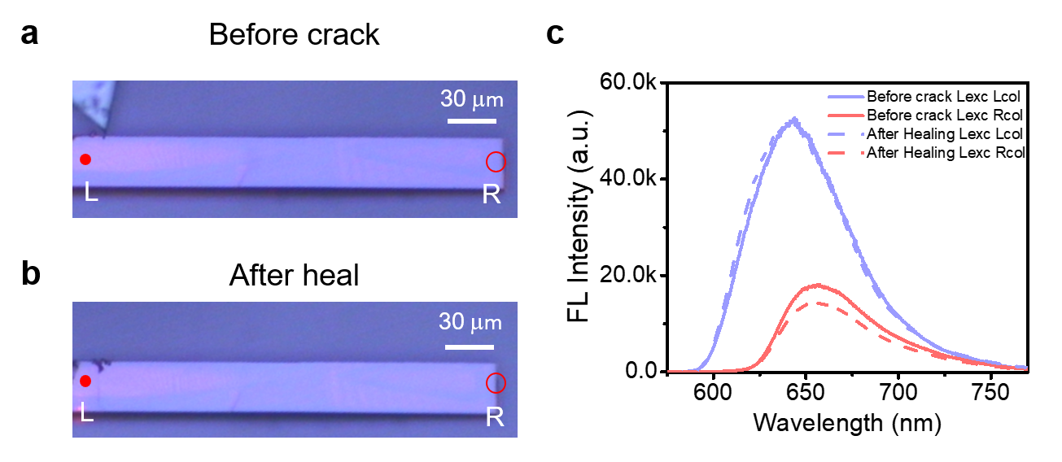
Supplementary Fig. 10 ⏐ Optical comparison of before and after healing. Confocal optical microscopic image of a before crack and b after healed microcrystal of HDMAC c corresponding FL spectra (solid lines: before crack; dashed lines: after healed; Lilac color: L excitation and L collection; Pastel red color: R excitation and R collection)
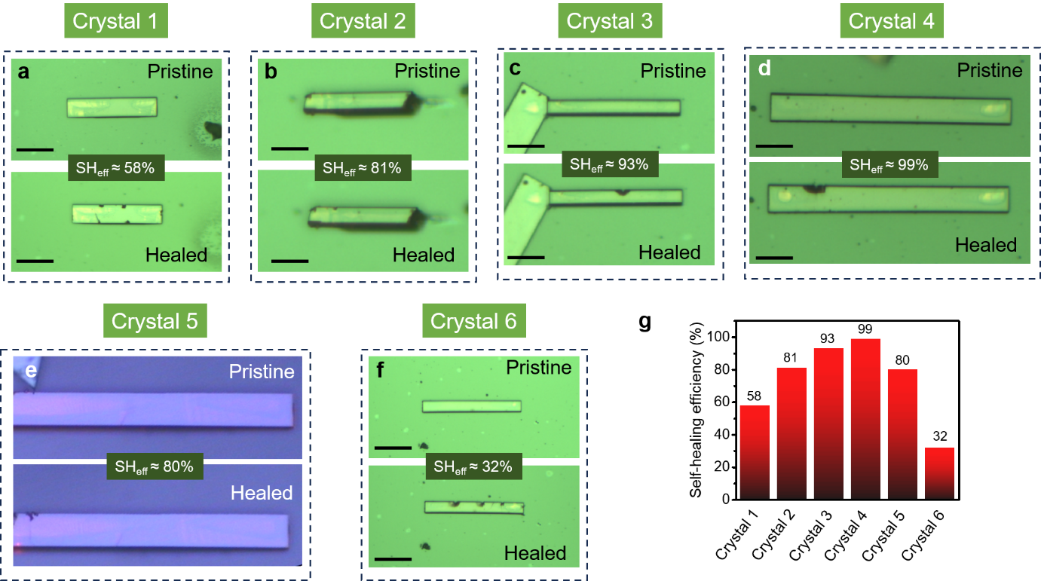
Supplementary Fig. 11 ⏐ Self-healing efficiency. a-f Confocal optical microscopic images of before crack and after healed microcrystals of HDMAC. Inset: Self-healing efficiency value. g Bar diagram of self-healing efficiency of different HDMAC microcrystals.
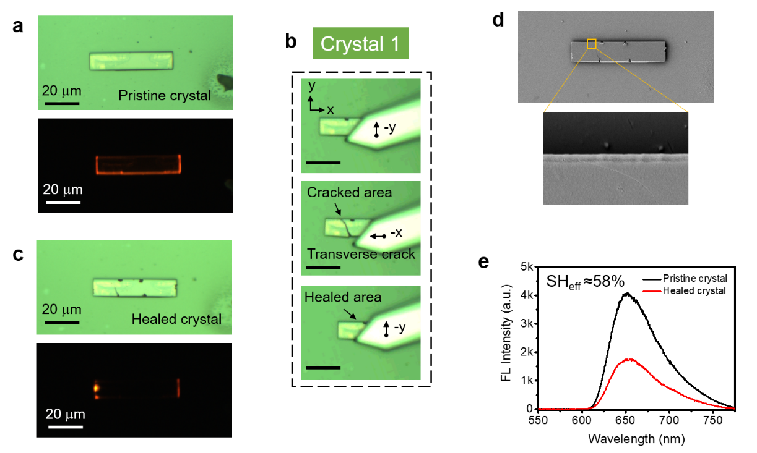
Supplementary Fig. 12 ⏐ Self-healing efficiency of crystal 1. Confocal optical microscopic image and FL image of a pristine microcrystal and c healed microcrystal of HDMAC. b Sequential confocal images depicting mechanophotonic process of self-healing. d FESEM images of the self-healed microcrystal. e FL spectra of pristine and healed microcrystal. Inset: Self-healing efficiency value (SH_{eff}).
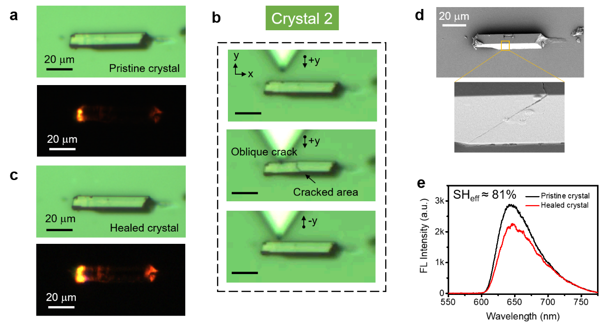
Supplementary Fig. 13 ⏐ Self-healing efficiency of crystal 2. Confocal optical microscopic image and FL image of a pristine microcrystal and c healed microcrystal of HDMAC. b Sequential confocal images depicting mechanophotonic process of self-healing. d FESEM images of the self-healed microcrystal. e FL spectra of pristine and healed microcrystal. Inset: Self-healing efficiency value (SH_{eff}).
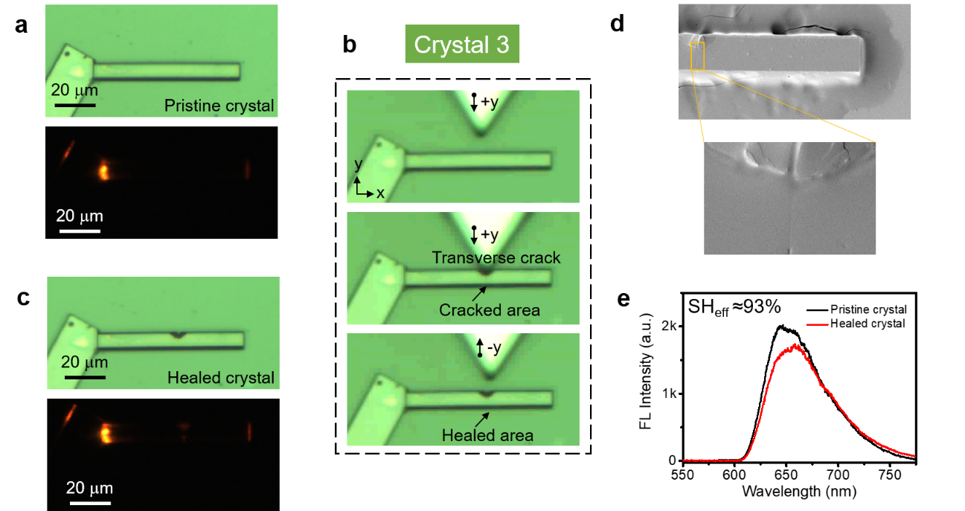
Supplementary Fig. 14 ⏐ Self-healing efficiency of crystal 3. Confocal optical microscopic image and FL image of a pristine microcrystal and c healed microcrystal of HDMAC. (b) Sequential confocal images depicting mechanophotonic process of self-healing. d FESEM images of the self-healed microcrystal. e FL spectra of pristine and healed microcrystal. Inset: Self-healing efficiency value (SH_{eff}).
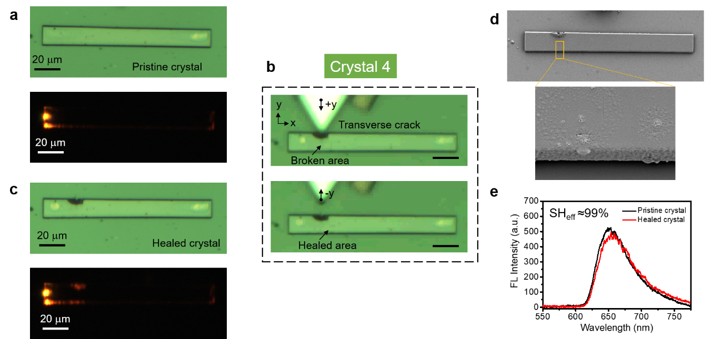
Supplementary Fig. 15 ⏐ Self-healing efficiency of crystal 4. Confocal optical microscopic image and FL image of a pristine microcrystal and c healed microcrystal of HDMAC. b Sequential confocal images depicting mechanophotonic process of self-healing. d FESEM images of the self-healed microcrystal. e FL spectra of pristine and healed microcrystal. Inset: Self-healing efficiency value (SH_{eff}).
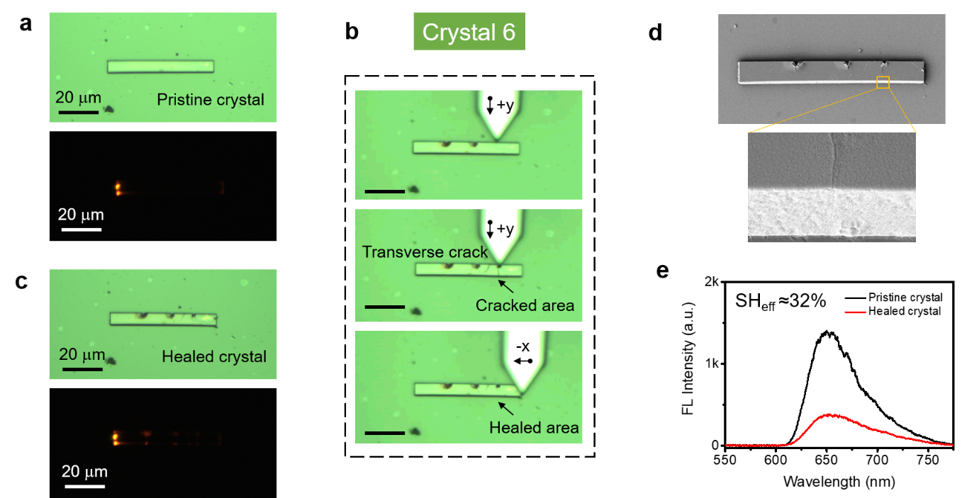
Supplementary Fig. 16 ⏐ Self-healing efficiency of crystal 6. Confocal optical microscopic image and FL image of a pristine microcrystal and c healed microcrystal of HDMAC. b Sequential confocal images depicting the mechanophotonic process of self-healing. d FESEM images of the self-healed microcrystal. e FL spectra of pristine and healed microcrystal. Inset: Self-healing efficiency value (SH_{eff}).
Supplementary note 2: Calculation of missing unicells at the misaligned interface
- Width of the misaligned interface: 30 µm
- Height: 36 nm
Using your unit-cell parameters:
- $a=1.21184$nm
- $b=1.02808$nm
- $c=1.25028$nm
- 4 molecules per unit cell
The number of unit cells across the 30 µm width (c-axis) is approximately
$$\frac{30000\text{ nm}}{1.25028\text{ nm}}≈23,994$$
The number of unit cells along the step height (a-axis) is
$$\frac{36}{1.21}≈30.$$
Therefore, the number of unit cells in the a-c surface in step defect is
$$23994×30≈7.19×{10}^{5}$$

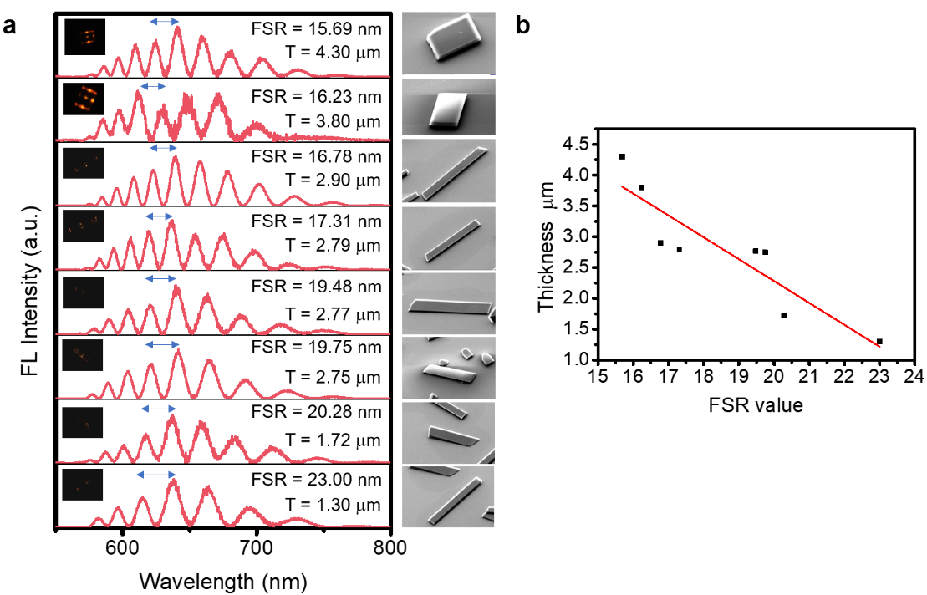
Supplementary Fig. 17 ⏐ Thickness-dependent optical modes of HDMAC microresonators. a Stacked FL spectra of various HDMAC optical resonators along with the corresponding FESEM images. (Inset: FL images, FSR, and Thickness, T). b The plot of thickness vs. FSR values.
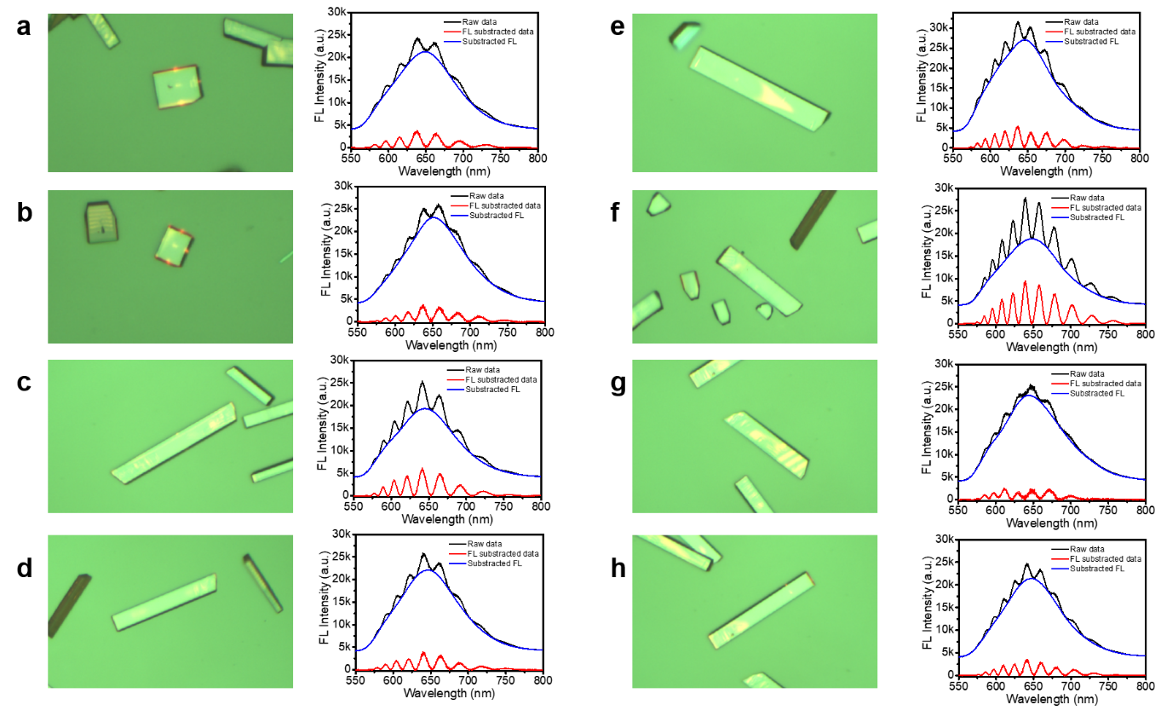
Supplementary Fig. 18 ⏐ Background subtraction of the HDMAC microcrystal’s FL spectrum. a-h Confocal optical microscopic images of HDMAC microcrystal optical resonators and the corresponding background subtraction of FL spectra.
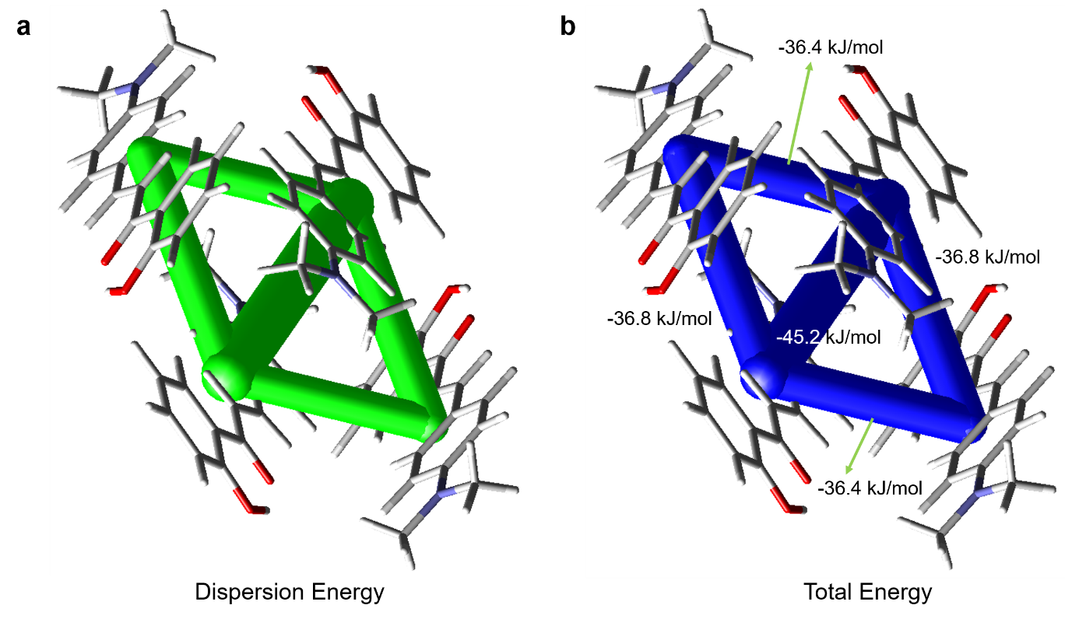
Supplementary Fig. 19 ⏐ Energy framework analysis. Energy frameworks of the HDMAC crystal. a Dispersion and b Total energy components of the intermolecular interaction energy visualized as energy frameworks, viewed along the crystallographic a-axis. Cylinders connecting molecular centroids represent pairwise interactions, with thickness proportional to interaction strength. Blue cylinders correspond to total energy interactions, and green cylinders correspond to dispersion interactions. The tube size and the cut-off energy are set to 150 and 10 kJ/mol, respectively. The plots were produced with CrystalExplorer21.¹

References
- Spackman, P. R. et al. CrystalExplorer: a program for Hirshfeld surface analysis, visualization and quantitative analysis of molecular crystals. J. Appl. Crystallogr. 54, 1006-1011 (2021).

