Supplementary Information for

Fire asymmetries across global borders reveal distinct ecological governance and cooperation priorities

Supplementary Figures

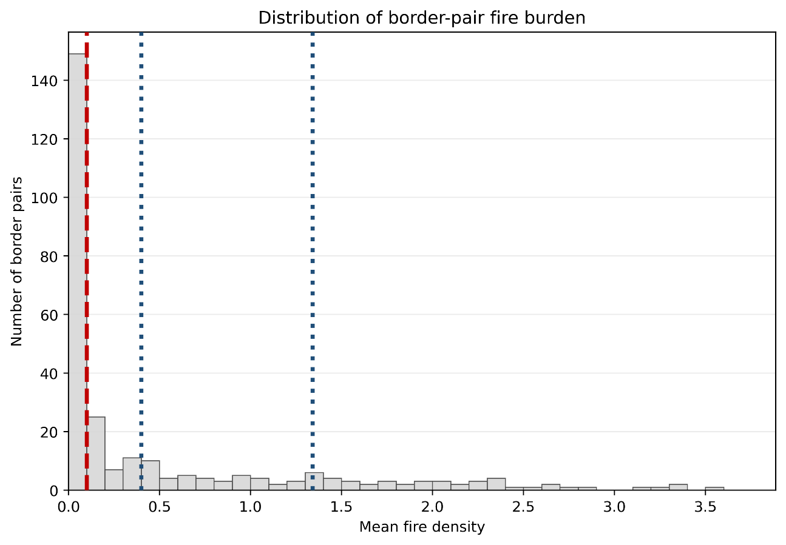

Supplementary Figure 1. Distribution of border pair fire burden (mean fire density of each pair over the 21-year study period). Red dashed line indicates active fire cutoff (> 0.1 fire records km⁻²). Blue dotted lines show the tercile thresholds used in the maps.

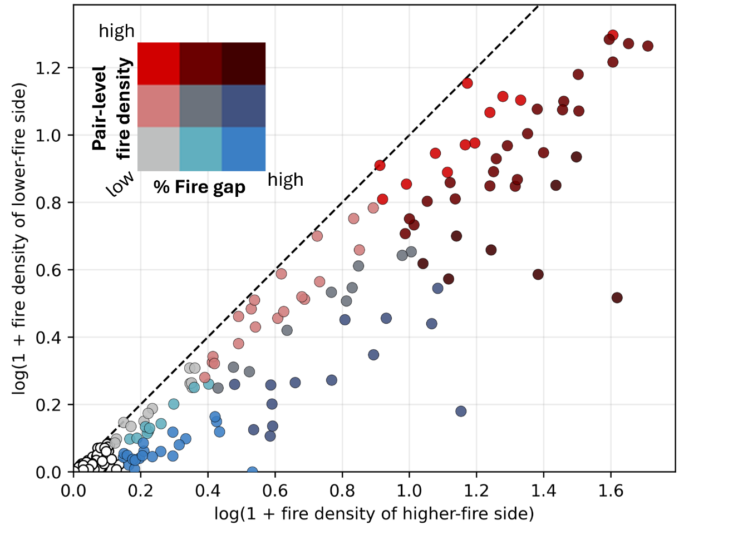

Supplementary Figure 2. Fire density (21 years totals) of each border unit, organized by pairs. The distance from the 1:1 line (black dashes) shows the absolute gap in fire density between border units of each pair. Relative fire gap vs pair-level fire density is coded with the same color blending as the map of Fig. 1 (in manuscript). White dots represent very low fire density.

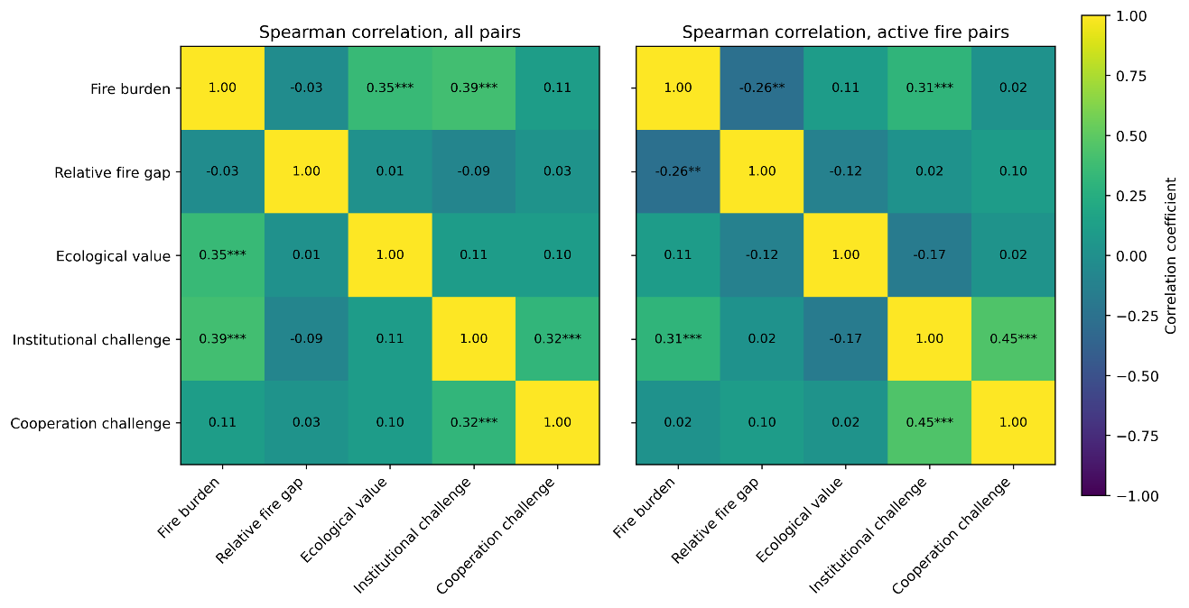
Supplementary Figure 3. Spearman correlation matrices among the five framework dimensions for all border pairs (n=277) and for active fire border pairs (n=128). Asterisks indicate significance levels: * P < 0.05, ** P < 0.01, *** P < 0.001.

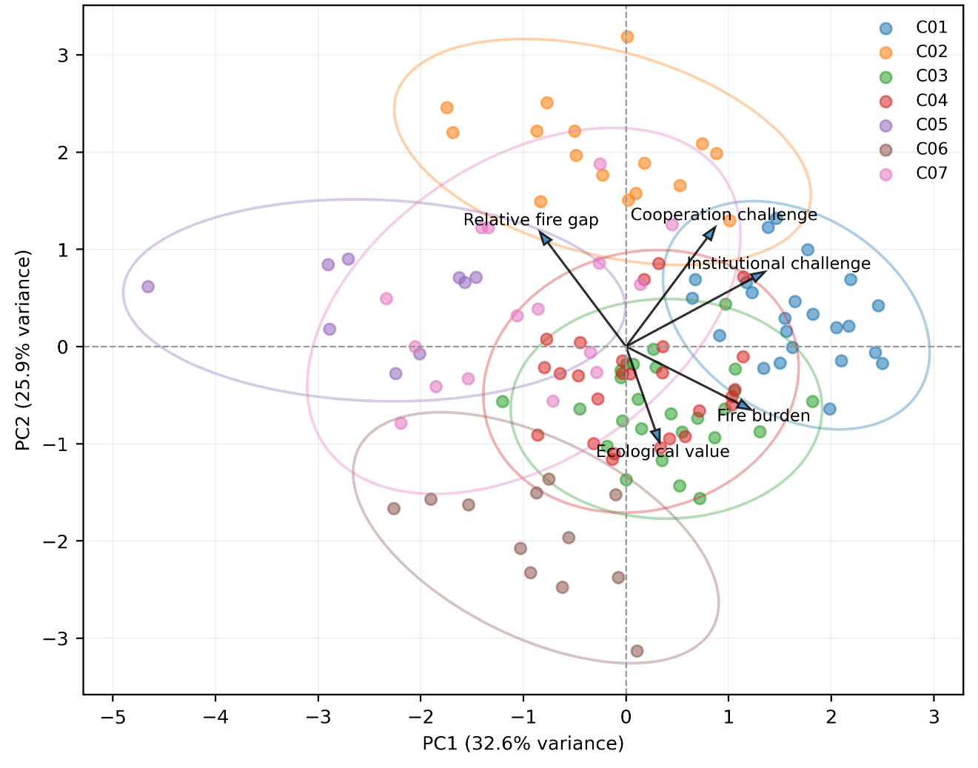
Supplementary Figure 4. PCA biplot of active fire border pairs clusters. PCA was applied to the same five standardized variables used in the clustering analysis. Points represent active fire border pairs, colors indicate the seven k-means clusters shown in Fig. 5 (main manuscript), ellipses show 95% covariance for clusters with sufficient observations, and arrows show variable loadings on PC1 and PC2. PCA is shown only as a diagnostic visualization; clustering was performed in the full standardized five-variable space.

Supplementary Tables

Supplementary Table 1. Summary statistics of fire burden and cross-border fire asymmetry among all border pairs and active fire border pairs, defined as pairs with mean fire density > 0.1 over the 21-year study period. Columns show the minimum, quartiles, 90th, 95th and 99th percentiles, maximum, mean, standard deviation, and number of zero values. The table highlights the strong right-skewness of fire burden and the reason for interpreting relative fire gaps primarily among active fire pairs.

All borders(n=277) | min | q1 | median | q3 | p90 | p95 | p99 | max | mean | sd | n zero
Fire density higher side | 0 | 0.0113 | 0.0977 | 0.7982 | 2.2160 | 2.9764 | 3.9946 | 4.5220 | 0.6322 | 1.0057 | 22
Fire density lower side | 0 | 0.0041 | 0.0384 | 0.4086 | 1.3394 | 1.7654 | 2.5464 | 2.6568 | 0.3570 | 0.6037 | 36
Mean fire density of pairs | 0 | 0.0077 | 0.0789 | 0.6192 | 1.8091 | 2.3162 | 3.2805 | 3.5311 | 0.4946 | 0.7935 | 22
Relative fire gap | 0 | 0.1485 | 0.2940 | 0.5714 | 0.7525 | 0.8940 | 0.9953 | 1.0000 | 0.3599 | 0.2769 | 22
Absolute fire gap | 0 | 0.0053 | 0.0490 | 0.2930 | 0.9892 | 1.3495 | 1.9731 | 3.3654 | 0.2753 | 0.4831 | 22
Active fire borders (n=128)
Fire density higher side | 0.1311 | 0.4087 | 0.8783 | 2.0688 | 3.0038 | 3.4948 | 4.1683 | 4.5220 | 1.3313 | 1.1318 | 0
Fire density lower side | 0 | 0.1575 | 0.5622 | 1.2366 | 1.9121 | 2.1294 | 2.6001 | 2.6568 | 0.7558 | 0.7025 | 1
Mean fire density of pairs | 0.1002 | 0.3225 | 0.7209 | 1.5980 | 2.3308 | 2.6896 | 3.3705 | 3.5311 | 1.0436 | 0.8960 | 0
Relative fire gap | 0.0012 | 0.1748 | 0.2576 | 0.4596 | 0.6554 | 0.7093 | 0.8912 | 1.0000 | 0.3241 | 0.2146 | 0
Absolute fire gap | 0.0021 | 0.1411 | 0.3431 | 0.8469 | 1.3549 | 1.6327 | 2.1308 | 3.3654 | 0.5755 | 0.5811 | 0

Supplementary Table 2. Observed-versus-expected overlap among high-priority framework dimensions for 128 active fire border pairs. Expected overlaps were estimated from 10,000 random permutations that preserved the number of high-priority pairs in each dimension while breaking associations among dimensions. The null interval is the 2.5–97.5% permutation interval. Empirical P values are two-sided.
Test | Threshold | N | Observed  overlap | Expected  overlap | Null 95%  interval | Observed  / expected | Empirical  P | Direction
Fire burden AND Relative fire gap | 0.67 | 128 | 9 | 14.45 | -10 | 0.62 | 0.051 | lower than expected
Ecological value AND Fire burden | 0.67 | 128 | 16 | 19.13 | -10 | 0.84 | 0.329 | lower than expected
Ecological value AND Relative fire gap | 0.67 | 128 | 18 | 19.14 | -10 | 0.94 | 0.818 | lower than expected
Ecological value AND Fire burden AND Relative fire gap | 0.67 | 128 | 5 | 6.44 | -8 | 0.78 | 0.668 | lower than expected
Fire burden AND Institutional challenge | 0.67 | 128 | 26 | 19.53 | -11 | 1.33 | 0.027 | higher than expected
Relative fire gap AND Cooperation challenge | 0.67 | 128 | 19 | 16.45 | -11 | 1.16 | 0.429 | higher than expected
All five dimensions | 0.67 | 128 | 0 | 1.11 | -3 | 0 | 0.627 | lower than expected
Fire burden AND Relative fire gap | 0.75 | 128 | 2 | 8 | -8 | 0.25 | 0.007 | lower than expected
Ecological value AND Fire burden | 0.75 | 128 | 7 | 10.72 | -9 | 0.65 | 0.162 | lower than expected
Ecological value AND Relative fire gap | 0.75 | 128 | 10 | 10.80 | -8 | 0.93 | 0.910 | lower than expected
Ecological value AND Fire burden AND Relative fire gap | 0.75 | 128 | 2 | 2.68 | -6 | 0.75 | 0.965 | lower than expected
Fire burden AND Institutional challenge | 0.75 | 128 | 16 | 11.23 | -9 | 1.43 | 0.071 | higher than expected
Relative fire gap AND Cooperation challenge | 0.75 | 128 | 13 | 9.28 | -9 | 1.40 | 0.147 | higher than expected
All five dimensions | 0.75 | 128 | 0 | 0.28 | -2 | 0 | 1 | lower than expected
Fire burden AND Relative fire gap | 0.9 | 128 | 1 | 1.34 | -4 | 0.75 | 1 | lower than expected
Ecological value AND Fire burden | 0.9 | 128 | 0 | 1.73 | -4 | 0 | 0.296 | lower than expected
Ecological value AND Relative fire gap | 0.9 | 128 | 1 | 1.70 | -4 | 0.59 | 0.937 | lower than expected
Ecological value AND Fire burden AND Relative fire gap | 0.9 | 128 | 0 | 0.17 | -1 | 0 | 1 | lower than expected
Fire burden AND Institutional challenge | 0.9 | 128 | 3 | 1.43 | -4 | 2.10 | 0.315 | higher than expected
Relative fire gap AND Cooperation challenge | 0.9 | 128 | 4 | 2.03 | -5 | 1.97 | 0.242 | lower than expected
All five dimensions | 0.9 | 128 | 0 | 0 | 0 | 0 | 1 | lower than expected

Supplementary Table 3. Sensitivity models for correlates of mean fire burden across international border pairs. The table reports the main fire-burden model and three sensitivity models. The main model was an OLS regression with HC3 robust standard errors fitted to log1p-transformed mean fire density across all 277 border pairs. Sensitivity models included the same OLS-HC3 specification fitted only to the 128 active fire pairs, a Gamma generalized linear model with log-link fitted to positive fire pairs using raw mean fire density as the response, and a Gamma log-link model fitted only to active fire pairs. All models were fitted one predictor at a time, and predictors were z-standardized before modeling. For OLS models, values are standardized coefficients with 95% confidence intervals and P values. For Gamma models, values are mean ratios, calculated as exp(β), with 95% confidence intervals transformed from the log-link scale and P values. FDR-adjusted P values (q) were calculated using the Benjamini–Hochberg procedure within each model specification. Mean ratios above 1 indicate higher expected mean fire density for a one-standard-deviation increase in the predictor; values below 1 indicate lower expected mean fire density.
 | all-pair OLS-HC3 (main) |  |  |  | active fires OLS-HC3 |  |  |  |  |  | positive fires Gamma log-link |  |  |  | active fires Gamma log-link
Variable | β | 95% CI | P | q |  | β | 95% CI | P | q | mean  ratio |  | 95% CI | P | q |  | mean  ratio | 95% CI | P | q
Latitude | -0.202 | [-0.244, -0.159] | <0.001 | <0.001 |  | -0.211 | [-0.261, -0.162] | <0.001 | <0.001 | 0.332 |  | [0.257, 0.429] | <0.001 | <0.001 |  | 0.559 | [0.49, 0.638] | <0.001 | <0.001
Temperature | 0.198 | [0.159, 0.236] | <0.001 | <0.001 |  | 0.182 | [0.133, 0.231] | <0.001 | <0.001 | 3.180 |  | [2.524, 4.007] | <0.001 | <0.001 |  | 1.683 | [1.492, 1.898] | <0.001 | <0.001
Evapotranspiration | 0.112 | [0.062, 0.161] | <0.001 | <0.001 |  | 0.099 | [0.017, 0.181] | <0.05 | <0.05 | 3.205 |  | [2.358, 4.356] | <0.001 | <0.001 |  | 1.430 | [1.142, 1.791] | <0.01 | <0.01
Terrain ruggedness | -0.090 | [-0.132, -0.048] | <0.001 | <0.001 |  | -0.087 | [-0.142, -0.032] | <0.01 | <0.01 | 0.686 |  | [0.572, 0.824] | <0.001 | <0.001 |  | 0.800 | [0.708, 0.905] | <0.001 | <0.01
Precipitation | 0.077 | [0.031, 0.122] | <0.001 | <0.01 |  | 0.041 | [-0.032, 0.114] | 0.266 | 0.349 | 1.523 |  | [1.114, 2.082] | <0.01 | <0.05 |  | 1.137 | [0.901, 1.435] | 0.280 | 0.360
Elevation | -0.065 | [-0.091, -0.04] | <0.001 | <0.001 |  | -0.006 | [-0.076, 0.064] | 0.859 | 0.886 | 0.564 |  | [0.415, 0.766] | <0.001 | <0.001 |  | 0.963 | [0.815, 1.139] | 0.662 | 0.690
Aridity | -0.031 | [-0.067, 0.005] | 0.090 | 0.116 |  | -0.035 | [-0.097, 0.027] | 0.272 | 0.349 | 0.713 |  | [0.563, 0.903] | <0.01 | <0.01 |  | 0.895 | [0.758, 1.056] | 0.188 | 0.267
Shrub cover | 0.202 | [0.155, 0.248] | <0.001 | <0.001 |  | 0.170 | [0.112, 0.228] | <0.001 | <0.001 | 1.924 |  | [1.619, 2.286] | <0.001 | <0.001 |  | 1.374 | [1.21, 1.561] | <0.001 | <0.001
Grass cover | -0.142 | [-0.176, -0.107] | <0.001 | <0.001 |  | -0.155 | [-0.23, -0.08] | <0.001 | <0.001 | 0.542 |  | [0.396, 0.742] | <0.001 | <0.001 |  | 0.724 | [0.582, 0.901] | <0.01 | <0.01
Tree cover | 0.049 | [-0.001, 0.098] | 0.053 | 0.075 |  | 0.084 | [0.015, 0.153] | <0.05 | <0.05 | 1.166 |  | [0.963, 1.413] | 0.115 | 0.130 |  | 1.195 | [1.035, 1.381] | <0.05 | <0.05
Agricultural cover | -0.034 | [-0.079, 0.012] | 0.151 | 0.186 |  | -0.115 | [-0.183, -0.047] | <0.001 | <0.01 | 0.781 |  | [0.652, 0.935] | <0.01 | <0.05 |  | 0.790 | [0.687, 0.909] | <0.001 | <0.05
EVI heterogeneity | 0.019 | [-0.013, 0.05] | 0.240 | 0.270 |  | -0.040 | [-0.135, 0.056] | 0.418 | 0.491 | 0.581 |  | [0.3, 1.127] | 0.108 | 0.127 |  | 0.825 | [0.556, 1.226] | 0.341 | 0.401
Road density | -0.085 | [-0.12, -0.05] | <0.001 | <0.001 |  | -0.083 | [-0.153, -0.013] | <0.05 | <0.05 | 0.492 |  | [0.364, 0.666] | <0.001 | <0.001 |  | 0.841 | [0.713, 0.991] | <0.05 | 0.066
Human footprint | -0.036 | [-0.073, 0] | <0.05 | 0.074 |  | -0.085 | [-0.149, -0.021] | <0.01 | <0.05 | 0.680 |  | [0.539, 0.856] | <0.01 | <0.01 |  | 0.782 | [0.666, 0.918] | <0.01 | <0.01
Night-time lights | -0.071 | [-0.096, -0.046] | <0.001 | <0.001 |  | -0.034 | [-0.093, 0.026] | 0.265 | 0.349 | 0.495 |  | [0.423, 0.58] | <0.001 | <0.001 |  | 0.895 | [0.717, 1.117] | 0.325 | 0.399
Agricultural GDP | -0.046 | [-0.085, -0.008] | <0.05 | <0.05 |  | -0.070 | [-0.144, 0.004] | 0.062 | 0.105 | 0.773 |  | [0.615, 0.97] | <0.05 | <0.05 |  | 0.854 | [0.725, 1.005] | 0.057 | 0.085
Population density | 0.000 | [-0.032, 0.033] | 0.991 | 0.991 |  | -0.039 | [-0.093, 0.014] | 0.149 | 0.224 | 0.942 |  | [0.8, 1.108] | 0.469 | 0.487 |  | 0.864 | [0.744, 1.003] | 0.054 | 0.085
HDI | -0.266 | [-0.309, -0.224] | <0.001 | <0.001 |  | -0.239 | [-0.292, -0.187] | <0.001 | <0.001 | 0.274 |  | [0.22, 0.341] | <0.001 | <0.001 |  | 0.532 | [0.468, 0.605] | <0.001 | <0.001
Government effectiveness | -0.190 | [-0.229, -0.151] | <0.001 | <0.001 |  | -0.171 | [-0.234, -0.109] | <0.001 | <0.001 | 0.349 |  | [0.236, 0.517] | <0.001 | <0.001 |  | 0.657 | [0.569, 0.759] | <0.001 | <0.001
Rule of law | -0.171 | [-0.208, -0.134] | <0.001 | <0.001 |  | -0.144 | [-0.209, -0.079] | <0.001 | <0.001 | 0.368 |  | [0.249, 0.544] | <0.001 | <0.001 |  | 0.695 | [0.603, 0.802] | <0.001 | <0.001
Political stability | -0.134 | [-0.177, -0.091] | <0.001 | <0.001 |  | -0.092 | [-0.157, -0.026] | <0.01 | <0.05 | 0.478 |  | [0.377, 0.606] | <0.001 | <0.001 |  | 0.806 | [0.694, 0.936] | <0.01 | <0.05
GDP per capita | -0.161 | [-0.201, -0.122] | <0.001 | <0.001 |  | -0.150 | [-0.426, 0.126] | 0.287 | 0.352 | 0.523 |  | [0.366, 0.747] | <0.001 | <0.001 |  | 0.863 | [0.772, 0.965] | <0.01 | <0.05
Habitat quality for  terrestrial vertebrates | 0.110 | [0.062, 0.157] | <0.001 | <0.001 |  | 0.050 | [-0.016, 0.116] | 0.136 | 0.215 | 1.590 |  | [1.236, 2.047] | <0.001 | <0.001 |  | 1.102 | [0.935, 1.3] | 0.245 | 0.331
BH coverage | -0.028 | [-0.071, 0.015] | 0.195 | 0.229 |  | -0.076 | [-0.139, -0.013] | <0.05 | <0.05 | 0.835 |  | [0.697, 1] | 0.050 | 0.064 |  | 0.824 | [0.714, 0.95] | <0.01 | <0.05
Protected area coverage | -0.008 | [-0.057, 0.042] | 0.761 | 0.822 |  | 0.006 | [-0.073, 0.084] | 0.886 | 0.886 | 0.919 |  | [0.746, 1.132] | 0.428 | 0.462 |  | 1.017 | [0.871, 1.189] | 0.828 | 0.828
KBA coverage | -0.006 | [-0.057, 0.045] | 0.825 | 0.857 |  | -0.017 | [-0.098, 0.064] | 0.685 | 0.771 | 0.952 |  | [0.788, 1.148] | 0.605 | 0.605 |  | 0.955 | [0.833, 1.096] | 0.514 | 0.579
Goldstein score | -0.045 | [-0.094, 0.004] | 0.074 | 0.100 |  | -0.011 | [-0.08, 0.058] | 0.753 | 0.814 | 0.860 |  | [0.726, 1.018] | 0.080 | 0.098 |  | 0.970 | [0.847, 1.111] | 0.665 | 0.690

Supplementary Table 4. Sensitivity models for correlates of relative cross-border fire asymmetry. The table reports the main relative-gap model and two sensitivity models. The main model was an OLS regression with HC3 robust standard errors fitted to logit-transformed relative fire gap among the 128 active fire border pairs, controlling for mean fire burden. Sensitivity models included the same active fire specification without the mean-fire control, and an all-pair model controlling for mean fire burden. All models were fitted one predictor at a time, and predictors were z-standardized before modeling. Values are standardized coefficients with 95% confidence intervals and P values. FDR-adjusted P values (q) were calculated using the Benjamini–Hochberg procedure within each model specification. Positive coefficients indicate larger proportional fire asymmetry, while negative coefficients indicate smaller proportional fire asymmetry.
 | active fires model  controlling for mean fire burden (main) |  |  |  | active fires  without mean fire control |  |  |  | all-pair controlled model
Variable | β | 95% CI | P | q | β | 95% CI | P | q | β | 95% CI | P | q
Latitude | 0.423 | [-0.284, 1.13] | 0.241 | 0.545 | 0.489 | [-0.089, 1.067] | 0.097 | 0.342 | 0.366 | [-0.232, 0.964] | 0.230 | 0.491
Temperature | -0.563 | [-1.213, 0.086] | 0.089 | 0.495 | -0.606 | [-1.175, -0.037] | <0.05 | 0.248 | -0.403 | [-1.175, 0.369] | 0.306 | 0.516
Evapotranspiration | -0.219 | [-0.659, 0.22] | 0.327 | 0.555 | -0.290 | [-0.742, 0.162] | 0.209 | 0.433 | -1.114 | [-1.892, -0.336] | <0.01 | <0.05
Terrain ruggedness | -0.004 | [-0.201, 0.193] | 0.969 | 0.969 | 0.056 | [-0.147, 0.258] | 0.591 | 0.786 | 0.329 | [-0.102, 0.76] | 0.134 | 0.330
Precipitation | -0.456 | [-0.771, -0.141] | <0.01 | 0.123 | -0.486 | [-0.813, -0.159] | <0.01 | 0.097 | 0.675 | [0.18, 1.17] | <0.01 | <0.05
Elevation | 0.220 | [-0.066, 0.506] | 0.131 | 0.515 | 0.225 | [-0.067, 0.516] | 0.132 | 0.342 | -0.453 | [-1.217, 0.31] | 0.244 | 0.491
Aridity | -0.243 | [-0.519, 0.034] | 0.086 | 0.495 | -0.211 | [-0.499, 0.076] | 0.150 | 0.342 | 0.856 | [0.279, 1.432] | <0.01 | <0.05
Shrub cover | -0.007 | [-0.247, 0.232] | 0.954 | 0.969 | -0.149 | [-0.338, 0.04] | 0.122 | 0.342 | -0.029 | [-0.427, 0.369] | 0.886 | 0.886
Grass cover | 0.309 | [-0.05, 0.667] | 0.092 | 0.495 | 0.395 | [0.036, 0.755] | <0.05 | 0.248 | -1.404 | [-2.158, -0.65] | <0.001 | <0.01
Tree cover | 0.025 | [-0.218, 0.268] | 0.843 | 0.948 | -0.047 | [-0.303, 0.208] | 0.716 | 0.801 | 0.789 | [0.305, 1.274] | <0.01 | <0.01
Agricultural cover | -0.257 | [-0.598, 0.083] | 0.139 | 0.515 | -0.140 | [-0.45, 0.169] | 0.374 | 0.562 | 0.576 | [0.087, 1.064] | <0.05 | 0.063
EVI heterogeneity | -0.011 | [-0.229, 0.207] | 0.920 | 0.969 | 0.022 | [-0.205, 0.25] | 0.847 | 0.847 | 1.623 | [0.841, 2.404] | <0.001 | <0.01
Road density | -0.169 | [-0.545, 0.207] | 0.378 | 0.567 | -0.092 | [-0.448, 0.263] | 0.611 | 0.786 | 0.119 | [-0.813, 1.05] | 0.803 | 0.851
Human footprint | -0.167 | [-0.607, 0.274] | 0.458 | 0.651 | -0.088 | [-0.505, 0.33] | 0.680 | 0.801 | 0.616 | [0.004, 1.228] | <0.05 | 0.131
Night-time lights | -0.087 | [-0.406, 0.232] | 0.594 | 0.729 | -0.058 | [-0.401, 0.286] | 0.742 | 0.801 | -0.291 | [-1.054, 0.471] | 0.454 | 0.681
Agricultural GDP | -0.147 | [-0.633, 0.34] | 0.555 | 0.713 | -0.083 | [-0.54, 0.374] | 0.722 | 0.801 | 0.230 | [-0.245, 0.705] | 0.343 | 0.545
Population density | -0.186 | [-0.757, 0.384] | 0.522 | 0.704 | -0.152 | [-0.71, 0.407] | 0.595 | 0.786 | 0.141 | [-0.297, 0.58] | 0.528 | 0.713
HDI | 0.300 | [-0.254, 0.854] | 0.289 | 0.555 | 0.400 | [-0.038, 0.838] | 0.074 | 0.342 | 0.178 | [-0.514, 0.871] | 0.613 | 0.788
Government effectiveness | 0.442 | [-0.349, 1.233] | 0.273 | 0.555 | 0.510 | [-0.185, 1.205] | 0.150 | 0.342 | 0.252 | [-0.527, 1.032] | 0.526 | 0.713
Rule of law | 0.500 | [-0.338, 1.338] | 0.242 | 0.545 | 0.560 | [-0.206, 1.326] | 0.152 | 0.342 | 0.156 | [-0.61, 0.922] | 0.690 | 0.847
Political stability | 0.220 | [-0.26, 0.699] | 0.369 | 0.567 | 0.286 | [-0.202, 0.774] | 0.250 | 0.451 | 0.363 | [-0.262, 0.987] | 0.255 | 0.491
GDP per capita | 0.709 | [-0.385, 1.803] | 0.204 | 0.545 | 0.711 | [-0.138, 1.56] | 0.101 | 0.342 | -1.093 | [-1.981, -0.205] | <0.05 | 0.053
Habitat quality for terrestrial vertebrates | -0.377 | [-0.713, -0.04] | <0.05 | 0.380 | -0.413 | [-0.758, -0.068] | <0.05 | 0.248 | 0.223 | [-0.188, 0.635] | 0.287 | 0.516
BH coverage | -0.227 | [-0.538, 0.084] | 0.153 | 0.515 | -0.155 | [-0.446, 0.136] | 0.297 | 0.501 | 0.062 | [-0.43, 0.554] | 0.805 | 0.851
Protected area coverage | 0.201 | [-0.112, 0.514] | 0.208 | 0.545 | 0.196 | [-0.131, 0.524] | 0.241 | 0.451 | 0.851 | [0.364, 1.338] | <0.001 | 0.006
KBA coverage | -0.193 | [-0.58, 0.194] | 0.329 | 0.555 | -0.178 | [-0.571, 0.214] | 0.373 | 0.562 | -0.098 | [-0.719, 0.522] | 0.757 | 0.851
Goldstein score | -0.046 | [-0.341, 0.25] | 0.762 | 0.895 | -0.036 | [-0.342, 0.269] | 0.816 | 0.847 | -0.054 | [-0.513, 0.406] | 0.819 | 0.851

Supplementary Table 5. Sensitivity models for within-pair side-level correlates of fire density. The table reports the main within-pair model and one sensitivity model. The main model was fitted to the two sides of the 128 active fire border pairs, and the sensitivity model was fitted to all border pairs. In both models, the response was log1p-transformed side-level fire density, and border-pair fixed effects were implemented by subtracting the pair mean from both the response and predictor variables. Standard errors were clustered by border pair. Models were fitted one predictor at a time. Values are standardized within-pair coefficients with 95% confidence intervals and P values. FDR-adjusted P values (q) were calculated using the Benjamini–Hochberg procedure within each model specification. Positive coefficients indicate that the side with higher predictor values tended to have higher fire density than its neighboring side; negative coefficients indicate that the side with higher predictor values tended to have lower fire density.

 | active fires model OLS model  with pair fixed effects |  |  |  | all-pair model
Variable | β | 95% CI | P | q | β | 95% CI | P | q
Latitude | 0.082 | [-0.09, 0.254] | 0.353 | 0.619 | 0.062 | [-0.05, 0.173] | 0.278 | 0.568
Temperature | 0.101 | [-0.023, 0.225] | 0.109 | 0.343 | 0.044 | [-0.036, 0.124] | 0.281 | 0.568
Evapotranspiration | -0.051 | [-0.236, 0.133] | 0.586 | 0.703 | -0.046 | [-0.169, 0.078] | 0.470 | 0.608
Terrain ruggedness | -0.116 | [-0.28, 0.049] | 0.168 | 0.462 | -0.103 | [-0.224, 0.017] | 0.093 | 0.349
Precipitation | -0.033 | [-0.231, 0.164] | 0.740 | 0.814 | -0.024 | [-0.15, 0.102] | 0.706 | 0.777
Elevation | -0.094 | [-0.254, 0.065] | 0.247 | 0.603 | -0.044 | [-0.143, 0.056] | 0.387 | 0.568
Aridity | -0.036 | [-0.172, 0.1] | 0.607 | 0.703 | -0.018 | [-0.104, 0.068] | 0.683 | 0.777
Shrub cover | 0.091 | [-0.109, 0.29] | 0.374 | 0.619 | 0.077 | [-0.083, 0.236] | 0.346 | 0.568
Grass cover | 0.131 | [-0.119, 0.381] | 0.304 | 0.619 | 0.062 | [-0.063, 0.188] | 0.330 | 0.568
Tree cover | 0.086 | [-0.112, 0.284] | 0.394 | 0.619 | 0.068 | [-0.083, 0.218] | 0.378 | 0.568
Agricultural cover | -0.247 | [-0.444, -0.05] | <0.05 | 0.127 | -0.173 | [-0.32, -0.025] | <0.05 | 0.239
EVI heterogeneity | 0.001 | [-0.287, 0.289] | 0.996 | 0.996 | -0.006 | [-0.18, 0.169] | 0.950 | 0.950
Road density | -0.132 | [-0.236, -0.028] | <0.05 | 0.127 | -0.079 | [-0.171, 0.014] | 0.095 | 0.349
Human footprint | -0.123 | [-0.273, 0.026] | 0.106 | 0.343 | -0.067 | [-0.15, 0.016] | 0.115 | 0.362
Night-time lights | 0.100 | [-0.149, 0.349] | 0.431 | 0.632 | 0.036 | [-0.033, 0.104] | 0.308 | 0.568
Agricultural GDP | -0.073 | [-0.268, 0.122] | 0.466 | 0.640 | -0.038 | [-0.136, 0.059] | 0.439 | 0.603
Population density | -0.012 | [-0.201, 0.177] | 0.902 | 0.945 | -0.008 | [-0.151, 0.135] | 0.911 | 0.950
HDI | -0.057 | [-0.25, 0.135] | 0.558 | 0.703 | -0.043 | [-0.171, 0.084] | 0.503 | 0.615
Government effectiveness | -0.073 | [-0.237, 0.091] | 0.382 | 0.619 | -0.047 | [-0.149, 0.054] | 0.359 | 0.568
Rule of law | -0.205 | [-0.374, -0.036] | <0.05 | 0.127 | -0.131 | [-0.233, -0.028] | <0.05 | 0.239
Political stability | -0.185 | [-0.363, -0.007] | <0.05 | 0.231 | -0.124 | [-0.241, -0.007] | <0.05 | 0.274
GDP per capita | -0.120 | [-0.258, 0.017] | 0.087 | 0.343 | -0.047 | [-0.101, 0.008] | 0.093 | 0.349

Supplementary Table 6. Cluster-number selection metrics for the k-means clustering analysis. Candidate k values were compared using silhouette score, Calinski-Harabasz score, Davies-Bouldin index, and inertia. The final seven-cluster solution was selected using the maximum silhouette criterion (greyed line).

N clusters  k | Silhouette  score | Calinski-Harabasz  score | Davies Bouldin  index | Inertia
2 | 0.210 | 33.9 | 1.833 | 504.4
3 | 0.204 | 33.9 | 1.558 | 414.8
4 | 0.212 | 32.7 | 1.443 | 357.1
5 | 0.204 | 31.8 | 1.360 | 314.8
6 | 0.210 | 31.2 | 1.278 | 280.8
7 | 0.223 | 31.0 | 1.251 | 252.0
8 | 0.202 | 29.1 | 1.300 | 237.1

Supplementary Table 7. PCA explained variance and variable loadings for the five clustering variables. The table reports the variance explained by each principal component and the loadings of log1p-transformed mean fire burden, relative fire gap, ecological value, institutional challenge, and cooperation challenge.

Principal  component | % variance  explained | % cumulative  variance | Fire  burden | Relative  fire gap | Ecological  value | Institutional  challenge | Cooperation  challenge
PC1 | 32.6 | 32.6 | 0.55 | -0.38 | 0.15 | 0.61 | 0.39
PC2 | 25.9 | 58.5 | -0.29 | 0.53 | -0.45 | 0.35 | 0.56
PC3 | 19.3 | 77.8 | -0.21 | 0.23 | 0.83 | -0.15 | 0.44
PC4 | 13.5 | 91.3 | 0.66 | 0.71 | 0.10 | -0.02 | -0.24
PC5 | 8.7 | 100 | -0.37 | 0.14 | 0.28 | 0.69 | -0.54

