Supplementary Table 1. Primer pairs used for gene expression analysis in Rhizopogon roseolus TUFC10010 and their quality parameters predicted using OligoAnalyzer
No | Genes | Primer | Sequence | T_{m} (ºC) | GC (%) | Hairpin ΔG (kcal/mol) | Selfdimer ΔG (kcal/mol) | Heterodimer ΔG (kcal/mol) | Product length | Product Tm (ºC)
1 | actin | ACT1_F | CTGAGCCTCATCACCAAC | 59.5 | 55.6 | 0.13 | -5.13 | -5 | 157 | 78.6
1 | actin | ACT1_R | GCTGCACTCGTTATTGATAAC | 59.4 | 42.9 | -1.31 | -7.05 | -5 | 157 | 78.6
2 | chitin synthase | CS1_R | GCCGATACACAAGTAAAG | 55.2 | 44.4 | -0.4 | -3.61 | -5.19 | 141 | 79
2 | chitin synthase | CS1_F | CTCGTATACCTGAATCATC | 54.2 | 42.1 | 0.47 | -6.08 | -5.19 | 141 | 79
3 | β-1,3-glucan synthase | BG1_F | GAAGATAGCAGGCAGAAC | 57.1 | 50 | NA | -3.14 | -4.01 | 94 | 76.7
3 | β-1,3-glucan synthase | BG1_R | GAGACAGAGAAGATGGATTATC | 57.6 | 40.9 | -0.39 | -3.05 | -4.01 | 94 | 76.7
4 | Mn/Fe superoxide dismutase | SOD1_F | CTTCATGTCGCCAAGGAC | 60.1 | 55.6 | -0.78 | -5.38 | -6.21 | 214 | 75.7
4 | Mn/Fe superoxide dismutase | SOD1_R | GAGGTCGGAGGCAGTTG | 61.4 | 64.7 | -0.39 | -3.61 | -6.21 | 214 | 75.7
5 | thioredoxin reductase | TR1_F | CTTATCTGACCAAGTACGG | 56.5 | 50 | -0.73 | -3.61 | -6.37 | 119 | 79.5
5 | thioredoxin reductase | TR1_R | GTTCCAGAGAATGGTGATC | 57.3 | 47.4 | -2.05 | -5.02 | -6.37 | 119 | 79.5
6 | ATP synthase | ATP_F | CATCCGAGGTTTCTTCCATAC | 54.8 | 47.6 | -0.73 | -3.61 | -5.12 | 94 | 82.6
6 | ATP synthase | ATP_R | TCACCGACGCTCAAGAC | 55.1 | 59 | 0.64 | -3.61 | -5.12 | 94 | 82.6
7 | cytochrome c oxidase | COX_F | GAGAGGAACTTGGCATAGACAC | 57.3 | 50 | -0.52 | -0.52 | -5.09 | 148 | 82.4
7 | cytochrome c oxidase | COX_R | TAGTCGAGGCACTGCAACT | 57.5 | 53 | -0.89 | -3.14 | -5.09 | 148 | 82.4
8 | calmodulin | CAL_F | TAGGCGAGAAGTTGACC | 51.5 | 52.9 | 0.62 | -3.61 | -3.61 | 107 | 83
8 | calmodulin | CAL_R | CGACAGCATCATCTTCAC | 51.7 | 50 | -0.23 | -3.61 | -3.61 | 107 | 83

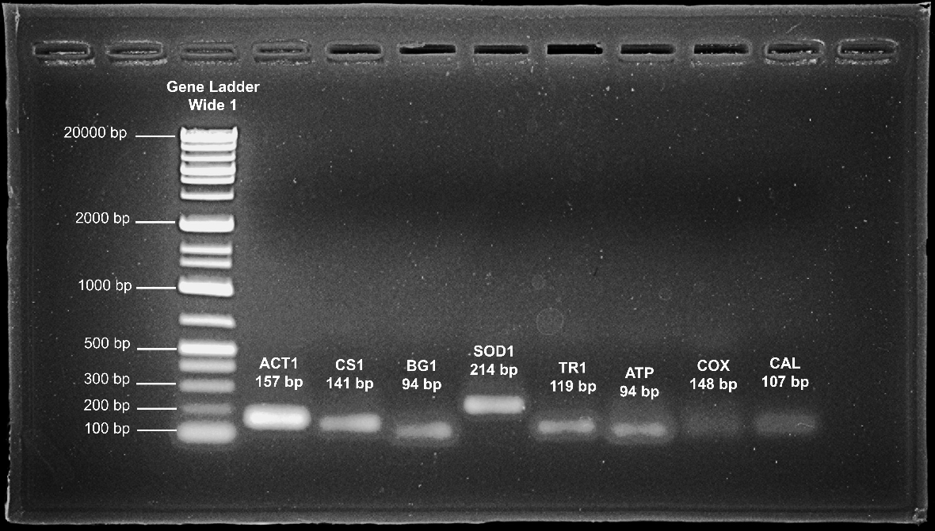
Supplementary Fig 1. Agarose gel electrophoresis of RT-qPCR amplicon from Rhizopogon roseolus TUFC10010. Primer pairs targeted actin (ACT1), chitin synthase (CS1), β-1,3-glucan synthase (BG1), Mn/Fe superoxide dismutase (SOD), thioredoxin reductase (TR1), ATP synthase F1 alpha subunit (ATP), cytochrome c oxidase (COX), and calmodulin (CAL). The observed amplicon sizes were consistent with the predicted size from OligoAnalyzer.

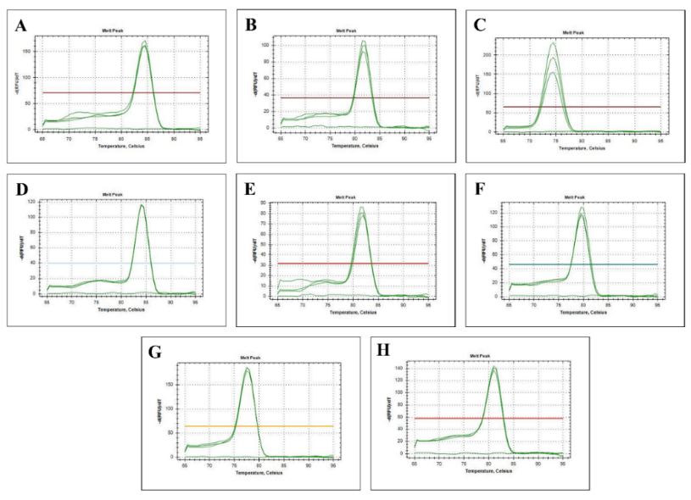
Supplementary Fig 2. Melting-curve analysis of RT-qPCR amplicons from Rhizopogon roseolus TUFC10010. The primer pairs includes (A) ACT1 targeting actin, (B) CS1 targeting chitin synthase, (C) BG1 targeting β-1,3-glucan synthase (BG1), (D) SOD targeting Mn/Fe superoxide dismutase, (E) TR1 targeting thioredoxin reductase, (F) ATP targeting ATP synthase F1 alpha subunit, (G) COX targeting cytochrome c oxidase, and (H) CAL targeting calmodulin. The observed melting temperature were close to the values predicted by OligoAnalyzer. Each amplicon produced a single sharp melting peak which indicates the present of specific amplicon.

