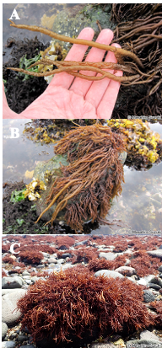
Figure S1. Gloiopeltis coliformis bed where the sample used in this study was collected.
A and B: morphology of the thallus; C: patchy beds

