Supplementary Material

Table S 1. Google Earth Engine app links for each case study presented in the spatial framework application section
Case study | Beneficiary class | Google Earth Engine app
3 | Private landowner | https://ee-lscogill4.projects.earthengine.app/view/iatmanagementcasestudy3
4 | Communal/tribal authority | https://ee-lscogill4.projects.earthengine.app/view/iatmanagementcasestudy4
7 | Collective | https://ee-lscogill4.projects.earthengine.app/view/iatmanagementcasestudy7

Table S2. Range of annual water supply benefits estimated from the satellite-derived ensemble model, presenting the minimum, mean, and maximum potential returns (ZAR/ha/year) based on the volume of water that could be saved if invasive alien trees were replaced with the corresponding adjacent indigenous vegetation class.
Total water supply benefit | Case study 1 | Case study 2 | Case study 3 | Case study 4 | Case study 5 | Case study 6 | Case study 7 | Case study 8 | Case study 9
Mean (ZAR/ha) | 665.78 | 719.33 | 150.89 | 682.99 | 692.56 | 612.45 | 547.06 | 300.98 | 594.19
Minimum (ZAR/ha) | 450.62 | 573.8 | 84.55 | 455.77 | 539.48 | 340.08 | 305.06 | 187.38 | 380.01
Maximum (ZAR/ha) | 794.01 | 814.04 | 210.33 | 825.52 | 823.13 | 757.29 | 798.69 | 495.52 | 985.42
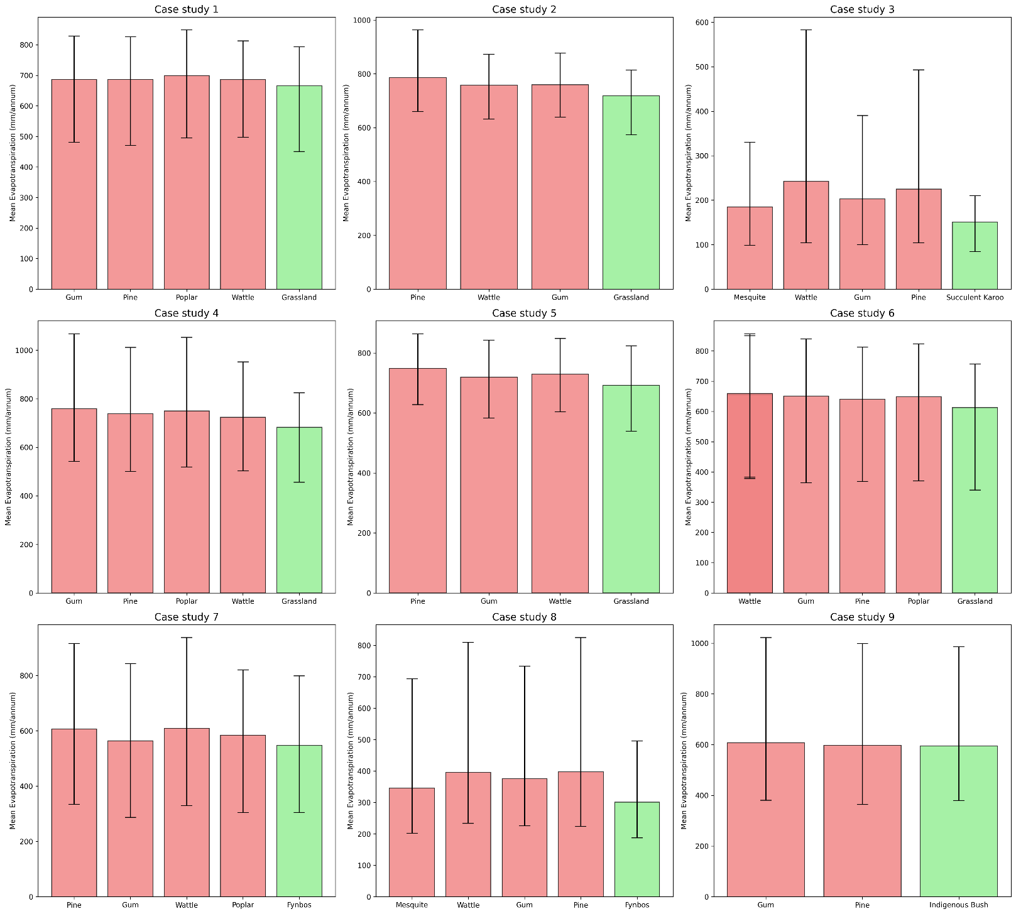
Figure S1. Graph of min-max ranges for each invasive alien tree class and the respective adjacent indigenous vegetation as well.
Table S3. The water-use tariffs assigned to each case study are specified according to the relevant water-user type. These tariffs are based on provincial average values reported by Ruiters and Amadi-Echendu (2023).
Case Study | Water-user | Province | Tariff type | Tariff (ZAR/m³) | Water-user assumptions
1 | farm | KZN | raw water | 0.629 | In this scenario, alien clearing is assumed to be undertaken and financed by the farmer. The water saved over the period therefore accrues directly to the farmer, who abstracts the raw water for on-farm use.
2 | farm | KZN | raw water | 0.629
3 | farm | NC | raw water | 1.388
4 | municipal | KZN | water board | 6.017 | In this scenario, a water board (e.g., Amatola Water in the Eastern Cape or uMngeni-uThukela Water in KwaZulu-Natal) is assumed to invest in alien clearing and store the recovered water in a bulk reservoir for sale to municipalities, which then distribute it to communities. It is important to note that this tariff reflects bulk supply only and excludes treatment and distribution costs typically included in municipal tariffs.
5 | municipal | KZN | water board | 6.017
6 | municipal | EC | water board | 9.034
7 | collective | WC | water board | 9.331 | In this scenario, a collective (i.e. Boland Groot Winterhoek SWSA Collective for case study 7 in the Western Cape, Citrusdal Water User Association for case study 8 in the Western Cape, and the Soutpansberg Conservancy for case study 9 in Limpopo) is assumed to invest in alien clearing and store the recovered water in a bulk reservoir for sale to municipalities, which is then distributed to communities. This tariff reflects bulk supply only and excludes treatment and distribution costs typically included in municipal tariffs.
8 | collective | WC | water board | 9.331
9 | collective | LIM | water board | 6.202

Table S4. The allocation of biomass from each invasive alien tree genus to its respective bioproducts is presented. Each bioproduct includes a conversion ratio indicating how many tonnes of a specific product can be derived from one tonne of raw woody biomass, along with the corresponding rate per tonne (ZAR/t).
Genus and applicable bioproduct | Conversion ratio (t/t) | ZAR (2025)/t | Reference | Note
Pinus spp - pulp | 0.5 | 1184 | Vundla et al., 2016 | The firewood value for Poplar, and Eucalyptus was assumed to be the same as Wattle
Poplar - firewood | 1 | 666 | Vundla et al., 2016
Wattle spp - firewood | 1 | 666 | Vundla et al., 2016
Eucalyptus spp - firewood | 1 | 666 | Vundla et al., 2016
Wattle spp - briquettes | 0.3 | 9250 | Vundla et al., 2016
Eucalyptus spp - charcoal | 0.8 | 3807 | Vundla et al., 2017 | The charcoal value for Mesquite was assumed to be equivalent to that of Eucalyptus to remain conservative, despite Mesquite being known to produce restaurant-quality charcoal.
Mesquite spp - charcoal | 0.8 | 3807 | Vundla et al., 2017
Mesquite spp - firewood | 1 | 1705 | Dovie et al., 2012 | Firewood price based on Northern Cape invasions

Table S5. The total biomass (tonnes) from each bioproduct type in each case study.
Case study | Biomass (tonnes) | Bioproduct | Bioproduct tonnes acquired after applying the conversion ratio
1 | 7023.98 | Gum charcoal | 5619.18
1 | 42131.87 | Firewood | 42131.87
2 | 4910.94 | Wattle briquettes | 1473.28
2 | 8297.28 | Firewood | 8297.28
3 | 67716.85 | Mesquite charcoal | 31826.92
3 | 81377.44 | Firewood | 81377.44
4 | 8346.21 | Wattle briquettes | 2503.86
4 | 26934.02 | Firewood | 26934.02
5 | 5032.56 | Wattle briquettes | 1509.77
5 | 14258.35 | Firewood | 14258.35
6 | 101247.40 | Wattle briquettes | 30374.22
6 | 58269.15 | Firewood | 58269.15
7 | 4299.52 | Wattle briquettes + Pine pulp | 1719.81
7 | 8959.12 | Firewood | 8959.12
8 | 78526.22 | Firewood | 78526.22
9 | 3180.74 | Gum charcoal | 2544.59
9 | 5533.54 | Firewood | 5533.54

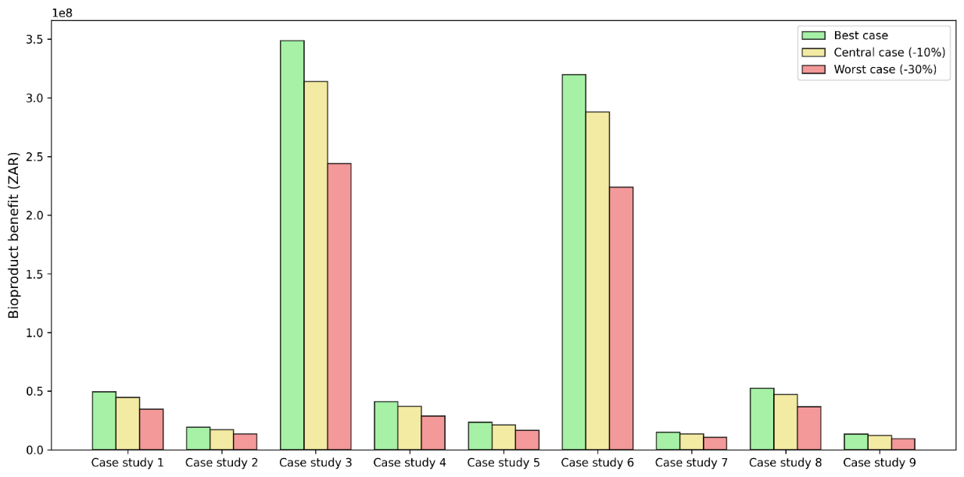
Figure S2. Comparison of estimated bioproduct benefits (ZAR) across nine case studies. Bars represent the projected benefits under a best-case scenario, a central case (assuming a 10% reduction), and a worst-case scenario (assuming a 30% reduction).

Table S6. Distribution of alien tree invasion counts across the different density categories (very scattered, scattered, medium, dense, and very dense) for each case study.
Case study | Invasive alien tree taxon | Very scattered (1-5%) | Scattered (5-25%) | Medium (25-50%) | Dense (50-75%) | Very dense (75-100%)
1 | Gum | 477 | 147 | 39 | 13 | 7
1 | Pine | 482 | 176 | 4 | 5 | 4
1 | Poplar | 1557 | 685 | 148 | 49 | 20
1 | Wattle | 844 | 362 | 17 | 0 | 0
2 | Pine | 54 | 50 | 14 | 2 | 0
2 | Wattle | 253 | 449 | 110 | 17 | 2
2 | Gum | 60 | 60 | 20 | 10 | 2
3 | Mesquite | 1684 | 2014 | 995 | 566 | 459
3 | Wattle | 52 | 4 | 0 | 0 | 0
3 | Gum | 258 | 94 | 0 | 0 | 0
3 | Pine | 89 | 55 | 1 | 0 | 0
4 | Gum | 122 | 96 | 22 | 2 | 3
4 | Pine | 133 | 90 | 4 | 0 | 0
4 | Poplar | 159 | 87 | 5 | 2 | 0
4 | Wattle | 348 | 749 | 345 | 107 | 30
5 | Pine | 83 | 24 | 0 | 0 | 0
5 | Gum | 317 | 518 | 145 | 38 | 13
5 | Wattle | 128 | 111 | 28 | 5 | 1
6 | Wattle | 1225 | 1677 | 643 | 347 | 206
6 | Gum | 799 | 439 | 20 | 1 | 0
6 | Pine | 114 | 90 | 7 | 0 | 0
6 | Poplar | 1082 | 560 | 13 | 0 | 0
7 | Pine | 151 | 116 | 16 | 0 | 0
7 | Gum | 214 | 89 | 1 | 0 | 0
7 | Wattle | 334 | 320 | 53 | 4 | 0
7 | Poplar | 56 | 8 | 0 | 0 | 0
8 | Mesquite | 1071 | 54 | 0 | 0 | 0
8 | Wattle | 1160 | 303 | 9 | 8 | 0
8 | Gum | 3271 | 1223 | 17 | 1 | 0
8 | Pine | 1501 | 1385 | 186 | 19 | 3
9 | Gum | 578 | 345 | 61 | 17 | 8
9 | Pine | 105 | 45 | 2 | 0 | 0

Table S7. The number of medium to very dense hectares for each genus is presented, defined as areas with more than 25% cover per hectare. These areas are assumed to be treated with herbicide, and the corresponding application rates and spray-mix volumes are provided. The mean RT12 contract prices are also included, together with the total herbicide cost for each genus.
Case study | Invasive alien tree taxon | Medium to very dense ha (density >25%) | Herbicide | Herbicide dosage/10L | Actipron Super dosage/ 10L | RT12 - herbicide (R/L) | RT12 – Actipron Super (R/L) | Total cost (ZAR)
1 | Gum | 59 | Imazapyr - Imidazolinone 100g/l | 0.5 | N/A | 219.5723 | N/A | 6477.38
1 | Wattle | 16 | Triclopyr - Amine salt 360 g/l | 0.3 | 0.05 | 246.4283 | 80.8555 | 1247.54
1 | Poplar | 216 | Imazapyr - Imidazolinone 100g/l | 0.5 | N/A | 219.5723 | N/A | 23713.81
1 | Pine | 13 | N/A |  |  |  |  | 0.00
1 | Total |  |  |  |  |  |  | 31438.74
2 | Wattle | 151 | Triclopyr - Amine salt 360 g/l | 0.3 | 0.05 | 246.4283 | 80.8555 | 11773.66
2 | Gum | 35 | Imazapyr - Imidazolinone 100g/l | 0.5 | N/A | 219.5723 | N/A | 3842.52
2 | Pine | 17 | N/A |  |  |  |  | 0.00
2 | Total |  |  |  |  |  |  | 15616.18
3 | Mesquite | 1977 | Triclopyr - Butoxy Ethyl Ester 29 g/l | 5 | N/A | 93.08 | N/A | 920095.80
3 | Wattle | 0 | Triclopyr - Amine salt 360 g/l | 0.3 | 0.05 | 246.4283 | 80.8555 | 0.00
3 | Gum | 0 | Imazapyr - Imidazolinone 100g/l | 0.5 | N/A | 219.5723 | N/A | 0.00
3 | Pine | 1 | N/A |  |  |  |  | 0.00
3 | Total |  |  |  |  |  |  | 920095.80
4 | Wattle | 482 | Triclopyr - Amine salt 360 g/l | 0.3 | 0.05 | 246.4283 | 80.8555 | 37582.15
4 | Gum | 27 | Imazapyr - Imidazolinone 100g/l | 0.5 | N/A | 219.5723 | N/A | 2964.23
4 | Pine | 4 | N/A |  |  |  |  | 0.00
4 | Poplar | 7 | Imazapyr - Imidazolinone 100g/l | 0.5 | N/A | 219.5723 | N/A | 768.50
4 | Total |  |  |  |  |  |  | 41314.88
5 | Pine | 0 | N/A |  |  |  |  | 0.00
5 | Gum | 39 | Imazapyr - Imidazolinone 100g/l | 0.5 | N/A | 219.5723 | N/A | 4281.66
5 | Wattle | 229 | Triclopyr - Amine salt 360 g/l | 0.3 | 0.05 | 246.4283 | 80.8555 | 17855.42
5 | Total |  |  |  |  |  |  | 22137.08
6 | Wattle | 1295 | Triclopyr - Amine salt 360 g/l | 0.3 | 0.05 | 246.4283 | 80.8555 | 100972.79
6 | Gum | 21 | Imazapyr - Imidazolinone 100g/l | 0.5 |  |  |  | 0.00
6 | Pine | 7 | N/A |  |  |  |  | 0.00
6 | Poplar | 13 | Imazapyr - Imidazolinone 100g/l | 0.5 | N/A | 219.5723 | N/A | 1427.22
6 | Total |  |  |  |  |  |  | 102400.01
7 | Wattle | 50 | Triclopyr - Amine salt 360 g/l | 0.3 | 0.05 | 246.4283 | 80.8555 | 3898.56
7 | Pine | 15 | N/A |  |  |  |  | 0.00
7 | Gum | 1 | Imazapyr - Imidazolinone 100g/l | 0.5 | N/A | 219.5723 | N/A | 109.79
7 | Poplar | 0 | Imazapyr - Imidazolinone 100g/l | 0.5 | N/A | 219.5723 | N/A | 0.00
7 | Total |  |  |  |  |  |  | 4008.35
8 | Gum | 15 | Imazapyr - Imidazolinone 100g/l | 0.5 | N/A | 219.5723 | N/A | 1646.79
8 | Pine | 189 | N/A |  |  |  |  | 0.00
8 | Wattle | 14 | Triclopyr - Amine salt 360 g/l | 0.3 | 0.05 | 246.4283 | 80.8555 | 1091.60
8 | Mesquite | 0 | Triclopyr - Butoxy Ethyl Ester 29 g/l | 5 | N/A | 93.08 | N/A | 0.00
8 | Total |  |  |  |  |  |  | 2738.39
9 | Gum | 73 | Imazapyr - Imidazolinone 100g/l | 0.5 | N/A | 219.5723 | N/A | 8014.39

Table S8. Notes on the environmental compatibility, human health considerations, and registration status of the herbicide products for each genus are provided.
Gum:

- Herbicide treatment is strictly required following mechanical felling (cut-stump) to prevent aggressive coppicing.
- Preferred selection & motivation: For Eucalyptus grandis, the recommended standard is Imazapyr 100 applied as a 5% mixture (10 L/ha). Imazapyr is selected primarily because it is highly effective at systemic root-kill and requires no adjuvant. This streamlines field logistics and simplifies the application process during active clearing operations.
- Alternative formulations: * Turbodor 29MPA (applied at 50ml per stump) is a viable alternative for E. grandis.
- Picloram 80/Fluroxypyr 80 mixtures could also be used but are not officially registered for adult E. grandis cut-stump treatments.
- Note on species variance: For Eucalyptus camaldulensis, the standard must shift to a Picloram 80/Fluroxypyr 80 formulation at 4.5% (9 L/ha), which demands extreme operational care to avoid water bodies due to its high mobility profile.

Pine:

- Herbicide treatment is entirely excluded for the effective clearing of invasive pines.
- Preferred selection & motivation: No herbicide is utilized. Mechanical felling alone achieves complete mortality. Avoiding herbicides ensures the immediate extraction of high-quality biomass for value-added products. Bypassing aerial/chemical applications eliminates prohibitive helicopter charter costs and prevents the severe environmental risks associated with Glyphosate drift or Triclopyr/Picloram volatility in sensitive, high-elevation fynbos and grassland catchments.
- Alternative formulations (evaluated but excluded): * Drill-and-fill and aerial basal bark application (ABBA) methods using Glyphosate 700 WG or Metsulfuron methyl 600 (50g/L), common in New Zealand studies, were excluded as they leave unusable standing dead timber.
- ABBA mixtures of Picloram and Triclopyr (100ml each mixed with 800ml paraffin) were excluded due to extreme application costs (e.g., MD500 or Robinson R44 helicopters) (Gous et al., 2014, 2015).
- A frill application of Triclopyr BEE and Picloram (120 + 20) is registered exclusively for Pinus pinaster but remains incompatible with the biomass recovery model (de Lange et al., 2022)
- Unlike gum species, herbicide treatment is not necessary for the effective clearing of invasive pines, and currently, there are no herbicides broadly registered for Pinus species in South Africa.

Neltuma:

- Targeted chemical intervention is required via cut-stump or basal applications.
- Preferred selection & motivation: The registered standard is a very low-dose formulation of Triclopyr butoxy ethyl ester (BEE) at 29g/l, enhanced with naturally derived oils. While standard Triclopyr BEE carries significant volatility and aquatic toxicity risks, this specific low-dose/natural oil mixture drastically minimizes the active ingredient's release into the environment. This ensures high target mortality while maintaining a much safer operational profile compared to highly mobile, persistent alternatives.
- Alternative formulations: Formulations containing Picloram remain operational options for Neltuma. However, they were not selected as the primary standard because they carry heavier environmental burdens, specifically high mobility, water solubility, and persistent soil residuality.
Wattle:

- Post-felling cut-stump treatment is essential to prevent vigorous regrowth and coppicing in mature wattles (e.g., A. mearnsii).
- Preferred selection & motivation: The highly effective, standard approach utilizes standalone Triclopyr amine formulations applied directly to the cut stump. Triclopyr is highly selective for broadleaf and woody invasive species, providing rapid, systemic disruption of the tree's vascular system to guarantee root death. The specific motivation for selecting the amine salt formulation over butoxy ethyl ester (BEE) formulations or Picloram mixtures is its superior environmental safety profile within sensitive catchments. Triclopyr amine exhibits lower volatility than ester formulations, drastically reducing the risk of off-target vapor drift in warm climates. Furthermore, it avoids the highly persistent soil residuality and extreme water mobility associated with Picloram, minimizing long-term ecological damage to the cleared site.

Poplar:

- Systemic herbicide application is mandatory post-felling to control extensive root networks
- Preferred selection & motivation: The preferred cut-stump treatment is Imazapyr 100 at a 5% mixture (10 L/ha). Similar to the Gum protocols, Imazapyr is the preferred choice because it delivers powerful, broad-spectrum root mortality and requires no adjuvant. This simplifies field operations while ensuring the root base is killed, allowing the above-ground biomass to be successfully felled and harvested.
- Alternative Formulations: Several alternatives are effective for the cut-stump technique but were bypassed as the primary standard:
  - Picloram 240.
  - Kaput Gel (50/50 mixture of Triclopyr and Picloram).
  - Triclopyr 480 and Triclopyr 360.
  - Note on Basal Treatments: Turbodor 29MPA is technically available for basal bark applications (50 ml/stump for 1.5–3m trees; 85 ml/stump for >3m trees). However, this is categorically excluded from the current operational model as it leaves standing dead timber, defeating the purpose of felling for biomass recovery.

Active ingredient profiles:

- Imazapyr (Imidazolinone): This active ingredient is non-volatile, does not bioaccumulate, and is virtually non-toxic to animals, carrying no strong systemic hazard as it is not classified as a carcinogen or mutagen. It is only a mild irritant for skin and eyes. However, it presents a high environmental risk due to being highly mobile, water-soluble, and possessing long soil residuality. As a broad-spectrum systemic herbicide, it can severely harm non-target terrestrial and aquatic vegetation long after application.
- Fluroxypyr (Methyl Heptyl Ester): Fluroxypyr does not bioaccumulate, has very low mammalian toxicity, and is relatively safe to animals, with no classifications for acute or chronic health hazards. It can, however, induce skin and eye irritation, and in high doses, even reproductive toxicity. Environmentally, it poses a moderate risk as it is moderately mobile with a potential for leaching, and it is toxic to aquatic plants and animals, such as estuarine oysters and invertebrates.
- Picloram: While Picloram has low volatility, it carries a high environmental risk because it is very mobile, water-soluble, and has a long soil residual. For human health, it is classified as a skin sensitizer that may cause allergic skin reactions. It can also cause severe eye irritation or damage and is harmful if swallowed.
- Triclopyr: The risks associated with Triclopyr depend heavily on the specific formulation. The Amine Salt formulation is highly water-soluble and mobile but has lower residuality; however, it is flammable, acts as an eye irritant, and carries the potential for kidney damage from prolonged exposure. In contrast, the Butoxy Ethyl Ester (BEE) formulation is non-flammable but is highly toxic to aquatic organisms and has higher relative volatility. It is also known to have higher acute oral toxicity, skin irritation, and eye irritation compared to amine salts.

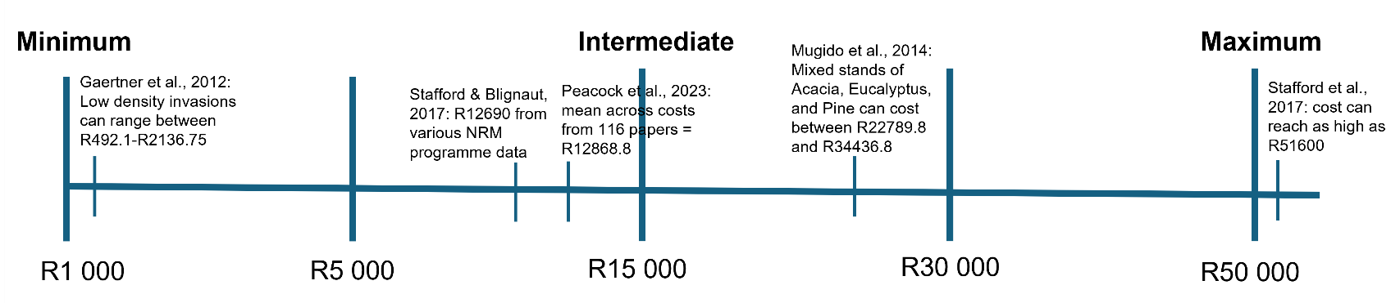
Figure S3. Average industry cost per hectare for invasive alien tree clearing, including personnel and equipment. Associated references are shown, with reported costs converted to 2025 values to demonstrate alignment with current industry standards.

Table S9. The mean distance of all invasive alien tree pixels to the nearest town, together with the total biomass (tonnes), is presented for each case study. Transport costs are estimated by applying a transport rate to both the mean distance and total biomass. The transport rate is derived from Mugido et al. (2014) and adjusted to 2025 values (R4.375 per tonne per km). An additional fixed cost for transport to the site from town (R2460 + R650) is also included (Truck Hire, n.d.).
Case study | Nearest Town | Invasive alien tree mean distance (m) | Biomass (t) | Rate (ZAR/t/km) | Total (ZAR)
1 | Winterton | 7849 | 49155.85 | 4.375 | 1691275.66
2 | Nottingham Road | 9647 | 13208.22 | 4.375 | 560797.707
3 | Niewoudtville | 25227 | 149094.30 | 4.375 | 16458959.7
4 | Van Reenen | 21374 | 35280.23 | 4.375 | 3302710.4
5 | Edendale | 8475 | 19290.91 | 4.375 | 718579.818
6 | Matatiele | 16553 | 159516.60 | 4.375 | 11555588.8
7 | Franschoek | 8732 | 13258.63 | 4.375 | 509828.192
8 | Citrusdal | 3396 | 78526.22 | 4.375 | 1169860.94
9 | Louis Trichardt | 19674 | 8714.28 | 4.375 | 753643.476

Table S10. The present values (PVs) of the benefit and cost components are reported over a 50-year period for each case study in ZAR, using a 4%, 6%, and 8% discount rate under the central scenario. The corresponding net present values (NPVs) and benefit-cost ratios (BCRs) are also provided.
Case study | PV Biomass 4% | PV Water 4% | PV Transport 4% | PV Chemical 4% | PV Personnel 4% | NPV (ZAR) | BCR
1 | 42795051.67 | 251582.71 | 1626226.60 | 73725.06 | 12728869.71 | 28617813.02 | 2.98
2 | 16575442.08 | 159535.01 | 539228.56 | 36620.55 | 4340666.51 | 11818461.46 | 3.40
3 | 301669942.80 | 967506.46 | 15825922.81 | 2157660.20 | 83176175.35 | 201477690.90 | 2.99
4 | 35566258.80 | 3645105.57 | 3175683.07 | 96884.99 | 64336134.96 | -28397338.65 | 0.58
5 | 20303145.87 | 1221415.28 | 690942.13 | 51912.31 | 7178163.26 | 13603543.44 | 2.72
6 | 276723016.00 | 13637286.13 | 11111143.04 | 240131.98 | 68711977.05 | 210297050.00 | 3.63
7 | 12927988.29 | 1654197.63 | 490219.42 | 9399.74 | 52728193.71 | -38645626.95 | 0.27
8 | 45258287.12 | 13430690.44 | 1124866.29 | 6421.63 | 51733897.33 | 5823792.31 | 1.11
9 | 11572444.31 | 248350.01 | 724657.19 | 18794.05 | 39255946.75 | -28178603.68 | 0.30
Case study | PV Biomass 6% | PV Water 6% | PV Transport 6% | PV Chemical 6% | PV Personnel 6% | NPV (ZAR) | BCR
1 | 41987597.87 | 205867.04 | 1595543.08 | 63039.51 | 10883975.85 | 29650906.47 | 3.36
2 | 16262697.89 | 130545.54 | 529054.44 | 31312.85 | 3711540.03 | 12121336.11 | 3.84
3 | 295978057.10 | 791698.66 | 15527320.49 | 1844933.76 | 71120806.81 | 208276694.70 | 3.35
4 | 34895197.31 | 2982745.12 | 3115764.53 | 82842.70 | 55011399.67 | -20332064.46 | 0.65
5 | 19920067.64 | 999469.12 | 677905.49 | 44388.25 | 6137776.36 | 14059466.66 | 3.05
6 | 271501827.00 | 11159223.76 | 10901498.83 | 205327.79 | 58753017.01 | 212801207.10 | 4.05
7 | 12684063.98 | 1353609.60 | 480969.99 | 8037.36 | 45085887.42 | -31537221.19 | 0.31
8 | 44404357.18 | 10990169.04 | 1103642.40 | 5490.89 | 44235702.13 | 10049690.79 | 1.22
9 | 11354096.30 | 203221.76 | 710984.41 | 16070.09 | 33566277.76 | -22736014.19 | 0.34
Case study | PV Biomass 8% | PV Water 8% | PV Transport 8% | PV Chemical 8% | PV Personnel 8% | NPV (ZAR) | BCR
1 | 41210049.76 | 171909.83 | 1565995.98 | 55977.04 | 9664617.16 | 30095369.41 | 3.67
2 | 15961536.81 | 109012.40 | 519257.14 | 27804.79 | 3295727.04 | 12227760.26 | 4.18
3 | 290496981.90 | 661110.11 | 15239777.52 | 1638241.28 | 63152967.20 | 211127106.10 | 3.64
4 | 34248989.95 | 2490749.39 | 3058065.18 | 73561.62 | 48848336.72 | -15240224.18 | 0.71
5 | 19551177.50 | 834609.40 | 665351.68 | 39415.33 | 5450146.12 | 14230873.77 | 3.31
6 | 266474015.40 | 9318540.03 | 10699619.22 | 182324.41 | 52170771.43 | 212739840.30 | 4.37
7 | 12449173.91 | 1130335.37 | 472063.14 | 7136.91 | 40034804.12 | -26934494.90 | 0.34
8 | 43582054.27 | 9177370.43 | 1083204.58 | 4875.74 | 39279867.19 | 12391477.19 | 1.31
9 | 11143835.26 | 169700.88 | 697818.03 | 14269.71 | 29805764.78 | -19204316.38 | 0.37

Table S11. The present values (PVs) of the benefit and cost components are reported over a 50-year period for each case study in ZAR, using a 4%, 6%, and 8% discount rate under the worst-case scenario. The corresponding net present values (NPVs) and benefit-cost ratios (BCRs) are also provided.
Case study | PV Biomass 4% | PV Water 4% | PV Transport 4% | PV Chemical 4% | PV Personnel 4% | NPV (ZAR) | BCR
1 | 33285040.19 | 188153.04 | 1626226.60 | 73725.06 | 12728869.71 | 19044371.86 | 2.32
2 | 12892010.51 | 106643.89 | 539228.56 | 36620.55 | 4340666.51 | 8082138.78 | 2.64
3 | 234632177.70 | 394192.92 | 15825922.81 | 2157660.20 | 83176175.35 | 133866612.30 | 2.32
4 | 27662645.73 | 3306471.46 | 3175683.07 | 96884.99 | 64336134.96 | -36639585.83 | 0.46
5 | 15791335.67 | 846826.65 | 690942.13 | 51912.31 | 7178163.26 | 8717144.62 | 2.10
6 | 215229012.40 | 11963877.62 | 11111143.04 | 240131.98 | 68711977.05 | 147129638.00 | 2.84
7 | 10055102.01 | 589342.28 | 490219.42 | 9399.74 | 52728193.71 | -42583368.58 | 0.20
8 | 35200889.98 | 5753120.22 | 1124866.29 | 6421.63 | 51733897.33 | -11911175.06 | 0.77
9 | 9000790.02 | -17350.01 | 724657.19 | 18794.05 | 39255946.75 | -31015957.98 | 0.22
Case study | PV Biomass 6% | PV Water 6% | PV Transport 6% | PV Chemical 6% | PV Personnel 6% | NPV (ZAR) | BCR
1 | 32657020.57 | 153963.32 | 1595543.08 | 63039.51 | 10883975.85 | 20268425.45 | 2.62
2 | 12648765.03 | 87265.39 | 529054.44 | 31312.85 | 3711540.03 | 8464123.10 | 2.98
3 | 230205155.50 | 322563.22 | 15527320.49 | 1844933.76 | 71120806.81 | 142034657.60 | 2.61
4 | 27140709.02 | 2705644.99 | 3115764.53 | 82842.70 | 55011399.67 | -28363652.88 | 0.51
5 | 15493385.94 | 692947.84 | 677905.49 | 44388.25 | 6137776.36 | 9326263.69 | 2.36
6 | 211168087.60 | 9789894.13 | 10901498.83 | 205327.79 | 58753017.01 | 151098138.10 | 3.16
7 | 9865383.10 | 482251.55 | 480969.99 | 8037.36 | 45085887.42 | -35227260.12 | 0.23
8 | 34536722.25 | 4707707.62 | 1103642.40 | 5490.89 | 44235702.13 | -6100405.56 | 0.87
9 | 8830963.79 | -14197.30 | 710984.41 | 16070.09 | 33566277.76 | -25476565.76 | 0.26
Case study | PV Biomass 8% | PV Water 8% | PV Transport 8% | PV Chemical 8% | PV Personnel 8% | NPV (ZAR) | BCR
1 | 32052260.93 | 128567.49 | 1565995.98 | 55977.04 | 9664617.16 | 20894238.23 | 2.85
2 | 12414528.64 | 72871.20 | 519257.14 | 27804.79 | 3295727.04 | 8644610.87 | 3.25
3 | 225942097.00 | 269357.29 | 15239777.52 | 1638241.28 | 63152967.20 | 146180468.30 | 2.83
4 | 26638103.30 | 2259356.18 | 3058065.18 | 73561.62 | 48848336.72 | -23082504.05 | 0.56
5 | 15206471.39 | 578647.97 | 665351.68 | 39415.33 | 5450146.12 | 9630206.24 | 2.56
6 | 207257567.50 | 8175077.61 | 10699619.22 | 182324.41 | 52170771.43 | 152379930.10 | 3.42
7 | 9682690.82 | 402705.46 | 472063.14 | 7136.91 | 40034804.12 | -30428607.89 | 0.25
8 | 33897153.31 | 3931184.00 | 1083204.58 | 4875.74 | 39279867.19 | -2539610.19 | 0.94
9 | 8667427.43 | -11855.49 | 697818.03 | 14269.71 | 29805764.78 | -21862280.59 | 0.28

Table S12. The present values (PVs) of the benefit and cost components are reported over a 50-year period for each case study in ZAR, using a 4%, 6%, and 8% discount rate under the best-case scenario. The corresponding net present values (NPVs) and benefit-cost ratios (BCRs) are also provided.
Case study | PV Biomass 4% | PV Water 4% | PV Transport 4% | PV Chemical 4% | PV Personnel 4% | NPV (ZAR) | BCR
1 | 47550057.41 | 300304.80 | 1626226.60 | 73725.06 | 12728869.71 | 33421540.85 | 3.32
2 | 18417157.87 | 175482.95 | 539228.56 | 36620.55 | 4340666.51 | 13676125.19 | 3.78
3 | 335188825.30 | 3395947.06 | 15825922.81 | 2157660.20 | 83176175.35 | 237425014.00 | 3.35
4 | 39518065.33 | 10318499.41 | 3175683.07 | 96884.99 | 64336134.96 | -17772138.28 | 0.74
5 | 22559050.96 | 2115215.01 | 690942.13 | 51912.31 | 7178163.26 | 16753248.27 | 3.12
6 | 307470017.70 | 28513985.21 | 11111143.04 | 240131.98 | 68711977.05 | 255920750.80 | 4.20
7 | 14364431.43 | 3587062.04 | 490219.42 | 9399.74 | 52728193.71 | -35276319.39 | 0.34
8 | 50286985.69 | 45091742.05 | 1124866.29 | 6421.63 | 51733897.33 | 42513542.49 | 1.80
9 | 12858271.45 | 660697.96 | 724657.19 | 18794.05 | 39255946.75 | -26480428.58 | 0.34
Case study | PV Biomass 6% | PV Water 6% | PV Transport 6% | PV Chemical 6% | PV Personnel 6% | NPV (ZAR) | BCR
1 | 46652886.52 | 245735.73 | 1595543.08 | 63039.51 | 10883975.85 | 34356063.81 | 3.74
2 | 18069664.32 | 143595.54 | 529054.44 | 31312.85 | 3711540.03 | 13941352.54 | 4.26
3 | 328864507.80 | 2778861.78 | 15527320.49 | 1844933.76 | 71120806.81 | 243150308.50 | 3.75
4 | 38772441.45 | 8443501.34 | 3115764.53 | 82842.70 | 55011399.67 | -10994064.09 | 0.81
5 | 22133408.49 | 1730854.47 | 677905.49 | 44388.25 | 6137776.36 | 17004192.86 | 3.48
6 | 301668696.60 | 23332643.91 | 10901498.83 | 205327.79 | 58753017.01 | 255141496.90 | 4.65
7 | 14093404.42 | 2935248.82 | 480969.99 | 8037.36 | 45085887.42 | -28546241.53 | 0.37
8 | 49338174.64 | 36898018.73 | 1103642.40 | 5490.89 | 44235702.13 | 40891357.95 | 1.90
9 | 12615662.56 | 540641.03 | 710984.41 | 16070.09 | 33566277.76 | -21137028.67 | 0.38
Case study | PV Biomass 8% | PV Water 8% | PV Transport 8% | PV Chemical 8% | PV Personnel 8% | NPV (ZAR) | BCR
1 | 45788944.18 | 205202.29 | 1565995.98 | 55977.04 | 9664617.16 | 34707556.29 | 4.08
2 | 17735040.91 | 119909.85 | 519257.14 | 27804.79 | 3295727.04 | 14012161.79 | 4.65
3 | 322774424.40 | 2320496.05 | 15239777.52 | 1638241.28 | 63152967.20 | 245063934.40 | 4.06
4 | 38054433.28 | 7050768.67 | 3058065.18 | 73561.62 | 48848336.72 | -6874761.58 | 0.87
5 | 21723530.56 | 1445354.71 | 665351.68 | 39415.33 | 5450146.12 | 17013972.14 | 3.76
6 | 296082239.30 | 19483987.50 | 10699619.22 | 182324.41 | 52170771.43 | 252513511.70 | 5.00
7 | 13832415.45 | 2451087.48 | 472063.14 | 7136.91 | 40034804.12 | -24230501.25 | 0.40
8 | 48424504.74 | 30811790.50 | 1083204.58 | 4875.74 | 39279867.19 | 38868347.73 | 1.96
9 | 12382039.18 | 451463.76 | 697818.03 | 14269.71 | 29805764.78 | -17684349.59 | 0.42

Table S13. Bias-corrected benefit-cost ratios (BCR) and the net present values (NPV) for the nine case-studies, accounting for the systematic underestimation in the satellite-derived evapotranspiration and biomass models. Modelled and bias-corrected BCR and NPV are shown together with the absolute shifts and the underlying modelled versus bias corrected present value for water and biomass. NPV values are expressed in ZAR.
Case study | BCR | BCR corrected | BCR shift | NPV | NPV corrected | NPV shift | PV Water corrected | PV Biomass corrected
6 | 4.0461 | 5.3891 | 1.343 | 212801207 | 306620959 | 93819752 | 12885556 | 363595246
2 | 3.8375 | 5.1335 | 1.296 | 12121336 | 17657839 | 5536503 | 150740.9 | 21779005
1 | 3.364 | 4.5021 | 1.138 | 29650906 | 43924947 | 14274041 | 237714.7 | 56229791
3 | 3.3536 | 4.4895 | 1.1359 | 208276695 | 308794927 | 100518233 | 914174.4 | 396373814
5 | 3.0495 | 4.057 | 1.0075 | 14059467 | 20970971 | 6911505 | 1154087 | 26676955
8 | 1.2216 | 1.5913 | 0.3697 | 10049691 | 26811828 | 16762137 | 12690348 | 59466315
4 | 0.6507 | 0.862 | 0.2113 | -20332064 | -8034183 | 12297882 | 3444176 | 46731648
9 | 0.337 | 0.4502 | 0.1132 | -22736014 | -18853266 | 3882748 | 234660.2 | 15205406
7 | 0.308 | 0.407 | 0.099 | -31537221 | -27025383 | 4511838 | 1563013 | 16986498

