Rising seas weaken an offshore sediment lifeline to coastal wetlands

Hangjie Lin¹, Song Jin^{1,2}, Sergio Fagherazzi¹, and Cédric G. Fichot^{1,*}

¹Department of Earth and Environment, Boston University, MA, 02215
²Yantai Institute of Coastal Zone Research, Chinese Academy of Sciences, Yantai 264003, P. R. China
*Cédric G Fichot
Email: cgfichot@bu.edu

Supporting Figures

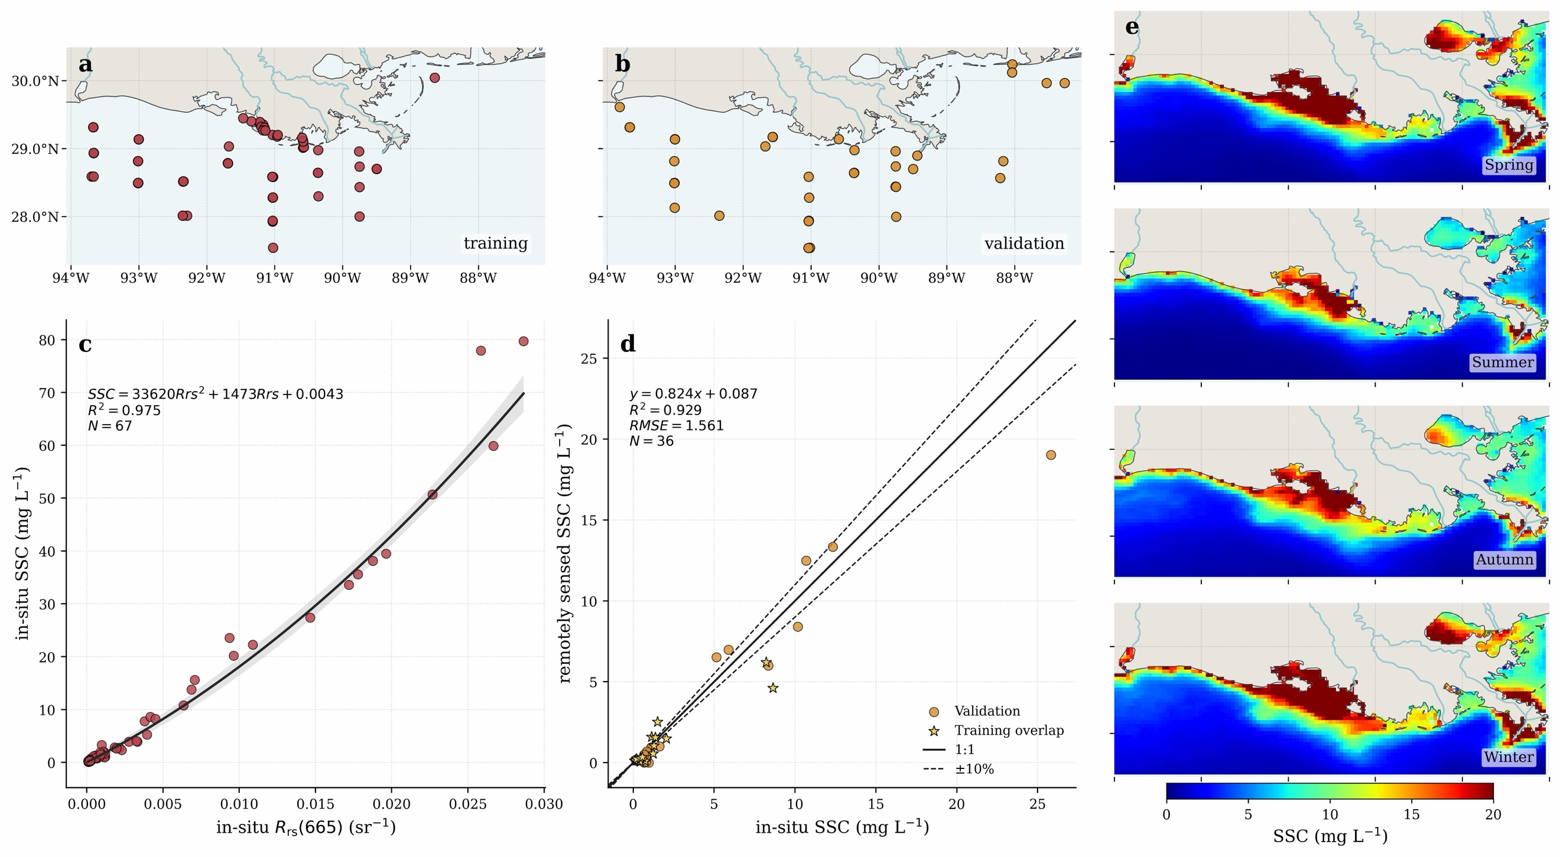

Figure S1 | Remote-sensing algorithm, validation and seasonal maps for suspended sediment concentration in coastal Louisiana. (a) Spatial distribution of in-situ training sites used to define the $Rrs(665)$–SSC relationship. (b) Spatial distribution of validation sites used for independent satellite–in-situ matchup assessment. (c) Quadratic relationship between in-situ $Rrs(665)$ and in-situ SSC, with the fitted curve, confidence envelope, coefficient of determination and sample size. (d) Validation of remotely sensed SSC against in-situ SSC, with the 1:1 line and ±10% reference bounds. (e) Seasonal mean SSC distributions for spring, summer, autumn and winter derived from monthly Ocean Colour CCI $Rrs(665)$ products over the Louisiana coastal shelf.
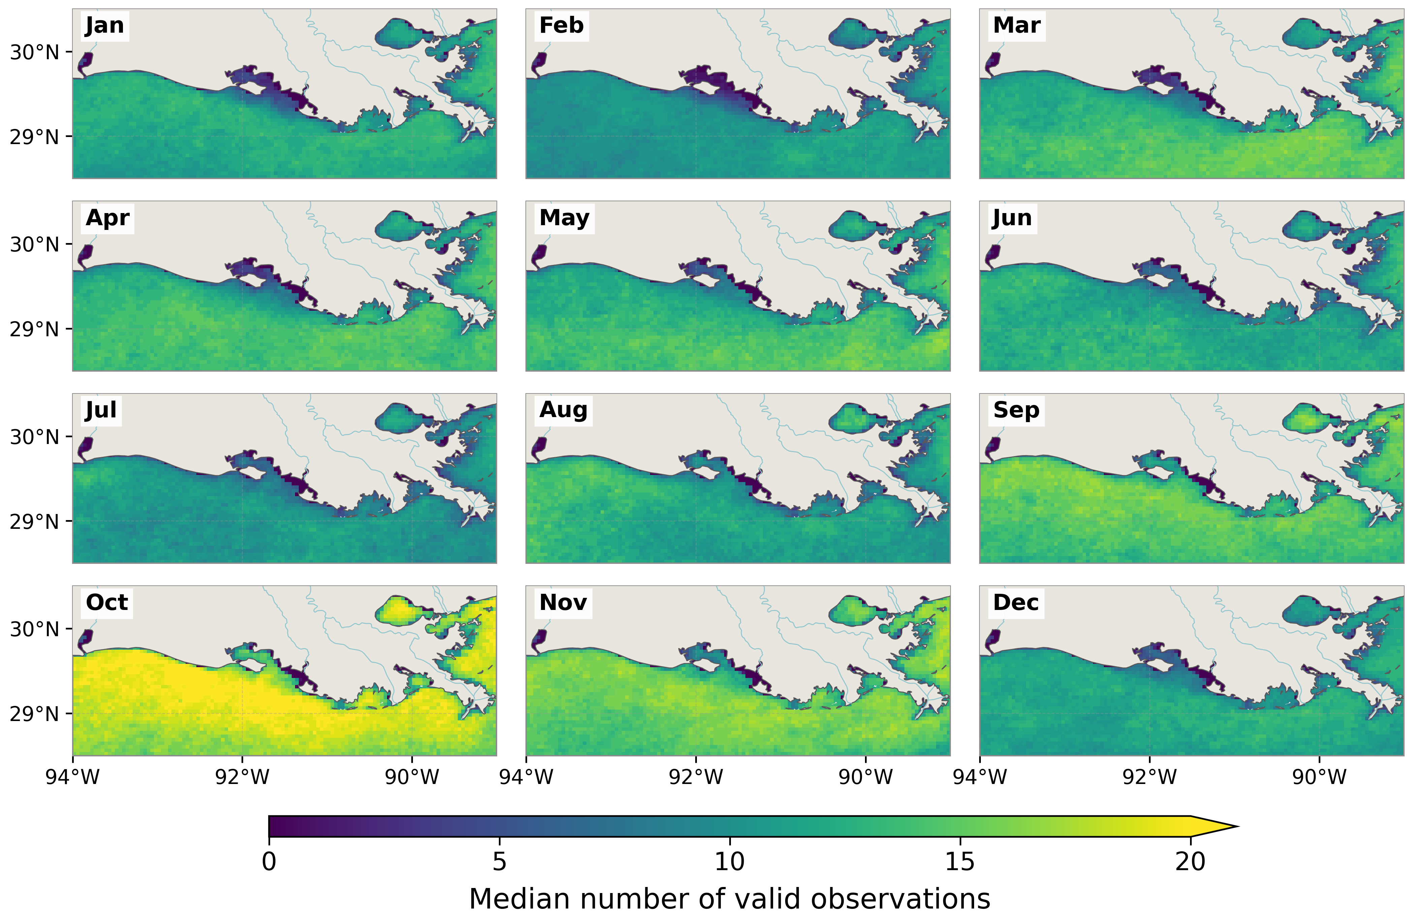

Figure S2 | Availability of Ocean Colour CCI observations along the Louisiana coast. Monthly climatology of valid daily Ocean Colour CCI $R_{rs}\left(665\right)$ observations from 2003 to 2024. Each panel shows, for each 4-km pixel, the median number of valid observation days for the corresponding calendar month across the 22-year record.
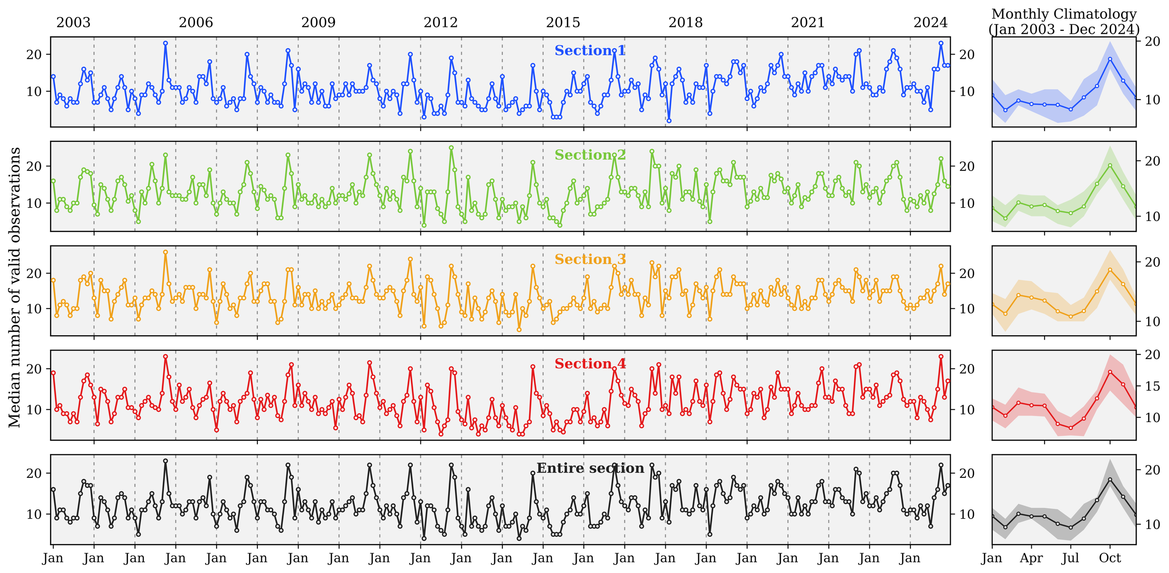

Figure S3 | Temporal variability in satellite observation availability along the Louisiana 4-m isobath. Monthly median number of valid daily Ocean Colour CCI $R_{rs}\left(665\right)$ observations from 2003 to 2024 for four predefined sections of the Louisiana 4-m isobath and for the entire section. For each month, values represent the spatial median of valid-observation days across eligible pixels within each section. Right panels show the monthly climatology, with lines indicating the climatological mean and shading the interquartile range.
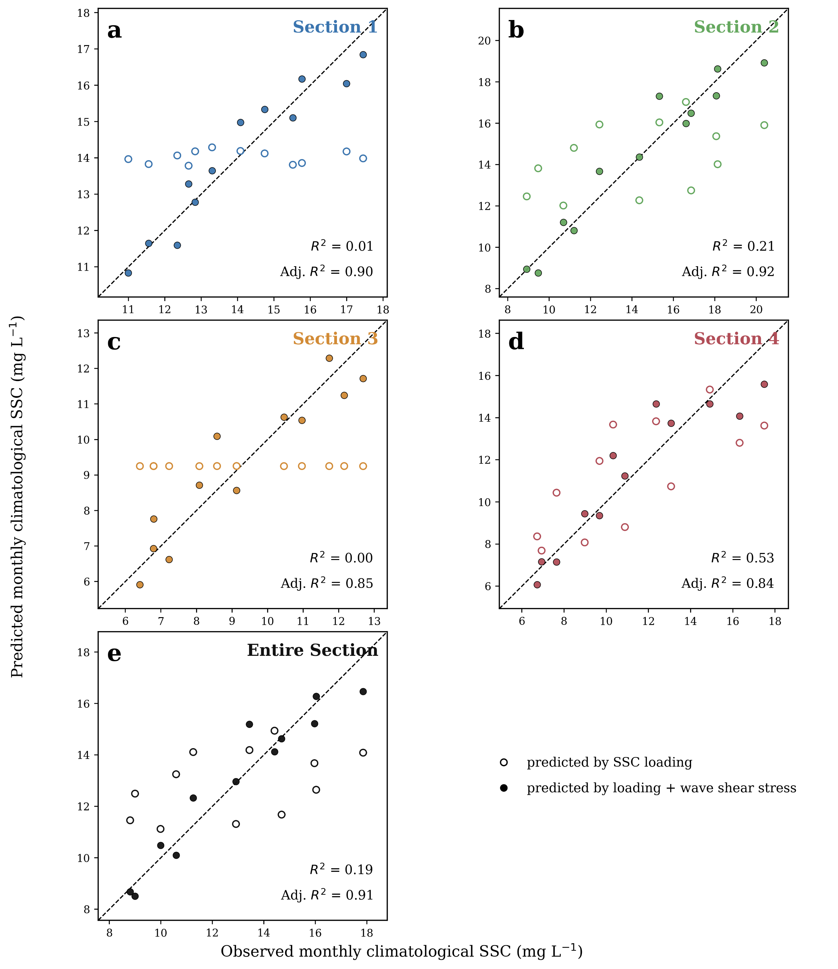

Figure S4 | Seasonal SSC relationships with riverine sediment loading and wave-driven bottom shear stress. Observed versus predicted monthly climatological SSC for the four Louisiana coastal sections (a-d) and the full coastal domain (e). Open circles show predictions from riverine sediment loading alone, whereas filled circles show predictions from a multiple-regression model that combines sediment loading with wave-driven bottom shear stress. The dashed line denotes the one-to-one relationship.

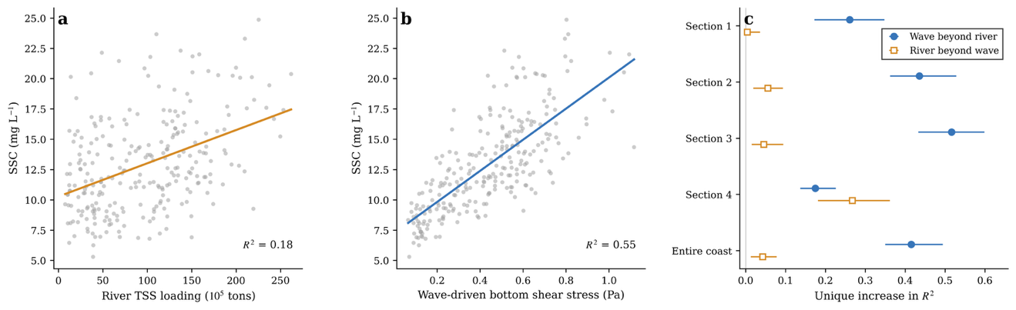
Figure S5 | Additional explanatory power of river sediment loading and wave-driven resuspension for monthly SSC variability. (a, b) Monthly suspended sediment concentration (SSC) across the Louisiana coast in relation to combined Mississippi–Atchafalaya river TSS loading (a) and wave-driven bottom shear stress (b); lines show ordinary least-squares fits. (c) Increase in explained SSC variance when wave stress is added to a river-only model, or river loading is added to a wave-only model, for each coastal section and the entire coast. Error bars show 95% intervals from whole-year bootstrap resampling. The comparisons retain seasonality and describe conditional statistical associations.

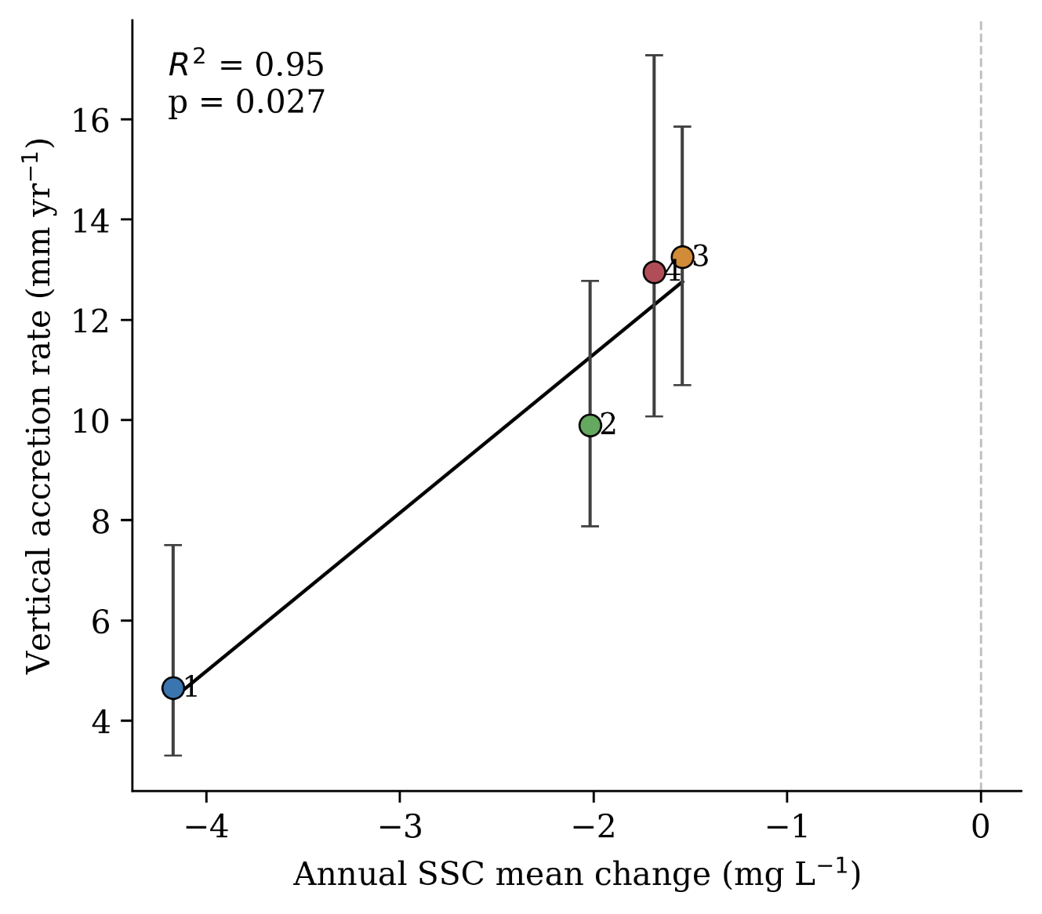

Figure S6 | Section-scale relationship between annual SSC change and vertical accretion rate. Section-median vertical accretion rates are plotted against the change in annual mean suspended sediment concentration (SSC) between the early and late halves of the accretion observation window, calculated as the 2011–2015 mean minus the 2006–2010 mean. Each point represents one Louisiana coastal section, with numbers indicating section IDs from west to east. Vertical error bars show the interquartile range of station-level accretion rates within each section. The black line shows an ordinary least-squares fit across the four sections, and the dashed grey line marks zero SSC change. Sections with stronger SSC declines show lower vertical accretion rates, providing a time-window-matched consistency check between declining nearshore sediment availability and reduced wetland vertical growth. Because the regression is based on four section-level observations, it is used as supporting evidence rather than as a formal attribution test.
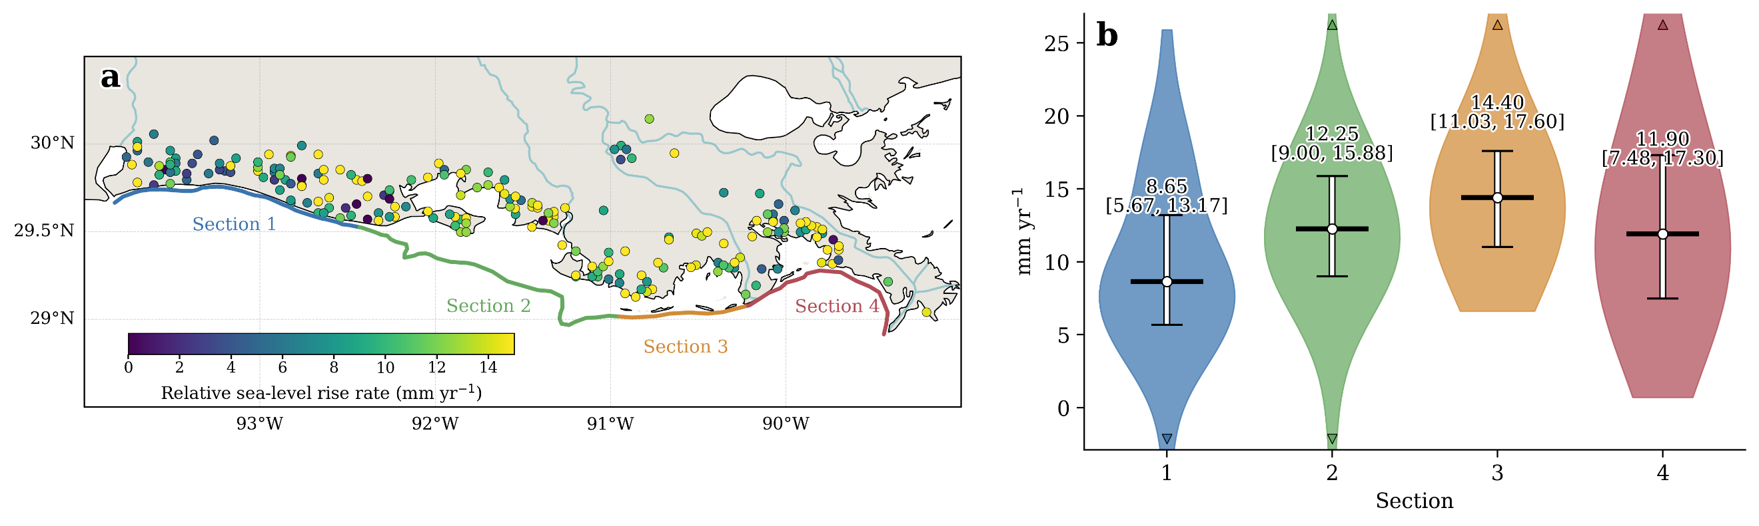

Figure S7 | Sectional structure of relative sea-level rise across coastal Louisiana. (a) Spatial distribution of relative sea-level rise rate at monitoring stations. (b) Section-level distributions of relative sea-level rise rate. In violin plots, colours denote Sections 1–4, black horizontal markers indicate medians, vertical white bars indicate the interquartile range, and bracketed values give the 25th–75th percentile interval. Focused y-axis ranges are used only to improve the visibility of the median and interquartile range; small edge triangles mark values outside the displayed range.
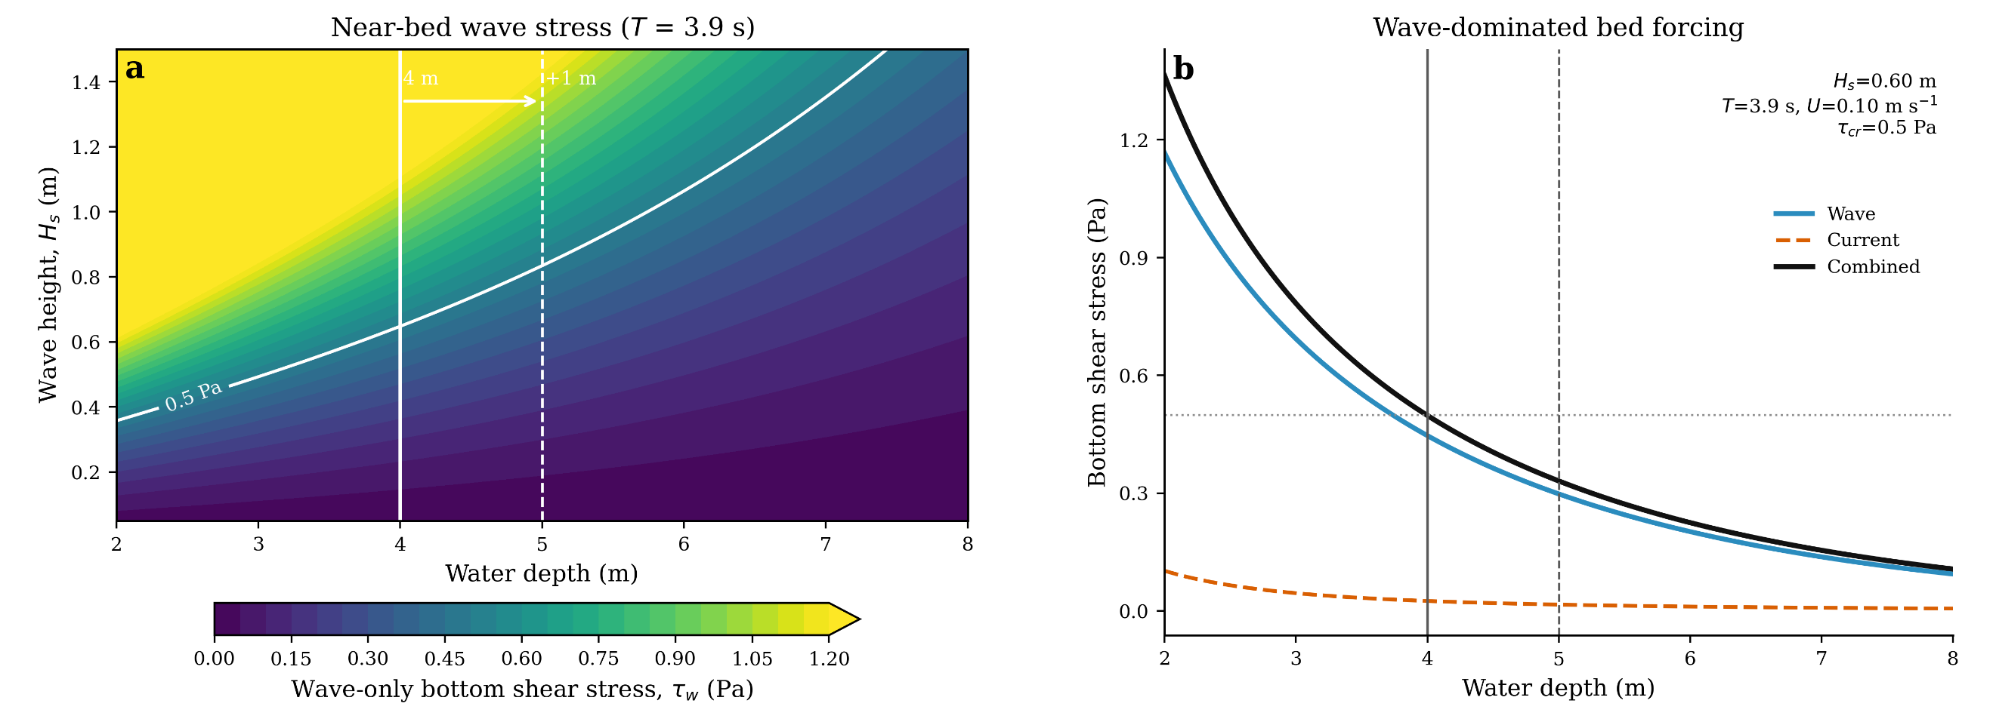

Figure S8 | Wave bottom shear stress response to significant wave height and water depth. (a) Near-bed wave shear stress as a function of water depth and significant wave height for a wave period of 3.9 s. The 0.5 Pa contour illustrates a representative critical-stress threshold for sediment resuspension. (b) Decomposition of bottom shear stress into wave, current and combined components for a wave height of 0.60 m, wave period of 3.9 s and current speed of 0.10 m s⁻¹. Wave stress dominates the combined bed stress, but declines strongly with increasing water depth.

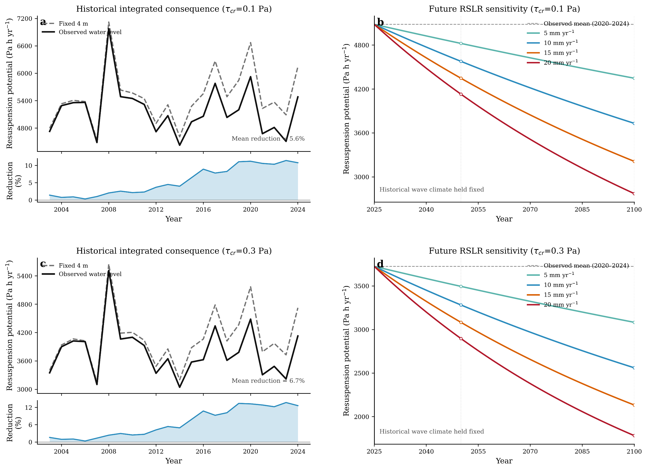

Figure S9 | Threshold sensitivity of historical and future wave-driven resuspension potential in coastal Louisiana. This figure tests whether the inferred weakening of wave-driven resuspension is robust to different critical shear-stress thresholds. (a, c) Historical annual resuspension potential calculated with a fixed 4 m water depth and with observed water-level variations, together with the corresponding reduction relative to the fixed-depth reference, for $τ_{cr}=0.1$ Pa and $τ_{cr}=0.3$ Pa, respectively. (b, d) Projected annual resuspension potential from 2025 to 2100 under linear relative sea-level-rise scenarios of 5, 10, 15 and 20 mm/yr, with the historical wave climate held fixed. The comparison shows how increasing water depth reduces the capacity of waves to exceed the bed-stress threshold across both low and moderate sediment-mobilization thresholds.
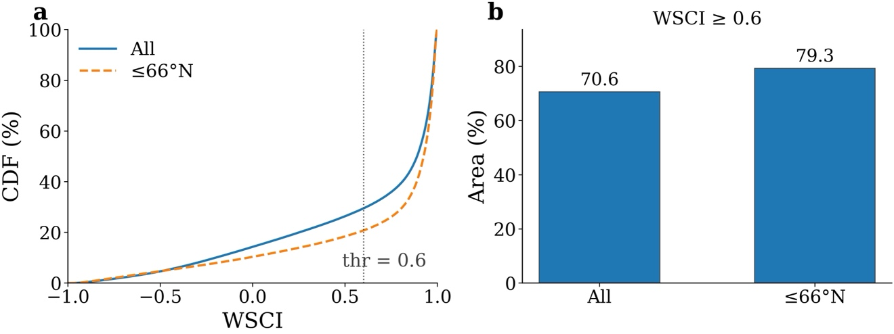Figure S10 | Sensitivity of global WSCI statistics to the exclusion of locations north of 66°N. (a) Area-weighted cumulative distributions of the Wave–Sediment Coupling Index (WSCI) for the full valid domain and the primary analysis domain restricted to ≤66°N. The vertical dotted line marks WSCI = 0.6, the threshold used to identify strong positive wave–SSC coupling. (b) Fraction of valid coastal area with WSCI ≥ 0.6 for the two domains. Area fractions account for the latitude-dependent area of raster cells.
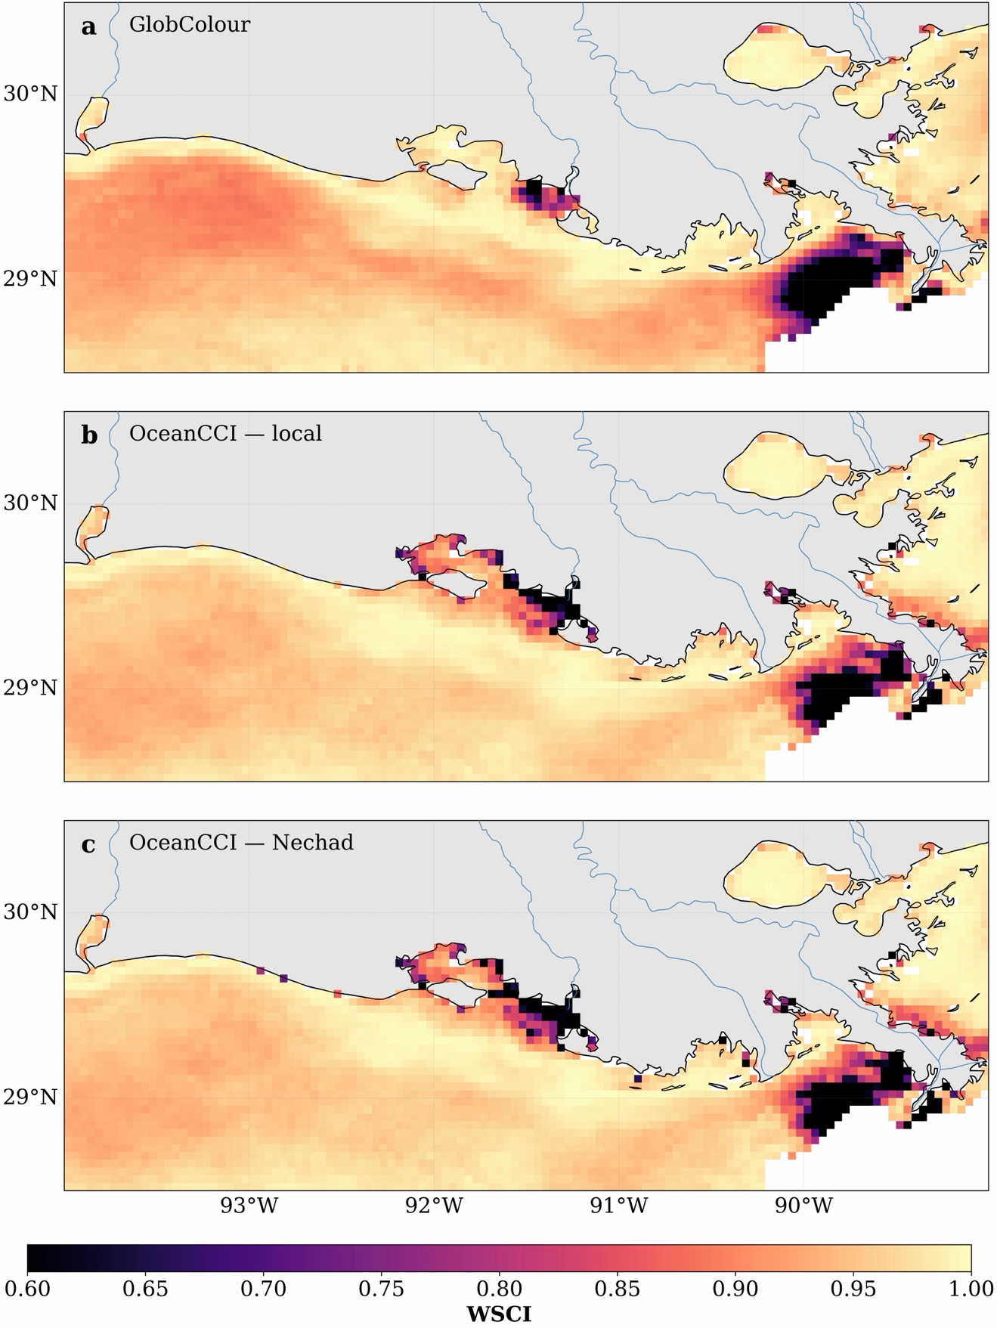
Figure S11 | Comparison of Louisiana WSCI patterns to satellite product and SSC retrieval algorithm. Spatial distributions of the Wave–Sediment Coupling Index (WSCI) over coastal Louisiana from 2003 to 2024 derived from (a) GlobColour SPM, (b) Ocean Colour CCI $R_{rs}\left(665\right)$ converted to SSC using the Louisiana field-calibrated algorithm and (c) Ocean Colour CCI $R_{rs}\left(665\right)$ converted using the Nechad algorithm⁴⁰. The Ocean Colour CCI estimates use the same daily ERA5 significant wave height data and identical 10-bin WSCI calculation.
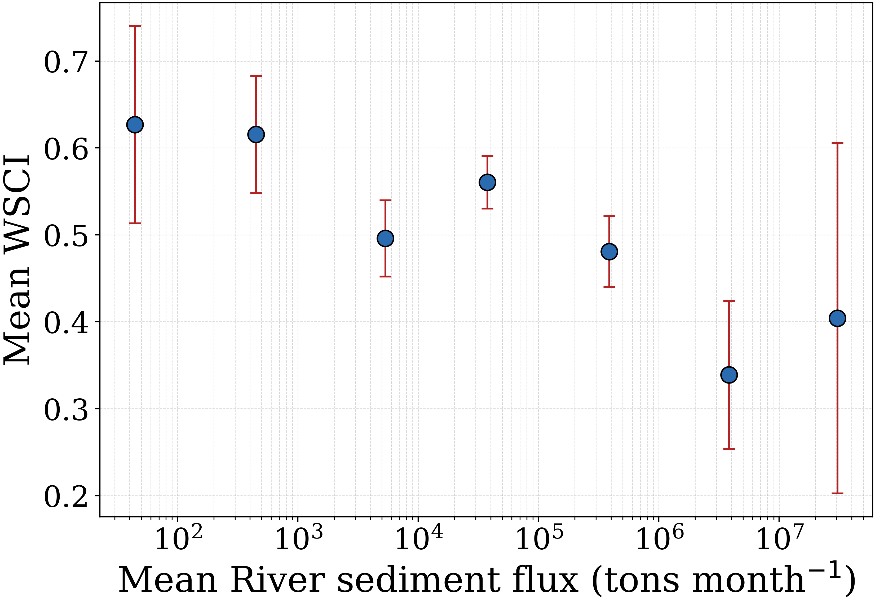
Figure S12 | Relationship between wave–SSC coupling and river sediment flux. Mean WSCI as a function of mean river sediment flux using sediment-flux estimates from Dethier et al.⁸. Rivers are grouped into logarithmically spaced sediment-flux classes; points show the mean sediment flux and mean WSCI within each class, and error bars denote ±1 s.e.m. of WSCI. River sediment flux is shown on a logarithmic scale.
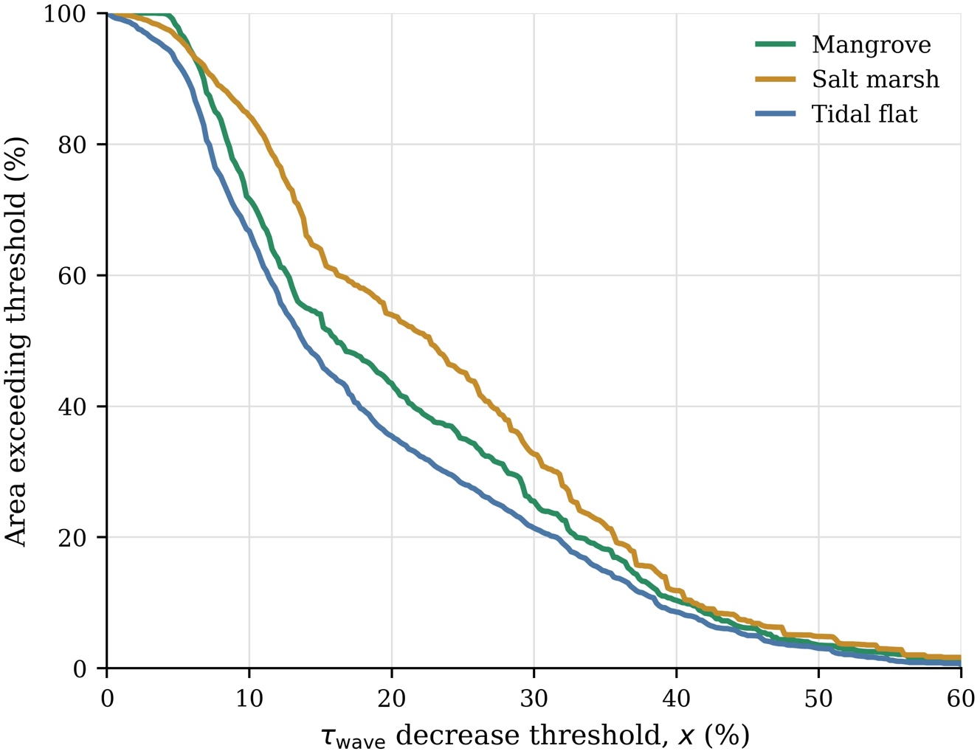

Figure S13 | Exceedance of projected wave-driven bottom-shear-stress decline across coastal wetlands. Exceedance curves show the percentage of declining linked wetland area experiencing a projected wave-driven bottom shear stress $τ_{wave}$ reduction greater than a given threshold, $x$, for mangroves, salt marshes and tidal flats. Percentages are calculated within the linked area experiencing declining $τ_{wave}$, such that all curves equal 100% at $x=0$. Results correspond to the median combined-wave projection for 2100 under SSP5-8.5, including vertical land motion, using the primary wetland–offshore distance kernel ($λ=50$ km; maximum linkage distance = 150 km) and the primary analysis domain (≤66°N).
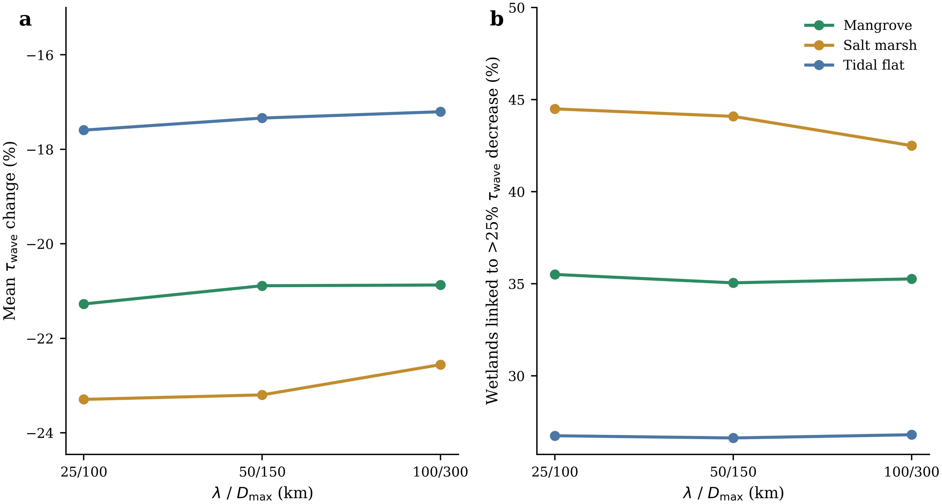

Figure S14 | Sensitivity of the wetland exposure metrics to the spatial scale of the distance-decay kernel. (a) Mean change in offshore $τ_{wave}$ linked to mangroves, salt marshes and tidal flats under alternative $λ/D_{max}$kernel settings. (b) Percentage of each wetland type linked to offshore cells with more than 25% decrease in $τ_{wave}$. The three kernels represent progressively broader offshore-to-wetland connectivity assumptions, from localized to more spatially diffuse sediment-lifeline coupling. Metrics are shown for the main case: SSP5-8.5 in 2100, with vertical land motion included and the median sea-level projection.
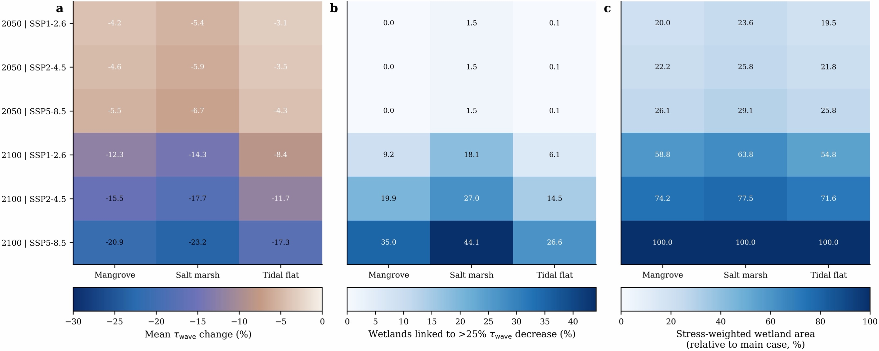

Figure S15 | Sensitivity of wetland exposure metrics to sea-level-rise scenario and target year. (a) Mean change in offshore wave-driven bed shear stress $τ_{wave}$, linked to mangroves, salt marshes and tidal flats under different SSP scenarios in 2050 and 2100. (b) Percentage of each wetland type linked to offshore cells with more than 25% decrease in $τ_{wave}$. (c) Stress-weighted wetland area, expressed as a percentage of the main-case value. Rows denote target year and SSP scenario; columns denote wetland class. The main case is SSP5-8.5 in 2100 and uses RSLR projections with vertical land motion included, the median sea-level projection, and the $λ=50$km, $D_{max}=150$km distance-decay kernel.
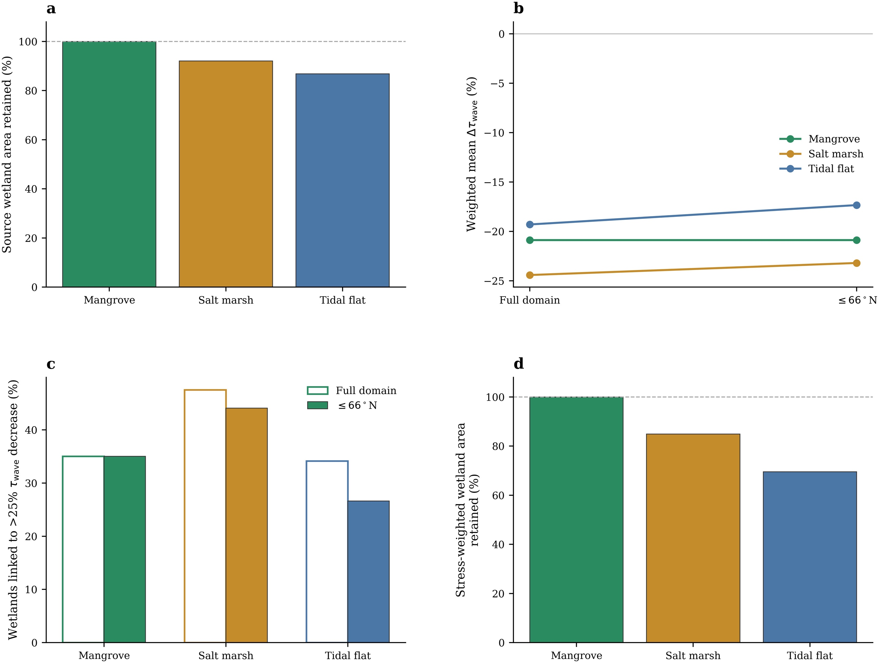
Figure S16 | Sensitivity of projected wetland exposure to the exclusion of locations north of 66°N. Comparison of the full-domain analysis with the primary analysis restricted to ≤66°N for mangroves, salt marshes and tidal flats. (a) Fraction of source wetland area retained after excluding locations north of 66°N. (b) Linked-area-weighted mean projected change in wave-driven bottom shear stress $Δτ_{wave}$. (c) Fraction of linked wetland area exposed to a >25% decline in $τ_{wave}$. (d) Fraction of stress-weighted wetland area retained after the latitude restriction, where stress-weighted wetland area is calculated as linked wetland area weighted by the fractional decline in $τ_{wave}$. Results correspond to the median combined-wave projection for 2100 under SSP5-8.5, including vertical land motion, with $λ=50$ km and a maximum linkage distance of 150 km.

