Genes Upregulated and Hypomethylated in MYC-High Breast, Liver and Colorectal Tumours: An Integrative Analysis of TCGA and DepMap Data
Supplementary Information
Mohammed A H Alsaedi and Gordon Strathdee. Biosciences Institute, Newcastle University Centre for Cancer, Newcastle University, Newcastle upon Tyne, UK

Supplementary Materials

Supplementary Figures
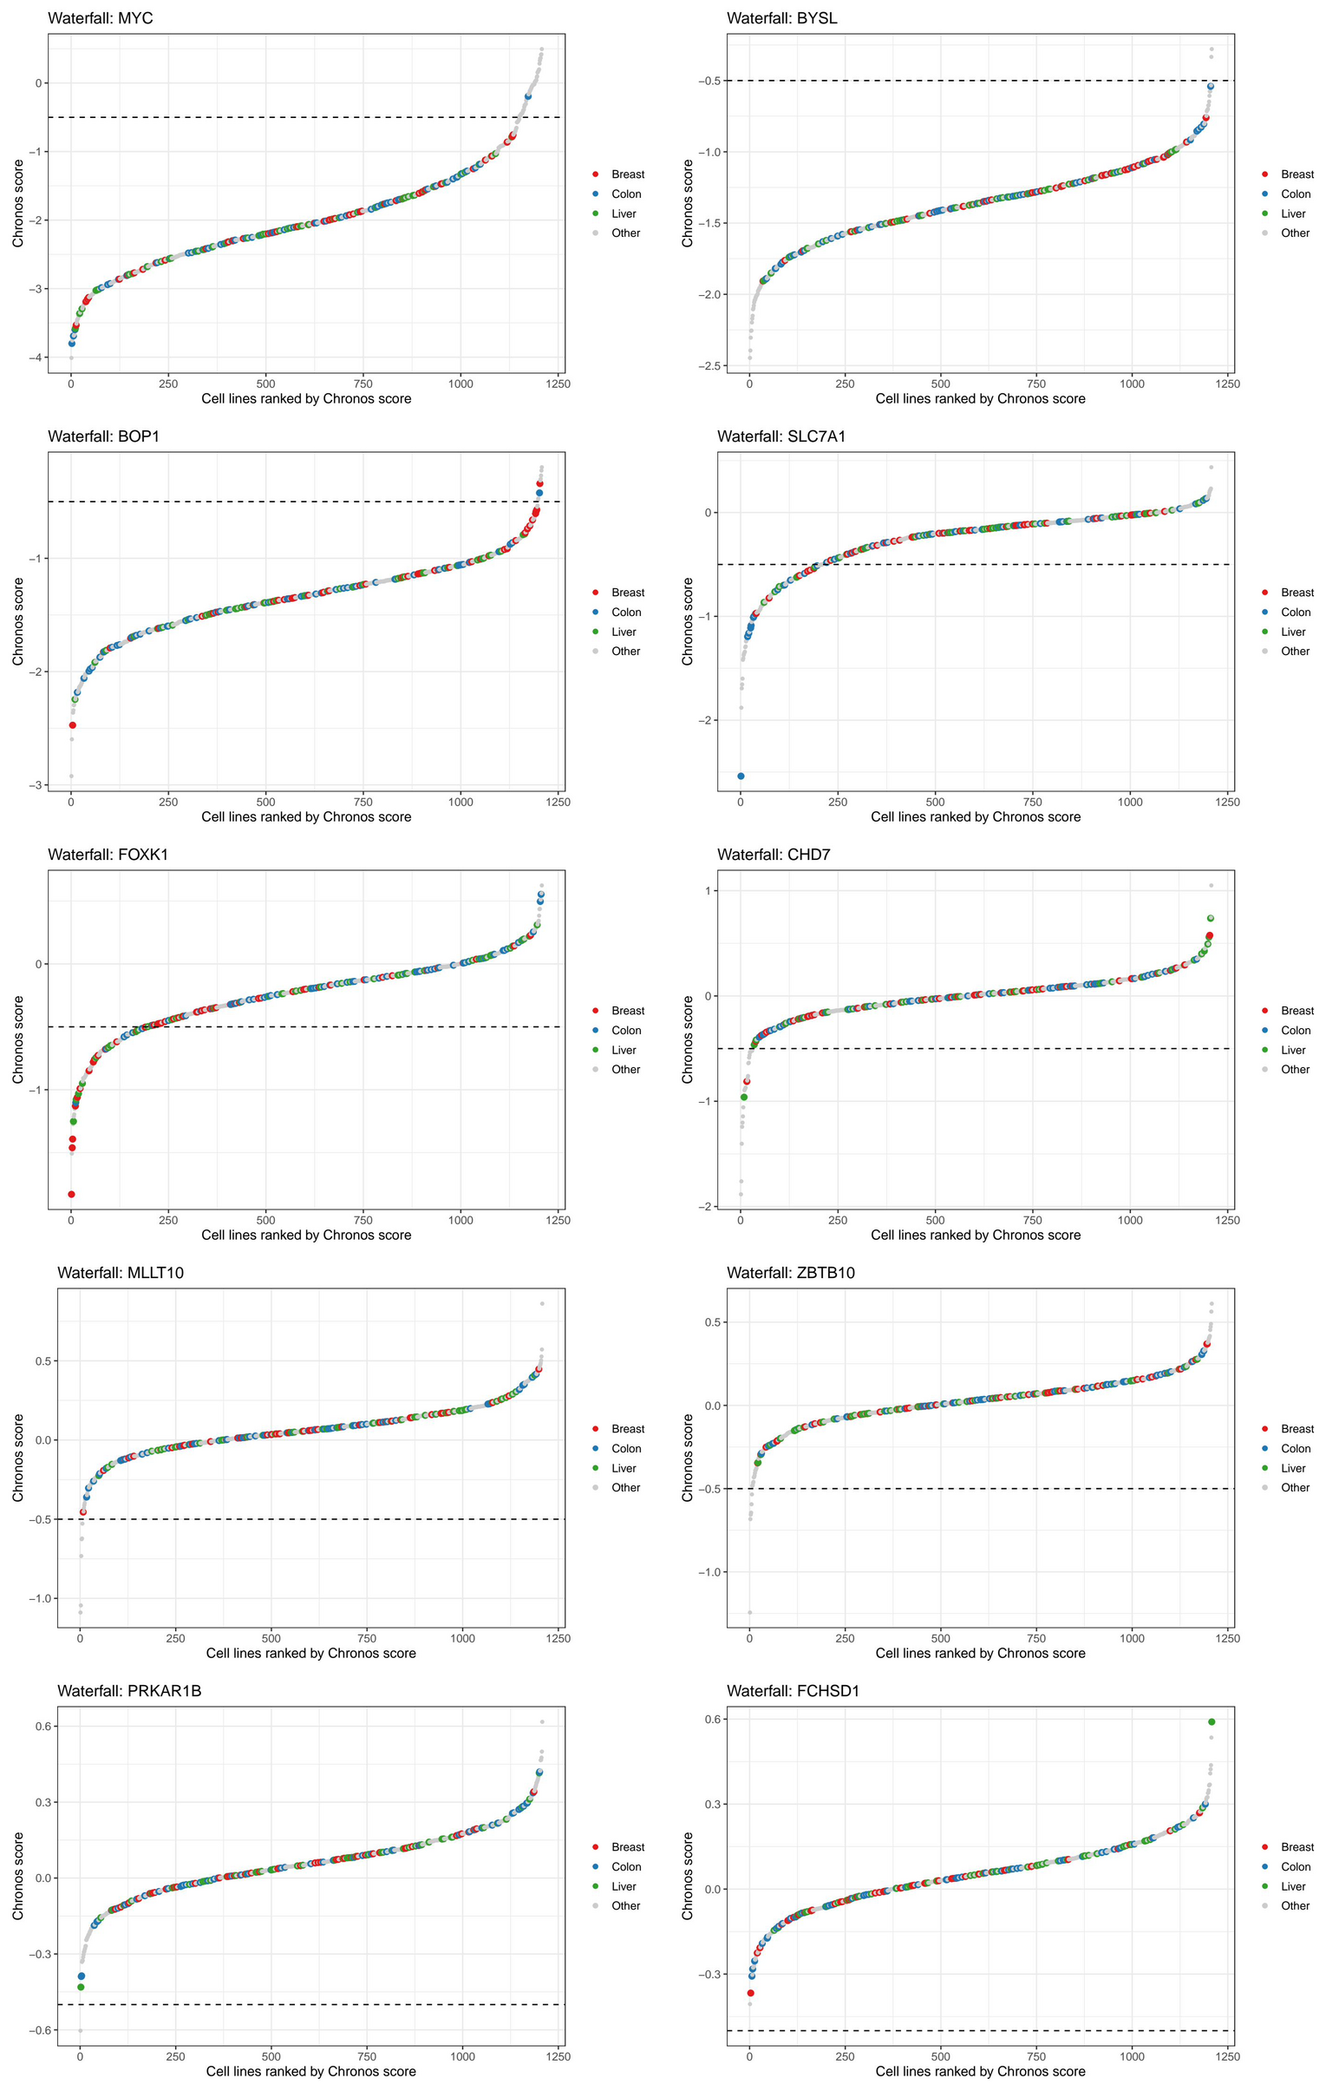
Supplementary Figure 1. DepMap Chronos waterfall plots for the ten protein-coding signature genes. In each panel, all 1,208 CRISPR-profiled DepMap cell lines are ranked by Chronos score (grey, other lineages); breast (red), colon (blue) and liver (green) cell lines are highlighted and the dashed line marks −0.5. Panels, left to right and top to bottom: MYC, BYSL, BOP1, SLC7A1, FOXK1, CHD7, MLLT10, ZBTB10, PRKAR1B, FCHSD1.
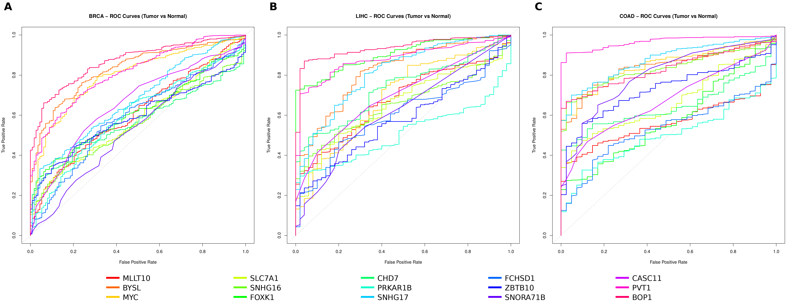
Supplementary Figure 2. ROC curves for the fifteen signature genes discriminating primary tumour from solid tissue normal samples in (A) BRCA (1,111 tumours, 113 normal), (B) LIHC (371 tumours, 50 normal) and (C) COAD (481 tumours, 41 normal). Each curve is one gene, coloured as in the shared legend below the panels; AUC values (95% CI) are in Supplementary Table S2.
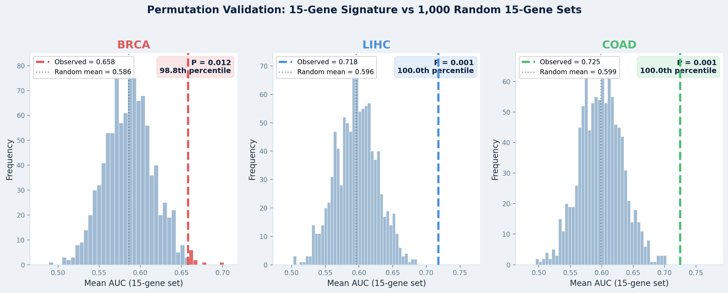
Supplementary Figure 3. Permutation benchmark for the mean AUC of the fifteen-gene signature. Histograms show the mean AUC of 1,000 random sets of fifteen genes in BRCA, LIHC and COAD; dashed lines mark the observed mean AUC of the signature (BRCA 0.658, LIHC 0.718, COAD 0.725).
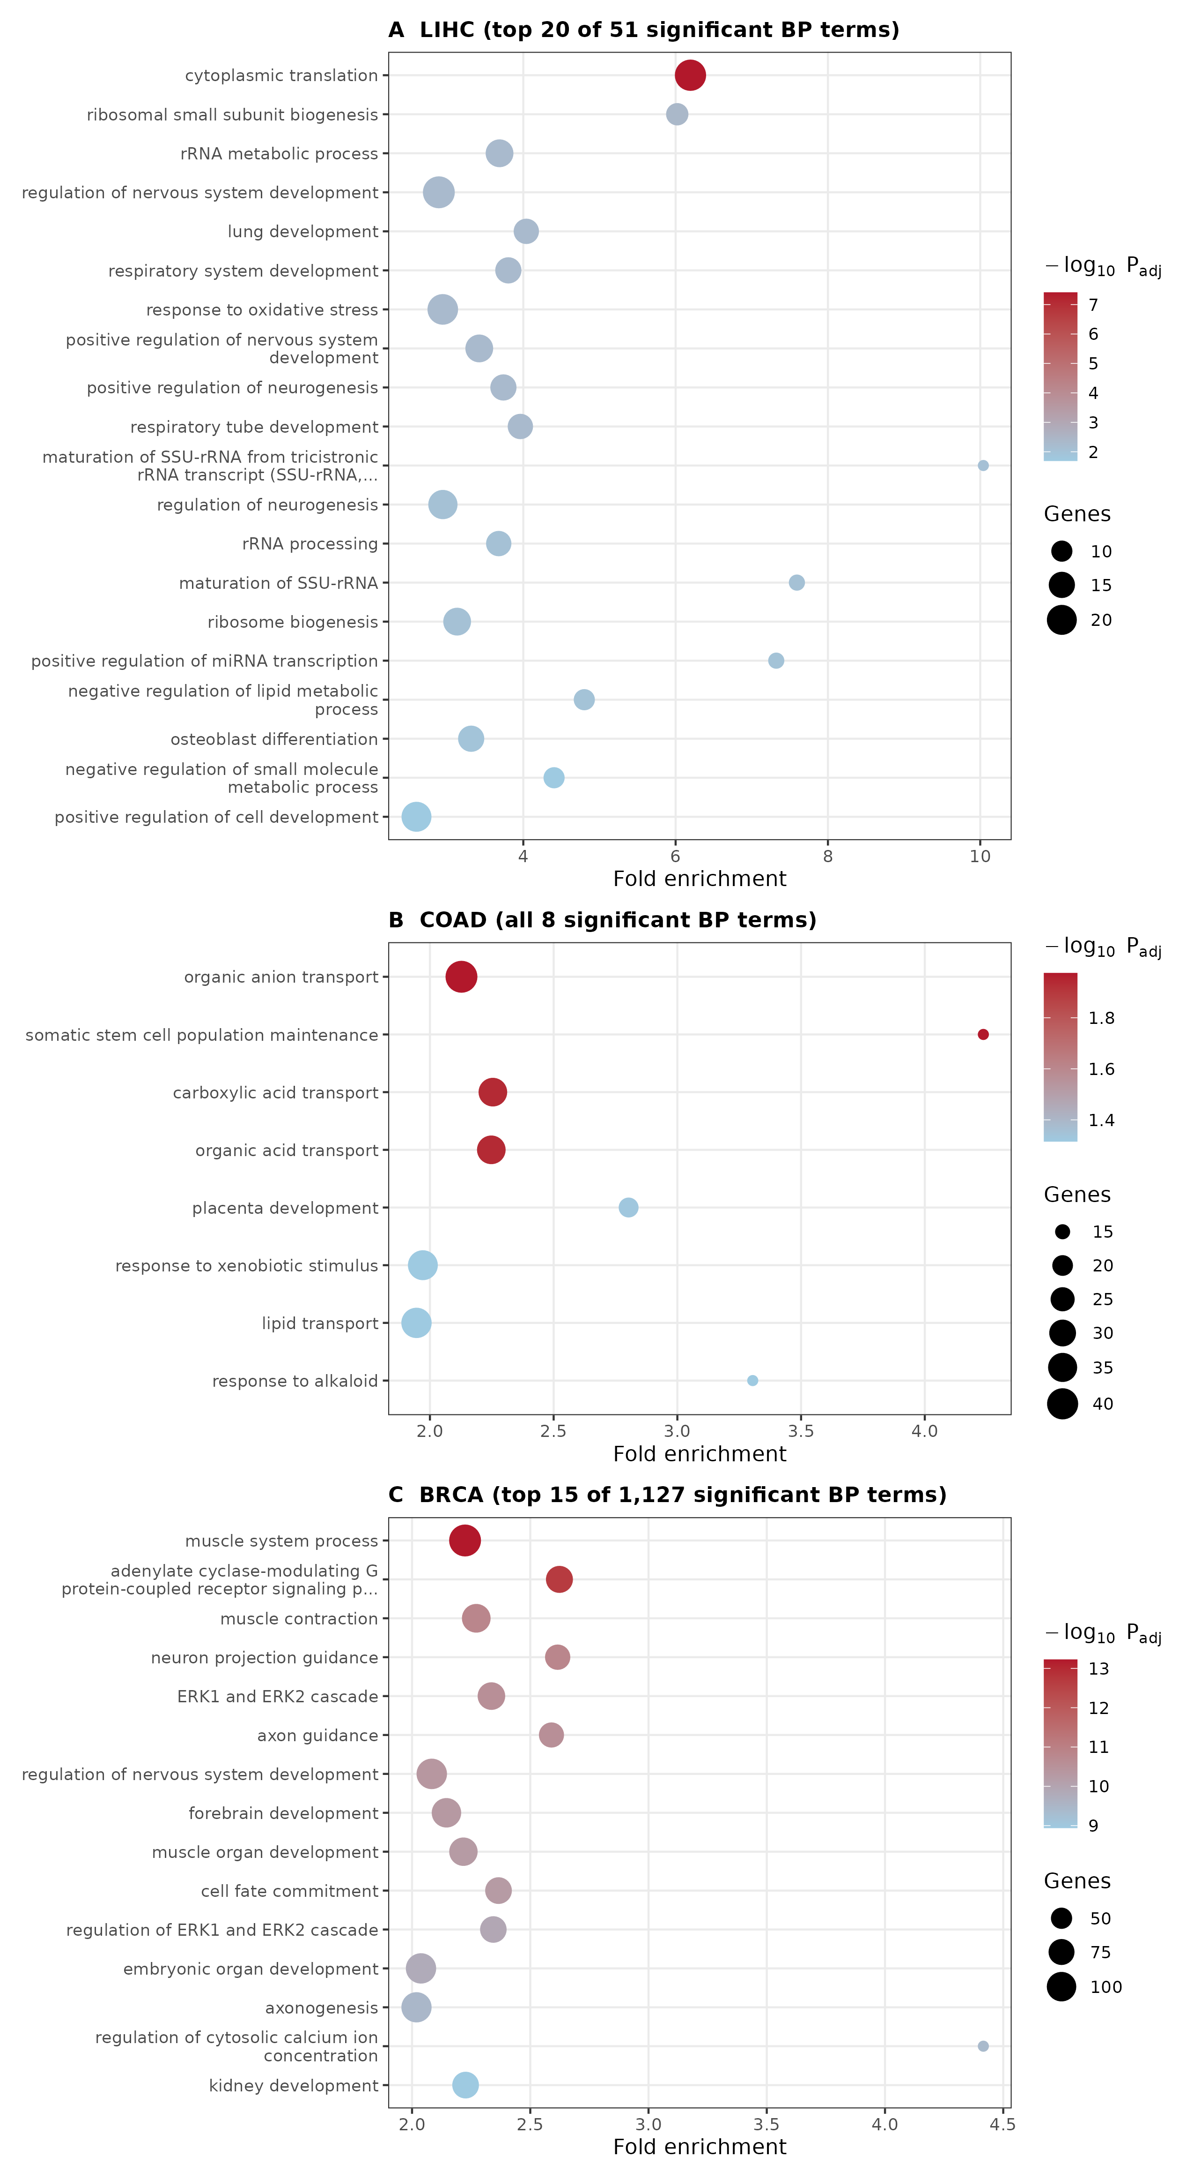
Supplementary Figure 4. Gene Ontology biological process enrichment of cancer-specific candidate genes (upregulated in MYC-high tumours and adjacent to hypomethylated DMRs). Dot position shows fold enrichment, size the number of genes, and colour -log10 BH-adjusted P (colour scales differ between panels). (A) LIHC, 20 of 51 significant terms; (B) COAD, all 8 significant terms; (C) BRCA, 15 of 1,127 significant terms. Terms are ordered by adjusted P.
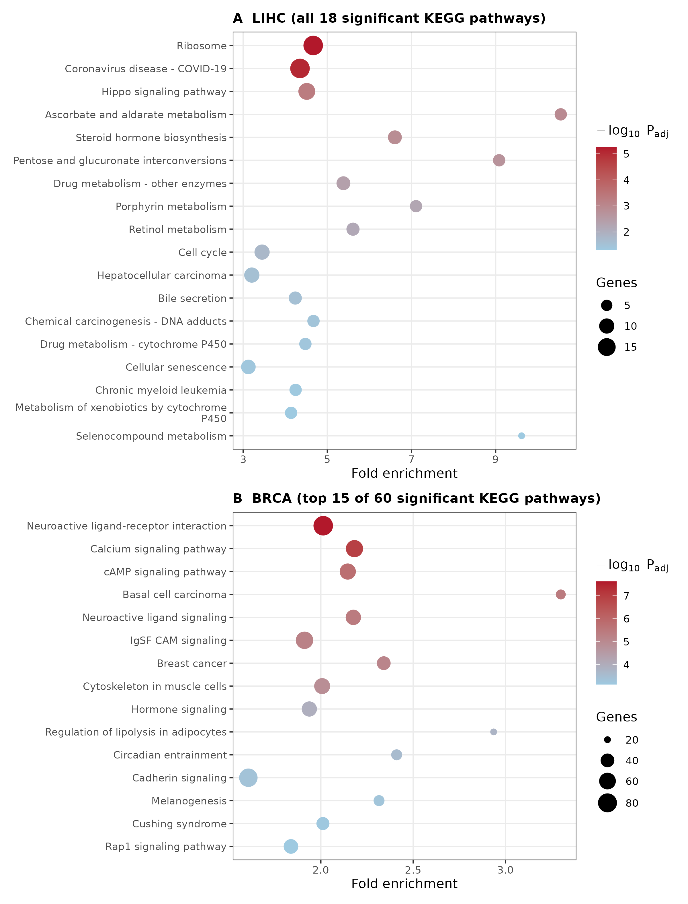
Supplementary Figure 5. KEGG pathway enrichment of cancer-specific candidate genes. (A) LIHC, all 18 significant pathways; (B) BRCA, 15 of 60 significant pathways. No KEGG pathway was significant in COAD (lowest adjusted P = 0.12). Dot position shows fold enrichment, size the number of genes and colour -log10 BH-adjusted P.

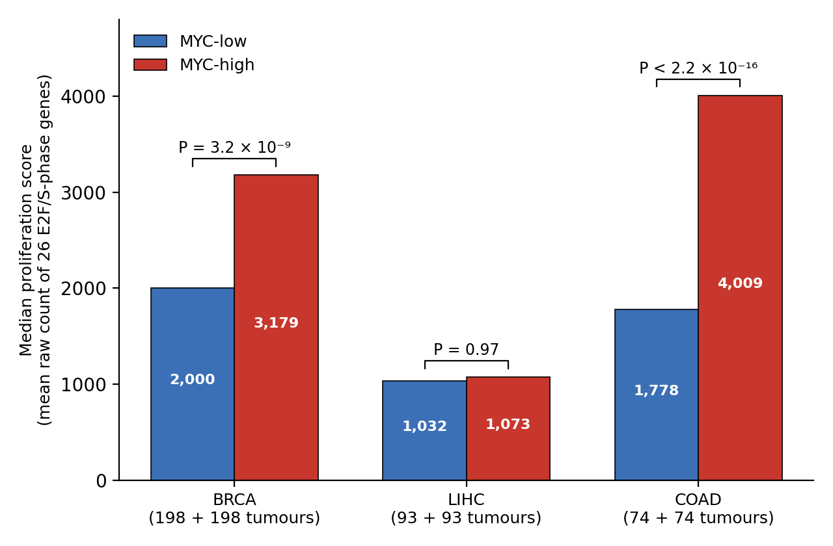
Supplementary Figure 6. Proliferation score in MYC-low and MYC-high tumours. Median proliferation score (mean raw count of 26 E2F and S-phase genes) in the stratified MYC-low and MYC-high tumours of each cancer type; P values are from two-sided Wilcoxon rank-sum tests. The score was higher in MYC-high tumours in BRCA (P = 3.2 × 10⁻⁹) and COAD (P < 2.2 × 10⁻¹⁶) but did not differ in LIHC (P = 0.97). Group sizes are given in Supplementary Table S5.

Supplementary Tables
Supplementary Table S1. Overall survival analysis for all 45 gene-cancer combinations (15 signature genes in BRCA, LIHC and COAD; median dichotomisation, log-rank test). q: Benjamini-Hochberg-adjusted P across all 45 tests; bold rows, q < 0.05. Direction is given for tests with nominal P < 0.05 only.
Cancer | Gene | N | Log-rank P | BH q | Direction
BRCA | CHD7 | 1,089 | 0.041 | 0.207 | High, worse OS
BRCA | BYSL | 1,089 | 0.139 | 0.422 | –
BRCA | PRKAR1B | 1,089 | 0.141 | 0.422 | –
BRCA | MLLT10 | 1,089 | 0.289 | 0.595 | –
BRCA | FOXK1 | 1,089 | 0.387 | 0.696 | –
BRCA | SNHG16 | 1,089 | 0.469 | 0.724 | –
BRCA | ZBTB10 | 1,089 | 0.469 | 0.724 | –
BRCA | SNHG17 | 1,089 | 0.527 | 0.765 | –
BRCA | CASC11 | 1,089 | 0.558 | 0.779 | –
BRCA | FCHSD1 | 1,089 | 0.571 | 0.779 | –
BRCA | SLC7A1 | 1,089 | 0.590 | 0.780 | –
BRCA | SNORA71B | 1,089 | 0.672 | 0.818 | –
BRCA | BOP1 | 1,089 | 0.724 | 0.818 | –
BRCA | PVT1 | 1,089 | 0.748 | 0.818 | –
BRCA | MYC | 1,089 | 0.782 | 0.818 | –
LIHC | SNHG17 | 366 | 3.6 × 10⁻⁴ | 0.013 | High, worse OS
LIHC | FOXK1 | 366 | 5.8 × 10⁻⁴ | 0.013 | High, worse OS
LIHC | BYSL | 366 | 0.0017 | 0.025 | High, worse OS
LIHC | BOP1 | 366 | 0.0036 | 0.040 | High, worse OS
LIHC | CASC11 | 366 | 0.0070 | 0.063 | High, worse OS
LIHC | SNHG16 | 366 | 0.017 | 0.125 | High, worse OS
LIHC | MLLT10 | 366 | 0.021 | 0.133 | High, worse OS
LIHC | SLC7A1 | 366 | 0.057 | 0.256 | –
LIHC | PVT1 | 366 | 0.107 | 0.370 | –
LIHC | CHD7 | 366 | 0.182 | 0.511 | –
LIHC | ZBTB10 | 366 | 0.212 | 0.530 | –
LIHC | FCHSD1 | 366 | 0.269 | 0.595 | –
LIHC | PRKAR1B | 366 | 0.410 | 0.696 | –
LIHC | SNORA71B | 366 | 0.483 | 0.724 | –
LIHC | MYC | 366 | 0.688 | 0.818 | –
COAD | BYSL | 457 | 0.026 | 0.147 | High, worse OS
COAD | SNHG17 | 457 | 0.062 | 0.256 | –
COAD | FCHSD1 | 457 | 0.096 | 0.361 | –
COAD | PVT1 | 457 | 0.204 | 0.530 | –
COAD | CASC11 | 457 | 0.226 | 0.536 | –
COAD | FOXK1 | 457 | 0.291 | 0.595 | –
COAD | SNORA71B | 457 | 0.336 | 0.657 | –
COAD | MLLT10 | 457 | 0.404 | 0.696 | –
COAD | ZBTB10 | 457 | 0.418 | 0.696 | –
COAD | PRKAR1B | 457 | 0.610 | 0.784 | –
COAD | CHD7 | 457 | 0.732 | 0.818 | –
COAD | SNHG16 | 457 | 0.749 | 0.818 | –
COAD | MYC | 457 | 0.767 | 0.818 | –
COAD | SLC7A1 | 457 | 0.815 | 0.833 | –
COAD | BOP1 | 457 | 0.934 | 0.934 | –

Supplementary Table S2. Area under the ROC curve (95% CI) for each signature gene, primary tumour versus solid tissue normal samples.
Gene | BRCA | LIHC | COAD
BOP1 | 0.87 (0.84-0.89) | 0.94 (0.91-0.96) | 0.83 (0.79-0.87)
PVT1 | 0.81 (0.78-0.85) | 0.88 (0.84-0.92) | 0.97 (0.95-0.98)
BYSL | 0.83 (0.80-0.86) | 0.82 (0.76-0.88) | 0.84 (0.80-0.88)
FOXK1 | 0.61 (0.57-0.65) | 0.90 (0.87-0.94) | 0.58 (0.50-0.65)
MYC | 0.80 (0.76-0.83) | 0.69 (0.62-0.77) | 0.85 (0.81-0.89)
SNHG17 | 0.67 (0.63-0.72) | 0.81 (0.75-0.87) | 0.87 (0.83-0.91)
SNHG16 | 0.56 (0.51-0.60) | 0.65 (0.59-0.71) | 0.83 (0.79-0.87)
CASC11 | 0.66 (0.61-0.71) | 0.70 (0.64-0.76) | 0.67 (0.61-0.74)
SNORA71B | 0.53 (0.48-0.59) | 0.62 (0.54-0.70) | 0.80 (0.74-0.86)
CHD7 | 0.57 (0.53-0.61) | 0.74 (0.68-0.79) | 0.65 (0.59-0.70)
ZBTB10 | 0.59 (0.55-0.63) | 0.58 (0.51-0.65) | 0.73 (0.67-0.78)
MLLT10 | 0.61 (0.56-0.66) | 0.68 (0.61-0.74) | 0.56 (0.51-0.62)
SLC7A1 | 0.58 (0.54-0.63) | 0.66 (0.59-0.72) | 0.67 (0.60-0.73)
FCHSD1 | 0.59 (0.54-0.64) | 0.60 (0.53-0.67) | 0.53 (0.47-0.60)
PRKAR1B | 0.60 (0.55-0.65) | 0.51 (0.45-0.57) | 0.50 (0.44-0.56)

Supplementary Table S3. Permutation benchmark: observed mean AUC of the fifteen-gene signature compared with 1,000 random fifteen-gene sets. Empirical P: proportion of random sets with mean AUC at least as high as observed.
Cancer | Observed mean AUC | Random mean AUC | Random SD | Empirical P | Percentile
BRCA | 0.658 | 0.586 | 0.030 | 0.012 | 98.8
LIHC | 0.718 | 0.596 | 0.031 | < 0.001 | 100.0
COAD | 0.725 | 0.599 | 0.034 | < 0.001 | 100.0

Supplementary Table S4. Functional enrichment of cancer-specific candidate genes (upregulated in MYC-high tumours and adjacent to hypomethylated DMRs). Significant terms are those with BH-adjusted P < 0.05; input size is the number of candidate genes with GO biological process annotation.
Cancer | Genes in GO BP input | Significant BP | Significant MF | Significant KEGG | Leading terms
LIHC | 322 | 51 | 13 | 18 | Cytoplasmic translation; rRNA processing and ribosome biogenesis; structural constituent of ribosome; KEGG Ribosome; Hippo signalling
COAD | 799 | 8 | 6 | 0 | Organic anion and acid transport; somatic stem cell population maintenance; transcription factor activity
BRCA | 2,098 | 1,127 | 83 | 60 | Muscle system process; GPCR, cAMP and ERK1/2 signalling; axon guidance; neuroactive ligand-receptor interaction

Supplementary Table S5. Cohort and pipeline summary for each cancer type. Proliferation score is the mean raw count of the 26 E2F/S-phase genes. Probe counts are for the stratified tumours; the 450K annotation filter was applied afterwards. CPE = consensus purity estimate. Tumour purity was not included as a covariate in the expression or methylation models; CPE values (matched by sample barcode; 4 BRCA and 1 COAD tumours lacked an estimate) are shown for reference. P values are from two-sided Wilcoxon rank-sum tests.
Measure | BRCA | LIHC | COAD
Patients with expression and methylation data | 789 | 371 | 295
Stratified tumours (MYC-high / MYC-low) | 396 (198 / 198) | 186 (93 / 93) | 148 (74 / 74)
Tumours with a CPE estimate (not used in models) | 392 (99.0%) | 186 (100%) | 147 (99.3%)
Median CPE, MYC-low vs MYC-high | 0.766 vs 0.733 | 0.802 vs 0.796 | 0.751 vs 0.795
Wilcoxon P (CPE, high vs low) | 0.12 | 0.44 | 0.002
Median proliferation score, MYC-low | 2,000.5 | 1,032.1 | 1,777.6
Median proliferation score, MYC-high | 3,178.6 | 1,073.2 | 4,009.3
Wilcoxon P (high vs low) | 3.2 × 10⁻⁹ | 0.97 | < 2.2 × 10⁻¹⁶
Methylation probes evaluated | 486,435 | 486,437 | 486,451
Probes removed (≥ 20% missing) | 84,134 (17.3%) | 92,071 (18.9%) | 75,115 (15.4%)
Probes retained after missingness filter | 402,301 | 394,366 | 411,336
Genes tested (mean count > 1) | 34,920 | 29,928 | 32,368
Genes upregulated in MYC-high | 6,500 | 5,905 | 3,561
Genes downregulated in MYC-high | 1,323 | 1,080 | 553
DMRs called (total) | 16,648 | 4,158 | 8,339
Hypomethylated DMRs in MYC-high | 9,571 | 739 | 6,911
Genes overlapping / within 10 kb of hypomethylated DMRs | 12,013 | 1,441 | 8,473
Candidate genes (upregulated ∩ DMR-proximal) | 2,588 | 366 | 994

