Supplementary Figures
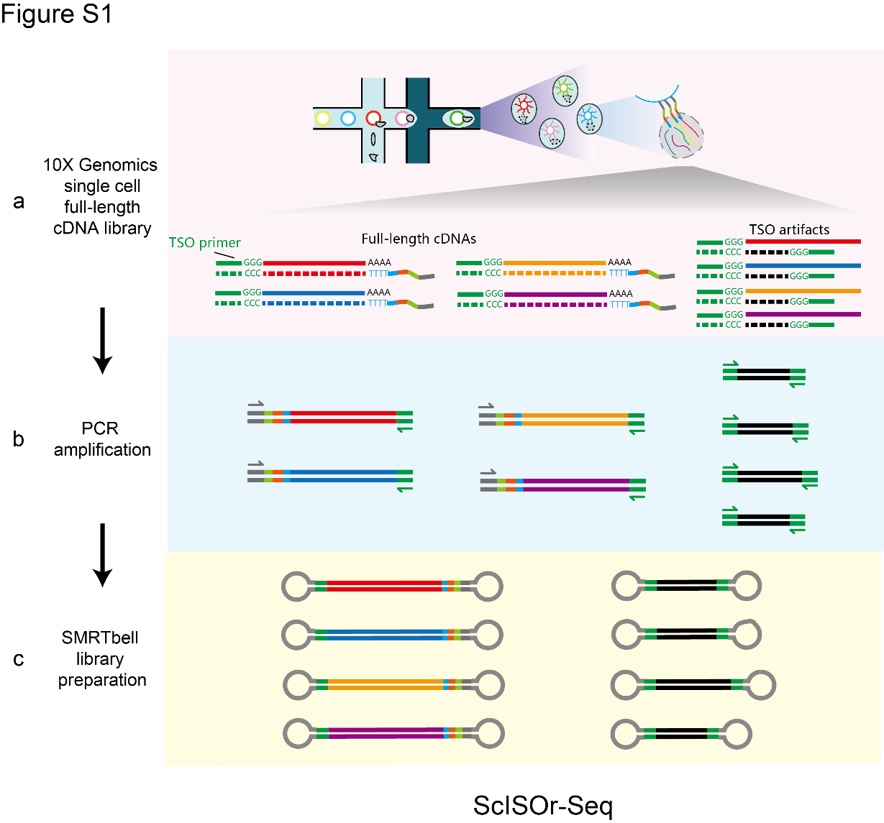
Figure S1. ScISOr-Seq workflow. (a) Overview of the 10X Genomics single cell full-length cDNA library construction. (b) cDNA amplification with a 3’ read 1 primer (gray arrow) and TSO PCR primer (green arrow). (c) SMRTbell library preparation.

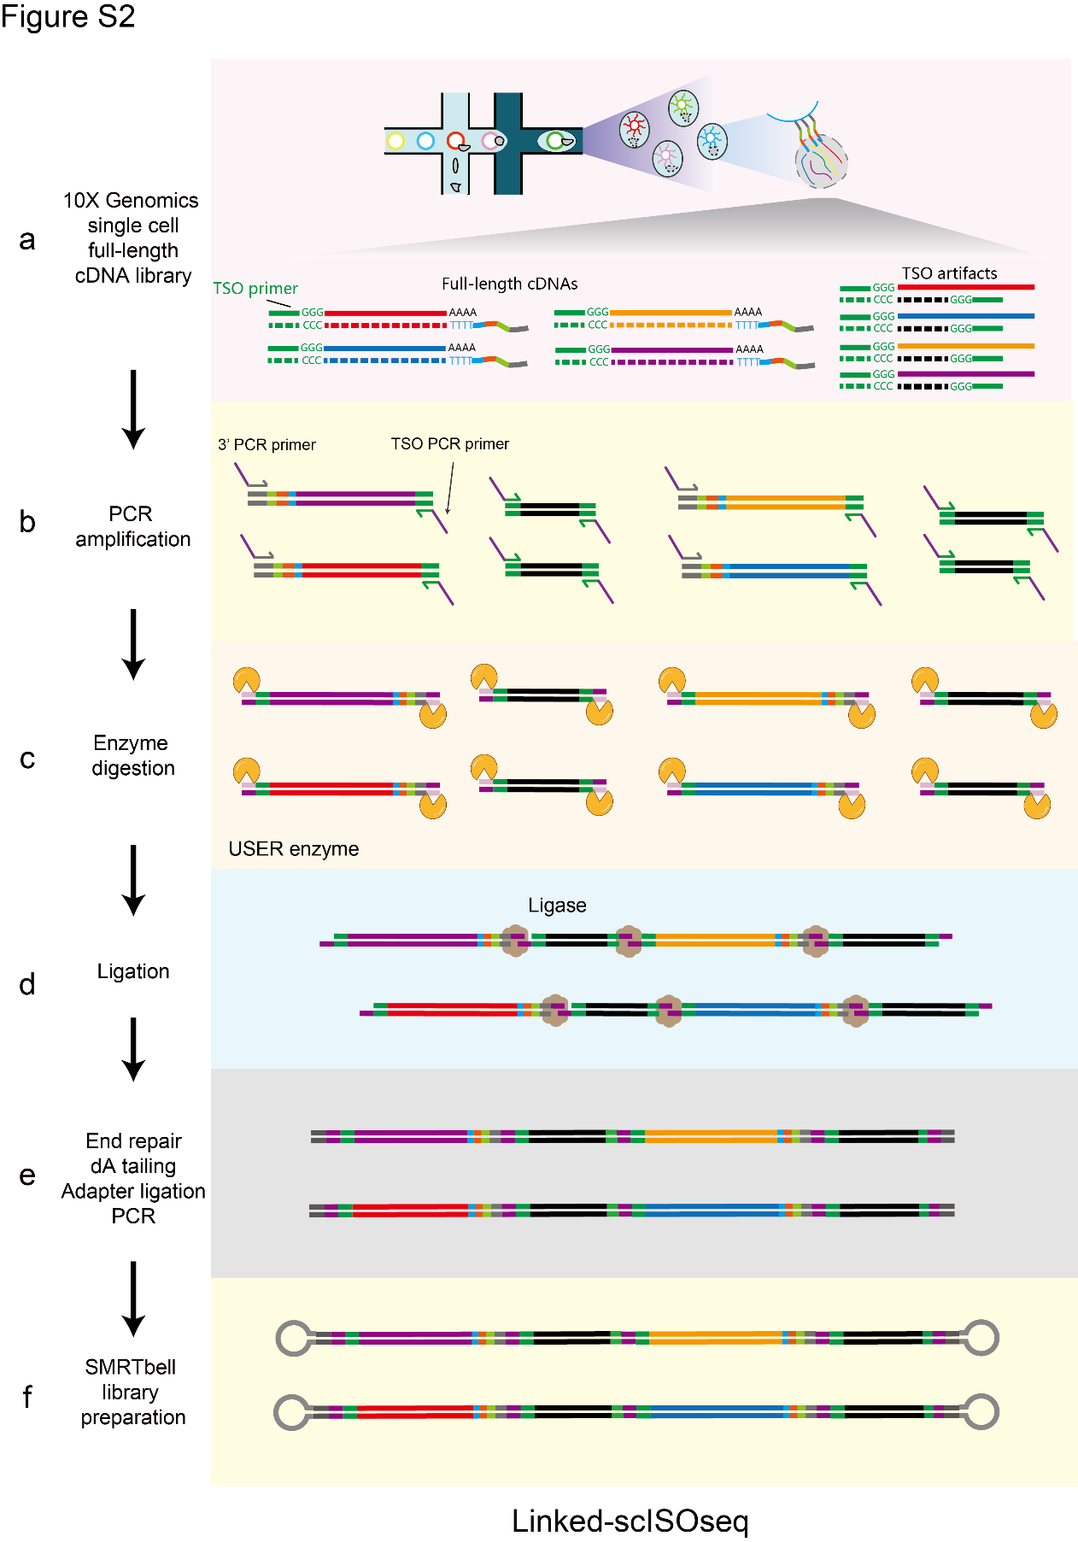
Figure S2. Linked-scISOseq workflow. (a) Overview of 10x Genomics single cell full-length cDNA library construction. (b) cDNA amplification with a 3’ PCR primer and a TSO PCR primer. (c) USER enzyme restriction digestion of the primers at both ends to produce sticky ends. (d) cDNAs ligation. (e-f) End repair, dA tailing, adapter ligation, and PCR enrichment of the ligated cDNAs, followed by SMRTbell library preparation.

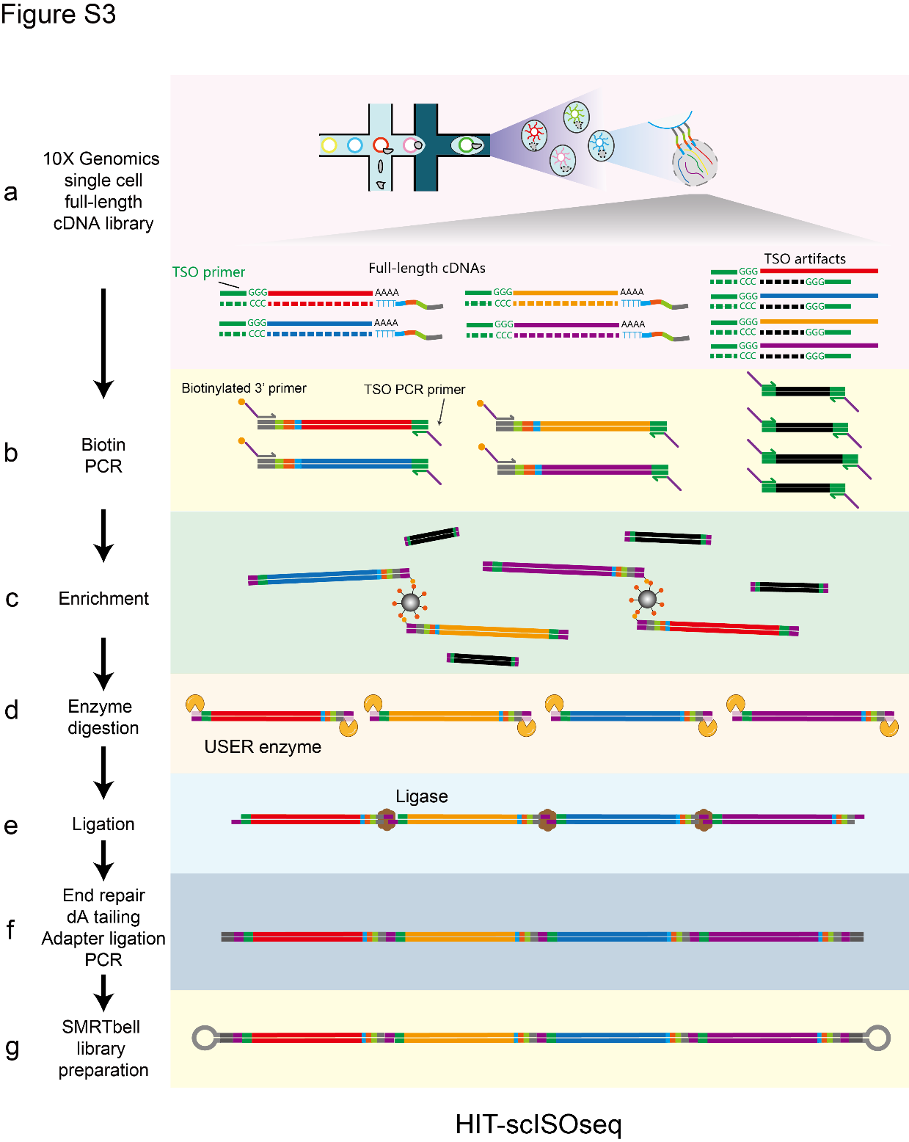
Figure S3. HIT-scISOseq workflow. (a) Overview of 10x Genomics single-cell full-length cDNA library construction. (b) Full-length cDNAs are amplified via PCR with a biotinylated 3’ primer. (c) Biotinylated full-length cDNAs are enriched by streptomycin magnetic beads. (d) Sticky ends are generated by restriction digestion with the USER enzyme. (e) Ligation of cDNAs. (f-g) End repair, dA tailing, adapter ligation and PCR enrichment of the ligated cDNAs, followed by SMRTbell library preparation.

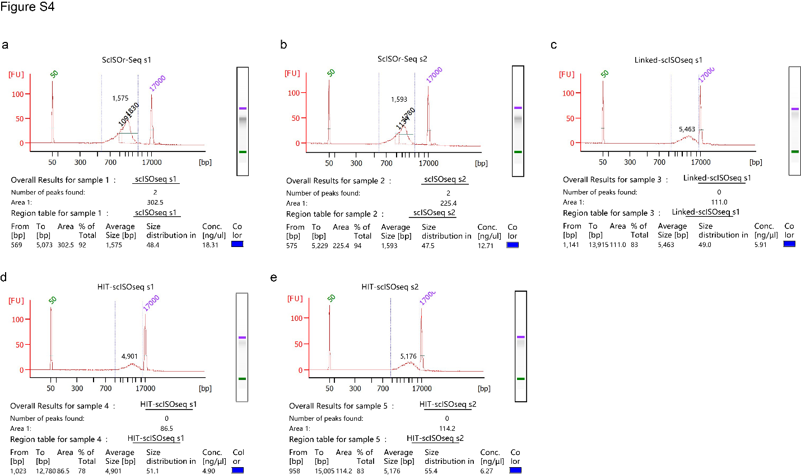
Figure S4. Agilent Bioanalyzer 2100 analysis showing results for the full-length cDNA libraries including QC and quantification results for the ScISOr-Seq (a-b) cDNA libraries, Linked-scISOseq (c) library, and HIT-scISOseq (d-e) libraries.

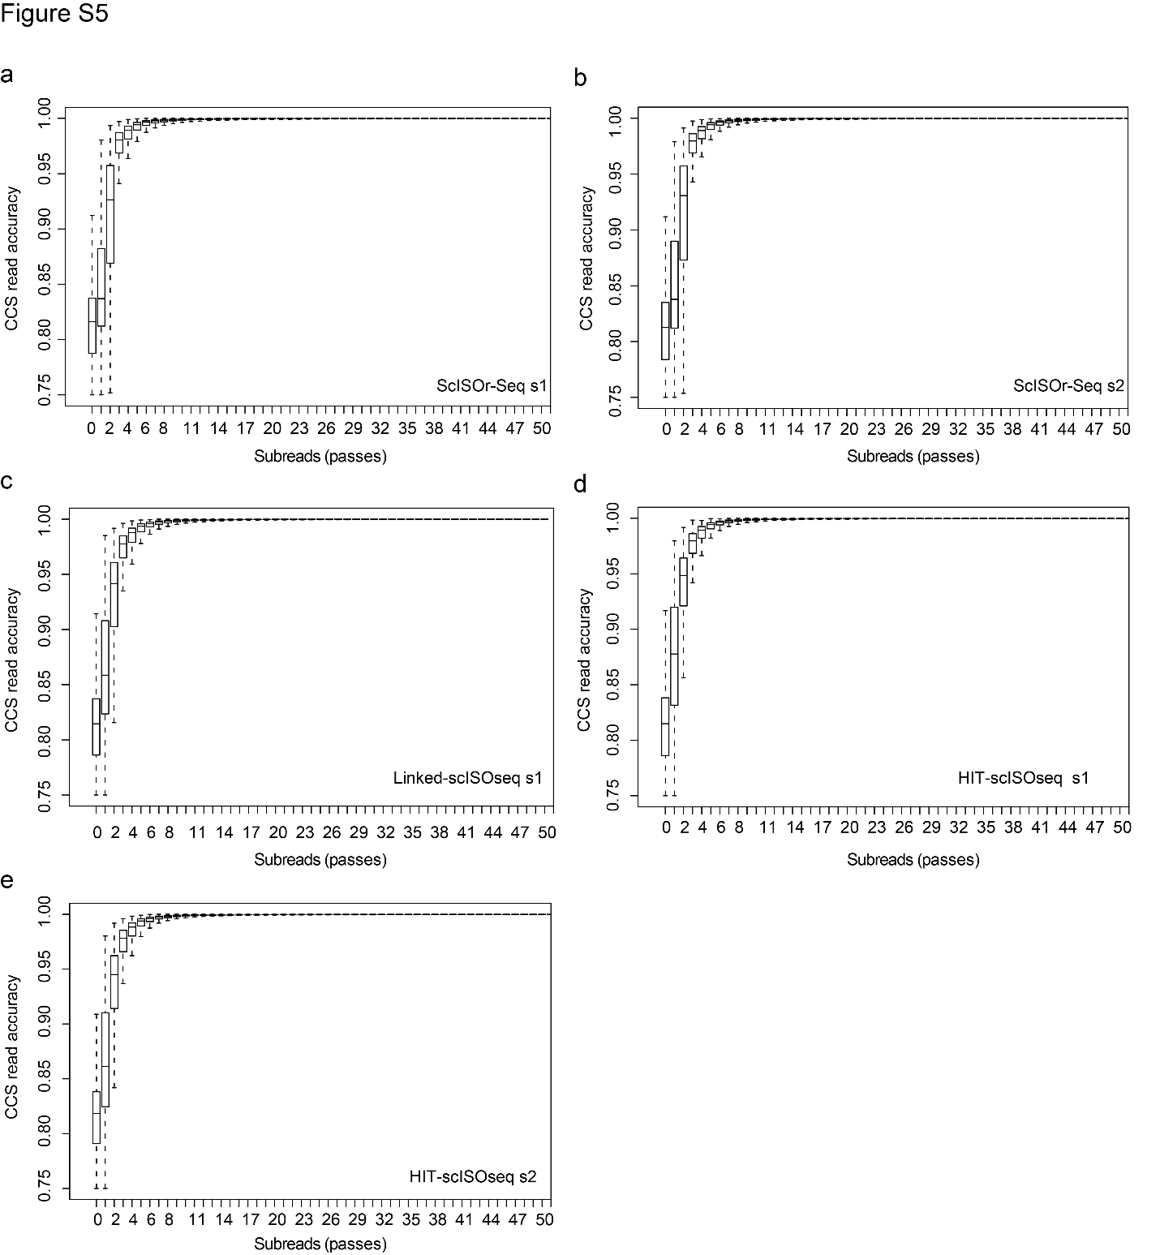
Figure S5. The CCS reads accuracy and the number of sequencing passes. The X-axis shows the number of subreads (passes) of SMRTbell, and Y-axis shows CCS consensus read accuracy. (a-b) ScISOr-Seq method. (c) Linked-scISOseq method. (d-e) HIT-scISOseq method.

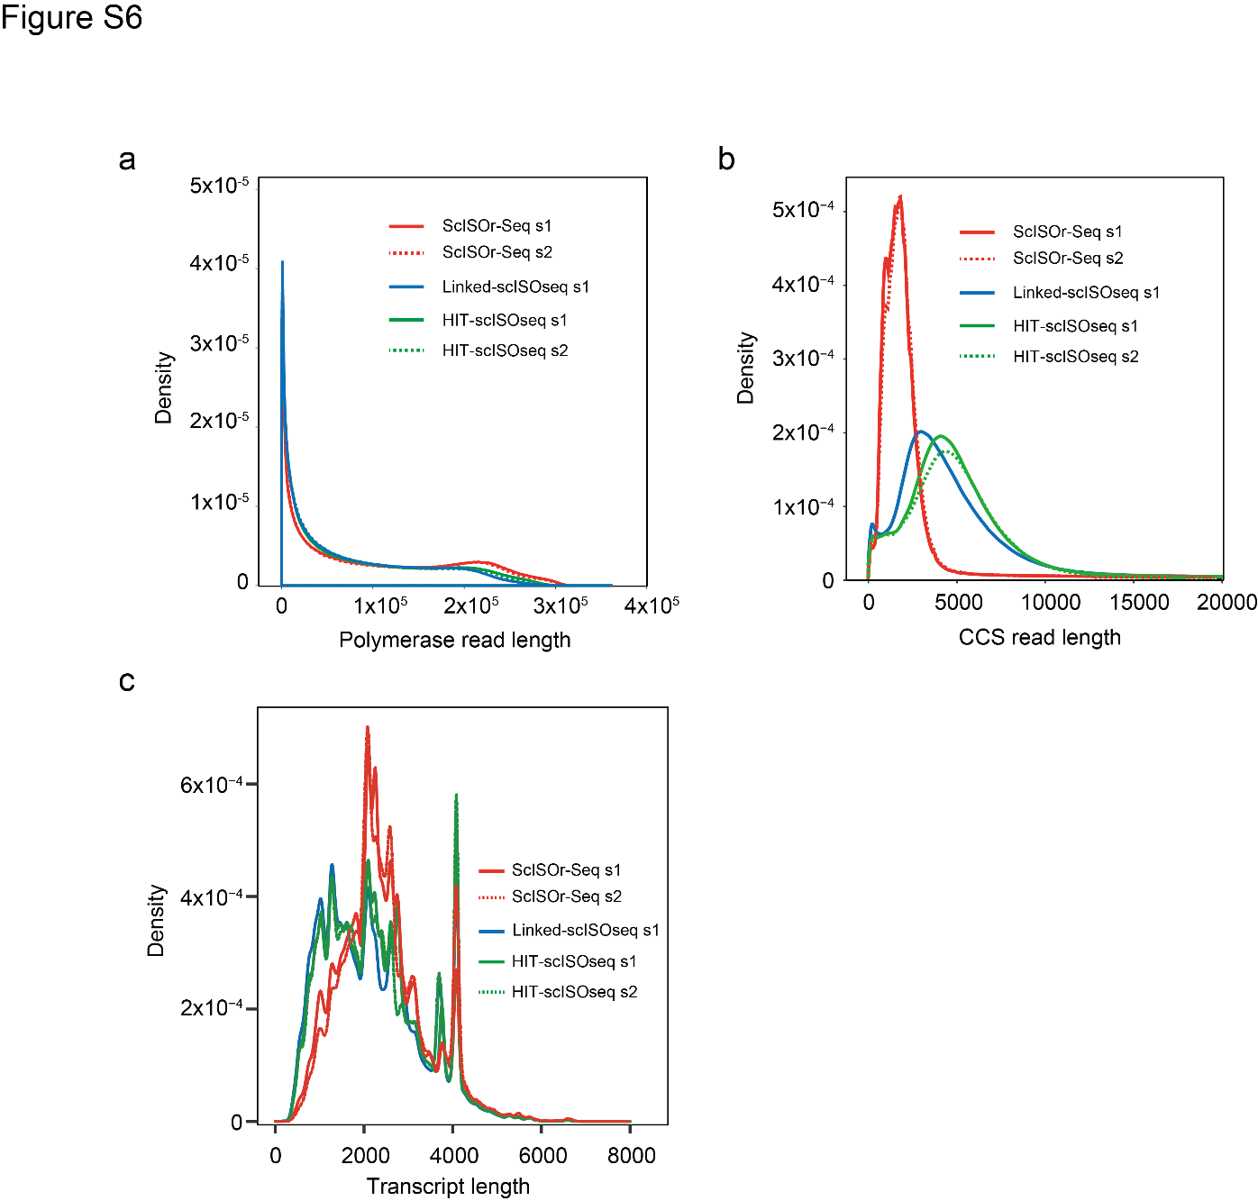
Figure S6. Distribution of read length. Polymerase read lengths (a), CCS read lengths (b), and transcript read lengths (c) ScISOr-Seq, Linked-scISOseq, and HIT-scISOseq data sets.

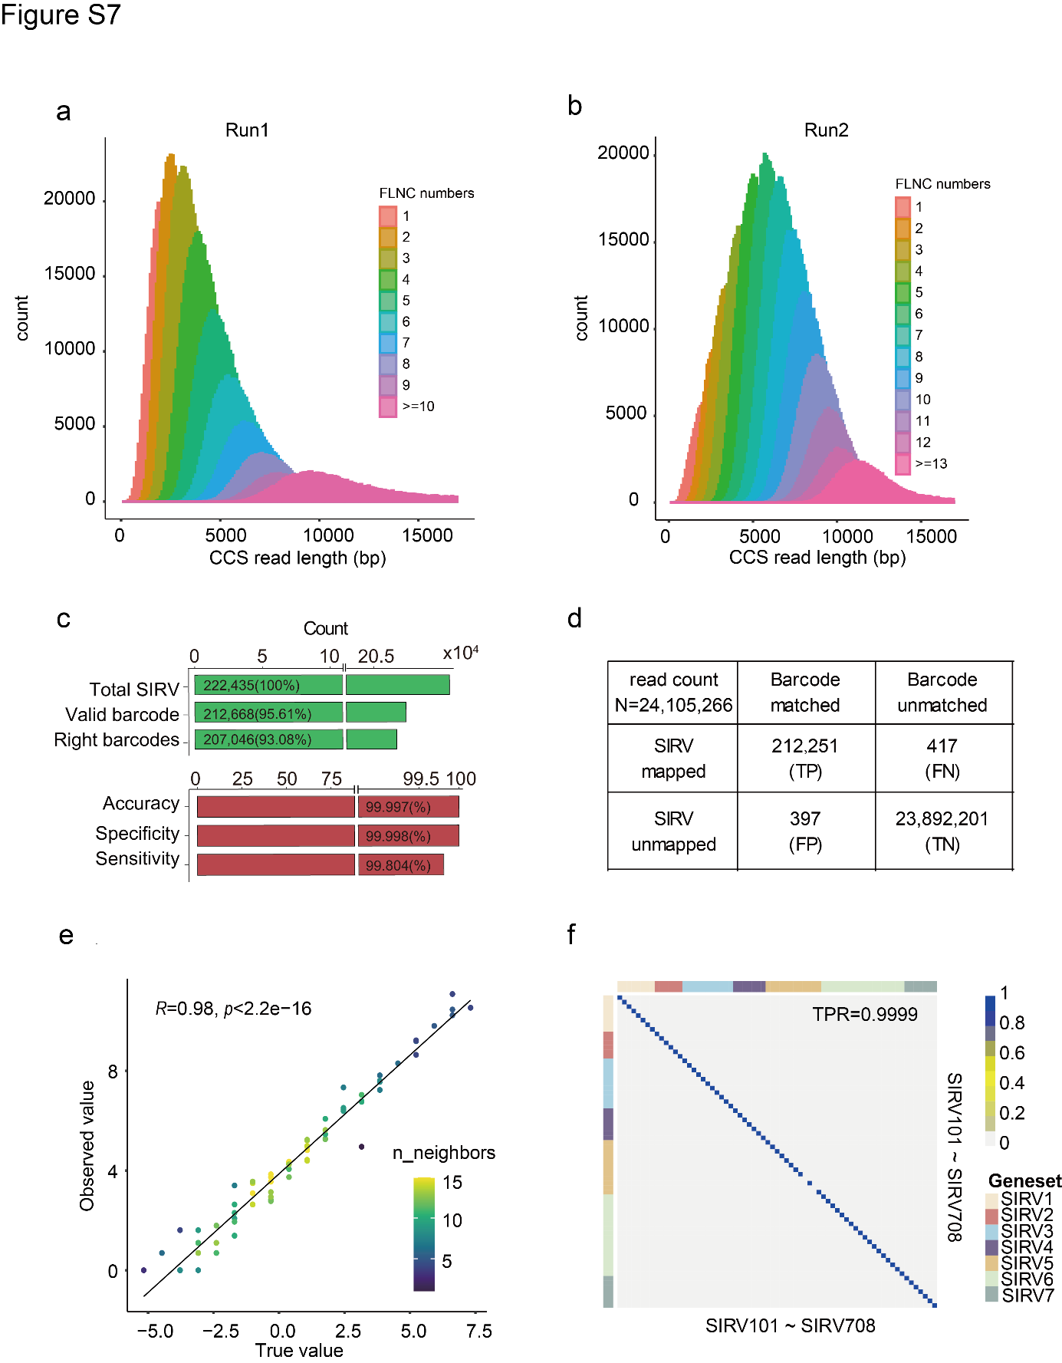
Figure S7. Performance of SIRV&Human-Mouse-Mixture data set. (a-b) Comparison of the number of FLNC per CCS between two SIRV&Human-Mouse sequencing runs. (c) The number of total Split SIRV FLNC, FLNC with validated and accurately split barcodes in SIRV&Human-Mouse sequencing Run2. (d) The accuracy, specificity and sensitivity of barcode assignment in SIRV&Human-Mouse sequencing Run2. (e) Dot plot shows the correlation between the expected (x axis) and observed abundances (y axis) of the SIRV transcripts in Run2. (f) Heatmap of Pearson correlation coefficient of the expected and observed of each individual SIRV transcript in Run2.

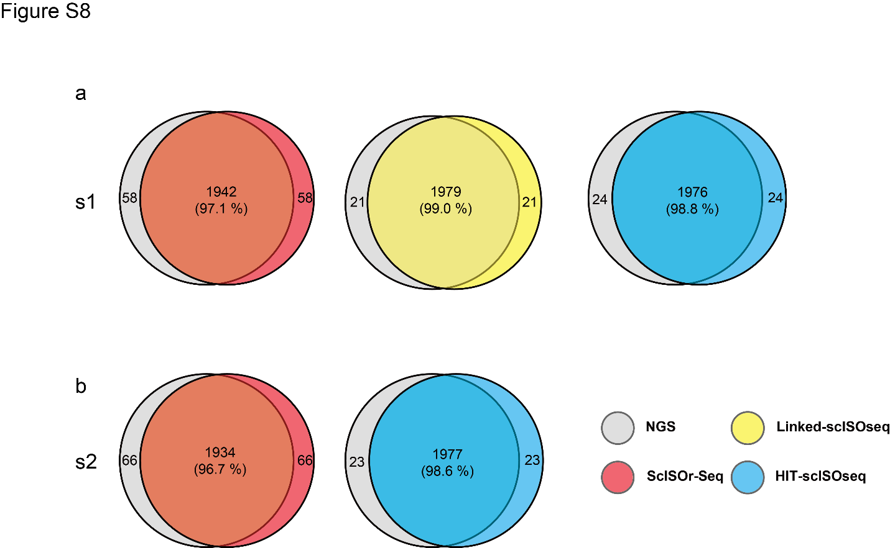
Figure S8. Consistency of the top-2,000 Cell barcodes between NGS and HIT-scISOseq. The numbers (percentages) of shared cell barcodes are shown in the middle areas. NGS method = gray; Linked-scISOseq = yellow; ScISOr-Seq = red; HIT-scISOseq = blue. The upper panel (a) shows data from replicate sample s1, and the lower panel (b) shows data from replicate sample s2.

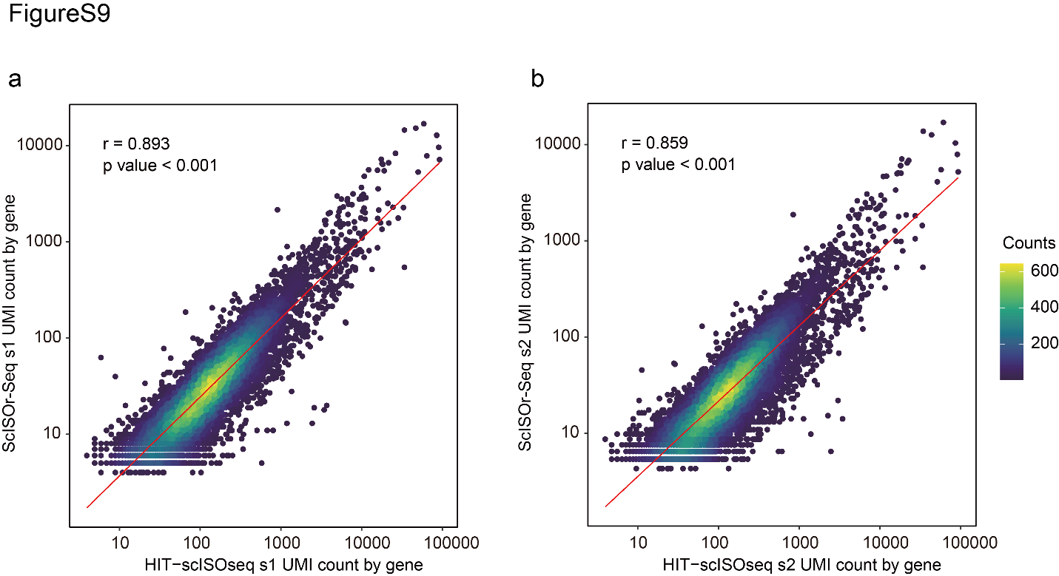
Figure S9. Comparison between HIT-scISOseq and ScISOr-Seq gene expression. (a) Correlation dot plot of UMI counts by gene for s1 replicate; (b) same as (a) for s2 replicate. The correlation coefficient Spearman‘s r and p-value are shown.

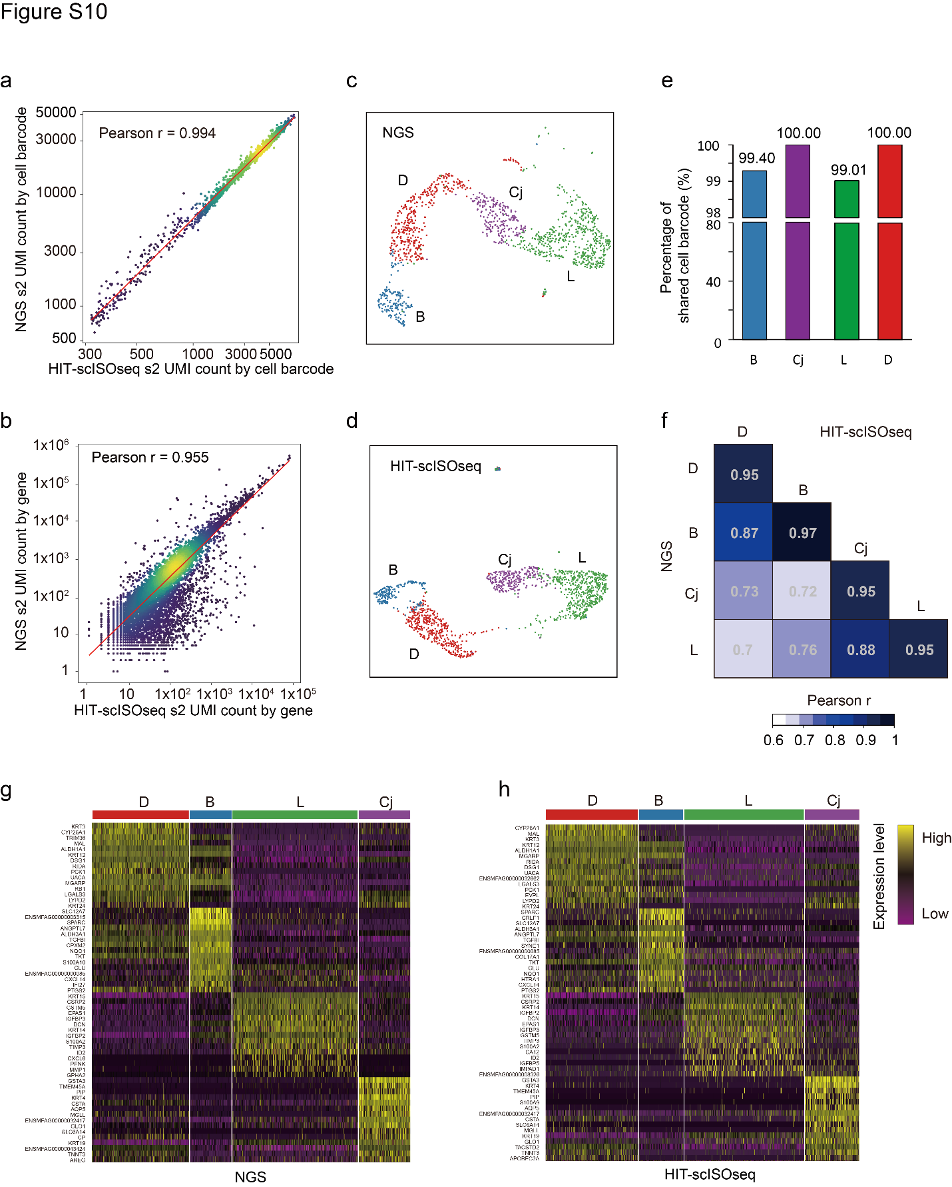
Figure S10. Accuracy and reproducibility of HIT-scISOseq gene expression for s2 sample. (a) Correlation dot plot of NGS (y axis) versus HIT-scISOseq (x axis) UMI counts by cell barcode. The Pearson correlation coefficient ® is shown. Dot color reflects the local density of data points. (b) Correlation dot plot of NGS (y-axis) versus HIT-scISOseq (x-axis) UMI counts by gene. The Pearson correlation coefficient (r) is shown. (c and d) UMAP of NGS and HIT-scISOseq data. Gene expression profiles were determined independently for each cell cluster using either NGS or HIT-scISOseq. Both NGS (d) and HIT-scISOseq (e) data sets show that the four main cell populations could be successfully clustered ( differentiated cells, indicated by D and red ; corneal basal cells, indicated by B and blue; limbal stem cells, indicated by L and green; and conjunctival cells, indicated by Cj and purple ). (e) Bar charts showing the percentage of cell barcodes shared between NGS and HIT-scISOseq data sets. (f) Correlation heatmap showing the gene expression correlation between NGS and HIT-scISOseq data sets for each cell cluster. (g and h) Expression heatmaps of marker genes for the four major cell clusters in the NGS (g) and HIT-scISOseq (h) data sets. The color gradient represents log-transformed and normalized counts scaled to a maximum of 1 per row. Upper bars represent cell cluster assignment for individual cells.

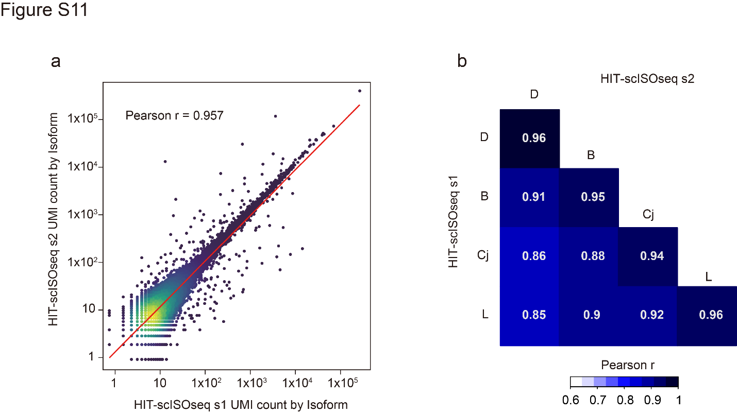
Figure S11. Reproducibility of the HIT-scISOseq isoform expression. (a) Correlation dot plot of UMI counts by isoform between the two replicate samples. Dot color reflects the local density of data points. The Pearson correlation coefficient (r) is shown. (b) Isoform expression correlation heatmap of each cell cluster between the two replicate HIT-scISOseq data sets.

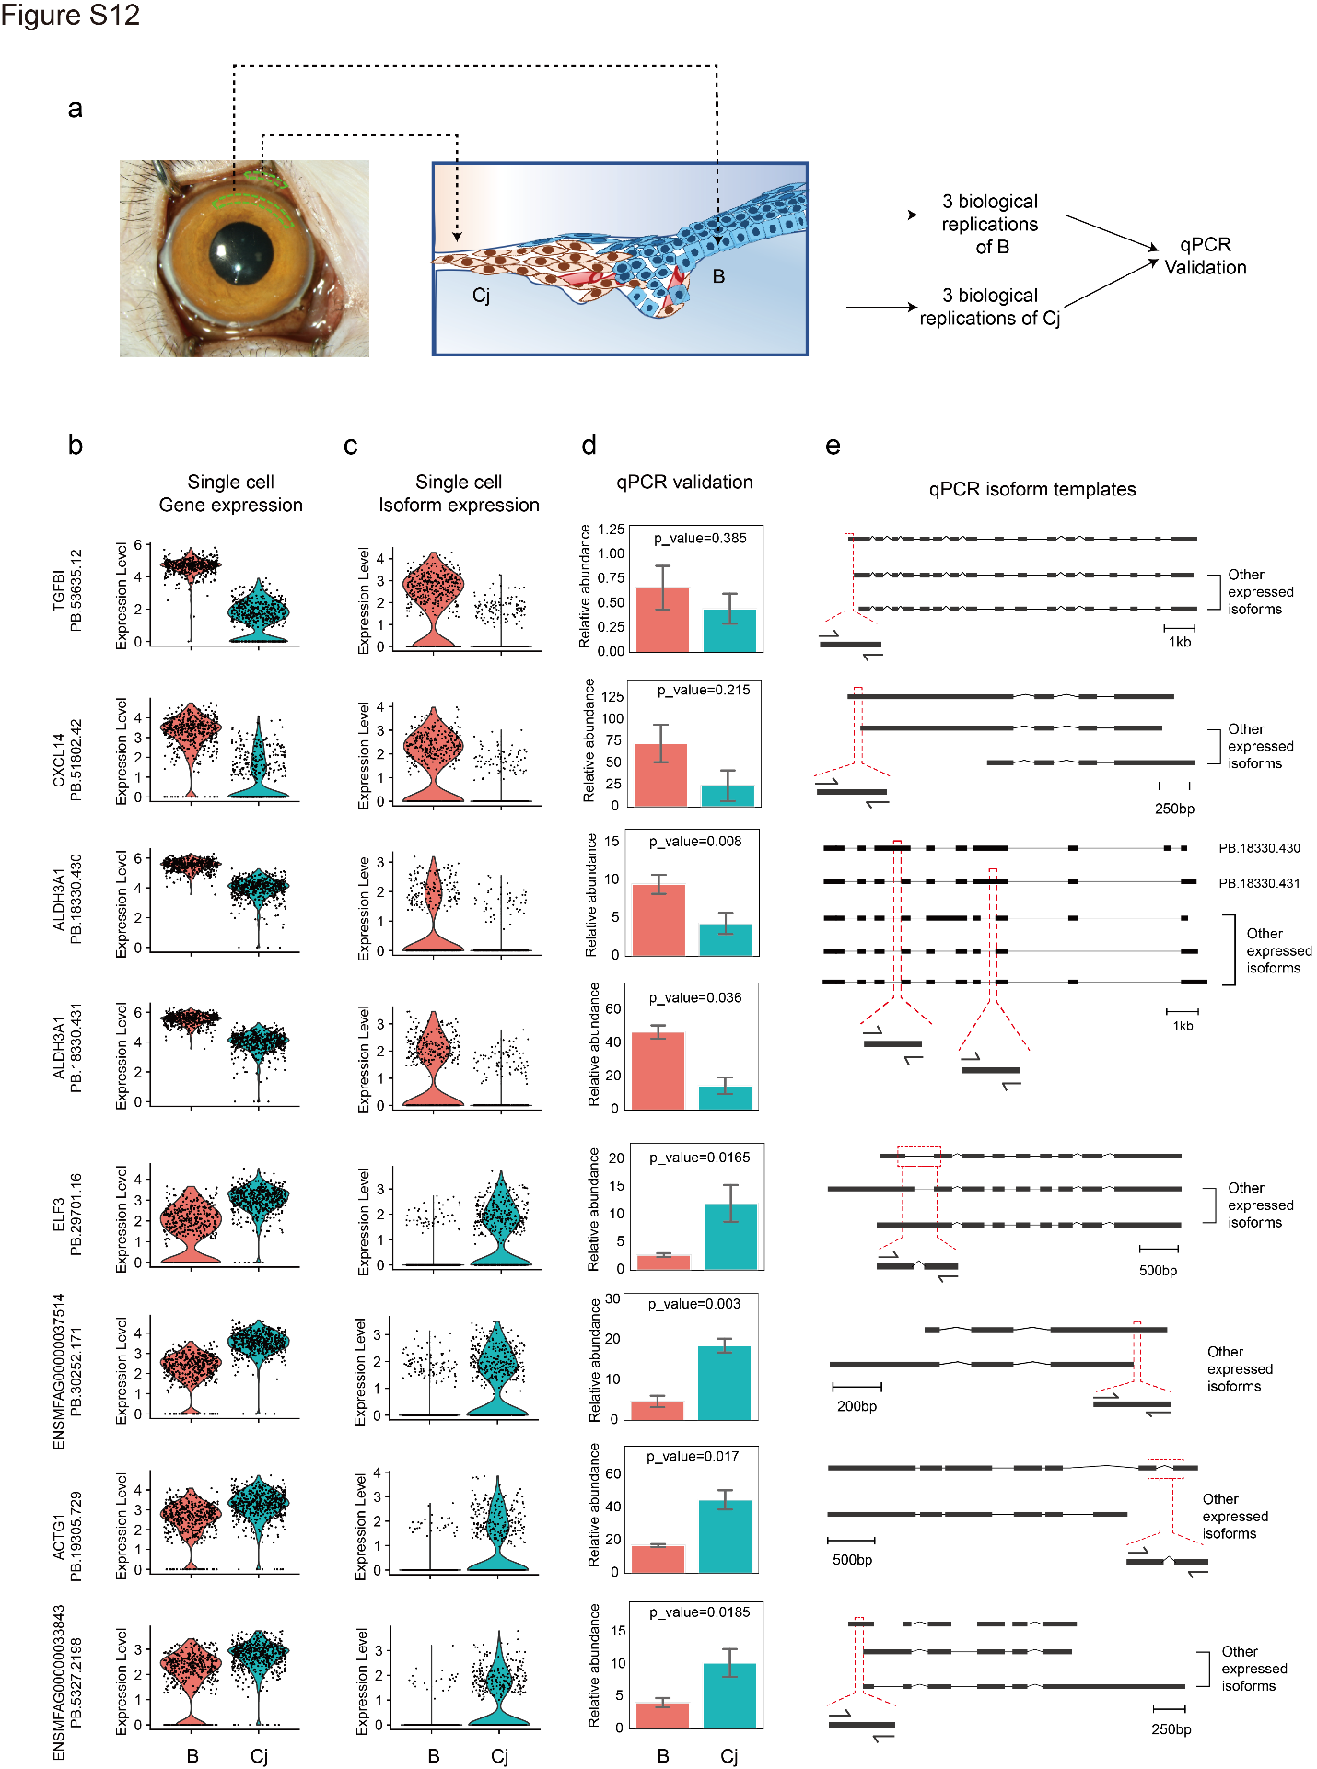
Figure S12. qPCR validation of cell type-specific isoforms. (a) Schematic representation of corneal basal cells (denoted as B) and conjunctival cells (denoted as Cj) that can be sampled for qPCR validation in two isolated regions of the ocular surface. (b-c) Violin plots of single-cell isoform expression of the 8 selected isoforms of B and Cj (c) and single-cell gene expression violin plots of their corresponding genes (b). (d) Barplot shows the relative abundance (2^-delta (Ct) * 10000) calculated from qPCR results of selected 8 isoforms of B and Cj (sample B showed more variation in qPCR results compared with Cj sample, possibly because sample B was more easily contaminated by other cells in sampling: sample B covered under differentiated epithelial cells, Figure S12 a). (e) Schematic representation of the position of the qPCR template on each isoform, the primer sequence shown in STable 11.

