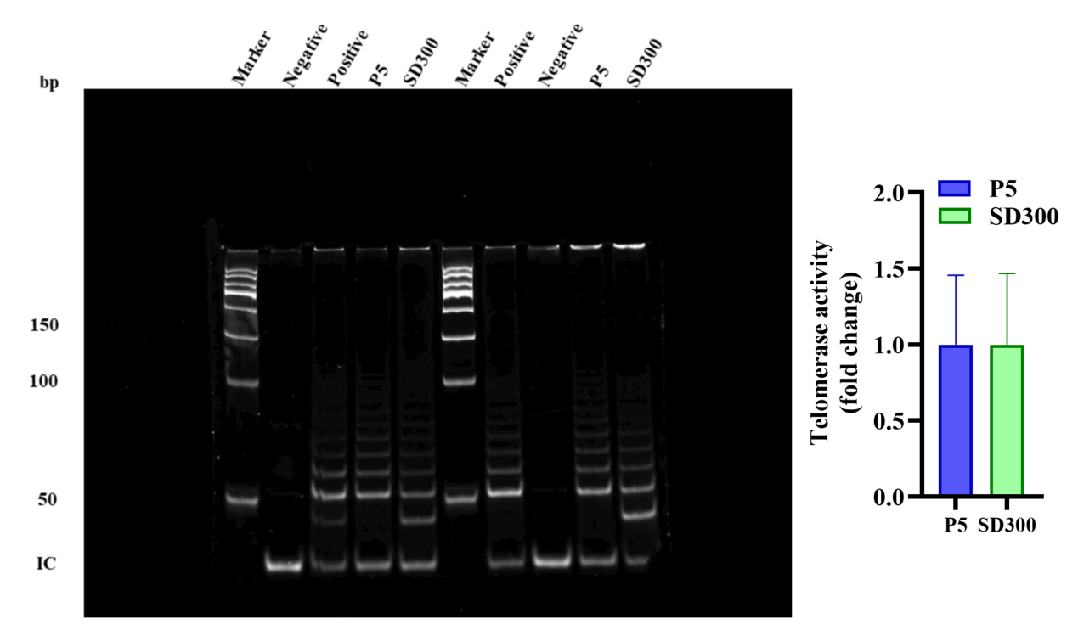
Extended Data Fig. 1 | Telomerase activity in P5 and SD300 cells assessed using the telomeric repeat amplification protocol assay.
Note: P, passage; SD, suspension day. Data are mean ± SD; n = 3.

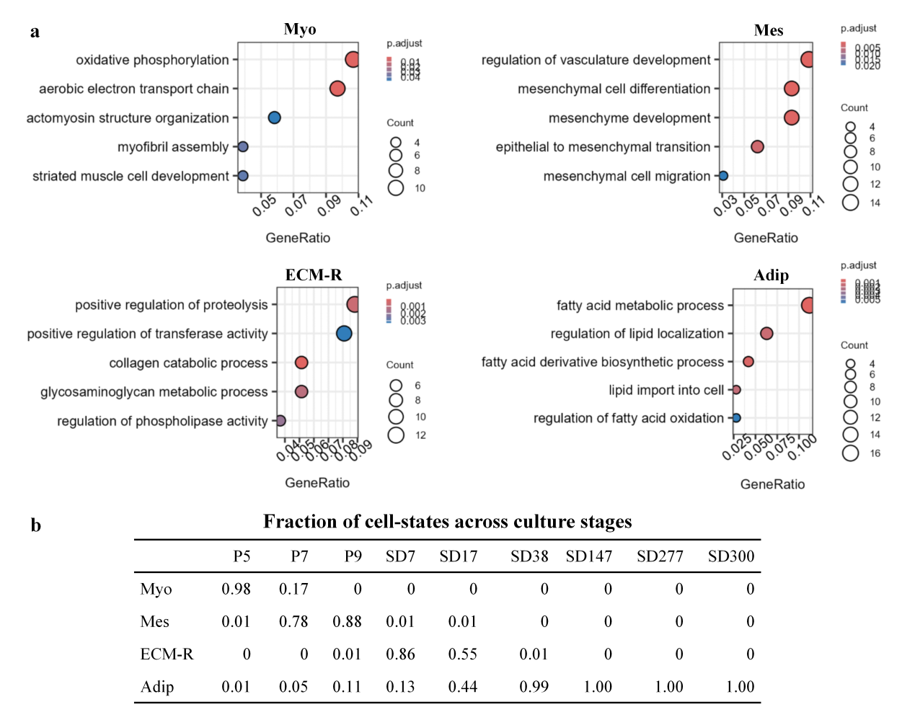
Extended Data Fig. 2 | Characterization and distribution of cell states during long-term culture and suspension adaptation.
a, Representative enriched Gene Ontology terms of top 150 maker genes for four transcriptional states identified by scRNA-seq: myogenic (Myo), mesenchymal stromal-like (Mes), extracellular matrix-remodelling (ECM-R) and adipogenic-like (Adip). b, Fractions cell states across the indicated culture stages.

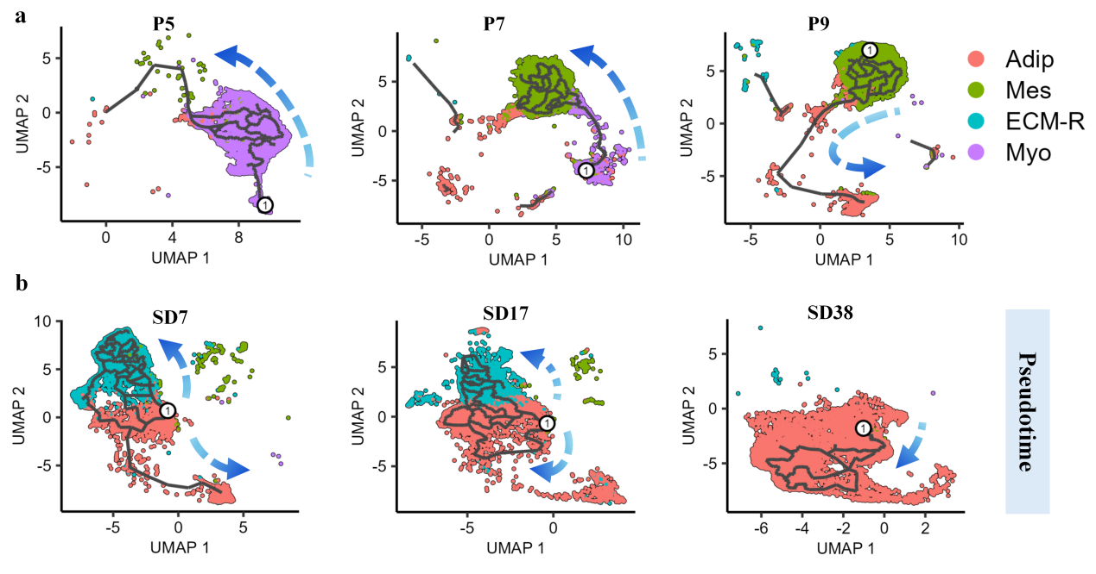
Extended Data Fig. 3 | Single-cell trajectory analysis during adherent culture and early suspension adaptation.
Pseudotime ordering of cells during adherent culture (a; P5, P7, and P9) and early suspension adaption (b; SD7, SD17, and SD38) along the inferred trajectory constucted by Monocle 3. Myo, myogenic; Mes, mesenchymal stromal-like; ECM-R, extracellular matrix-remodelling; Adip, adipogenic-like.

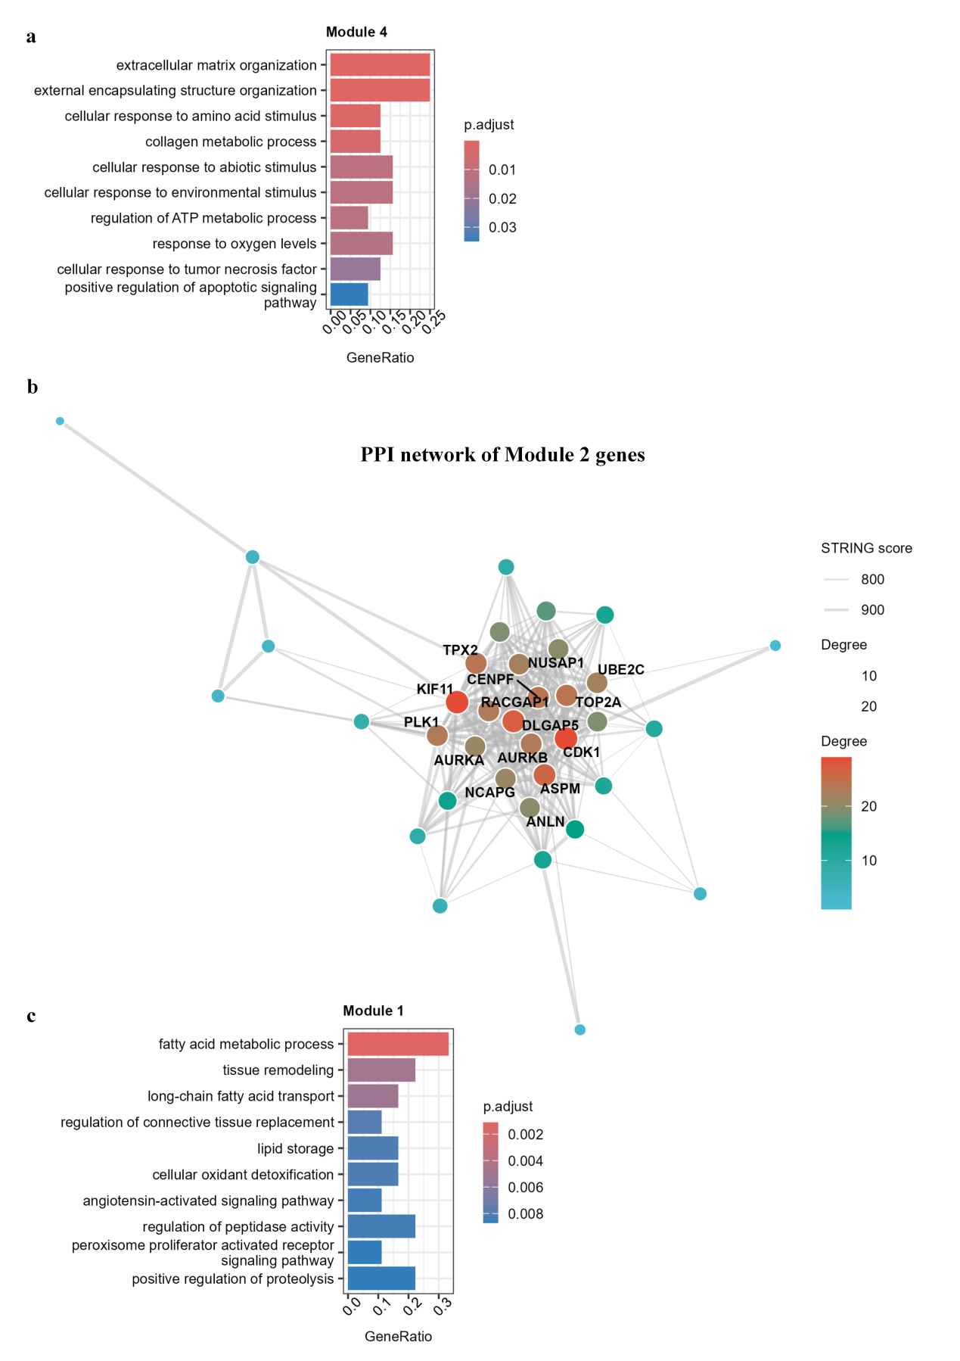
Extended Data Fig. 4 | Functional analysis of gene modules associated with the divergent trajectories in Fig. 2f.
a, Gene Ontology (GO) enrichment analysis of Module 4 genes associated with the path 1. b, Protein–protein interaction (PPI) network of Module 2 genes associated with path 2. c, GO enrichment analysis of Module 1 genes associated with path 2.

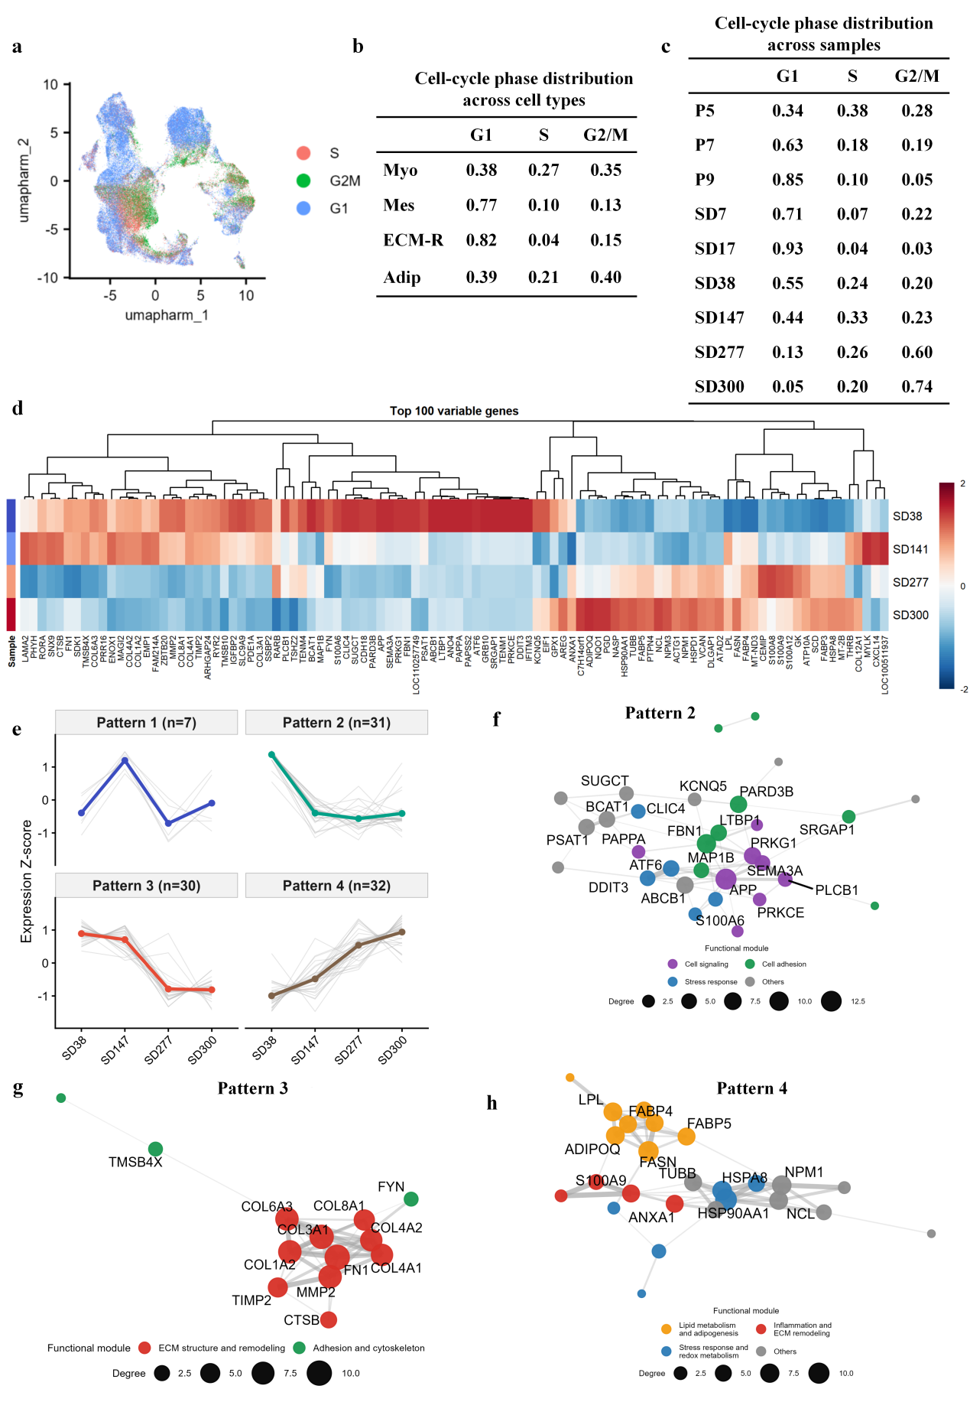
Extended Data Fig. 5 | Cell-cycle and transcriptional changes during long-term suspension culture.
a, Cell-cycle phase distribution across the four transcriptional states. Myo, myogenic; Mes, mesenchymal stromal-like; ECM-R, extracellular matrix-remodelling; Adip, adipogenic-like. b,c, Cell-cycle phase distribution across cell types (b) and culture stages from P5 to SD300 (c). d, Heatmap of the top 100 variable genes in cells from SD38, SD147, SD277, and SD300. e, Expression dynamics of the top 100 variable genes from SD38 to SD300. f–h, Protein–protein interaction (PPI) networks of genes assigned to Pattern 2 (f), Pattern 3 (g) and Pattern 4 (h).

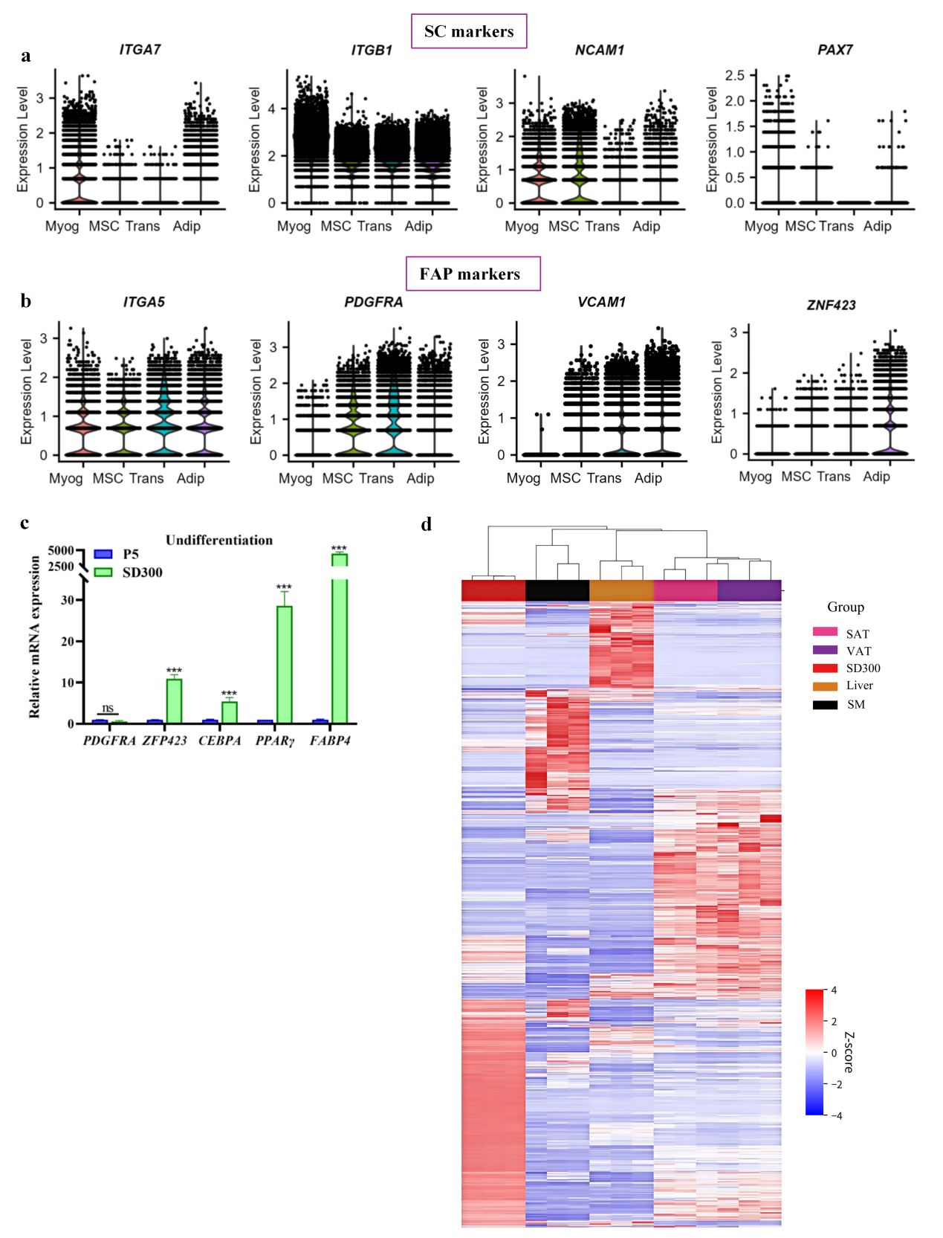
Extended Data Fig. 6 | Adipogenic and myogenic characteristics of SD300 cells.
Violin plot of maker gene expression for satellite cells (SCs; a) and fibro/adipogenic progenitors (FAPs; b). c, Relative mRNA expression of adipogenic genes without adipogenic induction. d, Heatmap of gene-expression profiles across SD300 cells and reference bulk RNA-seq datasets from porcine skeletal muscle, liver, and subcutaneous and visceral adipose tissues.Data are mean ± SD; n=3 for c and d.

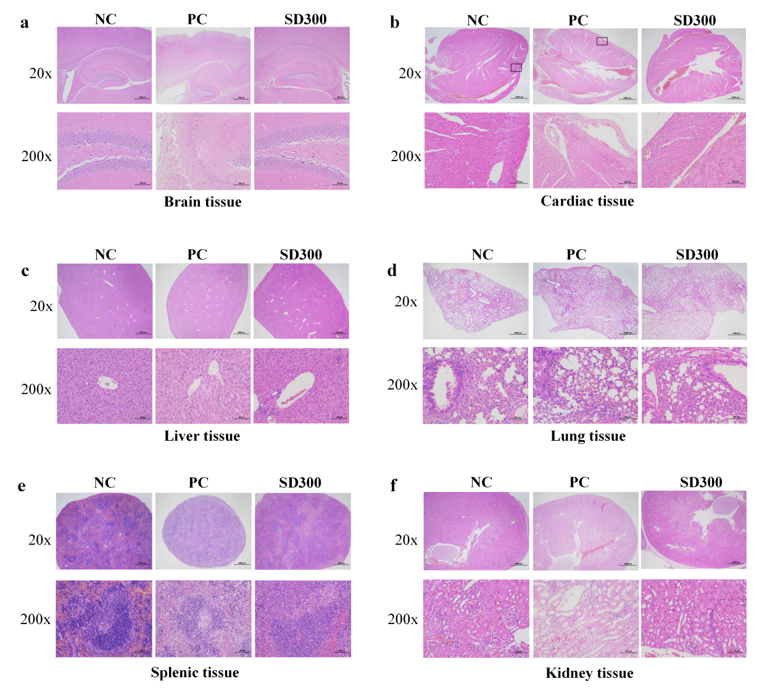
Extended Data Fig. 7 | Histological examination of major organs following the in vivo tumorigenicity assay.
a–f, Representative haematoxylin and eosin (H&E)-stained sections of the brain (a), heart (b), liver (c), lungs (d), spleen (e) and kidneys (f). Tissues were collected from mice in the negative-control (NC), positive-control (PC) and SD300 groups at the endpoint of the assay shown in Fig. 4g. No metastatic lesions were detected in the examined sections from any group. Scale bar, 1000 or 100 μm as indicated.

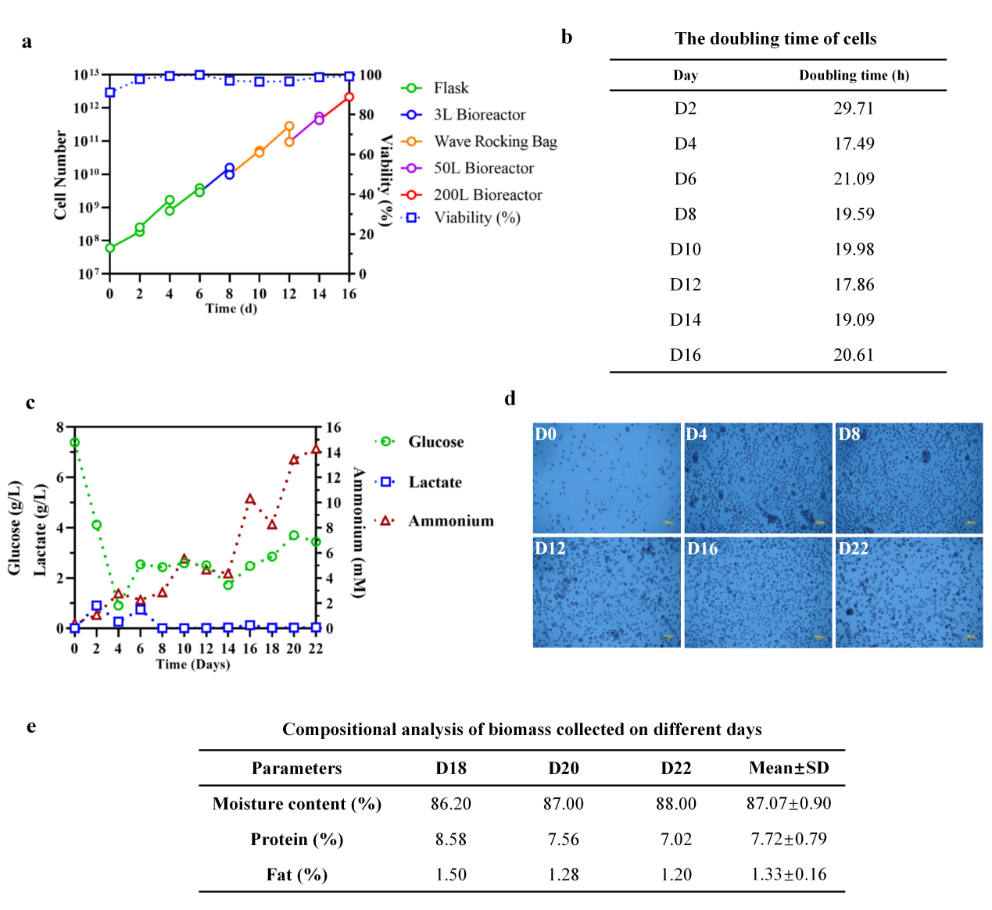
Extended Data Fig. 8 | Cell growth, metabolite profiles and morphology during scale-up.
a, Total cell number and viability during seed-train expansion. b, The doubling time of cells during 2000L production. c,Glucose, lactate and ammonium concentrations. d, Representative micrographs of cells collected on days 0, 4, 8, 12, 16 and 22. Day 0 denotes the start of seed expansion. e. Compositional analysis of biomass collected on different days. Scale bars, 100 μm.

