Supplementary Information
B Cells Modulate Alzheimer’s Disease-related Pathology in a Mouse Model of Down Syndrome
Dolev Michaelovich¹˒²˒³, Angel Moren Fiomi¹˒²˒³, Hadassah Rosenfeld¹˒²˒³, Jennifer Israel-Cohen¹, Eitan Okun¹˒²˒³*
¹ The Mina and Everard Goodman Faculty of Life Sciences, Bar-Ilan University, 5290002 Ramat-Gan, Israel
² The Leslie and Susan Gonda Multidisciplinary Brain Research Center, Bar-Ilan University, 5290002 Ramat-Gan, Israel
³ The Paul Feder Laboratory on Alzheimer's Disease Research, Bar-Ilan University, 5290002 Ramat-Gan, Israel
Corresponding author:
Eitan Okun, Ph.D.
Eitan.okun@biu.ac.il
Journal: Alzheimer's Research & Therapy
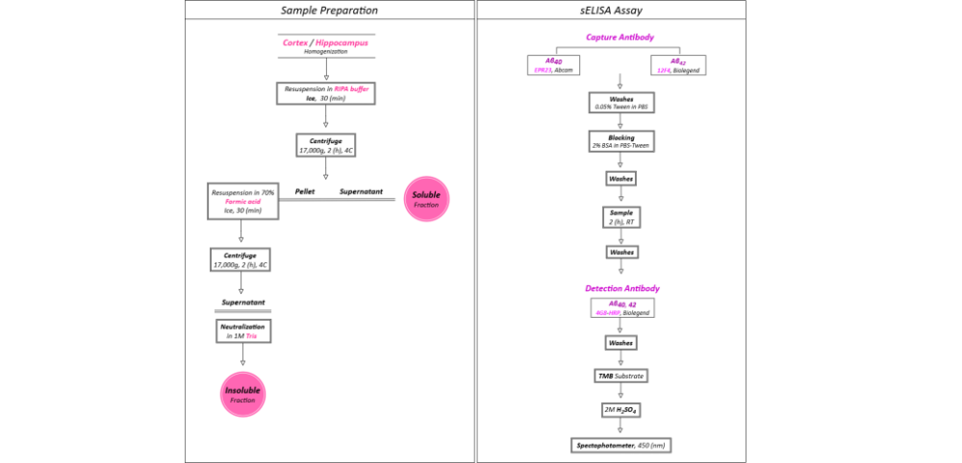

Fig. S1. Sample preparation and sELISA workflow. Workflow for brain tissue preparation and sELISA quantification of mAβ₄₀ and mAβ₄₂ in cortical and hippocampal samples using isoform-specific capture and detection antibodies. Brain homogenates were sequentially extracted to obtain soluble and insoluble fractions before mAβ quantification.

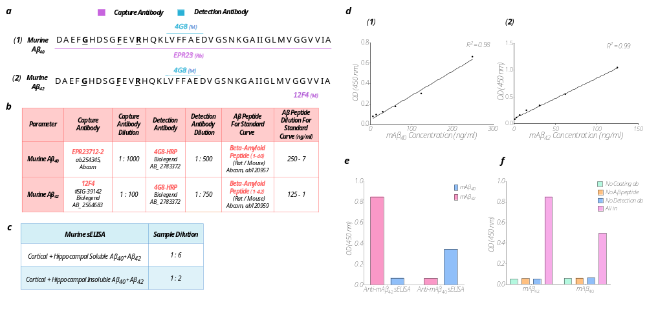
Fig. S2. Optimization and validation of the in-house mAβ₄₀ and mAβ₄₂ sELISA protocol. Optimization and validation of antibody combinations, sample dilutions, standard curves, and assay controls for the in-house sELISA for mAβ₄₀ and mAβ₄₂ measurements. (a) Assay Abs. Abs used in the assay and their corresponding epitopes on murine Aβ peptides. Amino acids shown in bold indicate differences between mouse and human Aβ peptides: (a₁) mAβ₄₀, (a₂) mAβ₄₂. M, mouse antibody host; Rb, rabbit antibody host. (b) Details of the antibodies and proteins for the sELISA protocol. Parameters used to distinguish brain mAβ₄₀ and mAβ₄₂ peptides, including capture and detection antibodies, dilutions, and standard-curve ranges for each measurement. (c) Protein sample dilutions for the sELISA protocol. Sample dilutions used for soluble and insoluble mAβ measurements. (d-f) Assay validation. (d) Representative standard curves generated with recombinant Aβ peptides for brain measurements: (d₁) mAβ₄₀ (R² = 0.98), (d₂) mAβ₄₂ (R² = 0.99). (e) Assessment of cross-reactivity between the mAβ₄₀ and mAβ₄₂ assays. Recombinant mAβ₄₂ was tested in the mAβ₄₀ assay and recombinant mAβ₄₀ in the mAβ₄₂ assay at 1 μg/ml. Signals generated by the non-target isoform were 5-14-fold lower than those generated by the corresponding target isoform, supporting preferential isoform detection. (f) Assay controls. Positive controls contained recombinant mAβ₄₀ or mAβ₄₂ peptide at 1 μg/ml. Negative controls omitted the capture antibody, detection antibody, or target peptide. Detectable signal was observed only when all assay components were present.

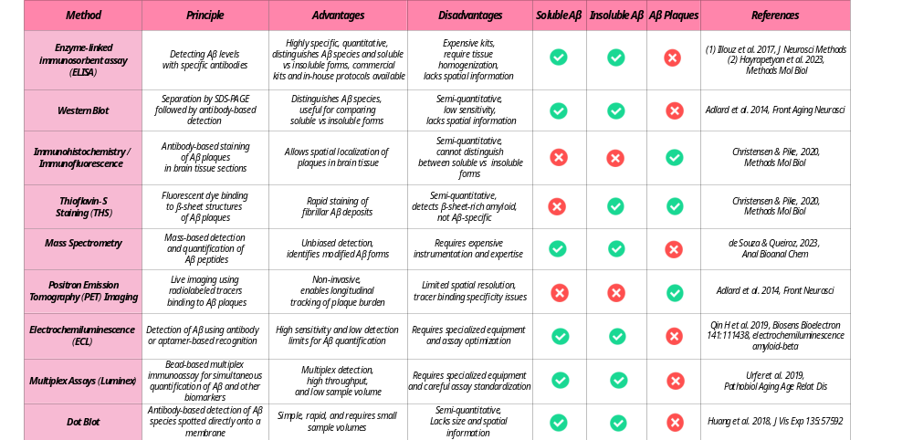Fig. S3. Comparison of amyloid quantification methods. Comparison of commonly used methods for Aβ quantification, summarizing their principal advantages, limitations, and suitability for measuring Aβ isoforms in AD and DS mouse models.

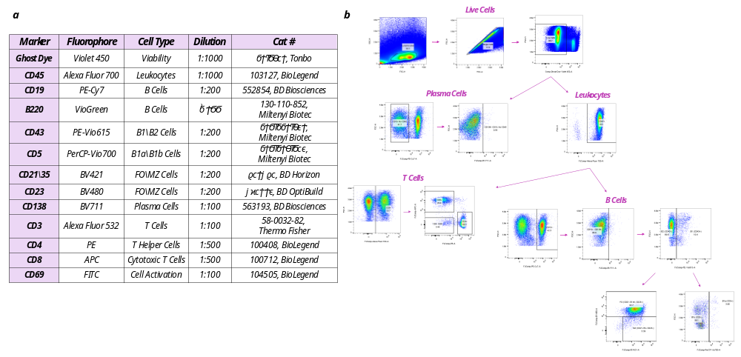

Fig. S4. Flow cytometry antibody panel and gating strategy for adaptive immune cell profiling. (a) Antibody panel for flow cytometry analysis. (b) Representative gating strategy used for adaptive immune cell profiling in Figs. 3-4, quantifying B, B1, B1a, B1b, B2, FO and MZ cells, along with plasma cells, total CD3⁺ T cells, CD4⁺ T cells, CD8⁺ T cells, and CD4⁻ CD8⁻ T cells.

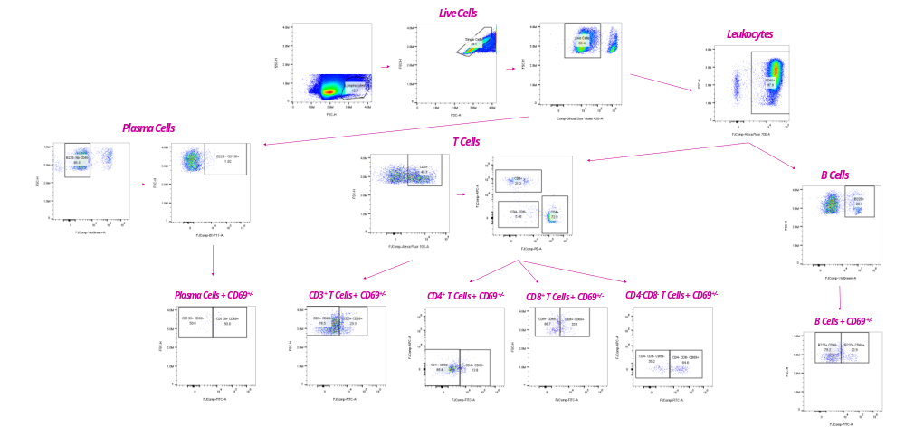

Fig. S5. Gating strategy for assessing CD69 activation following ex vivo mAβ stimulation. Representative gating strategy used to quantify CD69⁺ B cells, plasma cells, total CD3⁺ T cells, CD4⁺ T cells, CD8⁺ T cells, and CD4⁻ CD8⁻ T cells following ex vivo mAβ stimulation, corresponding to Fig. 6c.

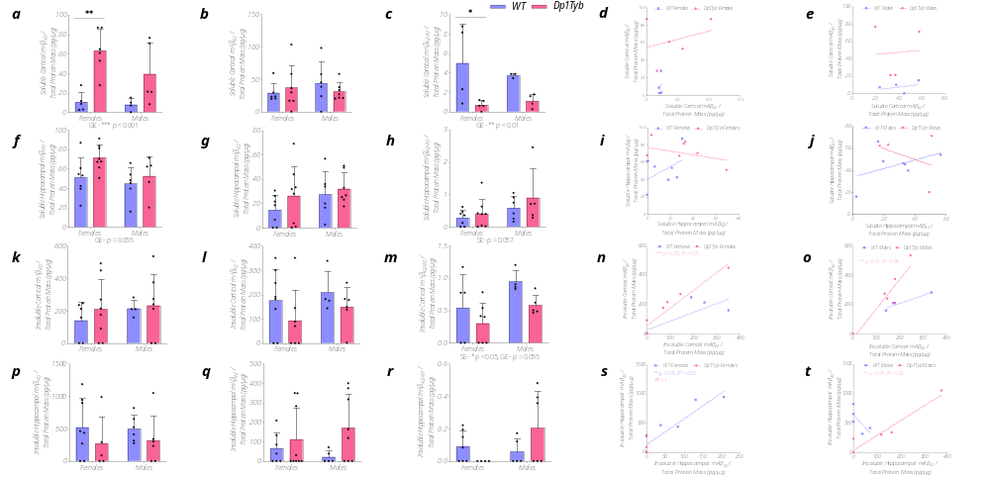
Fig. S6. Aβ Alterations in aged Dp1Tyb mice are not sex-dependent. (a) Soluble cortical mAβ₄₀ levels showed a significant genotype effect (GE, p < 0.001). Post hoc analysis identified significantly higher levels in female Dp1Tyb mice than in female WT mice (p < 0.01) (Dp1Tyb: females, n = 6; males, n = 5; WT: females, n = 5; males, n = 4). (b) Soluble cortical mAβ₄₂ levels did not differ significantly by genotype or sex (Dp1Tyb males and females: n = 7; WT males and females: n = 6). (c) The soluble cortical mAβ_{42/40} ratio showed a significant genotype effect (GE, p < 0.01) (Dp1Tyb: females, n = 5; males, n = 4; WT: females, n = 4; males, n = 3). Post hoc analysis revealed a significant reduction in female Dp1Tyb compared with female WT mice (p < 0.05). (d) No significant correlation was detected between soluble cortical Aβ₄₀ and Aβ₄₂ in female Dp1Tyb mice (n = 5) or female WT mice (n = 4). (e) No significant correlation was found between soluble cortical Aβ₄₀ and Aβ₄₂ in male Dp1Tyb mice (n = 4) or male WT mice (n = 4). (f) The genotype effect on soluble hippocampal mAβ₄₀ did not reach statistical significance (GE, p = 0.055) (Dp1Tyb: females, n = 5; males, n = 8; WT: females, n = 6; males, n = 7). (g) Soluble hippocampal mAβ₄₂ levels did not differ significantly by genotype or sex (Dp1Tyb: females, n = 8; males, n = 7; WT: females, n = 7; males, n = 6). (h) The sex effect on the soluble hippocampal mAβ_{42/40} ratio did not reach statistical significance (SE, p = 0.057) (Dp1Tyb: females, n = 5; males, n = 8; WT: females, n = 6; males, n = 7). (i) No significant correlation was found between soluble hippocampal Aβ₄₀ and Aβ₄₂ in female Dp1Tyb mice (n = 8) or female WT mice (n = 7). (j) No significant correlation was detected between soluble hippocampal Aβ₄₀ and Aβ₄₂ in male Dp1Tyb mice (n = 5) or male WT mice (n = 6). (k) Insoluble cortical mAβ₄₀ levels did not differ significantly by genotype or sex (Dp1Tyb: females, n = 8; males, n = 7; WT: females, n = 6; males, n = 4). (l) Insoluble cortical mAβ₄₂ levels did not differ significantly by genotype or sex (Dp1Tyb: females, n = 7; males, n = 6; WT: females, n = 8; males, n = 4). (m) The insoluble cortical mAβ_{42/40} ratio showed a significant genotype effect (GE, p < 0.05), whereas the sex effect did not reach statistical significance (SE, p = 0.055) (Dp1Tyb: females, n = 7; males, n = 5; WT: females, n = 6; males, n = 4). (n) A significant positive association between insoluble cortical mAβ₄₀ and mAβ₄₂ was detected in female Dp1Tyb mice (n = 7) (p < 0.001, R² = 0.91), but not in female WT mice (n = 5). (o) A significant positive association between insoluble cortical mAβ₄₀ and mAβ₄₂ was detected in male Dp1Tyb mice (p < 0.01, R² = 0.86; n = 6) and male WT mice (n = 4) (p < 0.05, R² = 0.9). (p) Insoluble hippocampal mAβ₄₀ levels did not differ significantly by genotype or sex (Dp1Tyb: females, n = 5; males, n = 6; WT: females, n = 8; males, n = 6). (q) Insoluble hippocampal mAβ₄₂ levels did not differ significantly by genotype or sex (Dp1Tyb: females, n = 8; males, n = 8; WT: females, n = 7; males, n = 5). (r) Insoluble hippocampal mAβ_{42/40} ratio did not differ significantly by genotype or sex (Dp1Tyb: females, n = 4; males, n = 6; WT: females, n = 7; males, n = 5). (s) In female Dp1Tyb mice (n = 4), insoluble hippocampal mAβ₄₀ and mAβ₄₂ values showed an R² of 1. A significant positive association was detected in female WT mice (p < 0.01, R² = 0.85; n = 7). (t) A significant positive association was detected in male Dp1Tyb mice (p < 0.01, R² = 0.92; n = 6), but not in male WT mice (n = 5). Data were analyzed using two-way ANOVA with genotype and sex as factors, followed by Tukey's post hoc test. Linear regression was used to assess relationships between mAβ₄₀ and mAβ₄₂ concentrations. Data are presented as mean ± SD. Each point represents an individual mouse. GE, genotype effect. SE, sex effect. Statistical significance is denoted as * p < 0.05, ** p < 0.01, *** p < 0.001, and **** p < 0.0001.

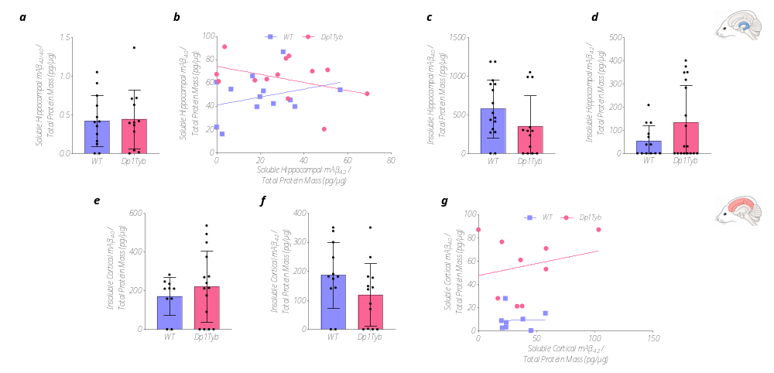

Fig. S7. Complementary mAβ₄₀ and mAβ₄₂ measurements in aged Dp1Tyb mice. (a) The soluble hippocampal mAβ_{42/40} ratio did not differ significantly between Dp1Tyb and WT mice (Dp1Tyb: n = 13; WT: n = 13). (b) No significant association between soluble hippocampal mAβ₄₀ and mAβ₄₂ was detected in either genotype (Dp1Tyb: n = 13; WT: n = 13). (c) Insoluble hippocampal mAβ₄₀ levels did not differ significantly between Dp1Tyb and WT mice (Dp1Tyb: n = 13; WT: n = 16). (d) Insoluble hippocampal mAβ₄₂ levels did not differ significantly between Dp1Tyb and WT mice (Dp1Tyb: n = 18; WT: n = 13). (e) Insoluble cortical mAβ₄₀ levels did not differ significantly between Dp1Tyb and WT mice (Dp1Tyb: n = 14; WT: n = 10). (f) No significant differences were detected in insoluble cortical mAβ₄₂ between Dp1Tyb and WT mice (Dp1Tyb: n = 13; WT: n = 12). (g) No significant correlation was found between soluble cortical mAβ₄₀ and mAβ₄₂ in either Dp1Tyb or WT mice (Dp1Tyb: n = 9; WT: n = 8). Normality was assessed using the Shapiro-Wilk test. Between-genotype comparisons were performed using an unpaired Student’s t-test or the Mann-Whitney test, as appropriate. Data are presented as mean ± SD. Each point represents an individual mouse. Linear regression was used to assess relationships between mAβ₄₀ and mAβ₄₂. Statistical significance is denoted as * p < 0.05, ** p < 0.01, *** p < 0.001, and **** p < 0.0001.

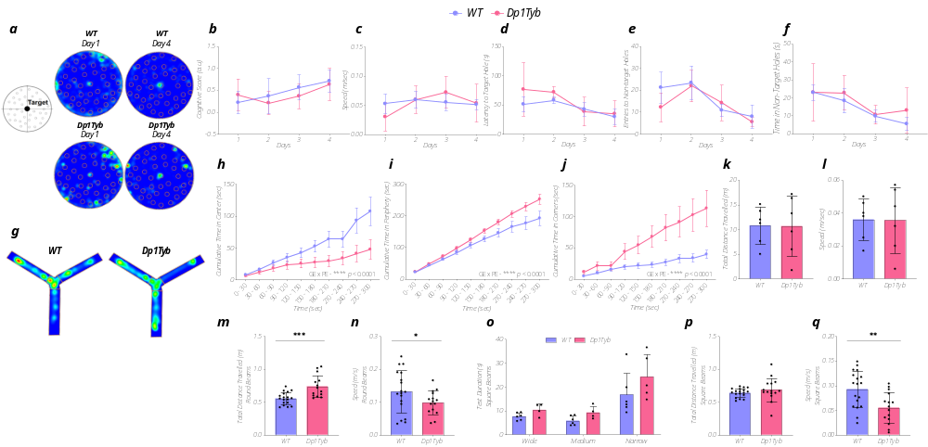Fig. S8. Complementary behavioral characterization of aged male Dp1Tyb mice. (a-f) MBM (Dp1Tyb: n = 5; WT: n = 6). (a) Representative MBM trajectory heatmaps from Dp1Tyb and WT mice on the first and the final training days, illustrating the evolution of search behavior around the target hole. (b) Cognitive score did not differ significantly between genotypes. (c) Mean movement did not differ significantly between genotypes. (d) Latency to enter the target hole did not differ significantly between genotypes. (e) The number of entries into the non-target holes did not differ significantly between genotypes. (f) Time spent exploring non-target holes did not differ significantly between genotypes. Data were analyzed using two-way repeated-measures ANOVA with genotype and training day as factors, followed by Šídák’s post hoc test. (g) Y-maze forced-choice (n = 6 per group). Representative Y-maze forced-choice occupancy heatmaps for Dp1Tyb and WT mice. (h-l) OFA (n = 6 per group). (h) Cumulative time spent in the center of the OFA (GE × PE interaction, p < 0.0001). (i) Cumulative time spent in the peripheral area of the OFA (GE × PE interaction, p < 0.0001). (j) Cumulative time spent in corner regions of the OFA (GE × PE interaction, p < 0.0001). (k) Total distance traveled in the OFA did not differ significantly between genotypes. (l) Speed in the OFA did not differ significantly between genotypes. Data were analyzed using two-way repeated-measures ANOVA with genotype and test phase as factors, followed by Šídák’s post hoc test. (m-q) Beam-walking (Dp1Tyb: n = 5; WT: n = 6). (m) Total distance traveled on round beams was significantly higher in Dp1Tyb mice (p < 0.001). (n) Average speed on round beams was significantly lower in Dp1Tyb mice (p < 0.05). (o) Test duration did not differ significantly between genotypes across square-beam widths. (p) Total distance traveled across square-beam widths did not differ significantly between Dp1Tyb and WT mice. (q) Average speed on square beams was significantly lower in Dp1Tyb mice (p < 0.01). Data were analyzed using two-way repeated-measures ANOVA with genotype and beam width as factors, followed by Šídák’s post hoc test or Shapiro-Wilk normality test followed by an unpaired t-test or Mann-Whitney test. Data are presented as mean ± SD. Each point represents an individual mouse. GE, genotype effect; LE, level effect; PE, phase effect. Statistical significance is denoted as * p < 0.05, ** p < 0.01, *** p < 0.001, and **** p < 0.0001.

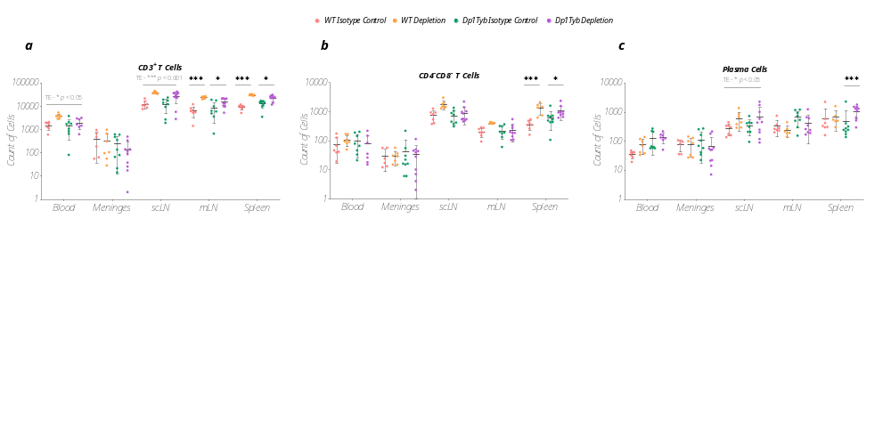

Fig. S9. Adaptive immune cell changes following B-cell depletion treatment. Absolute immune-cell counts across blood, meninges, scLN, mLN, and spleen. For each tissue, equal numbers of viable cells, normalized to the number of viable cells recovered from that tissue, were exported (Dp1Tyb isotype control: n = 8-9; Dp1Tyb depletion: n = 7-10; WT isotype control: n = 6-7; WT depletion: n = 6-7). (a) B-cell depletion treatment induced tissue- and genotype-dependent increases in absolute CD3⁺ T-cell counts. In the blood, a significant overall treatment effect was detected for increased CD3⁺ T-cell abundance (TE, p < 0.05). No significant differences were detected in the meninges. In the scLN, a strong overall treatment effect was observed (TE, p < 0.001). In the mLN and spleen, CD3⁺ T-cell abundance was significantly increased in both Dp1Tyb (p < 0.05) and WT mice (p < 0.001). (b) B-cell depletion had limited effects on CD4⁻CD8⁻ T-cell abundance. No significant differences were detected in the blood, meninges, scLN, or mLN, whereas splenic CD4⁻CD8⁻ T-cell abundance was significantly increased in both Dp1Tyb (p < 0.05) and WT mice (p < 0.001). (c) Plasma cell abundance showed limited changes following B-cell depletion. In the blood, meninges, and mLN, no differences were detected. In the scLN, a significant overall treatment effect was observed (TE, p < 0.05). In the spleen, plasma cell abundance was significantly increased only in Dp1Tyb mice (p < 0.001). Cell counts were calculated relative to the number of CD45⁺ cells within each tissue. Plasma-cell counts were calculated relative to the total number of live cells. For each tissue, data were analyzed by two-way mixed ANOVA with genotype and cell-type as factors, and mouse ID as random effect, followed by FDR-adjusted post hoc comparisons. Data are presented as mean ± SD. Each point represents an individual mouse. TE, treatment effect. Statistical significance is denoted as * p < 0.05, ** p < 0.01, *** p < 0.001, and **** p < 0.0001.

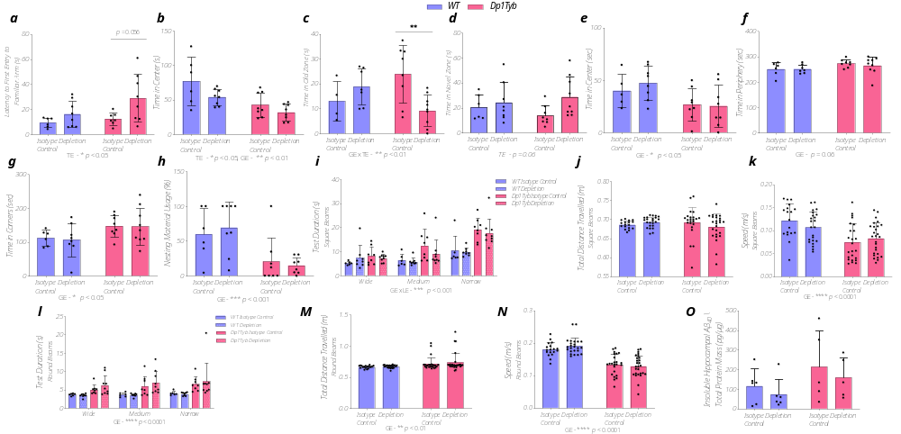Fig. S10. Complementary behavioral and Aβ outcomes following B-cell depletion treatment. (a-n) Behavioral outcomes (Dp1Tyb isotype control: n = 8; Dp1Tyb depletion: n = 9; WT isotype control: n = 6; WT depletion: n = 8). (a-b) Y-maze forced-choice. (a) A significant treatment effect was observed for latency to first enter the familiar arm following the opening of the novel arm (TE, p < 0.05). Post hoc analysis showed a non-significant increase in latency in B-cell depleted Dp1Tyb mice compared with isotype-treated Dp1Tyb mice (p = 0.056). (b) Significant main effects of treatment and genotype were detected for time spent in the Y-maze center (TE, p < 0.05; GE, p < 0.01). (c-d) OLR. (c) Time spent in the unchanged-object zone. A significant genotype × treatment interaction was detected (GE × TE interaction, p < 0.01). Post hoc analysis showed reduced time in B-cell-depleted Dp1Tyb mice compared with isotype-treated Dp1Tyb mice (p < 0.01). (d) Time spent in the novel-object zone. The treatment effect did not reach statistical significance (TE, p = 0.06). (e-g) OFA. (e) Time spent in OFA center (GE, p < 0.05). (f) The genotype effect on time spent in the OFA periphery did not reach statistical significance (GE, p = 0.06). (g) Time spent in the OFA corners (GE, p < 0.05). (h) Nesting. Dp1Tyb mice used significantly less nesting material than WT mice (GE, p < 0.001), with no significant effect of B-cell depletion. For a-h: Two-way ANOVA with genotype and treatment as factors, followed by Tukey's post hoc test. (i-n) Beam-walking. B-cell depletion did not normalize Dp1Tyb-related motor deficits. (i) Dp1Tyb mice showed increased test duration across square-beam widths (GE × LE interaction, p < 0.001). (j) Total distance traveled on square beams did not differ between genotypes. (k) Dp1Tyb showed lower movement speed on the square beams (GE, p < 0.0001). (l) Dp1Tyb mice showed increased test duration across round-beam widths (GE, p < 0.0001). (m) Dp1Tyb presented reduced total distance traveled on the round beams (GE, p < 0.0001). (n) Dp1Tyb mice presented reduced speed on round beams (GE, p < 0.0001). Three-way ANOVA with genotype, treatment, and beam width as factors. Data are presented as mean ± SD. (o) Insoluble hippocampal mAβ₄₀ levels were numerically lower following B-cell depletion, but the effect did not reach statistical significance (Dp1Tyb isotype control: n = 6; Dp1Tyb depletion: n = 6; WT isotype control: n = 6; WT depletion: n = 7). Each point represents an individual mouse. TE, treatment effect. GE, genotype effect. LE, level effect. Statistical significance is denoted as * p < 0.05, ** p < 0.01, *** p < 0.001, and **** p < 0.0001.

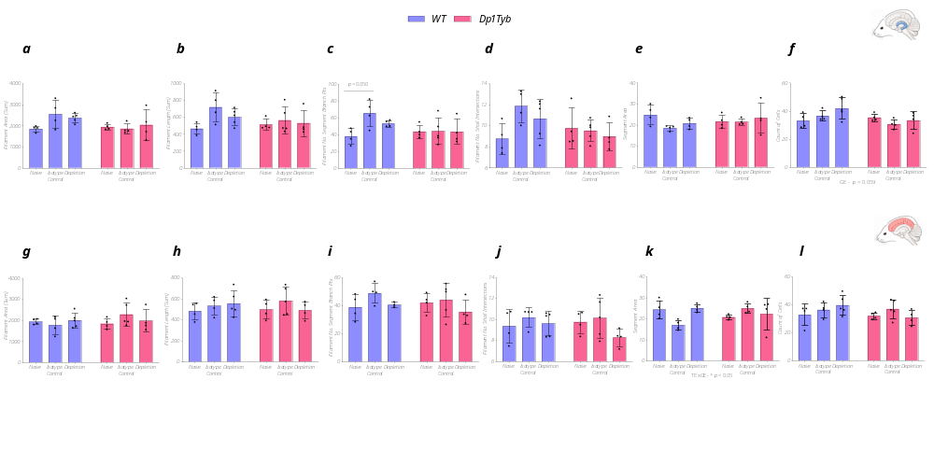Fig. S11. B-cell depletion does not alter microglial morphology in Dp1Tyb and WT mice.
Microglial morphology was assessed in Dp1Tyb naïve (n = 4), Dp1Tyb isotype control (n = 5), Dp1Tyb depletion (n = 4), WT naïve (n = 4), WT isotype control (n = 4), and WT depletion (n = 5). (a) Hippocampal microglial filament area did not differ significantly among groups. (b) Hippocampal microglial filament length did not differ significantly among groups. (c) A non-significant increase in branch-point number was observed in isotype-treated WT compared with naïve WT mice (p = 0.050). (d) The number of Sholl intersections in hippocampal microglia did not differ significantly among groups. (e) Hippocampal microglial segment area did not differ significantly among groups. (f) Hippocampal microglial cell count did not differ significantly among groups (GE, p = 0.059). (g) Cortical microglial filament area did not differ significantly among groups. (h) Cortical microglial filament length did not differ significantly among groups. (i) Cortical microglial number of segment branch points did not differ significantly among groups. (j) Cortical microglial number of Sholl intersections did not differ significantly among groups. (k) Cortical microglial segment area showed a TE × GE interaction (p < 0.05). (l) Cortical microglial cell count did not differ significantly among groups. Two-way ANOVA with genotype and treatment as factors, followed by Tukey's post hoc test. Data are presented as mean ± SD. Each point represents an individual mouse. GE, genotype effect. TE, treatment effect. Statistical significance is denoted as * p < 0.05, ** p < 0.01, *** p < 0.001, and **** p < 0.0001.

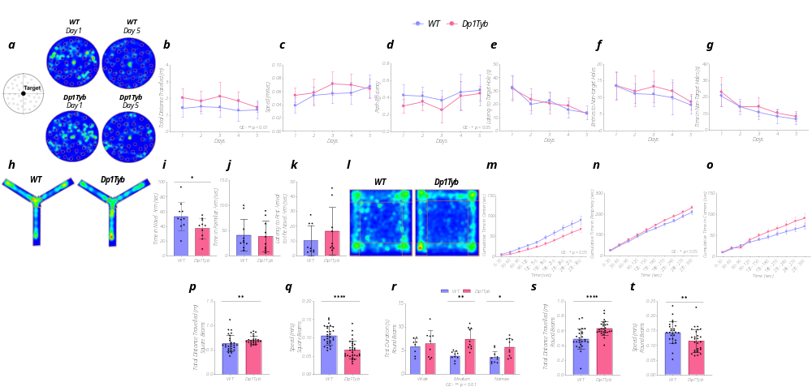
Fig. S12. Complementary behavioral characterization of middle-aged (5-7-month-old) female Dp1Tyb mice. (a-g) MBM (Dp1Tyb: n = 7; WT: n = 10). (a) Representative MBM trajectory heatmaps from Dp1Tyb and WT mice on the first and the final training days, illustrating the evolution of search behavior around the target hole. (b) Dp1Tyb mice traveled a greater total distance across training days (GE, p < 0.01). (c) Movement speed did not differ significantly between genotypes across MBM training. (d) Dp1Tyb mice exhibited lower path efficiency across training days (GE, p < 0.05). (e) Latency to enter the target hole did not differ significantly between genotypes across training days. (f) Number of entries into non-target holes did not differ significantly between genotypes across training days. (g) Time spent in non-target holes did not differ significantly between genotypes across training days. Two-way repeated-measures ANOVA with genotype and training day as factors, followed by Šídák’s post hoc test. (h-k) Y-maze forced-choice (n = 10 per group). (h) Representative Y-maze forced-choice heatmaps for female Dp1Tyb and WT mice. (i) Dp1Tyb mice spent significantly less time in the novel arm than WT mice (p < 0.05). (j) Time in the familiar arm did not differ significantly between Dp1Tyb and WT mice. (k) Latency to first enter the novel arm did not differ significantly between Dp1Tyb and WT mice. Normality was assessed using the Shapiro-Wilk test. Between-genotype comparisons were performed using an unpaired Student’s t-test or the Mann-Whitney test, as appropriate. (l-o) OFA (n = 10 per group). (l) Representative OFA occupancy heatmaps for female Dp1Tyb and WT mice. (m) Dp1Tyb mice spent less time in the center of the OFA (GE, p < 0.05). (n) Dp1Tyb mice spent more time in the periphery of the OFA (GE, p < 0.05). (o) Dp1Tyb mice spent more time in the corners of the OFA (GE, p < 0.05). Two-way repeated-measures ANOVA with genotype and test phase as factors, followed by Šídák’s post hoc test. (p-t) Beam-walking (n = 10 per group). (p) Total distance traveled on square beams was significantly greater in Dp1Tyb mice (p < 0.01). (q) Square-beam speed was significantly lower in Dp1Tyb mice (p < 0.0001). (r) Dp1Tyb mice showed significantly longer round-beam traversal times (GE, p < 0.01), with post hoc genotype differences on the medium (p < 0.01) and narrow (p < 0.05) beams. (s) Total distance traveled on round beams was significantly greater in Dp1Tyb mice (p < 0.0001). (t) Round-beam speed was significantly reduced in Dp1Tyb mice (p < 0.01). Two-way repeated-measures ANOVA with genotype and beam width as factors, followed by Šídák’s post hoc test or Shapiro-Wilk normality test followed by unpaired t-test or the Mann-Whitney test. Data are presented as mean ± SD. Each point represents an individual mouse. GE, genotype effect. LE, level effect. Statistical significance is denoted as * p < 0.05, ** p < 0.01, *** p < 0.001, and **** p < 0.0001.

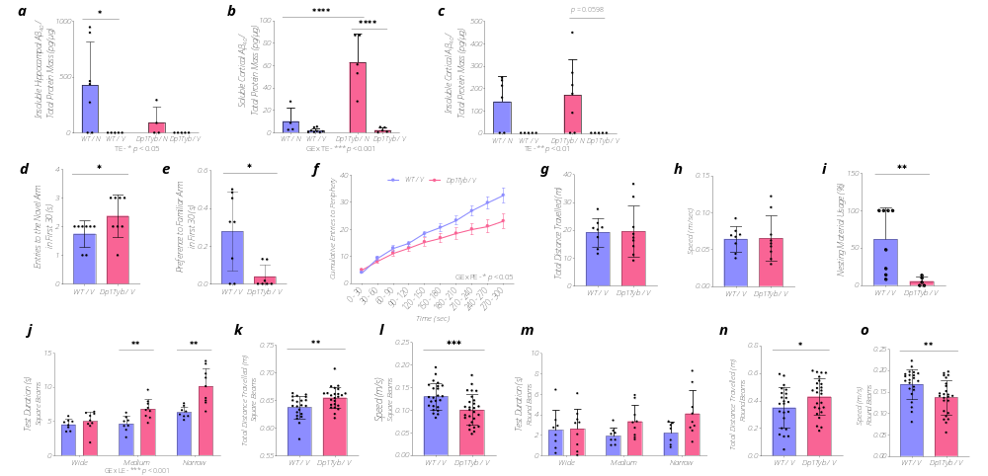Fig. S13. Complementary behavioral and Aβ outcomes following mAβ vaccination. (a-c) mAβ₄₀ was quantified in naïve WT (WT/N), vaccinated WT (WT/V), naïve Dp1Tyb (Dp1Tyb/N), and vaccinated Dp1Tyb (Dp1Tyb/V) mice. (a) A significant overall treatment effect was detected for insoluble hippocampal mAβ₄₀ (TE, p < 0.05). Post hoc analysis showed a significant reduction following vaccination only in WT mice (p < 0.05; Dp1Tyb/N: n = 4; Dp1Tyb/V: n = 5; WT/N: n = 7; WT/V: n = 5). (b) A significant genotype × treatment interaction was detected for soluble cortical mAβ₄₀ (GE × TE interaction, p < 0.001). Post hoc analysis showed significantly lower soluble cortical mAβ₄₀ in Dp1Tyb/V versus Dp1Tyb/N mice (p < 0.0001) and significantly higher levels in Dp1Tyb/N than WT/N mice (Dp1Tyb/N: n = 5; Dp1Tyb/V: n = 5; WT/N: n = 4; WT/V: n = 8). (c) A significant overall treatment effect was detected for insoluble cortical mAβ₄₀ (TE, p < 0.01). The within-genotype reduction in Dp1Tyb mice did not reach statistical significance in post hoc analysis (p = 0.0598; Dp1Tyb/N: n = 7; Dp1Tyb/V: n = 5; WT/N: n = 6; WT/V: n = 5). Two-way ANOVA with genotype and treatment as factors, followed by Tukey's post hoc test. (d-e) T-maze (vaccinated Dp1Tyb [Dp1Tyb/V]: n = 9; vaccinated WT [WT/V]: n = 8). (d) Number of entries into the novel arm during the first 30 s of the T-maze test was significantly higher in Dp1Tyb/V mice than in WT/V mice (p < 0.05). (e) Preference for the familiar arm during the first 30 s was significantly lower in Dp1Tyb/V mice (p < 0.05). Normality was assessed using the Shapiro-Wilk test. Between-genotype comparisons were performed using an unpaired Student’s t-test or Mann-Whitney test, as appropriate. (f-h) OFA (Dp1Tyb/V: n = 9; WT/V: n = 8). (f) Dp1Tyb mice spent less time in the periphery of the OFA (GE × PE interaction, p < 0.05). (g) Total distance traveled in the OFA did not differ between vaccinated genotypes. (h) Movement speed in the OFA did not differ between genotypes. Normality was assessed using the Shapiro-Wilk test. Between-genotype comparisons were performed using an unpaired Student’s t-test or Mann-Whitney test, as appropriate, or two-way repeated-measures ANOVA with genotype and test phase as factors, followed by Šídák’s post hoc test. (i) Nesting (Dp1Tyb/V: n = 5; WT/V: n = 8). Dp1Tyb/V mice used significantly less nesting material than WT/V mice (p < 0.01). Normality was assessed using the Shapiro-Wilk test. Between-genotype comparisons were performed using an unpaired Student’s t-test or Mann-Whitney test, as appropriate. (j-o) Beam-walking (Dp1Tyb/V: n = 9; WT/V: n = 8). Motor deficits remained evident in vaccinated Dp1Tyb mice relative to vaccinated WT mice. (j) Square-beam test duration was longer in Dp1Tyb/V mice (GE × LE interaction, p < 0.0001), with significant genotype differences on the medium and narrow beams (p < 0.01). (k) Total distance traveled on square beams was significantly higher in vaccinated Dp1Tyb/V mice (p < 0.01). (l) Movement speed on square beams was reduced in Dp1Tyb/V mice (p < 0.001). (m) No differences were detected between genotypes in test duration on round beams. (n) Total distance traveled on round beams was greater in Dp1Tyb/V mice (p < 0.05). (o) Movement speed on round beams was reduced in Dp1Tyb/V mice (p < 0.01). Two-way repeated-measures ANOVA with genotype and beam width as factors, followed by Šídák’s post hoc test or Shapiro-Wilk normality test followed by unpaired t-test or Mann-Whitney test. Data are presented as mean ± SD. Each point represents an individual mouse. TE, treatment effect. GE, genotype effect. PE, phase effect. LE, level effect. Statistical significance is denoted as * p < 0.05, ** p < 0.01, *** p < 0.001, and **** p < 0.0001.

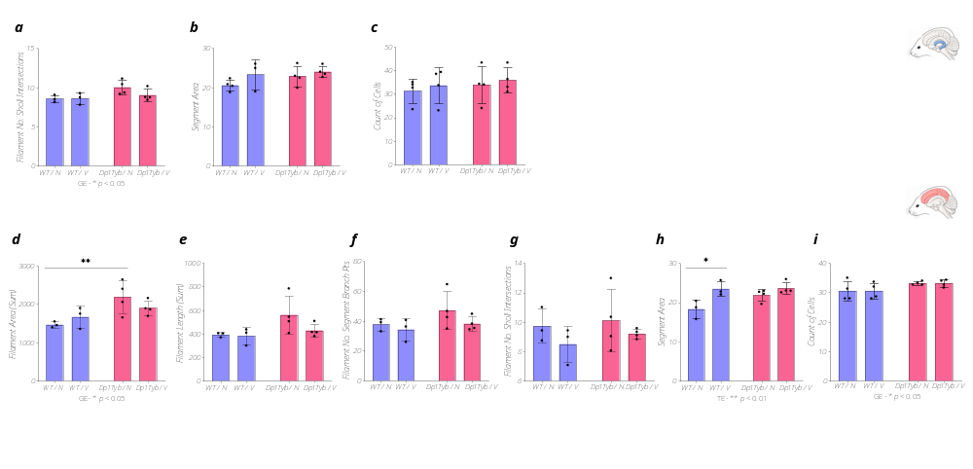Fig. S14. Cortical microglial morphology does not change following mAβ vaccination. (Dp1Tyb/N: n = 4; Dp1Tyb/V: n = 4; WT/N: n = 3; WT/V: n = 3) (a) The number of hippocampal microglial Sholl intersections was higher in Dp1Tyb mice (GE, p < 0.05). (b) Hippocampal microglial segment area did not differ significantly between genotypes. (c) Hippocampal microglial cell count did not differ significantly between genotypes. (d) Cortical microglial filament area showed a significant genotype effect (GE, p < 0.05), with higher filament area in Dp1Tyb/N than WT/N mice in post hoc analysis (p < 0.01). (e) Cortical microglial filament length did not differ significantly between genotypes. (f) The number of segment branch points in cortical microglia did not differ significantly between genotypes. (g) The number of Sholl intersections in cortical microglia did not differ significantly between genotypes. (h) Cortical microglial segment area showed a significant treatment effect (TE, p < 0.01). Post hoc analysis identified significantly greater segment area in WT/V compared with WT/N mice (p < 0.05). (i) Cortical microglial cell count was higher in Dp1Tyb compared to WT mice (GE, p < 0.05), without a significant treatment effect. Two-way ANOVA with genotype and treatment as factors, followed by Tukey's post hoc test. Data are presented as mean ± SD. Each point represents an individual mouse. TE, treatment effect. GE, genotype effect. Statistical significance is denoted as * p < 0.05, ** p < 0.01, *** p < 0.001, and **** p < 0.0001.

