Supporting Information
Contents
Supplementary Note 1 | Synthesis of RS-3 1
Supplementary Note 2 | ASE threshold, net gain and optical loss analysis 4
Supplementary Note 3 | Pump-power-dependent transient absorption analysis 6
Supplementary Note 4 | Time-resolved electroluminescence analysis 14
Supplementary Note 5 | Estimation of carrier densities under optical pumping, electrical injection and photoelectric co-injection 16
Supplementary Fig. 1-11 26
Supplementary Table 1-3 41

Supplementary Note 1 | Synthesis of RS-3
Synthesis of OMe-PTZ:
Phenothiazine (3.32g, 16.7 mmol), 4-Bromoanisole(3.25 mL, 17.5 mmol), Pd₂(dba)₃ (0.31 g, 0.3 mmol), ^{t}Bu₃P·HBF₄ (0.77 g, 2.7 mmol) and ^{t}BuONa (2.53 g, 26.3 mmol) were dissolved in 40 mL of anhydrous toluene. The reaction mixture was stirred at 110 ºC under argon atmosphere for 12 h. After cooling to room temperature, the mixture was poured into ice water (50 mL). The aqueous layer was extracted with CH₂Cl₂ (3 × 50 mL). The combined organic layers were dried over anhydrous Na₂SO₄ and concentrated under reduced pressure to afford the crude product. Purification by column chromatography on silica gel using petroleum ether: CH₂Cl₂ = 4:1 as eluent to afford OMe-PTZ as a white solid (4.62 g, 91.4%). ¹H NMR (500 MHz, Chloroform-d) δ 7.32 (d, J = 8.9 Hz, 2H), 7.12 (d, J = 8.8 Hz, 2H), 7.00 (dd, J = 7.4, 1.7 Hz, 2H), 6.88-6.75 (m, 4H), 6.20 (dd, J = 8.1, 1.4 Hz, 2H), 3.90 (s, 3H).
Synthesis of OMe-PTZ-CHO:
DMF (2.63 mL, 34.4 mmol) was added to a 100 mL round bottomed flask under ice-water bath conditions and an inert atmosphere. Phosphorus oxychloride (2.25 mL, 24.6 mmol) was added dropwise, followed by stirring for 30 min. A solution of OMe-PTZ (3.00 g, 9.8 mmol) in anhydrous trichloromethane (40 ml) was added slowly and stirred for 1 hour. The mixture was heated to 70 °C and stirred overnight. After cooling to room temperature, the mixture was quenched with 10% NaOH aqueous solution to pH = 7. The aqueous layer was extracted with CH₂Cl₂ (3×50 mL). The combined organic layers were dried over anhydrous Na₂SO₄, filtered and concentrated under reduced pressure. The crude product was purified by silica gel column chromatography using petroleum ether:CH₂Cl₂ (1:3, v/v) as eluent to give OMe-PTZ-CHO (2.93 g, yield: 89.6%) as a yellow solid. ¹H NMR (500 MHz, Chloroform-d) δ 9.68 (d, J = 3.2 Hz, 1H), 7.44 (t, J = 1.9 Hz, 1H), 7.26 (s, 3H), 7.19-7.08 (m, 2H), 6.95 (dt, J = 6.1, 3.3 Hz, 1H), 6.83 (dt, J = 5.7, 2.6 Hz, 2H), 6.19 (d, J = 8.8 Hz, 1H), 6.17-6.13 (m, 1H), 3.90 (d, J = 1.4 Hz, 3H).
Synthesis of Br-OMe-PTZ-CHO:
OMe-PTZ-CHO (1.40 g, 4.2 mmol) and THF (30 mL) were placed in a 100 mL round-bottom flask. The reaction was cooled to 0 °C，NBS (0.90 g, 5.0 mmol) was dissolved in 20 mL of THF and added dropwise. After stirring for 30 minutes, the mixture was placed in room temperature and stirred for 12 h. The mixture was poured into 50 mL water, and extracted with CH₂Cl₂ (3×50 mL). The combined organic layers were dried over anhydrous Na₂SO₄, filtered and concentrated under reduced pressure. The crude product was purified by silica gel column chromatography using petroleum ether:CH₂Cl₂ (1:3, v/v) as eluent to give Br-OMe-PTZ-CHO (1.60 g, yield: 92.6%) as a yellow solid. ¹H NMR (500 MHz, Chloroform-d) δ 9.70 (s, 1H), 7.44 (d, J = 2.0 Hz, 1H), 7.29 (dd, J = 8.6, 2.0 Hz, 1H), 7.25 (d, J = 2.2 Hz, 2H), 7.16 – 7.10 (m, 2H), 7.07 (d, J = 2.3 Hz, 1H), 6.90 (dd, J = 8.8, 2.3 Hz, 1H), 6.19 (d, J = 8.6 Hz, 1H), 6.00 (d, J = 8.8 Hz, 1H), 3.91 (s, 3H).
Synthesis of Br-OMe-PTZ-P:
Br-OMe-PTZ-CHO (1.40 g, 3.4 mmol) and diethyl cyanomethylphosphonate (0.56 mL, 3.6 mmol) were dissolved in anhydrous 1,4-dioxane (30mL) under argon atmosphere. Anhydrous ZnCl₂ (0.49 g 3.6 mmol) was added, and the mixture was stirred at 65 °C for 20 min. Triethylamine (1.10 mL, 7.8 mmol) was then added. After stirring overnight, the mixture was was poured into 30 mL water, and extracted with CH₂Cl₂ (3×50 mL). The combined organic layers were dried over anhydrous Na₂SO₄, filtered and concentrated under reduced pressure. The crude product was purified by silica gel column chromatography using petroleum ether:ethyl acetate (2:1, v/v) as eluent to give Br-OMe-PTZ-P (1.67 g, yield: 85.6%). ¹H NMR (500 MHz, Chloroform-d) δ 7.70 (d, J = 21.0 Hz, 1H), 7.54 (d, J = 2.1 Hz, 1H), 7.43 (dd, J = 8.8, 2.1 Hz, 1H), 7.25-7.21 (m, 2H), 7.13 (d, J = 8.7 Hz, 2H), 7.06 (d, J = 2.2 Hz, 1H), 6.90 (dd, J = 8.8, 2.2 Hz, 1H), 6.15 (d, J = 8.8 Hz, 1H), 5.99 (d, J = 8.9 Hz, 1H), 4.18 (td, J = 8.6, 7.1 Hz, 4H), 3.91 (s, 3H), 1.38 (t, J = 7.1 Hz, 6H).

Synthesis of RS-3:
Br-OMe-PTZ-P (1.00 g, 1.8 mmol) was dissolved in anhydrous CH₂Cl₂ (10 mL) under argon atmosphere. Bromotrimethylsilane (1.66 mL, 12.6 mmol) was added dropwise, and the reaction mixture was stirred for 12 h at room temperature under argon atmosphere. The solvent was distilled off under reduced pressure, and the solid residue was dissolved in methanol (10 mL) and stirred for 12 h. Distilled water was added dropwise (10 mL) until the solution became opaque, and the mixture was stirred for 1 h. The product was filtered off, and washed with water, and dried under argon atmosphere to give RS-3 (0.76 g, yield: 84.4%) as a red solid.
¹H NMR (500 MHz, DMSO-d6) δ 7.66 (dd, J = 11.7, 2.1 Hz, 1H), 7.60 (d, J = 19.8 Hz, 1H), 7.49 (dd, J = 8.9, 2.2 Hz, 1H), 7.41-7.35 (m, 2H), 7.30 (d, J = 2.3 Hz, 1H), 7.26-7.19 (m, 2H), 7.10 (dd, J = 8.9, 2.3 Hz, 1H), 6.13 (d, J = 8.8 Hz, 1H), 6.00 (d, J = 8.8 Hz, 1H), 3.86 (s, 3H).
¹³C NMR (125 MHz, DMSO-d6) δ 158.77, 151.37, 151.32, 145.65, 141.34, 130.83, 130.79, 130.66, 129.63, 129.45, 127.76, 126.84, 126.70, 126.47, 119.86, 117.67, 117.03, 116.60, 116.52, 115.95, 114.77, 114.10, 102.44, 100.97, 54.88 .
Elemental and bromine analyses of RS-3. Elemental analysis of the air-equilibrated RS-3 sample was consistent with the presence of approximately 1.5 equivalents of adsorbed water associated with its phosphonic-acid groups. Calculated for C₂₂H₁₆BrN₂O₄PS·1.5H₂O: C, 48.72; H, 3.53; N, 5.17; S, 5.91%. Found (mean of two measurements): C, 48.72; H, 3.43; N, 5.01; S, 5.78%. For bromine quantification, a 10-mg portion of RS-3 was made up to a final volume of 1.0 mL, and the resulting stock solution was diluted 60-fold before ICP–MS analysis. The measured bromine content was 15.46 ± 0.08 wt% (n = 2, RSD = 0.5%), in close agreement with the value calculated for anhydrous C₂₂H₁₆BrN₂O₄PS (Br, 15.51 wt%).
MS-ESI (m/z): [M-H]⁻ Calcd for (C₂₂H₁₆BrN₂O₄PS): 513.0, found: 513.2.

Supplementary Note 2 | ASE threshold, net gain and optical loss analysis
To evaluate the amplified spontaneous emission (ASE) characteristics and optical amplification capability of the perovskite films, the ASE threshold, net optical gain, and optical loss were systematically measured using stripe-pumping and variable stripe length (VSL) methods, following established optical-gain analysis protocols^{S1-S3}.
ASE threshold measurement
The ASE properties were measured at room temperature using a 337-nm nitrogen laser (SRS NL100; pulse duration, 20 ns; repetition rate, 1 kHz). For ASE-threshold measurements, the beam was focused through a cylindrical lens to form a 300 μm × 100 μm excitation stripe at the sample plane. Edge emission was collected with an optical fibre and analysed using a spectrometer.
As the pump fluence increased, the spontaneous emission gradually evolved into amplified spontaneous emission, accompanied by a pronounced spectral narrowing and superlinear increase in emission intensity. The ASE threshold was determined from the turning point of the integrated emission intensity versus excitation fluence curve, corresponding to the onset of stimulated emission.
The evolution of the full width at half maximum (FWHM) was simultaneously monitored to further confirm the ASE transition behavior.
Net optical gain measurement
The net optical gain was extracted using the variable stripe length (VSL) method. In this method, the excitation stripe length $L$ was continuously varied while maintaining a constant pump fluence. The excitation stripe width was fixed at 100 μm, while its length was varied from 0.00625 to 0.125 cm (62.5–1250 μm) in increments of 0.00625 cm (62.5 μm) using an adjustable slit, with the pump fluence maintained constant. The ASE intensity collected from the sample edge follows:
$$I(L)=\frac{A}{g}\left[e^{gL} − 1\right]$$
where $I(L)$ is the edge-emitted ASE intensity, $A$ is a proportionality constant related to spontaneous emission, and $g$ is the net modal gain coefficient.
By fitting the experimentally measured ASE intensity as a function of stripe length using the above equation, the net gain coefficient of the perovskite films was obtained.
In the low-gain regime, the ASE intensity increases approximately linearly with stripe length, whereas in the high-gain regime an exponential increase is observed due to stimulated amplification.
Optical loss measurement
The optical propagation loss was determined using the shifting excitation spot (SES) method. The pump stripe was displaced away from the sample edge by a distance $x$, and the emitted intensity collected from the edge decreases exponentially with propagation distance according to:
$$I(x)=I_{0}e^{-αx}$$
where $I(x)$ is the emission intensity detected at propagation distance $x$, $I_{0}$ is the initial intensity, and $α$ is the optical loss coefficient.
The optical loss coefficient was extracted from the slope of the linear fitting of $ln⁡[I(x)]$versus $x$. The measured loss mainly originates from waveguide scattering, self-absorption, surface roughness, and non-radiative dissipation within the perovskite layer.
By combining ASE threshold analysis, VSL-derived net gain, and SES-derived optical loss, the optical amplification properties and waveguiding quality of the perovskite films were comprehensively evaluated.

Supplementary Note 3 | Pump-power-dependent transient absorption analysis
Charge-transport layers can substantially modify perovskite ASE behaviour and excited-state relaxation pathways^{S4}. Femtosecond transient absorption (fs-TA) spectroscopy was employed to investigate the ultrafast carrier dynamics and stimulated emission evolution in the perovskite films with PVK and RS-3 interfacial layers under different pump fluences. The transient absorption spectra were collected under excitation energies ranging from 6 to 36 μW to monitor the evolution of excited-state absorption (ESA), ground-state bleaching (GSB), and stimulated emission (SE) processes.
The TA spectra exhibit three characteristic features: a positive ESA signal located at the high-energy side, a pronounced negative GSB signal near the band-edge absorption region, and a lower-energy negative SE band associated with stimulated radiative recombination^{S5-S10}. With increasing pump fluence, the spectral evolution reveals a gradual transition from spontaneous carrier relaxation to stimulated-emission-dominated carrier dynamics. The corresponding pump-fluence-dependent TA contour spectra of PVK- and RS-3-based films are presented in Supplementary Fig. 3.1.
ESA and GSB kinetic fitting
The ESA and GSB kinetic traces were extracted from their corresponding spectral regions and fitted using biexponential and triexponential decay functions, respectively. The extracted kinetic traces and corresponding fitting results are shown in Supplementary Fig. 3.2.
The ESA dynamics were fitted using:
$$ΔA(t)=A_{1}e^{-t/τ_{1}}+A_{2}e^{-t/τ_{2}}+C$$
where $A_{1}$and $A_{2}$ represent the amplitudes of the fast and slow decay components, respectively, while $τ_{1}$ and $τ_{2}$correspond to the associated carrier relaxation lifetimes.
The fast ESA component is mainly attributed to ultrafast hot-carrier cooling and carrier redistribution toward the band edge, whereas the slower component originates from long-lived excited-state relaxation and trap-assisted carrier dissipation.
The GSB dynamics were fitted using a triexponential decay model:
$$ΔA(t)=A_{1}e^{-t/τ_{1}}+A_{2}e^{-t/τ_{2}}+A_{3}e^{-t/τ_{3}}+C$$
where the fast component ($τ_{1}$) is associated with rapid carrier filling and stimulated recombination processes, the intermediate component ($τ_{2}$) corresponds to carrier relaxation and radiative recombination, and the long-lived component ($τ_{3}$) is mainly related to trapped carriers and delayed recombination pathways.
Compared with the PVK-based films, the RS-3-based films exhibit significantly accelerated fast decay dynamics in both ESA and GSB channels at elevated pump powers. In particular, the ESA fast lifetime ($τ_{1}$) decreases from 72.97 ps at 6 μW to 18 ps at 36 μW in the RS-3 films, indicating more efficient carrier relaxation and reduced carrier trapping. Meanwhile, the GSB fast component in RS-3 films decreases dramatically to ~2 ps at high pump fluence, suggesting ultrafast population accumulation near the band edge. The detailed fitting parameters and corresponding fitting coefficients are summarized in Supplementary Table 3.1 and 3.2.
In contrast, the longer fast-component lifetimes in the PVK-based films indicate slower carrier cooling and redistribution towards the band edge. Because trap-assisted non-radiative recombination would normally accelerate population decay, the slower kinetics are not assigned directly to this process; instead, they may reflect transient carrier capture in localized states followed by delayed release. Such capture–release dynamics can prolong the transient signal while reducing the population of mobile band-edge carriers available for optical gain, consistent with the higher excitation power required to observe stimulated emission in the PVK-based films.
Stimulated emission dynamics
Distinct SE signals were observed only above the ASE threshold region. For the PVK films, obvious SE behavior emerged only under high pump power conditions (18 and 36 μW), whereas the RS-3 films exhibited clear SE signatures beginning at 9.5 μW, indicating earlier establishment of population inversion. The extracted SE kinetic traces and fitting curves are shown in Supplementary Fig. 3.2.
The SE decay dynamics were fitted using:
$$ΔA(t)=A_{1}e^{-(t-t_{peak})/τ_{1}}+A_{2}e^{-(t-t_{peak})/τ_{2}}+C$$
where $t_{peak}$ represents the onset time of the stimulated emission process.
The SE fitting was initiated after the disappearance of the initial positive band-edge absorption signal to avoid interference from early-time carrier absorption. Therefore, the SE process was treated as a pure decay process without introducing an additional rise component.
The RS-3 films exhibit substantially accelerated SE dynamics compared with the PVK films. At 9.5 μW excitation, the RS-3 sample already shows a fast SE decay component of ~1.45 ps, while no observable SE signal is detected in the PVK sample under the same excitation condition. Even at higher pump powers, the RS-3 films maintain ultrafast SE formation dynamics with $τ_{1}$values of 2.21 ps and 2.51 ps at 18 and 36 μW, respectively. The complete SE fitting parameters are summarized in Supplementary Table 3.1 and 3.2.
In contrast, the PVK films only exhibit SE fast components of 22.9 ps and 2.33 ps at 18 and 36 μW, respectively, indicating weak stimulated emission.
Pump-power-dependent carrier transfer process
The power-dependent TA evolution reveals a clear carrier transfer pathway from ESA-dominated carrier dissipation toward SE-dominated stimulated amplification.
At low excitation power (6–8 μW), both PVK and RS-3 films are dominated by ESA and GSB processes, indicating that most photogenerated carriers undergo hot-carrier relaxation and spontaneous recombination. Under these conditions, no obvious SE signal is observed, as shown in Supplementary Fig. 3.1.
As the pump power increases to 9.5 μW, the RS-3 films begin to exhibit pronounced SE behavior, accompanied by accelerated ESA decay and stronger GSB bleaching. This behavior indicates that the RS-3 molecular interface effectively suppresses trap-assisted carrier loss and rapidly funnels carriers toward the band-edge stimulated emission channel, enabling earlier population inversion.
With further increasing excitation power (18–36 μW), the SE process becomes dominant in both systems. However, the RS-3 films consistently exhibit stronger SE intensity, faster carrier transfer dynamics, and shorter stimulated recombination lifetimes compared with the PVK films. The significantly enhanced fast-component fractions in the RS-3 samples further demonstrate that the molecular interface accelerates carrier accumulation and stimulated radiative recombination.
These results collectively indicate that the RS-3 molecular interface redistributes carrier relaxation pathways from trap-assisted non-radiative dissipation toward efficient stimulated-emission channels, thereby accelerating population inversion formation and promoting optical gain generation in the perovskite films. A schematic illustration of the pump-power-dependent carrier transfer process is shown in Supplementary Fig. 3.1-3.2 and results summary in the Supplementary Table 3.1-3.2.

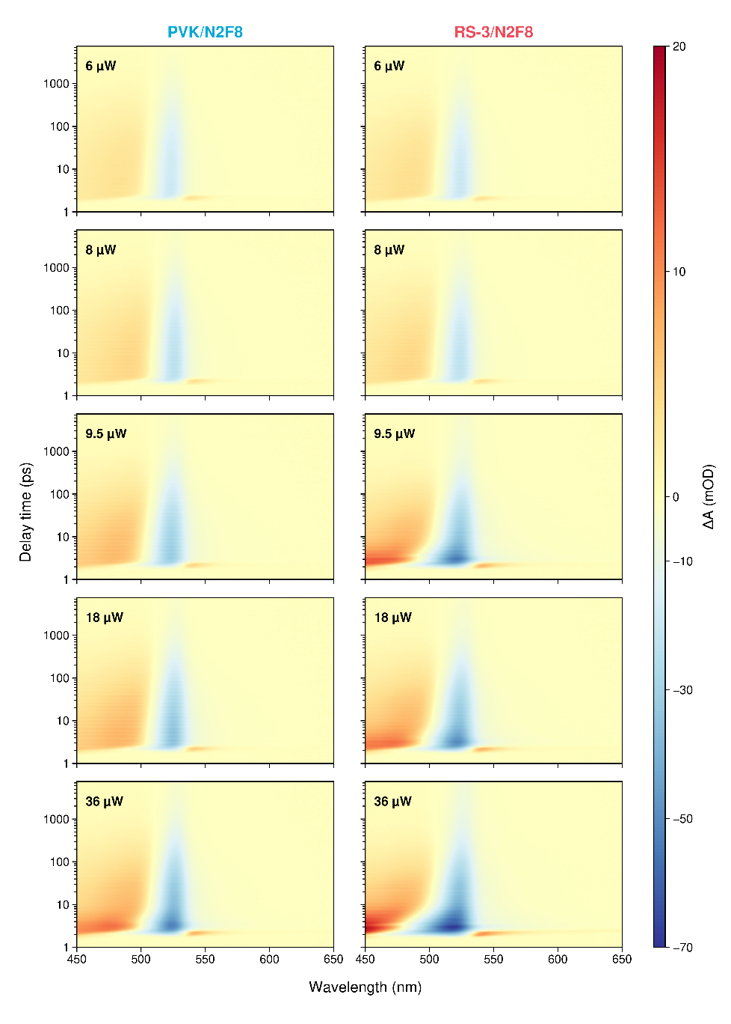
Supplementary Fig 3.1| Pump-power-dependent fsTA maps of PVK/N2F8 and RS-3/N2F8 films. Transient absorption maps recorded at pump powers of 6, 8, 9.5, 18 and 36 μW. All panels use identical wavelength and delay-time axes and a common colour scale representing the pump-induced change in absorbance, ΔA, in mOD (1 mOD = 10⁻³ OD). Positive signals are attributed primarily to excited-state absorption, whereas negative signals can contain contributions from ground-state bleaching and stimulated emission. The stimulated-emission-associated negative feature near 550 nm first becomes discernible at 9.5 μW for RS-3/N2F8 and at 18 μW for PVK/N2F8, indicating an earlier onset of the gain-associated response in the RS-3-based film.

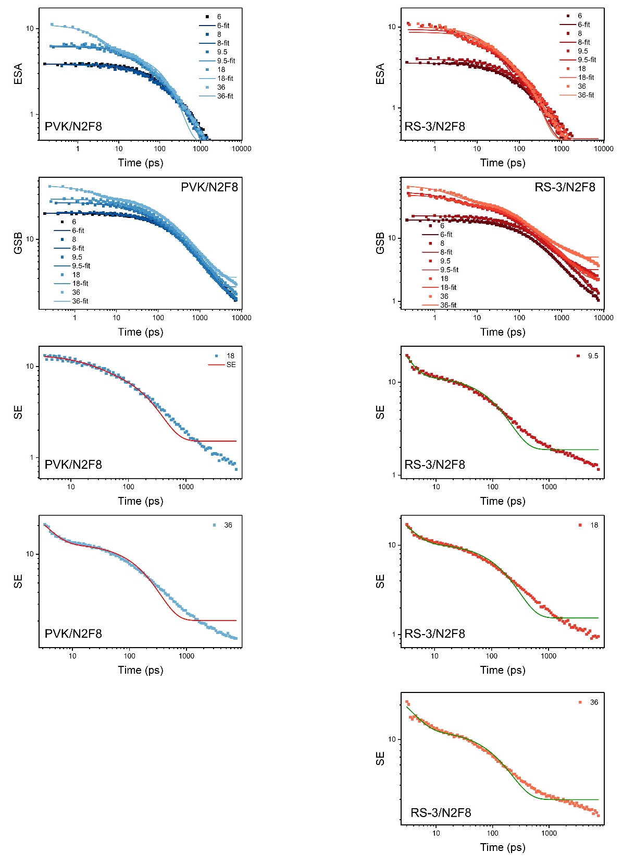
Supplementary Fig. 3.2 | Kinetic fitting of ESA, GSB and SE dynamics in PVK/N2F8 and RS-3/N2F8 films. Pump-power-dependent kinetic traces extracted from the excited-state absorption, ground-state bleaching and stimulated-emission spectral regions of PVK/N2F8 and RS-3/N2F8 films. Symbols represent experimental data and solid lines represent multiexponential fitting results. SE traces are shown only for pump powers at which a clear stimulated-emission-related signal is observed. The extracted fitting parameters are summarized in Supplementary Tables 3 and 4.
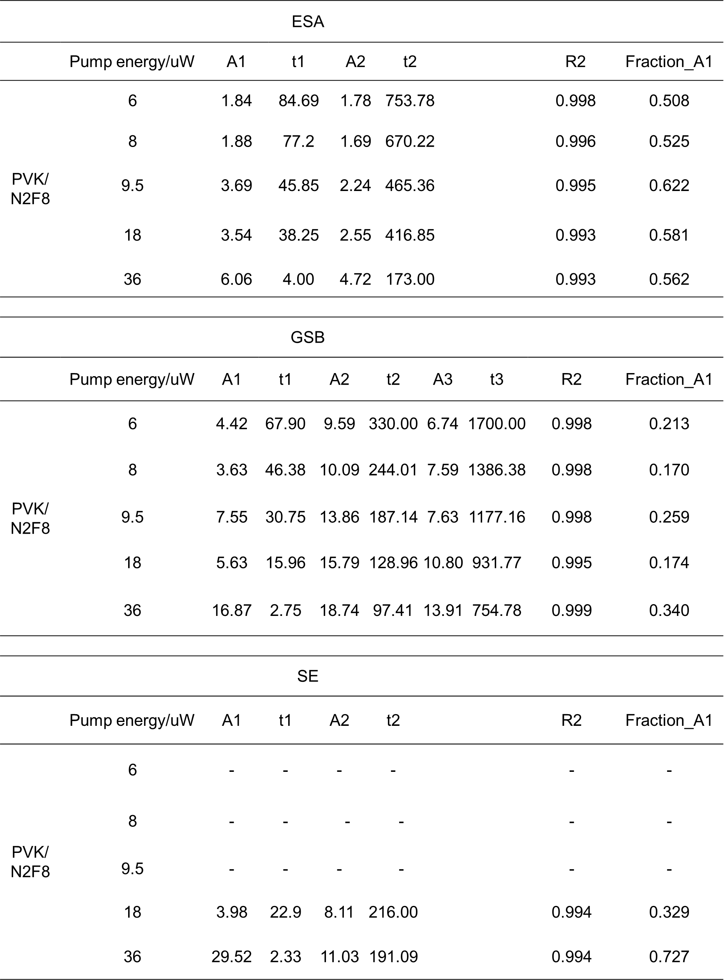
Supplementary Table 3.1 | Fitting parameters of ESA, GSB and SE kinetics of PVK/N2F8.

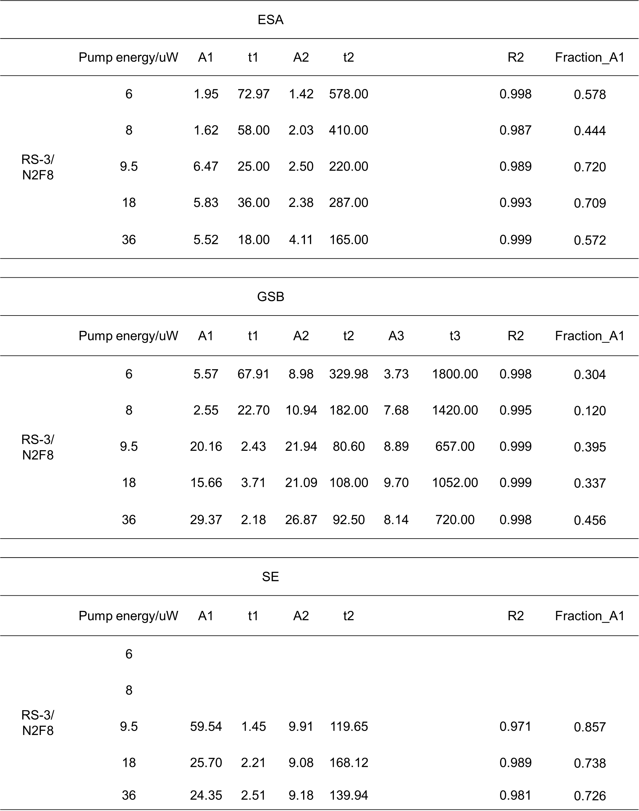
Supplementary Table 3.2 | Fitting parameters of ESA, GSB and SE kinetics of RS-3/N2F8

Supplementary Note 4 | Time-resolved electroluminescence analysis
Time-resolved electroluminescence (TREL) analysis was used to evaluate transient carrier injection, radiative build-up and post-pulse carrier depletion under nanosecond electrical excitation, following the high-current-density and pulsed-operation requirements of PeLEDs and PeLD-relevant devices^{S11–S13}. The temporal electroluminescence responses were collected using a high-speed oscilloscope synchronized with the pulsed voltage source.
The TREL decay dynamics were analyzed using a biexponential decay model:
$$y=A_{1}e^{-x/t_{1}}+A_{2}e^{-x/t_{2}}+y_{0}$$
where $A_{1}$and $A_{2}$represent the amplitudes of the fast and slow decay components, respectively, $t_{1}$and $t_{2}$correspond to the associated characteristic decay lifetimes, and $y_{0}$is the baseline offset.
The fast decay component ($t_{1}$) is mainly associated with rapid carrier recombination and immediate carrier extraction processes under pulsed excitation, while the slow component ($t_{2}$) is attributed to delayed carrier relaxation, trap-assisted recombination, and residual carrier dissipation within the device.
In addition to the biexponential fitting analysis, several characteristic temporal parameters were extracted from the TREL signals to quantitatively evaluate the carrier injection and recombination dynamics.
The delay time ($t_{delay}$) was defined as the time interval between the application of the electrical pulse and the initial detectable electroluminescence response, reflecting the carrier injection and transport delay within the device.
The rise time ($t_{rise}$) was defined as the time required for the electroluminescence intensity to increase from 10% to 90% of the maximum intensity:
$$t_{rise}=t_{90\%}-t_{10\%}$$
where $t_{10\%}$and $t_{90\%}$correspond to the times at which the electroluminescence intensity reaches 10% and 90% of the peak intensity, respectively. The $t_{rise}$parameter reflects the carrier injection efficiency and carrier accumulation rate within the emissive layer.
The decay time ($t_{decay}$) was extracted from the post-peak electroluminescence decay region using the biexponential fitting model described above, representing the carrier recombination and carrier depletion dynamics after electrical excitation.
To further evaluate the dynamic carrier accumulation behavior under pulsed electrical excitation, an accumulation factor (AF) was introduced and defined as:
$$AF=\frac{t_{decay}}{t_{rise}}$$
The AF parameter reflects residual carrier accumulation after pulsed excitation. A larger AF indicates slower carrier depletion relative to emission build-up, whereas a smaller AF suggests reduced residual accumulation and faster recombination/extraction.
Therefore, the AF parameter provides a quantitative metric for evaluating transient carrier accumulation capability and injection–recombination balance in perovskite electroluminescent devices.
The fitting was performed on the decay region of the TREL signals after the electroluminescence intensity reached its maximum value. All fitting procedures were conducted using nonlinear least-squares analysis, and the corresponding fitting parameters were extracted to compare the carrier dynamics under different pulse voltages and pulse widths.
The extracted TREL characteristic parameters, fitting curves, and corresponding fitting results are summarized in Supplementary Fig. 5 and Supplementary Table 3, respectively.

Supplementary Note 5 | Estimation of carrier densities under optical pumping, electrical injection and photoelectric co-injection
To quantitatively compare the carrier populations generated by optical pumping, electrical injection and photoelectric co-injection, we estimated the corresponding carrier densities in the perovskite gain layer. Such carrier-density estimates are commonly used to evaluate whether electrically contacted perovskite devices approach the gain regime required for lasing^{S13-S16}. The calculated values were used to support the carrier-density comparison shown in Fig. 4h. Calculations were performed using unrounded numerical values, and the final results were rounded according to the estimated precision of the measurements.
Carrier density generated by optical pumping
For pure optical pumping, the photogenerated carrier density was estimated from the absorbed photon density in the perovskite film^{S13,S15,S16}:
$$n_{OP}=F_{th}×\frac{λ_{excitation}}{hc}×\frac{1}{d}×a$$
where $n_{OP}$ is the photogenerated carrier density, $F_{th}$ is the optical pumping threshold fluence, $λ_{excitation}$ is the excitation wavelength, $h$ is the Planck constant, $c$ is the speed of light, $d$ is the perovskite film thickness, and $a$ is the optical absorption fraction of the perovskite film at the excitation wavelength.
For the RS-3-based DFB device under pure optical pumping, the following parameters were used:
$F_{th}$ = 28 μJ cm⁻²; $λ_{excitation}$ = 337 nm; $d$ = 120 nm; $a$ = 0.8
Therefore, the estimated carrier density is: $n_{OP}$ = 3.56 × 10¹⁸ cm⁻³
This value represents the photogenerated carrier density required to reach the lasing threshold under pure optical pumping.
Estimation of the instantaneous electrically injected carrier density
The instantaneous electrically injected carrier density immediately before arrival of the optical pulse, $n_{elec}(t_{opt}^{-})$, was estimated using an effective ABC carrier-recombination model. Similar rate-equation treatments have been used to estimate carrier densities under intense electrical excitation and optoelectrical co-excitation in perovskite light-emitting diodes^{S16-S20}. Throughout this analysis, $n$ denotes the carrier density of either species under the charge-neutrality approximation $n_{e}≈n_{h}=n$, equivalently the electron–hole-pair density; it does not denote $n_{e}+n_{h}$.
a. Full carrier-rate equation
Under simultaneous electrical and optical excitation, the carrier density is described by
$$\frac{dn}{dt}=\frac{η_{inj}J(t)}{qd_{eff}}+\frac{aI_{opt}(t)}{hvd_{eff}}-k_{1}n-k_{2}n^{2}-k_{3}n^{3}, \left(S1\right)$$
where $J\left(t\right)$is the current density, $η_{inj}$is the effective injection efficiency, $q$is the elementary charge, $d_{eff}$ is the effective carrier-population thickness, $a$ is the absorbed fraction of the incident optical excitation, $I_{opt}\left(t\right)$ is the incident optical intensity, and $hν$ is the photon energy.
The terms $k_{1}n$, $k_{2}n^{2}$and $k_{3}n^{3}$ describe effective first-order, bimolecular and third-order recombination, respectively. Here, the third-order term predominantly represents Auger-type carrier loss at high carrier densities.
The electrical pulse was approximated by a rectangular pulse:
$$\begin{matrix} & J\left(t\right)=\left\{\begin{matrix}J_{0}, & 0<t<τ_{e}, \\ 0, & \text{otherwise},\end{matrix}\right. & & \end{matrix}$$where $J_{0}=1.30×{10}^{3} A cm^{-2}$and $τ_{e}=240 ns$.
Immediately before the optical pulse arrives, $I_{opt}\left(t_{opt}^{-}\right)=0$. Equation (S1) therefore reduces to
$$\begin{matrix} & {\frac{dn}{dt}∣}_{t=t_{opt}}=G_{e}-k_{1}n-k_{2}n^{2}-k_{3}n^{3}, & & \text{(S}\text{2}\text{)}\end{matrix}$$with the volumetric electrical generation rate
$$\begin{matrix} & G_{e}=\frac{η_{inj}J_{0}}{qd_{eff}}. & & \text{(S}\text{3}\text{)}\end{matrix}$$
The optical excitation pulse had a wavelength of 337 nm, a pulse width of 20 ns and a repetition rate of 1 kHz. During photoelectrical co-excitation, the optical pulse was temporally positioned within the plateau region of the 240 ns electrical pulse.
b. Determination of the effective recombination coefficients from TRPL
The effective ABC coefficients were obtained from the experimentally measured TRPL decay measured under pulsed excitation at 337 nm. The initial photogenerated carrier density was calculated from
$$\begin{matrix} & n_{0}=\frac{aF_{TRPL}}{hνd_{eff}}=\frac{aF_{TRPL}λ}{hcd_{eff}}, & & \end{matrix}$$
where
$$\begin{matrix} & hν=\frac{hc}{λ}. & & \end{matrix}$$
The parameters used were
$$\begin{aligned}a&=0.80, \\ F_{TRPL}&=1.50 μJ cm^{-2}=1.50×{10}^{-6} J cm^{-2}, \\ λ&=337 nm, \\ d_{eff}&=120 nm=1.20×{10}^{-5} cm, \\ h&=6.62607015×{10}^{-34} J s, \\ c&=2.99792458×{10}^{8} m s^{-1}.\end{aligned}$$
The corresponding photon energy is
$$\begin{matrix} & hν=\frac{\left(6.62607015×{10}^{-34}\right)\left(2.99792458×{10}^{8}\right)}{337×{10}^{-9}}=5.8945×{10}^{-19} J. & & \end{matrix}$$
The absorbed photon number per unit area is therefore
$$\begin{matrix} & \frac{N_{abs}}{A}=\frac{aF_{TRPL}}{hν}=\frac{0.80×1.50×{10}^{-6}}{5.8945×{10}^{-19}}=2.0358×{10}^{12} cm^{-2}. & & \end{matrix}$$
Thus,
$$\begin{matrix} & n_{0}=\frac{2.0358×{10}^{12}}{1.20×{10}^{-5}}=1.6965×{10}^{17} cm^{-3}. & & \end{matrix}$$
Under the free-carrier radiative-recombination approximation,
$$\begin{matrix} & I_{PL}\left(t\right)-I_{bg}∝k_{2}n^{2}\left(t\right), & & \end{matrix}$$
and the normalized carrier density is
$$\begin{matrix} & x\left(t\right)=\frac{n\left(t\right)}{n_{0}}={\left[\frac{I_{PL}\left(t\right)-I_{bg}}{I_{PL}\left(0\right)-I_{bg}}\right]}^{1/2}. & & \end{matrix}$$
For the experimentally measured TRPL dataset show in Fig. 2e:
$$\begin{aligned}t_{0}&=82.944 ns, \\ I_{PL}\left(0\right)&=10010\text{ counts}, \\ I_{bg}&=1\text{ count}, \\ Δt&=0.512 ns.\end{aligned}$$
The time axis was shifted according to $t^{'}=t-t_{0}$. Substituting $n=n_{0}x$ into the carrier-decay equation gives
$$\begin{matrix} & \frac{dx}{dt}=-k_{1}x-\left(k_{2}n_{0}\right)x^{2}-\left(k_{3}n_{0}^{2}\right)x^{3}. & & \end{matrix}$$
The normalized TRPL trace was fitted using
$$\begin{matrix} & \frac{dx}{dt}=-a_{1}x-a_{2}x^{2}-a_{3}x^{3}, & & \end{matrix}$$
where
$$\begin{matrix} & a_{1}=k_{1}, a_{2}=k_{2}n_{0}, a_{3}=k_{3}n_{0}^{2}. & & \end{matrix}$$
The resulting effective fitting parameters were
$$\begin{matrix} & \begin{aligned}a_{1}&=2.87×{10}^{-4} ns^{-1}, \\ a_{2}&=2.19×{10}^{-2} ns^{-1}, \\ a_{3}&=1.42×{10}^{-2} ns^{-1}.\end{aligned} & & \end{matrix}$$
The calculated intensity was reconstructed using
$$\begin{matrix} & I_{fit}\left(t\right)=I_{bg}+\left[I_{PL}\left(0\right)-I_{bg}\right]x^{2}\left(t\right), & & \end{matrix}$$
giving $R^{2}≈0.988$ for the measured TRPL intensity decay (Fitting result showed in Supplementary Fig. 5.1 and Supplementary Table 5.1).
Converting the fitted coefficients into absolute units gives
$$\begin{matrix} & k_{1}=2.87×{10}^{-4} ns^{-1}=2.87×{10}^{5} s^{-1}, & & \end{matrix} \\ \begin{matrix} & k_{2}=\frac{2.19×{10}^{7} s^{-1}}{1.6965×{10}^{17} cm^{-3}}=1.291×{10}^{-10} cm^{3} s^{-1}, & & \end{matrix}$$
and
$$\begin{matrix} & k_{3}=\frac{1.42×{10}^{7} s^{-1}}{{\left(1.6965×{10}^{17} cm^{-3}\right)}^{2}}=4.934×{10}^{-28} cm^{6} s^{-1}. & & \end{matrix}$$
c. Electrical carrier-generation rate
For the electrical excitation,
$$\begin{aligned}J_{0}&=1.30×{10}^{3} A cm^{-2}, \\ η_{inj}&=1, \\ q&=1.602176634×{10}^{-19} C, \\ d_{eff}&=1.20×{10}^{-5} cm.\end{aligned}$$
Therefore, according to Equation (S3)
$$\begin{matrix} & \begin{aligned}G_{e}&=\frac{1×1.30×{10}^{3}}{\left(1.602176634×{10}^{-19}\right)\left(1.20×{10}^{-5}\right)}=6.7616×{10}^{26} cm^{-3} s^{-1}. \\ &\end{aligned} & & \end{matrix}$$
The device area was
$$\begin{matrix} & A_{dev}=300 μm×100 μm=3.00×{10}^{-4} cm^{2}, & & \end{matrix}$$
corresponding to a peak current of
$$\begin{matrix} & I_{peak}=J_{0}A_{dev}=\left(1.30×{10}^{3}\right)\left(3.00×{10}^{-4}\right)=0.390 A. & & \end{matrix}$$
The area is not required once $J_{0}$ is known, but it provides a consistency check between measured current and current density.

d. Carrier density immediately before optical excitation
Numerical integration of Equation (S2) from $n\left(t=0\right)=0$ shows that the carrier density reaches 99% and 99.9% of its plateau value after approximately 3.22 and 4.48 ns, respectively. These times are much shorter than the 240 ns electrical pulse. Because the 20 ns optical pulse was positioned within the electrical-pulse plateau, the carrier population immediately before optical excitation can be evaluated using the quasi-steady-state condition
$$\begin{matrix} & {\frac{dn}{dt}∣}_{t=t_{opt}^{-}}≈0. & & \end{matrix}$$
Consequently,
$$\begin{matrix} & k_{1}n_{elec}+k_{2}n_{elec}^{2}+k_{3}n_{elec}^{3}=G_{e}. & & \end{matrix}$$
Substitution of the numerical values gives
$$\begin{matrix} & \left(4.934×{10}^{-28}\right)n_{elec}^{3}+\left(1.291×{10}^{-10}\right)n_{elec}^{2}+\left(2.87×{10}^{5}\right)n_{elec}=6.7616×{10}^{26} & & \end{matrix}$$
Numerical solution of this cubic equation gives one physically meaningful positive root:
$$\begin{matrix} & n_{elec}\left(t_{opt}^{-}\right)=1.0299×{10}^{18} cm^{-3}. & & \end{matrix}$$
Accordingly, the value reported in the figure is
$$\begin{matrix} & n_{elec}\left(t_{opt}^{-}\right)=1.03×{10}^{18} cm^{-3}. & & \end{matrix}$$
e. Numerical consistency check of the steady-state solution
Substitution of $n_{elec}=1.03×{10}^{18} cm^{-3}$into the steady-state rate equation gives $k_{1}n=2.956×{10}^{23}$, $k_{2}n^{2}=1.369×{10}^{26}$, and $k_{3}n^{3}=5.389×{10}^{26} cm^{-3} s^{-1}$, where all three rates are expressed in $cm^{-3} s^{-1}$. Their sum, $6.7616×{10}^{26} cm^{-3} s^{-1}$, equals the electrical generation rate $G_{e}$, confirming the numerical consistency of the solution. The third-order channel accounts for approximately 79.7% of the total recombination rate, indicating that effective Auger-type losses dominate under the high-injection condition.

f. Interpretation and limitations
The effective carrier-injection efficiency was assumed to be unity, $η_{inj}=1$. Because $η_{inj}=1$was assumed, the calculated value represents an upper-bound estimate under ideal carrier-injection conditions. In addition, the effective recombination coefficients were extracted from a single-fluence TRPL decay using the approximation $I_{PL}∝n^{2}$and should therefore be regarded as model-dependent parameters rather than independently determined intrinsic coefficients. Accordingly, $n_{elec}\left(t_{opt}^{-}\right)$represents the total model-estimated carrier population within the assumed effective thickness, rather than a directly measured gain-active carrier density. Pump-fluence-dependent TRPL and absolute photoluminescence measurements would be required to determine the intrinsic recombination coefficients independently and establish rigorous confidence intervals.
Accordingly, the result is described as an estimated instantaneous electrically injected carrier density of $1.03×{10}^{18} cm^{-3}$, rather than as a directly measured carrier density.
Carrier-density accounting under synchronized optical–electrical co-injection
Under synchronized optical–electrical co-injection, the RS-3-based PeLD was driven by a 240 ns electrical pulse at a peak current density of $1.30 kA cm^{-2}$. A 20-ns optical pulse at 337 nm was temporally positioned within the plateau region of the electrical pulse, ensuring that a pre-established electrically injected carrier population was present when the optical pulse arrived.
Under these conditions, the optical lasing threshold was reduced to
$$F_{th,co}=19.31 μJ cm^{-2}.$$
Using the same parameters and optical carrier-density equation as those employed for the purely optically pumped device,
$$n_{opt}=\frac{aF_{th}}{hνd_{eff}}=\frac{aF_{th}λ_{exc}}{hc d_{eff}},$$
the optical carrier contribution at the co-injection threshold was estimated to be
$$n_{opt,co}=2.46×{10}^{18} cm^{-3}.$$
For comparison, the purely optically pumped device reached the lasing threshold at
$$n_{opt,pure}=3.56×{10}^{18} cm^{-3}.$$
The reduction in the required optically generated carrier density is therefore
$$Δn_{opt}=n_{opt,pure}-n_{opt,co}=\left(3.56-2.46\right)×{10}^{18}=1.10×{10}^{18} cm^{-3}.$$
From the effective ABC recombination model, the instantaneous electrically injected carrier density immediately before arrival of the optical pulse was estimated as
$$n_{elec}\left(t_{opt}^{-}\right)=1.03×{10}^{18} cm^{-3}.$$
The reduction in the optical fluence-equivalent density, calculated directly from the threshold-fluence difference, is $1.10×{10}^{18} cm^{-3}$. This value is comparable in order of magnitude to the model-estimated instantaneous electrically injected carrier density of $1.03×{10}^{18} cm^{-3}$immediately before the optical pulse. However, the optical values are fluence-integrated equivalent densities, whereas the electrical value is an instantaneous, model-dependent estimate with different temporal and spatial weightings. The two quantities are therefore not summed and are not interpreted as a one-to-one carrier balance. Their comparable magnitudes nevertheless support the conclusion that electrical injection assists gain build-up and reduces the additional optical excitation required to reach lasing.
Nevertheless, this agreement should not be interpreted as an exact one-to-one replacement of optically generated carriers by electrically injected carriers^{S16}. The value of $n_{elec}\left(t_{opt}^{-}\right)$ is a model-estimated total carrier population obtained by assuming an effective injection efficiency of unity and therefore represents an upper-bound estimate under ideal injection conditions. Not all electrically injected carriers necessarily occupy gain-active states. Carrier trapping, spatially nonuniform recombination, phase-selective localization, dark-state formation and imperfect overlap with the DFB optical mode can reduce the fraction contributing to stimulated emission. Electrical injection may additionally prefill electronic states and establish a favourable carrier distribution within the gain layer before arrival of the optical pulse. Therefore, the co-injection threshold is governed by the temporally and spatially overlapping gain-active carrier population rather than solely by the arithmetic sum of the two estimated carrier densities.

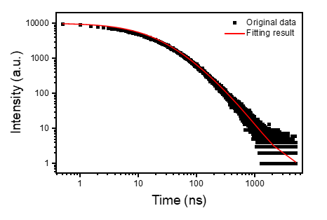
Supplementary Fig. 5.1 TRPL decay and effective ABC-model fitting.
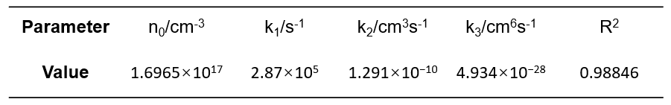
Supplementary Table 5.1 Effective fitting parameters and goodness-of-fit metrics for the TRPL decay.

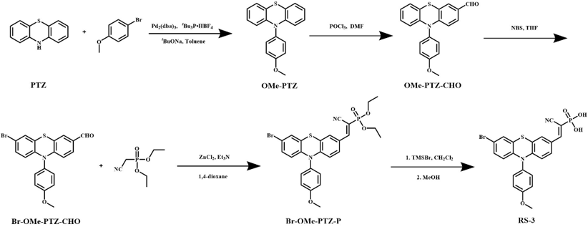
Supplementary Fig. 1a | Synthetic route of RS-3.

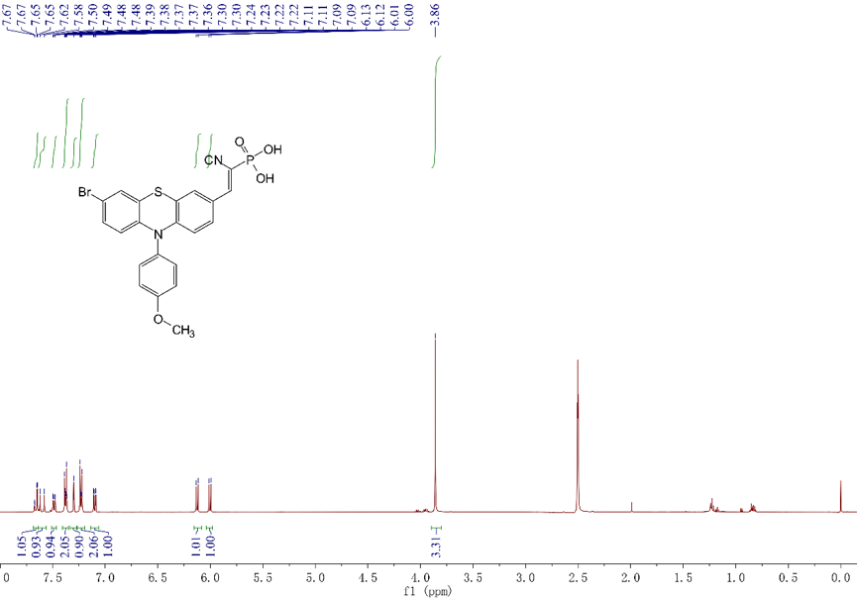Supplementary Fig. 1b | ¹H NMR characterization of RS-3. ¹H NMR spectrum of RS-3 recorded in DMSO-$d_{6}$ at 500 MHz. ¹H NMR δ (ppm): 7.67–7.65 (1H), 7.55–7.48 (2H), 7.42–7.36 (2H), 7.31–7.21 (2H), 7.12–7.08 (2H), 6.12–6.08 (2H) and 3.86 (3H). The molecular structure of RS-3 is shown in the inset. The residual signals at approximately 2.50 and 3.3 ppm originate from DMSO-$d_{6}$ and water, respectively.

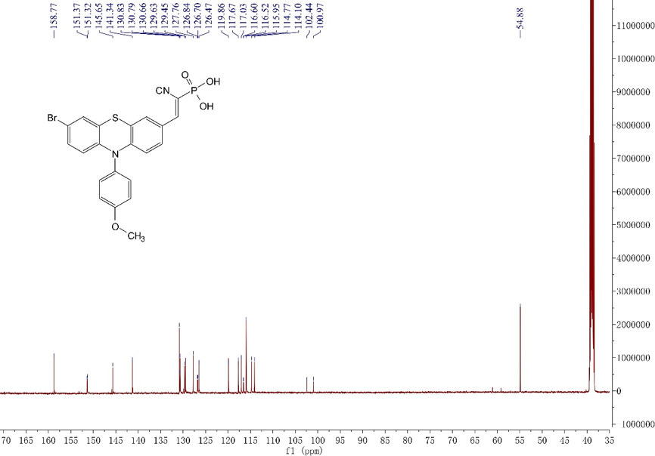
Supplementary Fig. 1c | C NMR characterization of RS-3. ¹³C NMR spectrum of RS-3 recorded in DMSO-$d_{6}$. ¹³C NMR δ (ppm): 158.77, 151.32, 151.31, 145.65, 141.34, 130.83, 130.79, 130.66, 129.65, 129.45, 127.76, 126.84, 125.70, 125.47, 119.86, 117.67, 117.23, 116.60, 116.25, 115.52, 114.77, 114.10, 102.44, 100.97 and 54.88. The intense signal at approximately 39.5 ppm originates from the DMSO-$d_{6}$ solvent. The molecular structure of RS-3 is shown in the inset.

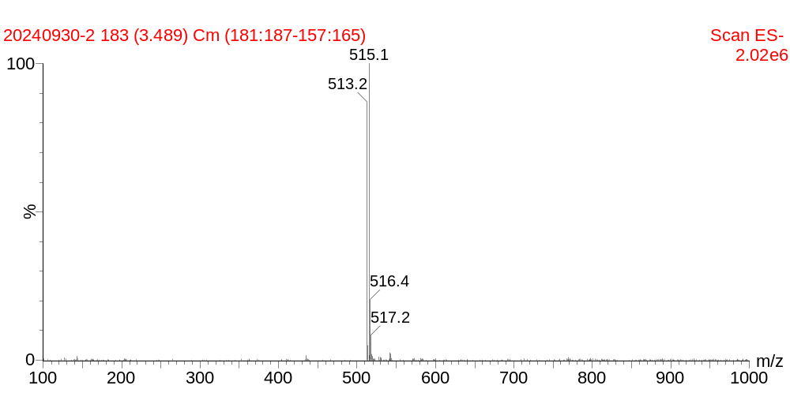Supplementary Fig. 1d | Negative-ion electrospray ionization mass spectrum of RS-3. ESI-MS (negative mode) m/z: calculated for C₂₂H₁₅⁷⁹BrN₂O₄PS⁻ [M − H]⁻, 512.968; found, 513.2. The accompanying peak at m/z 515.1 originates from the corresponding ⁸¹Br isotopologue, showing the characteristic bromine isotope pattern.

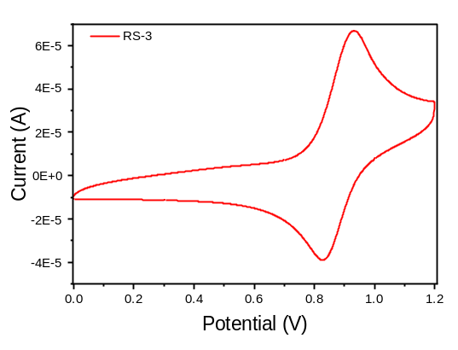
Supplementary Fig. 1e | Cyclic voltammetry curve of RS-3 for evaluating its electrochemical energy levels.

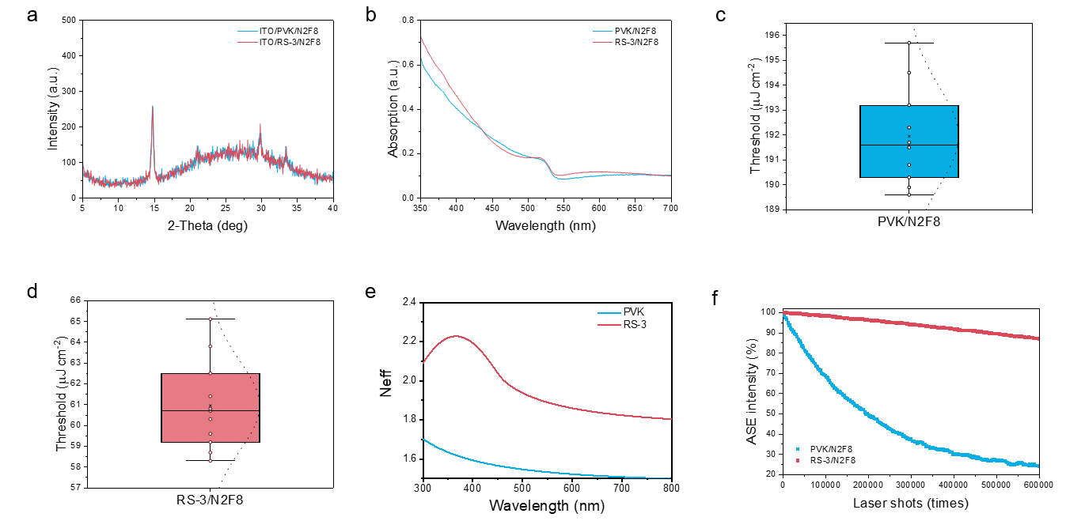
Supplementary Fig. 2 | Structural, optical and gain-related characterization of non-resonant PVK/N2F8 and RS-3/N2F8 films. a, X-ray diffraction patterns of PVK/N2F8 and RS-3/N2F8 films, confirming that the N2F8 crystalline phase is preserved after replacing PVK with RS-3. b, Steady-state absorption spectra of PVK/N2F8 and RS-3/N2F8 films. c,d, Statistical distributions of ASE thresholds measured from PVK/N2F8 (c) and RS-3/N2F8 (d) films. e, Effective refractive-index spectra of PVK- and RS-3-based films extracted from spectroscopic ellipsometry. f, ASE operational stability of PVK/N2F8 and RS-3/N2F8 films under repeated pulsed excitation (2Th). The ASE intensity was normalized to its initial value.

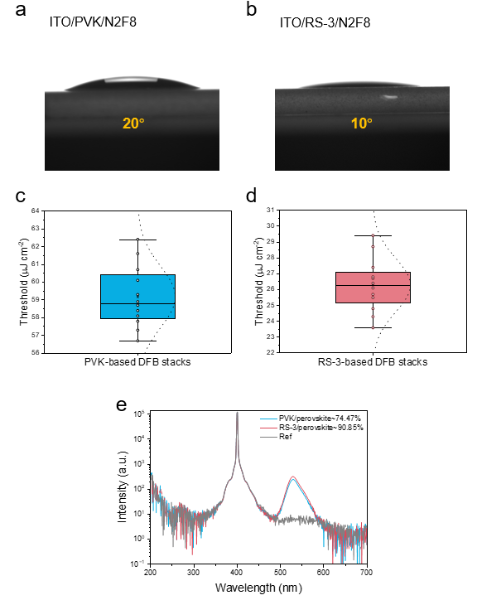
Supplementary Fig. 3 | Wetting, DFB-lasing reproducibility and emissive quality of PVK- and RS-3-based DFB stacks. a,b, Contact-angle images of N2F8 precursor droplets on ITO/PVK (a) and ITO/RS-3 (b) surfaces. The contact angle decreases from 20° on PVK to 10° on RS-3, indicating improved wetting of the RS-3-modified surface. c,d, Statistical distributions of optically pumped lasing thresholds measured from PVK-based (c) and RS-3-based (d) DFB stacks. e, Absolute PLQY spectra of PVK/N2F8 and RS-3/N2F8 films, showing higher PLQY for the RS-3-based film.

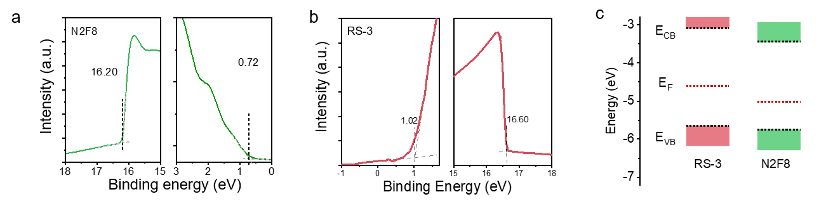
Supplementary Fig. 4 | Energy-level characterization of N2F8 and RS-3. a, UPS spectrum of the N2F8 film used to determine the valence-band maximum and work function. b, Energy-level characterization of RS-3 based on electrochemical and/or photoelectron spectroscopy measurements. c, Energy-level diagram of the materials used in the PeLD stack. The HOMO level of RS-3 is better aligned with the N2F8 valence band than that of PVK, reducing the hole-injection barrier at the buried contact.

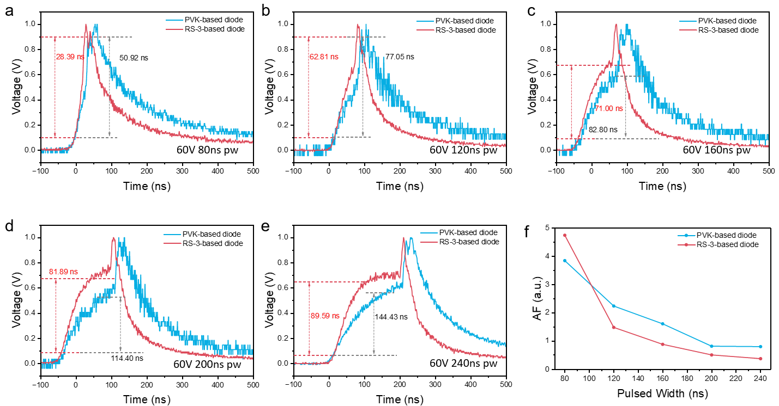
Supplementary Fig. 5 | Pulse-width-dependent TREL response of PVK- and RS-3-based N2F8 diodes. a–e, Time-resolved electroluminescence traces of PVK- and RS-3-based N2F8 diodes measured under 60 V electrical pulses with pulse widths of 80, 120, 160, 200 and 240 ns, respectively. The extracted rise and decay times indicate faster radiative build-up and more rapid post-pulse carrier depletion in the RS-3-based diode. f, Accumulation factor as a function of pulse width for PVK- and RS-3-based devices. The lower accumulation factor of the RS-3-based diode indicates reduced residual carrier accumulation after pulsed electrical excitation.

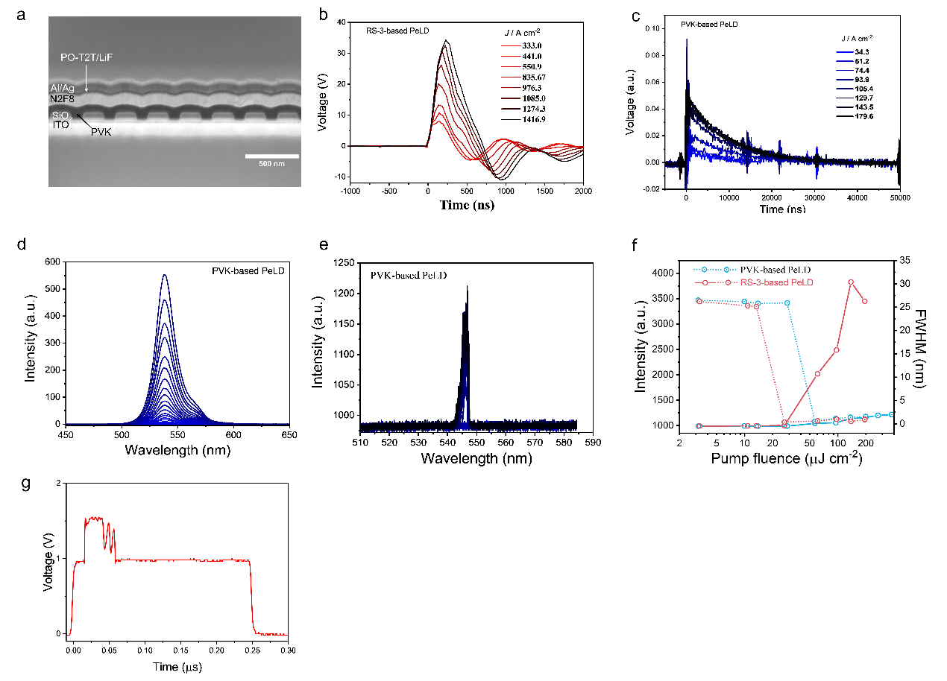
Supplementary Fig. 6 | Control measurements of complete PVK- and RS-3-based PeLDs. a, Cross-sectional SEM image of the PVK-based PeLD control stack, showing reduced retention of the DFB modulation after multilayer deposition. b, Pulsed electrical current-density response of the RS-3-based PeLD under increasing voltage pulses. c, Pulsed electrical response of the PVK-based control PeLD, showing limited current-density tolerance before device failure. d, Electroluminescence spectra of the PVK-based control PeLD under pulsed electrical excitation. e, Optically pumped emission spectra of the PVK-based control PeLD. f, Pump-fluence-dependent output intensity and linewidth analysis of the PVK-based control PeLD, showing weaker cavity-coupled emission and a higher lasing threshold than the RS-3-based device. g, Electrical pulse waveform used to define the temporal synchronization window for photoelectric co-injection measurements.

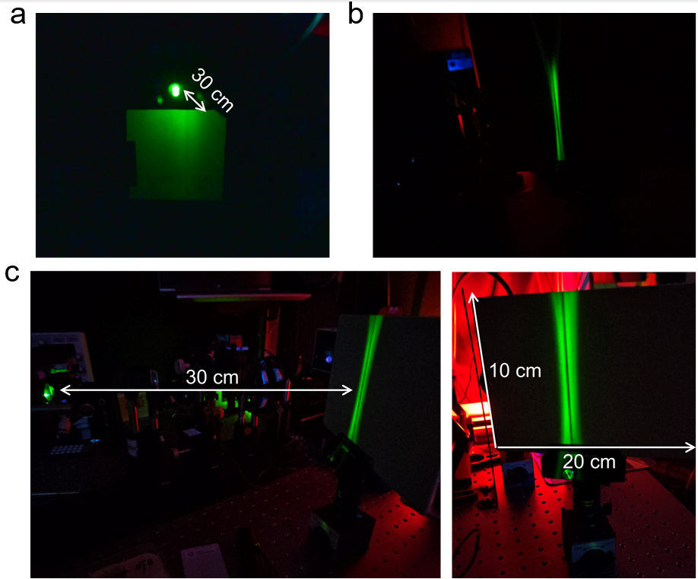
Supplementary Fig. 7 | Projected emission patterns of the RS-3-based PeLD under different excitation conditions. a–c, Photographs corresponding to the insets in Fig. 4c–e, respectively. a, Spatially broad emission pattern under pulsed electrical excitation alone, projected onto a screen positioned 30 cm from the device. b, Narrow, vertically elongated emission pattern under pulsed optical pumping. c, Emission pattern under synchronized optical–electrical co-injection. The left photograph shows the 30-cm projection path from the device to the screen, and the right photograph shows an enlarged view of the vertical emission pattern on a 20 cm × 10 cm screen.

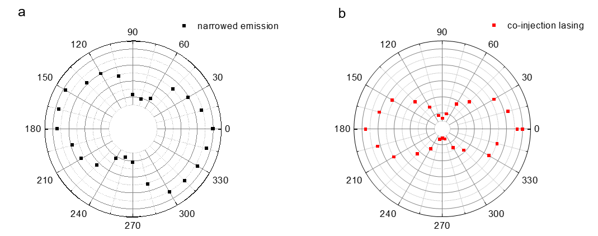
Supplementary Fig. 8 | Polarization-resolved emission characteristics of the RS-3-based PeLD.
a, Polar plot of the emission intensity as a function of analyzer angle for the electrically induced spectrally narrowed emission, showing a polarization degree of 46.5%. b, Polar plot of the emission intensity as a function of analyzer angle for the photoelectric co-injection lasing emission, showing an enhanced polarization degree of 79.3%. The analyzer was rotated through 360° in 15° increments for polarization-resolved measurements. Here, an analyzer angle of 0° corresponds to the transmission axis parallel to the DFB grating grooves, that is, perpendicular to the grating vector.

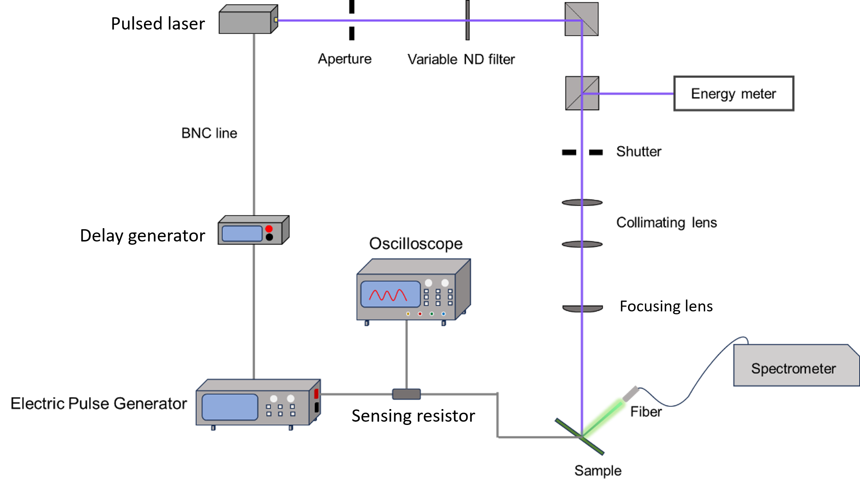
Supplementary Fig. 9 | Schematic of the synchronized photoelectric co-injection measurement setup. Schematic illustration of the optical and electrical setup used for synchronized photoelectric co-injection measurements. The pulsed laser beam was directed through an aperture, variable neutral-density filter, shutter, collimating lens and focusing lens before being focused onto the PeLD sample. The optical pump fluence was monitored using an energy meter. Electrical pulses were supplied by an electrical pulse generator and delivered to the sample through a BNC line. A delay generator was used to synchronize the temporal onset of the optical pulse within the plateau region of the 240 ns electrical pulse. The electrical response was monitored by an oscilloscope through a sensing resistor, and the device emission was collected by an optical fiber and analysed using a spectrometer.

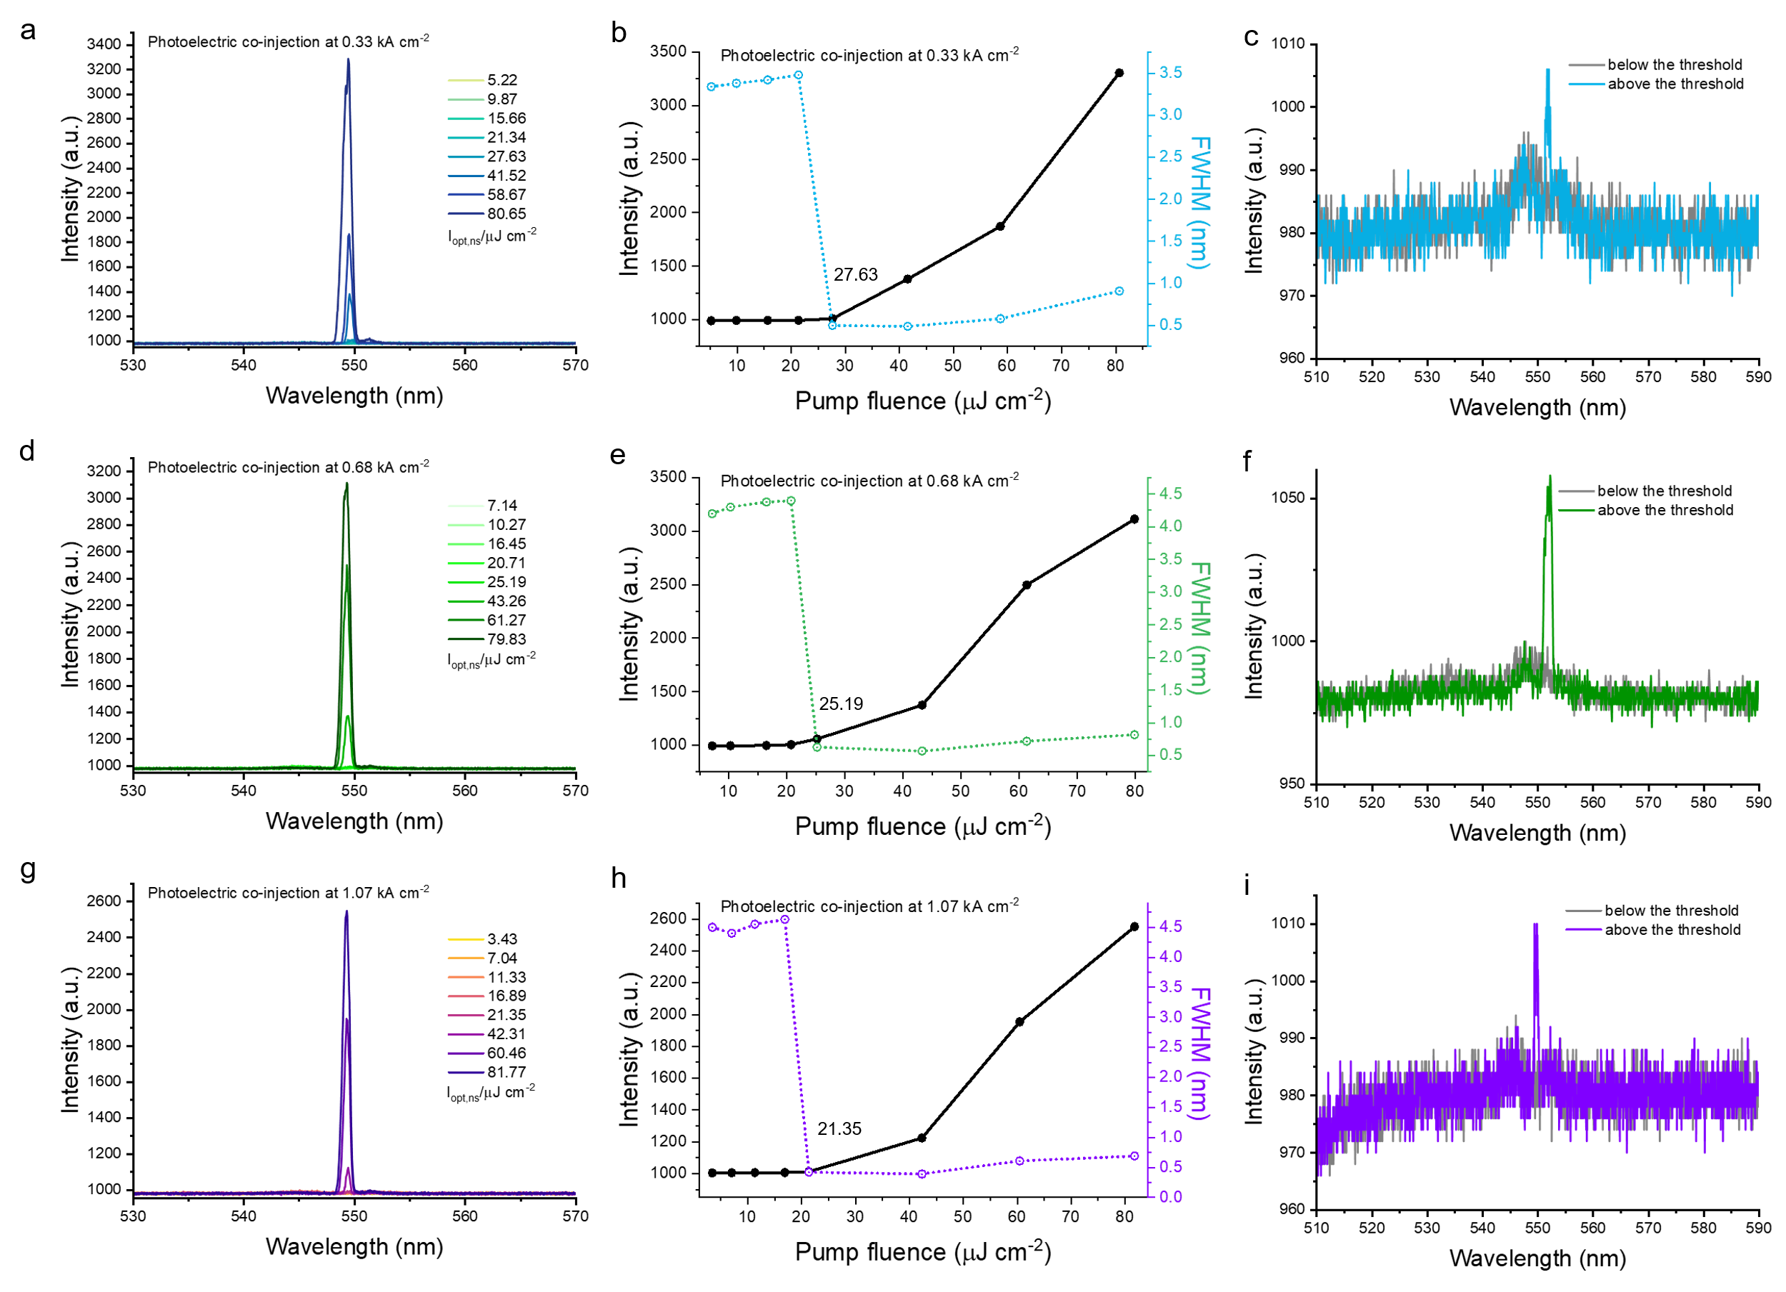
Supplementary Fig. 10 | Photoelectric co-injection lasing at different electrical current densities.
a, Pump-fluence-dependent emission spectra at a pulsed electrical current density of 0.33 kA cm⁻². b, Corresponding emission intensity (black, left axis) and full-width at half-maximum (FWHM; blue, right axis), yielding an optical lasing threshold of 27.63 μJ cm⁻². c, Representative emission spectra below and above this threshold. d, Pump-fluence-dependent emission spectra at 0.68 kA cm⁻². e, Corresponding emission intensity and FWHM, yielding a threshold of 25.19 μJ cm⁻². f, Representative spectra below and above this threshold. g, Pump-fluence-dependent emission spectra at 1.07 kA cm⁻². h, Corresponding emission intensity and FWHM, yielding a threshold of 21.35 μJ cm⁻². i, Representative spectra below and above this threshold.

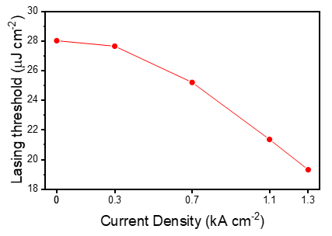
Supplementary Fig. 11 | Electrical-current-density dependence of the optical lasing threshold.
The optical lasing threshold fluence decreases monotonically from 28 μJ cm⁻² without electrical injection to 27.63, 25.19, 21.35 and 19.31 μJ cm⁻² at pulsed electrical current densities of 0.33, 0.68, 1.07 and 1.30 kA cm⁻², respectively. The line is a guide to the eye.

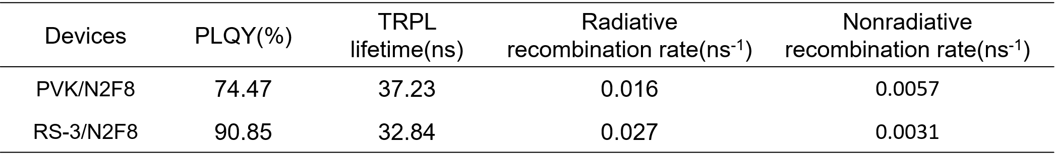
Supplementary Table 1 | PLQY, TRPL lifetime and recombination-rate parameters.

Supplementary Table 2 | Energy levels of the materials used in the devices.
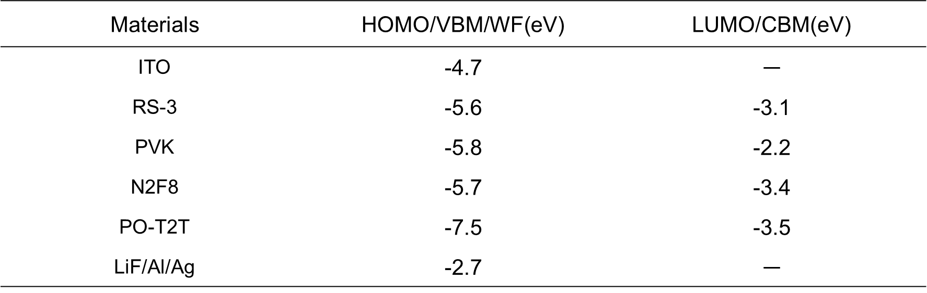

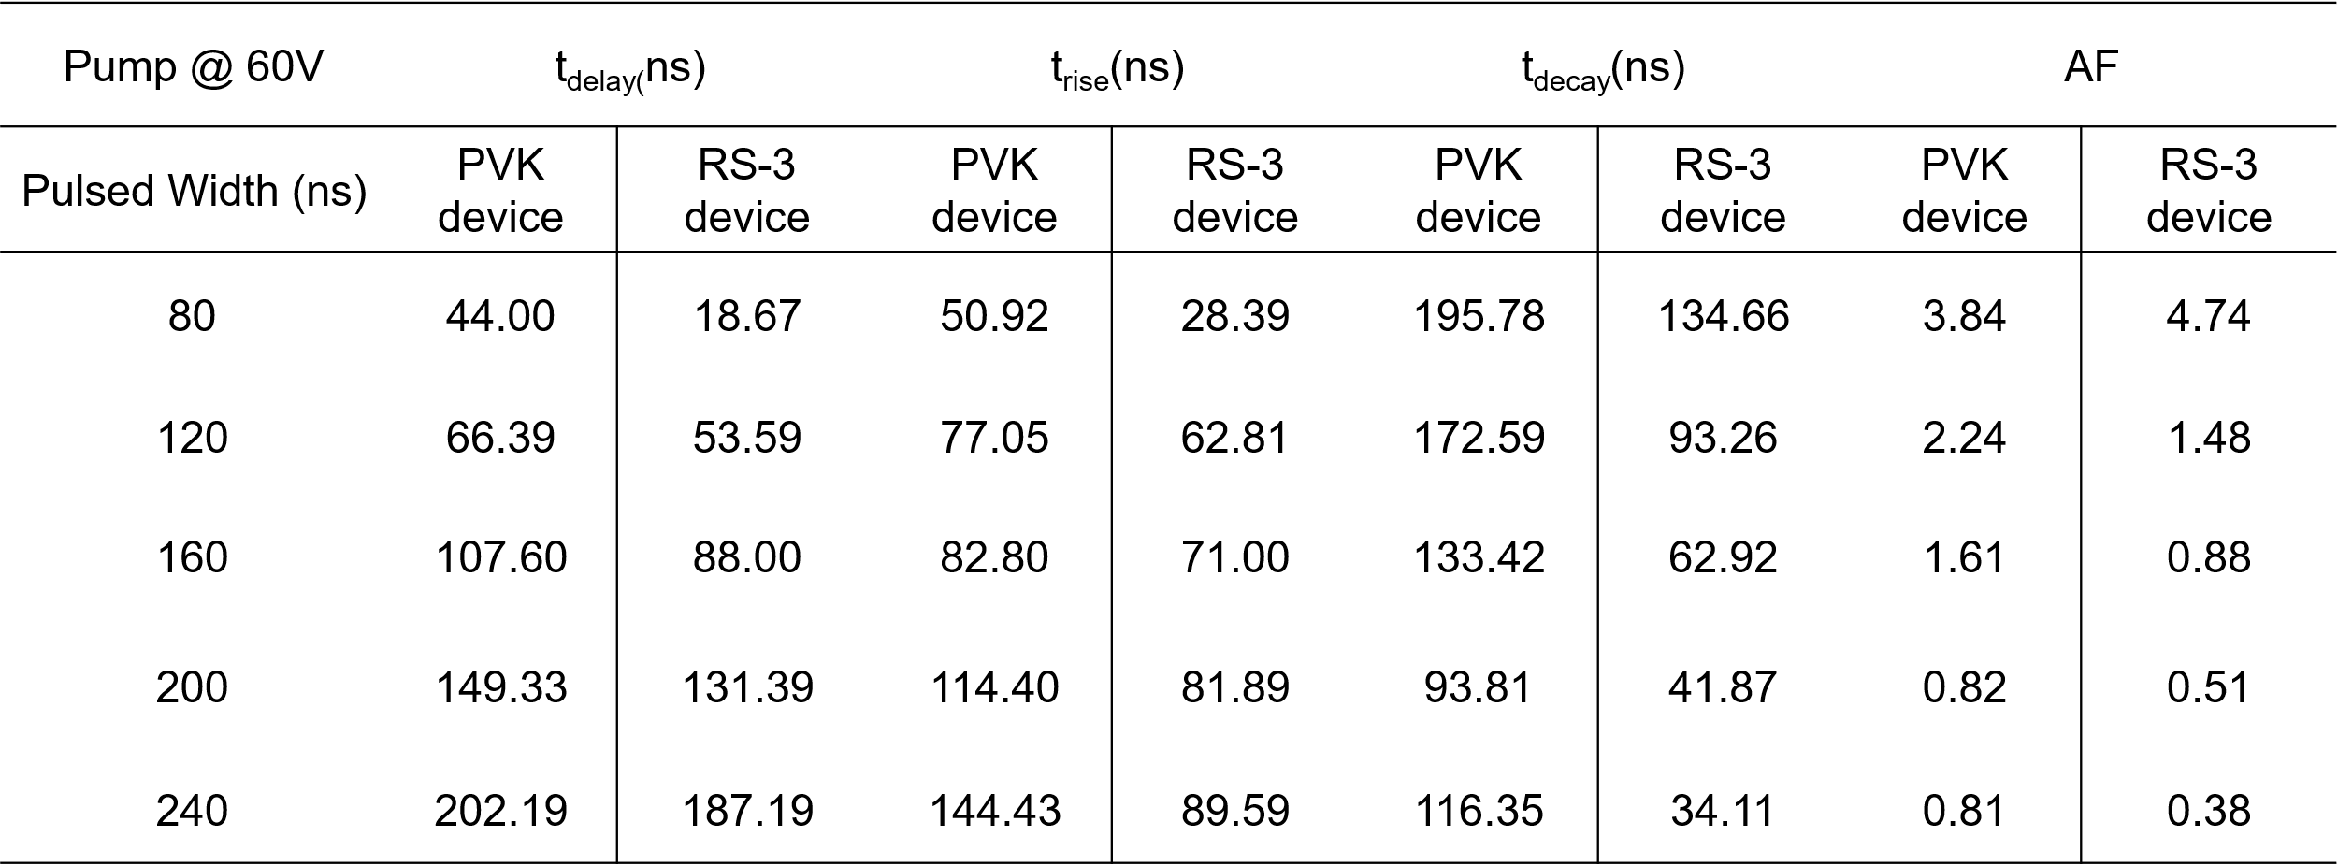
Supplementary Table 3 | Fitting parameters of TREL.

S1. Shaklee, K. L. & Leheny, R. F. Direct determination of optical gain in semiconductor crystals. Appl. Phys. Lett. 18, 475–477 (1971).
S2. Lange, C. et al. The variable stripe-length method revisited: improved analysis. Appl. Phys. Lett. 91, 191107 (2007).
S3. Alvarado-Leaños, R. et al. Optical gain of lead halide perovskites measured via the variable stripe length method: what we can learn and how to avoid pitfalls. Adv. Optical Mater. 9, 2001773 (2021).
S4. Zhang, J. et al. Transport layer engineering toward lower threshold for perovskite lasers. Adv. Mater. 35, 2300922 (2023).
S5. Lee, G. et al. Unravelling the amplified spontaneous emission mechanism in three-dimensional metal halide perovskites. Nanoscale 18, 6576–6585 (2026).
S6. Zhang, Y. et al. Enhanced performance of amplified spontaneous emission in Dion–Jacobson phase quasi-2D perovskite by facilitating carrier co-radiation. Opt. Express 32, 26306–26317 (2024).
S7. Zhang, D. et al. Break-through amplified spontaneous emission with ultra-low threshold in perovskite via synergetic moisture and BHT dual strategies. Light Sci. Appl. 15, 99 (2026).
S8. Shi, C. et al. Achieving tunable amplified spontaneous emission in Rb–Cs alloyed quasi-2D perovskites with low threshold and exceptional spectral stability. Adv. Mater. 37, 2504029 (2025).
S9. Zhang, H. et al. Active phase transfer enhances amplified spontaneous emission and mechanical deformability in FAPbBr₃ perovskite film. Adv. Funct. Mater. 36, e26164 (2026).
S10. Han, G. R. et al. In situ and real-time ultrafast spectroscopy of photoinduced reactions in perovskite nanomaterials. Nat. Commun. 16, 4956 (2025).
S11. Kim, H. et al. Hybrid perovskite light emitting diodes under intense electrical excitation. Nat. Commun. 9, 4893 (2018).
S12. Zhao, L. et al. Nanosecond-pulsed perovskite light-emitting diodes at high current density. Adv. Mater. 33, 2104867 (2021).
S13. Zou, C., Liu, Y., Ginger, D. S. & Lin, L. Y. Suppressing efficiency roll-off at high current densities for ultra-bright green perovskite light-emitting diodes. ACS Nano 14, 6076–6086 (2020).
S14. Setoguchi, Y. & Adachi, C. Suppression of roll-off characteristics of electroluminescence at high current densities in organic light emitting diodes by introducing reduced carrier injection barriers. J. Appl. Phys. 108, 064516 (2010).
S15. Qin, C. et al. Stable room-temperature continuous-wave lasing in quasi-2D perovskite films. Nature 585, 53–57 (2020).
S16. Elkhouly, K. et al. Electrically assisted amplified spontaneous emission in perovskite light-emitting diodes. Nat. Photon. 18, 132–138 (2024).
S17. Jiang, Y. et al. Reducing the impact of Auger recombination in quasi-2D perovskite light-emitting diodes. Nat. Commun. 12, 336 (2021).
S18. Allegro, I., Li, Y., Richards, B. S., Paetzold, U. W., Lemmer, U. & Howard, I. A. Bimolecular and Auger recombination in phase-stable perovskite thin films from cryogenic to room temperature and their effect on the amplified spontaneous emission threshold. J. Phys. Chem. Lett. 12, 2293–2298 (2021).
S19. Staub, F. et al. Beyond bulk lifetimes: insights into lead halide perovskite films from time-resolved photoluminescence. Phys. Rev. Applied 6, 044017 (2016).
S20. Kiligaridis, A. et al. Are Shockley–Read–Hall and ABC models valid for lead halide perovskites?. Nat. Commun. 12, 3329 (2021).

