4. Extended data
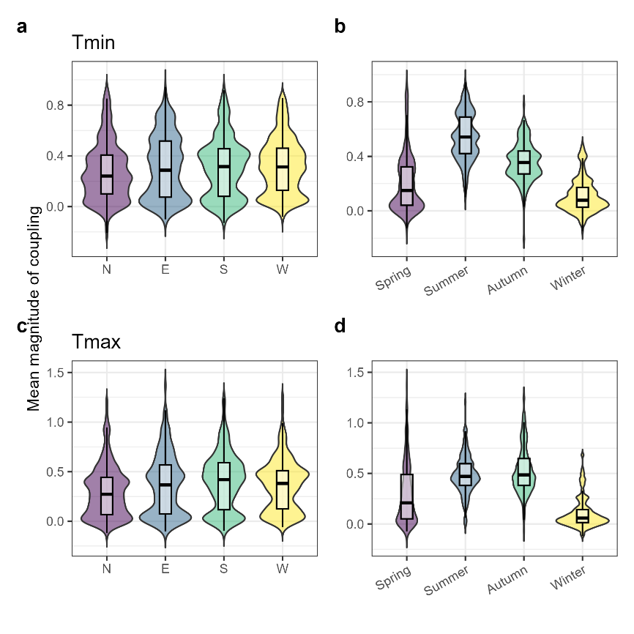
Extended data Fig. 1. Magnitude of coupling between soil microclimate and gridded macroclimate data across the different summit aspects and seasons. Across the 136 time-series, (a-e) show the magnitude of coupling (i.e., slope coefficient) between daily minimum and maximum in-situ recorded soil temperatures (microclimate), and corresponding gridded free-air temperatures (macroclimate, from E-OBS) for the different aspects and seasons on the 34 summits and over the 21-year period. Values <1 indicate buffering of soil temperatures relative to free-air conditions, while values >1 denote amplification of soil microclimates.
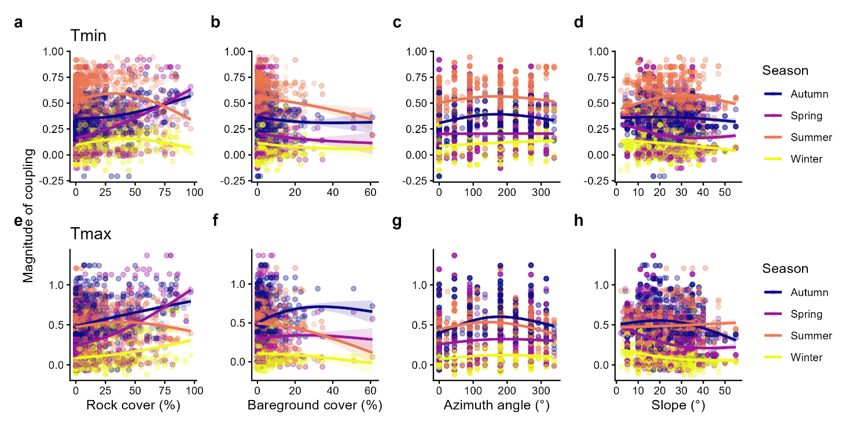
Extended data Fig. 2. Relationships between the magnitude of coupling between in-situ soil temperatures and gridded free-air temperatures, on the one hand, and site characteristics, on the other hand. Non-linear relationships between the magnitude of coupling temperatures and the plot-level rock cover, bare ground cover, azimuth angle and slope angle of the sampled mountainsides are depicted for minimum and maximum in a-c and b-d, respectively, across the different seasons and using generalised additive modelling (GAMs). The faded dots represent the raw data points (coloured per season), lines the different GAMs (coloured per season) and shaded areas the 95% confidence intervals. The magnitude of coupling was estimated as the slope coefficient of the relationship between daily minimum or maximum soil temperatures (microclimate) and the corresponding gridded free-air temperatures (macroclimate) for each of the mountain aspects and seasons across the 136 time-series.

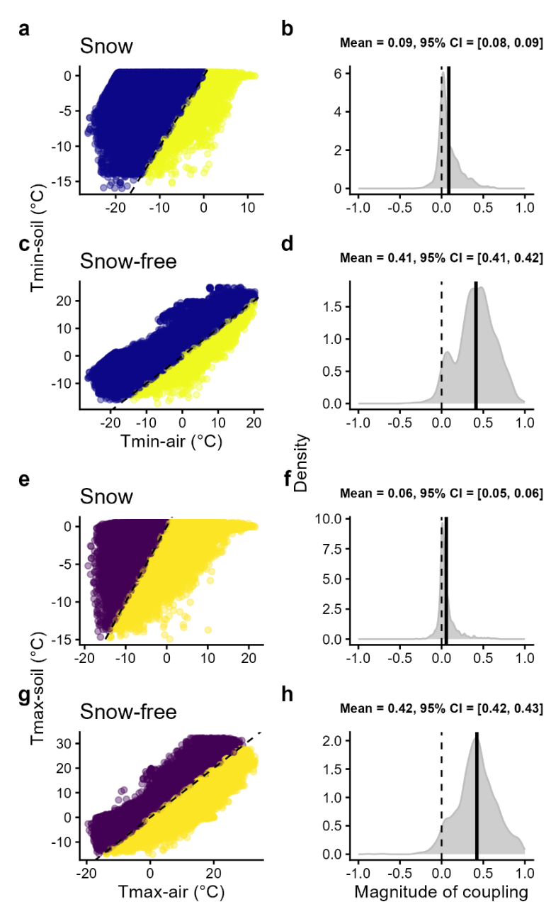
Extended data Fig. 3. Difference in magnitude of coupling between in-situ soil temperatures and gridded free-air temperatures between snow-covered and snow-free days. Daily minimum and maximum soil temperatures (microclimate) plotted against gridded free-air temperatures (macroclimate) on snow-covered (a, e) and snow and snow-free days (c, g). The dashed black line represents the 1:1 line, and dots above or below this line (different colours) indicate respectively warmer or cooler microclimates relative to macroclimates. Density plots for the magnitude of coupling on snow-covered and snow-free days are shown for minimum and maximum temperatures in b-d and f-d, respectively. The dashed lines show the perfect decoupling line, whereas the solid black lines depict the average magnitude of coupling across the 136 time-series.

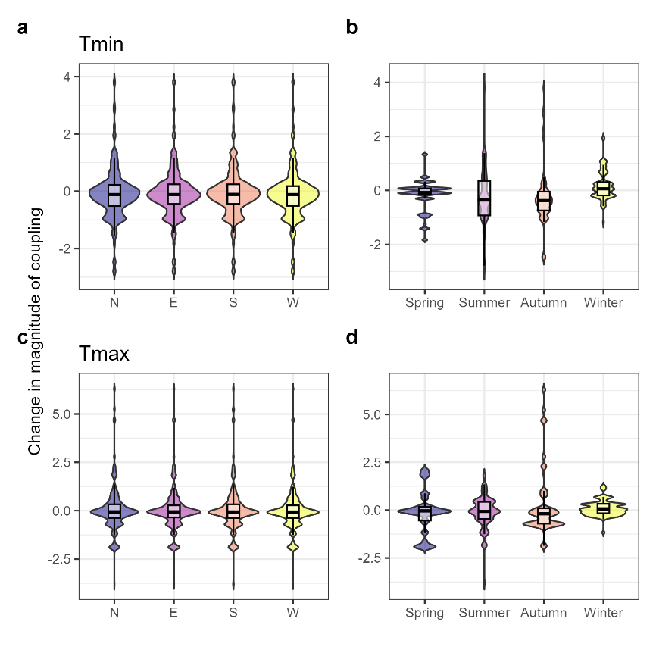
Extended data Fig. 4. Rate of change in the magnitude of coupling between 2001-2022 for the different mountain aspects and seasons. Violin plots and boxplots show the distribution in the magnitude of coupling across aspects and seasons for daily minimum temperatures (a-b) and maximum temperatures (c-d). The rate of change was quantified as the slope coefficient of the linear relationship between the magnitude of coupling and the sampling years for each of the 136 time-series, and recalculated to a decadal value.

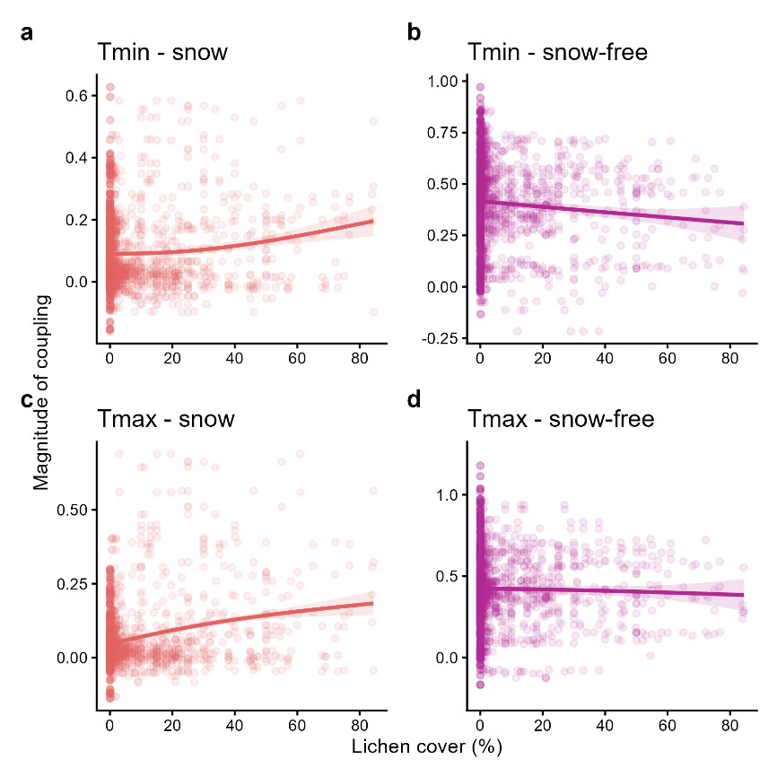
Extended data Fig. 5. Relationship between magnitude of coupling and lichen cover in snow-covered- vs. snow-free period on the alpine summits. Non-linear relationships between the magnitude of coupling temperatures and the plot-level lichen cover are depicted for minimum and maximum in a-b and c-d, respectively, for the snow-covered vs. snow-free season and using generalised additive modelling (GAMs). The faded dots represent the raw data points (coloured per season), lines the different GAMs (coloured per season) and shaded areas the 95% confidence intervals. The magnitude of coupling was estimated as the slope coefficient of the relationship between daily minimum or maximum soil temperatures (microclimate), on the one hand, and the gridded free-air temperatures (macroclimate), on the other hand, for each of the mountain aspects and seasons across the 136 time-series.

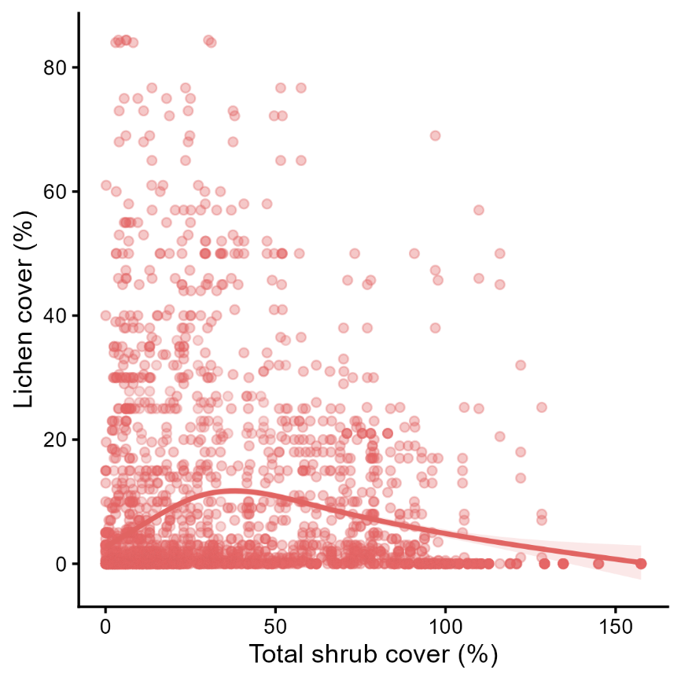
Extended data Fig. 6. Relationship between lichen cover and shrub cover on the alpine summits. Non-linear relationship between the plot-level lichen cover and the plot-level shrub cover, modelled using generalised additive modelling (GAMs). The faded dots represent the raw data points, the line depicts the GAM model predictions and the shaded areas show the 95% confidence interval. Low shrub cover seems to positively affect lichen abundance, likely due to facilitating interactions: shrubs provide more benign microclimates through their canopy buffering effect and protecting lichens against desiccation. At higher shrub cover, however, lichens are clearly outcompeted for light, resulting in a decreasing cover.

