Supplement materials
The effects of residential surrounding greenness exposure on hypertension incidence among Chinese oldest old: A 10-year prospective cohort study
Contents
Figure S1 The spatial distribution of NDVI/EVI value at baseline across China
Figure S2 Non-liner association between NDVI and hypertension incidence risk
Figure S3 Non-liner association between EVI and hypertension incidence risk
Table S1 Window periods analysis for the association between greenness exposure and hypertension incidence
Table S2 Sensitivity analysis for the association between greenness exposure and hypertension incidence
Table S3 Sensitivity analysis for the association between greenness exposure and hypertension incidence after excluding participants
Table S4 The mediation effect of various mediators on the association between greenness exposure and hypertension

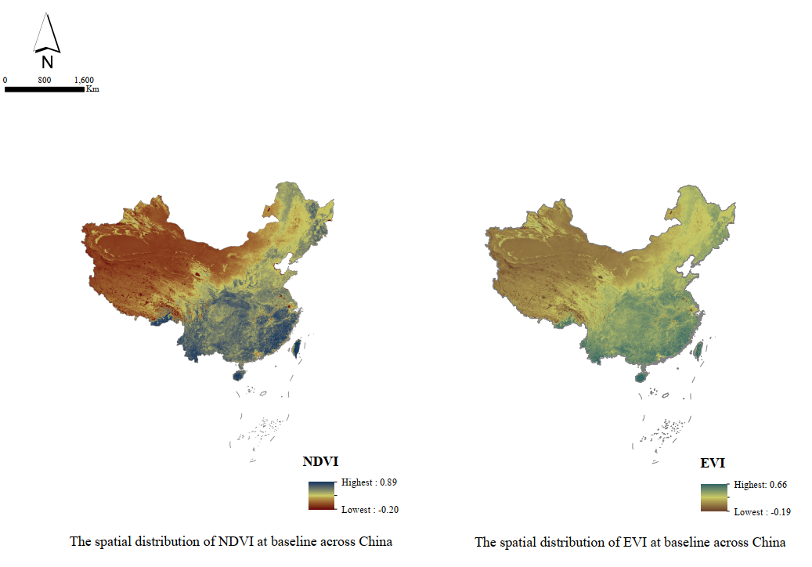
Figure S1 The spatial distribution of NDVI/EVI value at baseline across China

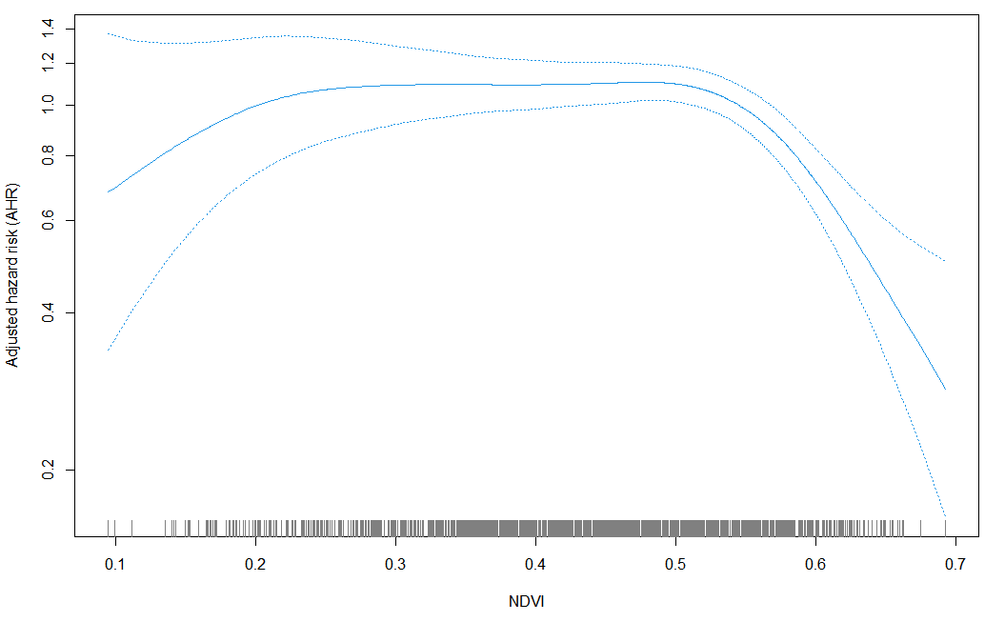
Figure S2 Non-liner association between NDVI-500 buffer and hypertension incidence risk (P for non-liner association was <0.001; df=4; reference was the lowest value and adjusted for age, living arrangement, PM_{2.5}, regions, ADL, residence, gender, smoking, drinking, exercising, pension, martial status, education attainment, self-reported diabetes, self-reported heart disease, leisure activity, and BMI)

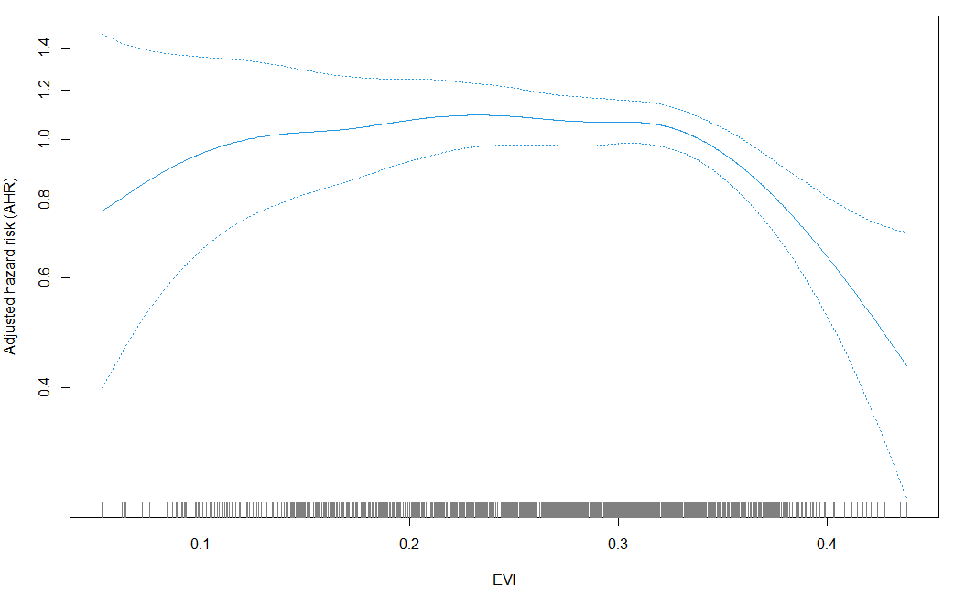
Figure S3 Non-liner association between EVI-500 buffer and hypertension incidence risk
(P for non-liner association was 0.038; df=4; reference was the lowest value and adjusted for age, living arrangement, PM_{2.5}, regions, ADL, residence, gender, smoking, drinking, exercising, pension, martial status, education attainment, self-reported diabetes, self-reported heart disease, leisure activity, and BMI)

Table S1 Window periods analysis for the association between each 0.1-unit increment in greenness exposure and hypertension *
 | NDVI | EVI
Average 2-year exposure | 0.82(0.76-0.90) | 0.82(0.76-0.90)
Average 1-year exposure | 0.80 (0.74-0.87) | 0.68 (0.60-0.77)
* After adjusted for age, living arrangement, PM_{2.5}, regions, ADL, residence, gender, smoking, drinking, exercising, pension, martial status, education attainment, self-reported diabetes, self-reported heart disease, leisure activity, and BMI.

Table S2 Sensitivity analysis for the association between each one unit increase in greenness exposure and hypertension incidence*
Buffer | NDVI | EVI
250 | 0.83(0.76-0.90) | 0.50(0.46-0.55)
500 | 0.80 (0.74-0.87) | 0.68 (0.60-0.77)
1000 | 0.78(0.71-0.85) | 0.52(0.48-0.58)
* After adjusted for age, living arrangement, PM_{2.5}, regions, ADL, residence, gender, smoking, drinking, exercising, pension, martial status, education attainment, self-reported diabetes, self-reported heart disease, leisure activity, and BMI.
Table S3 Sensitivity analysis for the association between each 0.1 unit increase in greenness exposure and hypertension incidence after excluding participants*
Sensitivity analysis | NDVI | EVI
Excluding participants with diabetes | 0.80(0.74-0.88) | 0.68(0.60-0.77)
Excluding participants with heart disease | 0.79(0.73-0.87) | 0.67(0.59-0.76)
Excluding participants dead during follow-up | 0.80(0.73-0.87) | 0.68(0.60-0.77)
Excluding participants changed residence | 0.83(0.76-0.90) | 0.70(0.61-0.79)
* After adjusted for age, living arrangement, PM_{2.5}, regions, ADL, residence, gender, smoking, leisure activity, drinking, exercising, pension, martial status, education attainment, leisure activity, and BMI.
Table S4 The mediation effects of BMI and leisure activity between greenness and hypertension incidence ª

Greenness exposure | Mediator | Total effect | Direct effect | Indirect effect | Indirect/total effects (%)
NDVI
 | BMI | 0.84  (0.77-0.91) | 0.84  (0.77-0.92) | 1.00  (0.99-1.01) | 2.9
 | Leisure activity | 0.84  (0.77-0.91) | 0.84  (0.78-0.92) | 1.00  (0.99-1.00) | 2.9
EVI
 | BMI | 0.69  (0.61-0.78) | 0.69  (0.61-0.78) | 1.00  (0.98-1.01) | 1.4
 | Leisure activity | 0.69  (0.61-0.78) | 0.70  (0.61-0.79) | 1.00  (0.99-1.00) | 1.4
Note:
a After adjusted for age, living arrangement, regions, ADL, residence, gender, smoking, drinking, exercising, pension, martial status, education attainment, self-reported diabetes, and self-reported heart disease.

