Supplementary Material
Supplementary Table S1 Complete Frequency distribution of MBL2 haplotypes. Supplementary Tables S2-S3(EBV) and S4 (CMV) present the complete association analyses for MBL2 alleles, genotypes and haplotypes, relocated from the main text. Supplementary Figures S1 to S4 present the in silico structural prediction analyses of the MBL protein monomer.
Supplementary Table S1. Frequency distribution of MBL2 haplotypes in patients with ALL and healthy controls.
Expression  Serum MBL | Haplotypes | Patients ALL  N (F*) | Control group  N (F*) | p**
 | HYA/HYA | 4 (0.03) | 1 (0.01) | 0.65
High | HYA/LYA | 5 (0.04) | 5 (0.07) | 0.51
 | LYA/LYA | 3 (0.03) | 1 (0.01) | 1.00
 | HYA/HYO | 8 (0.07) | 8 (0.11) | 0.60
 | HYA/LXA | 3 (0.03) | - | 0.28
Intermediate | HYA/LYO | 24 (0.22) | 15 (0.20) | 0.59
 | LYA/LXA | 1 (0.01) | 1 (0.01) | 1.00
 | LYA/LYO | 8 (0.07) | 8 (0.11) | 0.60
 | HYA/LXO | 7 (0.06) | 4 (0.05) | 0.76
 | HYO/HYO | 2 (0.01) | 2 (0.03) | 0.64
 | HYO/LYO | 18 (0.16) | 9 (0.12) | 0.41
 | LYA/LXO | 2 (0.02) | 5 (0.07) | 0.36
Low | LYO/LXO | 3 (0.03) | 4 (0.05) | 0.43
 | LYO/LYO | 15 (0.14) | 10 (0.13) | 1.00
 | HYO/LXO | 3 (0.03) | 2 (0.03) | 1.00
 | LXA/LXO | - | 1 (0.01) | 0.38
 | LXO/LXO | 1 (0.01) | - | 1.00
 | Total | 107 | 76
*F = Frequency ** Fisher’s exact test (p < 0.05 was considered statistically significant). Haplotypes were qualitatively categorized as associated with high, intermediate, or low serum MBL expression based on previously described patterns (Garred et al., 2003; Vasconcelos et al., 2011; Figueiredo et al., 2016).Serum MBL levels were not measured in this study.

Supplementary Table S2. Association of MBL2 gene allele-carrier status with EBV seropositivity in the study population.
Variants | Infection | Patients with ALL |  |  | Control group
 | EBV | Total infected  (n = 86) | p* | OR  (95% CI) | Total infected  (n = 67) | p* | OR  (95% CI)
Promoter  -550 | H/_ | 60/74 | 0.796 | 1.15 (0.44- 3.16) | 42/47 | 0.724 | 1.34 (0.38-5.15)
Promoter  -550 | L/_ | 73/93 | 0.294 | 0.28 (0.02 -1.75) | 57/65 | >0.999 | 0.71 (0.05-4.87)
Promoter  -221 | X/_ | 13/20 | 0.066 | 0.35 (0.12- 0.97) | 16/19 | 0.682 | 0.62 (0.16-2.51)
Promoter  -221 | Y/_ | 86/106 | 0.196 | - | 66/75 | >0.999 | -
Exon 1 | A/_ | 53/65 | 0.804 | 1.20 (0.48-3.17) | 42/49 | 0.478 | 0.48 (0.09-2.55)
Exon 1 | O/_ | 72/91 | 0.733 | 0.54 (0.11- 2.49) | 59/68 | 0.584 | -
Exon 1 | B/_ | 47/59 | >0.999 | 0.90 (0.36-2.36) | 40/43 | 0.165 | 2.96 (0.77-11.38)
Exon 1 | D/_ | 54/66 | 0.627 | 1.26 (0.50- 3.34) | 43/50 | 0.483 | 0.50 (0.09-2.67)
Values are infected/total within the displayed carrier category. The "_" denotes any other allele. Bold indicates nominal P < 0.05.

Supplementary Table S3. Association of MBL2 gene genotypes with EBV seropositivity.
Variants | Infection | Patients with ALL |  |  | Control group
 | EBV | Total infected  (n = 86) | P* | OR  (95% CI) | Total infected  (n = 67) | P* | OR  (95% CI)
Promoter  -221 | Y/Y | 73/87 | - | Ref. | 51/57 | - | Ref.
Promoter  -221 | X/Y | 13/19 | 0.311 | 0.49 (0.15 -1.46) | 15/18 | 0.441 | 0.58 (0.15 -2.36)
Promoter  -221 | X/X | 0/1 | 0.171 | - | 1/1 | >0.999 | -
Promoter  -550 | H/H | 13/14 | 0.282 | 3.59(0.51-41.02) | 10/11 | >0.999 | 1.25(0.16 -16.67)
Promoter  -550 | H/L | 47/60 | - | Ref. | 32/36 | - | Ref.
Promoter  -550 | L/L | 26/33 | >0.999 | 1.02 (0.35- 2.67) | 25/29 | >0.999 | 0.78 (0.21 - 2.91)
Exon 1 | A/A | 14/16 | 0.714 | 1.79 (0.37 -8.93) | 8/8 | 0.571 | -
Exon 1 | A/O | 39/49 | - | Ref. | 34/41 | - | Ref.
Exon 1 | O/O | 33/42 | >0.999 | 0.94 (0.36 -2.52) | 25/27 | >0.999 | 1.37 (0.36 - 5.36)
Values are infected/total within the displayed carrier category. Each locus was analyzed as one categorical predictor using the displayed reference genotype. Bold indicates nominal P < 0.05.
Supplementary Table S4. Association of MBL2 gene expression haplotype groups with CMV, EBV, and dual seropositivity
Haplotype group | Patients with ALL |  |  | Control group
Haplotype group | Total infected  n/N | Adjusted OR  (95% CI) | p* | Total infected  n/N | Adjusted OR  (95% CI) | p*
CMV
MBL-sufficient (high + intermediate) | 51/56 | 0.87 (0.22–3.26) | 0.831 | 37/39 | 2.91 (0.65–17.24) | 0.167
MBL-deficient (low) | 47/51 | 1.00 (reference) | — | 32/37 | 1.00 (reference) | —
Total | 98 |  |  | 69
EBV
MBL-sufficient (high + intermediate) | 47/56 | 1.69 (0.64–4.64) | 0.291 | 35/39 | 1.61 (0.39–7.03) | 0.509
MBL-deficient (low) | 39/51 | 1.00 (reference) | — | 32/37 | 1.00 (reference) | —
Total | 86 |  |  | 67
DUAL SEROPOSITIVITY
MBL-sufficient (high + intermediate) | 43/56 | 1.29 (0.53–3.21) | 0.573 | 33/39 | 1.71 (0.54–5.80) | 0.364
MBL-deficient (low) | 37/51 | 1.00 (reference) | — | 29/37 | 1.00 (reference) | —
Total | 80 |  |  | 62
Haplotypes were grouped by predicted serum MBL expression (Garred et al., 2003; Vasconcelos et al., 2011; Figueiredo et al., 2016) into MBL-sufficient (high- and intermediate-expression diplotypes: YA/YA, YA/YO and YA/XA) and MBL-deficient (low-expression diplotypes: XO-containing and O/O). Odds ratios were estimated by Firth penalized logistic regression adjusted for age and sex, with the MBL-deficient group as reference. The three-expression-level stratification is provided descriptively in Table S[x]; it was collapsed for inference because the high-expression stratum (12 patients, 7 controls) produced non-estimable estimates due to complete separation. *p from the penalized likelihood-ratio test.

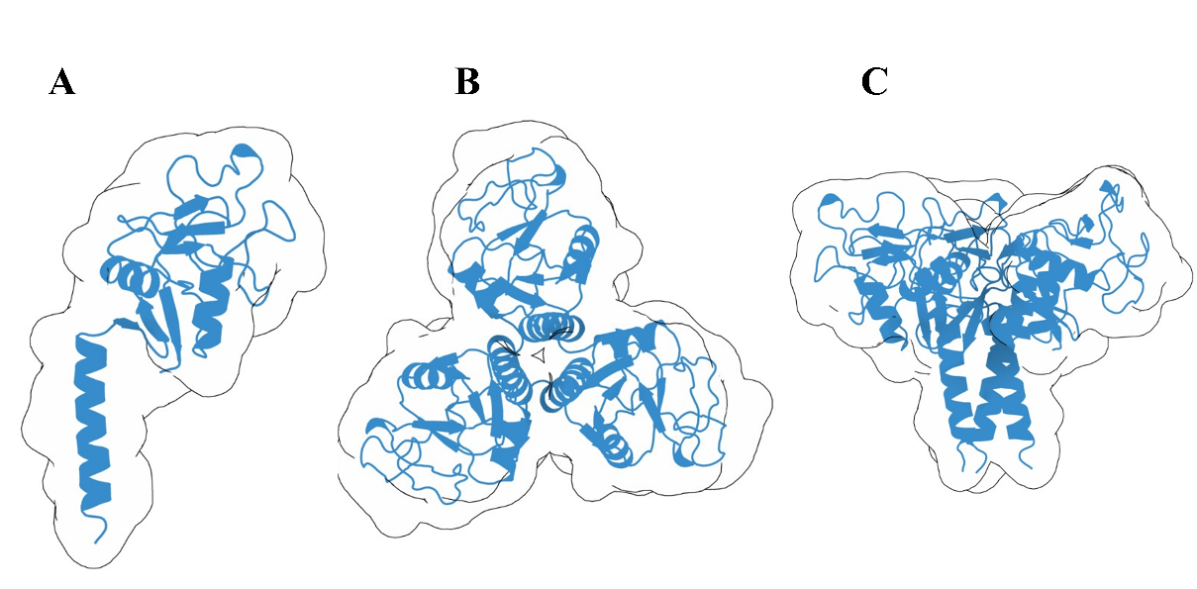
Figure S1. Experimental structure of MBL available in the PDB (1HUP). (A) MBL monomer; (B) trimer, top view (C3 symmetry); (C) trimer, side view, showing the helical regions and the carbohydrate-recognition domain (CRD).

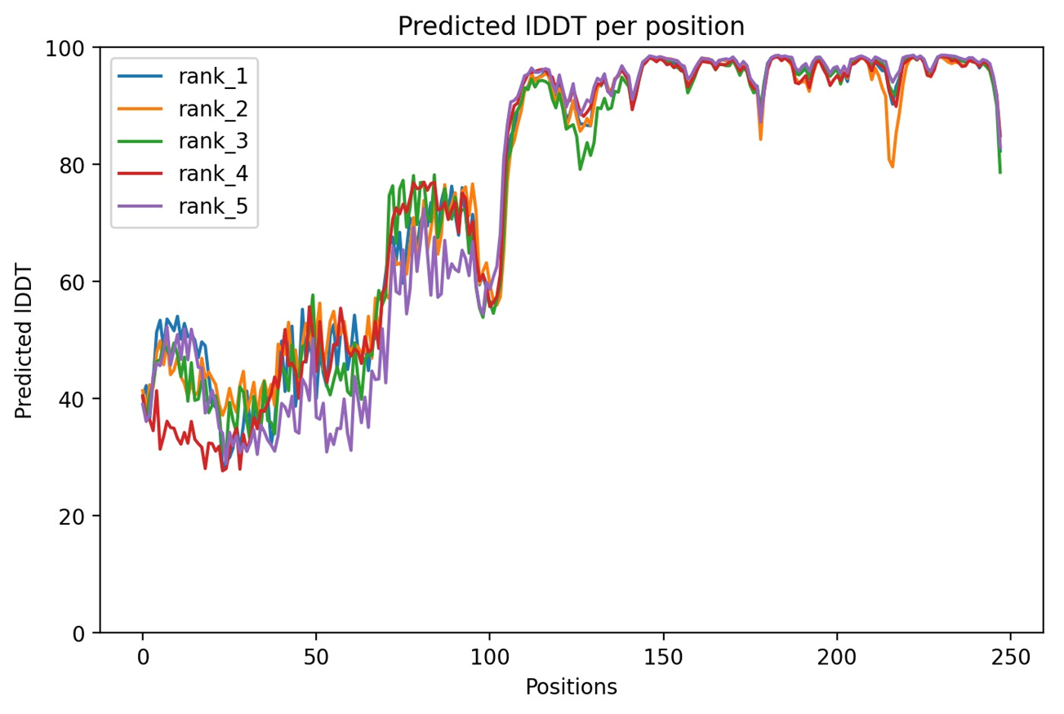
Figure S2. Predicted local confidence (pLDDT) per residue for the five ranked AlphaFold models of the MBL monomer. Higher values indicate greater confidence; the C-terminal neck+CRD region (approx. residues 110-240) shows high confidence.
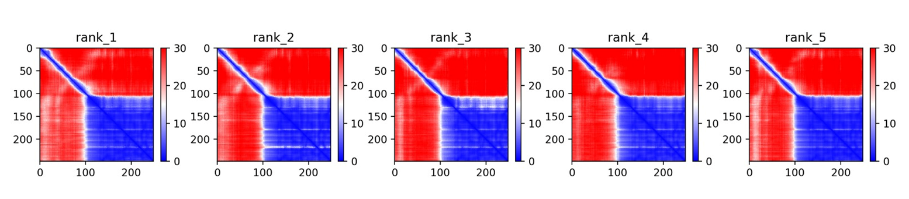
Figure S3. Predicted aligned error (PAE) for the five AlphaFold models. Blue denotes lower relative error (higher confidence); red denotes higher uncertainty, notably in the N-terminal region.
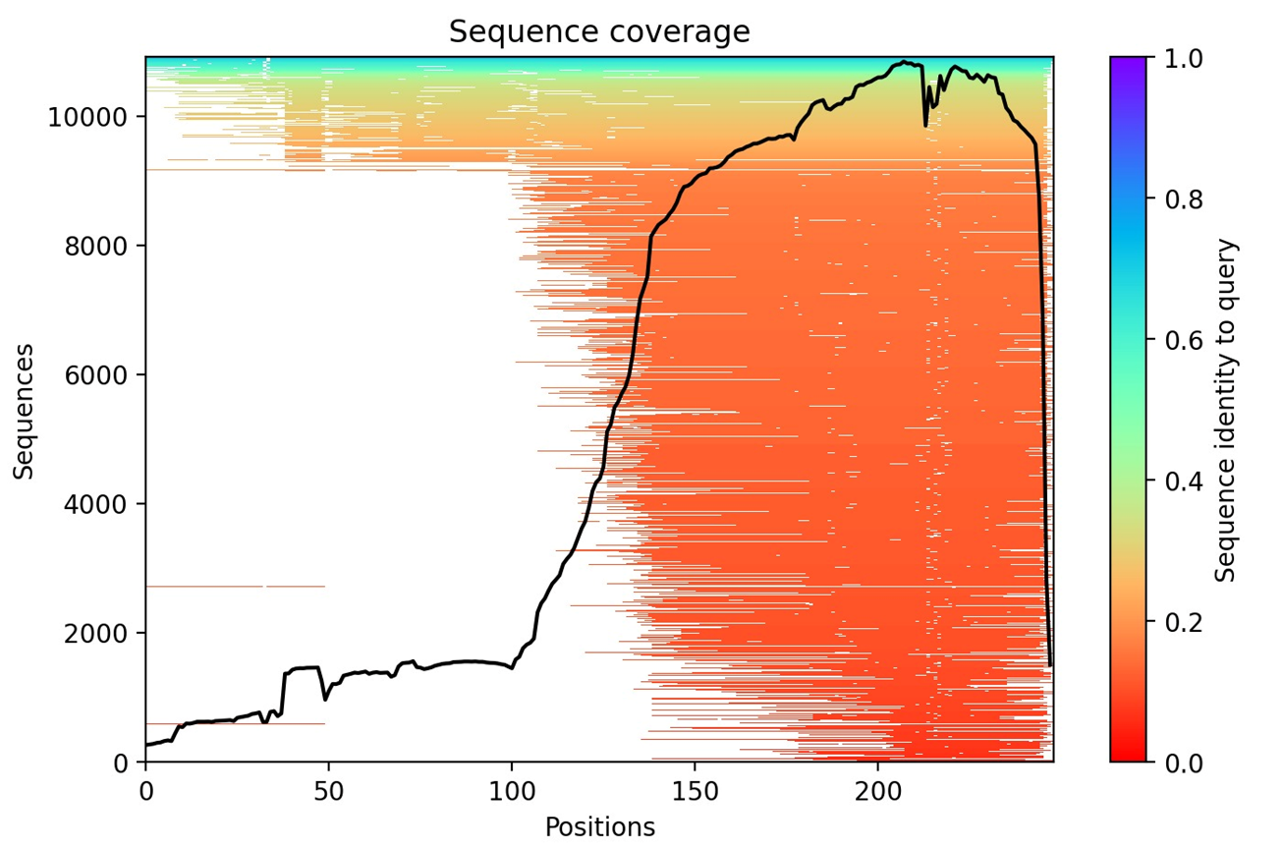
Figure S4. Multiple-sequence-alignment (MSA) coverage used by AlphaFold for MBL. Coverage increases substantially after residue ~110, providing stronger evolutionary support for the C-terminal region.

