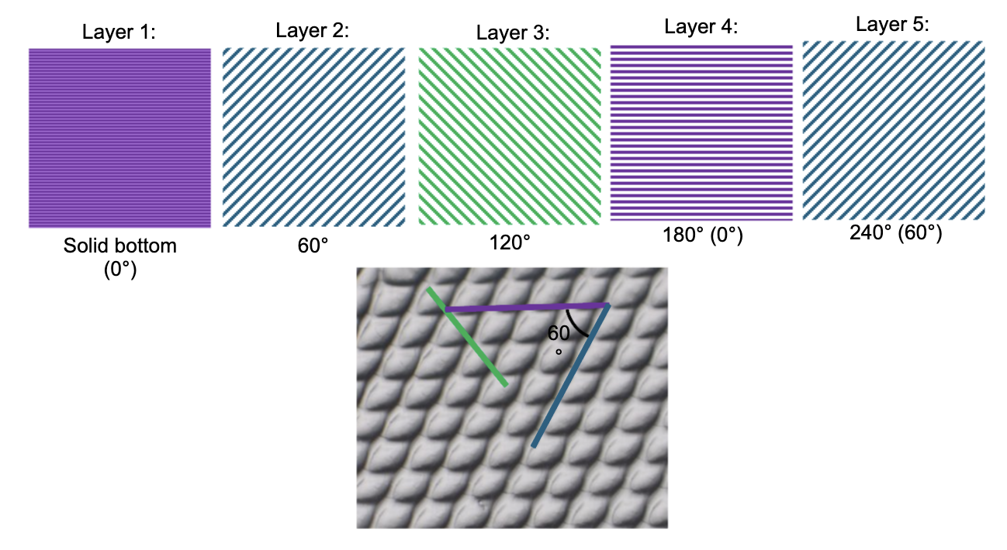
SI Fig 1 Scaffold architecture. Scaffolds were printed with a solid bottom layer and four additional layers oriented at 60° intervals to generate intersections that support follicle placement and growth.
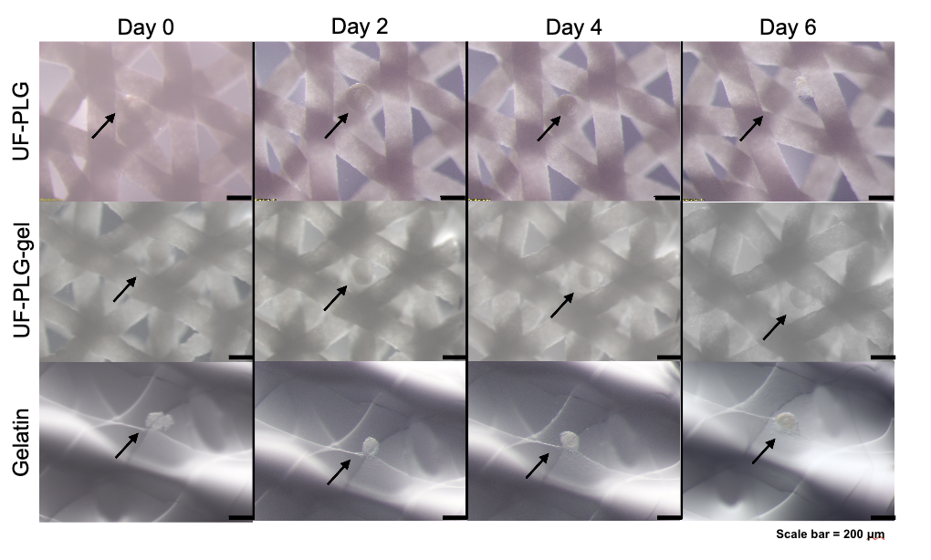SI Fig 2 Follicle morphology during culture. Representative light microscopy images of murine secondary follicles cultured on UF-PLG, UF-PLG-gel, and gelatin scaffolds for 0, 2, 4, or 6 days. Images illustrate changes in follicle morphology and interactions with scaffold struts over the culture period. Scale bar = 200 μm.

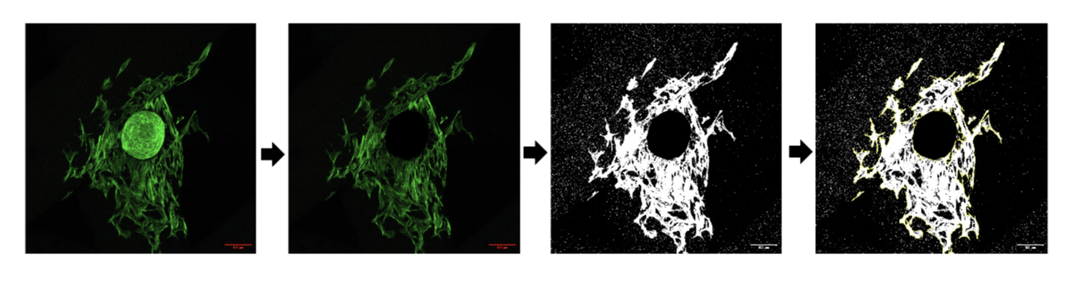SI Fig 3 Image analysis workflow for quantification of follicle attachment. Representative images demonstrating the ImageJ workflow used to quantify the area of attachment between follicles and scaffold struts. Confocal z-stacks were converted into maximum intensity projections, follicles were manually removed from the image, and remaining phalloidin-positive signal associated with scaffold attachment was thresholded and quantified.

