Additional file 2. Supplementary figures S1–S3
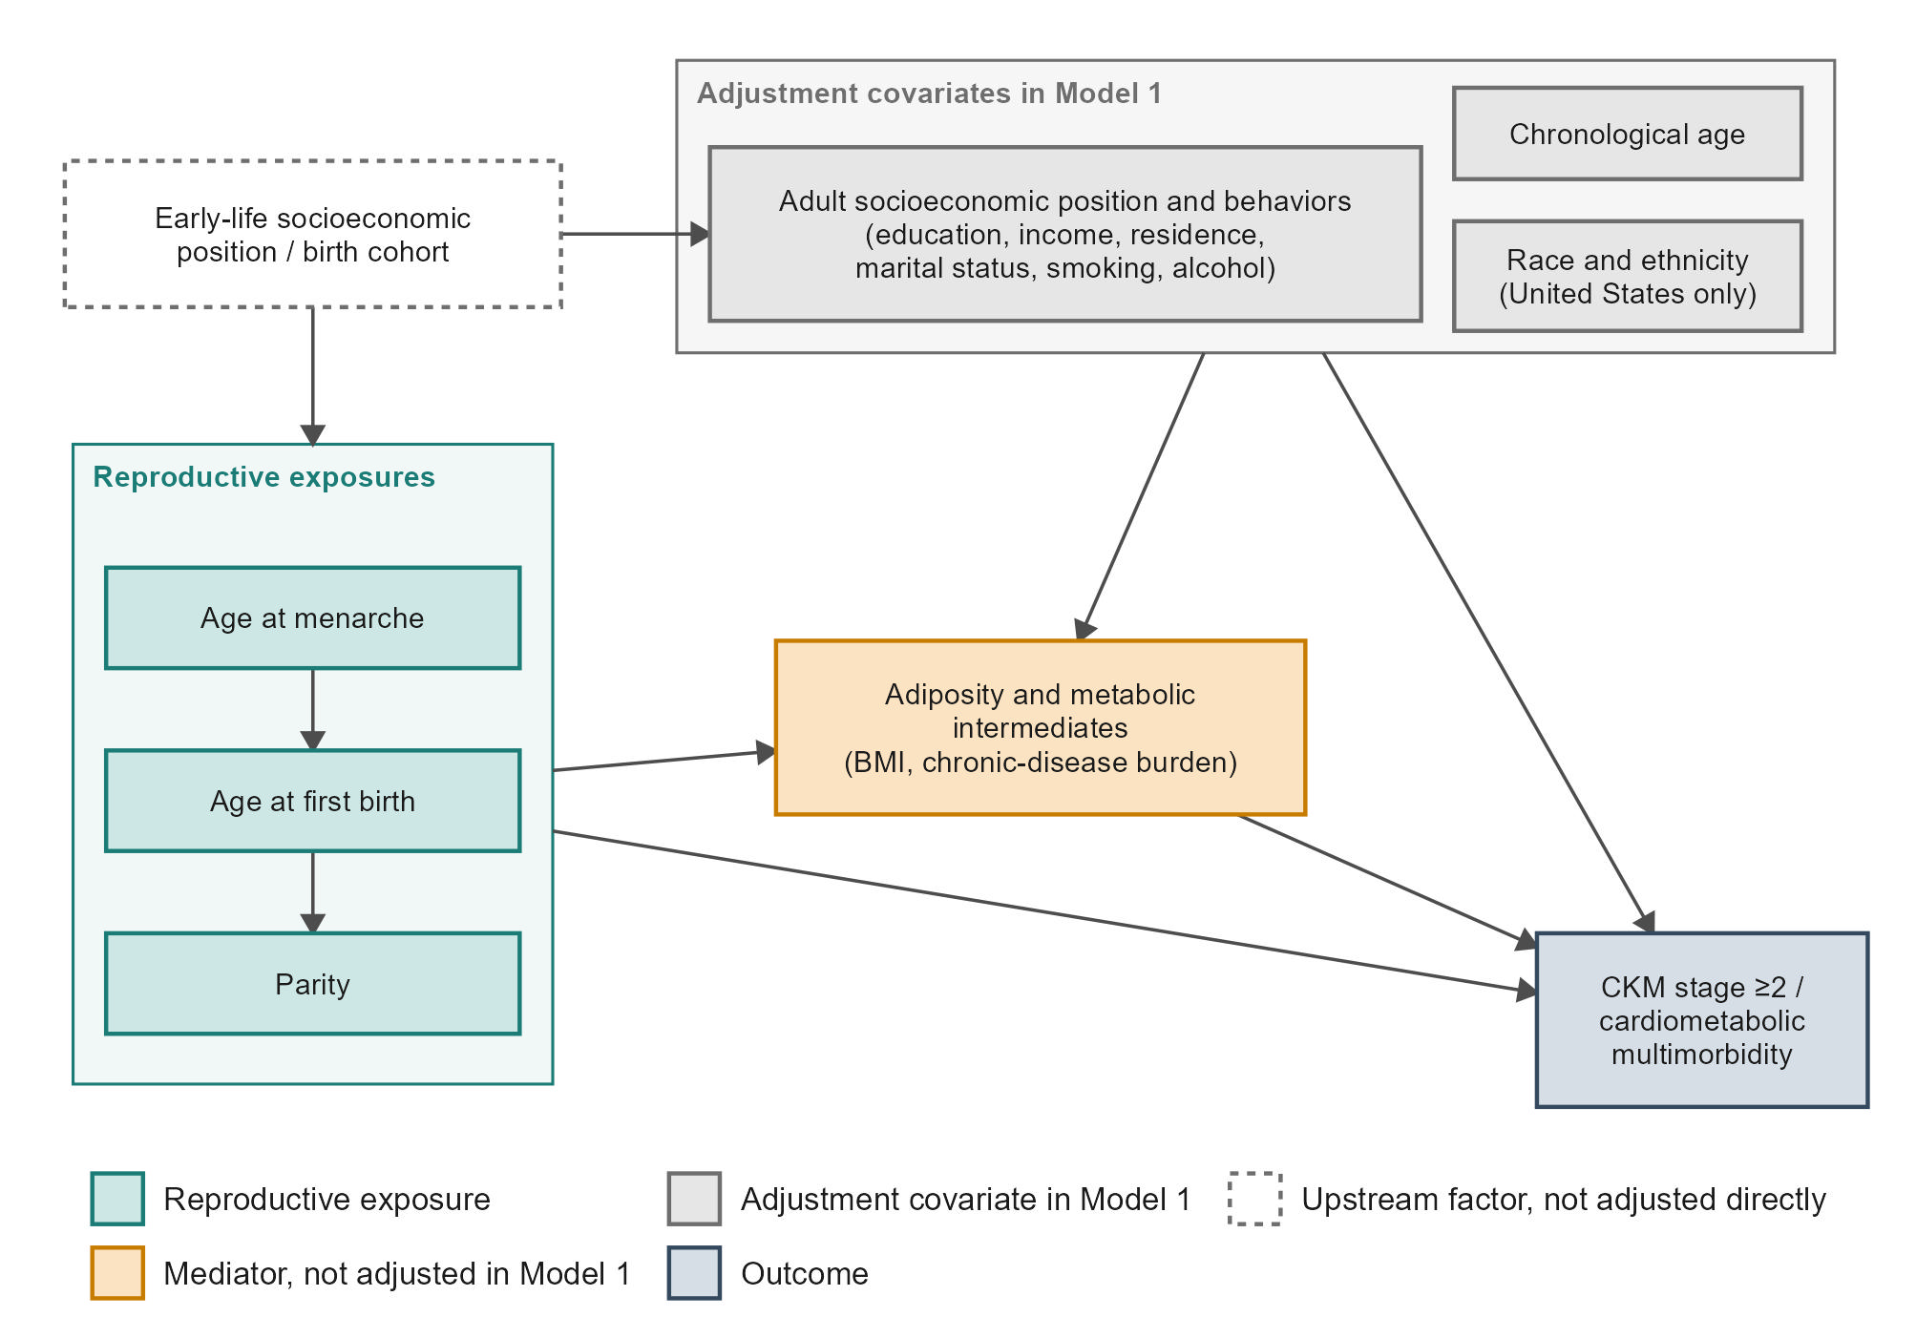
Figure S1. Conceptual directed acyclic graph (DAG) for the reproductive-factor and cardiovascular-kidney-metabolic (CKM) analysis. Assumed causal/temporal structure among early-life socioeconomic position and birth cohort, the reproductive exposures (age at menarche, age at first birth, parity), adult socioeconomic position and behaviors, chronological age, race and ethnicity, adult adiposity and metabolic intermediates, and the cardiometabolic-kidney outcomes. Node color denotes the variable’s role: reproductive exposures; an upstream factor that was not adjusted directly (birth cohort is captured by the adjustment for age and, in the United States, survey cycle; early-life socioeconomic position was not included); adjustment covariates in Model 1 (race and ethnicity in the United States only; adult socioeconomic position and behaviors may lie partly downstream of reproductive history); the adiposity and metabolic intermediates treated as mediators (and therefore deliberately not adjusted in Model 1); and the outcome. An arrow into or out of a box applies to every variable inside it. Age at first birth is placed upstream of completed parity, which is why simultaneous (mutual) adjustment among the reproductive factors is reported as a sensitivity analysis rather than as the primary model. The graph is conceptual and is not a statistical test of the depicted relationships.
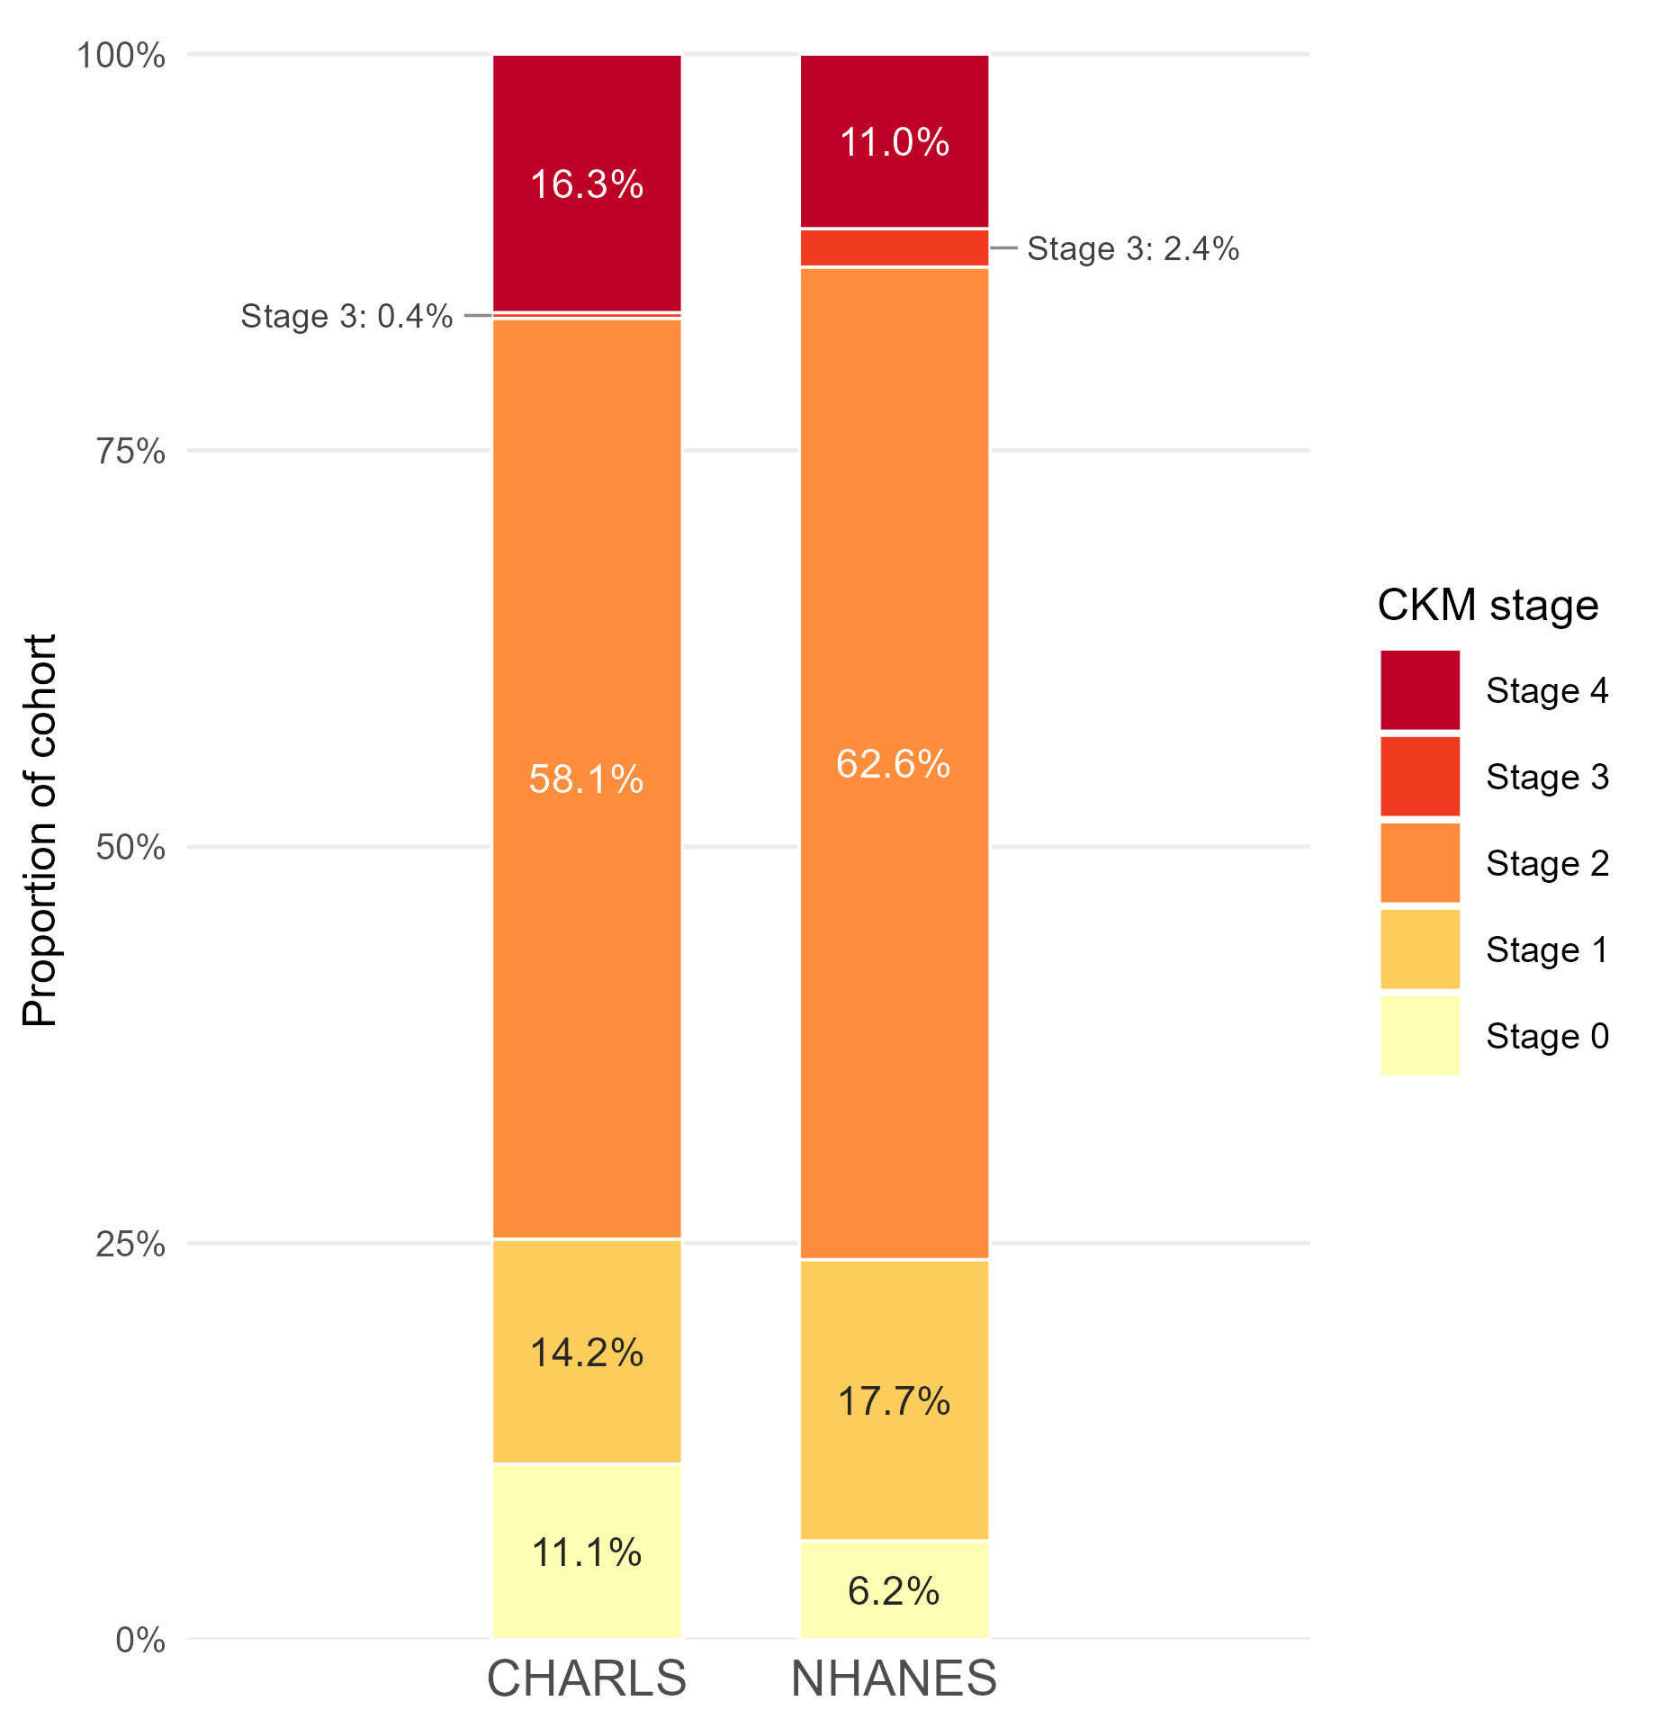
Figure S2. Distribution of cardiovascular-kidney-metabolic (CKM) syndrome stages by cohort. Proportion of postmenopausal women in CKM stages 0–4 in China (CHARLS, unweighted) and the United States (NHANES, survey-weighted). The stage-3-only proportion is very low in China (0.4%, 14 of 3,876 women) relative to the United States (2.4%); advanced CKM (stage ≥3) in the Chinese cohort is therefore driven almost entirely by stage 4 (clinical cardiovascular disease; 632 of 646 women at stage ≥3), which should be considered when interpreting the harmonized CKM stage ≥3 comparison.
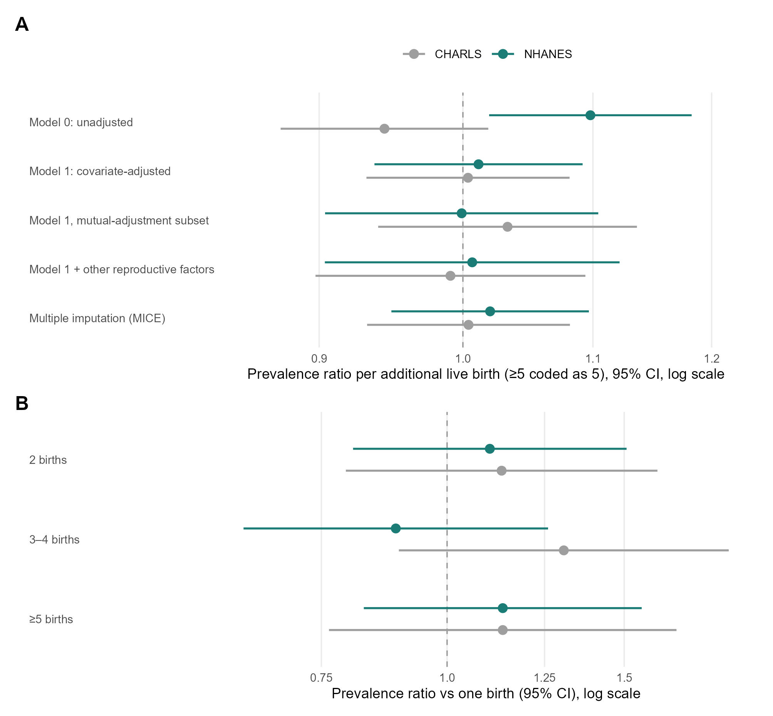
Figure S3. Specification sensitivity of the parity-cardiometabolic multimorbidity association in China (CHARLS) and the United States (NHANES). (A) Prevalence ratios (95% confidence intervals) per additional live birth (five or more births coded as five) in relation to cardiometabolic multimorbidity across model specifications – unadjusted (Model 0), Model 1, Model 1 restricted to the mutual-adjustment analytic subset, mutually adjusted for the other reproductive factors, and multiple imputation – in China (CHARLS) and the United States (NHANES). (B) Prevalence ratios by category of live births (reference = one birth; nulliparous women excluded) for cardiometabolic multimorbidity in both cohorts. In the Chinese cohort every confidence interval in both panels includes 1.0. NHANES estimates are survey-weighted; the dashed vertical line marks the null.

