Date:
School:
Name and surname:

1. Who can ride a bicycle on public roads?
 | A child that is six years old.
 | Anyone who knows how to ride a bicycle.
 | A child that is twelve years old.
 | A child with a schoolmate.

2. Mark a picture showing a cyclist who safely rides a bicycle.
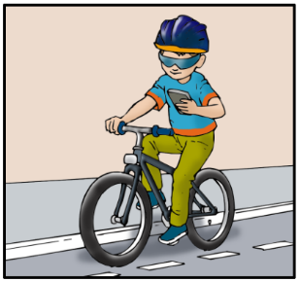 | 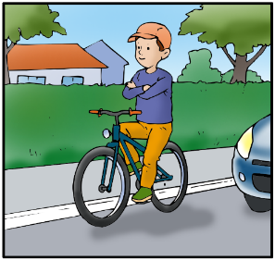 | 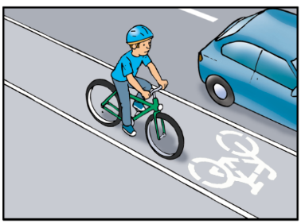 | 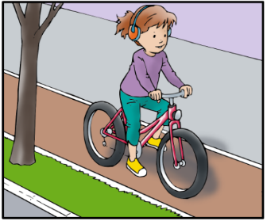

3. Mark images showing bicycle parts and equipment that your bike must have.
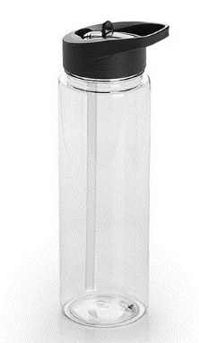 | 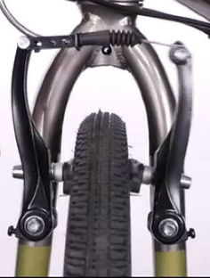 | 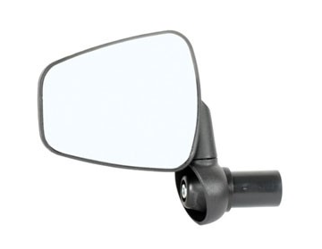 | 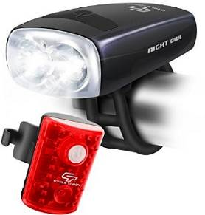
Water bottle | Brakes | Mirror | Front and rear lights

4. What must your bike have when you ride it at night and under conditions of reduced visibility?
Turn on a white light at the front and a red light at the rear.
A bell to warn pedestrians.
Bike locks.

5. Mark images showing the equipment that cyclists should have.
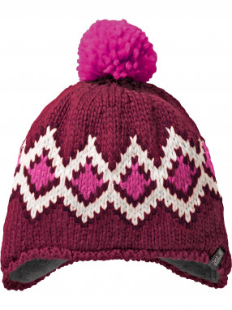 | 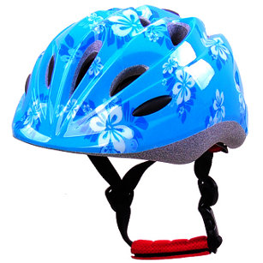 | 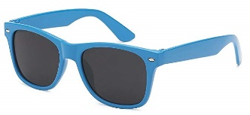 | 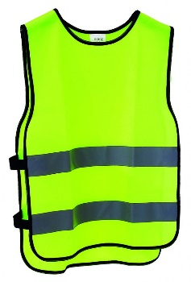
Winter hat | Helmet | Sunglasses | Reflective vest

6. Why should a cyclist wear a safety helmet?
It is required by law.
To protect the brain from injury.
Because parents said so.
Because it looks so beautiful.

7. Mark an image where a cyclist wears his helmet correctly.
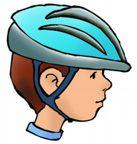 | 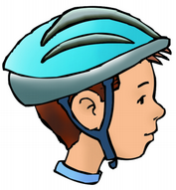 | 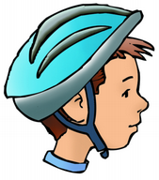 | 

8. What does the sign shown in the picture at the intersection mean? |  |  |  |  |  |  | 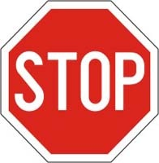
 |  |  | Continue to move, the sign is just related to cars.
 |  |  | Mandatory sign to stop.
 |  |  | Ban cyclists from road.
 |  |  | I am not sure.
9. What does each signal on traffic lights mean?
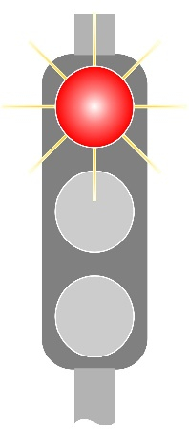 |  |  |  | 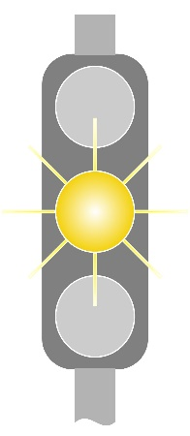 |  | 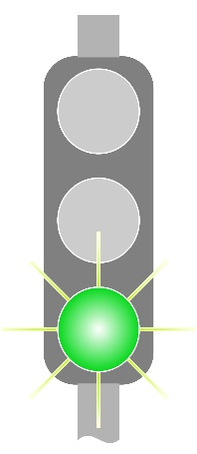
 |  | Prohibition of passage. |  |  | Prohibition of passage. |  |  | Prohibition of passage.
 |  | Deceleration, prohibition of passage, stop if it is safe to do so. |  |  | Deceleration, prohibition of passage, stop if it is safe to do so. |  |  | Deceleration, prohibition of passage, stop if it is safe to do so.
 |  | Permission of passage. |  |  | Permission of passage. |  |  | Permission of passage.
 |  | I am not sure. |  |  | I am not sure. |  |  | I am not sure.

10. What does each signal on traffic lights mean?
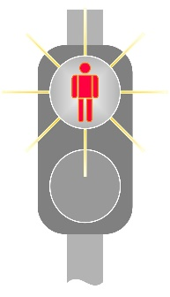 |  | 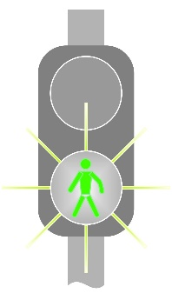 |  | 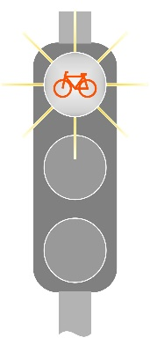 |  | 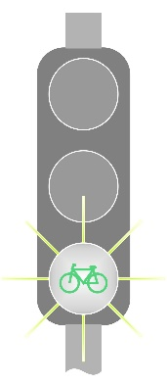
 | Permission of passage for pedestrians. |  | Permission of passage for pedestrians. |  | Permission of passage for pedestrians. |  | Permission of passage for pedestrians.
 | Permission of passage for cyclists. |  | Permission of passage for cyclists. |  | Permission of passage for cyclists. |  | Permission of passage for cyclists.
 | Prohibition of passage for pedestrians. |  | Prohibition of passage for pedestrians. |  | Prohibition of passage for pedestrians. |  | Prohibition of passage for pedestrians.
 | Prohibition of passage for cyclists. |  | Prohibition of passage for cyclists. |  | Prohibition of passage for cyclists. |  | Prohibition of passage for cyclists.

11. What does the sign shown in the picture at the intersection mean? |  |  | 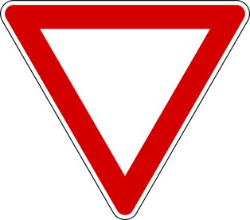
 |  | Prohibition of passage for cyclists.
 |  | Mandatory sign to stop.
 |  | Continue to move, but give way to vehicles on the main road.
 |  | I am not sure.

12. Mark what do the following road signs mean?
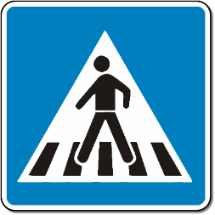 |  | 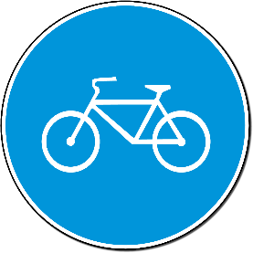 |  | 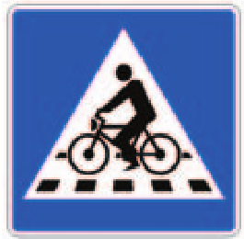 |  | 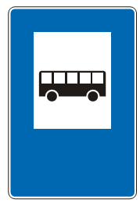
 | Pedestrain crossing |  | Pedestrain crossing |  | Pedestrain crossing |  | Pedestrain crossing
 | Cyclist lane |  | Cyclist lane |  | Cyclist lane |  | Cyclist lane
 | Cycle lane crosses the road |  | Cycle lane crosses the road |  | Cycle lane crosses the road |  | Cycle lane crosses the road
 | Bus stop |  | Bus stop |  | Bus stop |  | Bus stop

13. When a cyclist ride a bike, what do the signals mean?
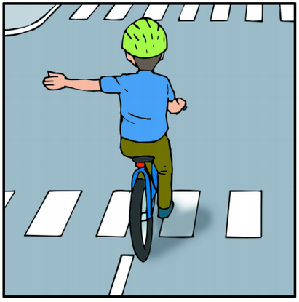 |  |  | 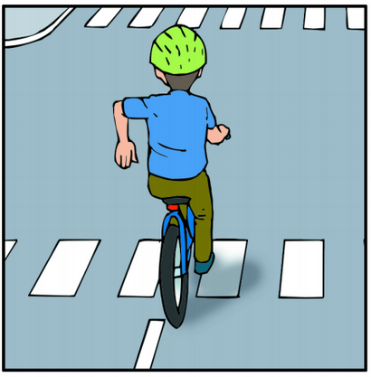 |  |  | 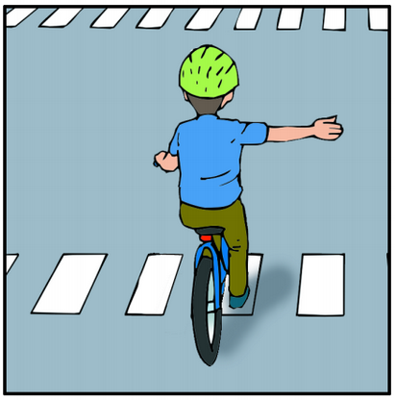
 |  | Stop |  | Stop |  |  | Stop
 |  | Turn left |  | Turn left |  |  | Turn left
 |  | Turn right |  | Turn right |  |  | Turn right
 |  | I am not sure. |  | I am not sure. |  |  | I am not sure.
14. Does a cyclist move properly in the situation shown in the picture? |  |  |  |  | 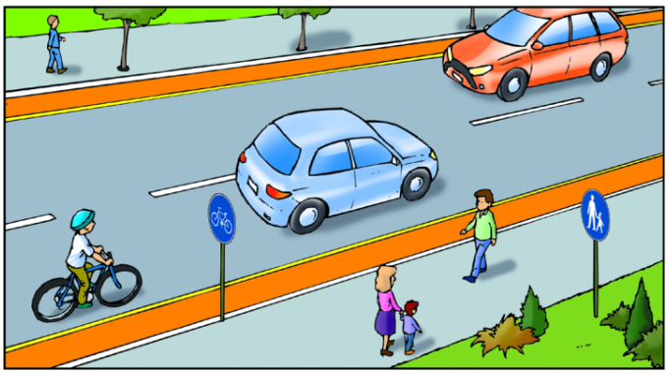
 |  | Yes, because he/she moves along the bicycle lane
 |  | No, because he/she ride a bike along the road where there is a bicycle lane.
 |  | Yes, because he/she moves in the middle of road.
 |  | I am not sure.

15. Who has priority at the intersection to move on in the picture? |  |  | 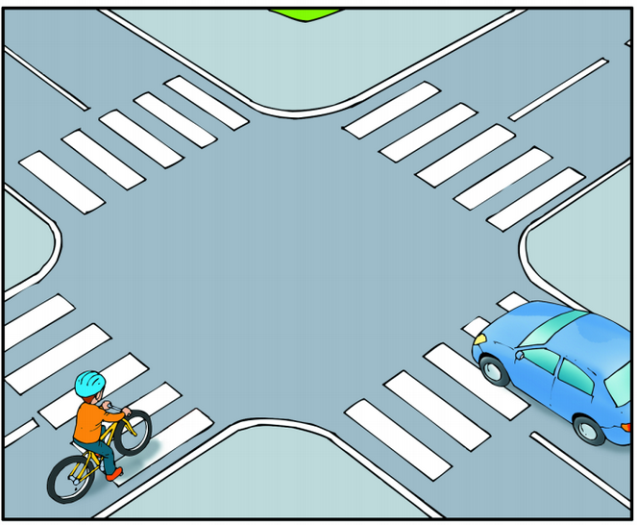
 |  | Car.
 |  | Cyclist.
 |  | I am not sure.
16. Who has priority at the intersection to move on in the picture? |  |  | 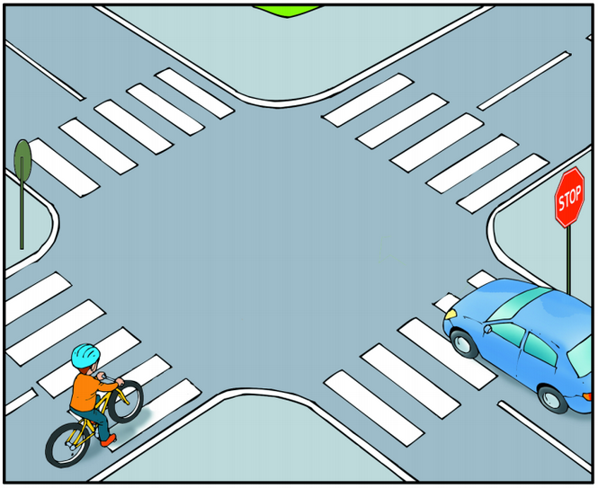
 |  | Car.
 |  | Cyclist.
 |  | I am not sure.

17. Does a cyclist move properly in the situation shown in the picture? |  |  | 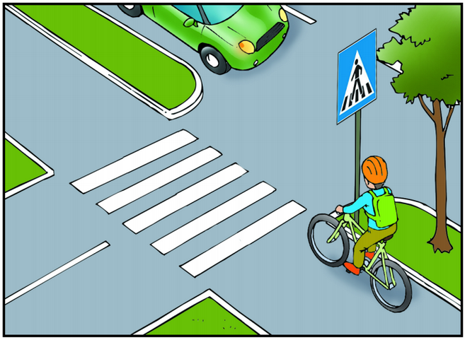
 |  | Yes, because the vehicle is turning right, and a cyclist has priority to move.
 |  | No, because a cyclist does not get off his/her bike and walk accross the crossing lane.
 |  | No, because a car is coming from the right.
 |  | I am not sure.

THANK YOU FOR TAKING YOUR TIME TO DO THIS TEST!


