Supplementary materials

PPARβ/δ priming enhances the anti-apoptotic and therapeutic properties of mesenchymal stromal cells in myocardial ischemia-reperfusion injury
By
Charlotte Sarre^{1,2$}, Rafael Contreras-Lopez^{1,2$}, Nitirut Nerpernpisooth³, Christian Barrere¹, Sarah Bahraoui², Claudia Terraza², Gautier Tejedor², Anne Vincent¹, Patricia Luz-Crawford^{4,5}, Kantapich Kongpol^{1,3}, Sarawut Kumphune⁶, Christophe Piot^{1,7}, Joel Nargeot¹, Christian Jorgensen^{2,8}, Farida Djouad^{2,#}, Stéphanie Barrere-Lemaire^{1,#}
$ Equally contributing first authors; # Equally contributing corresponding authors

Supplementary figures

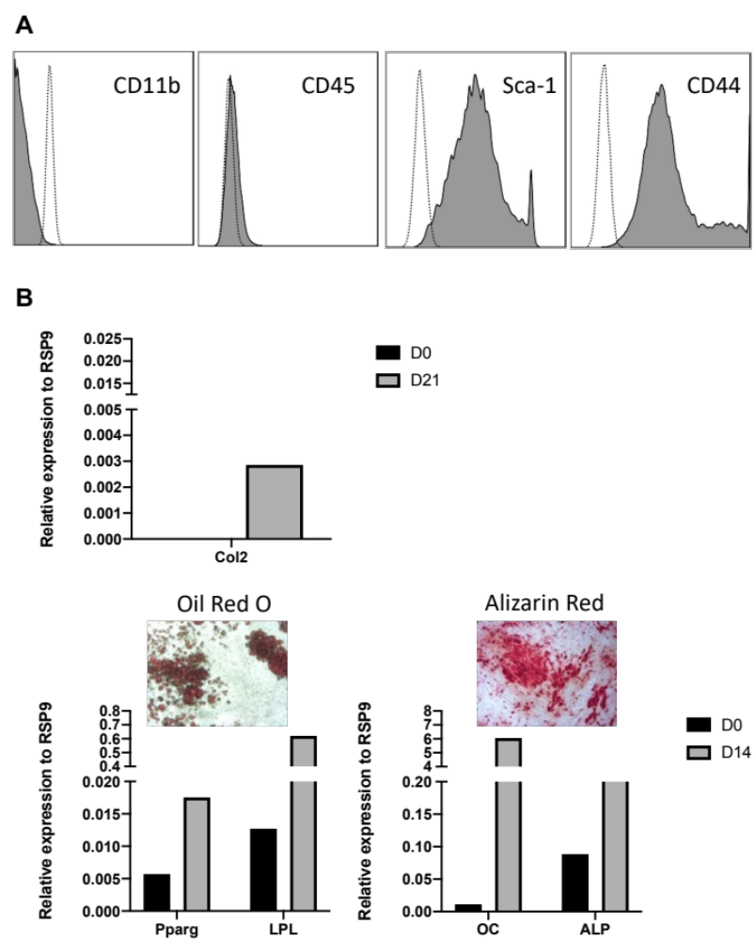

Supplementary Figure 1. Characterization of murine MSC derived from the bone marrow of C57BL/6 mice. (A) Phenotype of MSCs was assessed by flow cytometry. Differentiation potential of MSC. (B) The chondrogenic differentiation of MSC was assessed by RT-qPCR to measure the relative expression of collagen type II (Col2) a marker characteristic of chondrocytes. The adipogenic potential of MSC was evaluated by RT-qPCR to measure the relative expression of lpl and pparγ, markers characteristic of adipocytes, and by the visualization of lipid droplets by phase contrast microscopy at day 14 of the differentiation process. Finally, the osteogenic differentiation potential of MSC was evaluated by RT-qPCR to measure the relative expression of osteocalcin (oc) and alkaline phosphatase (alp), markers characteristic of osteoblasts, and by Alizarin Red S positive staining.

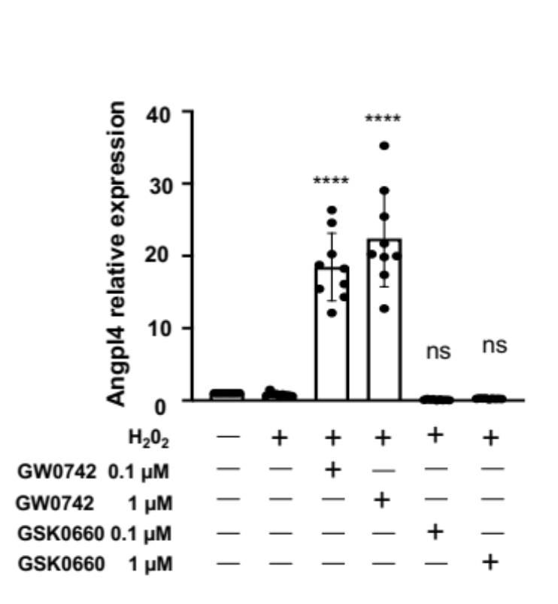

Supplementary Figure 2:
Agonist functionality of GW0742 on PPARβ/δ was assessed by RT-qPCR to measure the relative expression of the Angpl4 target gene. mRNA expression levels in untreated or preconditioned MSC exposed to H₂O₂ (250 µM) were assessed by RT-qPCR. Data (mean ± SD; n=9 for each group) normalized to the control values (data obtained for MSC without H₂O₂) were compared using ANOVA and the Tukey’s post hoc test (normality test passed). P values vs MSC/H₂O₂ were noted in (A): **** for p<0.0001 and ns for p>0.999 and in (B): *** for p=0.0001, ** for p=0.0046, * for p=0.0140 and ns for p=0.1006.

