Risk factors for persistent Staphylococcus aureus nasal carriage in the community
Kaptoge et al.

Supplementary Figures

Supplementary Fig.1. Age distribution of CARRIAGE participants by sex 2
Supplementary Fig.2. Distribution of persistent S. aureus nasal carriage prevalence across months and years of the study, showing no significant difference (p=0.298) 3
Supplementary Fig.3. Age and sex adjusted associations of further specific characteristics with first swab positivity 4
Supplementary Fig.4. Summary of the risk factors for S. aureus carriage 6
Supplementary Fig.5. Performance of multivariable risk factor model and first swab positivity in discriminating persistent

Supplementary Fig.1. Age distribution of CARRIAGE participants by sex

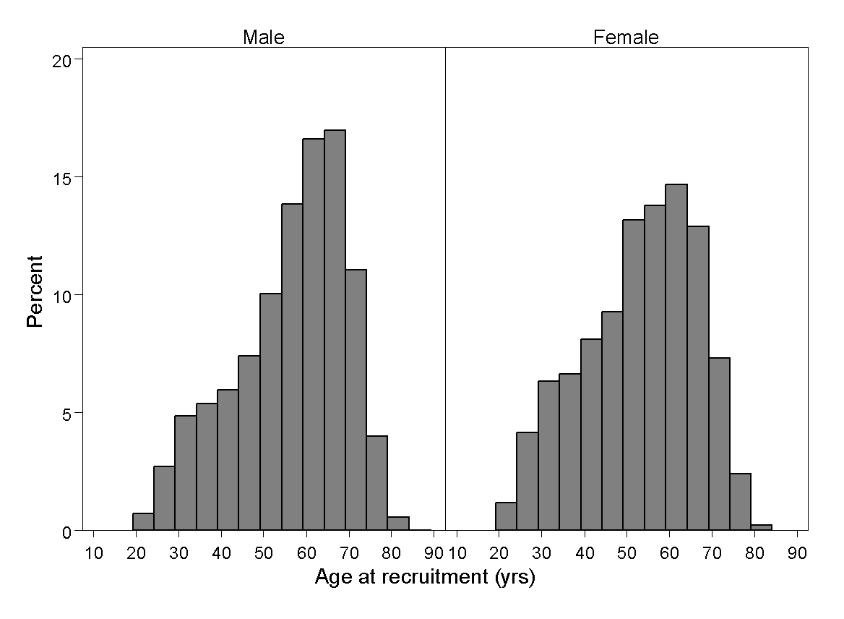

Supplementary Fig.2. Distribution of persistent S. aureus nasal carriage prevalence across months and years of the study, showing no significant difference (p=0.298)

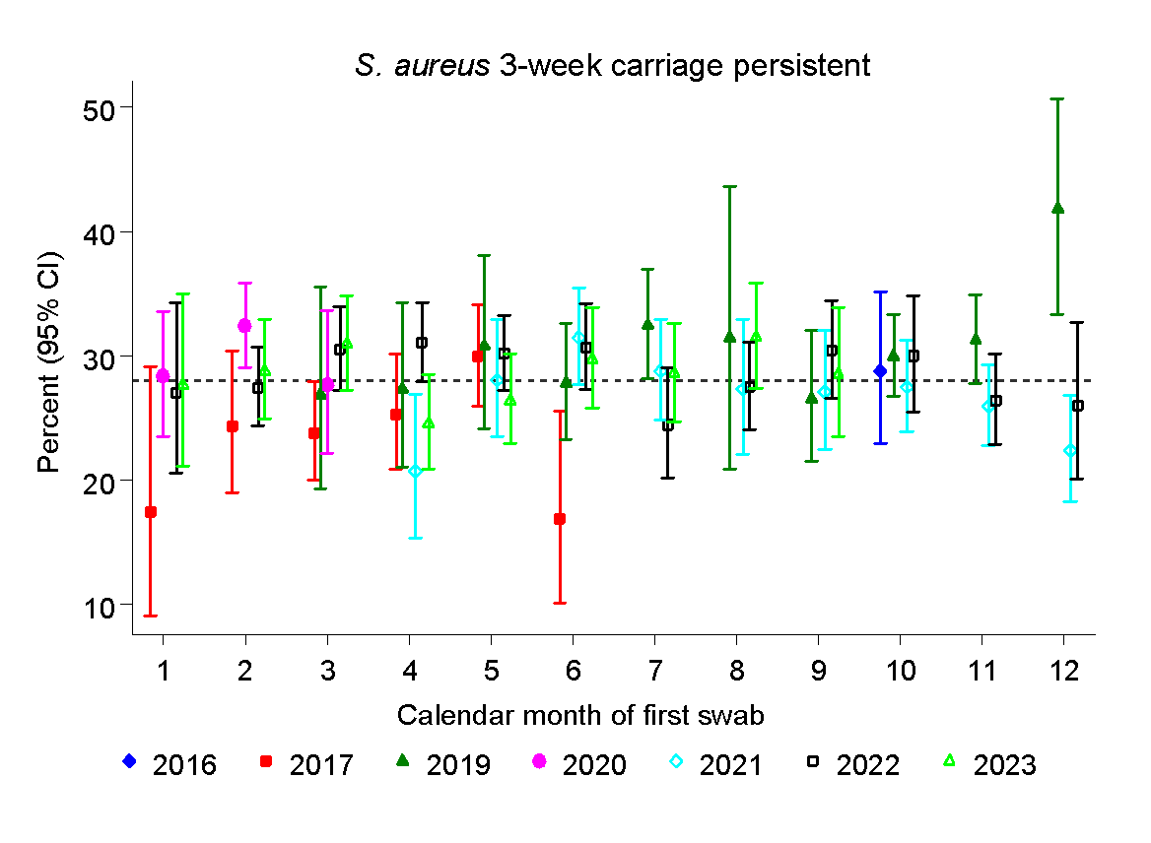

Supplementary Fig.3. Age and sex adjusted associations of further specific characteristics with first swab positivity
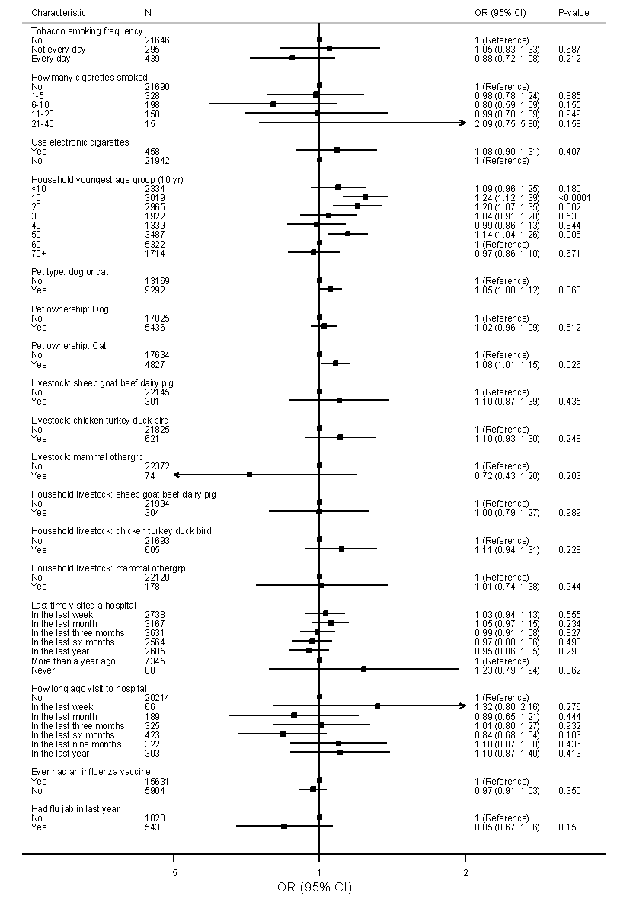

Supplementary Fig.3 (contd.). Age and sex adjusted associations of further specific characteristics with first swab positivity
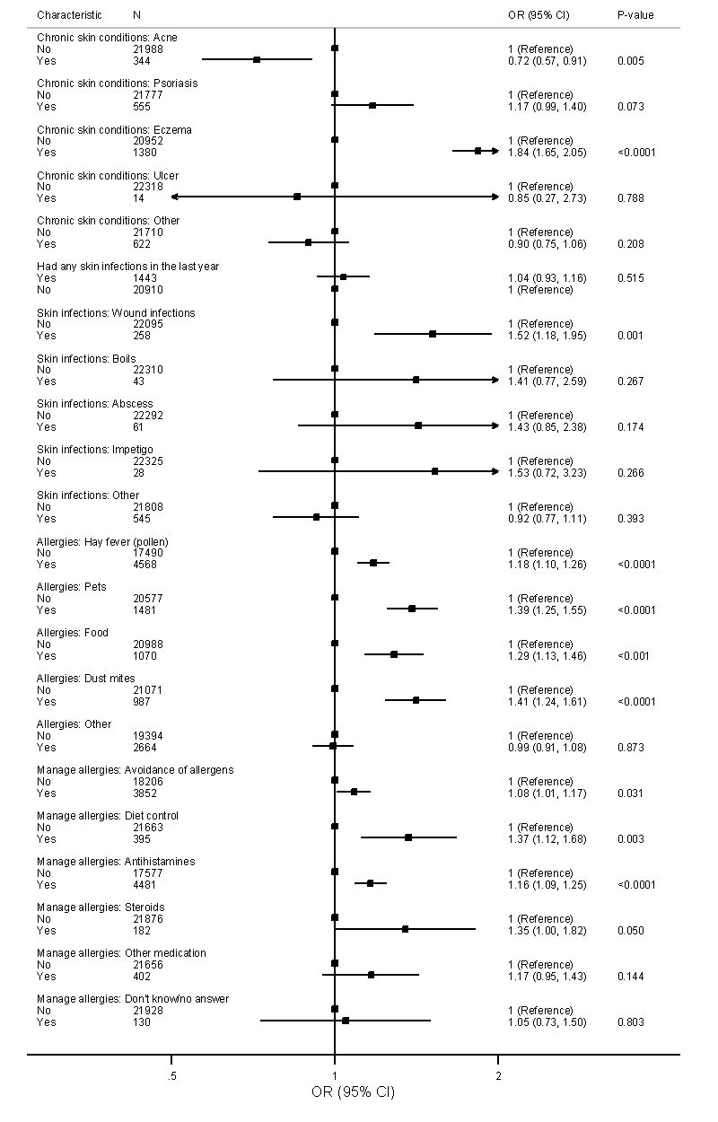

Supplementary Fig.4. Summary of the risk factors for S. aureus carriage

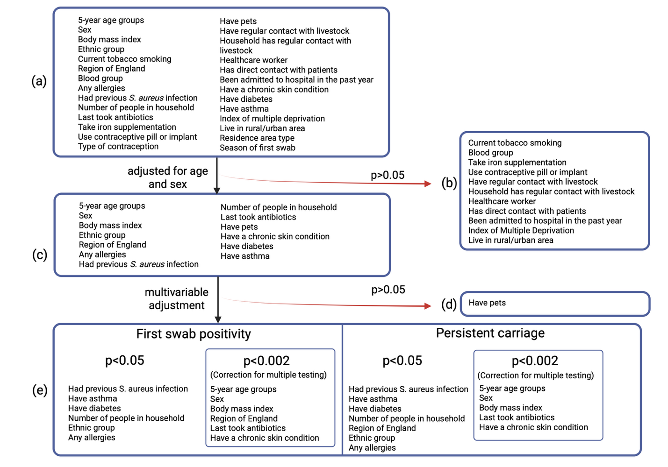
Created with BioRender.com

Supplementary Fig.5. Performance of multivariable risk factor model and first swab positivity in discriminating persistent S. aureus carriage.

(a) Persistent carriage versus absence or undetermined carriage
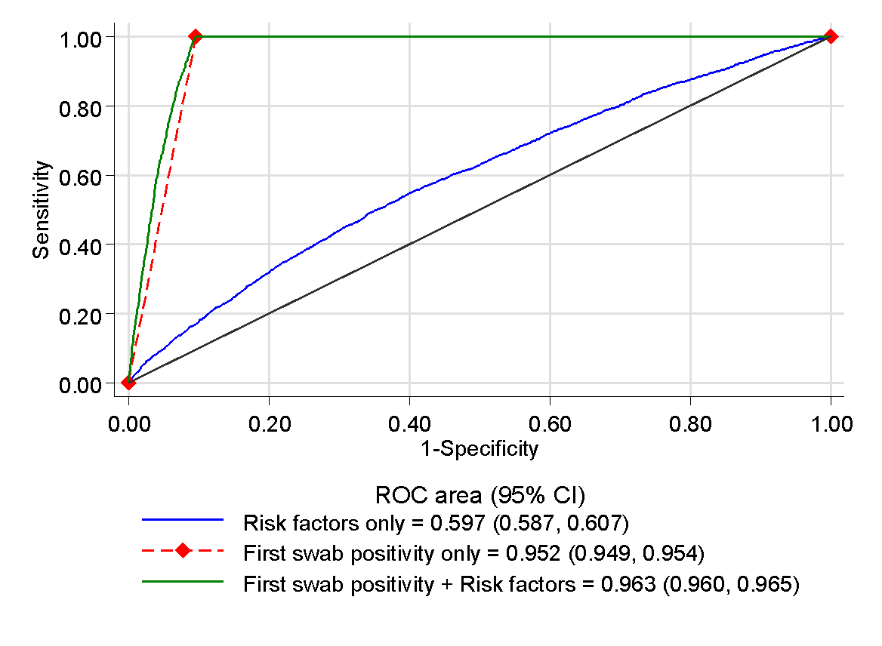
(b) Persistent carriage versus undetermined carriage
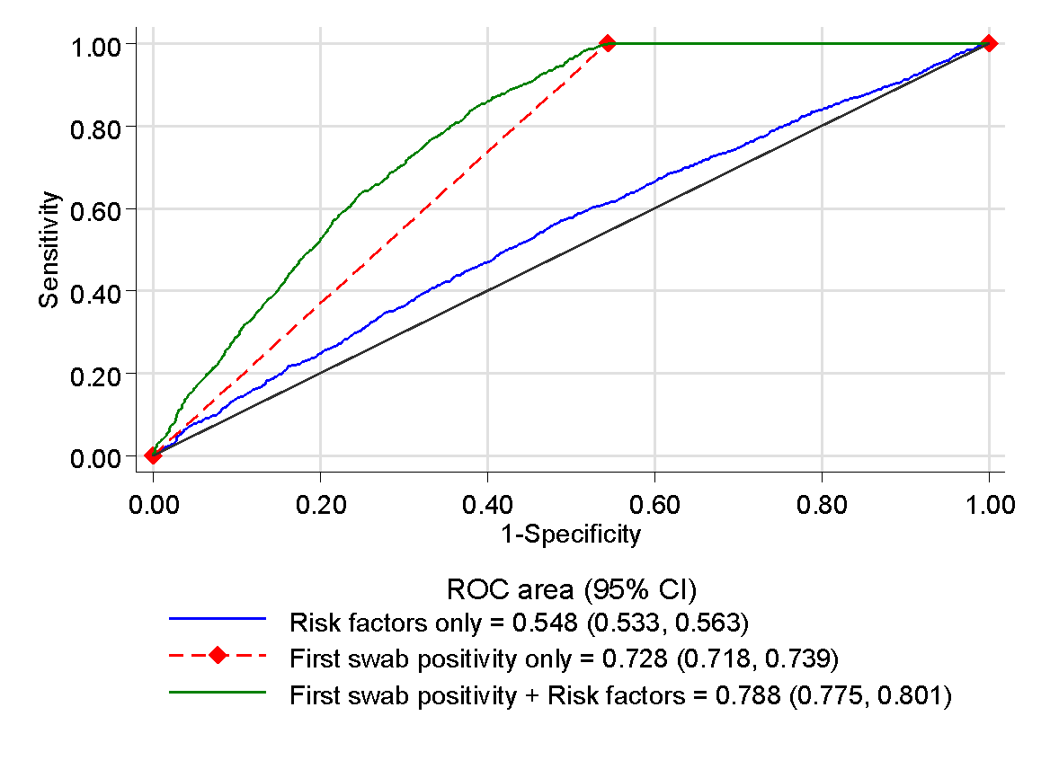

Supplementary Fig.6. Prevalence of Staphylococcus aureus first swab positivity and persistent carriage by age and sex

