Supplementary Figures

Genomic and ecological specialization of Methanobrevibacter species shape human methane emission and overall gut ecosystem function

Christina Kumpitsch^{1,2}, Alexander Mahnert^{1,2}, Stefanie Wimberger¹, Marcus Blohs¹, Rokhsareh Mohammadzadeh¹, Laura Schmidberger¹, Simone Vrbancic¹, Tobias Madl^{2,3}, Hansjörg Habisch³, Katharina Leithner^{2,4,5}, Theresa Haitzmann⁴, Sonja Lackner⁶, Sandra Holasek⁶, Christoph Högenauer^{2,7}, Adrian Mathias Moser, Tamara Zurabischvili¹, Christian Diener¹, Christine Moissl-Eichinger^{1,2 *}

¹ Diagnostics and Research Institute of Hygiene, Microbiology and Environmental Medicine, Medical University of Graz, Graz, Austria
² BioTechMed Graz, Graz, Austria
³ Division Medicinal Chemistry, Otto Loewi Research Center, Medical University of Graz, Graz, Austria
⁴ Division of Pharmacology, Otto Loewi Research Center, Medical University of Graz, Graz, Austria
⁵ Lung Research Cluster, Medical University of Graz, Graz, Austria
⁶ Division of Pathophysiology and Immunology, Otto Loewi Research Center, Medical University of Graz, Graz, Austria
⁷ Division of Gastroenterology and Hepatology, Department of Internal Medicine, Medical University of Graz, Graz, Austria

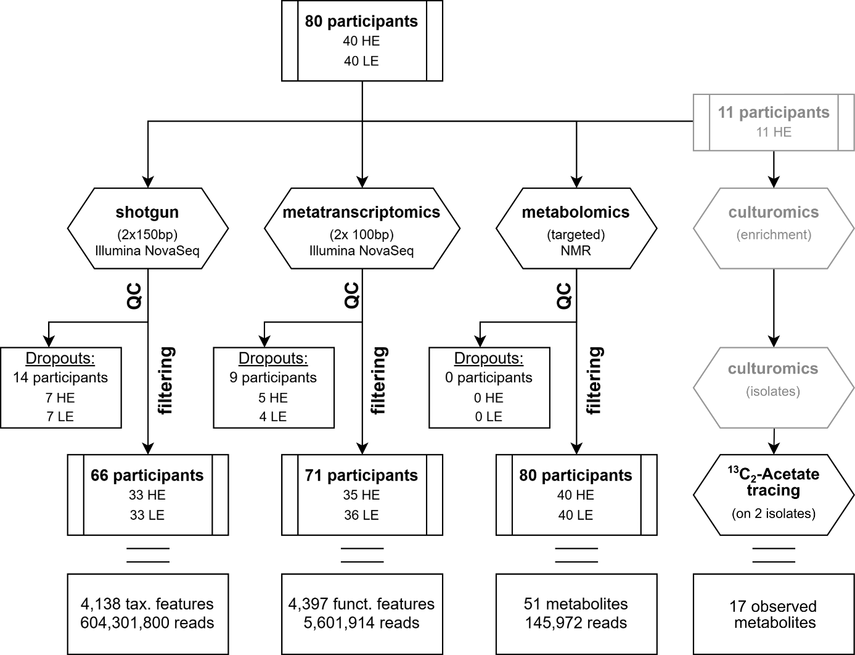

Supplementary Figure X1. A schematic representation of the study design, showing all dropouts, filtered samples, and the features and reads obtained using each method. The grey-highlighted parts were performed in Ref (Duller et al., 2024). HE - high methane emitters, LE - low methane emitters; QC - quality control

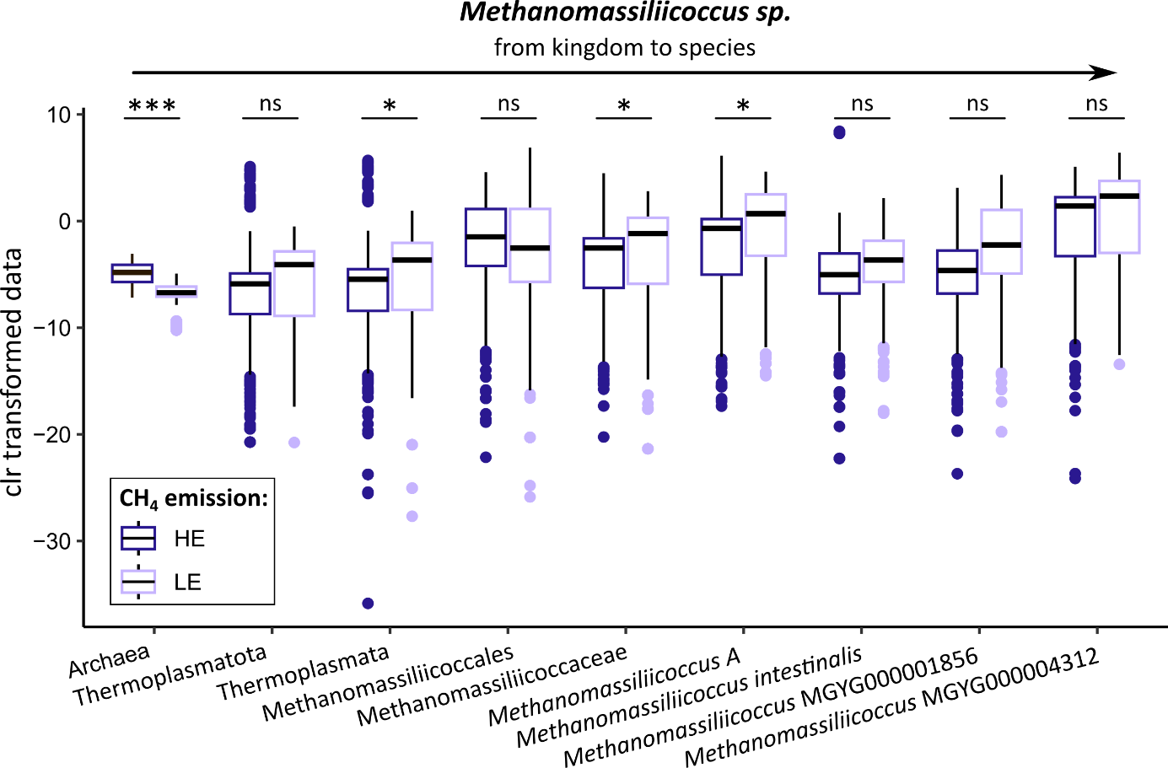
Supp. Figure X2. Differential abundance of Methanomassiliicoccus sp. from kingdom to species based on CH₄ emission phenotype. ALDEx2: Archaea (q=1.43e-069); Thermoplasmatota (q=0.068); Thermoplasmata (q=0.043); Methanomassiliicoccales (q=0.98); Methanomassiliicoccaceae (q=0.021); Methanomassiliicoccus A (q=0.021); Methanomassiliicoccus intestinalis (q=0.442); Methanomassiliioccus MGYG000001856 (q=0.113); Methanomassiliicoccus MGYG000004312 (q=0.075).

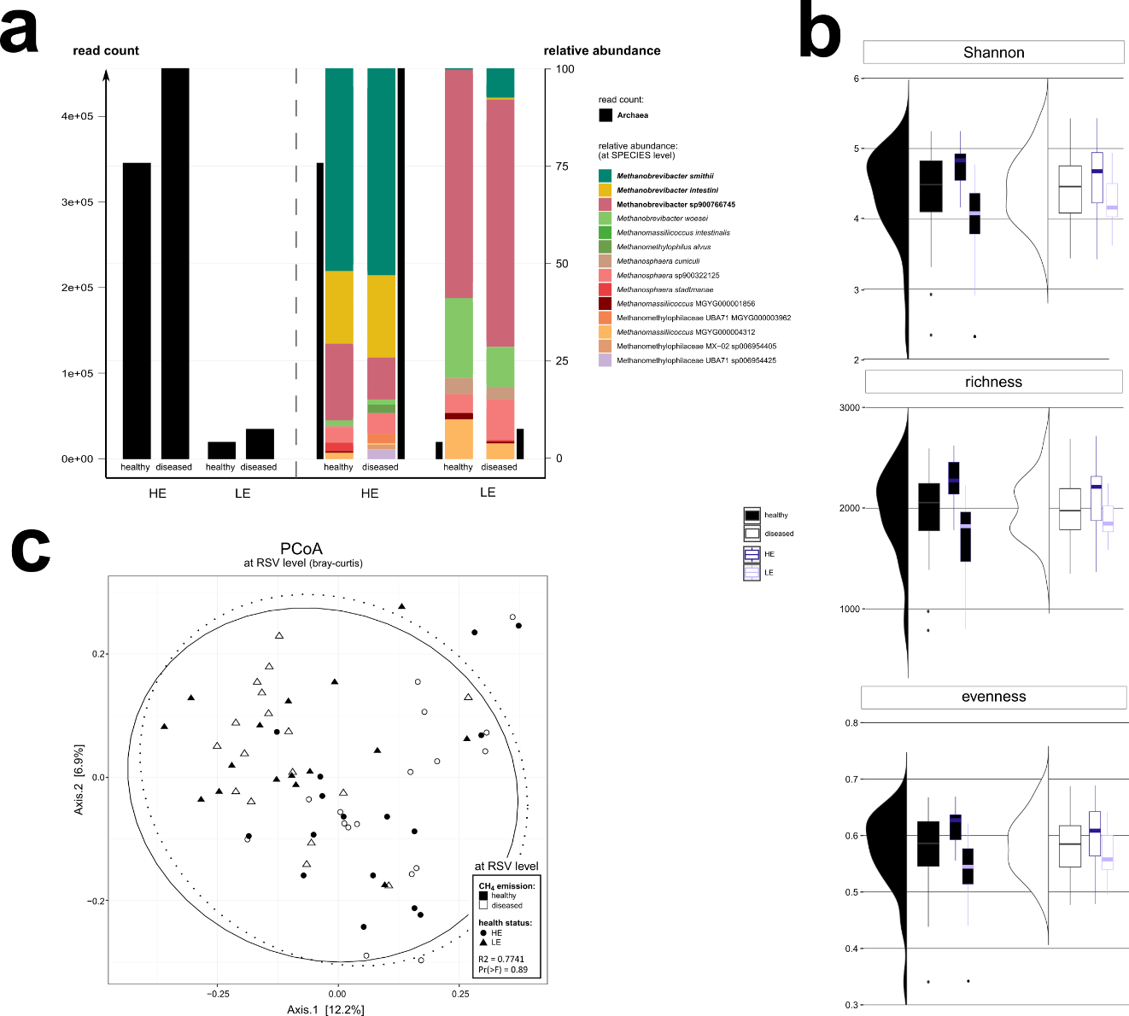
Supp. Figure X3. Microbiome of HE and LE participants did not differ based on health status. a. Read counts and relative abundance of archaeal taxa in HE and LE based on methane and health groups. b. Alpha diversity based on overall health status (black and white) as well as additionally separated by CH₄ phenotypes (light and dark purple). c. Beta diversity based on the participants health status. HE - high methane emitter, LE - low methane emitter.
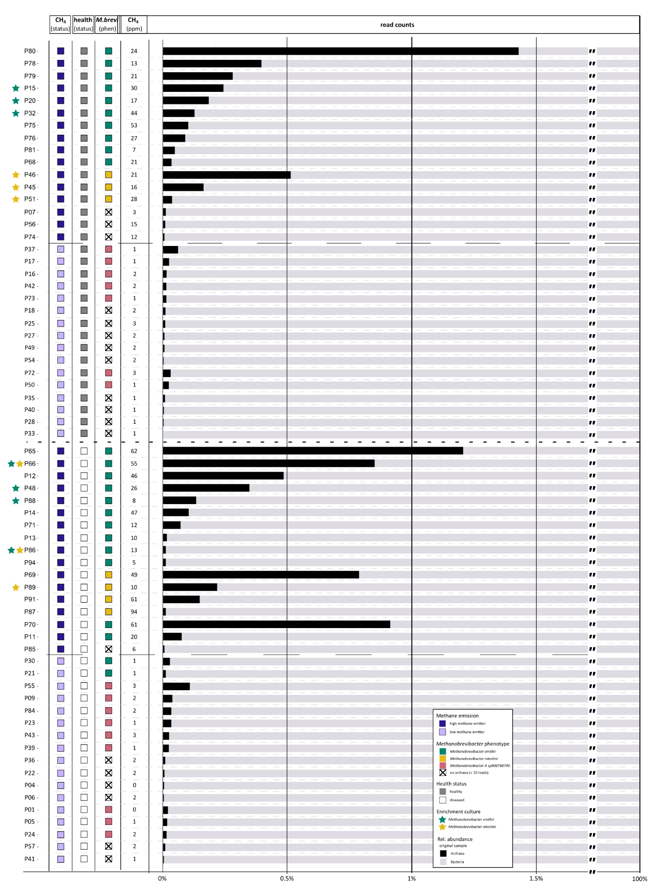Supp. Figure X4. Relative abundance of archaeal taxa in HE and LE. Data was grouped according to methane emission, health status and Methanobrevibacter state. Information was plotted on the left side. Relative abundance of archaeal and bacterial read counts are presented in the right barplot. Stars (✩) indicate samples from which Methanobrevibacter sp. were successfully isolated. The plot is based on non-normalized data.
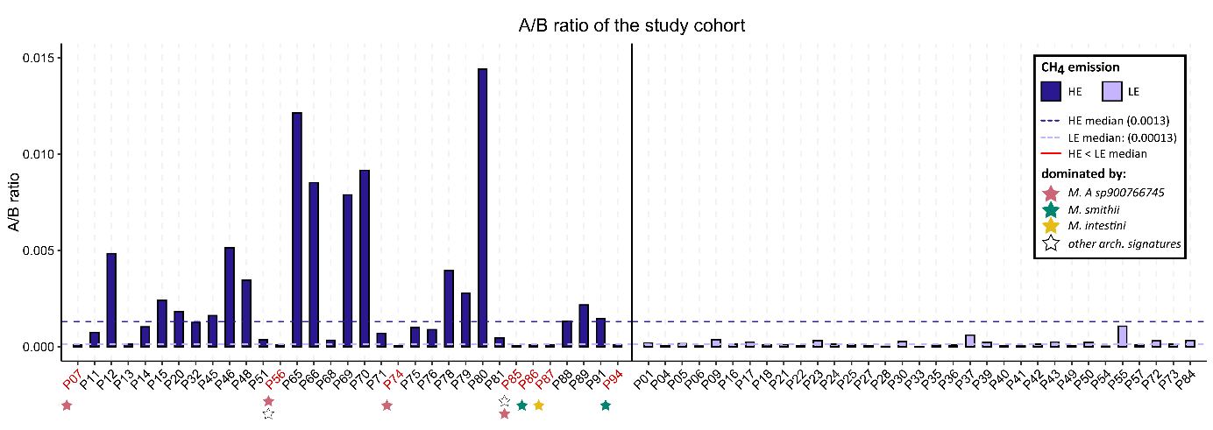
Supp. Fig. X5. Ratio between archaeal and bacterial reads in the samples of our study cohort. In general, HE show a higher A/B ratio compared to LE.

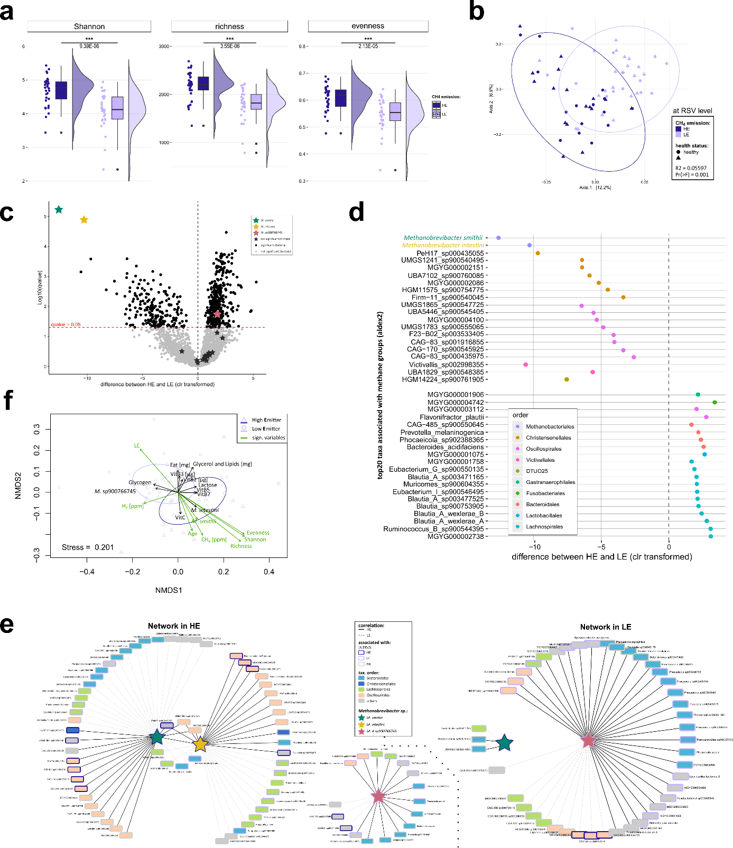

Supp. Fig. X6. Gut microbiome of HE and LE differs in diversity and bacterial partners. a. Alpha diversity of HE samples was significantly higher compared to LE. (Shapiro-Wilk: Shannon = 0.013; Richness = 0.030; Evenness = 0.009; Mann Whitney U q-value: Shannon = 9.39E-06; Richness = 3.55E-06; Evenness = 2.13E-05) b. Microbial communities of the CH₄ emission phenotypes were overlapping but not completely separated (beta diversity; nonSRS data; Permanova - p-value: 0.004) c. Differential abundance analysis shows several microbial taxa that are significantly associated with one or the other CH₄ emission phenotype. (ALDEx2: q-value and diff.btw). d. Differential abundance analysis of the top 20 taxa associated with either HE or LE. M. sp900766745 does not show up in the list of the top 20, however, was still significantly associated with LE. (ALDEx2: q-values; clr-transformed data). e. Microbial networks around the three most discriminative archaeal taxa built on HE and LE data, respectively(shotgun, species level; grey lines: negative correlation; black lines: positive. correlation) f. No dietary variable could explain the differences in the microbial communities between the two CH₄ emission states.

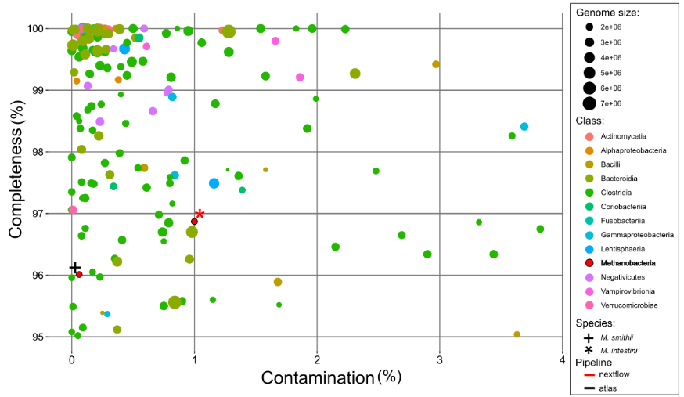
Supp. Fig. X7. Quality of retrieved MAGs of the shotgun data. Two complementary bioinformatic approaches, the metagenome-atlas and nextflow workflows, were used to recover MAGs. However, the Nextflow pipeline was applied only to reads mapped to the M. intestini reference genome. Only MAGs with >95% completeness and <5% contamination are shown.

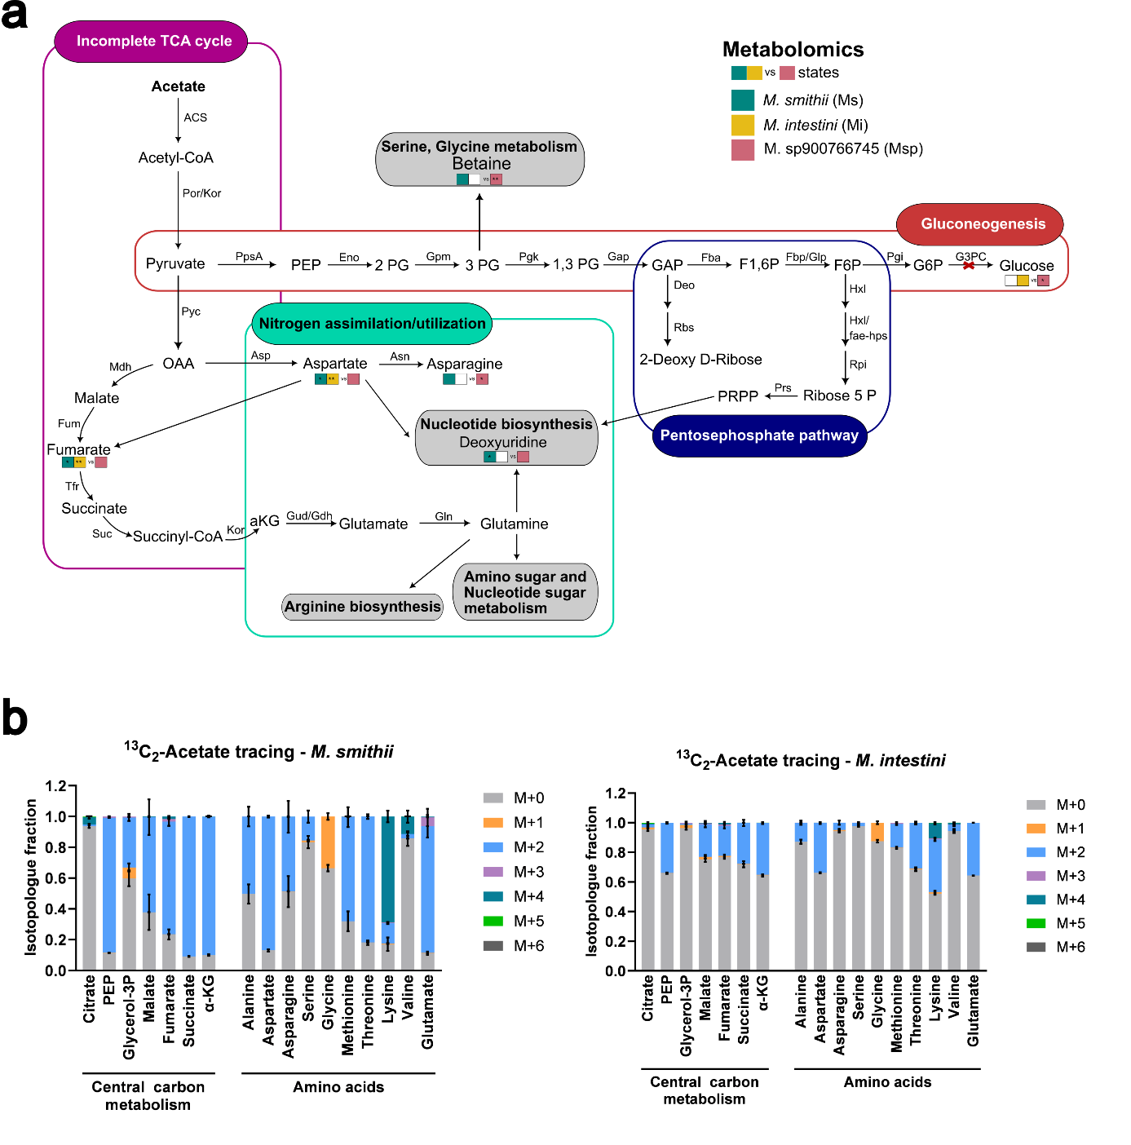
Supp. Fig. X8. Central carbon metabolism was highly conserved among all three lineages. a. Central carbon metabolism highlighting enzymes identified in genomic and metatranscriptomic data. Metabolites that differed significantly between Methanobrevibacter states based on metabolomic analysis are indicated by colored boxes and asterices. * p-value < 0.05, ** p-value < 0.01, *** p-value < 0.001 b. Stable isotope tracing with ¹³C₂-acetate in M. intestini and M. smithii. Isotopologue fractions of metabolites in M. smithii and M. intestini after tracing with 10 mM ¹³C₂-acetate for 26 hours (n = 3). Samples were analyzed by gas chromatography-mass spectrometry. OAA, oxalocetate; PEP, phosphoenolpyruvate; Glycerol-3P, glycerol-3-phopshate; α-KG, α-ketoglutarate; 2 PG, 2-phosphoglycerate; 3 PG, 3-phosphoglycerate; 1,3 PG, 1,3-bisphosphoglycerate; GAP, glyceraldehyde 3-phosphate; F1,6P, fructose 1,6-bisphosphate; F6P, fructose 6-phosphate; G6P, glucose 6-phosphate; PRPP, 5-phosphoribosyl-1-pyrophosphate.

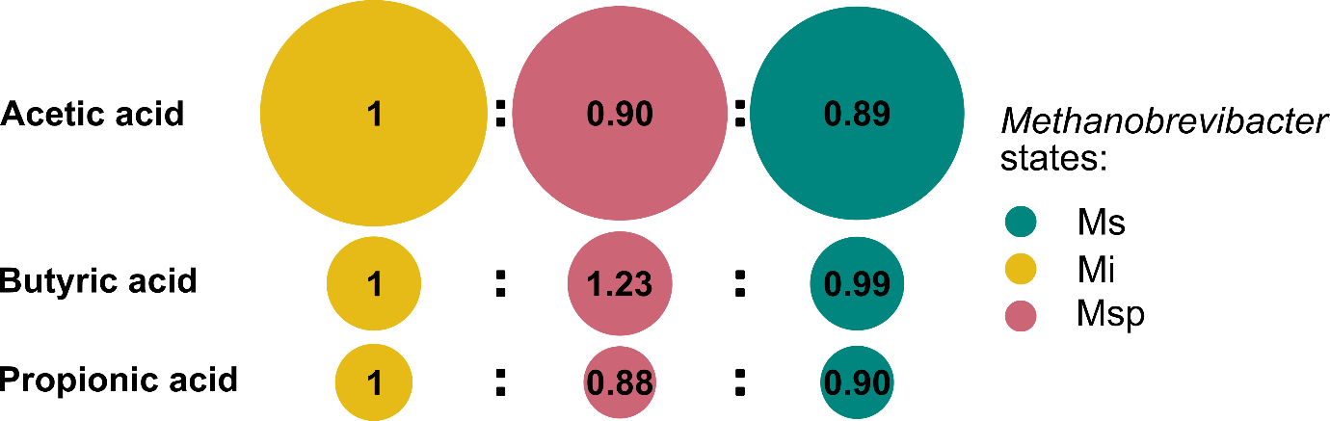
Supp. Figure X9. SCFA ratios between the Methanobrevibacter phenotypes. Ratios of acetic, butyric, and propionic acid concentrations across Methanobrevibacter states calculated from the mean metabolite concentrations for each Methanobrevibacter state.

