Can Low-Cost Sensor Networks Improve Analysis of Extreme Pollution Episodes in Delhi During Stubble Burning?
Prafull P. Yadav^{1,8*}, Rajmal Jat¹, Gaurav Govardhan^{1,2}, Rajesh Kumar³, Prabir K. Patra^{4,5}, Yutaka Matsumi^{6,4}, Tomoki Nakayama^{7,4}, Sachiko Hayashida⁴, Aditi Rathore^{1,8}, Vikram Kadam¹, Chinmay Jena⁹, Sachin D. Ghude¹*
¹Indian Institute of Tropical Meteorology, Ministry of Earth Sciences, Pune, India
²National Center for Medium Range Weather Forecasting, Ministry of Earth Sciences, Noida, UP, India
³National Science Foundation National Center for Atmospheric Research, Boulder, Colorado, USA
⁴Research Institute for Humanity and Nature (RIHN), Kyoto, Japan
⁵Research Institute for Global Change, JAMSTEC, Yokohama, Japan.
⁶Nagoya University, Nagoya, Japan
⁷Nagasaki university, Nagasaki, Japan
⁸Dept. of Atmospheric and Space Sciences, Savitribai Phule Pune University, Pune, India
⁹India Meteorological Department, Ministry of Earth Science, New Delhi 110003, India
*Corresponding Authors: Sachin D. Ghude, Prafull P. Yadav
E-mail address: sachinghude@tropmet.res.in, prafull.yadav@tropmet.res.in

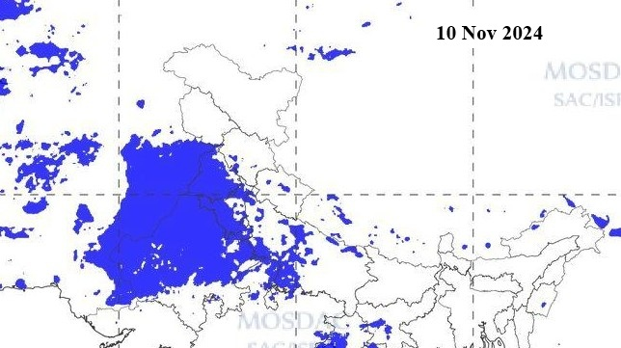
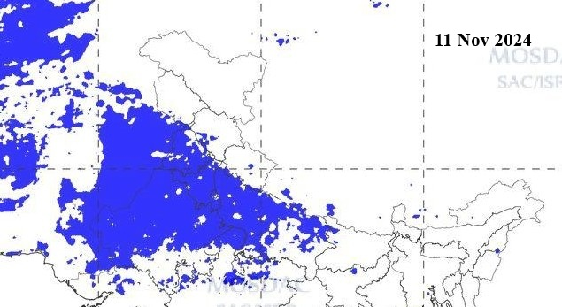
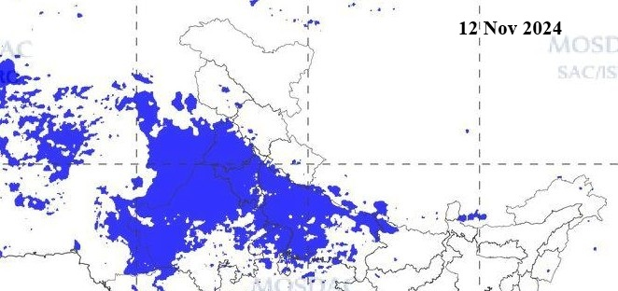
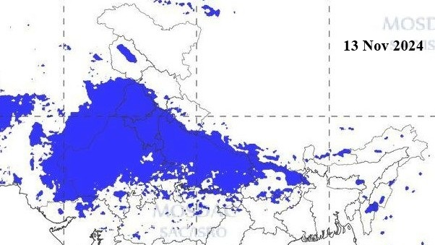
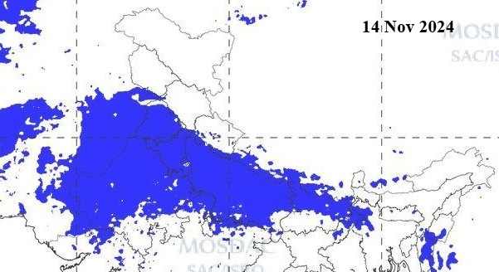
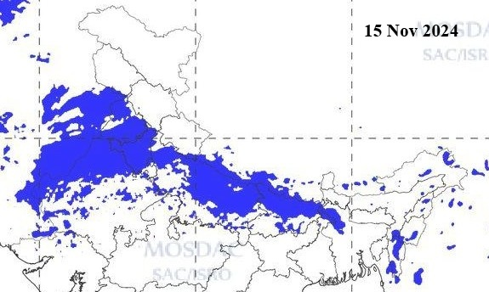
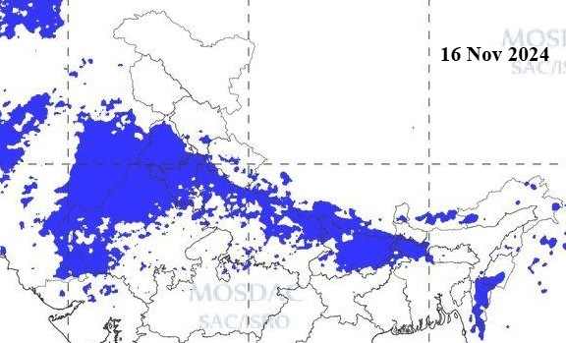
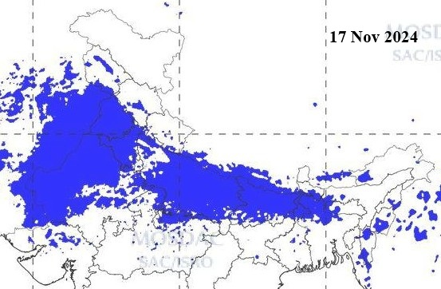
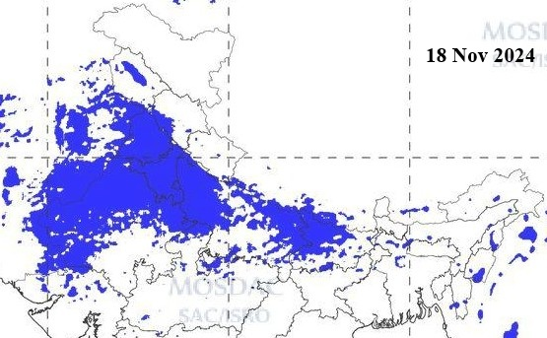
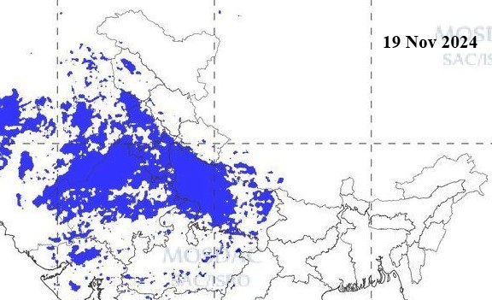
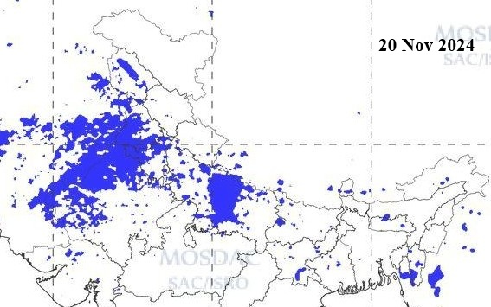
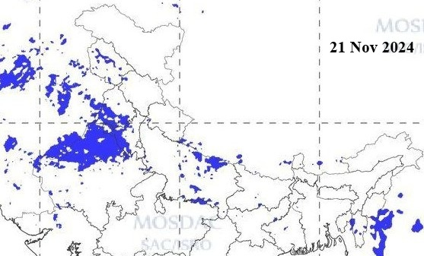
Figure S1. INSAT-3DR satellite-derived fog/low-cloud distribution over northern India from 10 to 21 November 2024. Dates are indicated in each panel.

Formulae for calculation of statistics
- Mean Fractional Bias (MFB)
$$MFB=\frac{2​}{N}∑\frac{P_{i}+O_{i}​​​}{P_{i}-O_{i}}$$
Pi are modelled and Oi are observed concentrations
Mean Fractional Bias (MFB) is a measure of the systematic bias in predictions. Negative values indicate underestimation, while positive values indicate overestimation.
- Normalized Mean Bias (NMB):

$$NMB=\frac{​∑(P_{i}-O_{i})​}{∑O_{i}}$$

Normalized Mean Bias (NMB) represents the average relative bias between the predicted and observed values. NMB close to 0% indicates minimal bias. Positive NMB shows overprediction, and negative NMB shows underprediction.

- Root Mean Square Error (RMSE)
$RMSE=\frac{1}{N}​\sqrt{{∑(P_{i}-O_{i})}^{2}​}$
Root Mean Square Error (RMSE) measures the standard deviation of prediction errors. Lower RMSE values indicate higher accuracy.

- Index of Agreement

$IOA=1- \frac{{∑(P_{i}-O_{i})}^{2}}{∑{(∣P​_{i}-\overline{O}∣+∣O​_{i}-\overline{O}∣)}^{2}}​$
Index of Agreement (IOA) measures how well values match observed values predicted. It ranges from 0 (poor agreement) to 1 (perfect agreement). Higher IOA values indicate better model performance.

