Supplementary Information – Process-level uncertainties challenge system-level direct air capture assessments
Henrik Wenzel^{1,2,3,*}, Malte Glaser³, Mattia Galanti⁴, Tom Terlouw^{5,6}, Daniel Rezo⁷, Vittoria Bolongaro⁸, Mak Ðukan¹, Aaron S. Jajjawi^{9,10}, Jochen Linßen¹, Niall Mac Dowell¹², Sean T. McCoy³, Russell McKenna^{5,6}, Ralf Peters^{9,10,11}, Thomas Schöb¹, Marwan Sendi¹³, Martin van Sint Annaland⁴, Niklas von der Assen⁷, Carsten Wedler⁷, Christoph Winkler¹ and Jann M. Weinand¹
¹ Forschungszentrum Jülich GmbH, Institute of Climate and Energy Systems – Jülich Systems Analysis (ICE-2), 52425 Jülich, Germany
² RWTH Aachen University, Chair for Fuel Cells, Faculty of Mechanical Engineering, 52062
Aachen, Germany
³ Department of Chemical and Petroleum Engineering, University of Calgary, 2500 University Drive NW, Calgary, T2N 1N4, Alberta, Canada
⁴ Department of Chemical Engineering and Chemistry, Eindhoven University of Technology, Eindhoven 5600MB, The Netherlands
⁵ Laboratory for Energy Systems Analysis, PSI Centers for Nuclear Engineering and Sciences and for Energy and Environmental Sciences, Paul Scherrer Institute, 5232 Villigen PSI, Switzerland
⁶ Chair of Energy Systems Analysis, Institute of Energy and Process Engineering, ETH Zurich, Zurich 8092, Switzerland
⁷ Institute of Technical Thermodynamics, RWTH Aachen University, 52062 Aachen, Germany
⁸ Energy and Process Systems Engineering, Institute of Energy and Process Engineering, ETH Zurich, 8092 Zurich, Switzerland
⁹ Forschungszentrum Jülich GmbH, Institute of Energy Technologies – Electrochemical Process Engineering (IET-4), 52425 Jülich, Germany
¹⁰ Ruhr-Universität Bochum, Chair for Synthetic Fuels, Faculty of Mechanical Engineering, Universitätsstraße 150, 44801 Bochum, Germany
¹¹ Jülich-Aachen-Research-Alliance, Wilhelm-Johnen-Straße, 52425 Jülich, Germany
¹² Centre for Environmental Policy, Imperial College London, London, UK
¹³ Life Cycle Assessment Group, Technology Strategy & Planning Department, Saudi Aramco, Dhahran, 31311, Saudi Arabia
* corresponding author: h.wenzel@fz-juelich.de

Supplementary Methods

Performance maps
Besides the four already published performance maps from Cai¹, Jajjawi², Sendi³ and Wiegner⁴, we created additional performance maps using three additional models to cover a wide range of plausible DAC representations. The models are described in previous publications^{5–8}. In the following we briefly describe the process of creating performance maps from those models.
The dynamic DAC process models for APDES-NFC and Lewatit by Rezo et al. are described in previous studies^{5,6}. The models represent cylindrical packed-bed contactors with radial heating jackets and one dimensional axial discretization. The DAC process is modelled as a temperature-vacuum swing adsorption cycle. Performance maps are generated by optimizing the process for discrete combinations of ambient temperature and relative humidity using the Python-based optimization framework pymoo. A grid of 7 temperature (-10 to 50 °C) and 9 relative humidity (10 to 90%) combinations were used. For the case of APDES a constant mass transfer coefficient is used while in the Lewatit case a temperature-dependent linear driving force model is utilized. A detailed description of the model can be found in a previous study⁶.
Performance maps for the Galanti model were generated on a 9x7 grid of relative humidity (10-90%) and feed temperature (263.15-323.15K), with an adsorber aspect ratio of 0.5. At each climate condition, NSGA-II generated a local Pareto front from the six operating variables (adsorption time, heating time, desorption time, vacuum pressure, volumetric inlet flowrate, mass flowrate of desorption steam). The optimization procedure therefore produced a Pareto envelope across the humidity-temperature domain. Since each climate condition has its own Pareto front, a common reference was required to ensure a consistent comparison across the map. The p50 point, corresponding to the midpoint of this common range, was selected as a representative balance between energy demand and productivity. For each climate condition, the actual Pareto solution closest to this p50 direction was then selected, avoiding comparisons between solutions representing different trade-offs. The resulting 63 operating points were subsequently reevaluated using the full cyclic-steady-state TVSA model, and the corresponding heat demand, electrical demand, and productivity were mapped over the humidity-temperature grid using contour lines. The simulations used humid-air feed at the prescribed relative humidity and temperature, with atmospheric pressure during adsorption. During blowdown and pre-heating, the inlet was closed and the outlet pressure was set to the vacuum pressure; during steam-assisted desorption, steam entered at the prescribed flow rate while the outlet remained at vacuum pressure. Cooling was performed with a sealed bed, followed by pressure-driven pressurization toward atmospheric pressure. More information about the implementation, boundary conditions and process configuration can be found in the corresponding publication⁷. The Young performance maps used exactly the same grid, operating points, cycle sequence, and boundary conditions as the p50 pivot maps. Only the CO₂ equilibrium model was changed to the Young et al.⁹ WADST parameterization, while the H₂O GAB model, transport correlations, and kinetic model were unchanged. For the geometry change to an aspect ratio of 2, the same procedure applies.
Performance maps labeled Glaser were obtained by taking the model first published in Glaser et al.⁸ and optimizing for Carbon Removal Rate (CRR), productivity (RR) or specific energy demand (SED). In alignment with Glaser et al.¹⁰ decision variables were restricted to the duration of the adsorption and desorption steps, as well as the potential use of steam and its inlet velocity. The model was then run for different combinations of constant relative humidity (10 to 90%) and temperature (-10 to 50 °C), with the upstream emission factor of electricity held constant at 184 g/kWh. Reported KPIs include productivity and specific energy demand, the latter subdivided into thermal and electrical components, for each cycle and each temperature–humidity combination. To account for total electricity demand while optimizing CRR, a heat pump is assumed to convert thermal energy demand into an equivalent electrical demand. For simplicity and comparability with other studies, APDES-NFC¹⁰ is used as the sole sorbent, with isotherm data adopted from Balasubramaniam et al.¹¹. Performance is reported only after cyclic steady state is reached, so that startup and heating transients are excluded from the results.

Supplementary Note 1
Differences between the performance maps arise from a combination of process characteristics, model formulations, parameter choices and operating assumptions. Because these aspects generally vary simultaneously across the models, the comparison does not allow individual differences in performance to be attributed unambiguously to specific assumptions. Nevertheless, inspection of the underlying model formulations provides plausible explanations for several of the observed trends, which we discuss here to improve understanding of the performance maps.
Among the published performance maps, the Cai et al.¹ model exhibits a particularly strong increase in heat demand under humid conditions. The model uses experimental data for a proprietary amine-functionalized sorbent characterized by Elfving et al.¹² and predicts a substantially larger water uptake under humid conditions than the models by Jajjawi et al.² or Sendi et al.³ for Lewatit. Greater water co-adsorption increases the amount of water that must be desorbed during regeneration and thereby contributes to the high specific heat demand predicted under humid conditions. Differences in operating strategy may further amplify this behavior. Cai et al.¹ apply fixed cycle durations across ambient conditions and report that this can result in incomplete desorption, reducing CO₂ productivity while increasing the H₂O-to-CO₂ ratio and specific heat demand. Jajjawi et al.², by contrast, optimize adsorption and desorption durations to minimize specific energy demand. Under humid conditions, this results in longer desorption periods and lower H₂O-to-CO₂ ratios, contributing to lower specific heat demand.
The Sendi³ and Jajjawi² models produce comparatively similar energy-demand maps but differ more strongly in productivity. One potential contributor is the substantially lower inlet-flow velocity used by Sendi et al., which is associated with longer cycle durations and lower productivity. Differences in contactor configuration and heat- and mass-transfer characteristics may additionally contribute. Because these characteristics differ simultaneously between the models, however, their individual contributions cannot be isolated from the present comparison.
The Wiegner et al.⁴ model differs more fundamentally from the other published performance maps. Both energy demand and productivity are predominantly sensitive to temperature, with a comparatively weak dependence on relative humidity. One potential explanation is the use of an exemplary sorbent representation constructed from properties reported for multiple sorbents, resulting in a distinct combination of thermodynamic parameters. The model also predicts absolute productivities approximately two orders of magnitude higher than several of the other models. This difference coincides with a substantially higher assumed CO₂ mass-transfer coefficient of 0.1 s⁻¹, compared with 0.003 s⁻¹ in the Jajjawi² and Sendi³ models. The higher mass-transfer coefficient provides a plausible explanation for at least part of the elevated productivity, although differences in the remaining process and model assumptions prevent direct attribution to this parameter alone.
Substantial differences are also apparent among the performance maps generated in this study. A particularly notable comparison is between the Glaser⁸ and Rezo⁵ models, which represent the same sorbent but predict qualitatively different responses to ambient conditions (see Figure 6). The models differ in several respects, including their dimensionality, contactor geometry and process formulation. In addition, they use different isotherm parameterizations derived from the same underlying experimental dataset of Gebald et al.¹³: Rezo uses the parameterization reported by Stampi-Bombelli et al.¹⁴, whereas Glaser uses that of Balasubramaniam et al.¹¹. The resulting isotherm parameters differ substantially and may contribute to the contrasting performance maps. The importance of isotherm parameterization is supported by the controlled comparison described below, although its contribution to the differences between Glaser and Rezo cannot be isolated independently of the other model differences. Differences in sorbent-to-contactor mass ratio and the resulting heat-transfer characteristics may further affect cycle duration and productivity, particularly at elevated temperatures.
The comparatively high electricity demand predicted by the Galanti⁷ model is consistent with differences in contactor geometry. Its adsorbent bed is taller than those represented, for example, by Jajjawi² and Sendi³, resulting in a greater pressure drop and consequently higher fan electricity demand. Because other process characteristics also differ between these models, this comparison alone does not establish bed geometry as the sole cause. However, the controlled bed-geometry comparison within the Galanti model supports the importance of this mechanism.
Controlled comparisons within individual model formulations provide a clearer means of isolating selected process-level influences. Within the Glaser⁸ model, the configurations shown in Supplementary Figure 2 differ in operating parameters, including cycle durations and steam use. Optimization for maximum productivity favors greater steam use and consequently higher energy demand, whereas minimizing energy demand generally reduces steam use and extends cycle durations at the expense of productivity. The intermediate strategy based on the net carbon removal rate (CRR) balances these effects, retaining comparatively high productivity while substantially reducing energy demand. A varied operational strategy can additionally shift the weather-response from being primarily temperature-driven to being mainly relative humidity dependent, or vice versa. This, in turn, affects temporal characteristics, such as diurnal cycles (see Supplementary Figure 9e).
For the Galanti⁷ model, the configurations in Supplementary Figure 3 differ only in their isotherm parameterization, while the remaining model formulation and operating conditions are held constant. The resulting differences therefore directly illustrate the sensitivity of predicted performance to alternative representations of adsorption equilibrium. We additionally use the Galanti model to isolate the influence of contactor geometry by increasing the bed aspect ratio from 0.5 in the base configuration to 2 in the LongBed configuration (Supplementary Figure 4). This produces a taller and narrower bed. The greater bed height increases pressure drop and therefore fan electricity demand, whereas the smaller radius improves radial heat transfer and reduces heat demand. Finally, the influence of sorbent choice is evaluated within the Rezo model by replacing the base sorbent while retaining the remaining model formulation (Supplementary Figure 5).

Supplementary Table 1: Literature review on existing DAC techno-economic or system-level assessments.
Reference | Scope & scale | System boundary | TEA approach | Energy-system model | Temporal & spatial | Sorbent/solvent technology | DAC model used | Climate conditions identified as favourable | Weather considerations | Weather input method | Optimization | Key assumptions | Main findings | Costs
Fasihi et al. (2019); DOI: 10.1016/j.jclepro.2019.03.086¹⁵ | Plant-level TEA with case study. | Capture and CO₂ compression, transport, and storage. | Bottom-up engineering TEA with learning and scale-up scenarios | None; predefined energy-supply cases | Static annual assessment; selected locations | High-temperature KOH and low-temperature solid-sorbent DAC | No climate-responsive DAC process model. | None. | No | Fixed specific energy requirements; climate does not change process performance | None | Future CAPEX learning, mass production, low-cost electricity and optional waste heat | Low-temperature DAC is favoured because of its lower regeneration temperature and access to low-cost heat; capture costs below €50/tCO₂ were projected under favourable long-term assumptions. | Approximately €133–222 per tCO₂ in 2020, falling to around €32–54 per tCO₂ in 2050 in various energy supply scenarios.
Sendi et al. (2022); DOI: 10.1016/j.oneear.2022.09.003³ | Global geospatial assessment | DAC capture and compression to 150 bar. | Dynamic process model coupled to geospatial TEA | None; electricity price is exogenous | Hourly weather for 2016–2020; global geospatial mapping | Amine-functionalized solid sorbent; steam-assisted vacuum-pressure temperature-swing adsorption | Own detailed adsorption model: 1D/2D adsorption-modelling of steam-assisted VTSA for an amine-functionalized sorbent. | Relatively cold and dry climates are reported as favourable for DAC performance. | Yes | Detailed adsorption simulations at combinations of temperature and relative humidity are converted into performance relationships and applied to hourly weather data | None; geospatial cost mapping | Electricity supplied at prescribed prices; regional WACC; heat and steam electrified through heat pumps | Relatively cold and dry regions generally perform best, although regions frequently below about -15◦C are unsuitable. Relative humidity particularly affects regeneration energy because of co-adsorbed water. | US$320–540 per tCO₂ at US$50/MWh electricity cost.
Prats-Salvado et al. (2024); DOI: 10.1021/acs.est.3c08269¹⁶ | Solar-resource screening with solar-based cases in Chile and Portugal, conventional cases in North-America and Europe. | Liquid-solvent DAC integrated with various system configurations considering conventional (natural gas for high temperate heat) and solar-thermal based heat. | Aspen-based process TEA and environmental life cycle assessment | Off-grid solar PV-battery sizing model for the solar-based case. | Hourly solar-resource profiles; location screening plus detailed sites | High-temperature liquid-solvent DAC | Aspen Plus process model of the liquid-solvent DAC system, based on the Carbon Engineering-DAC process. For weather-sensitive air-contactor performance, the study uses fitted relationships from prior climate-dependent liquid-DAC modeling from Ref. ¹⁹ | Higher humidity generally favours L-DAC performance, with warm and humid conditions enabling high CO₂ capture rates. | Energy supply only | Carbon removal efficiency and water losses obtained as functions of temperature and relative humidity | Solar PV and battery system sizing | Country-specific WACC, plant capacity around 0.1 MtCO₂/yr. | Solar-powered liquid-solvent DAC may become competitive in high-irradiance regions. | Broadly several hundred US$ per tCO₂, depending on geographical location and financing conditions.
Terlouw et al. (2024); DOI: 10.1021/acs.est.3c10041¹⁷ | Europe; 0.25◦ x 0.25◦ geospatial assessment of solid sorbent DACCS. | Full DACCS chain: capture, energy, CO₂ transport and geological storage. | Spatial bottom-up cost and CDR potential model | No endogenous energy-system optimization | Monthly climate averages; European grid cells | Low-temperature solid-sorbent DAC; performance correlations from Wiegner et al.⁹ | Wiegner et al. (2022)⁹ solid-sorbent DAC performance model. | Cold and humid conditions are favourable. | Yes | Monthly temperature and relative humidity are mapped to climate-dependent heat and electricity requirements using Wiegner’s process-performance model | None. | Grid electricity plus heat pump, power grid plus waste heat, or curtailed electricity plus heat pump; 8,000 full-load hours in the central case | Climate, electricity price and GHG intensity, waste-heat availability, and transport distance jointly determine DACCS costs and potential. The use of monthly averages excludes short-term and interannual weather variability. | Location- and configuration-dependent CDR cost, including transport and storage
Kirppu et al. (2025); DOI: 10.1016/j.ccst.2025.100533¹⁸ | Finnish case study with various low-carbon heat sources considered (small modular reactors, heat pumps, electric boilers) | Integrated district heat, small modular reactor and DACCS system. | Techno-economic energy-system assessment using the Backbone energy system modelling framework. | Backbone capacity and operational optimization | Hourly annual energy-system profiles; one regional heating system | Low-temperature solid-sorbent DAC | DAC energy demand is informed by Wiegner et al. (2022)⁹ climate-performance results. | Cold conditions are treated as favorable for solid-sorbent DAC. | Yes, based on the temperature considered using correlations from Wiegner et al.⁹ | Ambient conditions enter the annual energy-system and heating-demand profiles. | Co-optimization of heat production, storage, SMR and DAC operation | Nuclear heat and electricity, district-heating integration and heat storage | Economic performance depends strongly on plant utilization and the value of supplied heat. | Reported DAC-related capture costs are approximately €115–163 per tCO₂, depending on system assumptions
Wenzel et al. (2025); DOI: 10.1016/j.adapen.2025.100229¹⁹ | High-resolution geospatial siting assessment, demonstrated throughout Germany | DAC plant plus site-specific PV, wind and supporting energy technologies. | Location-specific cost minimization | DAC system optimization | Hourly weather for one meteorological year; regional German grid cells/sites | Solid-sorbent steam assisted-temperature swing adsorption technology and liquid-solvent DAC | LT-DAC: Sendi et al. (2022)⁸.  HT-DAC: electrified liquid-solvent model based on An et al. (2022)¹⁹, adapted to an electrified configuration. | LT-DAC generally benefits from lower relative humidity. HT-DAC is generally favoured by hot and humid conditions. | Yes | Sendi’s solid-sorbent process results are converted into hourly energy-demand and productivity time series; liquid-DAC performance is also weather dependent on a fully electrified system. | Cost optimization considering renewable power supply, storage and DAC configuration/operation | Site-specific PV and wind resources; weather-responsive DAC productivity and demand | Accounting for weather changes optimal technology choice and produces large cost differences even between neighbouring locations; hybrid solar PV and wind supply generally performs well. | Approximately €197–1,035 per tCO2, depending on geographic location and system configuration
Jajjawi et al. (2026); DOI: 10.1016/j.enconman.2025.121003² | Process-level assessment at four representative locations | Solid-sorbent DAC process and plant TEA | Dynamic process optimization coupled to TEA | None; process-centric optimizationmodel | Hourly weather for four locations over one year | Amine-based temperature-vacuum-swing adsorption with CO₂/H₂O co-adsorption | New Aspen TVSA process model using Lewatit® VP OC 1065. | Moderate temperature and relative humidity provide the most favourable overall performance. | Yes | A detailed co-adsorption process model is optimized; hourly, day–night and seasonal control strategies are compared | Process-cycle optimization | Adjustable adsorption/desorption durations and location-specific weather; externally prescribed energy costs | Weather-informed operation reduces electricity demand by up to 8.8% and heat demand by up to 0.9%. Weather produces cost differences of up to €72/tCO₂ | Absolute costs depend on the scenario; weather-driven cost variations of up to €72/tCO₂. Strong sensitivity to intermittent renewable energy
Okosun et al. (2026, preprint); DOI: 10.1016/j.ijggc.2026.104743²⁰ | Global technology and site optimization | DAC plus renewable electricity and heat supply; regional deployment screening | Hourly levelized-cost optimization | Site-specific renewable-energy configuration model | Hourly global resource and climate data | Solid-sorbent and liquid-solvent DAC | S-DAC: Sendi et al. (2022)⁸.  L-DAC: based on the An et al.¹⁹ process model. | Solid sorbent DAC (S-DAC) benefits from cold and moderate relative humidity conditions.  Liquid solvent DAC (L-DAC) is generally favoured by hot and humid conditions. | Yes | Weather-dependent DAC performance is combined with location-specific solar, wind and geothermal resource profiles | Optimization of fully electric and hybrid energy configurations | 2050 technology costs, learning assumptions and regional renewable resources | Identifies optimal cost regions for solid- and liquid-solvent based DAC and shows that both climate-dependent process performance and renewable-resource quality influence optimal siting. | Reported range approximately €165–1,720/tCO₂ for hybrid configurations.

Supplementary Table 2: Selected locations and their average climate conditions as well as the reached full load hours of open-field PV and onshore wind plants for the year 2018. Based on ERA5 weather data²¹. Dashes do not mean that no wind or PV potential is available in these regions, but that this is not modeled in the assessment to quantify the influence of various energy supply options.
longitude | latitude | Country | Wind FLH [h/a] |  | PV FLH [h/a] | RH [%] | T [°C] | Archetypes
-72,25 | -44,75 | CHL | 1407 | 1512 |  | 85 | 4 | Cold-humid, hybrid moderate
-73 | -37,75 | CHL | 2956 | 2083 |  | 80 | 10 | Cold-humid, hybrid good
-61,5 | -36,75 | ARG | 2980 | 2043 |  | 69 | 15 | Moderate, hybrid good
-66,75 | -25,25 | ARG | - | 3271 |  | 32 | 3 | Cold dry, Only PV
123,25 | -22,5 | AUS | 2995 | 2517 |  | 32 | 27 | Hot-dry, hybrid good
-77,25 | -10 | PER | - | 2475 |  | 81 | 4 | Cold-humid, Only PV
44,5 | 5 | ETH | 3242 | - |  | 54 | 28 | Hot-dry, Only wind
79,75 | 8,25 | LKA | 3561 | - |  | 82 | 27 | Hot-humid, Only wind
76,5 | 9,5 | IND | 1788 | 1860 |  | 84 | 28 | Hot-humid, hybrid moderate
75,75 | 23,75 | IND | 1884 | 2027 |  | 54 | 26 | Hot-dry, hybrid moderate
108 | 10,75 | VNM | 3315 | 2187 |  | 82 | 27 | Hot-humid, hybrid good
-7,75 | 22,75 | MRT | - | 2696 |  | 25 | 27 | Hot-dry, Only PV
-72,75 | 19,75 | HTI | - | 2366 |  | 82 | 25 | Hot-humid, Only PV
121,75 | 45,25 | CHN | 2795 | 1858 |  | 49 | 7 | Cold dry, hybrid moderate
-101 | 31,75 | USA | 3305 | - |  | 56 | 19 | Moderate, Only wind
-101,25 | 37,75 | USA | - | 2216 |  | 57 | 13 | Moderate, Only PV
6,5 | 49 | FRA | 2110 | 1521 |  | 73 | 12 | Moderate, hybrid moderate
96,75 | 42,75 | MNG | 2933 | 2288 |  | 35 | 7 | Cold dry, hybrid good
106,75 | 42,75 | MNG | 3194 | - |  | 36 | 8 | Cold dry, Only wind
-8,5 | 54,25 | IRL | 3061 | - |  | 83 | 10 | Cold-humid, Only wind
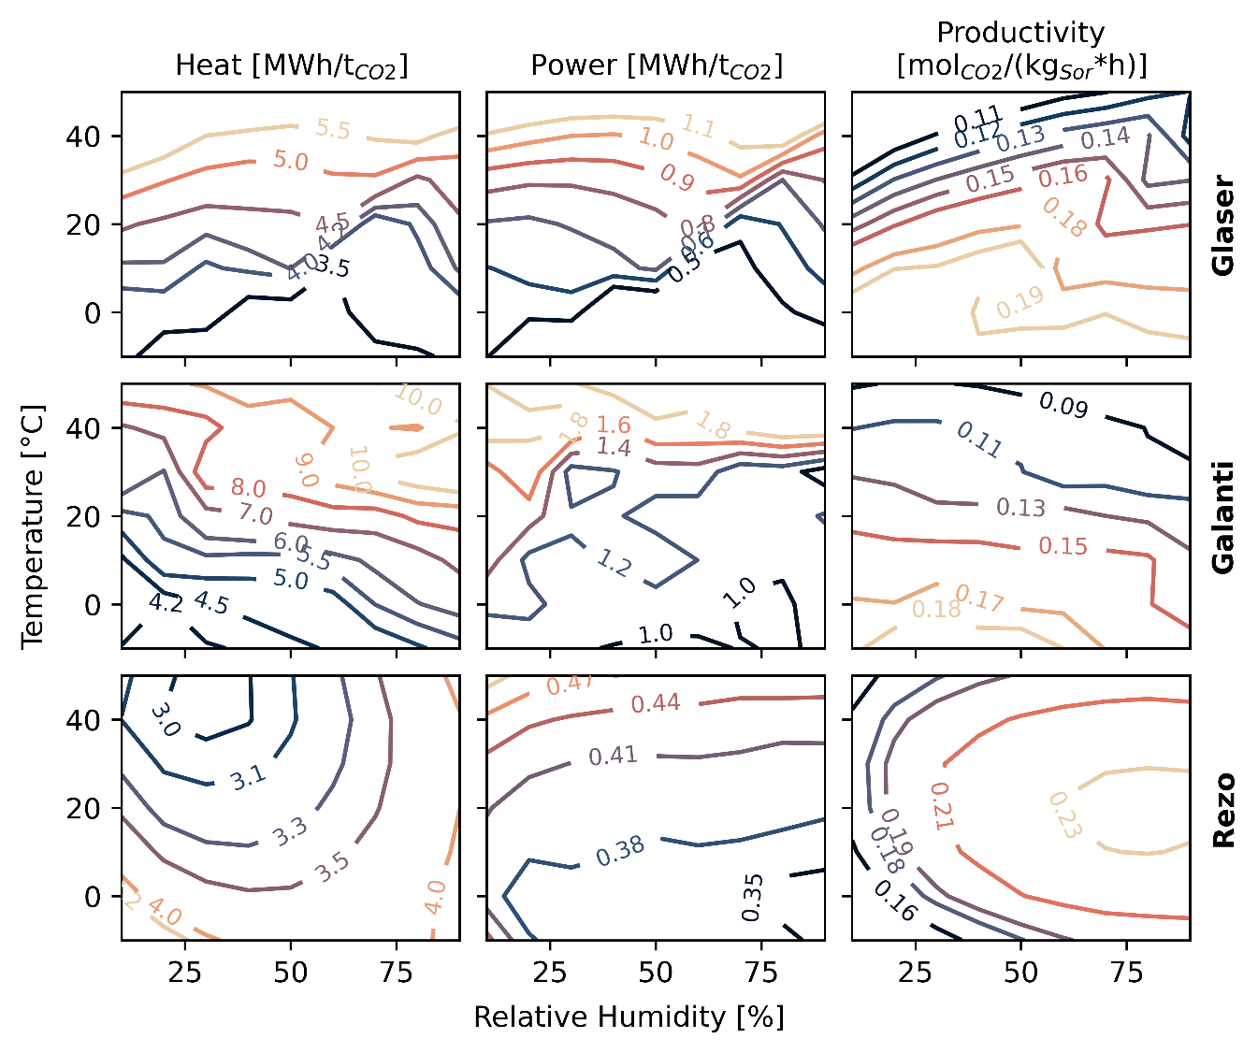
Supplementary Figure 1: Performance of different DAC process models^{5,7,8} under varying ambient conditions. Galanti uses Lewatit while Glaser and Rezo use APDES, albeit with different isotherm parameters. All three optimize for a trade-off between productivity and energy demand. The performance maps have been created within this study and further explanation can be found in the Supplementary Methods.
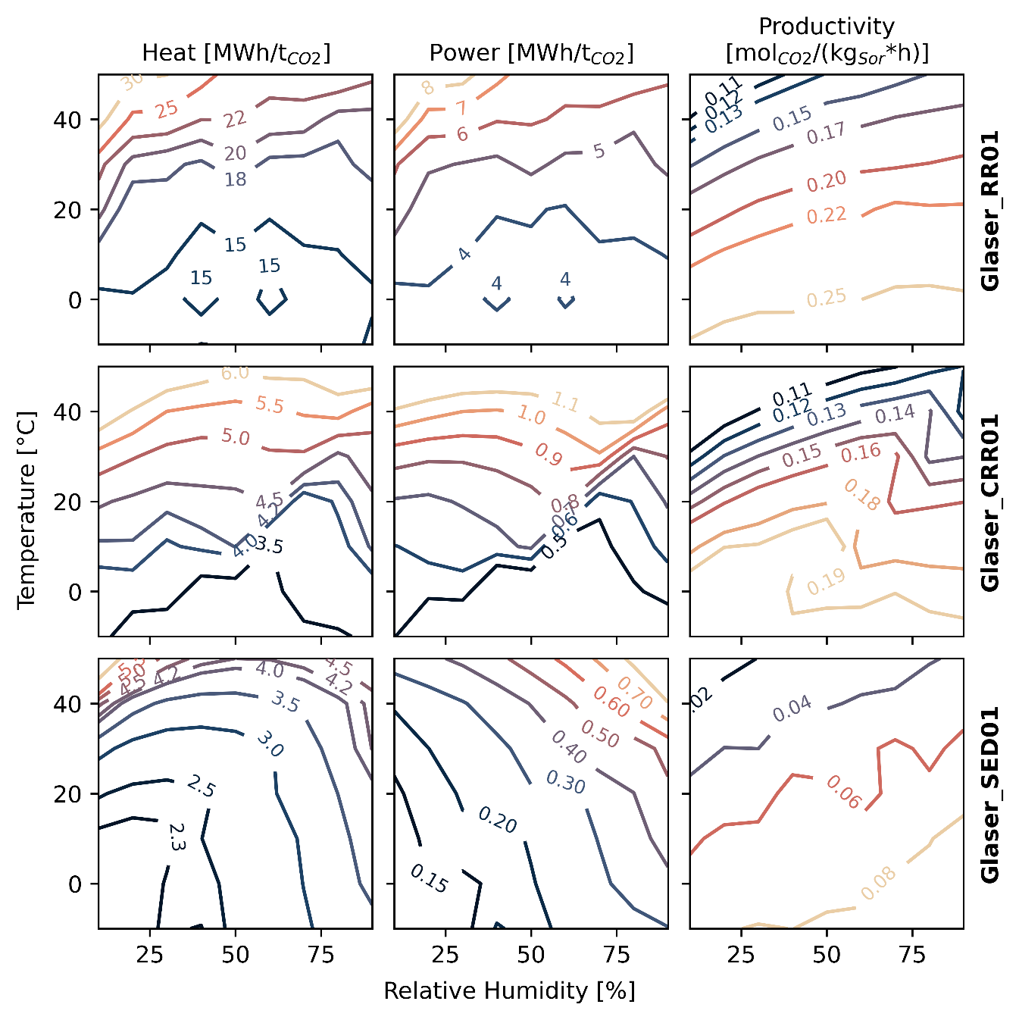
Supplementary Figure 2: Performance maps for three different operation strategies of the Glaser model. RR01: optimized for maximum productivity, CRR01: optimized for net carbon capture rate, a tradeoff between productivity and energy demand, SED01: optimized for minimum specific energy demand. The only changes between the configurations are operational, i.e., adapted cycle times and steam-usage.

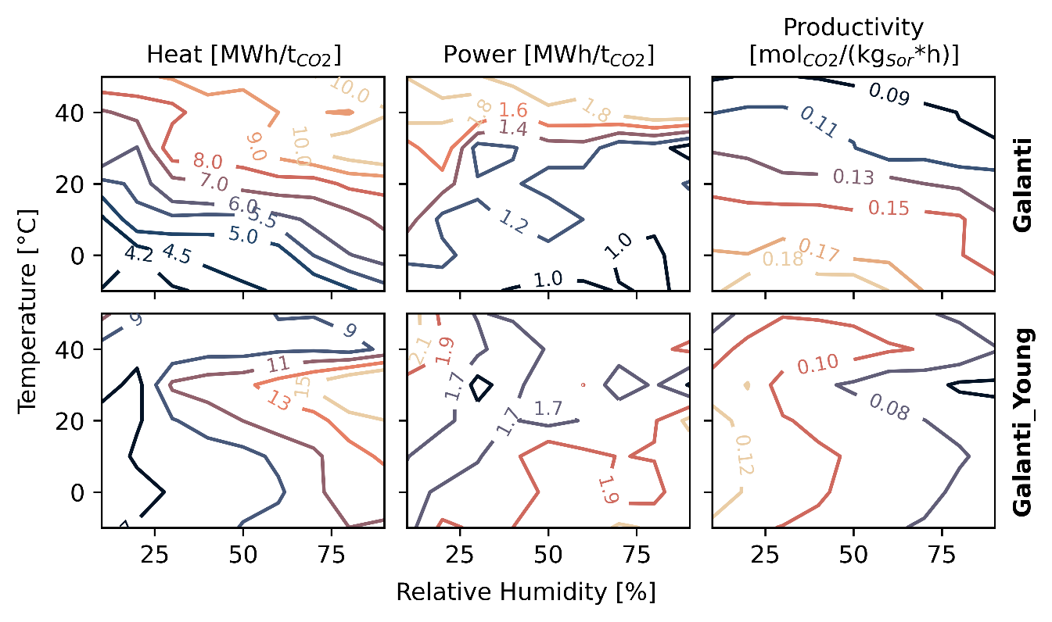
Supplementary Figure 3: Performance maps of the Galanti model using two different isotherm parameterizations. In the base case, the parameters are fitted to multiple different datasets while in the Young case they are only fitted to the measurement data by Young et al.⁹. Both configurations have the exact same operating parameters.
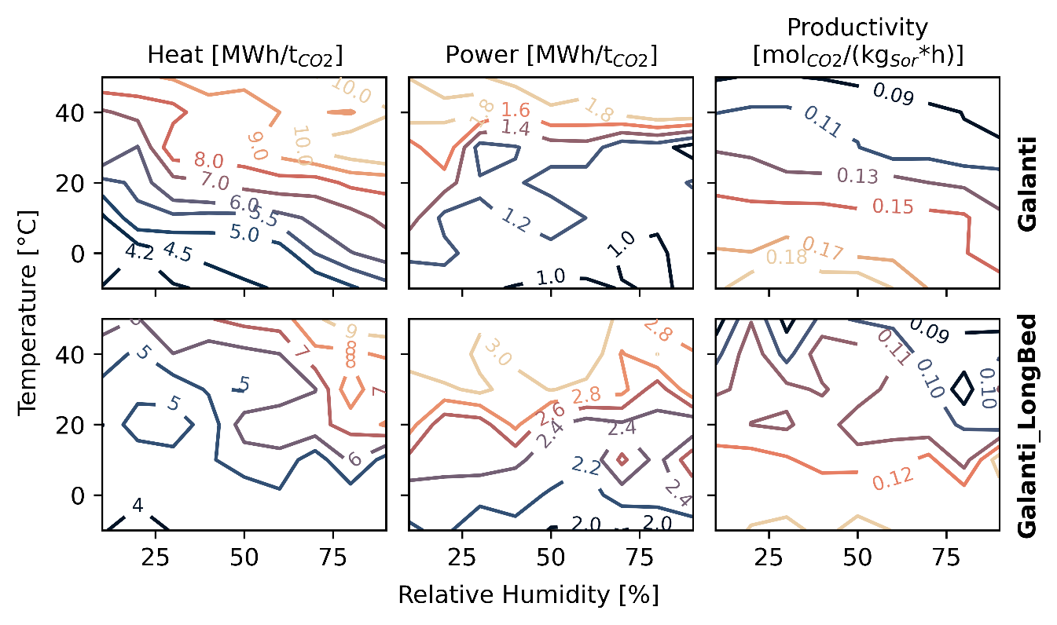
Supplementary Figure 4: Performance maps of the Galanti model using two different aspect ratios, i.e., bed geometries. In the base case, the height-to-diameter-ratio is 0.5 while in the LongBed case it is 2. Both beds have a volume of one liter and both configurations have been optimized for a tradeoff between productivity and energy demand.

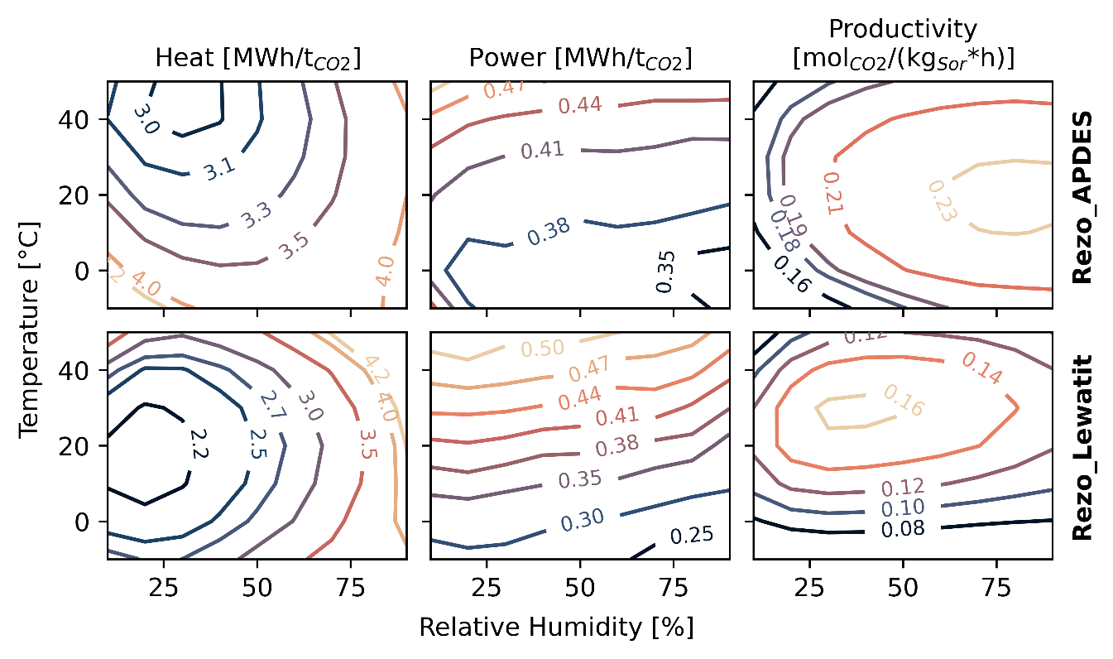
Supplementary Figure 5: Performance maps of the Rezo model using two different materials: APDES (base case) and Lewatit. Both configurations were optimized individually.

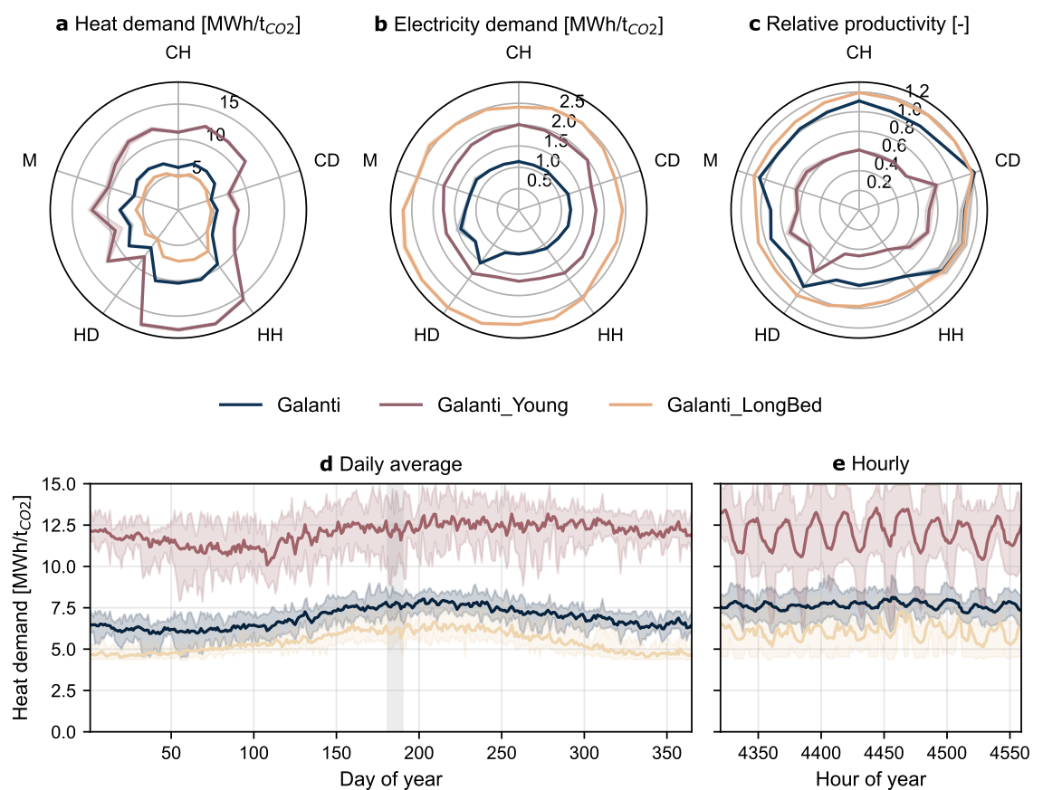
Supplementary Figure 6: Performance of the same DAC model by Galanti et al. with the same operating parameters and the same material but with a different parameterization of the isotherms (Galanti_Young). Same model, but a different bed geometry with an aspect ratio of 2, resulting in a long and small bed (Galanti_LongBed). The line corresponds to the mean of weather years 2010 to 2019 while the shaded area indicates the variability of different weather years. a-c. Yearly average heat demand, electricity demand and relative productivity. For each climate category, 4 different regions are shown clockwise starting from the label. CH: cold-humid, CD: cold-dry, HH: hot-humid, HD: hot-dry, M: moderate. d. Daily average heat demand in a moderate climate in eastern France. e. Hourly heat demand for the days indicated by the grey area in tile D.

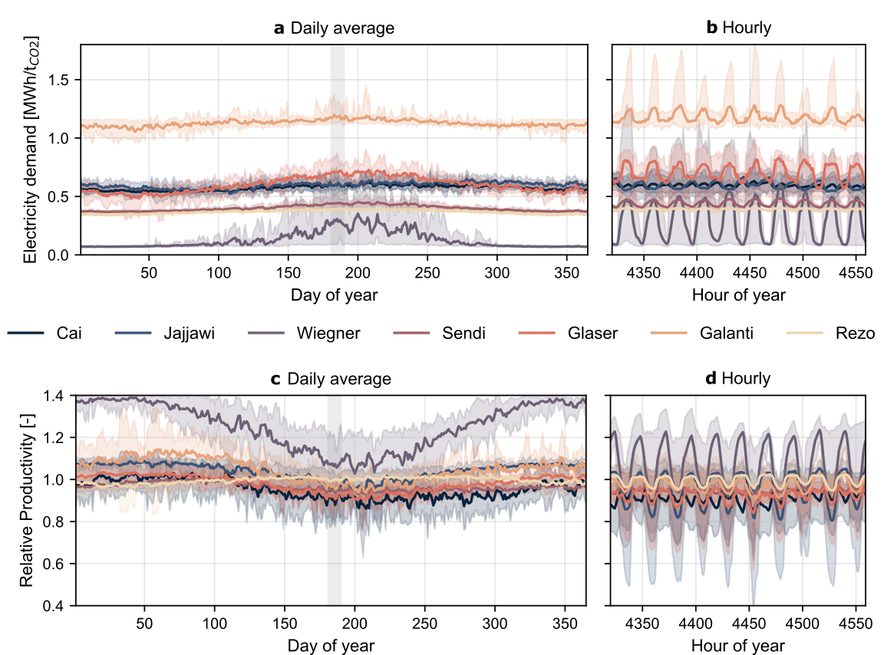
Supplementary Figure 7: Timeseries of electricity demand (a, b) and relative productivity (c, d) at a location with moderate climate conditions in eastern France (M-HM).

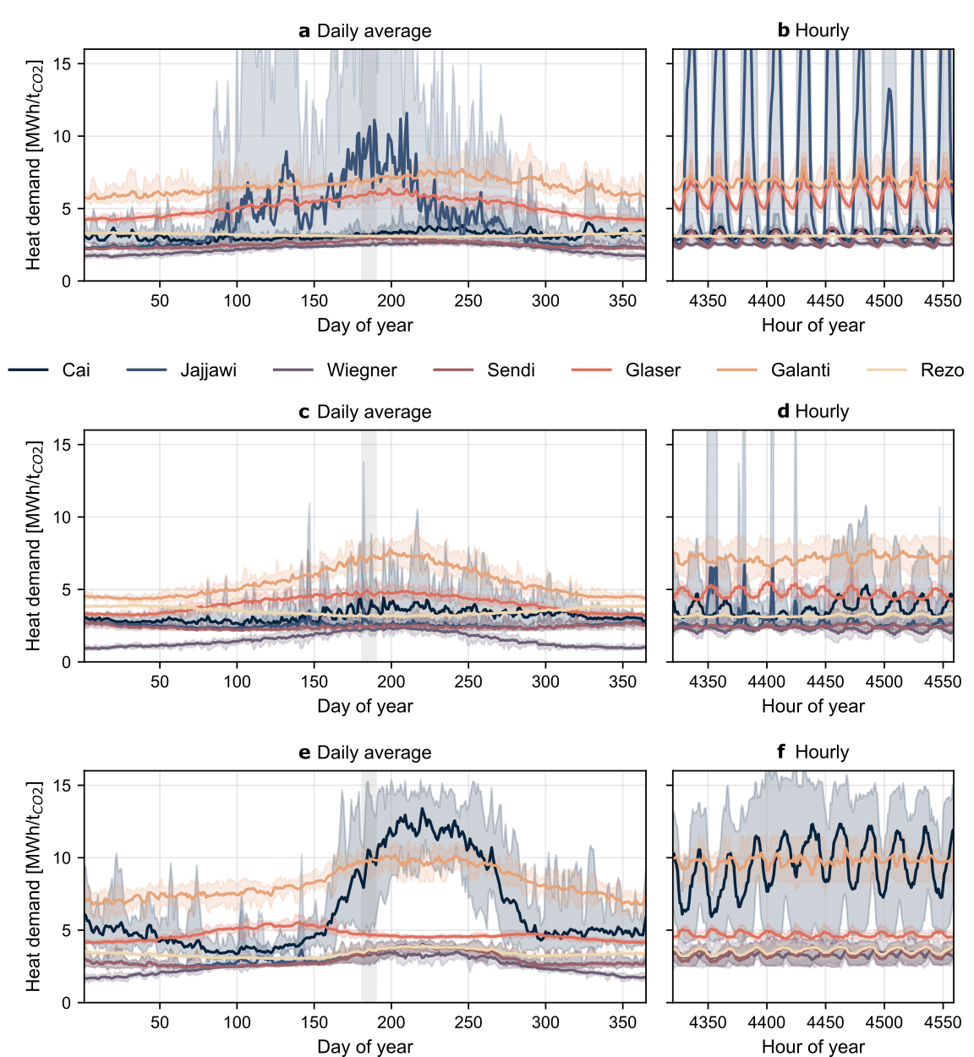
Supplementary Figure 8: Timeseries of heat demand for three different locations: one in a hot-dry climate in eastern Mauretania (a, b), one in a cold-dry climate in southern Mongolia (c, d) and one in a hot-dry climate in northern India (e, f).

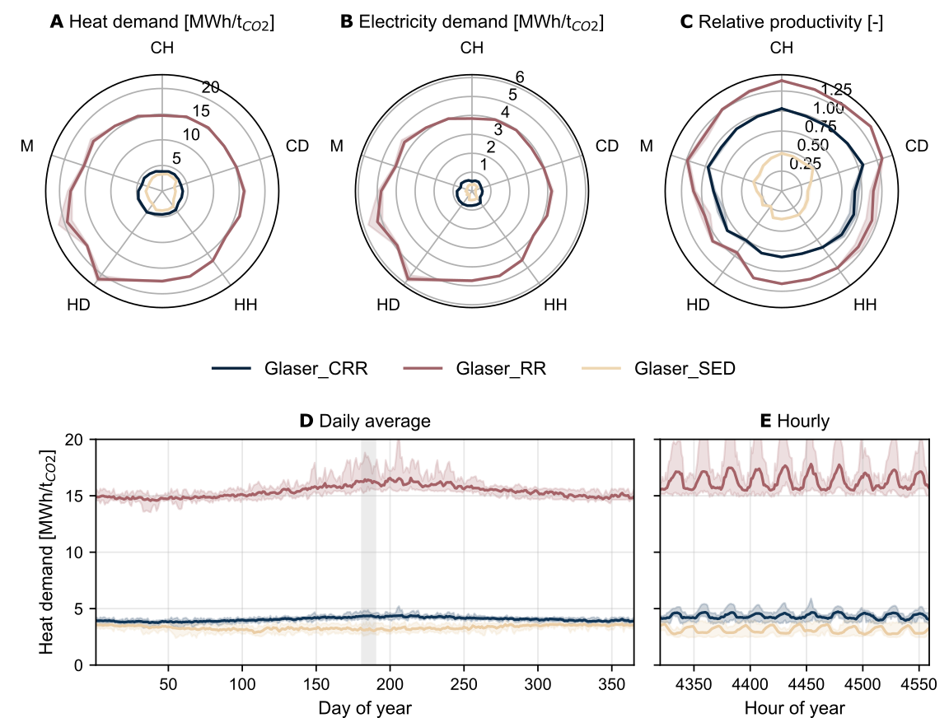
Supplementary Figure 9: Performance of three different configurations of the same DAC model by Glaser et al. at different locations for different weather years. The line corresponds to the mean of weather years 2010 to 2019 while the shaded area indicates the variability of different weather years. a-c. Yearly average heat demand, electricity demand and relative productivity. For each climate category, 4 different regions are shown clockwise starting from the label. CH: cold-humid, CD: cold-dry, HH: hot-humid, HD: hot-dry, M: moderate. d. Daily average heat demand in a moderate climate in eastern France. e. Hourly heat demand for the days indicated by the grey area in tile D.

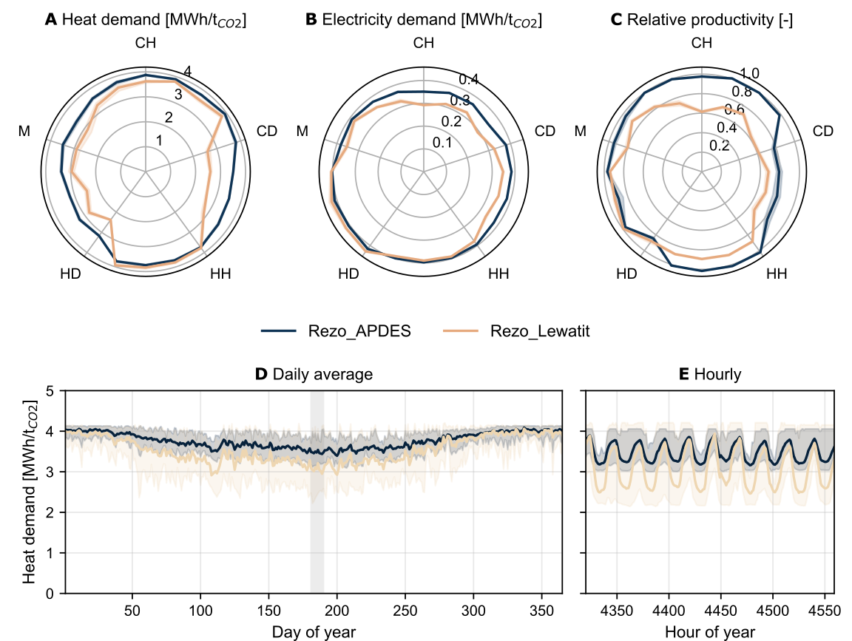
Supplementary Figure 10: Performance of two different materials in the same DAC model by Rezo et al. at different locations for different weather years. The line corresponds to the mean of weather years 2010 to 2019 while the shaded area indicates the variability of different weather years. a-c. Yearly average heat demand, electricity demand and relative productivity. For each climate category, 4 different regions are shown clockwise starting from the label. CH: cold-humid, CD: cold-dry, HH: hot-humid, HD: hot-dry, M: moderate. d. Daily average heat demand in a moderate climate in eastern France. e. Hourly heat demand for the days indicated by the grey area in tile D.

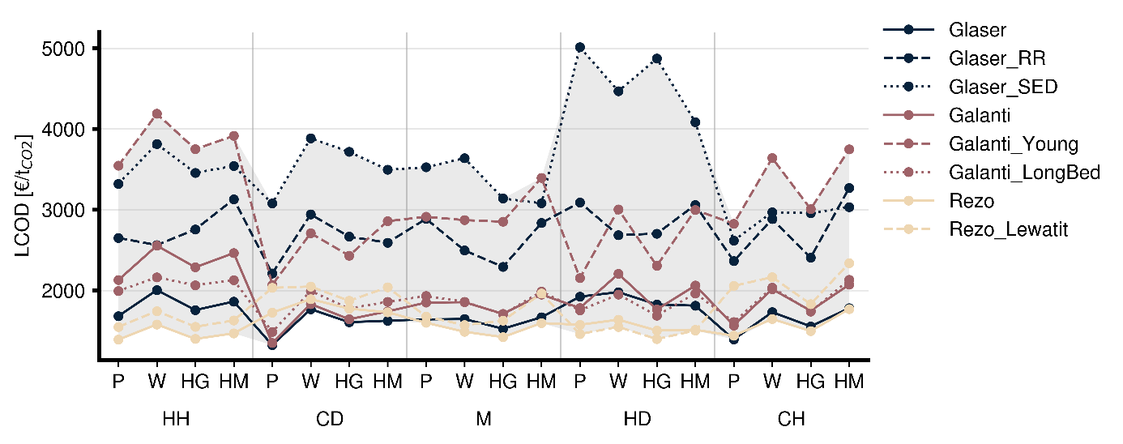
Supplementary Figure 11: Levelized cost of DAC in 20 different locations with varying climate and renewable conditions for three different models, each with different configurations. Climate labels: CH: cold-humid, CD: cold-dry, HH: hot-humid, HD: hot-dry, M: moderate, Renewable supply labels: P: only PV, W: only wind, HG: hybrid with good conditions, HM: hybrid with moderate conditions.
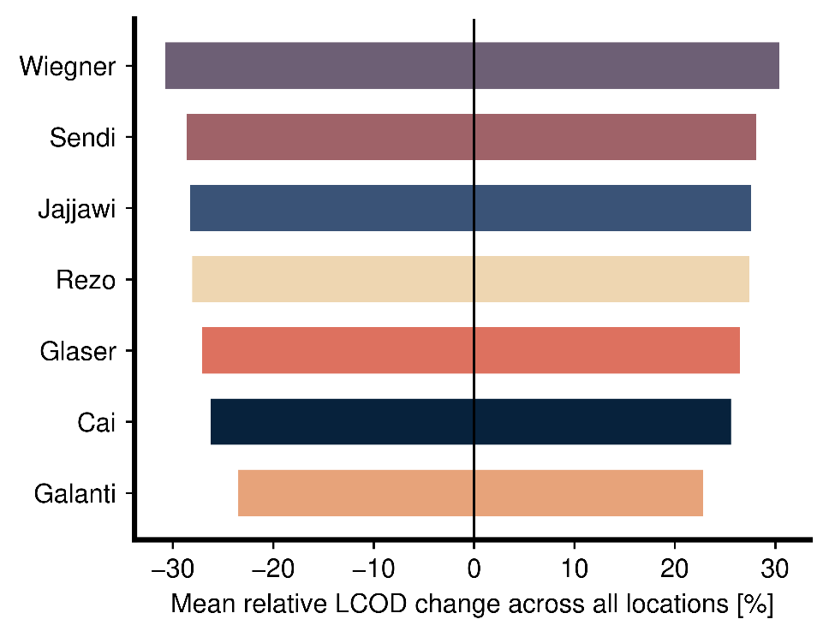
Supplementary Figure 12: Model-specific influence of a +-50% change in DAC CAPEX on the resulting levelized cost of DAC on average across all locations.

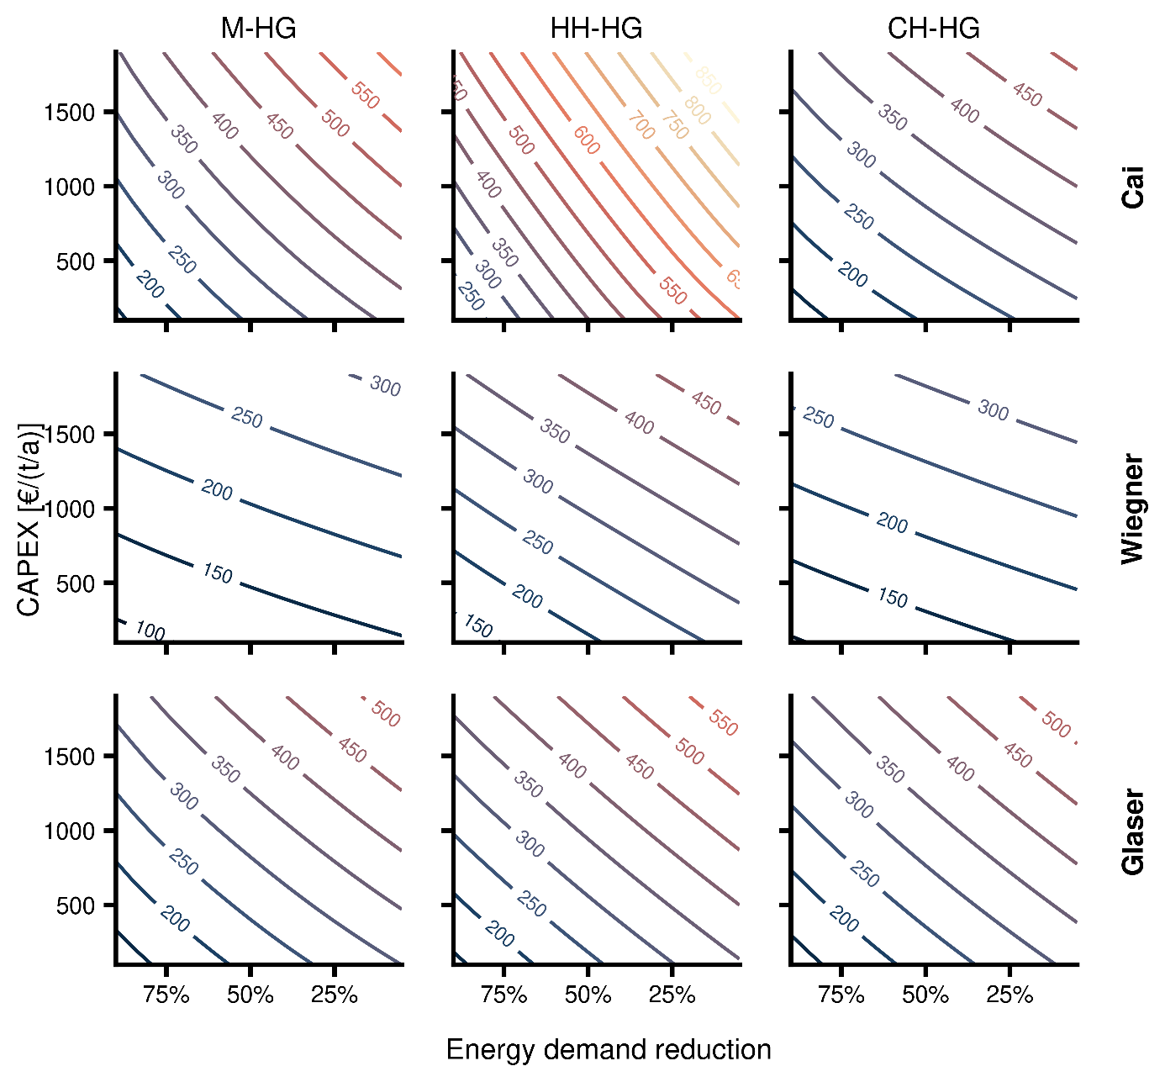
Supplementary Figure 13: Combinations of future CAPEX and energy demand reductions and the resulting capture costs for three different models in three different regions.
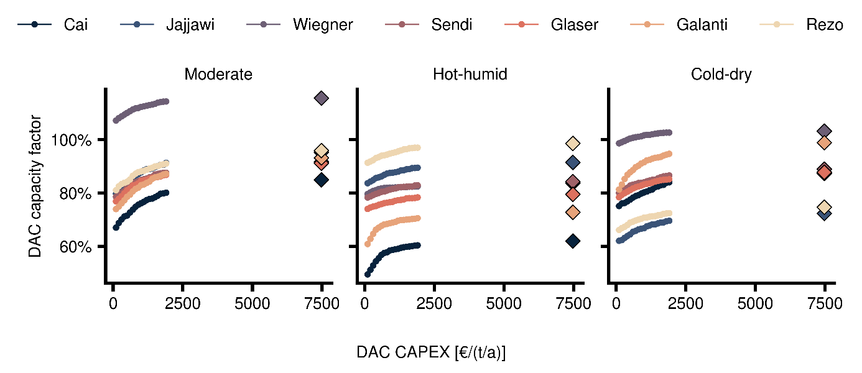
Supplementary Figure 14: Current (indicated by the diamond) and future reached yearly average capacity factors of the DAC unit in dependence of the CAPEX under an assumed energy demand reduction of 25%.
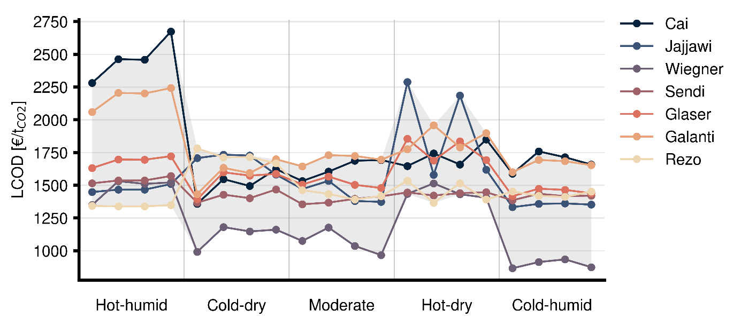
Supplementary Figure 15: Levelized cost of DAC in 20 different locations with varying climate conditions in a fixed electricity cost grid scenario. Per climate conditions, four different locations with varying weather patterns are evaluated.
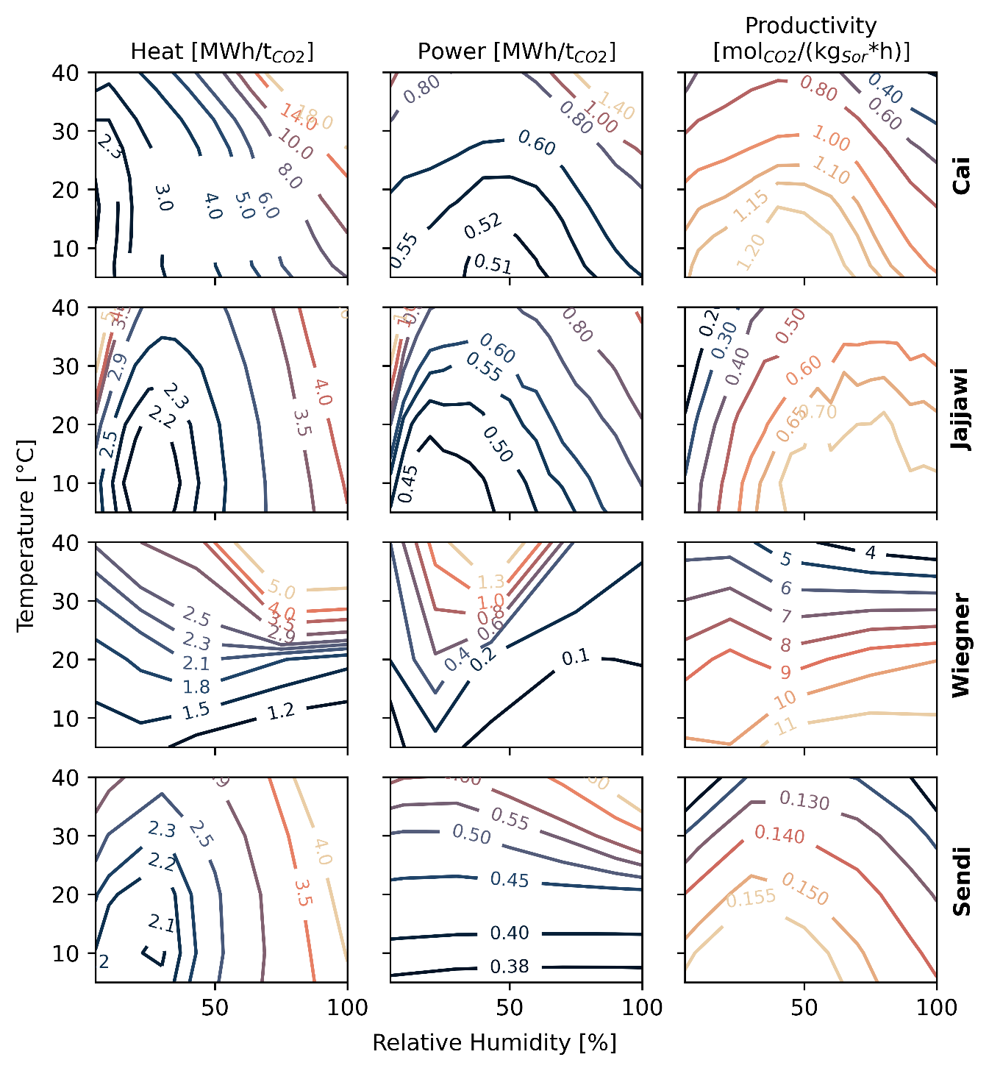
Supplementary Figure 16: Figure 1: Performance of different DAC process models^{1–4} under varying ambient conditions. The models by Sendi³ and Jajjawi² employ the same sorbent but differ in process conditions and design, while Cai¹ and Wiegner⁴ use different sorbents in addition to operation and design variations.

References
(1) Cai, X.; Coletti, M. A.; Sholl, D. S.; Allen-Dumas, M. R. Assessing Impacts of Atmospheric Conditions on Efficiency and Siting of Large-Scale Direct Air Capture Facilities. JACS Au 4, 1883–1891 (2024).
(2) Jajjawi, A. S.; Wenzel, H.; Harzendorf, F.; Weinand, J. M.; Stolten, D.; Peters, R. Weather-dependent direct air capture process modeling for techno-economic assessments. Energy Conversion and Management 351, 121003 (2026).
(3) Sendi, M.; Bui, M.; Mac Dowell, N.; Fennell, P. Geospatial analysis of regional climate impacts to accelerate cost-efficient direct air capture deployment. One Earth 5, 1153–1164 (2022).
(4) Wiegner, J. F.; Grimm, A.; Weimann, L.; Gazzani, M. Optimal Design and Operation of Solid Sorbent Direct Air Capture Processes at Varying Ambient Conditions. Ind. Eng. Chem. Res. 61, 12649–12667 (2022).
(5) Rezo, D.; Glaser, M.; Postweiler, P.; Engelpracht, M.; von der Assen, N. Control strategies to optimize adsorption-based direct air capture under varying weather conditions. Applied Energy 411, 127578 (2026).
(6) Rezo, D.; Postweiler, P.; Engelpracht, M.; Meuleneers, L.; von der Aßen, N. A method for siting adsorption-based direct air carbon capture and storage plants for maximum CO2 removal. Carb Neutrality 3 (2024).
(7) Galanti, M.; Kaaresvirta, K.; Roghair, I.; van Sint Annaland, M. Purity-constrained TVSA modeling of Lewatit VPOC 1065 for direct air capture: bridging cured thermodynamics, process design and geometrical analysis. Energy Adv. 5, 273–289 (2026).
(8) Glaser, M.; Rajendran, A.; McCoy, S. T. How do ambient conditions influence sorbent selection in adsorption-based direct air capture? Sustainable Energy Fuels 9, 4404–4416 (2025).
(9) Young, J.; García-Díez, E.; Garcia, S.; van der Spek, M. The impact of binary water–CO 2 isotherm models on the optimal performance of sorbent-based direct air capture processes. Energy Environ. Sci. 14, 5377–5394 (2021).
(10) Glaser, M.; McCoy, S. T. How does spatio-temporal optimisation affect the siting and operation of direct air capture systems? ChemRxiv [Online early access]. DOI: 10.26434/chemrxiv.15010123/v1.
(11) Balasubramaniam, B. M.; Thierry, P.-T.; Lethier, S.; Pugnet, V.; Llewellyn, P.; Rajendran, A. Process-performance of solid sorbents for Direct Air Capture (DAC) of CO2 in optimized temperature-vacuum swing adsorption (TVSA) cycles. Chemical Engineering Journal 485, 149568 (2024).
(12) Elfving, J.; Sainio, T. Kinetic approach to modelling CO2 adsorption from humid air using amine-functionalized resin: Equilibrium isotherms and column dynamics. Chemical Engineering Science 246, 116885 (2021).
(13) Gebald, C.; Wurzbacher, J. A.; Borgschulte, A.; Zimmermann, T.; Steinfeld, A. Single-component and binary CO2 and H2O adsorption of amine-functionalized cellulose. Environmental science & technology 48, 2497–2504 (2014).
(14) Stampi-Bombelli, V.; van der Spek, M.; Mazzotti, M. Analysis of direct capture of $${\hbox {CO}}_{2}$$ from ambient air via steam-assisted temperature–vacuum swing adsorption. Adsorption 26, 1183–1197 (2020).
(15) Fasihi, M.; Efimova, O.; Breyer, C. Techno-economic assessment of CO2 direct air capture plants. Journal of Cleaner Production 224, 957–980 (2019).
(16) Prats-Salvado, E.; Jagtap, N.; Monnerie, N.; Sattler, C. Solar-Powered Direct Air Capture: Techno-Economic and Environmental Assessment. Environmental science & technology 58, 2282–2292 (2024).
(17) Terlouw, T.; Pokras, D.; Becattini, V.; Mazzotti, M. Assessment of Potential and Techno-Economic Performance of Solid Sorbent Direct Air Capture with CO2 Storage in Europe. Environmental science & technology 58, 10567–10581 (2024).
(18) Kirppu, H.; Rämä, M.; Pursiheimo, E.; Koponen, K.; Lindroos, T. J. District heating with negative emissions – direct air carbon capture and storage combined with small modular reactors. Carbon Capture Science & Technology 17, 100533 (2025).
(19) Wenzel, H.; Harzendorf, F.; Okosun, K.; Schöb, T.; Weinand, J. M.; Stolten, D. Weather conditions severely impact optimal direct air capture siting. Advances in Applied Energy 19, 100229 (2025).
(20) Okosun, K.; et al. Global strategic deployment of Direct Air Capture technologies. International Journal of Greenhouse Gas Control 155, 104743 (2026).
(21) Hersbach, H.; et al. The ERA5 global reanalysis. Quart J Royal Meteoro Soc 146, 1999–2049 (2020).

