Supplementary material

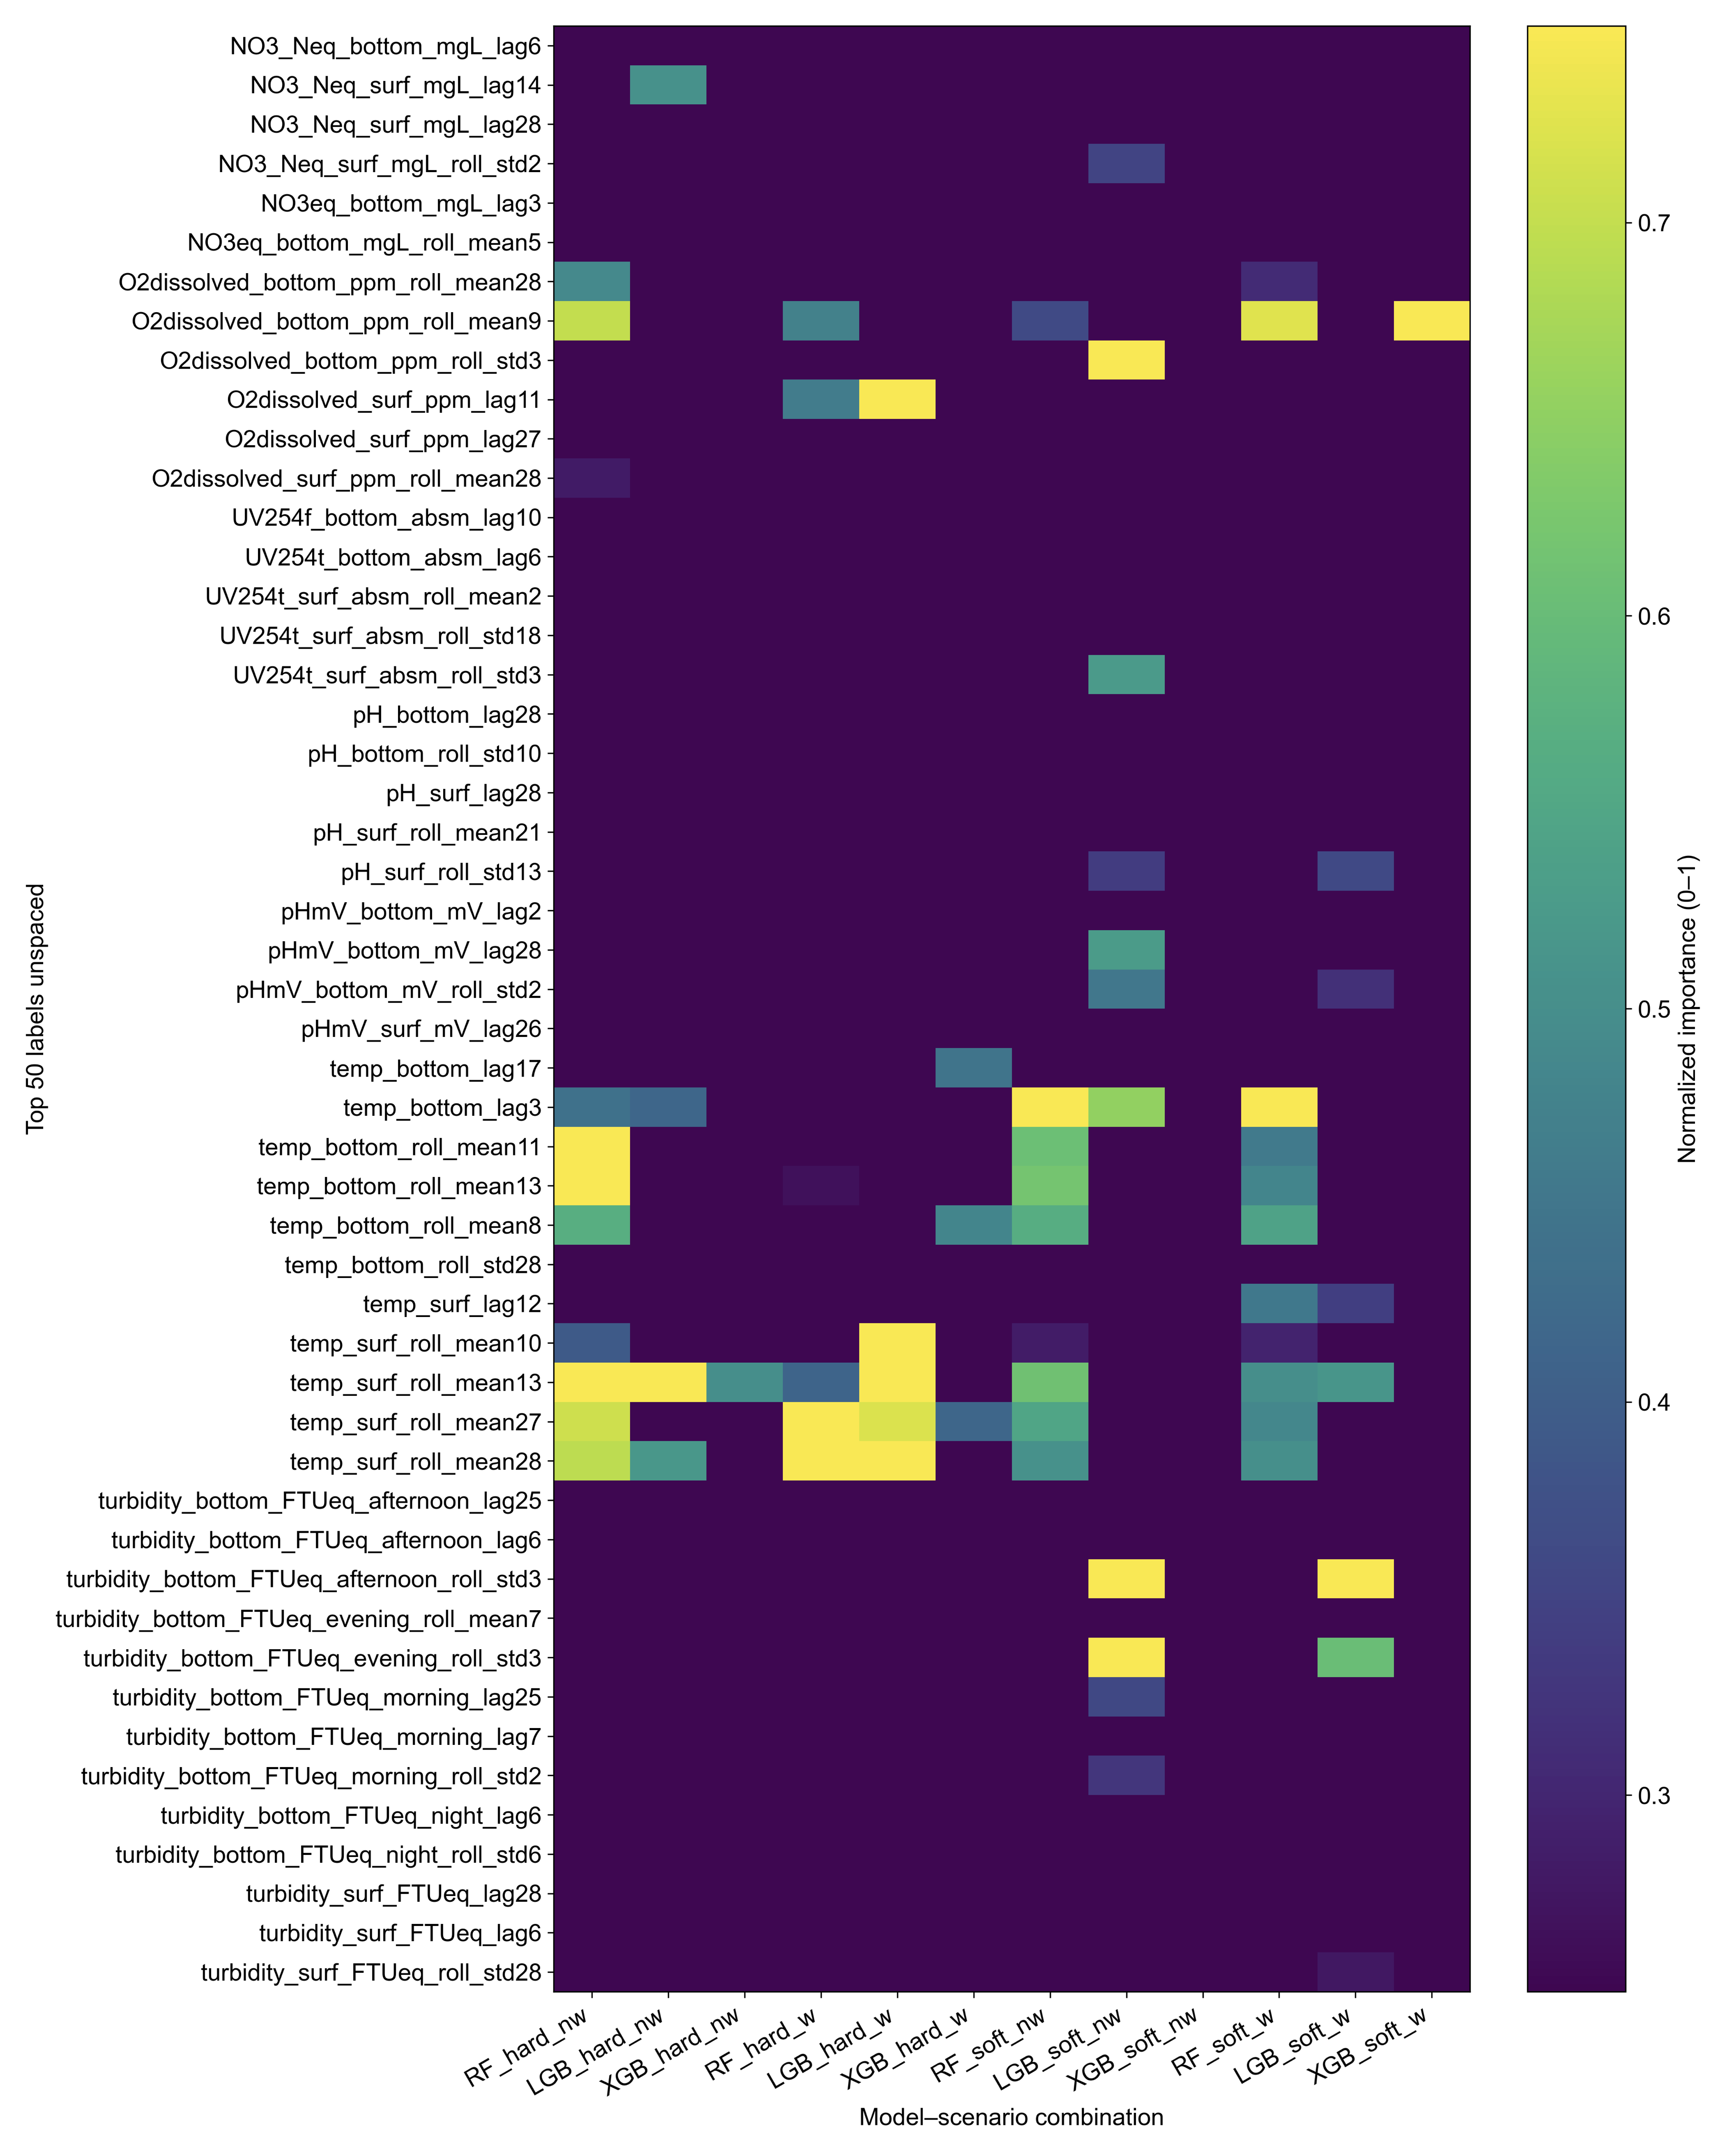
Figure S1. Heatmaps showing the degree of agreement among tree-based models, (RFLGB, and XGB), in the relative importance of predictors across soft/hard and weighted/unweighted scenarios. The heatmap displays the Top-50 features ranked by consensus votes across models. Color intensity represents normalized feature importance (0–1) averaged across outer folds and model types under all four evaluation settings (soft/hard × weighted/unweighted).

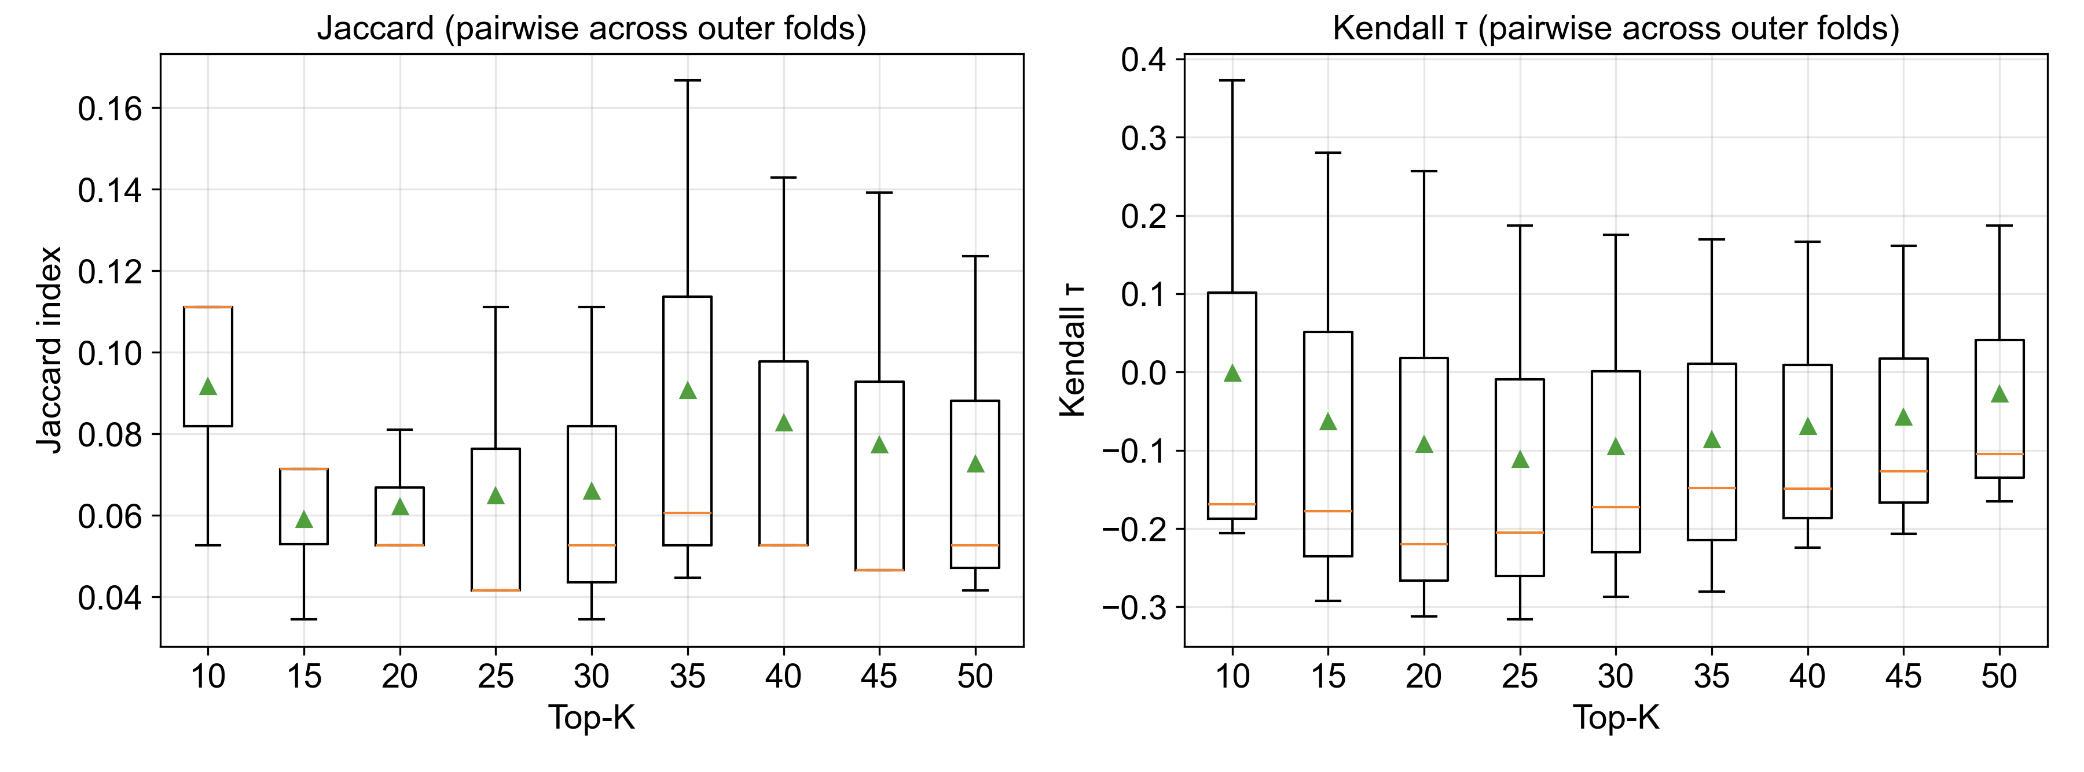
Figure S2. Stability of feature selection across outer cross-validation folds.
Boxplots show pairwise Jaccard indices (feature set overlap) and Kendall’s τ coefficients (rank concordance) for spaced Top-K features across all modelling scenarios (hard/soft targets; weighted/unweighted). Lower values indicate greater variability in selected features, reflecting differences in model-specific importance patterns.
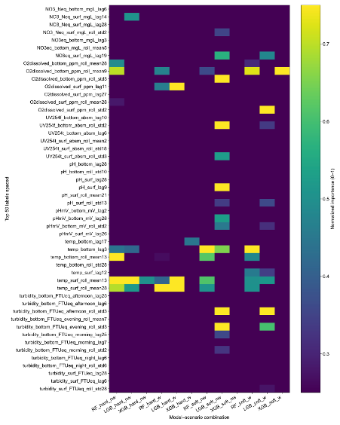
Figure S3. Feature selection and model agreement across tree-based learners. Heatmaps showing the degree of agreement among tree-based models—Random Forest (RF), LightGBM (LGB), and XGBoost (XGB)—in the relative importance of predictors across soft/hard and weighted/unweighted scenarios after applying a 15-day exclusion rule. The spaced heatmap applies this 14-day exclusion across lag, rolling-mean, and rolling-standard-deviation feature families within each variable, thereby reducing redundancy among temporally correlated predictors. The colour gradient from dark blue to bright yellow indicates normalised feature importance (0–1) averaged across outer folds and models under all four scenarios (soft/hard × weighted/unweighted).

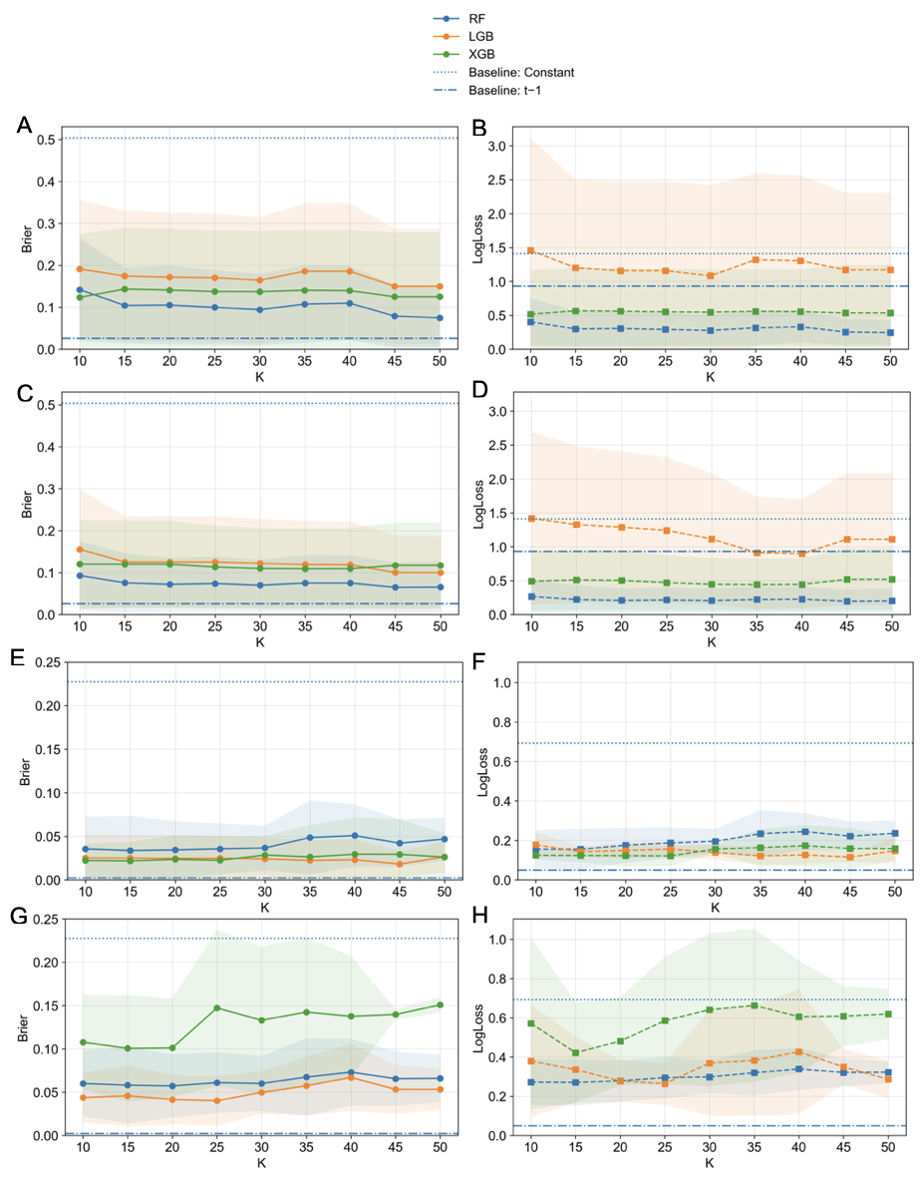
Figure S4. Performance of Top-K feature subsets evaluated on temporally ordered data using ensemble models (RF, LGB, XGB). Panel shows average Brier score or LogLoss across time-series cross-validation folds for A) and B) hard label weighted, C) and D) hard labels unweighted, E) and F) soft label weighted, and G) and H) soft label unweighted evaluation schemes. Dashed and dotted horizontal lines indicate baseline models (constant and persistence). Lower values denote better predictive performance. Error bands represent one standard deviation across folds. All y-axes share consistent scaling per task (soft or hard labels) to enable direct comparison, and legends summarize model and baseline identities.

