Supporting information
for

Effective band structure control for single-atom-thick arsenic chain via strain manipulation by single-walled carbon nanotubes

Xu Zhang^{1,3}, Ziyi Hu*^{2,3}, Dawid Janas⁴, Lin Geng³, Yatong Wang³, Xinxin Gao^{5,6}, Hao Yan*⁵, Haddou Ourada⁷, Rahmani Abdelhai⁷, Mourad Boutahir⁸, Ge Song³, Yunlei Zhong³, Song Qiu³, Lixing Kang*^{3,9}

1. School of Nano-Tech and Nano-Bionics, University of Science and Technology of China, Hefei, China
2. College of Chemical and Material Engineering, Quzhou University, Quzhou 324000, China
3. Advanced Materials Division, Suzhou Institute of Nano-Tech and Nano-Bionics, Chinese Academy of Sciences, 398 Ruoshui Road, Suzhou 215123, China
4. Department of Chemistry, Silesian University of Technology, Krzywoustego 4/5, 44-100 Gliwice, Poland
5. Institute of Deep-sea Science and Engineering, Chinese Academy of Sciences, Sanya 572000, China
6. University of Chinese Academy of Sciences, Beijing 100049, China
7. Laboratoire d’Etude des Matériaux Avancés et Applications (LEM2A), Moulay Ismail University (Umi), Meknes 50000, Morocco
8. Equipe des Matériaux Avancés pour la Transition énergétique (MATE), Laboratoire d’Etude des Matériaux Avancés et Applications (LEM2A), Ecole Normale Supérieure (ENS), Moulay Ismail University (UMI), Meknes 50000, Morocco
9. Jiangsu Key Laboratory of Organoid Engineering and Precision Medicine, Suzhou Institute of Nano-Tech and Nano-Bionics, Chinese Academy of Sciences, Suzhou 215123, China
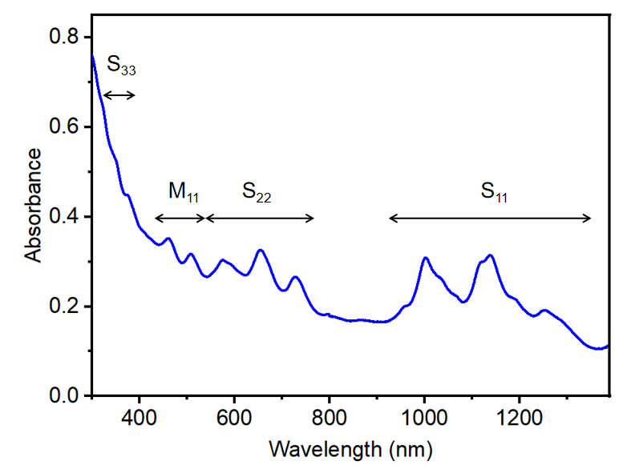
Figure S1. UV-vis-NIR absorption spectrum of unseparated SWCNTs (centrifuged but not purified via GPC).

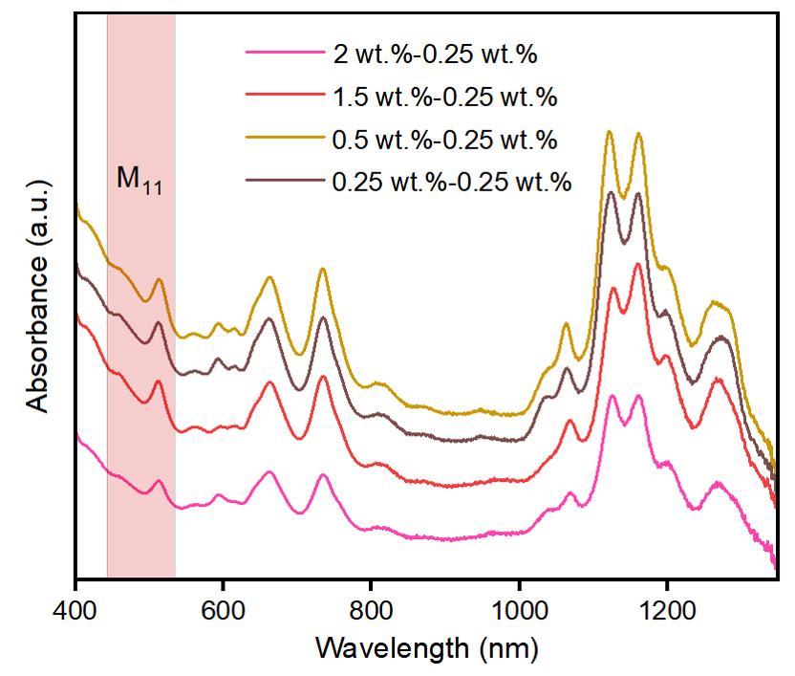
Figure S2. UV-vis-NIR absorption spectra of SWCNTs purified via GPC using equilibrating solution and eluent of relatively low SDS concentrations.

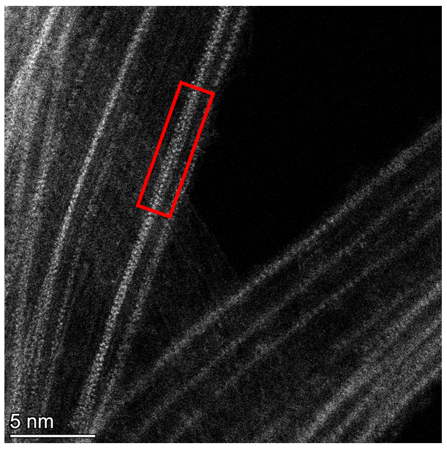
Figure S3. HAADF-STEM image of unseparated raw SWCNTs showing the presence of wide As chain.

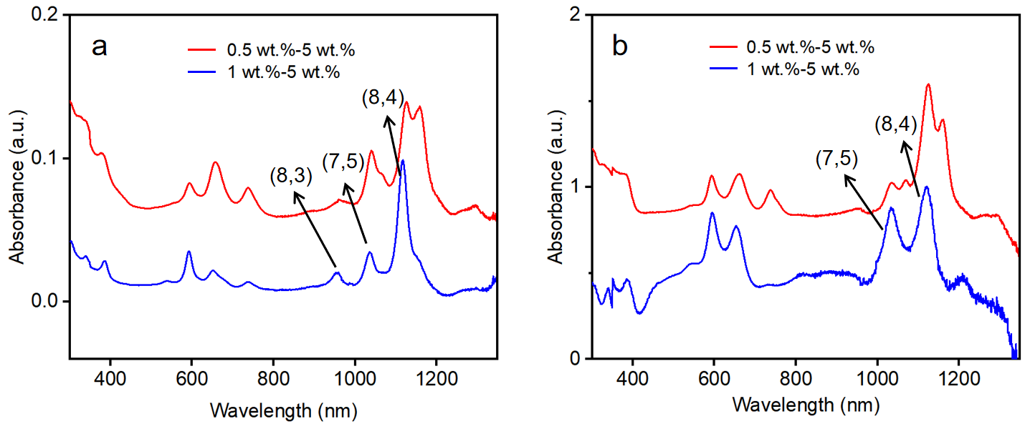
Figure S4. UV-vis-NIR absorption spectra of As-filled SWCNTs separated in repeated GPC experiments.

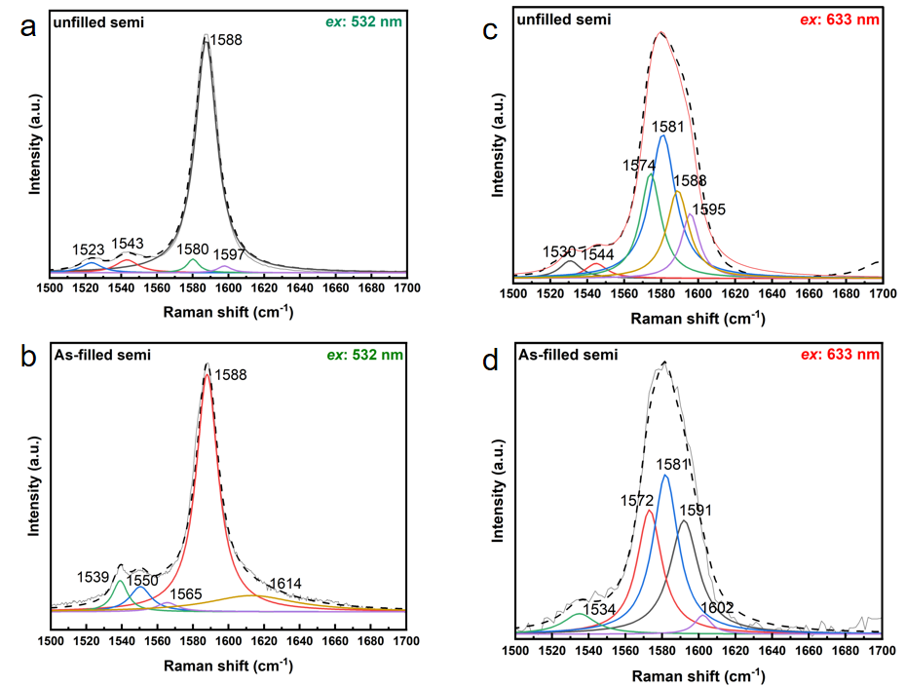
Figure S5. Experimental G mode Raman spectra (solid lines) of dropcasted unfilled and As chain-filled semiconducting SWCNTs under the excitation wavelength of (a,b) 532 nm and (c,d) 633 nm. The simulated spectra (dashed lines) are fits consisting of a number of Lorentzian functions.

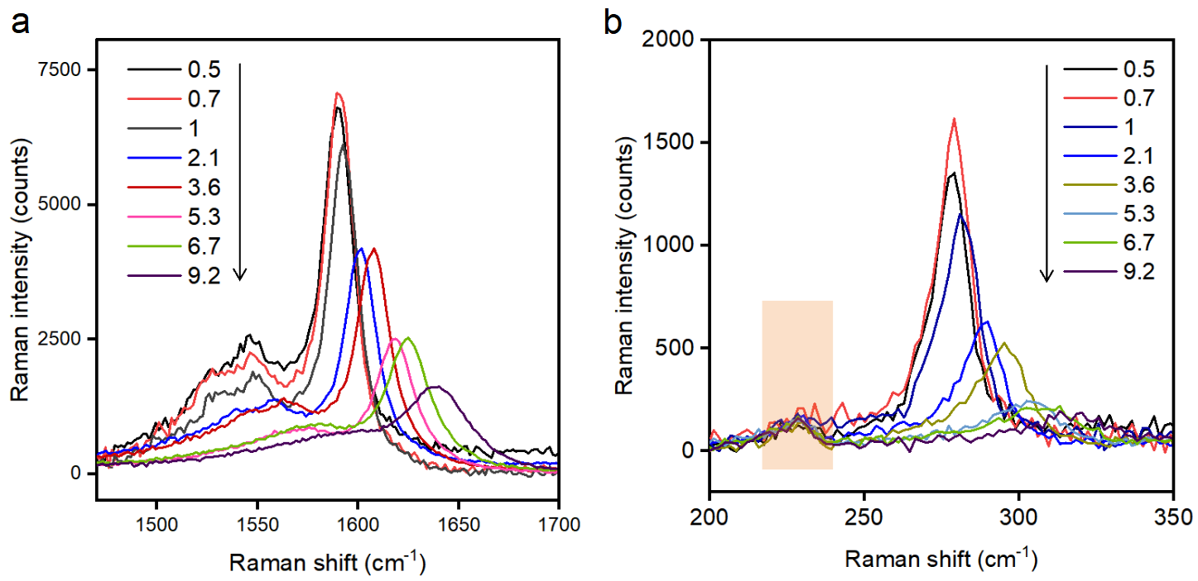
Figure S6. Background-subtracted pressure-dependent (a) G mode and (b) RBM spectra of unfilled mixed-chirality SWCNTs measured upon pressure increasing run. The Raman feature highlighted by the light yellow rectangle is not related to SWCNTs.

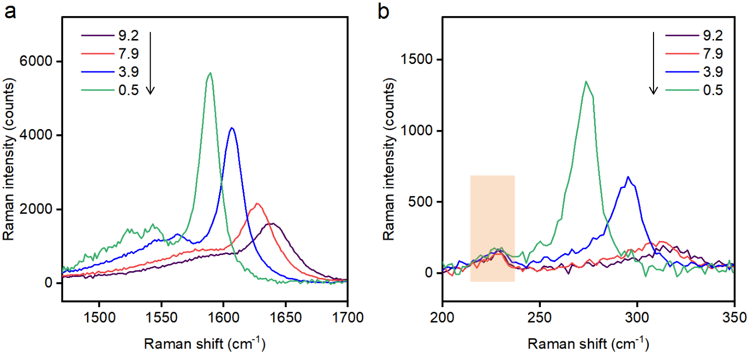
Figure S7. Background-subtracted pressure-dependent (a) G mode and (b) RBM spectra of unfilled mixed-chirality SWCNTs measured upon pressure decreasing run. The Raman feature highlighted by the light yellow rectangle is not related to SWCNTs.

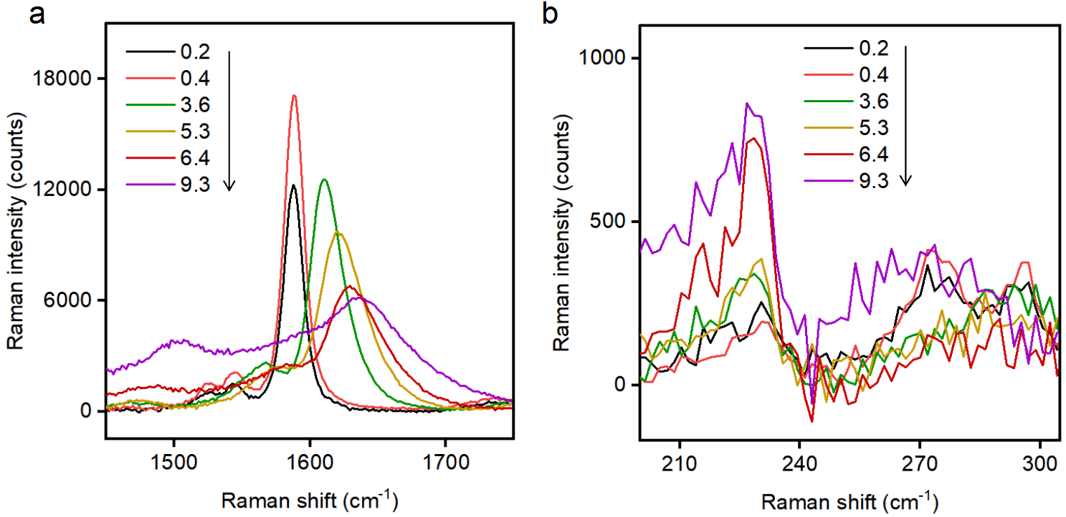
Figure S8. Background-subtracted pressure-dependent (a) G mode and (b) RBM spectra of unfilled semiconducting SWCNTs measured upon pressure increasing run.

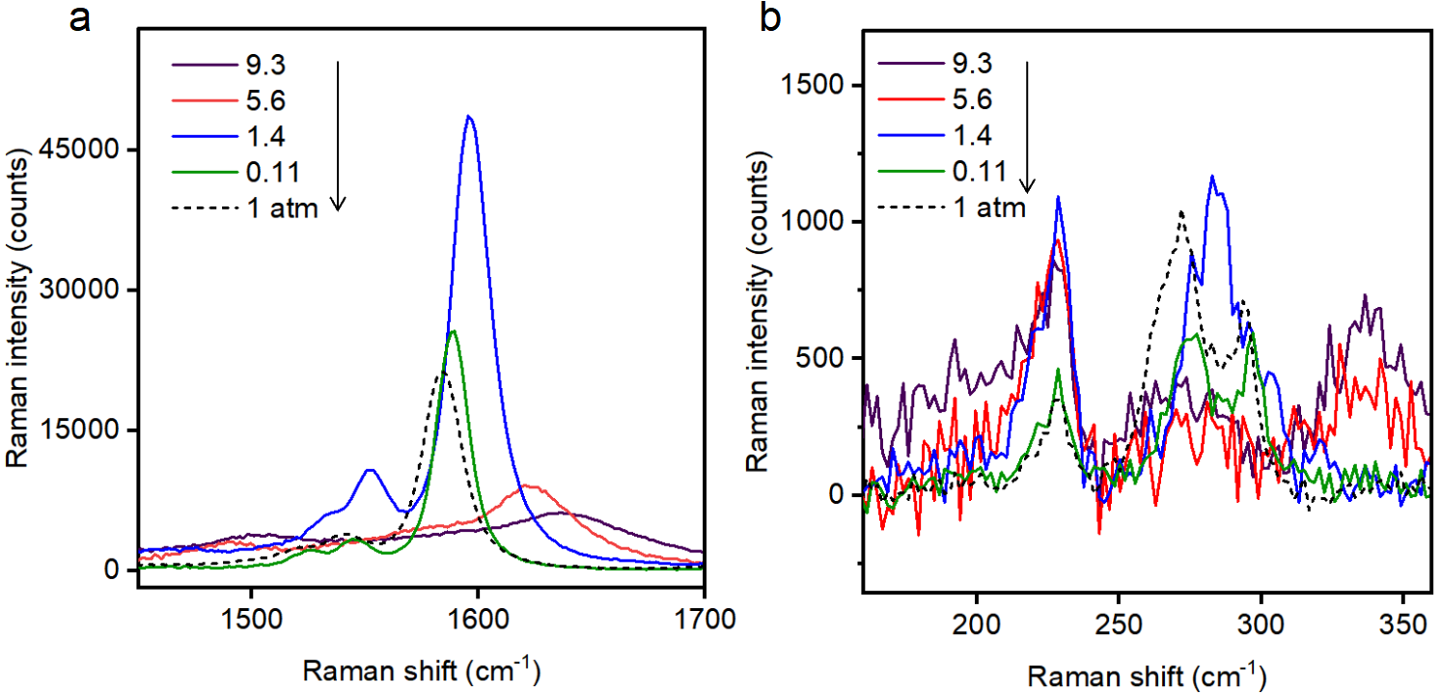
Figure S9. Background-subtracted pressure-dependent (a) G mode and (b) RBM spectra of unfilled semiconducting SWCNTs measured upon pressure decreasing run.

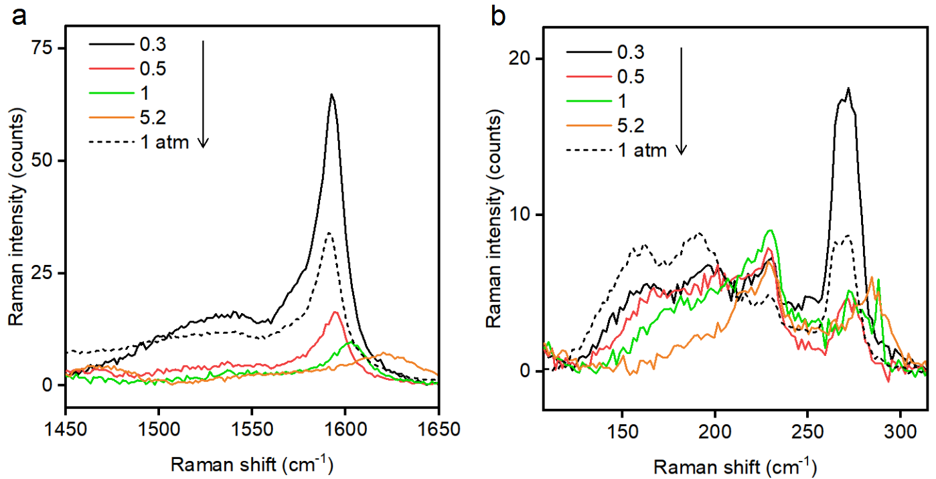
Figure S10. Background-subtracted pressure-dependent (a) G mode and (b) RBM spectra of As-filled mixed-chirality SWCNTs measured upon pressure increasing and decreasing run.

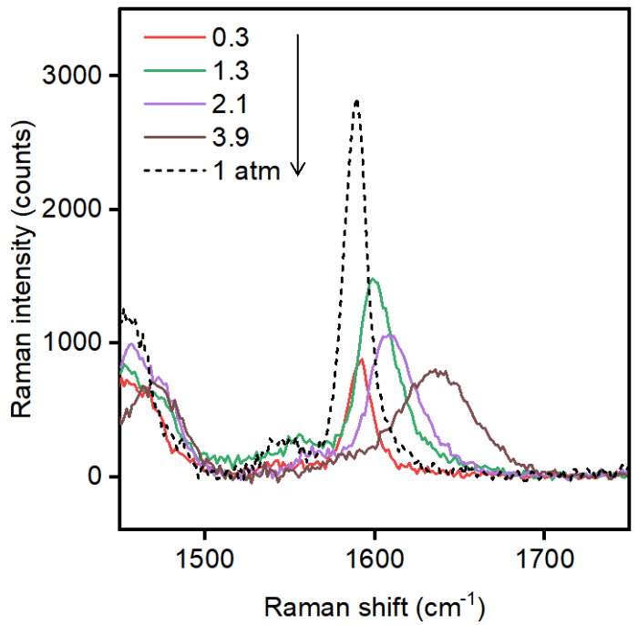
Figure S11. Background-subtracted pressure-dependent G mode spectra of As-filled semiconducting SWCNTs measured upon pressure increasing and decreasing run.

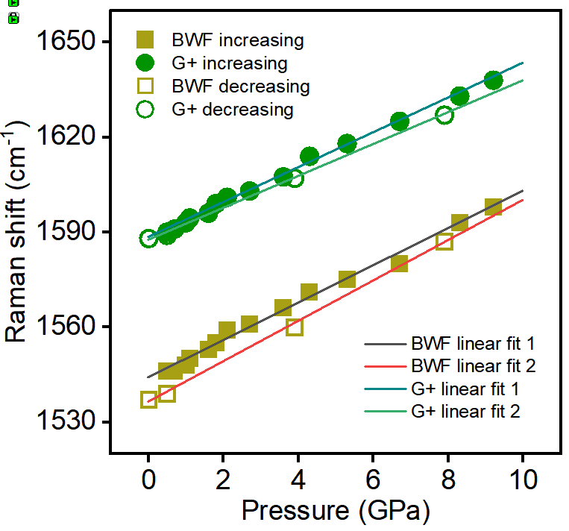

Figure S12. Pressure-dependent frequencies of G modes of unfilled mixed-chirality SWCNTs measured upon pressure increasing and decreasing run.

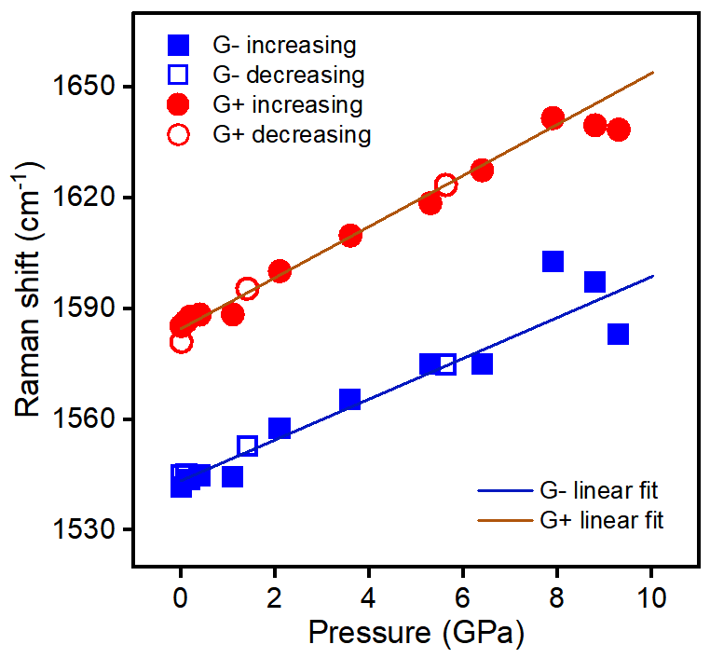
Figure S13. Pressure-dependent frequencies of G modes of unfilled semiconducting SWCNTs measured upon pressure increasing and decreasing run.

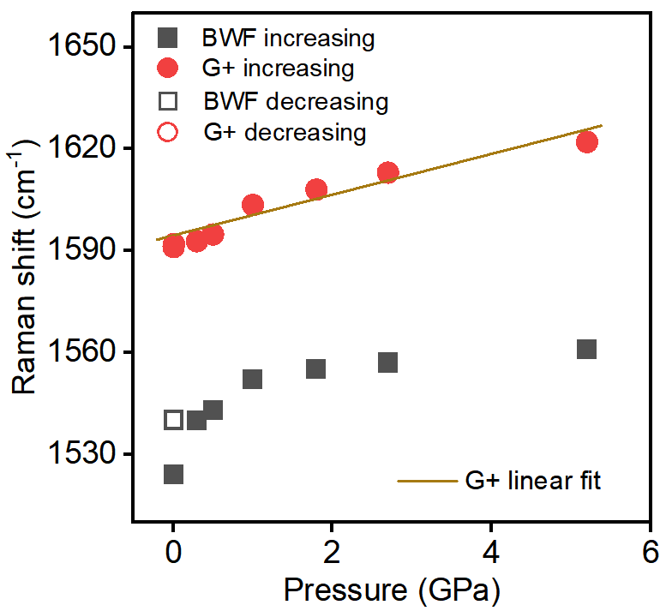
Figure S14. Pressure-dependent frequencies of G modes of As-filled mixed-chirality SWCNTs measured upon pressure increasing and decreasing run.

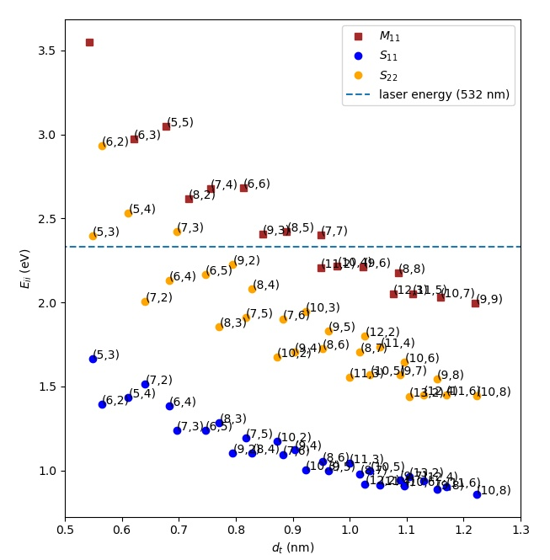
Figure S15. Diameter-dependent optical transition energies of (n,m) belonging to mod families 12-29.

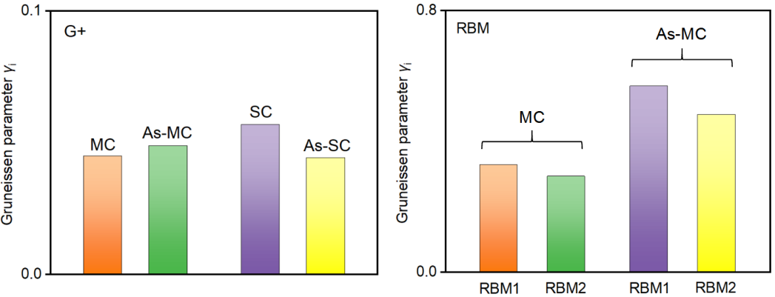
Figure S16. Gruneissen parameters γ_{i} calculated from G+ mode and RBM of various SWCNT samples. MC, As-MC, SC and As-SC stands for (As-filled) mixed-chirality and (As-filled) semiconducting SWCNTs, respectively. RBMs for these samples originate from SWCNTs with diameters between 0.8-0.91 nm.
Table S1. Parameters of fits to experimental pressure-induced Raman frequency change of unfilled SWCNTs and the calculated Grüneisen parameters γ_{i}.
Sample name | Raman mode | Pressure increasing/decreasing run | ω₀ / cm⁻¹ | a / cm⁻¹ GPa⁻¹ | b / cm⁻¹ GPa⁻² | γ_{i}
Mixed-chirality | G+ | Increasing | 1588.16±0.44 | 5.5±0.1 | - | 0.045
Mixed-chirality | G+ | Decreasing | 1587.27±0.52 | 5.03±0.12 | - | 0.0412
Mixed-chirality | BWF | Increasing | 1543.8±0.71 | 5.89±0.16 | - | 0.0496
Mixed-chirality | BWF | Decreasing | 1536.13±0.7 | 6.37±0.16 | - | 0.0539
Mixed-chirality | RBM1 | Increasing | 275.3±0.64 | 6.97±0.22 | -0.24±0.02 | 0.329
Mixed-chirality | RBM2 | Increasing | 269.44±0.91 | 6.09±0.79 | -0.22±0.04 | 0.294
Semiconducting | G+ | Increasing | 1584.38±0.83 | 6.94±0.22 | - | 0.0569
Semiconducting | G- | Increasing | 1543.27±1.03 | 5.54±0.32 | - | 0.0467
Semiconducting | RBM1 | Increasing | 293.96±0.38 | 8.61±0.25 | -8.69±0.08 | 0.381
Semiconducting | RBM2 | Increasing | 285.98±0.07 | 4.69±0.26 | - | 0.213
Graphiteª | G | - | 1579 | 4.7 | - | 0.1
Graphiteª | BM | - | 44 | 4.8 | - | 3.7
a Data obtained from ref. 37.

Table S2. Parameters of fits to experimental pressure-induced Raman frequency change of As-filled SWCNTs and the calculated Grüneisen parameters γ_{i}.
Sample name | Raman mode | Pressure increasing/decreasing run | ω₀ / cm⁻¹ | a / cm⁻¹ GPa⁻¹ | b / cm⁻¹ GPa⁻² | γ_{i}
Mixed-chirality | G+ | Increasing | 1593.9±1.8 | 5.99±0.77 | - | 0.0489
Mixed-chirality | RBM1 | Increasing | 269.98±0.53 | 11.83±0.17 | -2.03±0.02 | 0.57
Mixed-chirality | RBM2 | Increasing | 263.78±0.51 | 9.81±0.18 | -1.59±0.02 | 0.483
Semiconducting | G+ | Increasing | 1589.29±0.3 | 5.43±0.17 | 1.50±0.02 | 0.0444
Graphiteª | G | - | 1579 | 4.7 | - | 0.1
Graphiteª | BM | - | 44 | 4.8 | - | 3.7
a Data obtained from ref. 37.

