SUPPLEMENTARY METHODS

Comparisons of highly variable genes with genetic and genomic associations for ASD
We compared the genes with high intra-individual or high inter-individual variability with previously reported ASD-associated genes from 2 publications^{1,2}. There are 102 genes associated with ASD reported in Satterstrom FK et al.¹, and we found that 5 of these genes (4.9%) had high intra-individual variability and 5 of them (4.9%) had high inter-individual variability in the bulk RNA sequence data from the organoids. Similarly, for Gandal MJ et al.², there are 1,611 genes associated with ASD and 44 of these genes (2.7%) had high intra-individual variability, and 61 of these genes (3.8%) had high inter-individual variability in the bulk RNA sequence data from the organoids. These observations show that the genes with high inter-individual or intra-individual variability in RNA sequence data from the cerebral organoids are not enriched for genes with genetic or genomic associations with ASD.

Comparisons of bulk RNA sequence data from cerebral organoids with post-mortem brain samples from the BrainSpan Project
To determine how accurately RNA sequence data from cerebral organoids can reflect RNA sequence data from post-mortem human brain samples, we compared our data with data from 578 post-mortem brain samples in the BrainSpan Project³ (Supplementary Figs. 6A-F). We observed a wide range of correlations (Pearson’s $r^{2}$ from 0.21 to 0.82, Supplementary Fig. 6A). The mean correlations between the organoids with individual prenatal brain samples (maximum $r^{2}$=0.67, minimum $r^{2}$=0.38) were significantly higher than the mean correlations between the organoids with individual postnatal brain samples (maximum $r^{2}$=0.58, minimum $r^{2}$=0.28), shown in Supplementary Fig. 6B (two-sided Wilcoxon P<2.2×10⁻¹⁶).
The highest mean correlations were with prenatal brain samples from regions such as the hippocampus ($r^{2}$=0.61), primary visual cortex ($r^{2}$=0.61) and amygdala ($r^{2}$=0.61), shown in Supplementary Fig. 6C. The lowest correlations with prenatal brain samples were across brain regions such as the mediodorsal thalamus ($r^{2}$=0.49), ventrolateral prefrontal cortex ($r^{2}$=0.56) and primary somatosensory ($r^{2}$=0.56). Similar observations were made when comparing RNA sequence data from cerebral organoids prior to removing the outlier genes (Supplementary Fig. 6D-F).
To determine how accurately RNA sequence data from cerebral organoids can reflect RNA sequence data from post-mortem human brain samples, we compared our data with data from 578 post-mortem brain samples in the BrainSpan Project³ (Supplementary Figs. 6A-F). We observed a wide range of correlations (Pearson’s $r^{2}$ from 0.21 to 0.82, Supplementary Fig. 6A). The mean correlations between the organoids with individual prenatal brain samples (maximum $r^{2}$=0.67, minimum $r^{2}$=0.38) were significantly higher than the mean correlations between the organoids with individual postnatal brain samples (maximum $r^{2}$=0.58, minimum $r^{2}$=0.28), shown in Supplementary Fig. 6B (two-sided Wilcoxon P<2.2×10⁻¹⁶).
The highest mean correlations were with prenatal brain samples from regions such as the hippocampus ($r^{2}$=0.61), primary visual cortex ($r^{2}$=0.61) and amygdala ($r^{2}$=0.61), shown in Supplementary Fig. 6C. The lowest correlations with prenatal brain samples were across brain regions such as the mediodorsal thalamus ($r^{2}$=0.49), ventrolateral prefrontal cortex ($r^{2}$=0.56) and primary somatosensory ($r^{2}$=0.56). Similar observations were made when comparing RNA sequence data from cerebral organoids prior to removing the outlier genes (Supplementary Fig. 6D-F). These observations suggest that RNA sequence data from the cerebral organoids are highly correlated with RNA sequence data from prenatal brain samples but not with postnatal brain samples.

Identifying second hit outside the 16p11.2 locus contributing to ASD risk
Many risk loci associated with complex disorders such as ASD have incomplete penetrance⁴, and are present in control individuals who are not clinically diagnosed with these disorders, albeit at a lower prevalence than in affected individuals. A two-hit model was previously described for another microdeletion locus in 16p12.1, where the microdeletion was reported to exacerbate neurodevelopmental phenotypes in association with other large CNVs⁵. We asked if we could similarly detect a second genetic factor that contributes to increased risk for ASD, in addition to the 16p11.2 deletion background, and this might explain for the incomplete penetrance observed with the 16p11.2 deletions. The SetD comparison between individuals with ASD and 16p11.2 deletions versus resilient individuals with 16p11.2 deletions did not yield any gene with FDR≤0.05. There is less than 80% power to detect a gene with small effects (fold changes of less than 4) at FWER≤0.05 given our current sample sizes (Supplementary Table 9).

Conceptual comparisons of CIBERSORTx and CellScore (Orgo-Seq)
There are existing methods such as CIBERSORTx⁶ to enable deconvolution of bulk RNA sequence data using scRNA-seq data as input. We use an example illustrated in the figure below: there are 3 cell types (blue, yellow and red circles) in a mixture of cells derived from cases (such as individuals with 16p11.2 deletions) and controls (such as individuals without 16p11.2 deletions), and there twice as many of the yellow cell type in the cases compared to controls. For each cell type, there are 2 cell type specific marker genes (Genes A and B for the blue cell type, Genes C and D for the yellow cell type and Genes E and F for the red cell type). Using the gene expressions detected from scRNA-seq, we can infer the proportions of each of the 3 cell types for cases and controls. In this example, for the cases, the expected proportion of the blue cell type is 1/4 from the bulk RNA sequence data, the expected proportion of the yellow cell type is 1/2 from the bulk RNA sequence data, and the expected proportion of the red cell type is 1/4 from the bulk RNA sequence data. For the controls, the expected proportion of each cell type is 1/3 from the bulk RNA sequence data. We can then compare the proportions of each cell type between cases and controls to evaluate if there are any cell types that are enriched in the cases.

Using the same example, Orgo-Seq uses the scRNA-seq data to identify cell type markers as input. Instead of using manual curation or canonical cell type markers to identify which genes are cell type specific marker genes (e.g. Genes C and D), we obtain the lists of cell clusters and cell cluster marker genes from previously published scRNA-seq data. We further exclude genes that are found in multiple cell clusters, and thus are unlikely to be unique cell type markers. In this example, the scRNA-seq data identified 3 cell clusters (blue, yellow and red), and there are 2 genes in each cluster that are cell type specific gene markers (Genes A-F). The CellScore statistic in Orgo-Seq is then used to calculate if Genes C and D are significantly differentially expressed between the cases and controls in the bulk RNA sequence data. In this example, we expect to observe that all the cell type specific gene markers (Genes C and D) for a particular cell type (yellow cell type) are overexpressed in bulk RNA sequence data from the cases, compared to bulk RNA sequence data from the controls (indicated by the green up arrows), and this suggests that the yellow cell type is enriched in the cases compared to the controls. We further perform permutations to obtain a null distribution for estimating P(CellScore).

One advantage of Orgo-Seq compared to CIBERSORTx is that Orgo-Seq is not dependent on the scRNA-seq gene expression, and cell marker identification can be performed with scRNA-seq data from cerebral organoids that are not age-matched (e.g. scRNA-seq data from 3-months or 6-months organoids can be used as input with bulk RNA sequence data from 1.5-months organoids), or with scRNA-seq data from human post-mortem brains. One disadvantage of Orgo-Seq compared to CIBERSORTx is that Orgo-Seq does not estimate the proportions of cell types that are enriched in cases versus controls. As an alternative solution, we will use flow cytometry or FACS to quantify the differences in proportions of cell types between cases and controls if needed. We can also perform an expectation maximization for the gene expression from bulk RNA sequence data across all the cell type markers to obtain an estimate for how much the cell type specific markers are overexpressed by, in the cases compared to the controls⁷, and this provides an estimate of the proportions of cell types that are enriched in cases versus controls. However, for the purpose of this manuscript to identity cell types and cell type specific driver genes, the estimates of the proportions of cell types that are enriched in the cases compared to the controls, do not change the conclusions of the manuscript.

Comparisons of CIBERSORTx and CellScore (Orgo-Seq) using 3-month and 6-month cerebral organoid scRNA-seq data
To illustrate the differences between an existing deconvolution method (CIBERSORTx) and Orgo-Seq, we applied both methods using bulk RNA sequence data from our patient-derived cerebral organoids with or without 16p11.2 deletions, and as a reference input, we used data from a previous publication by Velasco et al. where scRNA-seq data from 3-months organoids and 6-months organoids are available⁸. We grouped the 3-months and 6-months organoids into a single analysis as there were much fewer 6-months organoids compared to 3-months organoids, and we performed 2 sets of analyses using scRNA-seq data from: 1) all the organoids (3-months and 6-months), and 2) only the 3-months organoids. For CIBERSORTx⁶, we performed t-test to evaluate the differences in the proportions of cell types, and for the results from CIBERSORTx and CellScore (Orgo-Seq), we further performed meta-analyses on the P-values for the enrichment of cell types between 16p11.2 deletion cases and controls by using equal weights for each replicate in each batch.

Meta-analysis of deconvolution results from CIBERSORTx
Cell types (all 3mos and 6mos organoids) | P values
RG | 0.0398
Immature CPNs | 0.0718
CPNs | 0.0739
Cycling | 0.0916
oRG | 0.1126
Immature PNs | 0.3601
CFuPNs | -
IPCs/Immature PNs | -
Immature CFuPNs | -

Cell types (only 3mos organoids) | P values
IPCs/Immature PNs | 0.0343
Immature CPNs | 0.0454
oRG | 0.0734
Cycling | 0.0748
CPNs | 0.0994
RG | 0.1122
Immature CFuPNs | 0.1683
CFuPNs | 0.1788
Immature PNs | 0.3831

We observed that using CIBERSORTx, the top critical cell type identified for 16p11.2 deletion was radial glia (RG) cells using the scRNA-seq data from all the 3-months and 6-months organoids (T-test P=0.0398). However, the top critical cell type identified from using only the 3-months organoids was IPCs/immature PNs (T-test P=0.0343). The differences in the results are likely to be driven by gene expression differences between 3-months and 6-months organoids and can influence the critical cell type identification from bulk RNA sequence data. As such, we will need to generate age-matched scRNA-seq data from 1.5-months organoids to deconvolve bulk RNA sequence data from 1.5-months organoids.

Deconvolution results from CellScore (Orgo-Seq)
Cell types (all 3mos and 6mos organoids) | P values
Cycling | 0.0160
CPNs | 0.0809
IPCs/Immature PNs | 0.1879
RG | 0.6545
Immature CPNs | 0.3457
Immature PNs | 0.5535
oRG | 0.9739
Immature CFuPNs | -
CFuPNs | -

Cell types (only 3mos organoids) | P values
Cycling | 0.0264
Immature CFuPNs | 0.2193
CPNs | 0.2284
IPCs/Immature PNs | 0.2479
Immature PNs | 0.4568
RG | 0.7506
Immature CPNs | 0.7517
oRG | 0.9703
CFuPNs | 0.9998

We observed that using CellScore in our Orgo-Seq approach, cycling progenitor cells were consistently identified as the top critical cell type that is perturbed in the 16p11.2 deletion cases compared to controls using either all the organoids or only the 3-months organoids (P=0.016 and P=0.0264 respectively). This is because Orgo-Seq uses the cell markers identified from scRNA-seq, but not the gene expressions from scRNA-seq, so differences in gene expressions of the cell markers between 3-month and 6-month organoids are less likely to influence the critical cell type identification from bulk RNA sequence data. Our results using scRNA-seq data from Velasco et al. also provide further supporting evidence for our results using scRNA-seq data from Quadrato et al. described in our main text, that neural progenitor cells are most likely to be the critical cell type perturbed by 16p11.2 deletions.

Additional comparisons of patient-derived cerebral organoids with isogenic 16p11.2 lines
We used a more stringent criteria and observed that 34/9,504 (0.36%) of the genes in both the organoids and neural stem cells were similarly differentially expressed with fold changes of greater or less than 1 in the cases/deletion compared to the controls/wildtype. In contrast, none of the 9,526 genes that were expressed in both the induced neurons with 16p11.2 deletions and patient-derived cerebral organoids, were differentially expressed with FDR≤0.05 in both the neurons and organoids.
For the duplication lines, using a more stringent criteria, we observed that 63/9,500 genes (0.66%) in both the organoids and neural stem cells were reciprocally differentially expressed with fold changes of greater than 1 in the case organoids compared to control organoids, and fold changes of less than 1 in the neural stem cells with 16p11.2 duplications compared to wildtype, as well as vice versa. In contrast, 3/9,531 genes (0.031%) were reciprocally differentially expressed with fold changes of greater than 1 in the case organoids compared to control organoids, and fold changes of less than 1 in the induced neurons with 16p11.2 duplications compared to wildtype, as well as vice versa (OR = 21.2, 95% CI = [6.9, 105.7], Fisher’s Exact Test P = 5.7≤10⁻¹⁶).

References
1 Satterstrom, F. K. et al. Novel genes for autism implicate both excitatory and inhibitory cell lineages in risk. 484113, doi:10.1101/484113 %J bioRxiv (2018).
2 Gandal, M. J. et al. Transcriptome-wide isoform-level dysregulation in ASD, schizophrenia, and bipolar disorder. Science 362, doi:10.1126/science.aat8127 (2018).
3 Kang, H. J. et al. Spatio-temporal transcriptome of the human brain. Nature 478, 483-489, doi:10.1038/nature10523 (2011).
4 Cooper, D. N., Krawczak, M., Polychronakos, C., Tyler-Smith, C. & Kehrer-Sawatzki, H. Where genotype is not predictive of phenotype: towards an understanding of the molecular basis of reduced penetrance in human inherited disease. Hum Genet 132, 1077-1130, doi:10.1007/s00439-013-1331-2 (2013).
5 Girirajan, S. et al. A recurrent 16p12.1 microdeletion supports a two-hit model for severe developmental delay. Nat Genet 42, 203-209, doi:10.1038/ng.534 (2010).
6 Newman, A. M. et al. Determining cell type abundance and expression from bulk tissues with digital cytometry. Nat Biotechnol 37, 773-782, doi:10.1038/s41587-019-0114-2 (2019).
7 Chan, Y. et al. Enabling multiplexed testing of pooled donor cells through whole-genome sequencing. Genome Med 10, 31, doi:10.1186/s13073-018-0541-6 (2018).
8 Velasco, S. et al. Individual brain organoids reproducibly form cell diversity of the human cerebral cortex. Nature, doi:10.1038/s41586-019-1289-x (2019).

SUPPLEMENTARY FIGURES AND TABLES

Supplementary Figure 1. Characterization of cerebral organoids. (A) As previously described in Lancaster et al., 2014, we started with the formation of an embryoid body, followed by neural induction, embedding in matrigel and differentiation on an orbital shaker. (B) Markers for an organoid at Day 31 are shown. (C) Markers for an organoid at Day 46 are shown. (D) Transcriptomic profiling using RNA sequencing showed a similar pattern across stem cell markers (in orange box), neural progenitor cell markers (in green box) and neuronal cell markers (in pink box) for organoids differentiated for 31 days (D31_PGP1_1, D31_PGP1_2 and D31_PGP1_3) compared to organoids differentiated for 46 days (D46_PGP1_1, D46_PGP1_2 and D46_PGP1_3). The values represented by the heatmap shows the log2(FPKM) values.
Supplementary Figure 2. Intra-individual and inter-individual correlations. (A) Histogram of the standard deviations of normalized expression values for each gene across all replicates for each individual. (B) Histogram of the standard deviations of normalized expression values for each gene across all replicates from different individuals. (C) Histogram showing the intra-individual Pearson’s correlations $r^{2}$ for control individuals after removing outlier genes. (D) Histogram showing the intra-individual Pearson’s correlations $r^{2}$ for all individuals after removing outlier genes. (E) Histogram showing the intra-individual Pearson’s correlations $r^{2}$ for all individuals prior to removing outlier genes. (F) Histogram showing the inter-individual Pearson’s correlations $r^{2}$ for control individuals after removing outlier genes. (G) Histogram showing the inter-individual Pearson’s correlations $r^{2}$ for all individuals after removing outlier genes. (H) Histogram showing the inter-individual Pearson’s correlations $r^{2}$ for all individuals prior to removing outlier genes.

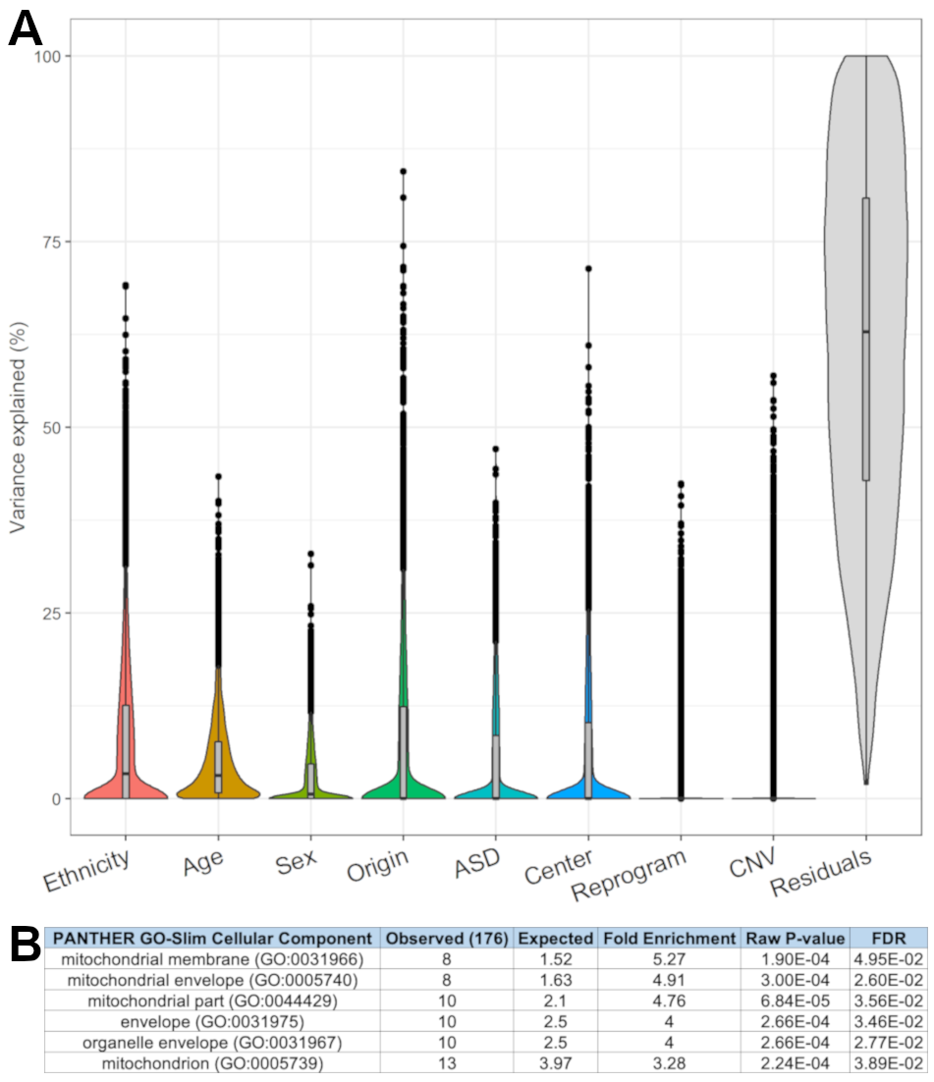

Supplementary Figure 3. variancePartition analyses. (A) Percentage of variance in gene expression explained (y-axis) by 8 factors and the residuals (x-axis). (B) Gene ontology enrichment analyses for genes with >99% of the variance explained by the residuals.

Supplementary Figure 4. Principal components analyses. (A) Variance in gene expression (y-axis) accounted for by the first 20 principal components (x-axis). (B) First two principal components (PC1 and PC2) showing classified by sample replicates. (C) First two principal components (PC1 and PC2) classified by ethnicity. (D) First two principal components (PC1 and PC2) classified by sex. (E) First two principal components (PC1 and PC2) classified by the origin of reprogramming. (F) First two principal components (PC1 and PC2) classified by the type of reprogramming. (G) Principal component 3 (PC3) and principal component 4 (PC4) classified by sample replicates.

Supplementary Figure 5. Correlation of sample variables with principal components (PCs). Correlation tests were performed between each sample variable (RIN, Sex, Age, Ethnicity, Origin of tissue, and Reprogramming method), and the -log₁₀(P(Correlation)) values were plotted for the principal component 1 (PC1) in pink, the principal component 2 (PC2) in orange, and the principal component 3 (PC3) in green. The red dotted line indicates the significance threshold after Bonferroni correction (P=2.8×10⁻³). These results show that sample variables such as age of the individual, origin of sample and type of reprogramming are highly correlated and are captured by PC1.
Supplementary Figure 6. Correlation with RNA sequence data from the cerebral organoids and post-mortem brain samples from the BrainSpan Project. (A-C) After removing outlier genes and (D-F) Prior to removing outlier genes.
(A) There is a wide range of correlations between the transcriptome data from cerebral organoids with post-mortem brain samples in the BrainSpan Project, with the x-axis showing individual cerebral organoid sample and the y-axis showing the Pearson’s correlations for each organoid sample with all post-mortem brain samples in BrainSpan. (B) There is a higher range of mean correlations between transcriptome data from cerebral organoids with individual prenatal brain samples (red), compared to postnatal brain samples (blue), with the x-axis showing individual BrainSpan sample and the y-axis showing the mean Pearson’s correlations for each BrainSpan sample (from different brain regions across different donors) with all organoid samples. (C) The mean correlations between transcriptome data from cerebral organoids compared to prenatal brain samples from individual regions of the brain, sorted in decreasing order of the means. The x-axis shows the various brain regions in BrainSpan (HIP: hippocampus, AMY: amygdala, V1C: primary visual cortex, STC: posterior superior temporal cortex, STR: striatum, A1C: primary auditory cortex, DFC: dorsolateral prefrontal cortex, ITC: inferolateral temporal cortex, IPC: posteroventral parietal cortex, OFC: orbital frontal cortex, M1C: primary motor cortex, MFC: anterior cingulate cortex, S1C: primary somatosensory cortex, VFC: ventrolateral prefrontal cortex, MD: mediodorsal nucleus of thalamus), and the y-axis shows the mean Pearson’s correlations for all prenatal BrainSpan samples for each brain region, with all organoid samples. (D) Figure S5A prior to removing outlier genes. (E) Figure S5B prior to removing outlier genes. (F) Figure S5C prior to removing outlier genes.

Supplementary Figure 7. Plots for the first two principal components in the differential expression analyses. (A) First 2 principal components (PC1 and PC2) for the samples from the cases with 16p11.2 deletions versus unaffected controls without 16p11.2 deletions (SetA). (B) First 2 principal components (PC1 and PC2) for the samples from the probands with ASD and 16p11.2 deletions versus unaffected controls without 16p11.2 deletions (SetP). (C) First 2 principal components (PC1 and PC2) for the samples from the probands with 16p11.2 deletions versus resilient individuals with 16p11.2 deletions (SetD). (D) First 2 principal components (PC2 and PC3) for the samples from the probands with ASD and 15q11-13 duplications versus unaffected controls.

Supplementary Figure 8. Schematic of our permutation design. The schematic of our permutation design, where the observed case samples are colored in red, while the observed control samples are colored in blue. Given the relatively small numbers of samples, and to avoid sampling actual observed case samples as “pseudo-cases” in the permutations, we sampled the number of observed cases from the observed control samples only, and assigned all initial observed cases as “pseudo-controls” in the permutations. In the following schematic, we have 4 observed case samples and 8 observed control samples that we calculated the observed CellScores and GeneScores from. In the permutations, we sampled 4 “pseudo-cases” from the control samples randomly and assigned these “pseudo-cases” to be cases in the permutations (illustrated as cases colored in blue in the permuted scenario). The remaining 4 control samples (illustrated as controls colored in blue in the permuted scenario), as well as the observed case samples (illustrated as controls colored in red in the permuted scenario), are then assigned to be “pseudo-controls” in the permutation. Using this approach, we ensure that we create a true null distribution where the case and control samples are randomly shuffled up, and do not result in a scenario where at least one of the permutations is exactly the same as the observation.

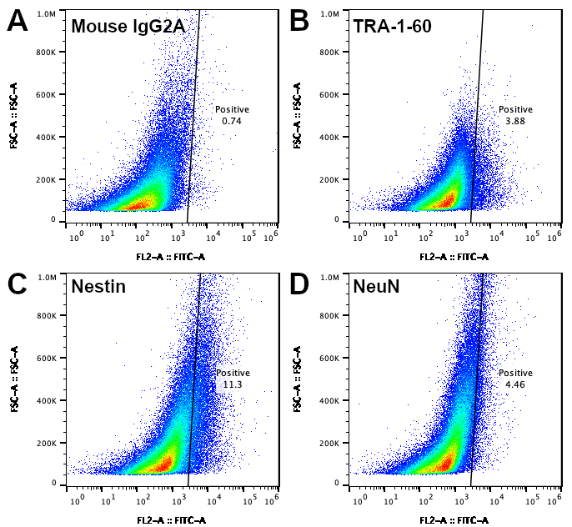

Supplementary Figure 9. FACS plots. The recordings for 100,000 cells for each marker is shown. (A) For the mouse IgG2A marker, 0.74% of the live cells were gated as positive. (B) For the TRA-1-60 marker, 3.88% of the live cells were gated as positive. (C) For the Nestin marker, 11.3% of the live cells were gated as positive. (D) For the NeuN Marker, 4.46% of the live cells were gated as positive.

Supplementary Table 1: DNA Integrity Numbers (DINs) and RNA Integrity Numbers (RINs) for all samples across all individuals.
The DIN values for all DNA samples extracted from the iPSCs of all individuals, as well as the RIN values for all the organoids from individuals with 15q11-13 duplications, 16p11.2 deletions and controls.

Supplementary Table 2: Array CGH results for all iPSCs.
The CNVs detected from all iPSCs using array CGH.

Supplementary Table 3: CNVs detected from whole-exome sequence data for all iPSCs.
The CNVs detected using CoNIFER from whole-exome sequence data.

Supplementary Table 4: CNVs detected from whole-genome sequence data for all iPSCs.
The CNVs detected using CNVnator from whole-genome sequence data.

Supplementary Table 5: Gene Ontology analyses for highly variable genes.
The highly variable outlier genes (intra-individual and inter-individual), as well as the gene ontology results for all highly variable genes.

Supplementary Table 6: Differential expression results for 16p11.2 SetA results.
The differential expression results for all the organoids from all individuals with 16p11.2 deletions versus controls (SetA). The FoldChange column shows the mean expression in cases divided by the mean expression in controls, and the log2(FoldChange) is the log₂ transformed fold change.

Supplementary Table 7: Differential expression results for 16p11.2 SetP results.
The differential expression results for all the organoids from all probands with 16p11.2 deletions versus controls (SetP). The FoldChange column shows the mean expression in cases divided by the mean expression in controls, and the log2(FoldChange) is the log₂ transformed fold change.

Supplementary Table 8: Differential expression results for 16p11.2 SetD results.
The differential expression results for all the organoids from the 3 ASD probands with 16p11.2 deletions versus all resilient individuals with 16p11.2 deletions (SetD). The FoldChange column shows the mean expression in cases divided by the mean expression in controls, and the log2(FoldChange) is the log₂ transformed fold change.

Supplementary Table 9: Power calculations for SetD.
The power calculations for SetD comparisons between individuals with ASD and 16p11.2 deletions versus resilient individuals with 16p11.2 deletions.

Supplementary Table 10: Differential expression results for 15q11-13 duplications.
The differential expression results for all the organoids from individuals with 15q11-13 duplications versus controls. The FoldChange column shows the mean expression in cases divided by the mean expression in controls, and the log2(FoldChange) is the log₂ transformed fold change.

Supplementary Table 11: Cell type specific and non-cell type specific genes.
Genes found to be uniquely expressed in each cell clusters were labeled as “cell type specific genes”, while genes found to be expressed in multiple cell clusters were labeled as “non-cell type specific genes”.

Supplementary Table 12: CellScores and P(CellScores) for the 16p11.2 and 15q11-13 loci.
The cell type results for the 16p11.2 locus are shown in the table, with the calculated CellScores and the probability of cell cluster being perturbed in the 16p11.2 organoids (SetA comparison). Clusters with FDR≤0.05 or P(CellScore)≤0.005 are highlighted in yellow, and clusters with FDR≤0.1 or P(CellScore)≤0.01 are highlighted in blue. The cell type results for the 15q11-13 locus are also shown in the table, with the calculated CellScores and probability of the cell cluster being perturbed in the 15q11-13 organoids. There are no clusters with FDR≤0.05 or P(CellScore)≤0.005, nor FDR≤0.1 or P(CellScore)≤0.01.

Supplementary Table 13: Critical cell types identified from cerebral organoids and post-mortem brain samples with 15q11-13 duplications.
The cell type results for the 15q11-13 locus are shown in the table, with the calculated CellScores and the probability of cell cluster being perturbed in the 15q11-13 organoids and post-mortem brain samples (cortex) with 15q11-13 duplications, as well as an weighted average P(CellScore) calculated based on the results from the cerebral organoids and post-mortem brain samples. The cell clusters with positive CellScores are shaded in orange while the cell clusters with negative CellScores are shaded in blue.

Supplementary Table 14: Percentage of gene expressions for the genes in the 16p11.2 and 15q11-13 loci.
The mean expression of the genes in the 16p11.2 locus, calculated using the control samples, are shown in the table with the percentiles of expression across all genes in decreasing order. The genes with higher expression are in lower percentiles. Similarly, the mean expression of the genes in the 15q11-13 locus, calculated using the control samples, are shown in the table with the percentiles of expression across all genes in decreasing order.

Supplementary Table 15: GeneScores and P(GeneScores) for the top 2 critical cell types for the 16p11.2 locus and the top critical cell type for the 15q11-13 locus.
The 20 genes in the 16p11.2 locus are shown in the table, with calculated GeneScores and probability of GeneScores, P(GeneScores), the fold change, P-value and FDR from the cerebral organoid RNA sequence data. The GeneScores calculated based on the scRNA-seq signature in the neuroepithelial cell cluster (c9) are shown under the column GeneScore_{c9}, and the GeneScores calculated based on transcriptome-wide RNA signatures are shown under the column GeneScore_{all}. Results for high-confidence driver genes with FDR≤0.05, corresponding to P(GeneScore_{c6}) or P(GeneScore_{c9})≤0.031, are highlighted in yellow. Results for lower confidence driver genes with FDR≤0.1, corresponding to P(GeneScore_{c6}) or P(GeneScore_{c9})≤0.058), are highlighted in blue. The 11 genes in the 15q11-13 locus are also shown in the table, with calculated GeneScores and probability of GeneScores, P(GeneScores), the fold change, P-value and FDR, from the cerebral organoid RNA sequence data. The GeneScores calculated based on the scRNA-seq signature in cluster 10 (c10) are shown under the column GeneScore_{c10}, and the GeneScores calculated based on transcriptome-wide RNA signatures are shown under the column GeneScore_{all}. Results for high-confidence driver genes with FDR≤0.05, corresponding to P(GeneScore_{c10})≤0.110, are highlighted in yellow. Results for lower confidence driver genes with FDR≤0.1, corresponding to P(GeneScore_{c10})≤0.128), are highlighted in blue.

Supplementary Table 16: Full set of cell type specific GeneScores and P(GeneScores) for the 16p11.2 and 15q11-13 loci.
The cell type specific GeneScores and P(GeneScores) for clusters 1-10 calculated for 16p11.2, as well as the cell type specific GeneScores and P(GeneScores) for clusters 1-10 calculated for 15q11-13.

Supplementary Table 17: MiSeq results from FACS-sorted mosaic organoids.
List of all detected mutations that are present in dissociated cells that are Ig2A⁻, NeuN⁻, NeuN⁺, Nestin⁻, Nestin⁺, TRA-1-60⁻ and TRA-1-60⁺ (≥25 reads), but are not present in the background unedited PGP1 iPSCs (<25 reads), and the number of reads across each FACS-sorted pool. The odds ratio (OR) shown is the ratio of cells (mutant reads divided by reference reads) found in the positively labeled cells versus the negatively labeled cells.

