Supplementary Appendix

Carrier Burden and Birth Prevalence of Recessive Inborn Errors of Metabolism in South Asians: A gnomAD and GenomeIndia Study
This appendix contains Supplementary Figures S1–S6 and Supplementary Tables S1–S3 referenced in the main text of the revised manuscript (v2.2).
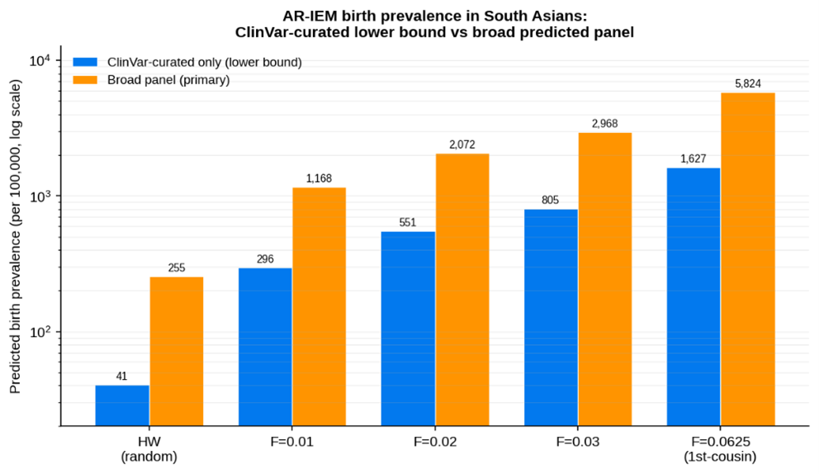
Supplementary Figure S1. Predicted AR-IEM birth prevalence across mating models: ClinVar-curated lower bound vs. broad predicted panel. Comparison of predicted prevalence (per 100,000, log scale) between the conservative ClinVar-only set (blue) and the primary broad panel (orange) from HW to F = 0.0625.
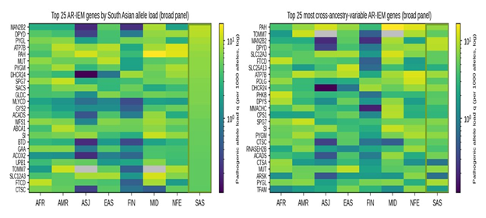
Supplementary Figure S2. Pathogenic allele load (q) for top 25 South Asian genes across global ancestries. Log-scale heatmap of pathogenic allele load q (per 1,000 alleles) for the top 25 genes ranked by South Asian load across eight gnomAD populations (SAS outlined). Top 25 most cross-ancestry-variable AR-IEM genes. Heatmap of pathogenic allele load q for the 25 panel loci showing the greatest variance across global ancestries. (MMUT [labeled MUT] is among the top-ranking South Asian AR-IEM loci).
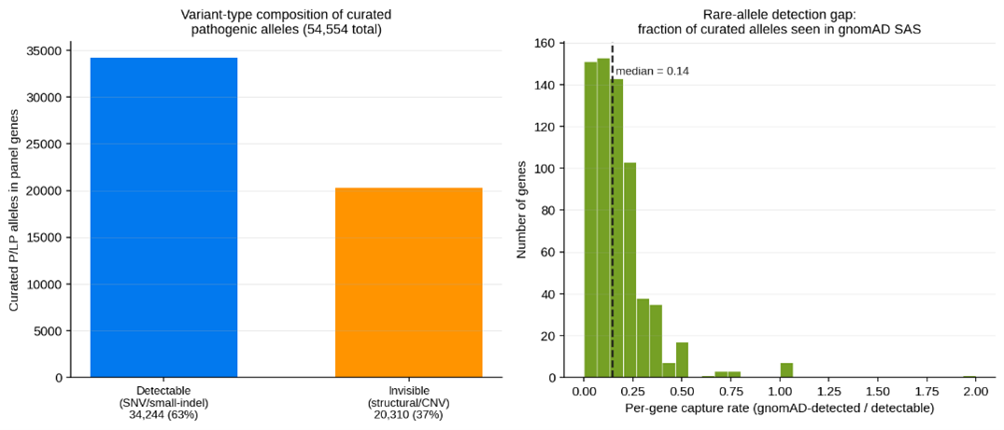
Supplementary Figure S3. Variant-type composition and rare-allele detection gap. Left: Proportion of curated ClinVar pathogenic alleles detectable by short-read SNV/indel exome sequencing (63%) versus invisible structural/CNV variants (37%). Right: Distribution of per-gene SNV/indel capture rates into gnomAD SAS (median capture = 0.14).
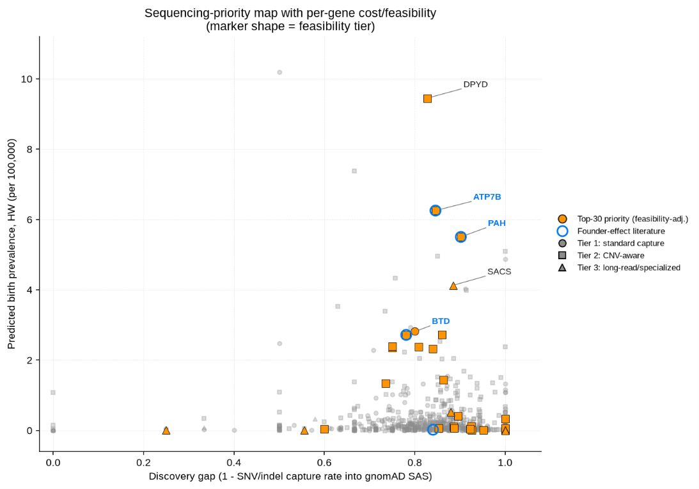
Supplementary Figure S4. Sequencing-priority map with per-gene cost and feasibility. Panel genes plotted by predicted birth prevalence (y-axis) against discovery gap (x-axis). Marker shapes represent sequencing feasibility tiers (circle = standard capture, square = CNV-aware, triangle = long-read/specialized); top-30 feasibility-adjusted target loci highlighted.
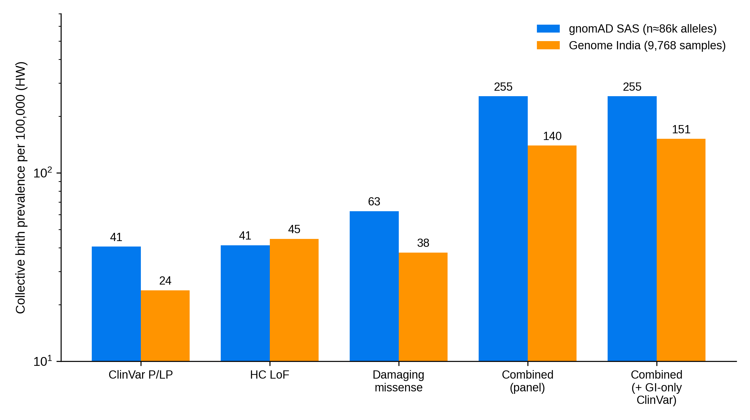
Supplementary Figure S5. Independent replication in the GenomeIndia cohort: collective AR-IEM birth prevalence by variant type and combined, estimated from GenomeIndia (9,768 samples) versus gnomAD South Asian, under random mating (log scale).
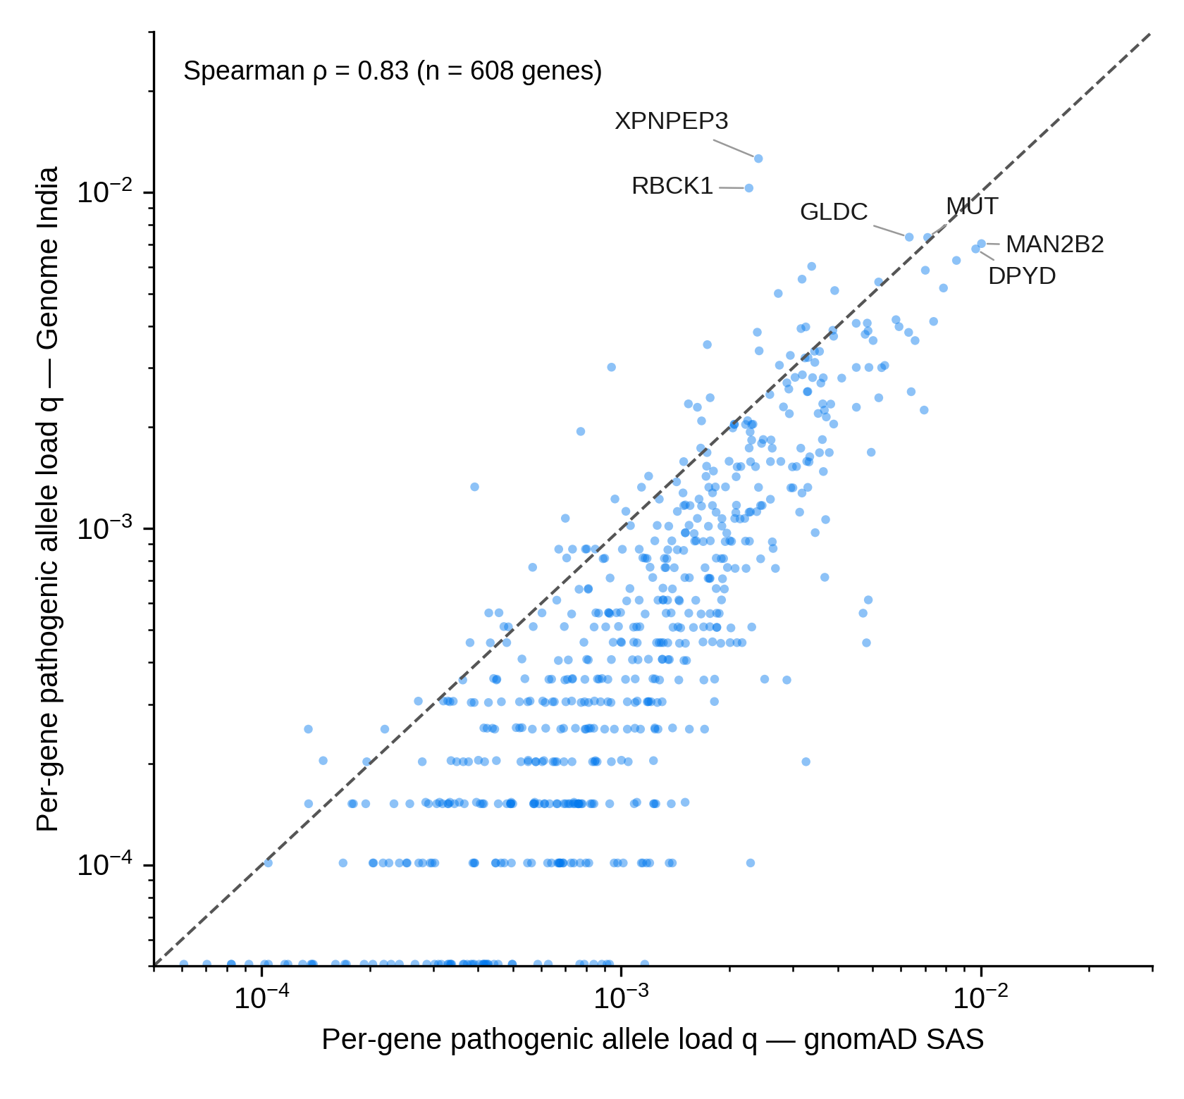
Supplementary Figure S6. Per-gene pathogenic allele load (q) in GenomeIndia versus gnomAD South Asian across the 696-gene panel (log–log). Dashed line: equality. Founder-amplified genes (XPNPEP3, RBCK1, GLDC) and other high-burden loci (MMUT [labeled MUT], MAN2B2, DPYD) are labelled. Spearman ρ = 0.83 across 608 genes with non-zero load in both cohorts.

Supplementary Table S1. Sensitivity analyses of collective AR-IEM birth prevalence and carrier frequency across variant filtering thresholds, computational predictor combinations, and gene validity tiers in South Asians.
Analysis / Filter Parameter | Variant Set / Subset | Variants (n) | Genes (n) | Carrier Freq (%) | HW Birth Prev (per 100k) | F = 0.02 Birth Prev (per 100k) | Description / Methodological Note
Variant Definition Thresholds | ClinVar P/LP only (conservative lower bound) | 4,857 | 590 | 40.1% | 40.6 (1 in 2,461) | 550.9 (1 in 181) | Restricted strictly to ClinVar-curated P/LP assertions (expert panel or clinical submission)
Variant Definition Thresholds | High-confidence LoF (LOFTEE-HC) | 6,777 | 680 | 37.2% | 41.3 (1 in 2,419) | 614.6 (1 in 163) | Predicted loss-of-function passing LOFTEE high-confidence filters
Variant Definition Thresholds | Predicted-damaging missense (AM ∩ REVEL) | 9,225 | 637 | 49.5% | 62.7 (1 in 1,595) | 813.0 (1 in 123) | Conservative intersection: AlphaMissense likely_pathogenic AND REVEL ≥ 0.75
Variant Definition Thresholds | Broad panel (primary combined) | 20,859 | 695 | 84.2% | 255.1 (1 in 392) | 2,072.1 (1 in 48) | Primary broad panel; includes cross-type compound-heterozygous increment of 110.5/100k (~43%)
Allele Frequency Ceiling | No AF ceiling (unfiltered) | — | 696 | >99% | 88,948 | — | Massive contamination by common hypomorphic polymorphisms (e.g., MTHFR c.677C>T)
Allele Frequency Ceiling | AF ≤ 0.5% ceiling (study standard) | 20,859 | 695 | 84.2% | 255.1 | 2,072.1 | Standard quality threshold eliminating common benign/mild polymorphisms across all classes
Missense Predictor Thresholds | AlphaMissense alone (likely_pathogenic) | — | — | — | 473.4 | 3,114.7 | Higher sensitivity (70.2%), moderate specificity (95.6%) against ClinVar truth set
Missense Predictor Thresholds | REVEL alone (REVEL ≥ 0.75) | — | — | — | 498.8 | 2,929.8 | Higher sensitivity (72.8%), specificity (97.5%) against ClinVar truth set
Missense Predictor Thresholds | STUDY intersection (AM ∩ REVEL ≥ 0.75) | 9,225 | 637 | 49.5% | 255.1 | 2,072.1 | Most conservative: highest specificity (98.9%) and PPV (98.9%) against ClinVar truth set
Missense Predictor Thresholds | Union (AM OR REVEL ≥ 0.75) | — | — | — | 645.2 | 3,980.5 | Broadest missense inclusion (sensitivity 83.9%, specificity 94.2%)
ClinGen Gene Validity Tiering | Tier A only (Definitive / Strong) | — | 452 | 71.8% | 167.2 (1 in 598) | 1,419.1 (1 in 70) | Restricted strictly to genes with definitive/strong clinical validity
ClinGen Gene Validity Tiering | Tier A + B (Definitive / Strong + Moderate) | — | 527 | 75.1% | 177.5 (1 in 563) | 1,551.9 (1 in 64) | Includes moderate validity genes
ClinGen Gene Validity Tiering | Tier A + B + U+ (PanelApp-validated) | — | 669 | 83.1% | 240.4 (1 in 416) | 1,994.4 (1 in 50) | Re-incorporates 142 Tier U genes verified on diagnostic panels (Genomics England PanelApp)
ClinGen Gene Validity Tiering | Full Panel (Tier A + B + C + U) | 20,859 | 696 | 84.2% | 255.1 (1 in 392) | 2,072.1 (1 in 48) | Complete 696-gene AR-IEM panel

Supplementary Table S2. Calibration of predicted Hardy–Weinberg genetic birth prevalence against published newborn screening (NBS) clinical incidence across 15 standard metabolic conditions.
Condition | Gene(s) | Pred GP, HW (per 100k) | Pred GP, F=0.02 (per 100k) | Obs NBS Incidence (per 100k) | Ratio (HW) | Ratio (F=0.02) | Reference / Screening Cohort
Phenylketonuria (PKU) | PAH | 5.50 | 20.23 | 6.00 | 0.92× | 3.37× | Shoraka et al. 2020 [16]
MCAD deficiency | ACADM | 1.27 | 8.38 | 7.30 | 0.17× | 1.15× | Martín-Rivada et al. 2022
Classic galactosemia | GALT | 0.52 | 5.09 | 2.60 | 0.20× | 1.96× | Cantley et al. 2023
Maple syrup urine disease | BCKDHA, BCKDHB, DBT | 0.41 | 6.90 | 2.00 | 0.20× | 3.45× | Chapman et al. 2018
Methylmalonic acidemia (mut) | MMUT (MUT) | 5.10 | 19.27 | 3.40 | 1.50× | 5.67× | Almási et al. 2019 [17]
Propionic acidemia | PCCA, PCCB | 1.57 | 12.50 | 0.31 | 5.07× | 40.31× | Almási et al. 2019
Pompe disease | GAA | 2.53 | 12.54 | 5.30 | 0.48× | 2.37× | Colburn & Lapidus 2024 [18]
MPS I (Hurler) | IDUA | 1.47 | 9.11 | 1.56 | 0.94× | 5.84× | Polo et al. 2020
VLCAD deficiency | ACADVL | 0.52 | 5.08 | 1.10 | 0.47× | 4.62× | Lin et al. 2020
Glutaric acidemia type 1 | GCDH | 0.76 | 6.26 | 0.90 | 0.85× | 6.96× | Moorthie et al. 2014 [19]
Isovaleric acidemia | IVD | 0.21 | 3.07 | 0.70 | 0.29× | 4.38× | Moorthie et al. 2014 [19]
Homocystinuria (CBS) | CBS | 0.01 | 0.55 | 0.50 | 0.01× | 1.11× | Moorthie et al. 2014 [19]
Biotinidase deficiency | BTD | 2.72 | 13.09 | 1.20 | 2.26× | 10.90× | Strovel et al. 2017
Citrullinemia type 1 | ASS1 | 1.07 | 7.58 | 0.60 | 1.78× | 12.63× | Berardo et al. 2025
Tyrosinemia type 1 | FAH | 0.32 | 3.91 | 0.50 | 0.65× | 7.82× | Berardo et al. 2025
Note: Across the 15 standard newborn screening conditions, the median clinical-to-genetic scaling factor (Clinical / Genetic) under random mating is 0.65× (interquartile range: 0.25–1.22×). Applying this 0.65× scaling factor across the broad panel yields a calibrated clinical incidence of 165 per 100,000 live births (1 in 608) (255 × 0.65).

Supplementary Table S3. Candidate GenomeIndia-enriched alleles (GenomeIndia AF ≥ 0.1% and ≥2-fold enrichment over gnomAD SAS, or GenomeIndia AF ≥ 0.5%), with transcript-level and population review outcomes. Review: consequences annotated on MANE Select/canonical transcripts (Ensembl VEP); population frequencies and homozygote counts from gnomAD v4; ClinVar records and literature reviewed. GI = GenomeIndia; SAS = gnomAD South Asian; dash = not individually reviewed.
Gene | Variant | Class | GI AF (%) | SAS AF (%) | GI/SAS | Tier | Review outcome
XPNPEP3 | 22:40860676:A:G | LoF_HC | 1.248 | 0.1981 | 6.3 | 1 | Likely benign (annotation artefact)
RBCK1 | 20:417296:C:T | LoF_HC | 1.028 | 0.1919 | 5.4 | 1 | Likely benign (annotation artefact)
GLDC | 9:6622821:C:A | LoF_HC | 0.594 | 0.3055 | 1.9 | 1 | Likely benign (annotation artefact)
PGAM2 | 7:44065240:C:T | missense_damaging | 0.333 | 0.0692 | 4.8 | 2 | –
MMACHC | 1:45509213:TG:T (c.848del, p.Ter283ext*) | LoF_HC | 0.312 | 0.0088 | 35.5 | 2 | Candidate (c.848del stop-lost/extension); pathogenicity unproven / ClinVar VUS
NAXD | 13:110615956:T:TGACAGAGG | LoF_HC | 0.292 | 0.0518 | 5.6 | 2 | Likely benign (annotation artefact)
MMUT | 6:49457878:T:C | missense_damaging | 0.235 | 0.0395 | 6.0 | 2 | –
ALDOB | 9:101429853:C:T | missense_damaging | 0.174 | 0.0406 | 4.3 | 2 | –
ABCG8 | 2:43875152:G:A | missense_damaging | 0.159 | 0.0439 | 3.6 | 2 | –
SLC25A36 | 3:140956672:G:A | missense_damaging | 0.159 | 0.0431 | 3.7 | 2 | –
BTD | 3:15645647:G:A | ClinVar P/LP (GI-only) | 0.154 | – | ∞ | 2 | Candidate; pathogenicity unproven
BCKDHA | 19:41424462:G:A | missense_damaging | 0.138 | 0.0384 | 3.6 | 2 | –
ACAD8 | 11:134257136:G:A | missense_damaging | 0.128 | 0.0055 | 23.3 | 2 | –
LPIN1 | 2:11787137:A:T | missense_damaging | 0.123 | 0.0242 | 5.1 | 2 | –
NAGLU | 17:42538419:G:T | missense_damaging | 0.118 | 0.0176 | 6.7 | 2 | –
HSD17B4 | 5:119471667:A:T | ClinVar_PLP | 0.113 | 0.0027 | 41.6 | 2 | Uncertain (intronic on canonical)
PGAM2 | 7:44064849:A:G | missense_damaging | 0.107 | 0.0023 | 45.8 | 2 | –
FH | 1:241504137:A:G | missense_damaging | 0.159 | 0.0714 | 2.2 | 3 | –
DYM | 18:49209688:A:T | LoF_HC | 0.143 | 0.0498 | 2.9 | 3 | Candidate (canonical LoF, SA-enriched); pending replication
LDHA | 11:18396968:GGTAA:G | LoF_HC | 0.133 | 0.0624 | 2.1 | 3 | Likely benign (globally common)
MMUT | 6:49451512:T:C | ClinVar_PLP | 0.123 | 0.0483 | 2.5 | 3 | –

