Appendix 1. Monte Carlo–Modeled Sodium Distributions Across Food Subgroups
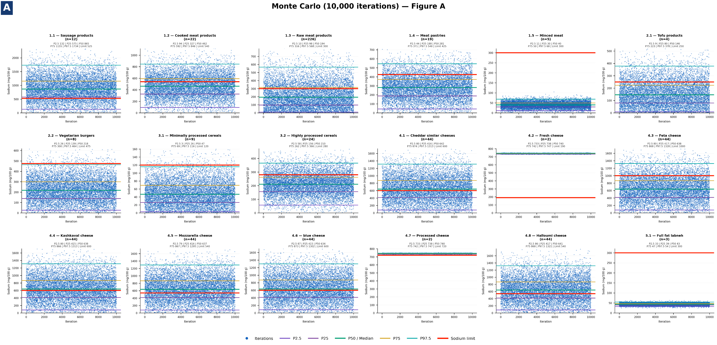

Figure A1. Monte Carlo–Modeled Sodium Distributions Across Food Subgroups (Part I)

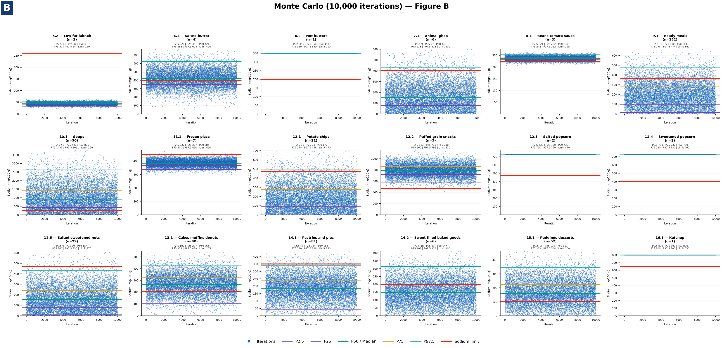
Figure A2. Monte Carlo–Modeled Sodium Distributions Across Food Subgroups (Part II)

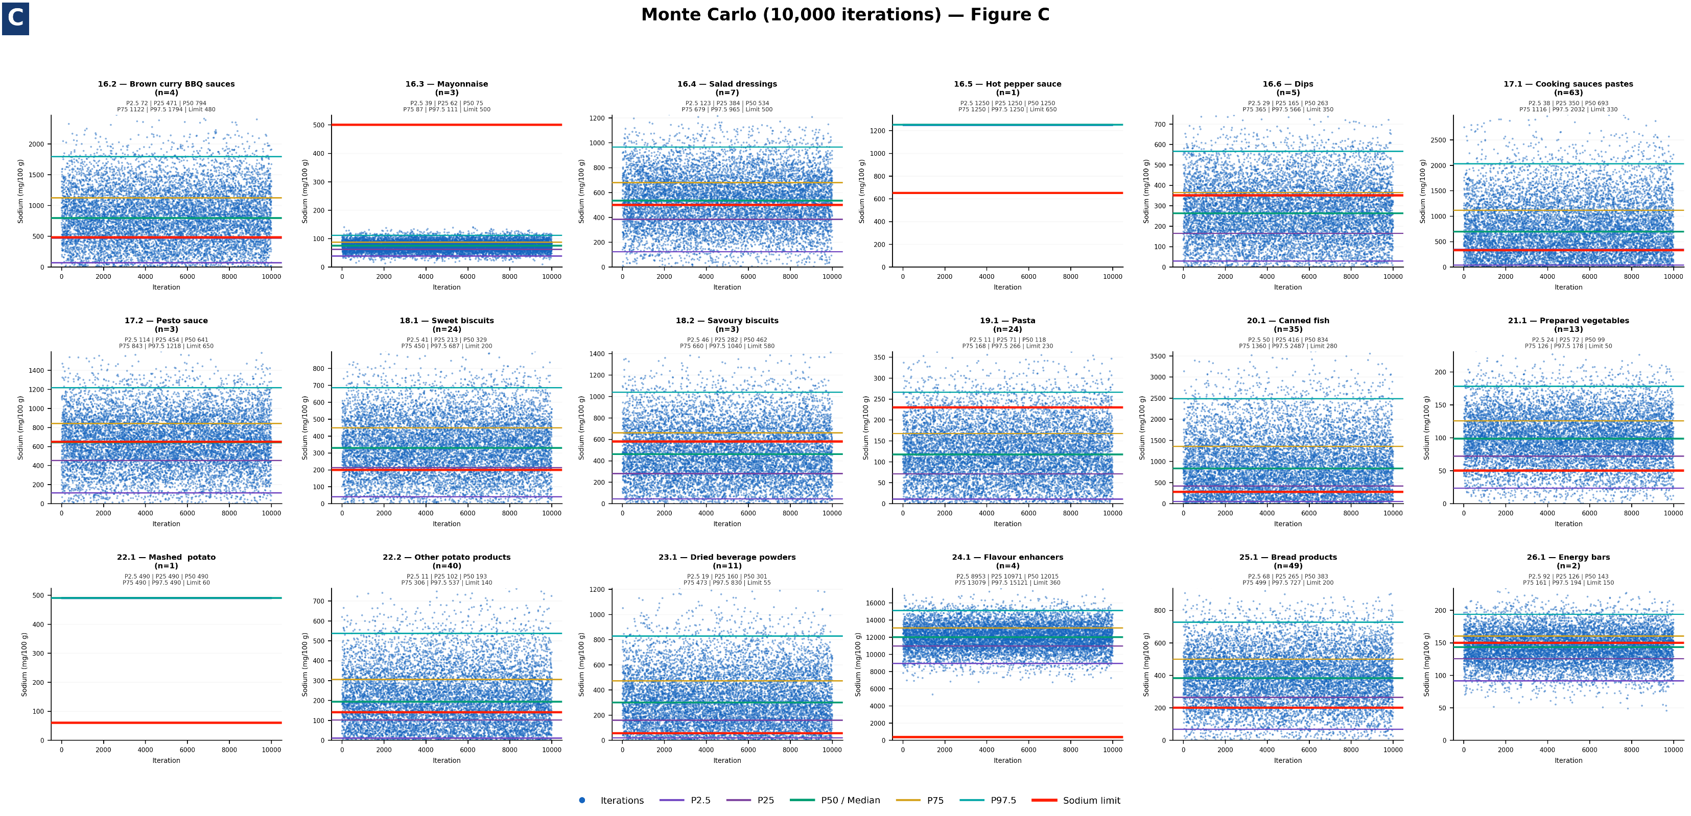
Figure A3. Monte Carlo–Modeled Sodium Distributions Across Food Subgroups (Part III)

