Supplementary Figures Kumar et al “Adaptation of central metabolite pools to variations in growth rate and cultivation conditions in Saccharomyces cerevisiae”

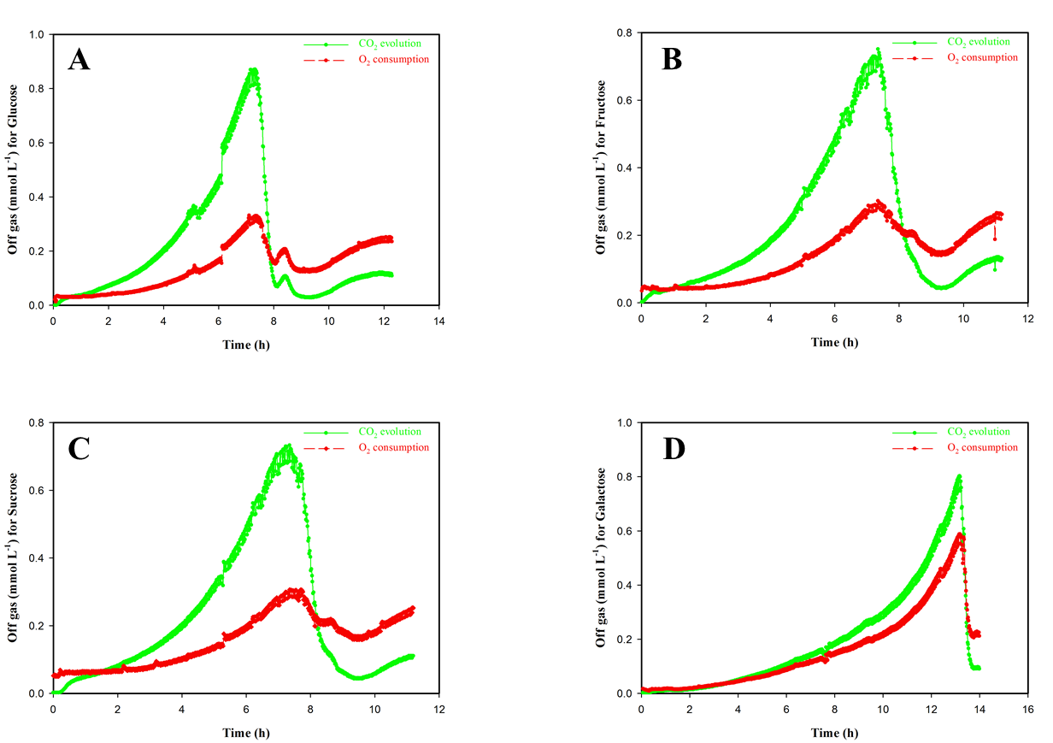

Supplementary Figure S1. CO₂ evolution and O₂ consumption curve of Saccharomyces cerevisiae CENPK when cultivated in batch using different carbon sources A) Glucose B) Fructose C) Sucrose D) Galactose

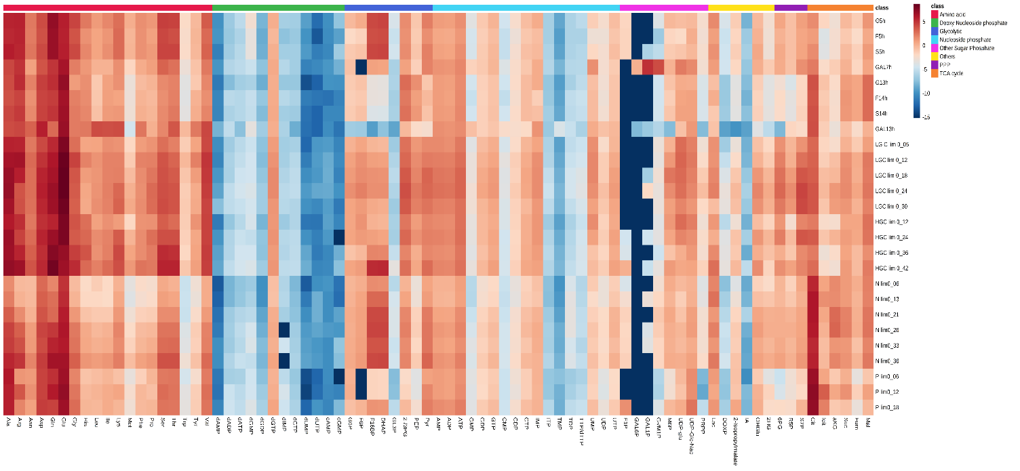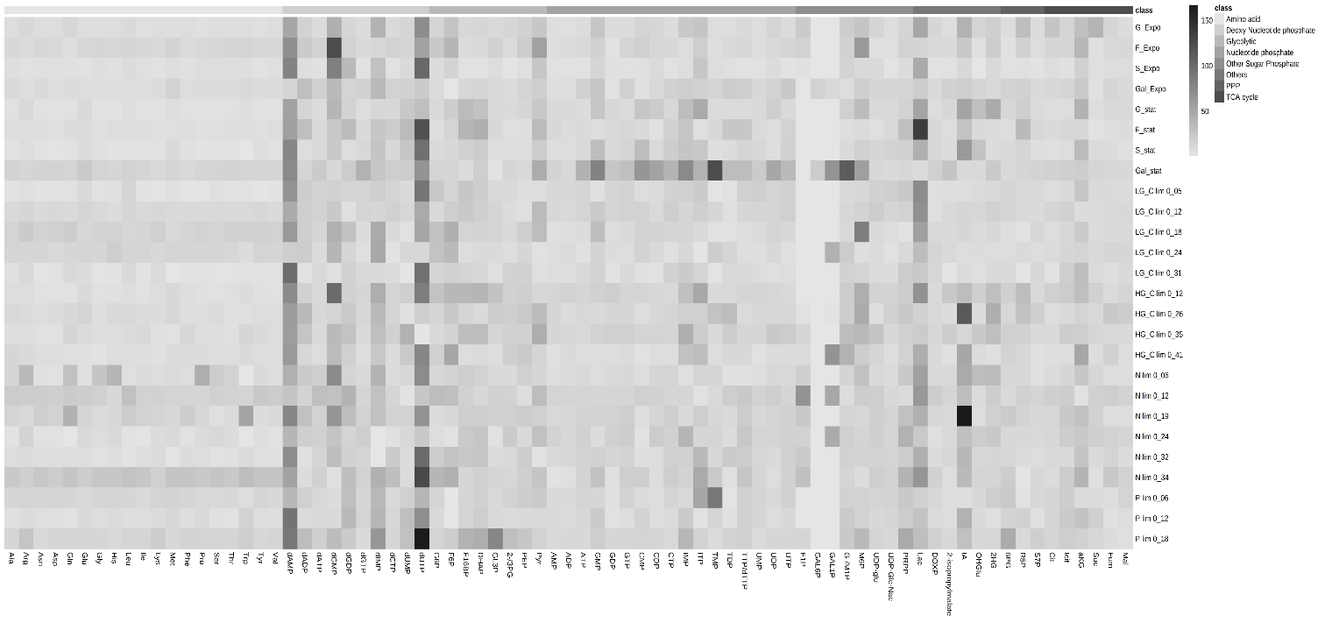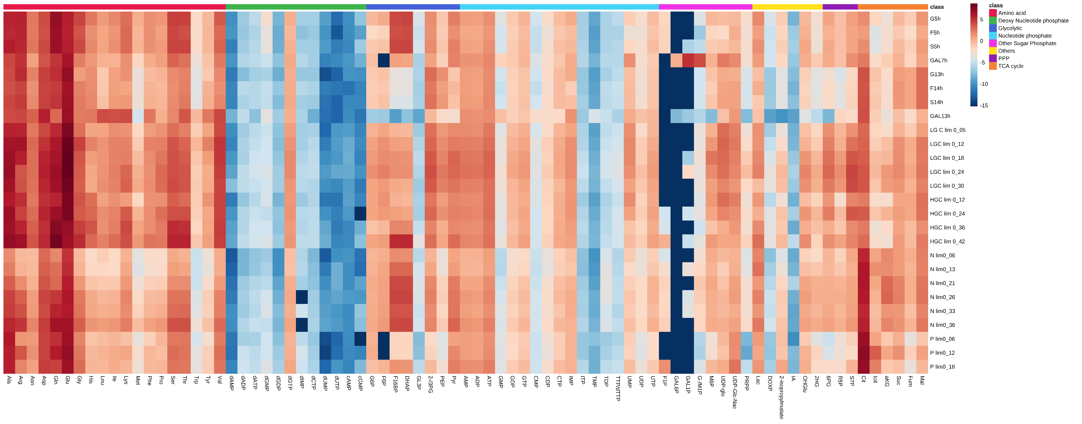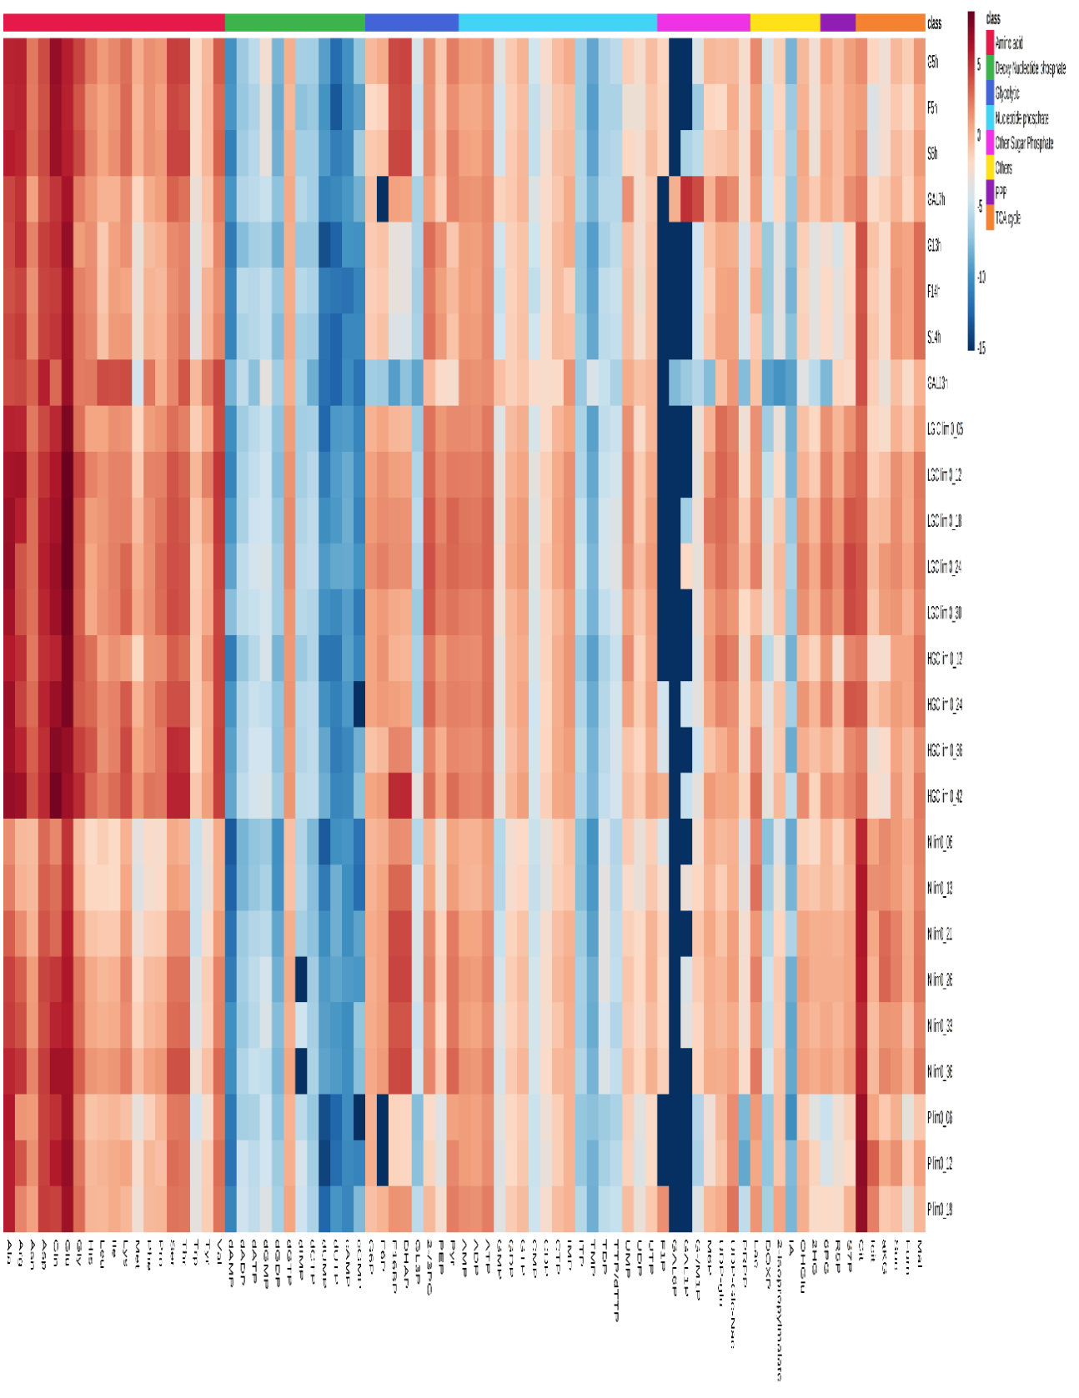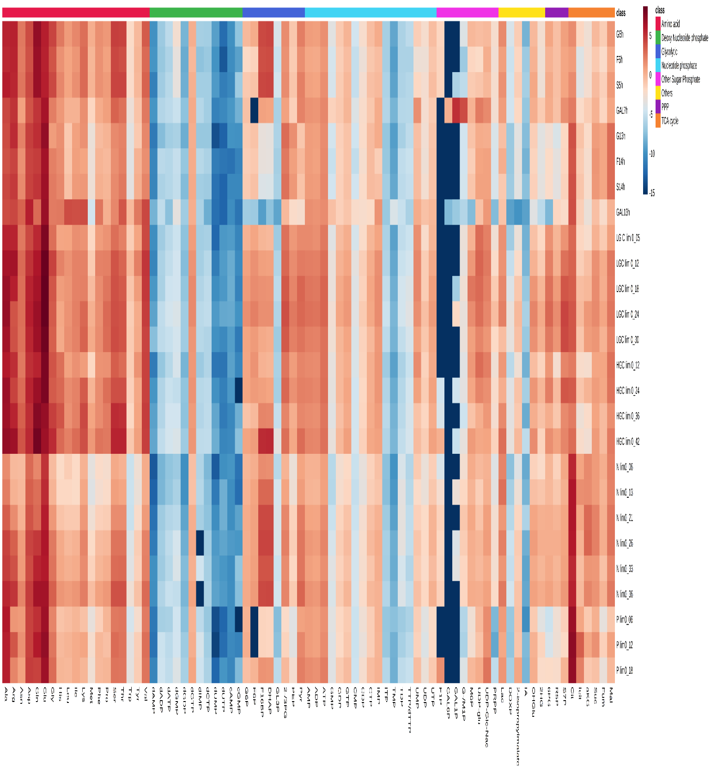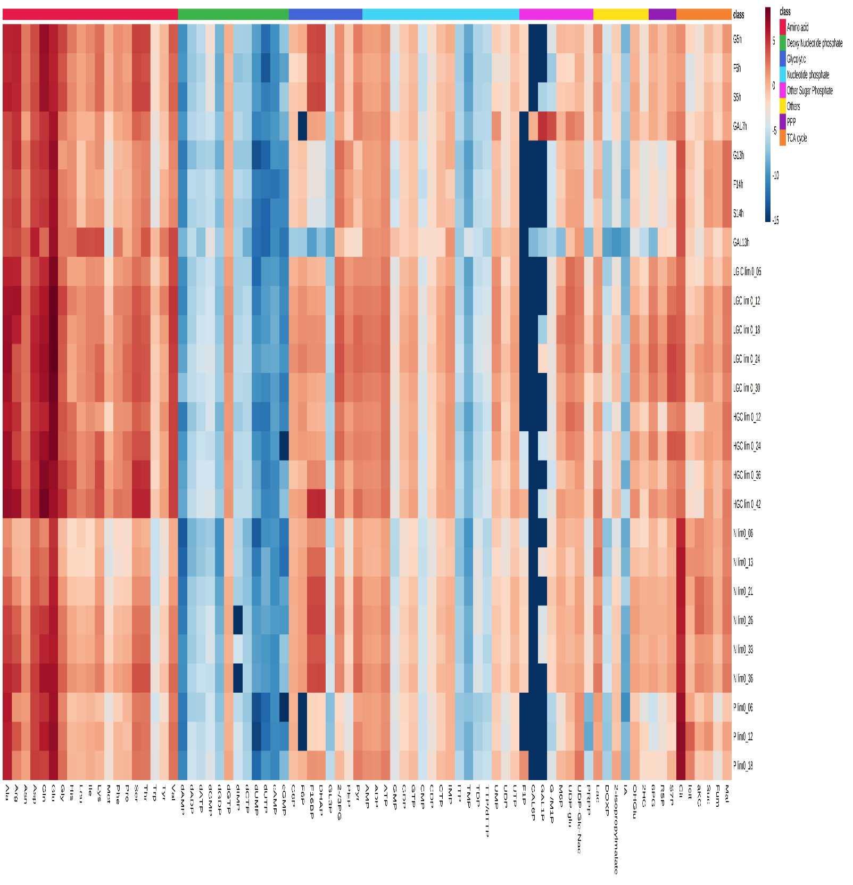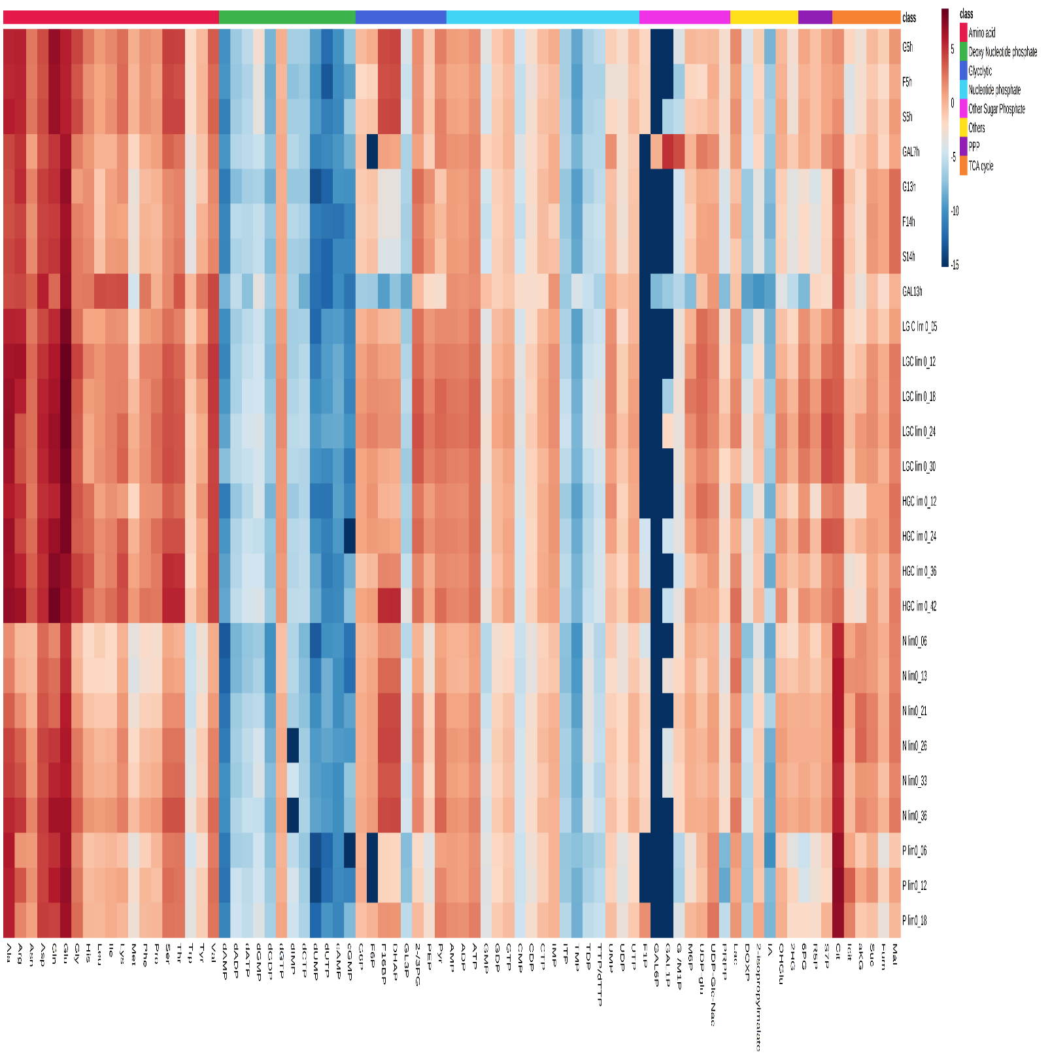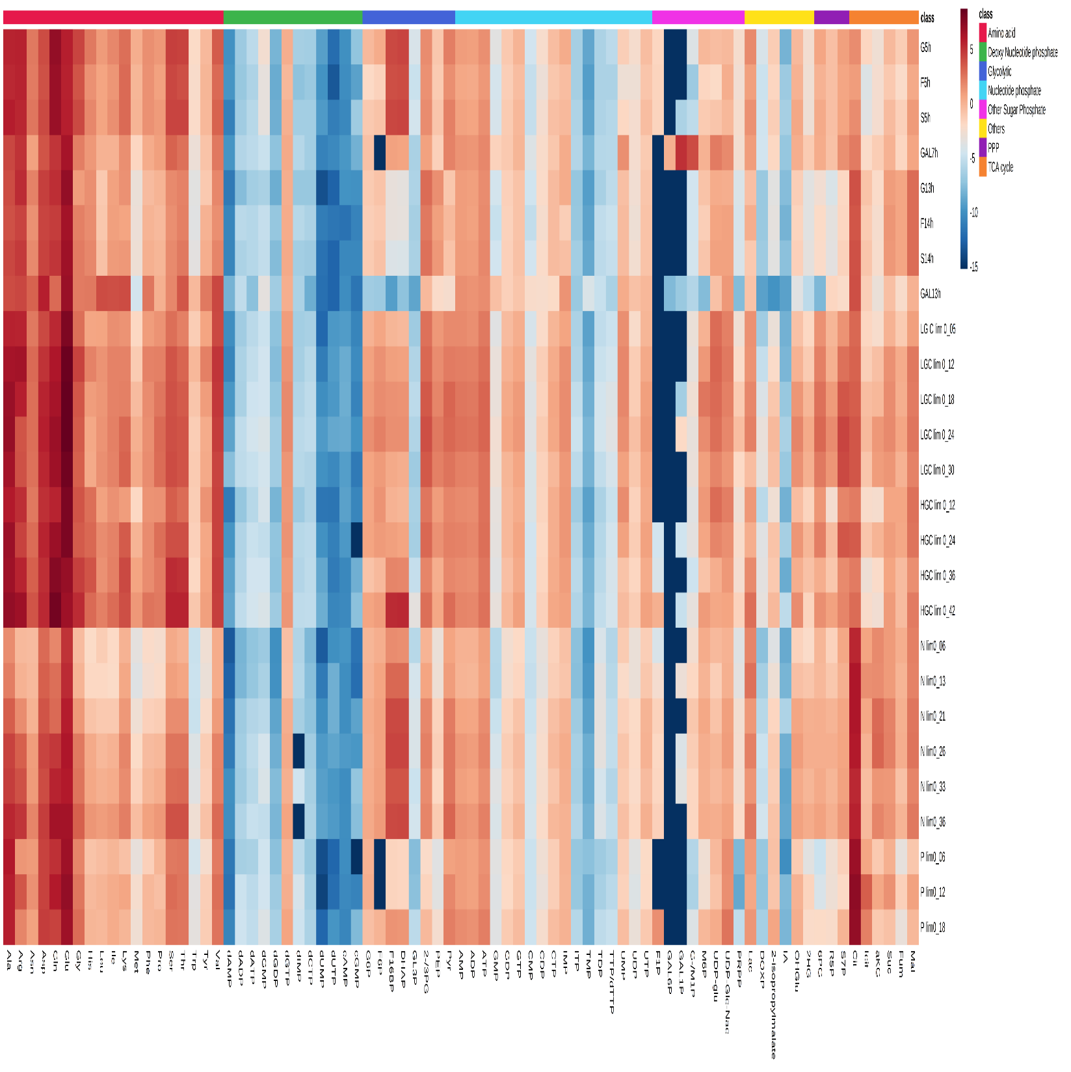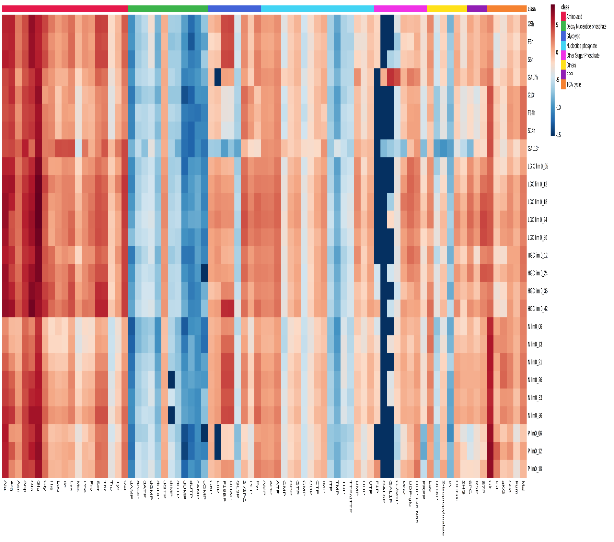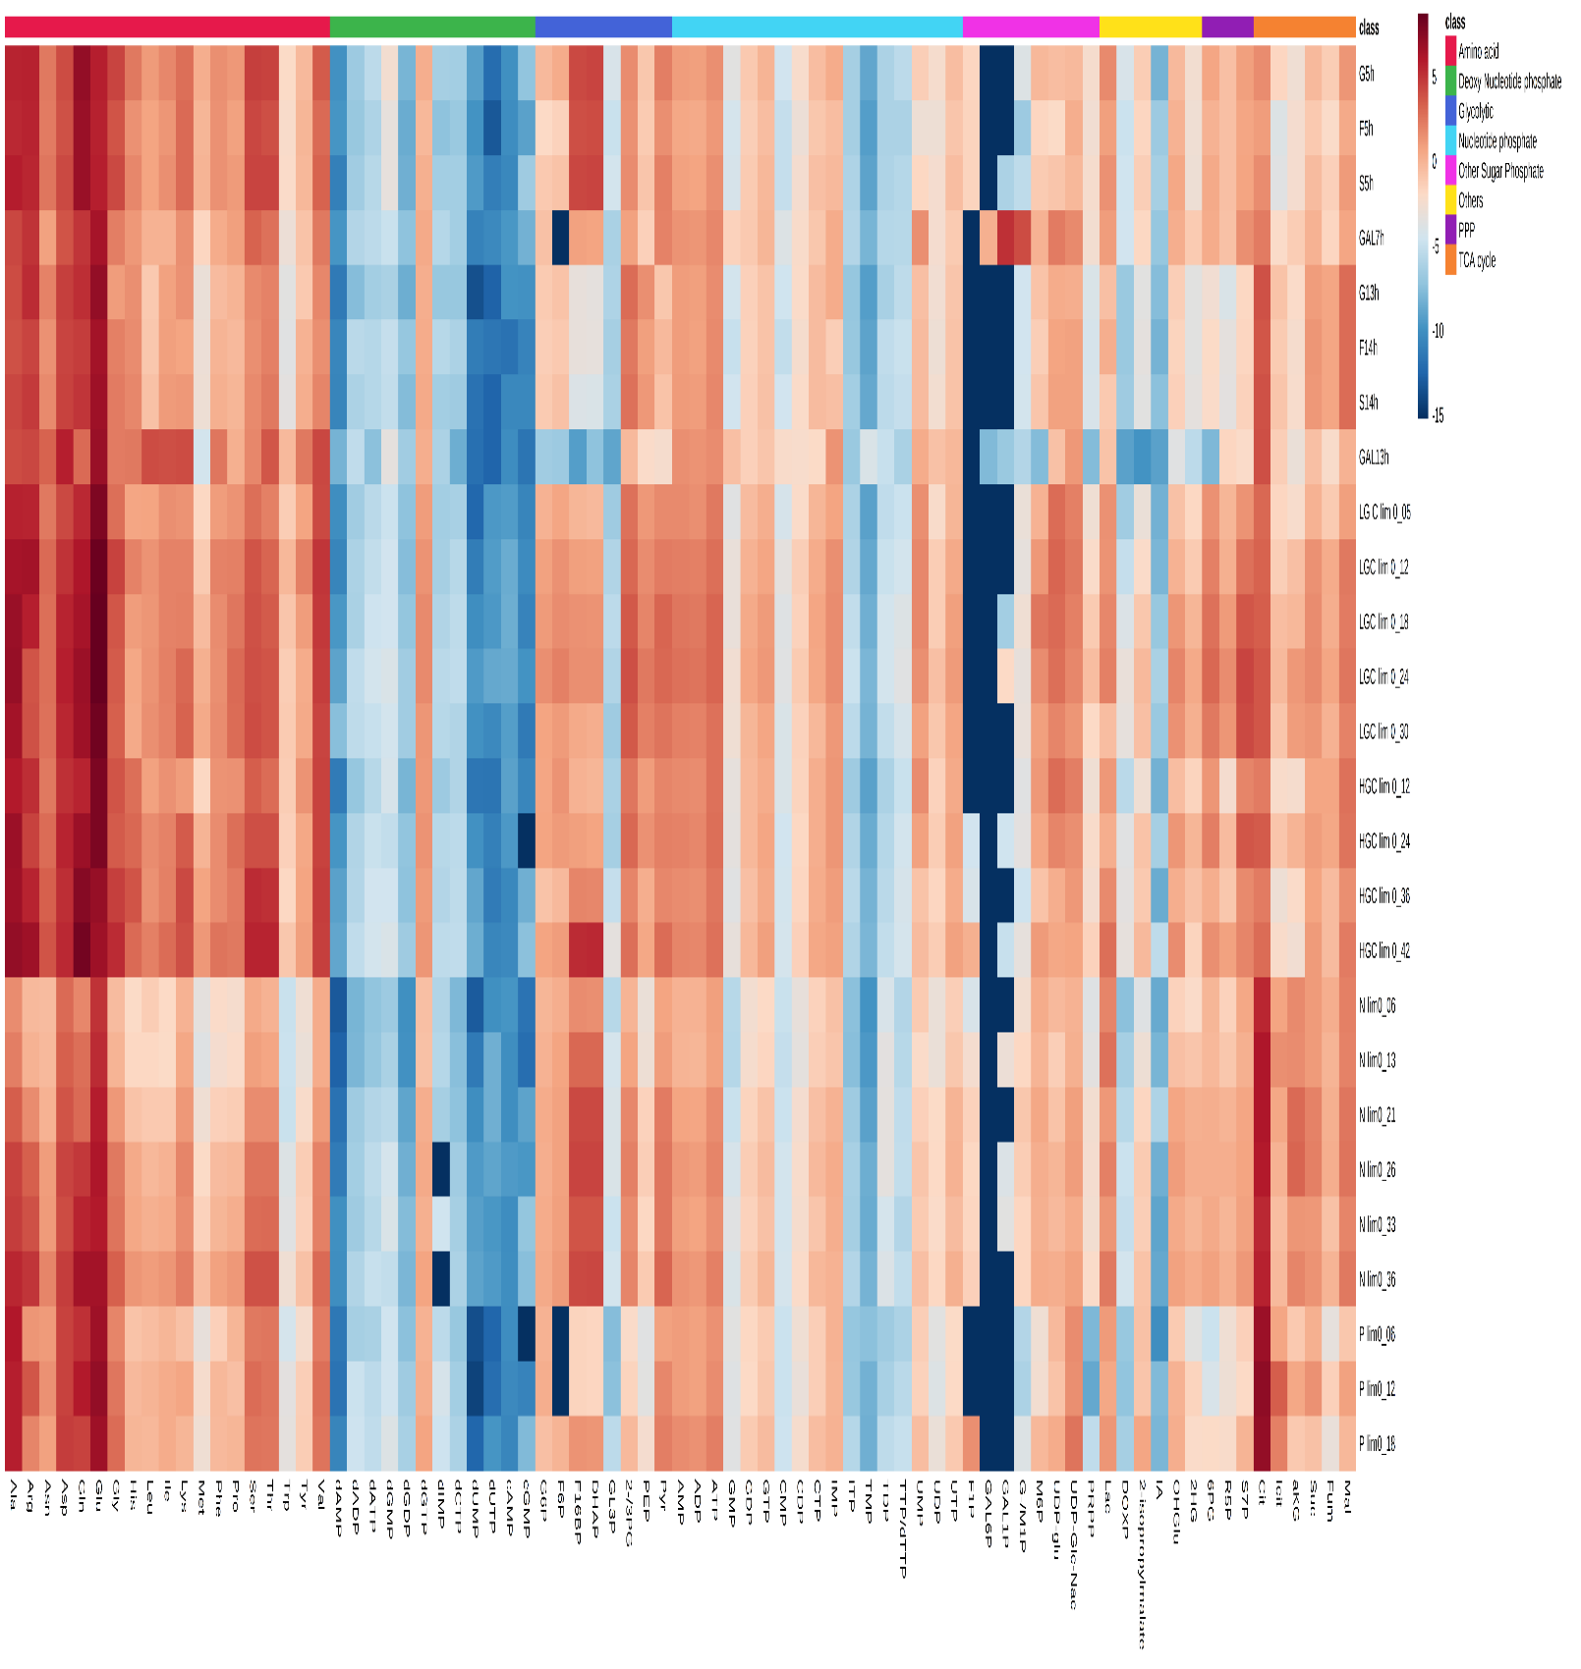
Supplementary Figure S2. Heat-map showing relative standard deviation of intracellular metabolites for four independent samples.

Suppmentary Figure S3. Metabolites variations (symbol, left and right error indicate average, minimum and maximum value of metabolite, respectively) across different cultivation conditions under current study on absolute concentration scale (Left panel), and log2 of lowest (left bar range) and highest (right bar range) concentration, normalized by subtracting log2 of average for each metabolite from their lowest and highest value (Right panel).

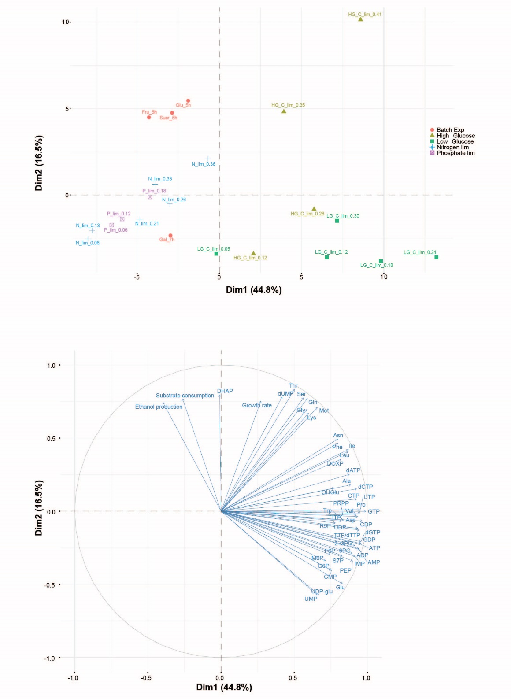
Supplementary Figure S4. PCA scores (upper panel) and loadings (lower panel, top 50 metabolites) plots of merged extracellular rates - and endometabolite data from all cultivations except stationary batch phase. Gal1P and Gal6P were removed from analysis since <LOD for most conditions and data was normalized to sum and autoscaled before analysis.

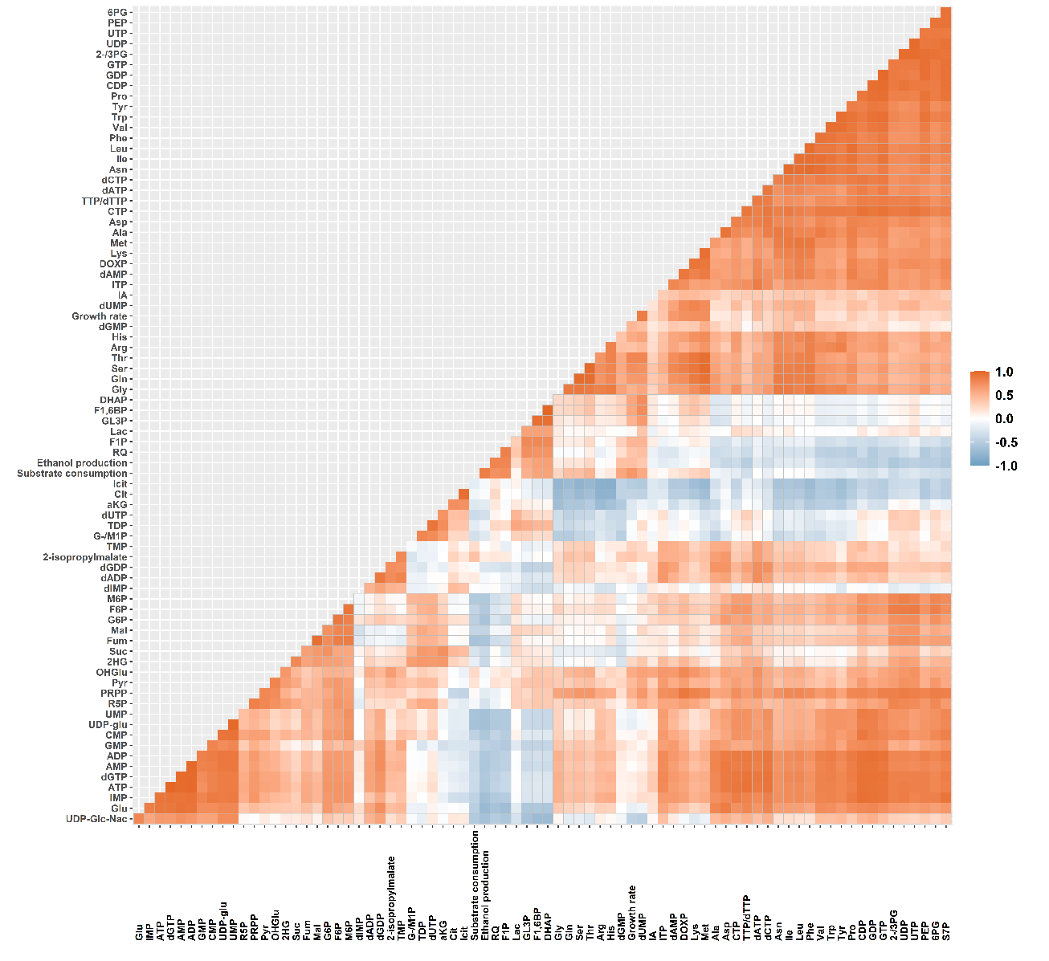
Supplementary Figure S5. Spearman rank correlation of combined exo and endo metabolite data for all cultivation conditions, except batch stationary phase.

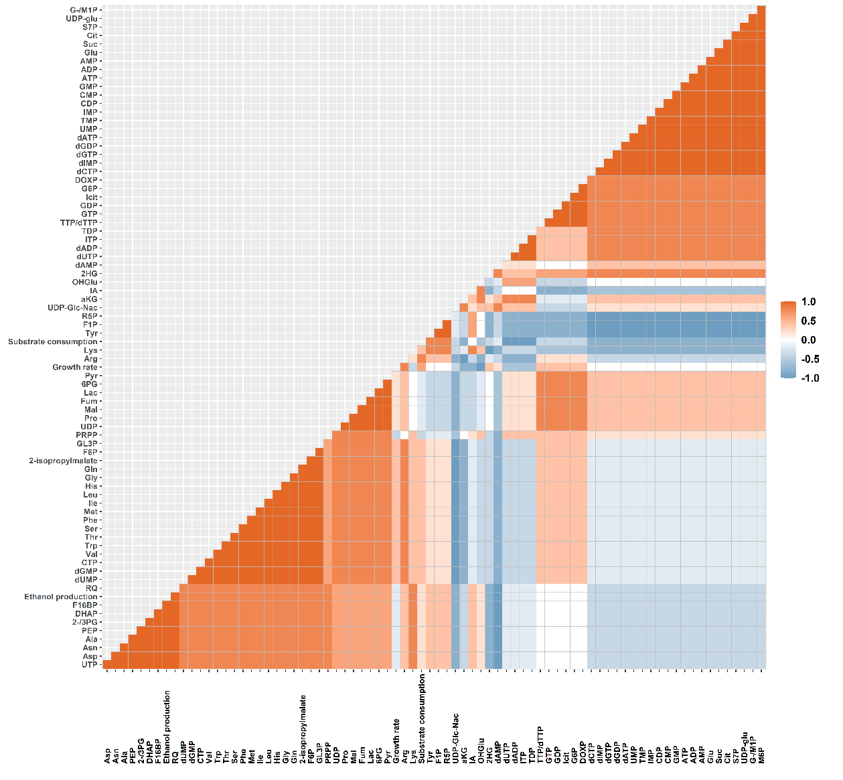
Supplementary Figure S6. Spearman rank correlation of combined exo and endo metabolite data for the four batch growth phase conditions.

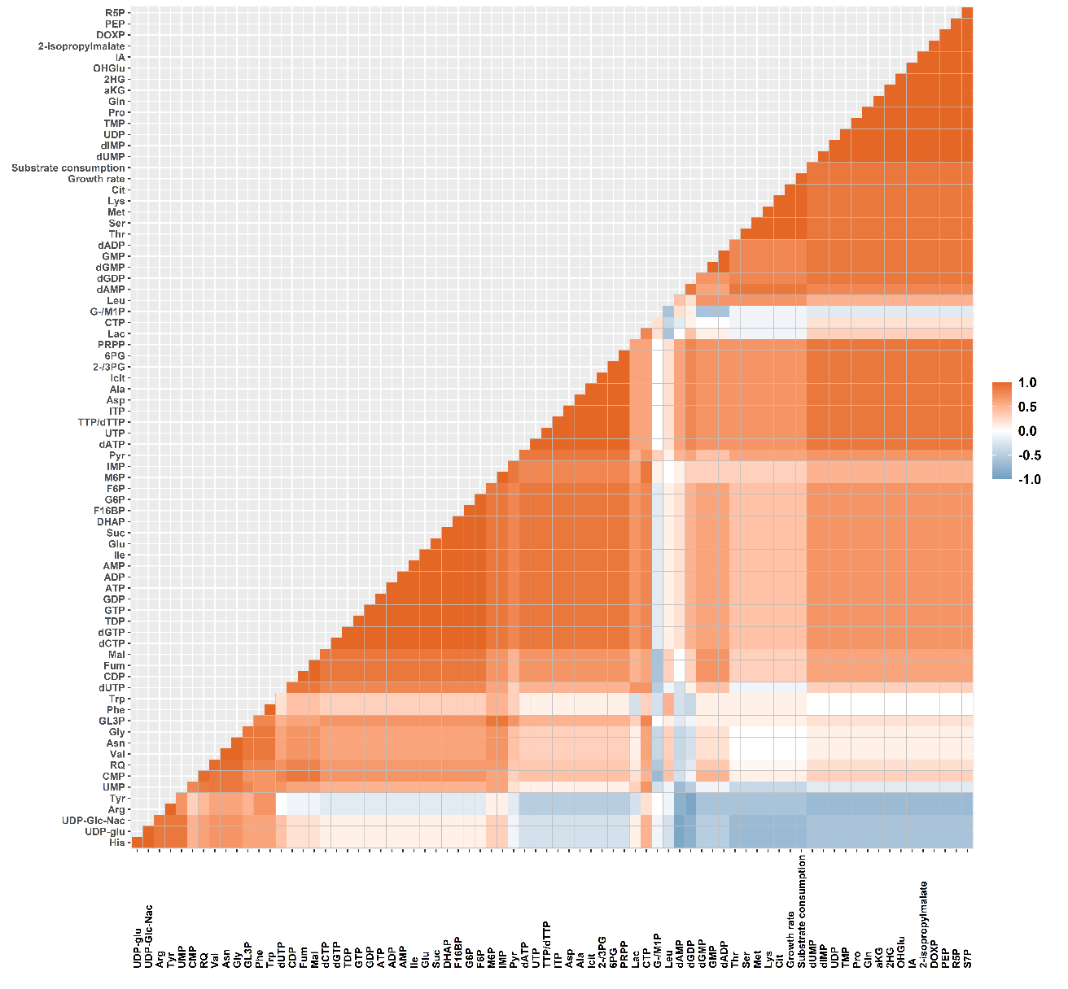
Supplementary Figure S7. Spearman rank correlation of combined exo and endo metabolite data for the Low Glucose limited chemostats.

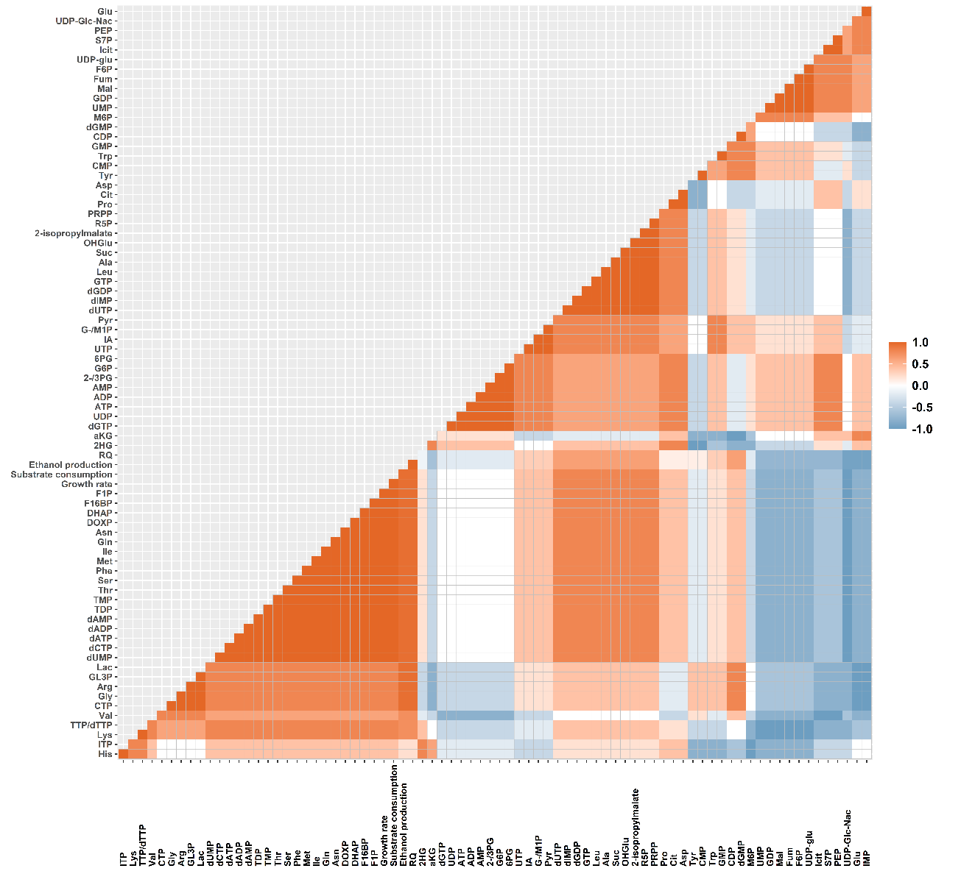

Supplementary Figure S8. Spearman rank correlation of combined exo and endo metabolite data for the High Glucose limited chemostats.

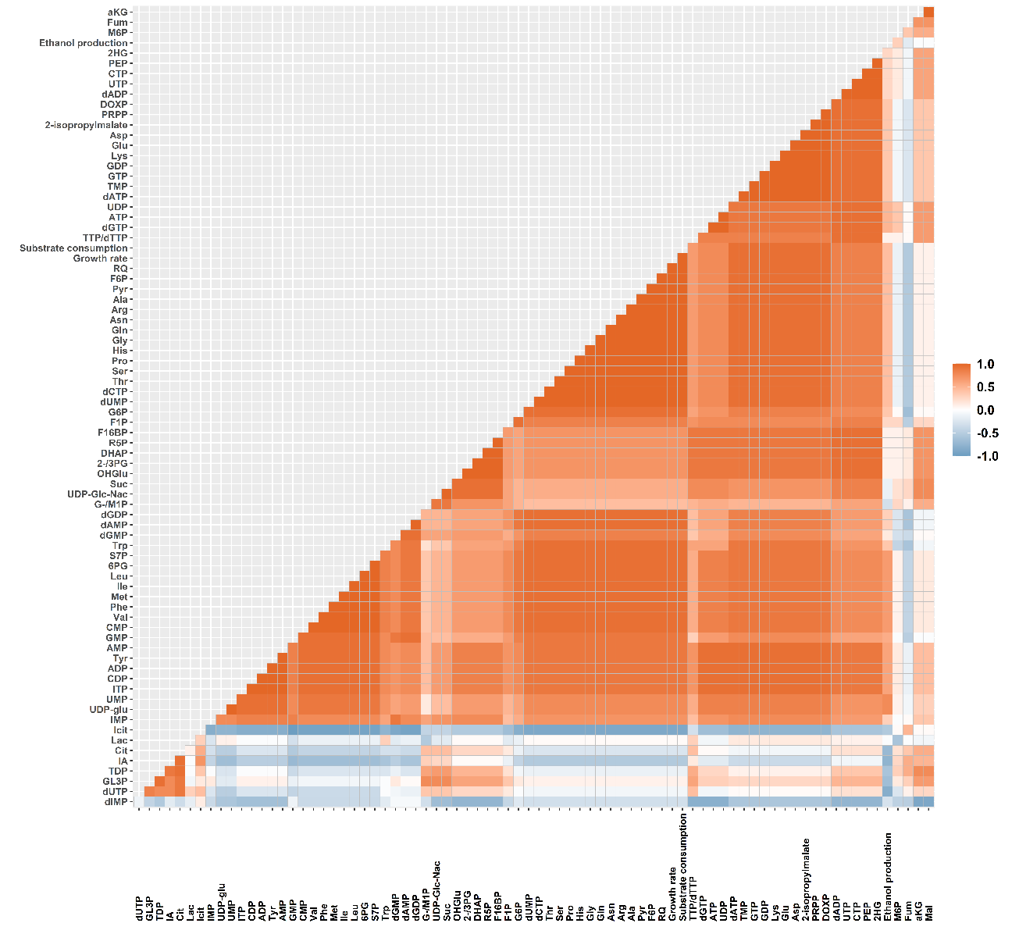

Supplementary Figure S9. Spearman rank correlation of combined exo and endo metabolite data for the Nitrogen limited chemostats.

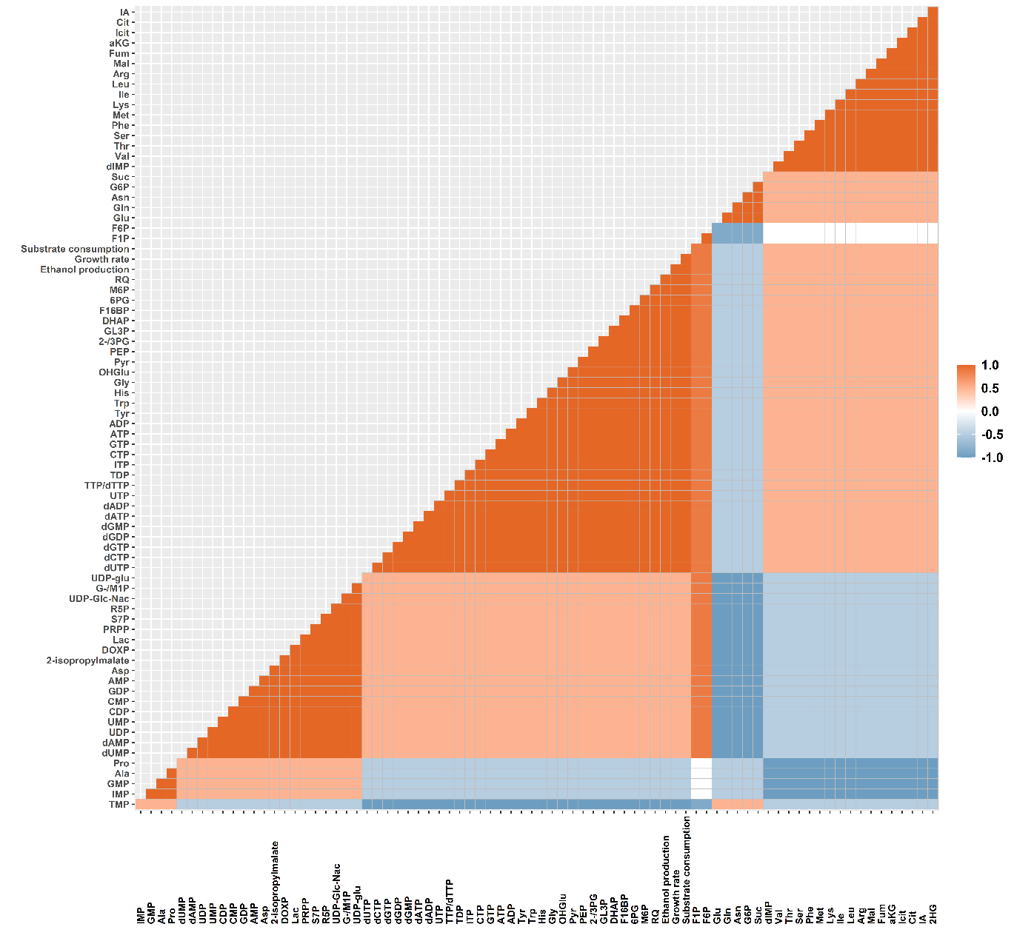
Supplementary Figure S10. Spearman rank correlation of combined exo and endo metabolite data for the Phosphate limited chemostats.

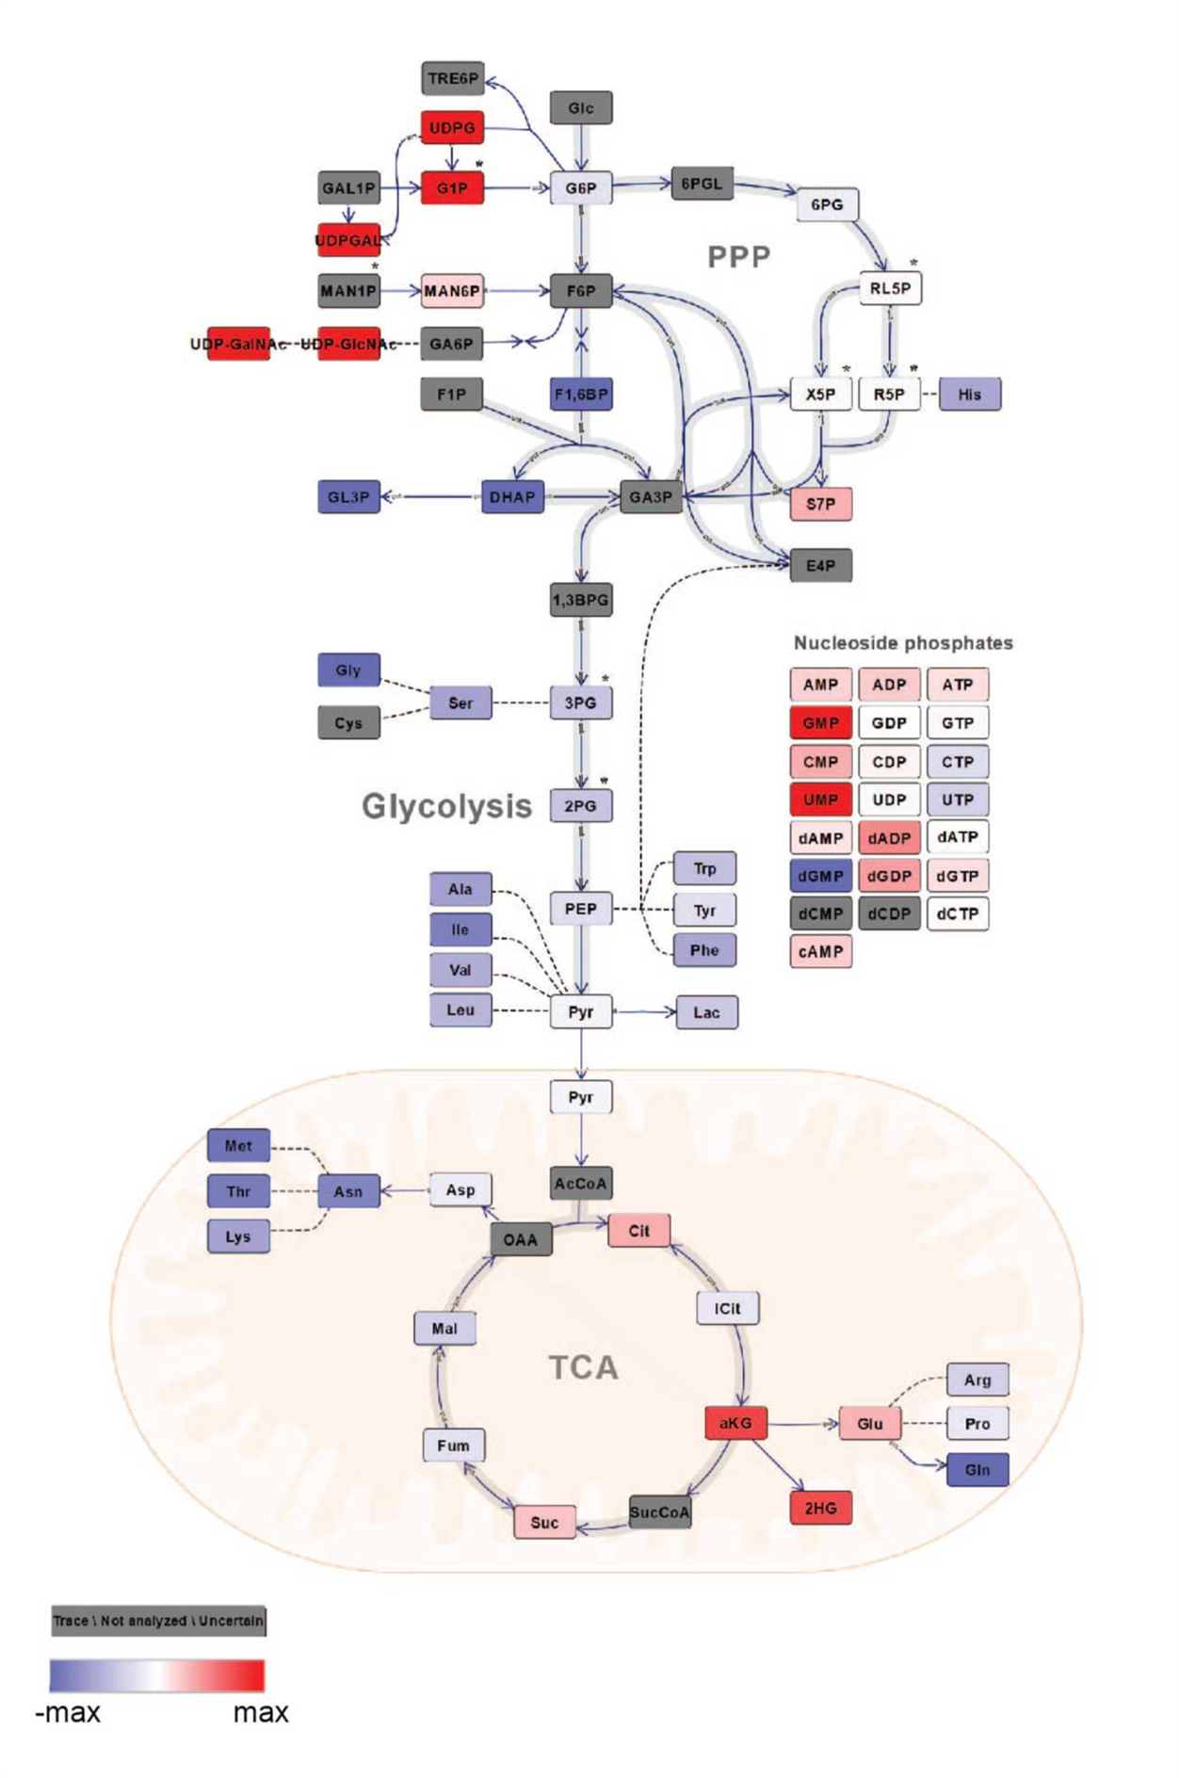

Supplementary Figure S11. A plot showing changes in the metabolites of central metabolic pathways. This plot is plotted based on logarithmic value (base 2) of ratio of intracellular metabolites concentration of yeast cultivated on galactose to yeast cultivated on glucose’ in exponential phase of batch operation. GAL1P is highly expressed in galactose but not detected in glucose grown yeast in batch reasoning gray color in plot.

