Supplemental materials

A

B
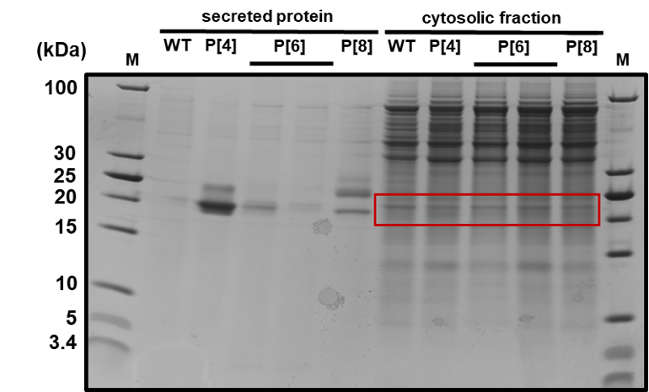
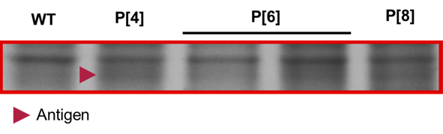

Fig. S1. Titers of antigen expression. A) Secreted titers of each NRRV antigen variant produced in 3 mL, plate-based cultures. Titer was calculated using SDS-PAGE and densitometry, with comparison to a known standard. B) SDS-PAGE of supernatant and intracellular lysates from expression of original serotypes. No significant amount of P[6] antigen was detected in cell lysates.

A
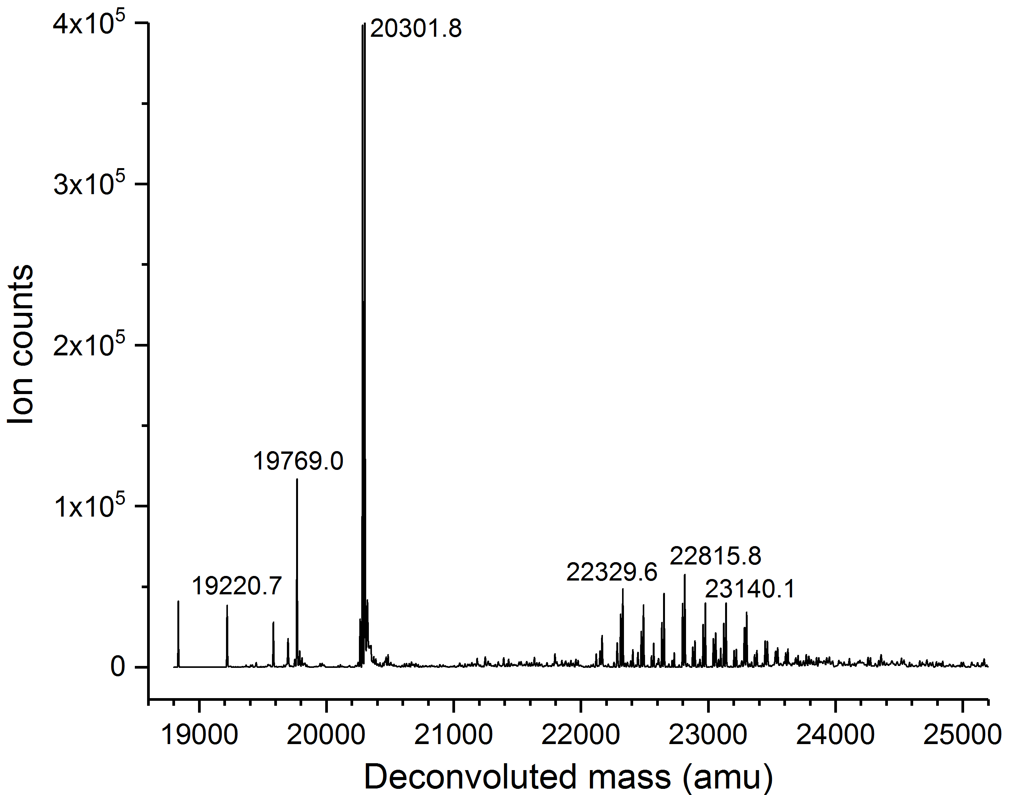

B
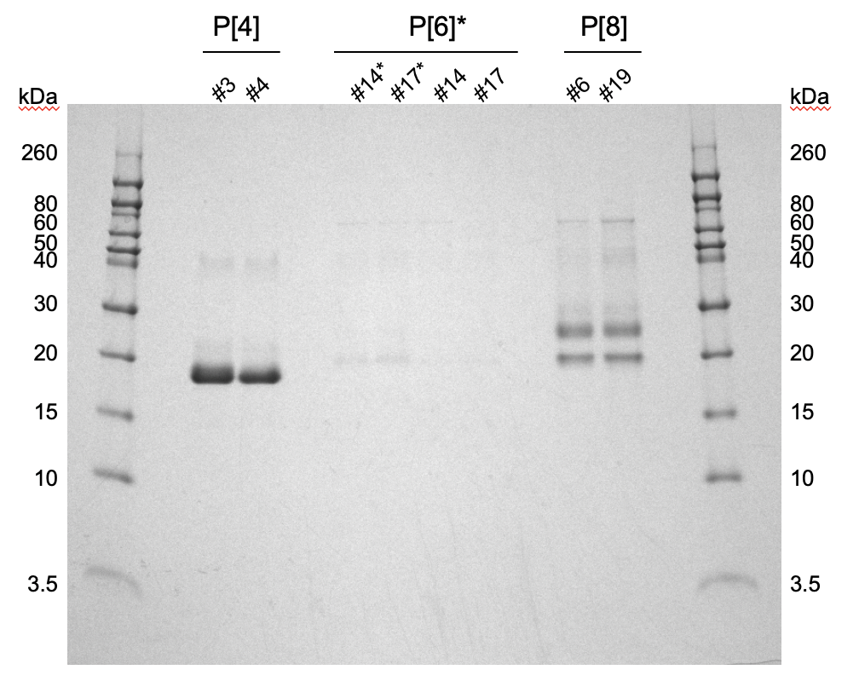

Fig. S2. Quality analyses of antigens. A) Mass spectrum of P[8] from intact LCMS showing putative full-length, aglycosylated P[8] (~20.3 kDa) and high-mannose variants of P[8] (>22 kDa). B) Non-reduced SDS-PAGE of P[4], P[6], and P[8] supernatants. P[6] samples with an asterisk are concentrated 5x. Dimer and higher aggregates are visible in P[4] and P[8] lanes.

A

Fig. S3. Glycosylation removal in P[8]. A) Mass spectra of P[8] variants, indicating the removal of hypermannosylated product variants with the introduction of N85Q and N151Q mutations.

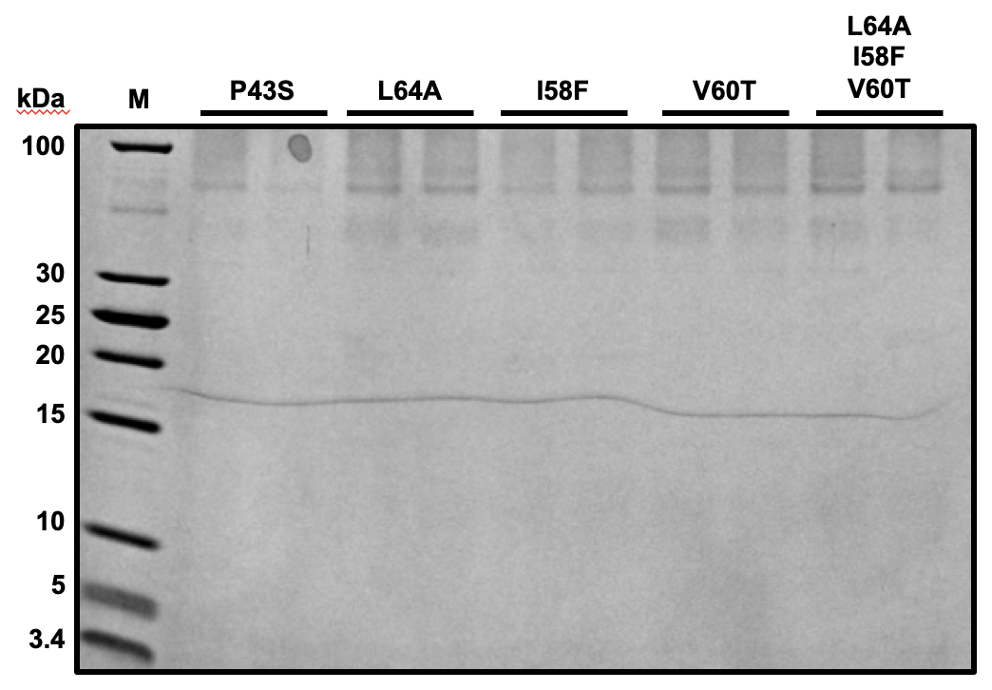

Fig. S4. Hydrophobic region mutations in P[6]. A) SDS-PAGE of sequence variants of P[6] with reduced hydrophobicity. Expected product size is ~20 kD.

D

Fig. S5. Animal study results. Titer over time of neutralizing antibodies generated in guinea pigs against A) P[8], B) P[4], and C) P[6] virus strains. Each line represents one animal, vaccinated with the antigen indicated at right. Animals were immunized at 0, 14, and 28 days for a total of three doses. Lines extending above the chart limits indicate a titer of 40,960, or 10,240 for ST3 G4P[6]. D) Cross reactivity of serum across all seven antigens by ELISA for IgG antibodies. Serum from all animals in each group was pooled.

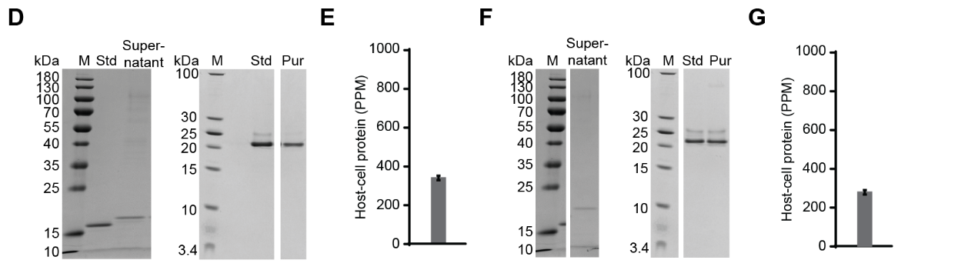

Fig. S6. Process development of individual antigens. A) Schematic and B,C) process development data for an end-to-end production run of engineered P[8]. D-G) Purification development of engineered versions of P[4] (D,E), and P[6] (F,G). Cells were cultured in shake flasks, and supernatant was purified using the same process as engineered P[8].

A B
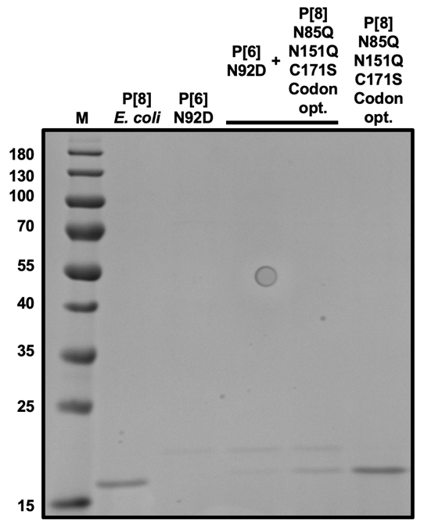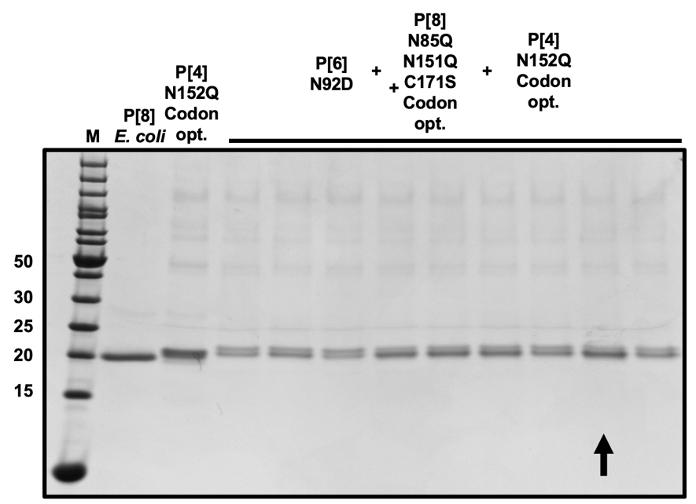

C D
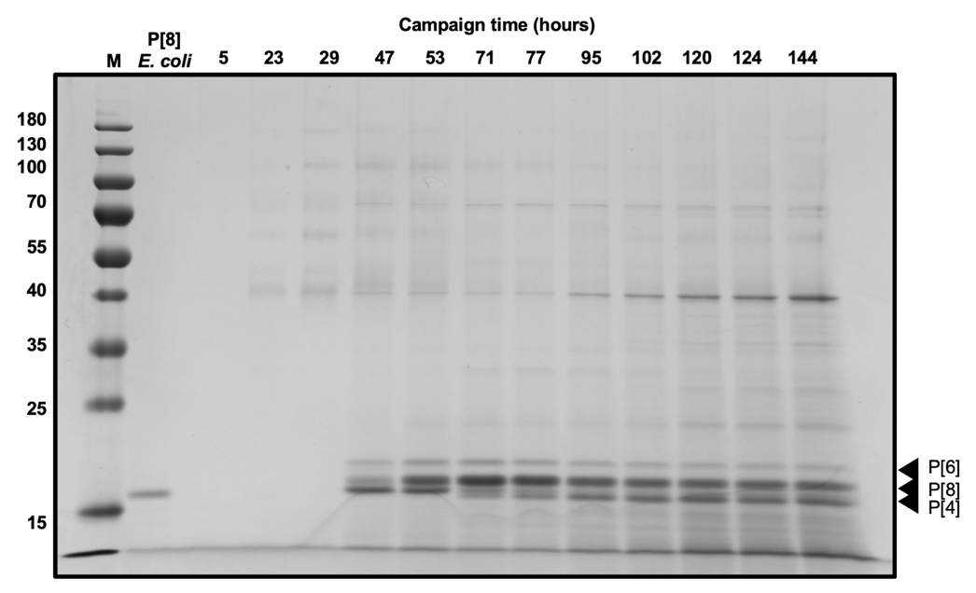

Fig. S7. Expression of all three NRRV antigens. A) SDS-PAGE of supernatant of two clones that express engineered P[8] in a background strain expressing engineered P[6]. B) SDS-PAGE of supernatant of cells that express all three antigens. Cells were cultivated at 3 mL plate scale. The strain marked with an arrow was carried forward to reactor scale. C) SDS-PAGE of bioreactor samples across the campaign. All three engineered antigens are visible by SDS-PAGE. D) Concentration of host cell protein in purified product pools, as measured by host cell protein ELISA for K. phaffii.

Table S1. Accessibility scores of potential N-linked glycosylation sites in P[8], identified with NetNGlyc.

Index | N-X-S/T | Accessibility score
53 | N-N-S | 0.2
85 | N-V-S | 0.7
88 | N-D-S | 0.2
151 | N-I-S | 0.9

Table S2. Normalized enrichment scores for gene sets significantly enriched (p-adj <0.05) in genes differentially expressed between serotype-expressing strains.
Gene ontology - biological process | P[6] vs. Null | P[6] vs. P[4] | P[6] vs. P[8]
cytoplasmic translation | 2.19 | 2.52 | 2.19
translocation | 1.92 | 1.81
protein glycosylation | 2.13 | 2.22 | 2.02
cell wall organization or biogenesis | 2.38 | 2.18 | 2.28
DNA replication | 1.78 | 1.96 | 2.20
carbohydrate metabolic process | 1.68 | 1.88 | 2.18
DNA repair |  | 1.79 | 2.16
telomere organization | 1.89 | 1.78 | 1.95
cell budding | 1.80 | 1.72 | 1.97
DNA recombination |  | 1.66 | 2.04
cellular response to DNA damage stimulus |  | 1.63 | 2.02
signaling | 1.73 | 1.55 | 1.65
cytoskeleton organization | 1.68 | 1.51 | 2.11
Golgi vesicle transport | 1.65 | 1.51 | 1.39
cell morphogenesis |  |  | 1.84
chromatin organization |  |  | 1.50
chromosome segregation |  |  | 1.97
cofactor metabolic process |  |  | 1.63
conjugation | 1.78 |  | 1.80
cytokinesis |  |  | 1.75
generation of precursor metabolites | -1.74 |  | 1.82
meiotic cell cycle |  |  | 1.89
mitochondrial translation |  |  | -2.01
mitotic cell cycle | 1.62 |  | 1.93
monocarboxylic acid metabolic process |  |  | 1.61
mRNA processing |  |  | -1.61
small molecule metabolic process |  |  | 2.06
organelle fission |  |  | 1.96
protein folding |  |  | -2.26
regulation of cell cycle |  |  | 1.70
regulation of protein modification |  |  | 1.57
regulation of transport | 1.68
ribosomal large subunit biogenesis |  |  | -1.52
ribosomal small subunit biogenesis | 1.81 |  | -1.72
RNA modification |  |  | -2.12
RNA splicing |  |  | -1.63
rRNA processing | 1.70 |  | -2.10
sporulation |  |  | 1.59
transposition |  |  | 1.69
tRNA processing |  |  | -1.77
vitamin metabolic process | -2.41
Table S3. Animal study groups.

Host | Antigen | N | Notes
E. coli | P[8] | 5 | 1 animal died
E. coli | P[6] | 5
E. coli | P[4] | 5
K. phaffii | P[8]-N85Q-N151Q-C171S-Codon opt. | 5
K. phaffii | P[6]-N92D | 5
K. phaffii | P[4]-N152Q-Codon opt. | 5
K. phaffii | P[4] | 5
--- | RVA trivalent | 6
--- | Buffer | 5

