Extended data figures
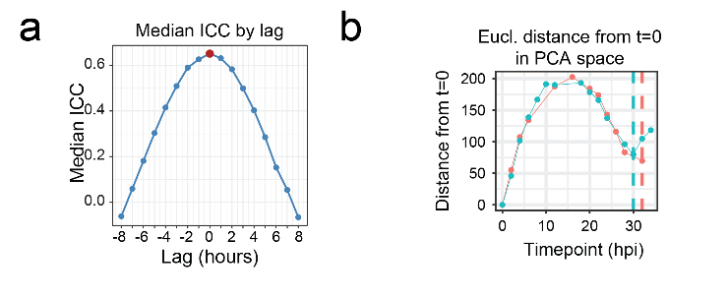
Extended Data Figure 1. a Dependency of the ICC correlation between two replicates on potential lag shows that the two replicates are synchronous within 2-hour window. b Euclidean distances between timepoint 0 and other timepoints in the PCA space estimate the IDC length to 31 hours.

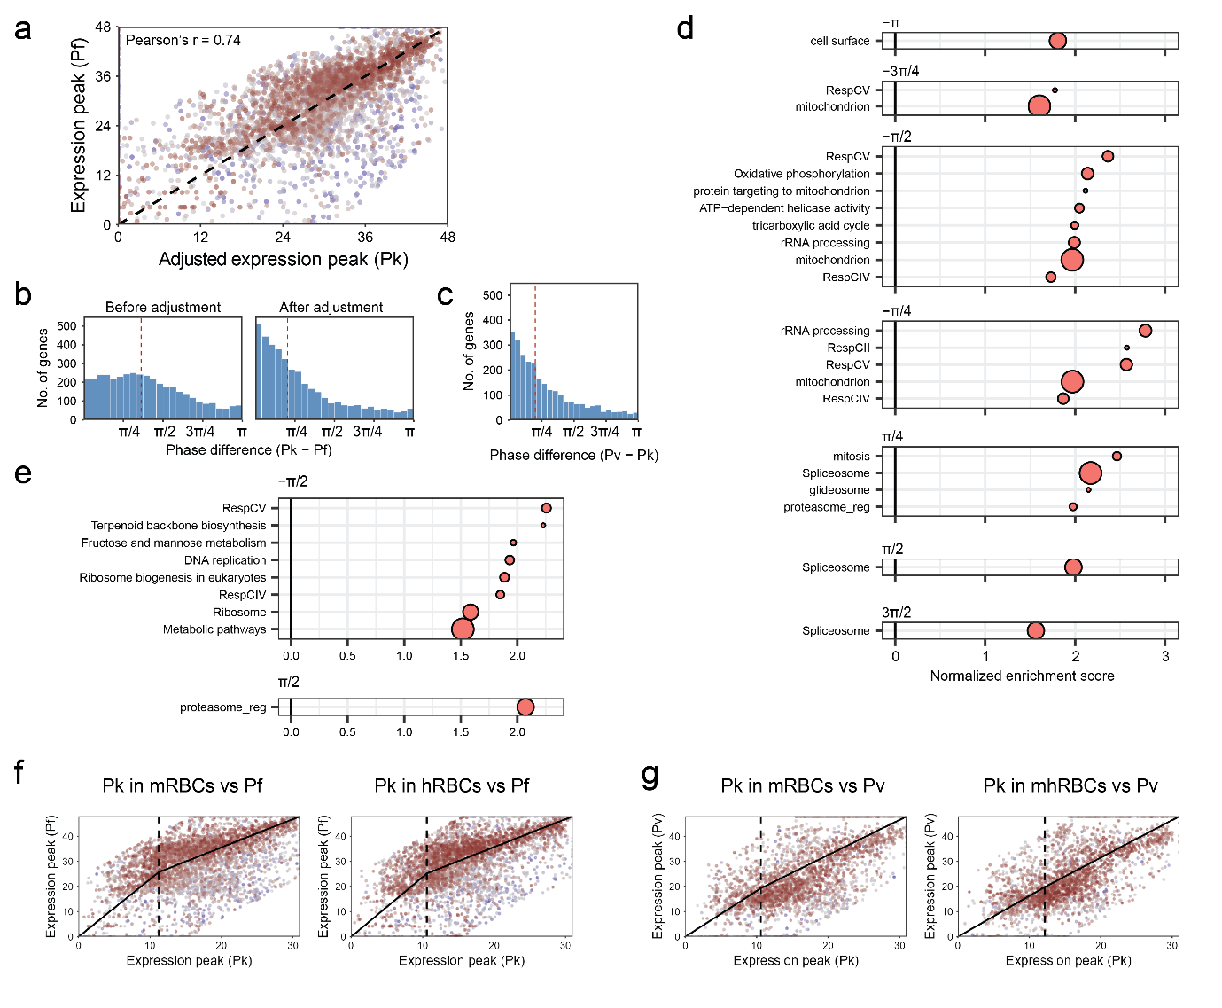
Extended Data Figure 2. a Gene expression peaks show a linear correlation between P. knowlesi and P. falciparum after the adjustment of P. falciparum expression by two-segment function. b Absolute phase differences between genes of P. knowlesi and P. falciparum before and after adjustment. c Phase differences between genes of P. knowlesi and P. vivax. d One-sided GSEA across different gene expression time shifts between P. knowlesi and P. falciparum. e One-sided GSEA across different gene expression time shifts between P. knowlesi and P. vivax. f-g Correlation between expression peak times of P. knowlesi grown in macaque or human RBCs and P. falciparum (f) or P. vivax (g).

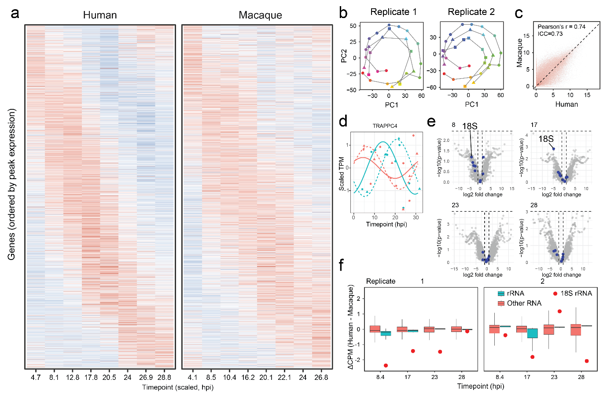
Extended Data Figure 3. a Heatmap of scaled gene expression TPM values of P. knowlesi cultured in human or macaque blood, replicate 2. b PCA plots with human (square points) and macaque triangle points) overlayed on top of the consensus IDC (round points). c Correlation between log2 TPM values of P. knowlesi genes grown in human and macaque RBCs. d Expression profile of TRAPP complex subunit 4 in hRBCs and mRBCs. e Differential expression analysis at 4 timepoints. rRNAs are blue. f Difference in CPM (counts per million) values between hRBCs and mRBCs, comparing the distribution of rRNA and other RNA. 18S rRNA is highlighted by the red point.

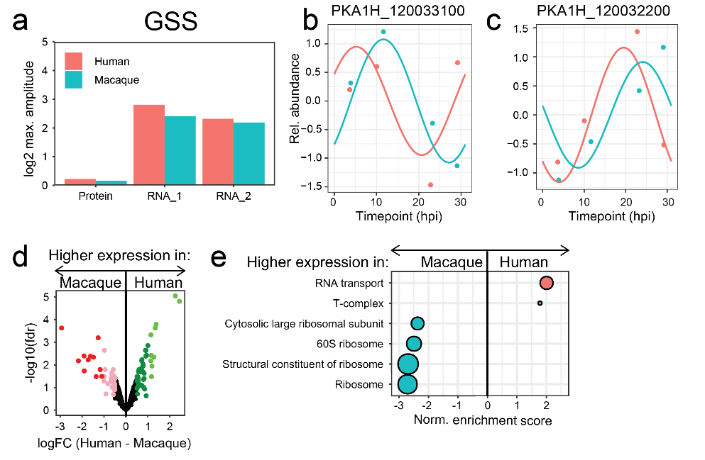
Extended Data Figure 4. a Protein and RNA expression amplitudes of glutathione synthetase (GSS). b-c Gene expression profiles of glucose-6-phosphate dehydrogenase-6-phosphogluconolactonase (b) and 6-phosphogluconate dehydrogenase (c). d Differential expression analysis of proteins across the entire IDC. e Terms enriched by GSEA based on logFC values from the differential expression analysis.

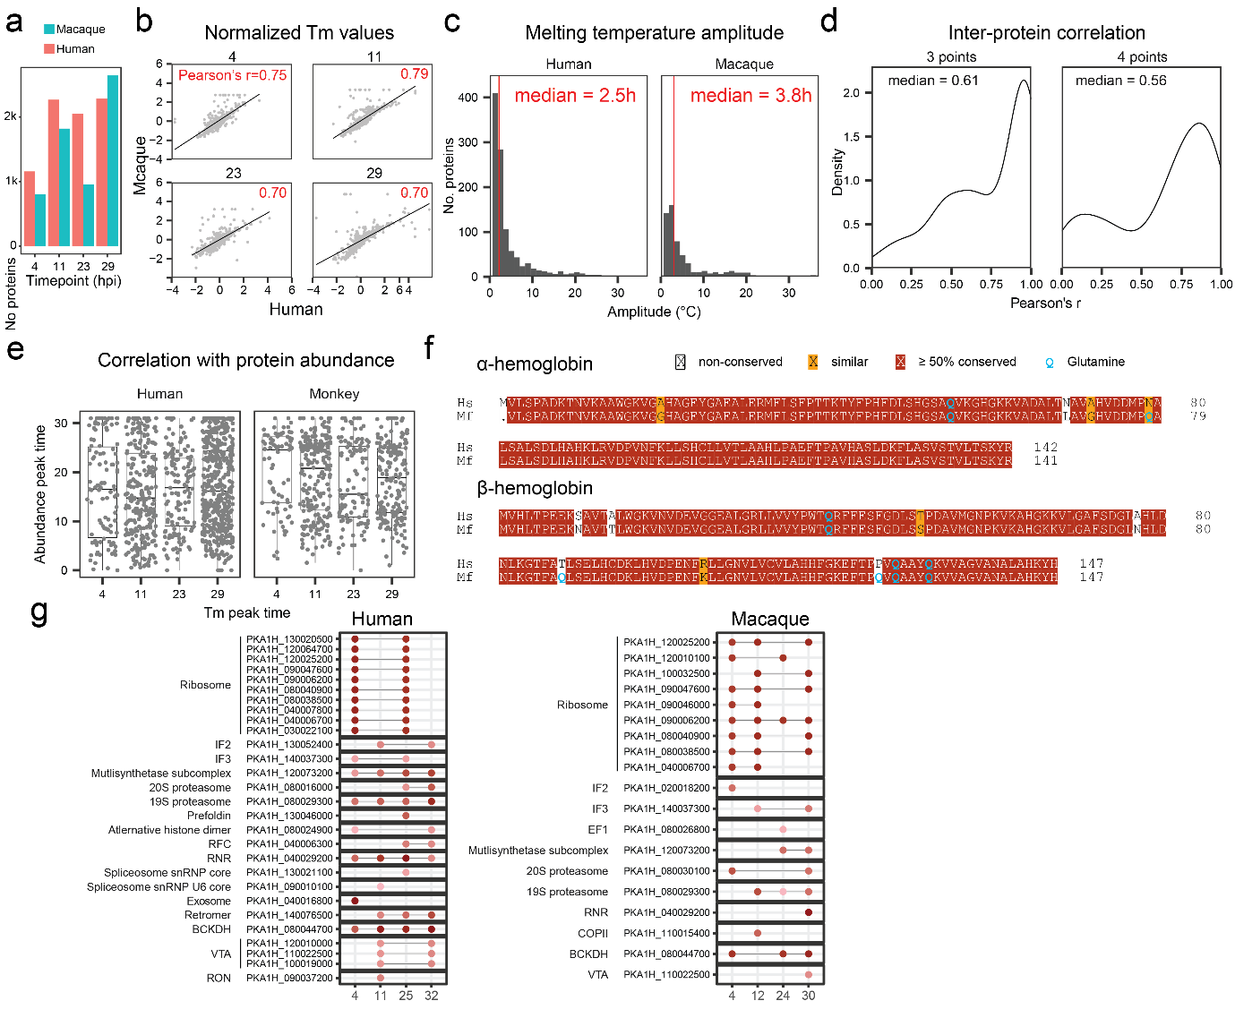
Extended Data Figure 5. a Number of P. knowlesi proteins detected at different timepoints in macaque and human RBCs. b Correlation of melting temperatures (Tm) in hRBCs and mRBCs at different timepoints. c Amplitudes of melting temperatures of P. knowlesi cultured in human or monkey RBCs. d Correlation of stability profiles between pairs of proteins in hRBCs and mRBCs. e Distribution of abundance peak times at different stability peak times suggest that there is no correlation between the two. f Sequence alignment between human and macaque hemoglobins shows enrichment of glutamine residues in macaque hemoglobin. g Prediction of moonlighting proteins in human and macaque-cultured P. knowlesi.

