Supplementary Information for
Monolithic Vertically Stacked Carbon Nanotube Transistor with Emergent Negative Transconductance for Ternary Logic
Seonghyeon Jeong¹, Jeong Yeon Im¹, Hanbin Lee¹, Ji Won Park¹, Youngmin Kim¹, Minji Choi¹, Dae Hwan Kim¹, Yoon Jung Lee¹, Junjong Lee¹, Min-Ho Kang²* and Sung-Jin Choi¹*
¹School of Electrical Engineering, Kookmin University, Seoul 02707, Korea
²Department of Nanoprocess, National Nanofab Center (NNFC), Daejeon 34141, Korea
Email: sjchoiee@kookmin.ac.kr and kmh@nnfc.re.kr
Authors’ contact information
Seonghyeon Jeong, sunghyen4880@kookmin.ac.kr
Jeong Yeon Im, wjdakfwjddus@kookmin.ac.kr
Hanbin Lee, 123koabc@kookmin.ac.kr
Ji Won Park, 951x951@kookmin.ac.kr
Youngmin Kim, carcar999@kookmin.ac.kr
Minji Choi, minji0402@kookmin.ac.kr
Dae Hwan Kim, drlife@kookmin.ac.kr
Yoon Jung Lee, yoonjung.lee@kookmin.ac.kr
Junjong Lee, lee1539@kookmin.ac.kr
Min-Ho Kang, kmh@nnfc.re.kr, corresponding author
Sung-Jin Choi, sjchoiee@kookmin.ac.kr, corresponding author

Table of contents
Supplementary Figure 1. Cross-sectional transmission electron microscopy (TEM) and energy-dispersive X-ray spectroscopy (EDS) elemental mapping of the gate region, showing the vertical layer configuration and elemental distribution around the common gate.
Supplementary Figure 2. Sequential fabrication process of the vertically stacked NTC transistor, showing the formation of the lower and upper CNT networks, common gate and interlayer via.
Supplementary Figure 3. Scanning electron microscopy (SEM) images at different magnifications, extending from the device array to the active channel region of an individual vertically stacked NTC transistor.
Supplementary Figure 4. CNT-network morphologies in the upper and lower channels and Raman characterization of the CNT material, showing a G/D intensity ratio of approximately 230 and a radial breathing mode (RBM) peak used to estimate the representative CNT diameter and semiconducting CNT bandgap.
Supplementary Figure 5. Channel-length dependence of the lower-layer electron-branch V_{T} and upper-layer p-type V_{T} extracted using the constant-current method (CCM).
Supplementary Figure 6. Channel-width dependence of the transfer characteristics of the vertically stacked NTC transistor, showing that I_{peak} increases more strongly than I_{valley} as the widths of both channels increase, resulting in a larger PVR.
Supplementary Figure 7. Atomic force microscopy (AFM) characterization of the upper-layer CNT networks with low, medium and high CNT densities.
Supplementary Figure 8. Dependence of the upper-layer p-type V_{T} on CNT network density, ρ_{CNT}, under the low-density (LD), medium-density (MD) and high-density (HD) conditions.
Supplementary Figure 9. Device-to-device transfer characteristics and PVR distributions for HD and MD devices at two integration settings.
Supplementary Figure 10. Fixed-bias current–time measurements, signed low-current statistics and open-contact background comparisons.
Supplementary Figure 11. HSPICE Level 3 compact-model fitting of the individual transistors and simulation of the series-connected stack. Parametric analysis examines the effects of the common-gate work function and the relative permittivity of the upper-layer gate dielectric on the operating voltage window and PVR.
Supplementary Figure 12. Comparison of ideal and measured pull-up and pull-down current characteristics used to interpret the residual slope within the intermediate-state window of the ternary inverter in terms of conductance matching.
Supplementary Figure 13. Layout-derived footprint comparison of vertical and lateral inverter implementations, including four- and eight-stage estimates and routing-space sensitivity.
Supplementary Figure 14. Behavioural simulations of four- and eight-stage ternary inverter chains based on the measured single-inverter VTC.
Supplementary Table 1. Benchmark comparison of this work and previously reported NTC devices in terms of the number and type of semiconductor materials, PVR and |V_{D}|.
Supplementary Table 2. HSPICE Level 3 compact-model parameters for the electron and hole branches of the lower-layer transistor and the p-type response of the upper-layer transistor.
Supplementary Table 3. Population statistics of the operational PVR.
Supplementary Table 4. Open-contact current statistics at PLC = 1.
Supplementary Table 5. Footprints calculated using the matched repeated-cell layout convention.

Cross-sectional structural characterization of the common-gate region
Supplementary Fig. 1 provides cross-sectional structural characterization of the common-gate region in the vertically stacked NTC transistor. The schematic indicates the A–A′ cross-section through the common gate and the vertically arranged lower and upper CNT network channels. The cross-sectional TEM image resolves the dielectric and metal layers surrounding the common gate. The Ti/Pd common gate is positioned between the lower and upper HfO₂ layers, with the substrate SiO₂ below the lower HfO₂ layer and the upper SiO₂ layer above the upper HfO₂ layer.
From the TEM image, the thicknesses of the lower and upper HfO₂ layers were each extracted to be approximately 28 nm. The Ti and Pd layers forming the common gate were approximately 2 nm and 20 nm thick, respectively. These dimensions are consistent with the intended vertical gate-stack configuration used for the vertically stacked NTC transistor.
The corresponding EDS elemental maps show the spatial distributions of O, Hf, Ti, Pd and Si across the same cross-sectional region. Hf is distributed in the dielectric regions above and below the common gate, whereas Ti and Pd are localized within the intervening metal gate region. The Si signal is primarily observed in the substrate region, while the O distribution follows the oxide-containing layers. Together with the TEM image, the elemental maps support the vertical layer configuration around the common gate described in Fig. 1a.

Supplementary Figure 1. Cross-sectional structure and elemental distribution around the common gate of the vertically stacked NTC transistor. The grey plane and blue dashed A–A′ marker in the upper schematic indicate the cross-section through the gate region. The lower row shows a cross-sectional transmission electron microscopy (TEM) image followed by energy-dispersive X-ray spectroscopy (EDS) elemental maps of O, Hf, Ti, Pd and Si from left to right. The TEM image is labelled with the Si substrate, substrate SiO₂, lower HfO₂ dielectric, Ti/Pd common gate, upper HfO₂ dielectric and surface SiO₂ layer.
Sequential fabrication of the vertically stacked NTC transistor
Supplementary Fig. 2 details the sequential fabrication of the lower and upper CNT network channels on opposite sides of a common gate. In step I, highly doped p-type Si wafers with 50 nm SiO₂ formed by wet oxidation were prepared as substrates. The surface was treated with O₂ plasma at 30 W for 60 s, followed by application of a 0.1% aqueous poly-L-lysine solution for 20 min. In step II, a semiconducting CNT dispersion (IsoNanotubes-S, NanoIntegris, 99.9% semiconducting purity) was dispensed onto the substrate maintained at 30 °C. After CNT deposition, the samples were rinsed with isopropyl alcohol and deionized water for 1 min each.
In step III, the lower-layer Ti/Pd source/drain electrodes were formed by electron beam evaporation at a base pressure of approximately 1.0 × 10^{–6} Torr. The Ti and Pd thicknesses were 2 and 20 nm, respectively. The lower CNT channel was patterned using O₂ plasma at 3 W for 60 s. All patterns throughout the fabrication process were defined by i-line photolithography. The accompanying top-view image shows the lower-layer transistor in the back-gate configuration, in which the highly doped Si substrate serves as the gate.
In step IV, the lower HfO₂ gate dielectric was deposited at 250 °C by ALD using TEMAH and H₂O. Each cycle consisted of a 0.5 s TEMAH pulse, a 15 s purge, a 0.5 s H₂O pulse and a second 15 s purge. A total of 280 cycles was used. In step V, the Ti/Pd common gate was formed with the same Ti and Pd thicknesses of 2 and 20 nm, respectively. At this stage, the common gate is positioned above the lower CNT network and functions as the top gate of the lower-layer transistor, as indicated in the corresponding top-view image.
In step VI, an additional HfO₂ layer was deposited above the common gate under the same ALD conditions. A 5 nm SiO₂ layer was then deposited by electron beam evaporation at approximately 1.0 × 10^{–6} Torr to facilitate adsorption of the upper CNT network. The interlayer via opening was formed by reactive ion etching at 150 W for 4 min using SF₆, CHF₃ and Ar flow rates of 20, 30 and 4 sccm, respectively. Thus, the upper dielectric stack and interlayer via opening were completed before deposition of the upper CNT network. Cross-sectional TEM gave thicknesses of approximately 28 nm for each of the lower and upper HfO₂ layers, as described in Supplementary Fig. 1.
In step VII, the upper-layer CNT network was formed on the upper SiO₂ surface using the same surface treatment and deposition procedure as the lower-layer CNT network. CNT network densities of 5–7, 11–13 and 18–20 tubes/μm were obtained using deposition times of 3, 7 and 11 min, respectively, at 30 °C. The same deposition conditions were used for the corresponding CNT network densities in the lower- and upper-layer transistors.
In step VIII, the upper-layer Ti/Pd source/drain electrodes were formed, followed by O₂ plasma patterning of the upper CNT channel using the same procedures as for the lower channel. In the complete device, the external source contacts the lower channel and the external drain contacts the upper channel. The remaining terminals of the two channels are connected through the interlayer via, forming the series-connected stack. The common gate functions as a top gate for the lower-layer transistor and as a bottom gate for the upper-layer transistor. The final top-view images show the terminal arrangement of the complete device and the upper-layer bottom-gate configuration.
The fabrication sequence places the lower CNT network before HfO₂ processing and the upper CNT network after completion of the dielectric processes. Although the two channels consist of the same CNT semiconductor, they therefore experience different process histories. This distinction provides the process context for the contrasting gate responses of the lower- and upper-layer transistors discussed in the main text.

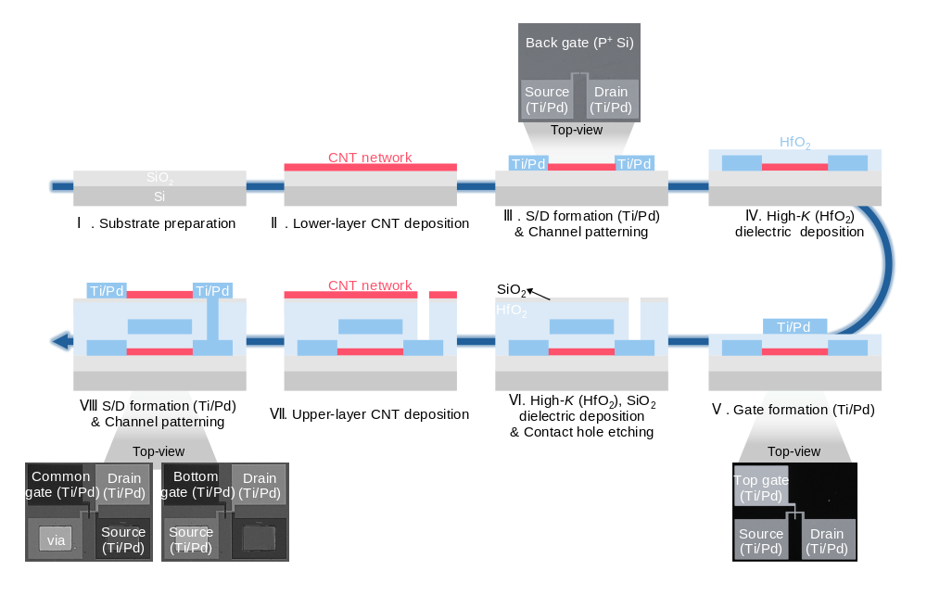
Supplementary Figure 2. Sequential fabrication process of the vertically stacked NTC transistor. I Preparation of the Si/SiO₂ substrate. II Deposition of the lower-layer CNT network. III Formation of the lower-layer Ti/Pd source/drain electrodes and CNT channel patterning. IV Deposition of the lower HfO₂ gate dielectric by atomic layer deposition (ALD). V Formation of the Ti/Pd common gate. VI Deposition of the upper HfO₂/SiO₂ dielectric stack and opening of the interlayer via. VII Deposition of the upper-layer CNT network. VIII Formation of the upper-layer Ti/Pd source/drain electrodes and CNT channel patterning. The blue arrows indicate the fabrication sequence. The top-view images show the back-gate configuration after step III, the lower-layer top-gate configuration after step V, and the common-gate and upper-layer bottom-gate configurations after step VIII.
Top-view structural characterization of the vertically stacked NTC transistor
Supplementary Fig. 3 provides top-view SEM images extending from the device array to the active channel region of an individual vertically stacked NTC transistor. The images were obtained using an SU8700 field-emission scanning electron microscope (Hitachi), as described in Methods. The leftmost image shows the patterned device array, and the selected device is enlarged in the second image to identify the lateral registration of the common gate, drain, source and interlayer via.
In the device architecture described in Fig. 1a, the external source contacts the lower channel, whereas the external drain contacts the upper channel. The remaining terminals of the two channels are connected through the interlayer via to form the series-connected stack. The labelled via therefore corresponds to the internal interlayer connection rather than an additional external terminal of the complete device.
The third and fourth images progressively enlarge the central device region, with the dashed yellow box in the rightmost image identifying the active channel region. These images connect the terminal arrangement shown in Fig. 1a to the local channel geometry. Together with the cross-sectional TEM and EDS characterization in Supplementary Fig. 1, they provide complementary views of the lateral device layout and vertical layer configuration.
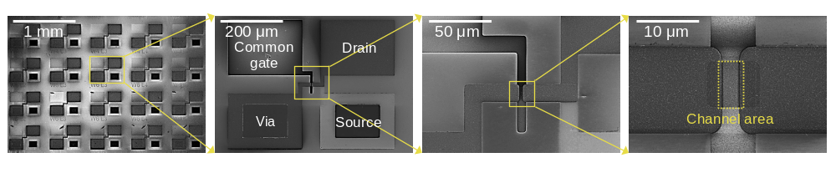 Supplementary Figure 3. Top-view structural characterization of the vertically stacked NTC transistor at different magnifications. From left to right, the scanning electron microscopy (SEM) images show the device array, an individual device with the common gate, drain, source and interlayer via labelled, and two successive enlargements of the central device region. The solid yellow boxes and connecting lines indicate the regions enlarged in the subsequent images. The dashed yellow box in the rightmost image marks the active channel region. Scale bars are 1 mm, 200 μm, 50 μm and 10 μm from left to right.
Morphological and Raman characterization of the CNT networks
Supplementary Fig. 4 combines layer-resolved morphological characterization with Raman spectroscopy to examine the CNT networks and the structural properties of the CNT material used in the vertically stacked NTC transistor. The SEM images in Supplementary Fig. 4a show the upper-layer CNT network at the top and the lower-layer CNT network at the bottom. Both layers contain interconnected nanotube networks with numerous CNT–CNT junctions, providing the morphological basis for percolative transport through each channel.
Raman spectroscopy was performed after deposition of the CNT network used to form the lower channel. The spectra were acquired using a DXR3xi Raman imaging microscope (Thermo Fisher Scientific), as described in Methods. Supplementary Fig. 4b shows a weak D band near 1350 cm^{–1} and a dominant G band with distinguishable higher-frequency G⁺ and lower-frequency G– components. The G-band components are associated with tangential vibrations of the carbon framework [1], whereas the D band is associated with disorder-activated Raman scattering [2]. The G/D intensity ratio was calculated from the maximum Raman intensities of the G and D bands rather than their integrated areas [2]. Because the G-band maximum corresponds to the G+ component, the ratio was evaluated as G/D = I(G⁺)/I(D) ≈ 230, where I(G⁺) and I(D) denote the maximum Raman intensities at the G⁺ and D peaks, respectively. The weak D-band contribution relative to the G⁺ peak is consistent with a low defect level in the Raman-probed CNT material [2]. Supplementary Fig. 4c presents the RBM region of the Raman spectrum. The measured spectrum exhibits a dominant RBM peak at approximately 175 cm^{–1}. The representative CNT diameter was estimated using the inverse relationship between the RBM peak position and nanotube diameter reported for isolated single-wall CNTs [3], ω_{RBM} = A/d_{CNT}, where ω_{RBM} is the RBM Raman shift, d_{CNT} is the CNT diameter and A = 248 cm^{–1} nm. Applying this relationship to the measured peak position gives d_{CNT} = A/ω_{RBM} = (248 cm^{–1} nm)/(175 cm^{–1}) ≈ 1.417 nm.
The representative CNT diameter was therefore estimated to be approximately 1.4 nm. Because this relationship was derived for isolated CNTs, it is used here as an approximate calibration for the deposited CNT network. The bandgap of a semiconducting CNT with this estimated diameter was calculated using the diameter-dependent relationship employed by Tseng et al. [4], E_{g} ≈ B/d_{CNT}, where B = 0.84 eV nm. Substituting the estimated diameter gives E_{g} ≈ (0.84 eV nm)/(1.417 nm) ≈ 0.593 eV, corresponding to an estimated semiconducting CNT bandgap of approximately 0.6 eV.

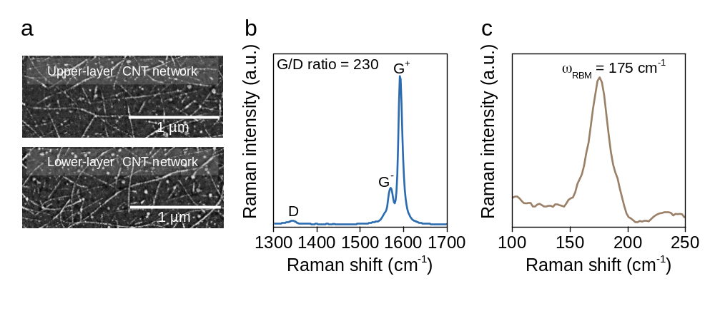
Supplementary Figure 4. CNT-network morphologies and Raman characterization of the CNT material. a Scanning electron microscopy (SEM) images of the upper-layer CNT network (top) and lower-layer CNT network (bottom), showing interconnected nanotubes and CNT–CNT junctions. Scale bars are 1 μm. b Raman spectrum of the CNT material used to form the two channels, showing the D band and the G– and G⁺ components of the G band. The G/D intensity ratio is approximately 230. c Raman spectrum in the radial breathing mode (RBM) region, showing a dominant peak at approximately 175 cm^{–1}. The peak position corresponds to an estimated representative CNT diameter of approximately 1.4 nm and a semiconducting CNT bandgap of approximately 0.6 eV, as described in the supplementary text.
Channel-length-dependent shifts in the constituent-channel threshold voltages
Supplementary Fig. 5 quantifies the channel-length-dependent shifts in the isolated transfer characteristics of the lower- and upper-layer transistors shown in Fig. 3b. The two transistors were measured independently by changing the probing configuration within each vertically stacked device. Both channel lengths were varied simultaneously while maintaining W_{ch} = 20 μm and the respective CNT network density conditions.
V_{T} was defined as the gate voltage at which the drain-current magnitude reached the prescribed current criterion on the relevant carrier branch. The lower-layer electron-branch V_{T} was extracted at |I_{D}| = 10^{–10} A from the V_{Top-gate} sweep at V_{D} = +0.1 V. The upper-layer p-type V_{T} was extracted at |I_{D}| = 10^{–9} A from the V_{Bottom-gate} sweep at V_{D} = –0.1 V. The lower current criterion was used for the lower-layer transistor because of its smaller current level. Within each layer, the same criterion was applied across all L_{ch} conditions. Because the measured I_{D} was not normalized by W_{ch}/L_{ch}, these fixed-current V_{T} values include the L_{ch}-dependent change in branch-current magnitude and are used here as operational measures of the branch positions rather than geometry-independent threshold voltages.
As L_{ch} decreases from 30 to 3 μm, the lower-layer electron-branch V_{T} shifts overall toward negative gate voltage, from 0.43 to –0.23 V. Over the same range, the upper-layer p-type V_{T} shifts toward positive gate voltage, from –1.50 to –0.76 V. These opposite shifts are consistent with electron conduction in the lower channel becoming accessible at a lower gate voltage and hole conduction in the upper channel persisting to a higher gate voltage. They therefore support the interpretation that channel-length scaling adjusts the relative alignment of the constituent-channel responses in the gate-voltage range where the current peak forms.
The lower-layer V_{T} at L_{ch} = 4 μm shows a small positive deviation relative to the value at L_{ch} = 5 μm, rather than following a strictly monotonic negative shift. This local variation may reflect device-to-device differences in the random CNT network. Nevertheless, PVR of the series-connected stack continues to increase as L_{ch} decreases from 5 to 4 and 3 μm (Fig. 3d). Thus, the local V_{T} variation does not disrupt the overall increase in peak-to-valley current contrast with channel-length scaling.

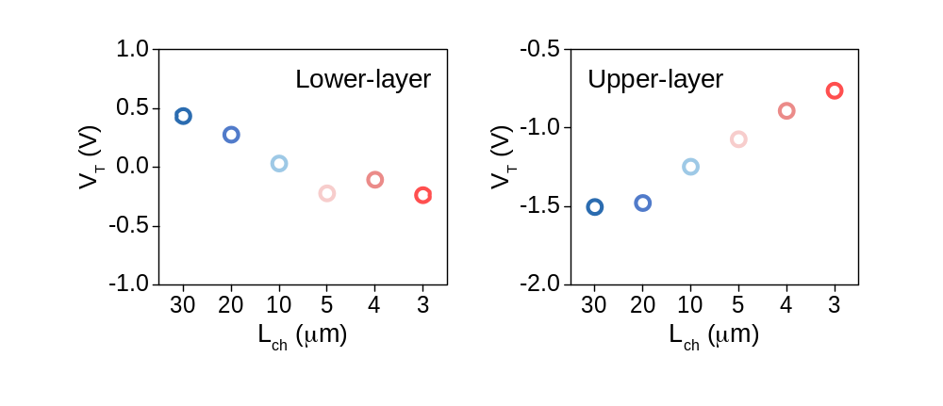
Supplementary Figure 5. Channel-length dependence of the threshold voltages of the lower- and upper-layer transistors. The left and right plots show the lower-layer electron-branch V_{T} and upper-layer p-type V_{T}, respectively, extracted from the isolated transfer characteristics in Fig. 3b using the constant-current method (CCM). The lower-layer V_{T} was extracted at |I_{D}| = 10^{–10} A during a V_{Top-gate} sweep at V_{D} = +0.1 V, whereas the upper-layer V_{T} was extracted at |I_{D}| = 10^{–9} A during a V_{Bottom-gate} sweep at V_{D} = –0.1 V. The channel lengths of both layers were varied together among 30, 20, 10, 5, 4 and 3 μm while maintaining W_{ch} = 20 μm. The lower- and upper-layer CNT network densities were 5–7 and 11–13 tubes/μm, respectively.

Channel-width-dependent control of the NTC response
Supplementary Fig. 6 examines channel width as an additional geometric parameter for adjusting the nonmonotonic response of the vertically stacked NTC transistor. The widths of the lower and upper channels were increased together from W_{ch} = 10 to 20 and 60 μm. L_{ch} was fixed at 4 μm, and both layers retained the MD CNT network density condition of 11–13 tubes/μm. The common-gate transfer characteristics were measured at V_{D} = –0.1 V. The common gate, dielectric stack and series connection were unchanged.
All three transfer characteristics retain a current valley followed by a current peak and a subsequent reduction in current. Increasing W_{ch} raises the current magnitude throughout the measured gate-voltage range. However, the relative increase in I_{peak} is larger than that in the preceding I_{valley}, resulting in a larger PVR. Here, PVR = I_{peak}/I_{valley} follows the definition given in Methods. The width dependence therefore involves a change in the peak-to-valley current contrast rather than a uniform multiplication of the entire transfer curve, which would leave PVR unchanged.
The overall current increase is consistent with wider CNT networks containing a larger statistical population of parallel percolation paths. The unequal changes in I_{peak} and I_{valley} indicate that the current enhancement differs between the peak-forming and valley conditions. Thus, the measured width dependence provides a complementary means of adjusting the current level and PVR without changing L_{ch}, the CNT network density condition or the gate-stack parameters.
Width-dependent modulation of an NTC response has also been reported by Lee et al. in mixed-dimensional CNT/MoS₂ transistors [8]. In that study, changing the source-electrode width modified the printed CNT p-channel characteristics and the voltage range of the NTC interval. The width variation was accompanied by changes in the printed CNT network morphology associated with ink confinement [8]. The present comparison instead varies the widths of both constituent channels together while maintaining the same nominal CNT network density condition. The cited study therefore provides a precedent for width-based control of NTC characteristics, whereas Supplementary Fig. 6 shows the corresponding geometric tunability within the single-semiconductor vertically stacked device.
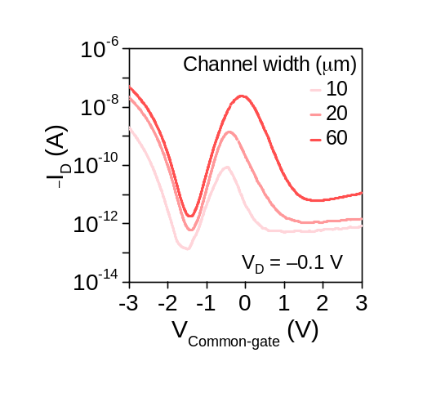
Supplementary Figure 6. Channel-width-dependent transfer characteristics of the vertically stacked NTC transistor. Measured common-gate transfer characteristics are shown for W_{ch} = 10, 20 and 60 μm, represented by progressively darker red curves. The widths of the lower and upper channels were varied together while maintaining L_{ch} = 4 μm and medium-density (MD) CNT networks of 11–13 tubes/μm in both layers. The gate-stack parameters were unchanged. The curves show the drain-current magnitude over V_{Common-gate} = –3 to 3 V. Measurements were performed at V_{D} = –0.1 V.

Density-dependent morphology of the upper-layer CNT networks
Supplementary Fig. 7 compares the upper-layer CNT networks used for the LD, MD and HD conditions. As ρ_{CNT} increases from 5–7 to 18–20 tubes/μm, the AFM images show progressively denser nanotube coverage, consistent with the intended variation in CNT network density. The corresponding height profiles further reflect the increasing frequency of CNT-related surface features.
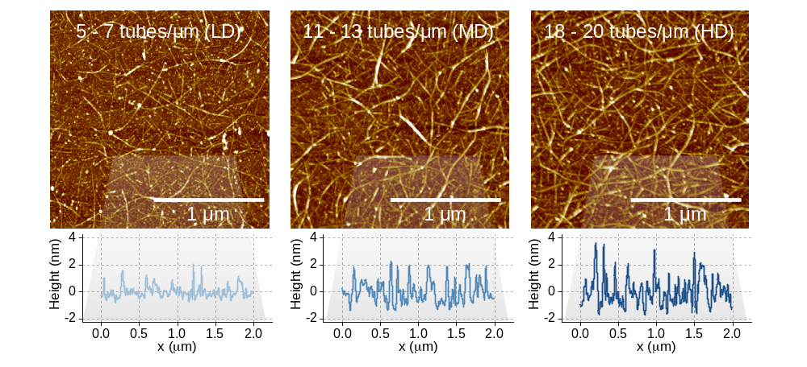
Supplementary Figure 7. Atomic force microscopy (AFM) characterization of the upper-layer CNT networks with different CNT densities. AFM images of the low-density (LD, 5–7 tubes/μm), medium-density (MD, 11–13 tubes/μm) and high-density (HD, 18–20 tubes/μm) CNT networks are shown from left to right. The corresponding height profiles extracted along the indicated regions are shown below each AFM image. Scale bars, 1 μm.
Density-dependent shift of the upper-layer threshold voltage
Supplementary Fig. 8 quantifies the density-dependent shift of the upper-layer p-type transfer characteristic shown in Fig. 4b. The upper-layer transistor was measured independently within each vertically stacked device. Upper-layer ρ_{CNT} was varied among the LD, MD and HD conditions while maintaining W_{ch} = 20 μm and L_{ch} = 4 μm. The lower-layer CNT network density was maintained at 11–13 tubes/μm, and the lower-layer fabrication conditions were unchanged.
V_{T} was extracted using CCM from the V_{Bottom-gate} sweep at V_{D} = –0.1 V. It was defined as the gate voltage at which the hole-current magnitude reached |I_{D}| = 10^{–9} A, with the same current criterion applied to all three density conditions. The extracted V_{T} shifts from –1.00 V for LD to –0.76 V for MD and 0.29 V for HD, quantifying the systematic movement of the p-type transition toward more positive V_{Bottom-gate}. The positive V_{T} under the HD condition still describes the upper-layer p-type response rather than a change in carrier polarity. Because increasing ρ_{CNT} raises the hole-current magnitude, the positive shift of the fixed-current V_{T} also reflects the more positive V_{Bottom-gate} required to suppress the current to the same CCM criterion.
This positive shift is consistent with hole conduction in the upper channel persisting to a higher gate voltage. During a common-gate sweep, the upper channel can therefore retain appreciable hole conduction while the lower channel enters its rising electron branch. The extracted V_{T} trend supports the interpretation that increasing upper-layer ρ_{CNT} adjusts the relative alignment of the constituent-channel responses, contributing to the increase in I_{peak} relative to I_{valley} and the larger PVR extracted from the transfer characteristics in Fig. 4c.

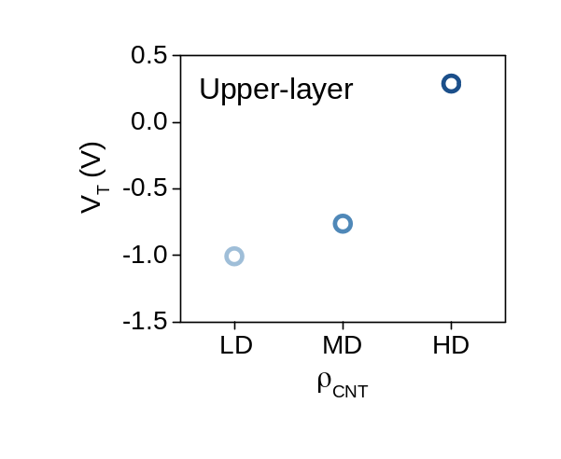
Supplementary Figure 8. Dependence of the upper-layer threshold voltage on CNT network density, ρ_{CNT}. The upper-layer p-type V_{T} was extracted from the isolated transfer characteristics in Fig. 4b using the constant-current method (CCM) at |I_{D}| = 10^{–9} A. Measurements were performed by sweeping V_{Bottom-gate} at V_{D} = –0.1 V. Low-density (LD), medium-density (MD) and high-density (HD) conditions correspond to upper-layer CNT network densities of 5–7, 11–13 and 18–20 tubes/μm, respectively. W_{ch} and L_{ch} were fixed at 20 and 4 μm, respectively.

Device-to-device reproducibility of the peak-to-valley current contrast
Supplementary Fig. 9 examines the distribution of the measured NTC response in the HD and MD device conditions. Both constituent channels had W_{ch} = 20 μm and L_{ch} = 4 μm. The lower-layer CNT network density was maintained at 11–13 tubes/μm, while the upper-layer density was 11–13 tubes/μm for MD and 18–20 tubes/μm for HD. Each density and integration-setting dataset contains 30 device records. The common-gate transfer characteristics were measured at V_{D} = −0.1 V over V_{Common-gate} = −3 to +3 V using 0.05 V steps and integration settings of 1 and 5 power-line cycles (PLC). All records in each dataset were included in the analysis without selection by PVR rank.
The same peak/pre-rise extraction described in Methods was applied throughout. I_{peak} was determined from three raw current-magnitude readings around the central local maximum, and the operational I_{valley} was calculated from five raw readings in the curve-relative pre-rise window. The resulting PVR values and central peak voltages are shown against the original device indices. Statistics were calculated separately for each density and PLC setting rather than pooling repeated-setting records as additional independent devices.
The HD median PVR is 6.42 × 10³ at PLC = 1 and 5.95 × 10³ at PLC = 5, compared with 4.16 × 10² and 4.94 × 10² for MD, respectively. The full distributions are summarized in Supplementary Table 3. These results show that large current contrast persists across the analysed records at both integration settings. The maximum HD values are 1.84 × 10⁴ and 9.10 × 10³ for PLC = 1 and 5. Accordingly, the original representative value of approximately 1.6 × 10⁴ in Fig. 4 lies in the upper performance range and is distinguished from the population median. The low-current background and fixed-bias measurements in Supplementary Fig. 10 provide complementary information for interpreting the denominator of the measured ratio.
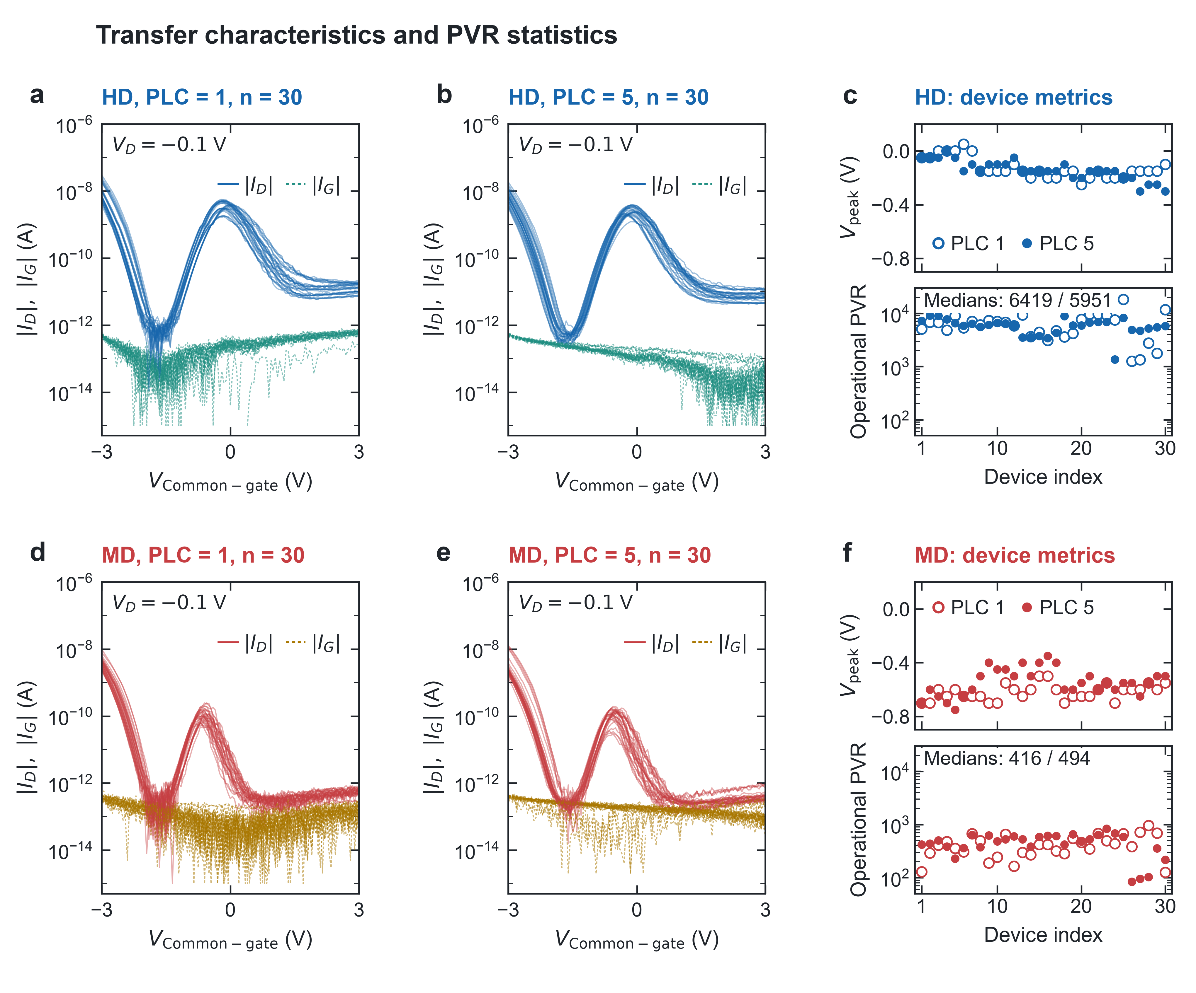
Supplementary Figure 9. Device-to-device transfer characteristics and PVR distributions. a,b HD transfer curves at PLC = 1 and 5. d,e Corresponding MD curves. Drain-current magnitudes are solid and gate-current magnitudes are dashed. c,f Central peak voltage and PVR versus device index for HD and MD, with open and filled markers denoting PLC = 1 and 5. Each group contains 30 records. Measurements were performed at V_{D} = −0.1 V, and the same peak/pre-rise extraction was applied to all curves.

Low-current background and fixed-bias current–time characterization
Supplementary Fig. 10 combines fixed-bias current–time measurements with an open-contact control to assess the low-current observations underlying the PVR analysis. Current–time measurements were performed at V_{D} = −0.1 V for 30 indexed devices in each density group. The high-conduction gate biases were V_{Common-gate} = 0 V for HD and −0.65 V for MD, while the low-conduction bias was −1.3 V for both groups. Each trace contains 1,201 readings over approximately 120 s. These fixed biases were selected from the representative-device characteristics and do not coincide with the exact transfer extrema of every device.
Supplementary Figs. 10a and 10b show the complete current-magnitude traces. Signed-current means and temporal standard deviations were calculated over the common interval of 60–120 s and are summarized in Supplementary Figs. 10c and 10d. The median magnitudes of the signed high-bias means are 3.85 nA for HD and 52.5 pA for MD; the corresponding low-bias values are 0.410 and 0.462 pA. All low-bias traces retain a negative signed mean in successive non-overlapping 5 s blocks within this interval. The median within-trace standard deviation is approximately 0.32 pA for both density groups. This scatter describes temporal fluctuations rather than the accuracy of the current measurement.
High-current relaxation is visible in the complete traces. The median ratio of the current magnitude averaged over 110–120 s to that averaged over 10–20 s is approximately 0.48 for HD and 0.47 for MD. Thus, the high- and low-conduction levels remain separated, but the high-current response is not described as perfectly stationary. Supplementary Figs. 10g and 10h retain the signed low-bias readings, including zero crossings and positive values, without smoothing or conversion to current magnitude. These panels display the same measurements as the magnitude plots rather than additional independent datasets.
The open-contact control in Supplementary Fig. 10e was acquired at PLC = 1 with all probe contacts disconnected. The programmed gate sweep and drain bias matched the PLC = 1 transfer conditions. Across the 121-point sweep, the signed drain current has a mean of −14.9 fA, a standard deviation of 18.4 fA and a range of −55 to +47 fA. The corresponding source- and gate-channel statistics are listed in Supplementary Table 4. In Supplementary Fig. 10f, the operational pre-rise currents extracted at PLC = 1 are compared with the observed open-contact drain-current magnitude range of 0–55 fA. Their medians are 660 fA for HD and 260 fA for MD, supporting a distinction between these operational current levels and the observed open-contact baseline.
No background subtraction was applied. In particular, the nonzero open-contact gate-current baseline shows that the entire sub-pA gate-current reading cannot be assigned directly to device leakage. The control characterizes the observed open-contact background under PLC = 1 rather than a complete uncertainty bound for a contacted device or a calibration at PLC = 5. Likewise, the fixed-bias time records do not independently determine each device’s transfer-curve valley. The measurements therefore complement the reproducibility analysis while preserving the distinction between operational PVR and an uncertainty-free intrinsic current ratio.
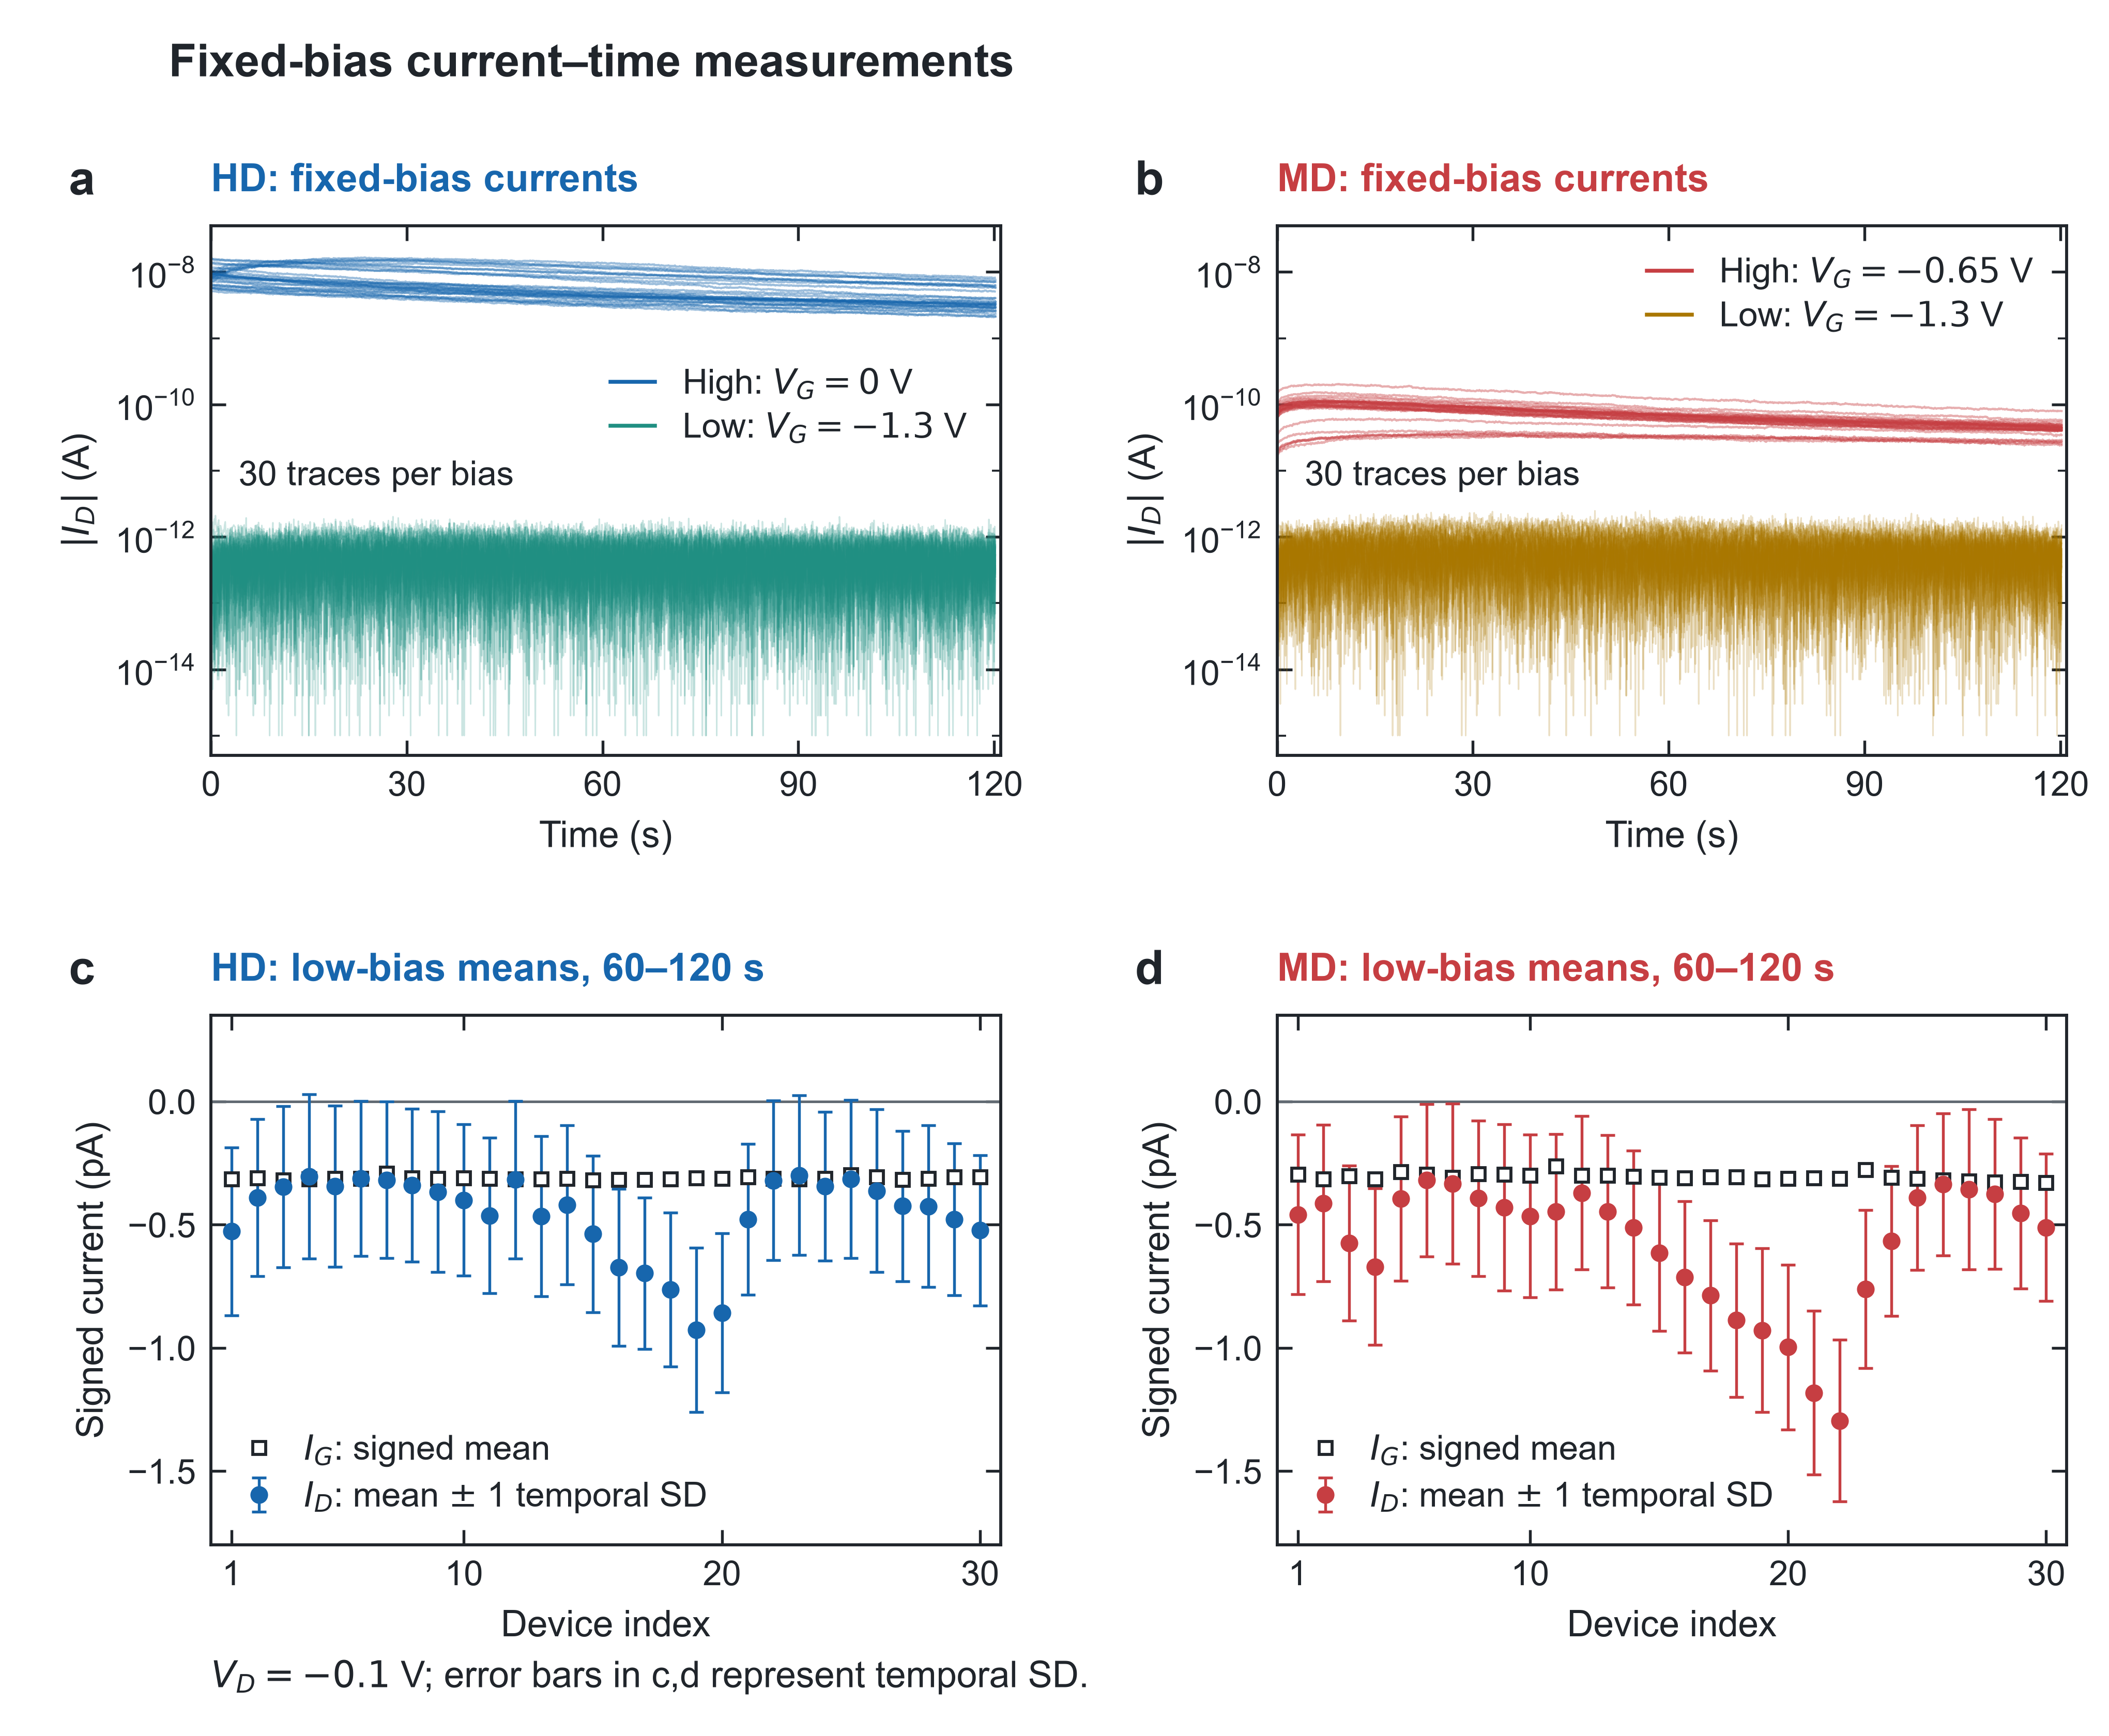
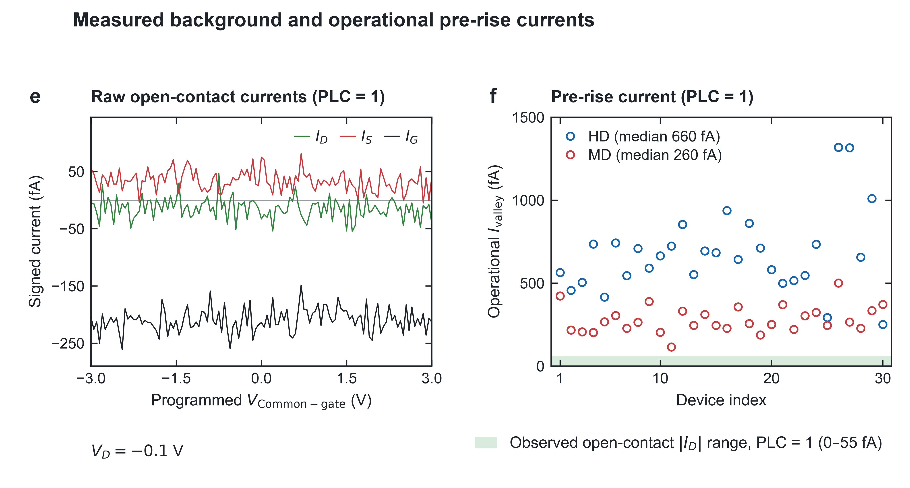
Supplementary Figure 10. Fixed-bias currents and open-contact background. a,b HD and MD current–time traces at high- and low-conduction biases. High V_{Common-gate} is 0 V for HD and −0.65 V for MD; low V_{Common-gate} is −1.3 V for both. c,d Signed low-bias I_{D} means with ±1 temporal SD over 60–120 s and the corresponding I_{G} means. e Open-contact currents at PLC = 1. f Operational pre-rise currents at PLC = 1 compared with the observed open-contact |I_{D}| range. g,h Full signed low-bias traces. V_{D} = −0.1 V throughout; n = 30 per density and bias condition.

Compact-model calibration and electrostatic control of the PVR response
Supplementary Fig. 11 examines how common-gate and layer-selective parameter changes affect the operating voltage window and current contrast of the vertically stacked NTC transistor. The compact-model approach was motivated by Cao et al., who described CNT network transistors using a Level 3 p-channel MOSFET model combined with a parallel voltage-controlled current source to account for ambipolar conduction [5]. In the present work, the electron and hole branches of the lower-layer transistor were parameterized separately using HSPICE Level 3 models and combined to describe its electron-dominant ambipolar response. A separate p-type model was used for the upper-layer transistor. The reference model parameters are summarized in Supplementary Table 2. The model dimensions were W = 20 μm and L = 4 μm. The reference KP was 20 × 10^{–6} A V^{–2} for each branch model. In HSPICE, KP is the intrinsic transconductance parameter, whereas V_{TO} specifies the model threshold-voltage parameter [6]. V_{TO} is therefore distinguished from the constant-current V_{T} extracted from the measured transfer characteristics. The isolated lower- and upper-layer responses were evaluated at V_{D} = +0.1 and –0.1 V, respectively, and the series-connected stack was simulated at V_{D} = –0.1 V over a common-gate voltage range of –3 to 3 V.
Supplementary Fig. 11a compares the measured transfer characteristics with the fitted constituent-channel responses and shows the simulated response of the series-connected stack. The models capture the upper-layer p-type response and the lower-layer conductance minimum followed by the rising electron branch. A discrepancy remains near the transition from subthreshold to on-state electron conduction in the lower-layer transistor. In this more positive gate-voltage region, however, the upper channel increasingly limits the current through the complete device. The lower-layer fitting discrepancy is therefore expected to have a reduced influence on the stack response in this region, although its quantitative contribution was not separately evaluated. Connecting the fitted models in series produces a current valley, a subsequent current peak and a decreasing post-peak response, consistent with the principal features of the measured nonmonotonic transfer characteristic.
In Supplementary Fig. 11b, the common-gate work-function variation was represented by coordinated changes in V_{TO} for the lower-layer electron and hole branches and the upper-layer p-type model. The reference condition and work-function offsets of Δφ_{m} = –1.0 and +0.7 eV were represented by the corresponding threshold-voltage shifts rather than by explicitly introducing different gate metals. The lower-work-function condition shifts the current valley, current peak and NTC interval toward more negative V_{Common-gate}, whereas the higher-work-function condition shifts these features toward more positive V_{Common-gate}. Because the constituent-channel responses shift together, their relative alignment is largely preserved, and I_{peak}, I_{valley} and PVR remain nearly unchanged.
In Supplementary Fig. 11c, the effect of the upper-layer gate dielectric was represented by adjusting the upper-layer KP while retaining the lower-layer model. This parameterization was motivated by the compact-model relationship [6], KP = μ₀ × C_{ox}, where μ₀ is the low-field mobility expressed in m² V^{–1} s^{–1} and C_{ox} is the oxide capacitance per unit area expressed in F/m². At fixed mobility, a change in C_{ox} changes the current-strength parameter KP. Here, the gate-capacitance contribution was represented through KP rather than through a complete recalculation of the dielectric electrostatics. The reference dielectric condition was κ_{UL} = 20. Values of κ_{UL} = 9 and 25 were selected as representative conditions motivated by Al₂O₃ and ZrO₂, respectively [7]. Increasing the upper-layer KP associated with these dielectric conditions raises the simulated I_{peak}, whereas I_{valley} remains nearly unchanged. PVR, calculated as I_{peak}/I_{valley} using the current peak and its preceding valley, increases from 75 at κ_{UL} = 9 to 122.53 at κ_{UL} = 20 and 141.39 at κ_{UL} = 25. Unlike the common-gate V_{TO} adjustment, this layer-selective change modifies the upper-layer current relative to the fixed lower-layer response and thereby changes the peak-to-valley current contrast.
These analyses distinguish a common shift of the constituent-channel responses from a layer-selective change in their relative current levels. Within the calibrated compact model, the former primarily translates the operating voltage window, whereas the latter adjusts the current peak and PVR. The results describe phenomenological trends obtained by varying V_{TO} and KP and do not constitute direct measurements or full material-specific predictions for replacement gate metals and dielectrics.
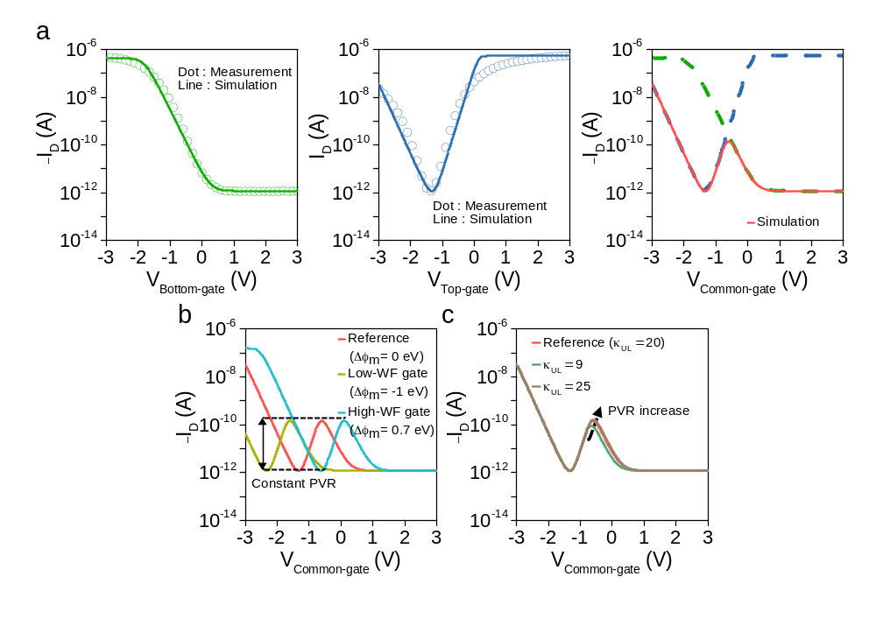
Supplementary Figure 11. Compact-model fitting and electrostatic parametric analysis of the vertically stacked NTC transistor. a Measured transfer characteristics (open circles) and HSPICE Level 3 fitting results (solid lines) for the upper-layer p-type transistor (left) and lower-layer electron-dominant ambipolar transistor (middle). The right plot shows the simulated transfer characteristic of the series-connected stack (red), with the upper- and lower-layer model responses shown as dashed green and blue curves for comparison. b Simulated common-gate transfer characteristics for work-function offsets Δφ_{m} = –1.0, 0 and +0.7 eV, represented by the yellow, red and cyan curves, respectively. The black dashed guides indicate the nearly unchanged peak and valley current levels. c Simulated common-gate transfer characteristics for upper-layer gate dielectric relative permittivities κ_{UL} = 9, 20 and 25. The arrow indicates increasing PVR. The model dimensions were W = 20 μm and L = 4 μm, and the fitted parameters are summarized in Supplementary Table 2. The gate-voltage range was –3 to 3 V. The isolated upper- and lower-layer characteristics were evaluated at V_{D} = –0.1 and +0.1 V, respectively, whereas the complete-device simulations were performed at V_{D} = –0.1 V.

Conductance matching and the residual slope of the intermediate output state
Supplementary Fig. 12 compares an idealized conductance-matching picture with the measured transfer characteristics of the pull-up and pull-down devices. This comparison complements the interpretation of the finite slope within the intermediate-state window in Fig. 5c. The pull-up element is the complete vertically stacked NTC transistor, whereas the pull-down is a separate n-type CNT FET. Conductance matching here therefore refers to the two inverter paths rather than to the lower and upper channels within the series-connected stack.
The left schematic illustrates how the nonmonotonic pull-up response can be aligned with the opposing pull-down characteristic to provide a finite gate-voltage range over which their current-supporting capabilities are comparable. In the intermediate-input regime, both paths conduct, and voltage division between them establishes the intermediate output state, consistent with previous analyses of NTC-based ternary inverters [8]. For a flat output near V_{DD}/2, the pull-up and pull-down conductances should remain comparable, with their ratio close to unity across the intermediate-state window. Matching at an isolated bias point is insufficient to ensure that this output level remains constant as V_{in} changes.
The right plot shows the individual-device transfer characteristics measured at |V_{D}| = 0.1 V. In the right plot, the lower red and upper blue x-axes correspond to the V_{Common-gate} range of the pull-up device (–3 to 0 V) and the V_{Top-gate} range of the pull-down device (0 to 3 V), respectively, while the y-axis represents the drain-current magnitude, |I_{D}|. These voltage ranges correspond to the actual operating windows of the pull-up and pull-down devices in the inverter at V_{DD} = 3 V, where V_{Top-gate} of the pull-down device follows V_{in} from 0 to 3 V, while the effective V_{Common-gate} of the pull-up device is given by V_{in} – V_{DD} and therefore varies from –3 to 0 V. The pull-up characteristic exhibits a current valley, a subsequent current peak and a decreasing post-peak response. By comparison, the pull-down current varies relatively weakly after its initial turn-on. Consequently, the two current profiles do not track one another throughout the highlighted region. Their relative current levels change with gate voltage rather than differing by a constant scaling factor.
This difference provides a qualitative illustration of the imperfect conductance matching discussed in the main text. A gate-dependent change in the relative pull-up and pull-down conductances can change the voltage division within the intermediate-state window, allowing V_{out} to vary with V_{in}. This interpretation is consistent with the residual slope in Fig. 5c and the nonzero absolute voltage gain, |dV_{out}/dV_{in}|, between the two switching peaks in Fig. 5c. The distinction between a sloped intermediate output and a flatter intermediate level has also been discussed in previous NTC-based ternary inverters [8]. The fixed-drain-bias transfer curves in Supplementary Fig. 12 are used as a qualitative comparison of the device responses rather than a quantitative reconstruction of the inverter VTC, because the voltage across each inverter element depends on V_{out} during circuit operation.
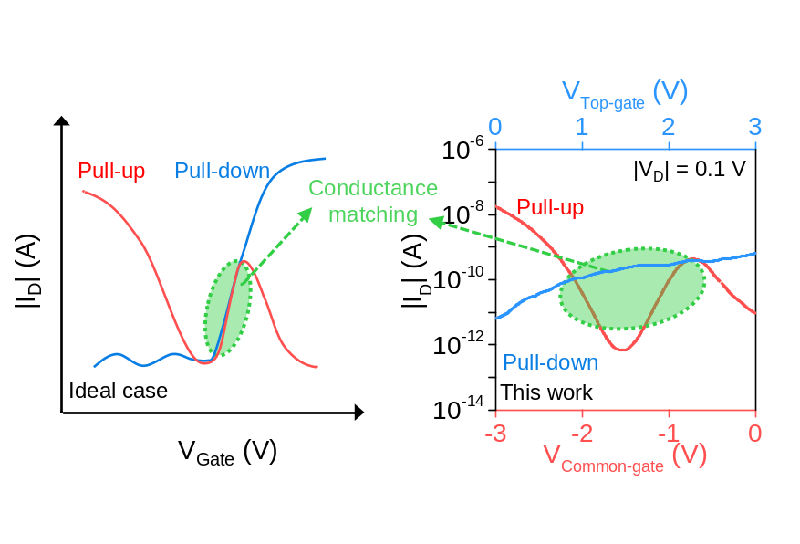
Supplementary Figure 12. Comparison of idealized and measured pull-up and pull-down characteristics for conductance matching in the ternary inverter. The left schematic illustrates the relative alignment of the pull-up (red) and pull-down (blue) transfer characteristics in an idealized case. The right plot compares the measured drain-current magnitudes of the vertically stacked NTC transistor serving as the pull-up and the n-type CNT FET serving as the pull-down. The green shaded regions and dotted outlines highlight the portions of the transfer characteristics considered in the conductance-matching discussion. The green dashed arrows connect the schematic and experimental comparisons. Measurements were performed at V_{D} = –0.1 V.
Layout-derived footprint comparison of vertical and lateral inverter implementations
Supplementary Fig. 13 compares the documented layout of the fabricated ternary inverter with a hypothetical lateral counterpart. The vertical reference uses the vertically stacked NTC transistor as the pull-up and a separate n-type CNT pull-down. In the lateral reference, the two constituent channels of the NTC pull-up occupy separate lateral positions while retaining a series connection and common input control. The lateral counterpart has not been fabricated, and its electrical correspondence is a design assumption based on retaining the constituent responses and circuit topology.
Each NTC constituent channel has W_{ch} = 20 μm and L_{ch} = 4 μm, and the pull-down in both references has W_{ch} = 6 μm and L_{ch} = 20 μm. The fabricated devices use the gate-contact openings defined in the original mask. Both layout references retain the same contact-landing convention, a 900 μm cell width, a 15 μm contact-opening-to-routing clearance and 50 μm inter-device spacing. The resulting vertical and lateral envelopes are 900 × 1,200 μm and 900 × 1,600 μm, respectively. Their calculated areas are 1.08 and 1.44 mm², corresponding to a 25% reduction in the assessed inverter footprint and a 1.33-fold density ratio. The comparison includes the separate pull-down and contact/supply regions rather than considering CNT-channel area alone.
Four- and eight-stage rows were estimated by repeating the respective unit cells with a common inter-cell gap g = 50 μm. For N stages, the row width is 900N + g(N − 1) μm. The calculated footprints are summarized in Supplementary Table 5. The inter-cell connections indicate V_{out,i}-to-V_{in,i+1} connectivity, with shared V_{DD} and GND. These are repeated-cell estimates based on the documented envelopes; they are not measured footprints of fabricated multistage circuits or a completed routing sign-off.
Supplementary Fig. 13d evaluates sensitivity to additional in-plane routing space. An identical strip height h was added to each row envelope, giving a reduction of 100 × [1 − (1,200 + h)/(1,600 + h)]%. For h = 0, 120 and 240 μm, the reductions are 25.00%, 23.26% and 21.74%, respectively. Here, h denotes an in-plane layout dimension, not the thickness of the vertical stack. The added strips are explicit common-overhead scenarios, not extracted routing requirements, and identical design rules do not by themselves establish equal routing overhead.
The analysis quantifies an integration benefit under the chosen layout convention while maintaining the demonstrated active-device dimensions. It does not establish a globally optimized lateral reference or a universal area-reduction limit. The layout-derived estimates complement the experimentally established transfer-function engineering without treating a projected multistage arrangement as a fabricated circuit.

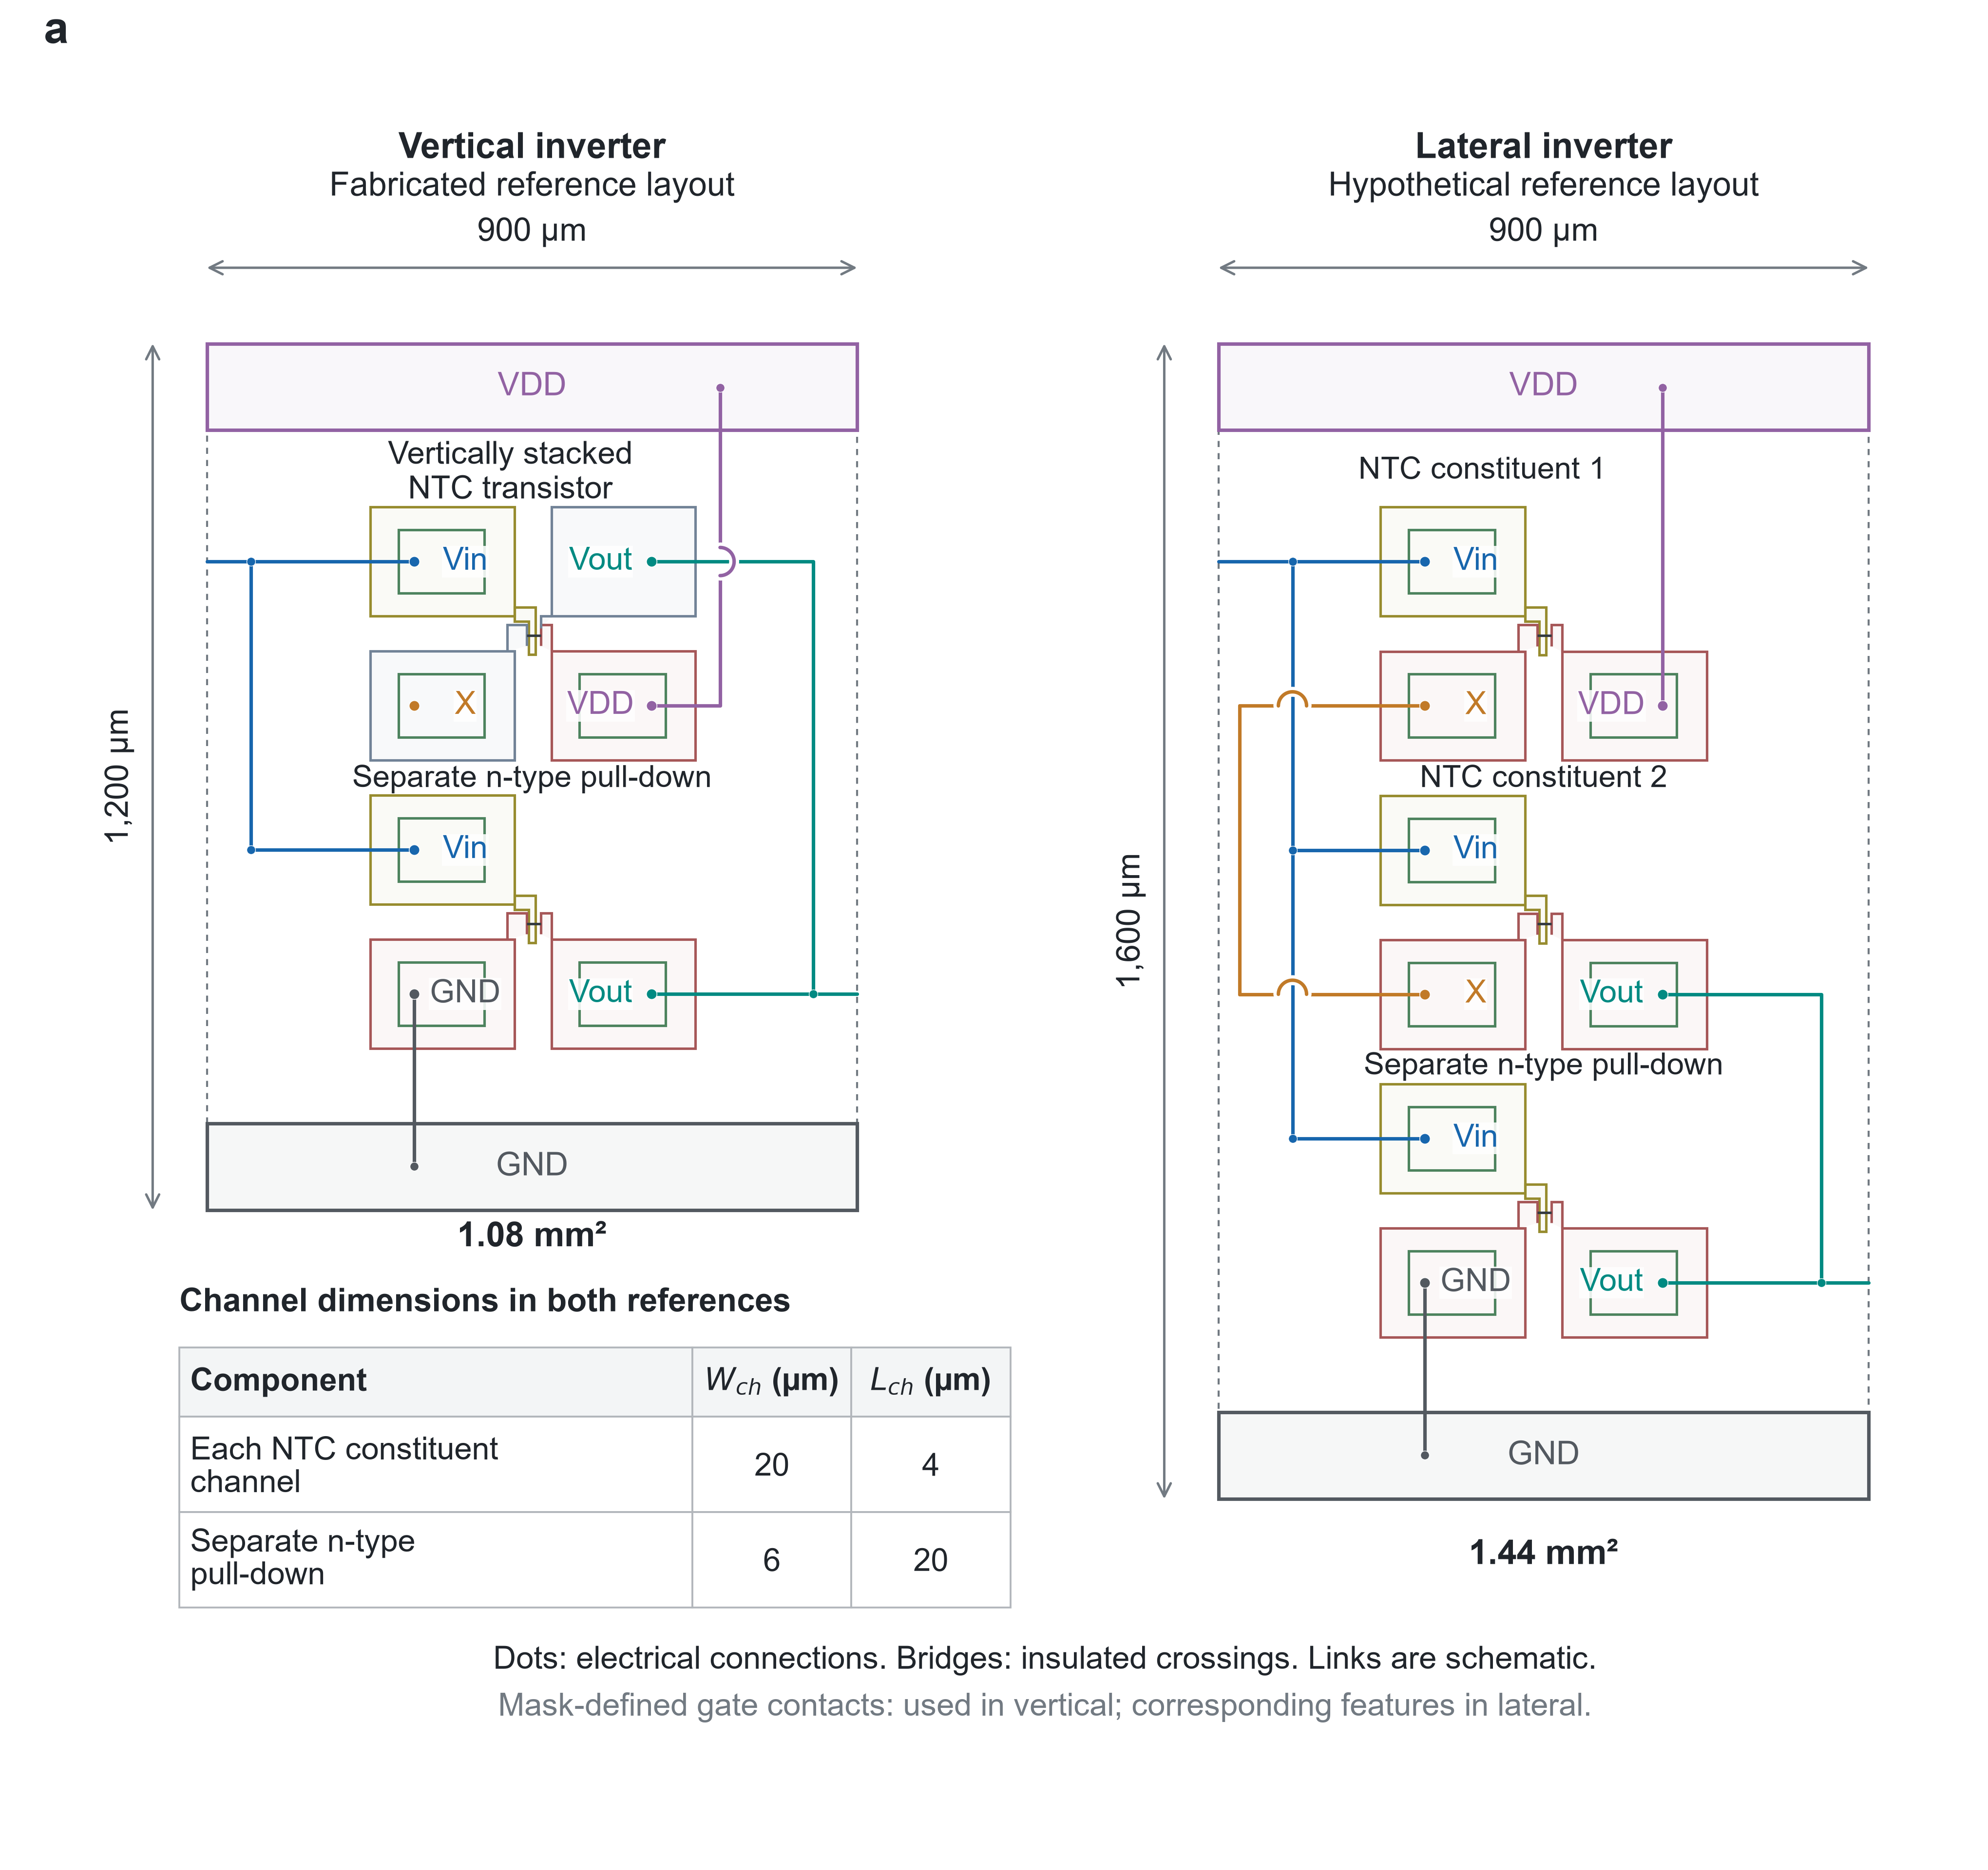
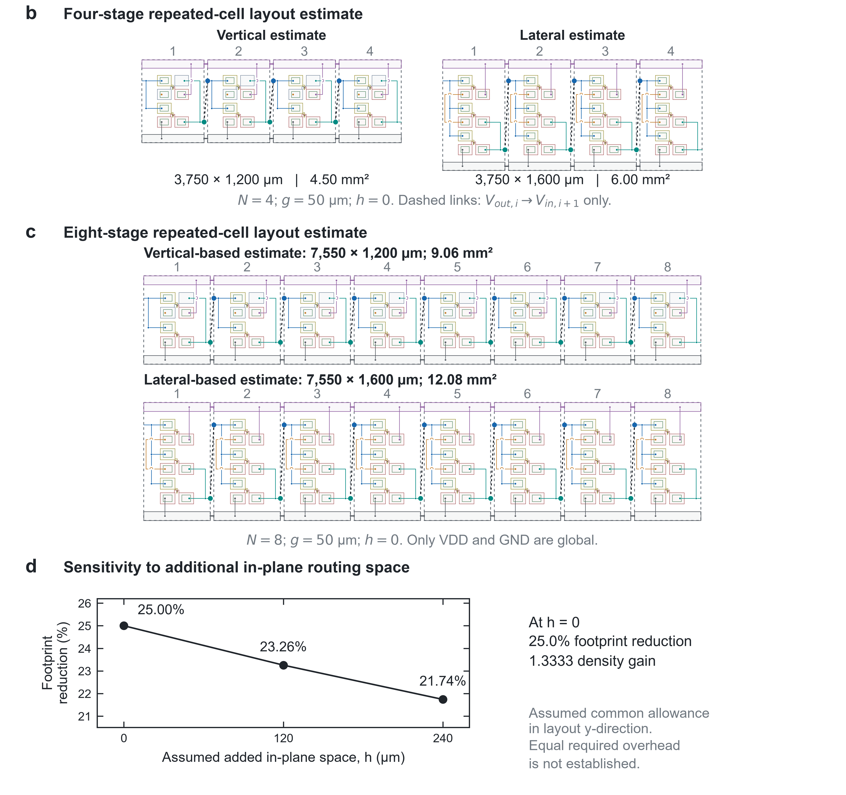
Supplementary Figure 13. Layout-derived inverter footprint comparison. a Fabricated vertical-inverter reference and hypothetical lateral counterpart with matched device dimensions and spacing conventions. Calculated cell areas are 1.08 and 1.44 mm². b,c Four- and eight-stage repeated-cell estimates with 50 μm inter-cell spacing; connections indicate the circuit net topology. d Sensitivity to an assumed common allowance for additional in-plane routing space. The multistage layouts and routing allowances are estimates rather than fabricated circuits or routing-verified implementations.

Behavioural analysis of four- and eight-stage ternary inverter chains
Supplementary Fig. 14 examines nominal level propagation using behavioural inverter stages based on the measured single-inverter VTC in Fig. 5c. The measured relation between V_{in} and V_{out} at V_{DD} = 3 V was implemented in HSPICE, and identical stages were connected in feed-forward chains containing four or eight inverters. Each stage output drives the input of the following stage in the model.
A first-order RC response with a time constant of approximately 0.06 s was imposed to represent transient settling. The input sequence uses levels of 0, 1.5 and 3 V. Because the chains contain an even number of inversions, the final outputs follow the nominal input logic sequence while retaining distinct high, intermediate and low levels. The eight-stage model exhibits greater accumulated settling delay than the four-stage model because the imposed response is repeated over more stages.
These results illustrate the behaviour of identical nominal stages under the measured VTC-based model. The RC parameter is not a parasitic-extracted interconnect delay, and the simulations do not establish measured cascade operation, fan-out capability or process-variation tolerance. They also do not independently validate the electrical behaviour of the hypothetical lateral reference. Their role is to provide circuit-level context for the layout estimates while keeping the measured single-inverter operation distinct from the projected multistage response.
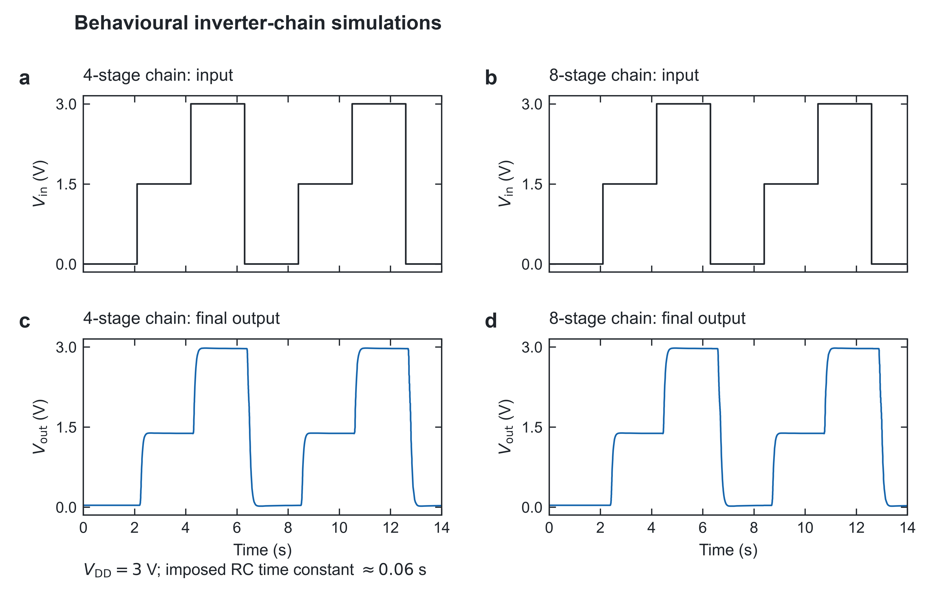Supplementary Figure 14. Behavioural simulations of ternary inverter chains. a,b Input waveforms for four- and eight-stage feed-forward chains. c,d Corresponding final-stage outputs at V_{DD} = 3 V. Identical stages use the measured single-inverter VTC and an imposed RC time constant of approximately 0.06 s. These are nominal behavioural simulations rather than experimental multistage measurements.

Benchmarking the peak-to-valley current contrast and semiconductor composition
Supplementary Table 1 summarizes the literature entries used for the PVR–|V_{D}| benchmark in Fig. 4d. The comparison includes NTC devices incorporating two semiconductor materials [9–15] and single-semiconductor devices based on CNTs [16] and MoTe₂ [17]. The classification counts the semiconductor materials forming the active device, excluding electrode metals and gate dielectrics. Accordingly, the vertically stacked NTC transistor is classified as a single-semiconductor device because both constituent channels are formed from CNT networks, despite their contrasting gate responses.
The entry for this work corresponds to the upper-layer HD condition in Fig. 4c. Both channels had W_{ch} = 20 μm and L_{ch} = 4 μm, with CNT network densities of 11–13 tubes/μm in the lower layer and 18–20 tubes/μm in the upper layer. The original representative common-gate transfer characteristic gives a PVR of approximately 1.6 × 10⁴ at V_{D} = −0.1 V. This benchmark entry represents an upper-range device result rather than a population mean or median. The additional device distributions and low-current controls are reported in Supplementary Figs. 9 and 10 and Supplementary Table 3. PVR was calculated as I_{peak}/I_{valley} using the current peak and its preceding valley in the drain-current magnitude |I_{D}|, following the extraction procedure described in Methods.
The literature entries retain the PVR values and drain-bias conditions reported in the respective studies [9–17]. They therefore provide a comparison of reported current contrast under the listed bias conditions rather than measurements obtained using a common experimental protocol. The present device combines a large peak-to-valley current contrast with a low drain bias while using CNTs as the sole semiconductor.
This benchmark concerns the device-level nonmonotonic response rather than the overall performance of a ternary inverter. As discussed in the main text, PVR quantifies the current contrast but does not by itself determine whether a finite intermediate output state is formed or how the static noise margins are distributed. Those circuit characteristics also depend on the shape and alignment of the NTC profile relative to the opposing inverter branch.

Reference  number | Number of semiconductor materials | Semiconductor materials | PVR | |V_{D}| (V)
[9] | 2 | DNTT / ZnO | ≈ 10⁵–10⁶ | 5–30
[10] | 2 | p-TeO_{x} / n-IGTO | > 1 × 10³ | 3.0
[11] | 2 | p-WSe₂ / n-MoS₂ | ≈ 10² | 0.7
[12] | 2 | p-DNTT / n-PTCDI-C13 | 9.6 | 50
[13] | 2 | p-Cu₂O / n-IGZO | 25 | 20
[14] | 2 | MoS₂ / MoTe₂ | ≈ 6 × 10³ | 0.1–1.0
[15] | 2 | GeS_{0.29}Se_{0.71} / SnS₂ | 6.6 × 10³ | 3
[16] | 1 | CNT | ≈ 3.5 × 10² | 0.6
[17] | 1 | MoTe₂ | > 1 × 10³ | 2.0
This work (representative HD device) | 1 | CNT | 1.6 × 10⁴ | 0.1
Supplementary Table 1. Benchmark comparison of semiconductor composition, PVR and drain bias for previously reported NTC devices and the vertically stacked NTC transistor. The table lists the number and type of semiconductor materials, PVR and drain-bias magnitude |V_{D}| for the devices compared in Fig. 4d [9–17]. The material count refers to the semiconductor constituents of the NTC device rather than the number of channels or layers. Values for previously reported devices are taken from the cited studies, whereas the value for this work was extracted from the measured common-gate transfer characteristic at V_{D} = –0.1 V. The value for this work represents the original representative HD device; additional population statistics are provided in Supplementary Table 3.
Reference parameters for the constituent-channel compact models
Supplementary Table 2 summarizes the reference parameter sets used to describe the constituent-channel responses in Supplementary Fig. 11a. The electron and hole branches of the lower-layer transistor were parameterized separately and combined to describe its electron-dominant ambipolar response. The resulting lower-layer model was then connected in series with the upper-layer p-type model and operated through a common gate. The two lower-layer columns therefore represent different carrier branches of the same physical transistor rather than two separate CNT channels.
The fitted V_{TO} values were 0.18 V for the lower-layer electron branch, –3.2 V for the lower-layer hole branch and –1.8 V for the upper-layer p-type response. These model parameters are distinct from the constant-current V_{T} values extracted from the measured transfer characteristics. NFS was used to parameterize the subthreshold response within the Level 3 model [6]. In the present phenomenological description, the fitted NFS values are not interpreted as independently measured trap densities in the CNT networks or gate dielectrics.
All three models used W = 20 μm, L = 4 μm and a reference KP of 20 × 10^{–6} A V^{–2}, equivalent to 20 μA V^{–2}. R_{S} and R_{D} were each set to 70 kΩ for the lower-layer electron branch, 150 kΩ for the lower-layer hole branch and 110 kΩ for the upper-layer p-type model. These values represent effective series-resistance contributions used in fitting. Assigning equal R_{S} and R_{D} within each model does not establish that the physical source and drain contact resistances are identical.
The listed values define the reference condition before the parametric changes in Supplementary Figs. 11b and 11c. The common-gate work-function variation was represented by coordinated changes in the constituent-model V_{TO} values. The upper-layer gate-capacitance variation was represented by changing the upper-layer KP while retaining the lower-layer parameters. The table therefore provides the baseline for distinguishing a common shift of the constituent-channel responses from a layer-selective change in their relative current levels.
Parameter | Lower-layer  electron branch | Lower-layer  hole branch | Upper-layer  p-type CNT FET
V_{TO} (V) | 0.18 | −3.2 | −1.8
NFS (cm⁻² V⁻¹) | 2.1 × 10¹² | 3.4 × 10¹² | 3.8 × 10¹²
KP (A V⁻²) | 20 × 10⁻⁶ | 20 × 10⁻⁶ | 20 × 10⁻⁶
W (μm) | 20 | 20 | 20
L (μm) | 4 | 4 | 4
R_{S} (kΩ) | 70 | 150 | 110
R_{D} (kΩ) | 70 | 150 | 110

Supplementary Table 2. Reference HSPICE Level 3 compact-model parameters for the vertically stacked NTC transistor. The three parameter sets describe the lower-layer electron branch, lower-layer hole branch and upper-layer p-type CNT FET. V_{TO} is the model threshold-voltage parameter, NFS is the fast surface state density parameter and KP is the intrinsic transconductance parameter. W and L denote the model channel width and length, respectively, while R_{S} and R_{D} denote the source and drain series resistances. The parameter sets were calibrated to the isolated transfer characteristics measured at V_{D} = +0.1 V for the lower-layer transistor and V_{D} = –0.1 V for the upper-layer transistor.

Statistical summary of the measured peak-to-valley current contrast
Supplementary Table 3 summarizes the PVR distributions obtained from the additional HD and MD transfer measurements in Supplementary Fig. 9. Each density and integration-setting group contains 30 device records measured at V_{D} = −0.1 V. The same peak/pre-rise extraction procedure described in Methods was applied to all records, without selection by PVR rank. Statistics were calculated separately for PLC = 1 and PLC = 5, rather than pooling records from different integration settings as additional independent devices.
The median describes the central value of the measured PVR distribution, while Q1–Q3 denotes the interval between its 25th and 75th percentiles. This interval characterizes the spread of the middle half of the distribution. The maximum is reported separately to distinguish upper-range performance from the population response. These quantities therefore provide complementary information about representative current contrast, device-to-device variation and the highest observed value within each dataset.
The HD median PVR values are 6.42 × 10³ and 5.95 × 10³ at PLC = 1 and 5, respectively, whereas the corresponding MD values are 4.16 × 10² and 4.94 × 10². Thus, the higher current contrast of the HD condition is retained at both integration settings. The original representative PVR of approximately 1.6 × 10⁴ in Fig. 4 is distinguished from these population medians rather than treated as the typical response of every HD device. The statistics describe the operational PVR obtained using the stated extraction procedure; the complementary low-current controls are presented in Supplementary Fig. 10.

Condition | n | Median PVR | 25th–75th percentiles, Q1–Q3 | Maximum PVR
HD, PLC = 1 | 30 | 6.42 × 10³ | (4.28–7.66) × 10³ | 1.84 × 10⁴
HD, PLC = 5 | 30 | 5.95 × 10³ | (4.98–6.88) × 10³ | 9.10 × 10³
MD, PLC = 1 | 30 | 4.16 × 10² | (2.93–5.37) × 10² | 9.61 × 10²
MD, PLC = 5 | 30 | 4.94 × 10² | (3.79–6.08) × 10² | 8.40 × 10²
Supplementary Table 3. Population statistics of the operational PVR. Values were calculated from the complete HD and MD datasets at V_{D} = −0.1 V using the extraction procedure described in Methods. Q1–Q3 denotes the interval between the 25th and 75th percentiles of the record-level PVR values.

Quantification of the open-contact measurement background
Supplementary Table 4 summarizes the signed drain-, source- and gate-current readings from the open-contact control shown in Supplementary Fig. 10e. All probe contacts were disconnected, and the programmed gate voltage was swept from −3 to +3 V in 0.05 V steps at PLC = 1, with V_{D} = −0.1 V and V_{S} = 0 V. The table reports the mean, standard deviation, minimum and maximum across the 121 readings for each measurement channel.
The drain-channel mean is −14.9 fA, with a standard deviation of 18.4 fA and recorded values ranging from −55 to +47 fA. The source and gate channels exhibit different mean backgrounds, showing that the baseline is channel-dependent. In particular, the nonzero gate-current reading under open-contact conditions cautions against assigning the entire sub-pA gate-current reading of a contacted device to dielectric leakage.
For comparison at the same integration setting, the median operational pre-rise currents extracted from the device transfer characteristics are 660 fA for HD and 260 fA for MD, as shown in Supplementary Fig. 10f. These values exceed the drain-current magnitude range observed in the open-contact control. The comparison provides a measured reference for interpreting the low-current levels used in the PVR analysis, without applying background subtraction. The listed standard deviations describe variation across the programmed sweep, not fixed-bias temporal noise or instrument accuracy. The control therefore characterizes the open-contact background at PLC = 1 rather than a complete uncertainty bound for contacted-device measurements or a calibration at PLC = 5.

Channel | Mean current (fA) | Across-sweep SD (fA) | Minimum (fA) | Maximum (fA)
I_{D} | −14.9 | 18.4 | −55 | +47
I_{S} | +33.5 | 17.6 | −5 | +81
I_{G} | −210.0 | 20.4 | −261 | −149
Supplementary Table 4. Open-contact current statistics at PLC = 1. Signed-current statistics were calculated across the 121-point programmed gate sweep from −3 to +3 V at V_{D} = −0.1 V with all probe contacts disconnected. The standard deviation describes variation across this sweep and is not an instrument accuracy specification.

Circuit-footprint estimates under matched layout conventions
Supplementary Table 5 summarizes the footprint calculations for the vertical and lateral inverter references in Supplementary Fig. 13. The vertical unit-cell reference corresponds to the fabricated inverter containing a vertically stacked NTC transistor and a separate n-type CNT pull-down. The lateral reference places the two constituent channels of the NTC pull-up at separate lateral positions while retaining the same channel dimensions, separate pull-down and input-control topology. The lateral counterpart has not been fabricated.
The documented cell envelopes are 900 × 1,200 μm for the vertical reference and 900 × 1,600 μm for the lateral reference. These dimensions include the contact-landing and supply-routing regions retained in the comparison. The corresponding areas are 1.08 and 1.44 mm², giving a 25% reduction in the assessed inverter footprint and a density ratio of 1.33. The calculation therefore concerns the inverter layout rather than the sum of CNT-channel areas alone.
For the four- and eight-stage arrangements, the unit cells were repeated with a common inter-cell gap of 50 μm. The row width was calculated as 900N + 50(N − 1) μm, where N is the number of stages, and multiplied by the corresponding cell height. The resulting vertical/lateral areas are 4.50/6.00 mm² for four stages and 9.06/12.08 mm² for eight stages. The reduction remains 25% in this repeated-cell model because both arrangements use the same row width and retain their respective unit-cell heights.
The table uses the documented envelopes without an additional routing-height allowance. It therefore reports layout-derived multistage estimates rather than measured areas of fabricated cascades or routing-verified implementations. Sensitivity to additional in-plane routing space is evaluated separately in Supplementary Fig. 13d. This separation identifies which values follow directly from the stated cell dimensions and which depend on further routing assumptions.

Stages, N | Row width (μm) | Vertical height (μm) | Lateral height (μm) | Vertical area (mm²) | Lateral area (mm²) | Reduction
1 | 900 | 1,200 | 1,600 | 1.08 | 1.44 | 25.0%
4 | 3,750 | 1,200 | 1,600 | 4.50 | 6.00 | 25.0%
8 | 7,550 | 1,200 | 1,600 | 9.06 | 12.08 | 25.0%
Supplementary Table 5. Footprints calculated using the matched repeated-cell layout convention. Row widths were calculated as 900N + 50(N − 1) μm. The listed areas use the documented unit-cell heights without an additional routing-height allowance. The single-cell vertical reference corresponds to the fabricated inverter layout, whereas the lateral counterpart and multistage extensions are design estimates.

REFERENCES
(1) Jorio, A. et al. G-band resonant Raman study of 62 isolated single-wall carbon nanotubes. Phys. Rev. B 65, 155412 (2002).
(2) Miyata, Y., Mizuno, K. & Kataura, H. Purity and defect characterization of single-wall carbon nanotubes using Raman spectroscopy. J. Nanomater. 2011, 786763 (2011).
(3) Jorio, A. et al. Structural (n,m) determination of isolated single-wall carbon nanotubes by resonant Raman scattering. Phys. Rev. Lett. 86, 1118–1121 (2001).
(4) Tseng, Y.-C., Phoa, K., Carlton, D. & Bokor, J. Effect of diameter variation in a large set of carbon nanotube transistors. Nano Lett. 6, 1364–1368 (2006).
(5) Cao, Q. et al. Medium-scale carbon nanotube thin-film integrated circuits on flexible plastic substrates. Nature 454, 495–500 (2008).
(6) Synopsys, Inc. HSPICE MOSFET Models Manual, Version X-2005.09 (Synopsys, 2005).
(7) Biercuk, M. J., Monsma, D. J., Marcus, C. M., Becker, J. S. & Gordon, R. G. Low-temperature atomic-layer-deposition lift-off method for microelectronic and nanoelectronic applications. Appl. Phys. Lett. 83, 2405–2407 (2003).
(8) Lee, H. Y. et al. Mixed-dimensional semiconductors-based ternary circuits with tunable negative transconductance characteristics. ACS Appl. Mater. Interfaces 17, 6774–6782 (2025).
(9) Lee, Y. et al. Demonstration of anti-ambipolar switch and its applications for extremely low power ternary logic circuits. ACS Nano 16, 10994–11003 (2022).
(10) Jung, C. et al. Scalable ternary logic device based on TeOₓ/IGTO heterojunction transistor. Adv. Funct. Mater. 35, 2501834 (2025).
(11) Kim, J. Y. et al. Distinctive field-effect transistors and ternary inverters using cross-type WSe₂/MoS₂ heterojunctions treated with polymer acid. ACS Appl. Mater. Interfaces 12, 36530–36539 (2020).
(12) Kim, S., Jeon, Y., Cho, H. R., Kim, C. H. & Yoo, H. Organic ternary logic inverter using negative transconductance pull-down switching transistor. IEEE Electron Device Lett. 45, 590–592 (2024).
(13) Shin, J. C. et al. Oxide semiconductor heterojunction transistor with negative differential transconductance for multivalued logic circuits. ACS Nano 18, 1543–1554 (2024).
(14) Duong, N. T. et al. Modulating the functions of MoS₂/MoTe₂ van der Waals heterostructure via thickness variation. ACS Nano 13, 4478–4485 (2019).
(15) Long, Y. et al. Composition-modulated anti-ambipolar behavior enabled by two-dimensional GeSₓSe₁₋ₓ/SnS₂ van der Waals heterostructures for high-performance logic inverters. Nanoscale Horiz. 11, 572–584 (2026).
(16) Zhu, X. et al. High-performance ternary logic circuits and neural networks based on carbon nanotube source-gating transistors. Sci. Adv. 11, eadt1909 (2025).
(17) Zhang, Z. et al. Near-perfect standard ternary inverter based on MoTe₂ homojunction anti-ambipolar transistor. Adv. Funct. Mater. 35, 2424728 (2025).

