Online Data Supplement – Figures and Tables

Supplementary Figure 1. Percent increase in cause-specific mortality for PM_{2.5}, O₃, and NO₂ using the single-lag model.

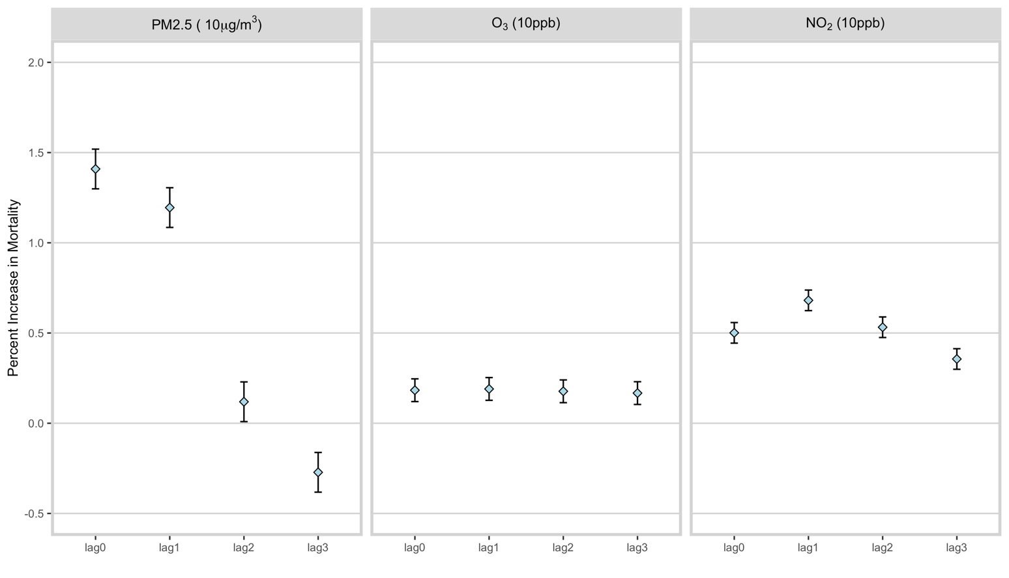
Percent increase in the risk of mortality for each 10 μg/m3 unit increase in PM_{2.5}, 10 ppb increase in O₃, and 10 ppb increase in NO₂. Effects were for individual pollutants on the lag days indicated, without adjusting for other pollutants. Error bars represent 95% CIs of the estimates.

Supplementary Table 1. Incremental effect modification

 | Predictors† | PM_{2.5} (µg/m3) |  |  | O₃ (ppb) |  |  | NO₂ (ppb)
 | Predictors† | % | 95% CI | p | % | 95% CI | p | % | 95% CI | p
Education | HS | -0.07 | (-0.40, 0.25) | 0.653 | 0.00 | (-0.10, 0.11) | 0.970 | -0.01 | (-0.17, 0.16) | 0.938
Education | >HS | -0.10 | (-0.46, 0.27) | 0.612 | 0.00 | (-0.12, 0.11) | 0.943 | -0.01 | (-0.20, 0.17) | 0.897
Age group | 45-65 | 0.02 | (-0.62, 0.66) | 0.952 | 0.02 | (-0.19, 0.23) | 0.855 | 0.04 | (-0.29, 0.37) | 0.826
Age group | 65-75 | -0.01 | (-0.65, 0.64) | 0.983 | 0.01 | (-0.19, 0.22) | 0.896 | 0.07 | (-0.26, 0.40) | 0.675
Age group | >=75 | 0.26 | (-0.34, 0.85) | 0.393 | 0.02 | (-0.18, 0.21) | 0.868 | 0.14 | (-0.17, 0.44) | 0.374
Sex | Female | 0.19 | (-0.05, 0.44) | 0.117 | 0.01 | (-0.06, 0.09) | 0.713 | 0.07 | (-0.05, 0.20) | 0.258
Race | Black | 0.09 | (-0.27, 0.45) | 0.626 | 0.02 | (-0.10, 0.14) | 0.761 | 0.02 | (-0.15, 0.20) | 0.789
Race | Other | -0.32 | (-1.24, 0.60) | 0.491 | -0.01 | (-0.30, 0.29) | 0.963 | 0.02 | (-0.38, 0.43) | 0.915
Urbanicity | Urban | -0.25 | (-0.58, 0.08) | 0.143 | -0.06 | (-0.16, 0.04) | 0.261 | -0.13 | (-0.34, 0.08) | 0.209

Effect modifications were incremental effects (i.e. coefficients of the interaction terms) and were evaluated using periods lag0-1 for PM_{2.5}, lag0-2 for O₃, and lag0-2 for NO₂. Values are percent increase (95% CI) for 10 µg/m3 increase in PM_{2.5}, 10 ppb in O₃, and 10 ppb in NO₂.

† The effects of high school and higher-than-high school education were in comparison to lower-than-high school education; the effects of age groups were in comparison to age <45 years; the effects of female gender were in comparison to male; the effects of race of black were in comparison to race of white; the effects of urbanicity (defined as total population density above 25th percentile) were in comparison to rural areas.

Supplementary Table 2. Single lag models for temperature and absolute humidity

 | Temperature |  |  | Humidity
Model | % | 95% CI | p | % | 95% CI | p
Lag 0 | -0.40 | (-0.54, -0.26) | <0.01 | -472.82 | (-792.80, -152.84) | <0.01
Lag 1 | -1.08 | (-1.08, -0.79) | <0.01 | -2110.29 | (-2430.53, -1790.06) | <0.01
Lag 2 | -1.49 | (-1.49, -1.21) | <0.01 | -3226.40 | (-3226.40, -3546.94) | <0.01
Lag 3 | -1.47 | (-1.47, -1.19) | <0.01 | -3127.71 | (-3127.71, -3448.23) | <0.01

Reported estimates were independent effects without adjustment for the other variable. Values are percent increase (95% CI) for 1 degree Celsius (Kelvin) increase in temperature and 1 g/cm3 increase in absolute humidity.
Supplementary Table 3. Model using propensity score (PS) and inverse probability weighting (IPW).
 | PM2.5 (ug/m3) |  |  | O3 (ppb) |  |  | NO2 (ppb)
Model | % | 95% CI | p | % | 95% CI | p | % | 95% CI | p
PS and IPW | 1.09 | (0.81, 1.38) | <0.01 | 0.09 | (-0.09, 0.28) | 0.32 | 0.56 | (0.39, 0.73) | <0.01
The PS and IPW model adjusted for all other pollutants, temperature and absolute humidity.
Values are percent increase (95% CI) for 10 µg/m3 increase in PM_{2.5}, 10 ppb in O₃, and 10 ppb in NO₂. All models were adjusted for temperature and absolute humidity. Lag periods for all models were lag0-1 for PM_{2.5}, lag0-2 for O₃, and lag0-2 for NO₂.

