Research Article
Severity of COVID-19 Infection in ACEI/ARB Users in Two Saudi Public Specialty Hospitals: Retrospective Cohort Study
Ahmed A. Alrashed¹, Tahir M. Khan^{2,3}, Noara K. Alhusseini⁴, Syed Mohammed Basheeruddin Asdaq⁵*, Mushira Enani⁶, Bandar Alosaimi^{7,8}, Nada M. Alkhani¹, Yahya Mohzari⁹, Maram M. Alghalbi¹⁰, Wafa Alfahad¹⁰, Mona A. Alanazi¹¹, Asma S. Albujaidya¹¹, Amal Ben-Akresh¹⁰, Malak Almutairi⁵, Ivo Abraham^{12,13}, Ahmad Alamer^{13,14}
¹Pharmaceutical Service Department, Main Hospital, King Fahad Medical City, Riyadh, Saudi Arabia; fahad@ksmc.med.sa (A.A.A.); mhospital1920@gmail.com (N.M.A.)
²The institute of Pharmaceutical Science (IPS) of University of Veterinary and Animal Sciences, Lahore, Pakistan; qualityasdaq@gmail.com
³School of Pharmacy, Monash University, Sunway City, Selangor, Malaysia.
⁴College of Medicine, Alfaisal University, Riyadh, Saudi Arabia; sasdaq@gmail.com
⁵College of Pharmacy, AlMaarefa University, Riyadh, Saudi Arabia; sasdag@mcst.edu.sa (S.M.B.A.); farhana.basheer13@gmail.com (M.A.)
⁶Infectious Disease Section, Medical specialties Department, King Fahad Medical City, Saudi Arabia; emadasdaq@mcst.edu.sa
⁷Research Center, King Fahad Medical City, Riyadh, Saudi Arabia; basheer_1@rediffmail.com
⁸College of Medicine, King Fahad Medical City, Riyadh, Saudi Arabia
⁹Pharmacy Department, Clinical Pharmacy section, King Saud Medical City, Saudi Arabia; Yali2016@hotmail.com
¹⁰Pharmacy Services Department, Prince Sultan Military Medical City, Riyadh, Saudi Arabia; emadfaiqa@gmail.com (W.A.); research.dir@mcst.edu.sa (A.B.);malghalbi@gmail.com (M.M.A.)
¹¹Prince Mohammed Bin Abdulaziz Hospital, Riyadh, Saudi Arabia; abstracts@mcst.edu.sa (M.A.A.); irb@mcst.edu.sa (A.S.A.)
¹²Department of Pharmacy Practice and Science, College of Pharmacy, University of Arizona, Tucson, Arizona, USA; basheer96@yahoo.com
¹³ Center for Health Outcomes and PharmacoEconomic Research, University of Arizona, Tucson, Arizona, USA; alamer@pharmacy.arizona.edu
¹⁴ Department of Clinical Pharmacy, Prince Sattam Bin Abdulaziz University, Alkharj, Saudi Arabia

*Corresponding author:
Dr. Syed Mohammed Basheeruddin Asdaq
Department of Pharmacology, College of Pharmacy, AlMaarefa University,
Dariyah, Riyadh-11597, KSA, Fax:00966-4903501-3399
E-mail:sasdag@mcst.edu.sa

Submission considerations: This work has not been published before; is not under consideration elsewhere; and has been approved by all authors.

Table S1. Propensity Score-Matching (PSM) matching balance
Table S2. The severity of COVID-19 disease based on WHO definition and classification among ACEI/ARB vs non-ACEI/ARB users based on WHO definition.
Figure S1. Propensity scores distribution (mirror diagram).
Figure S2. Love plot for the propensity score matching model-Covariates balance.
Figure S3. Love plot for IPSW-Covariates balance (A - Diabetes, hypertension or renal disease, B-hypertension and diabetes, C- Diabetes alone, D- Hypertension alone)
Table S1. Propensity Score-Matching (PSM) matching balance
Confounders | ACEI/ARBs  (unmatched)  n=146 |  | Non-ACEI/ARB  (unmatched)  n=208 | SMD* before matching |  | ACEI/ARB  (matched)  n=145 | Non-ACEI/ARB  (matched)  n=63 |  | SMD*  after matching
Age (years), mean (±SD) | 56.36 (11.87) |  | 40.29 (11.57) | 1.353 |  | 56.46 (11.84) | 49.21 (12.54) |  | -0.083
BMI (kg/m2), mean (±SD) | 28.81(6.32) |  | 27.39 (7.35) | 0.224 |  | 28.68 (6.13) | 29.22 (6.58) |  | -0.229
Diabetes, n (%) | 98 (67.1) |  | 42 (20.2) | 0.995 |  | 97 (66.9) | 29 (46.0) |  | 0.124
Hypertension,  N (%) | 123 (84.2) |  | 22 (10.6) | 2.015 |  | 122 (84.1) | 22 (34.9) |  | 0.066
Renal disease,  n (%) | 17 (11.6) |  | 9 (4.3) | 0.737 |  | 17 (11.7) | 9 (14.3) |  | 0.092
Number of Comorbidities¶, median (IQR) | 2 (2-3) |  | 0 (0-1) | 1.217 |  | 2 (2-3) | 1 (1-3) |  | -0.061
Propensity score matching with age, BMI, diabetes, hypertension, renal disease and number of comorbidities
¶Comorbidities include: diabetes, hypertension, cardiovascular disease (heart failure/coronary artery disease), stroke, renal disease, asthma and obesity
*Standardized mean difference
IQR: Interquartile range. SD: Standard deviation. SMD: Standardized mean difference: Angiotensin-converting enzyme inhibitors (ACE). ARB: Angiotensin II receptor blockers. BMI: body mass index

Table S2. The severity of COVID-19 disease based on WHO definition and classification among ACEI/ARB vs non-ACEI/ARB users based on WHO definition
Variable |  | ACEI/ARB  (matched)  n=145 |  |  | Non-ACEI/ARB  (matched)  n=63 |  |  | P value*
WHO Severity Classification,  n (%) |  |  |  |  |  |  |  | <0.001
Mild-moderate |  | 20 (13.8) |  |  | 33 (52.4)
Severe |  | 106 (73.1) |  |  | 24 (38.1)
Critical |  | 19 (13.1) |  |  | 6 (9.5)
Length of stay(days),  median (IQR) |  | 11 (7.0-17.0) |  |  | 9 (6.5-15) |  |  | 0.099
* For count data fisher exact test was used. Non-parametric Mann Whitney test for length of stay.
Angiotensin-converting enzyme inhibitors (ACE). ARB: Angiotensin II receptor blockers. WHO: World health organization

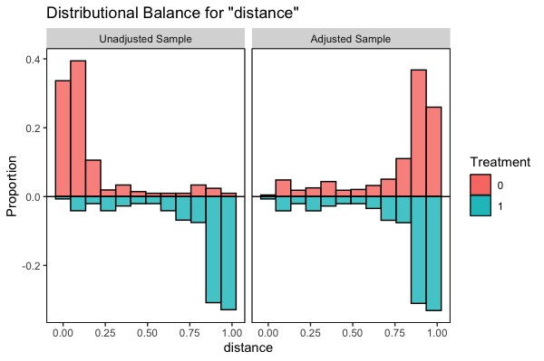
Figure S1. Propensity scores distribution (mirror diagram).

0= Non-angiotensin-converting–enzyme inhibitors (ACEI) or angiotensin-receptor blockers (ARB) users; 1=ACEI/ ARB users

Figure S2. Love plot for the propensity score matching model-Covariates balance

Figure S3. Love plot for IPSW-Covariates balance (A - Diabetes, hypertension or renal disease, B-hypertension and diabetes, C- Diabetes alone, D- Hypertension alone)

