Appendix

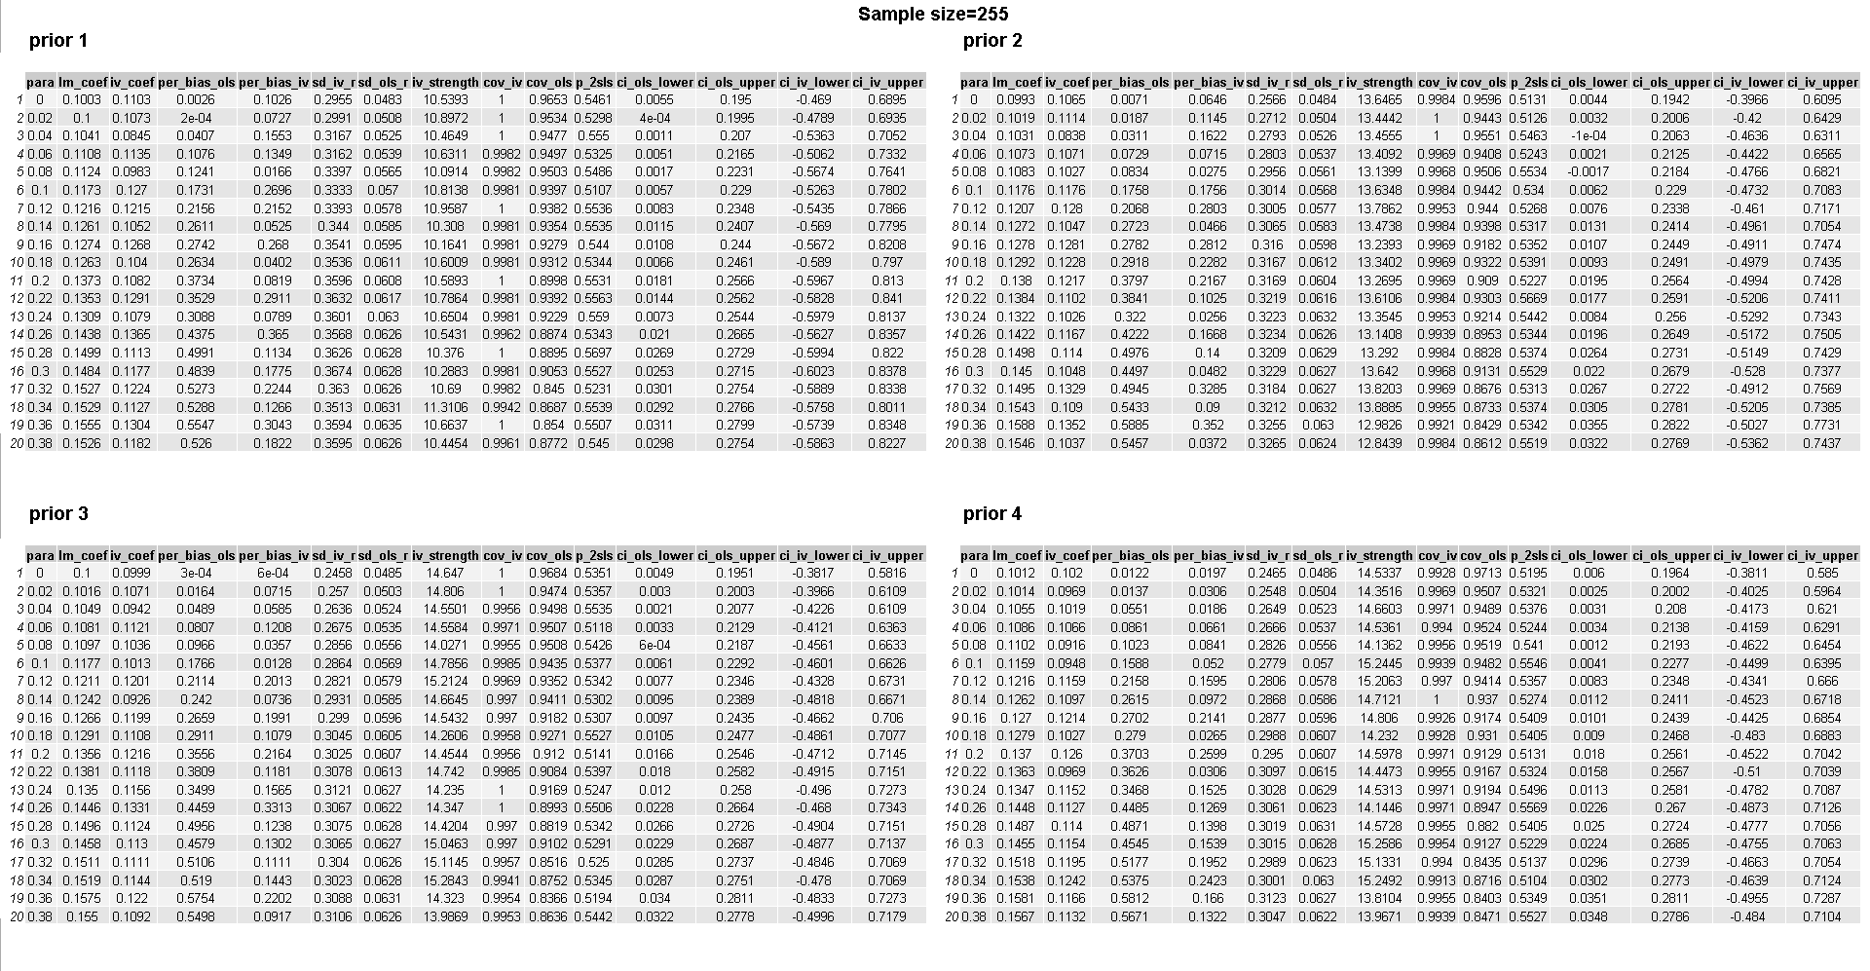
Figure 5．The performance of IV estimates and OLS estimates in the samples size of 255. ; sd_iv_r: robust standard deviation of 2SLS estimate; sd_ols_r: robust standard deviation of OLS estimate; lm_coef : OLS estimates; iv_coef: 2SLS estimates; iv_strength : F-statistics of first stage of 2SLS; cov_ols: coverage rate of OLS estimate; cov_iv : coverage rate of 2SLS estimate; ci_ols_lower,ci_ols_upper: the lower and upper bound of 95 % CI of ols estimates; ci_iv_lower,ci_iv_upper: the lower and upper bound of 95% CI of 2SLS estimates.

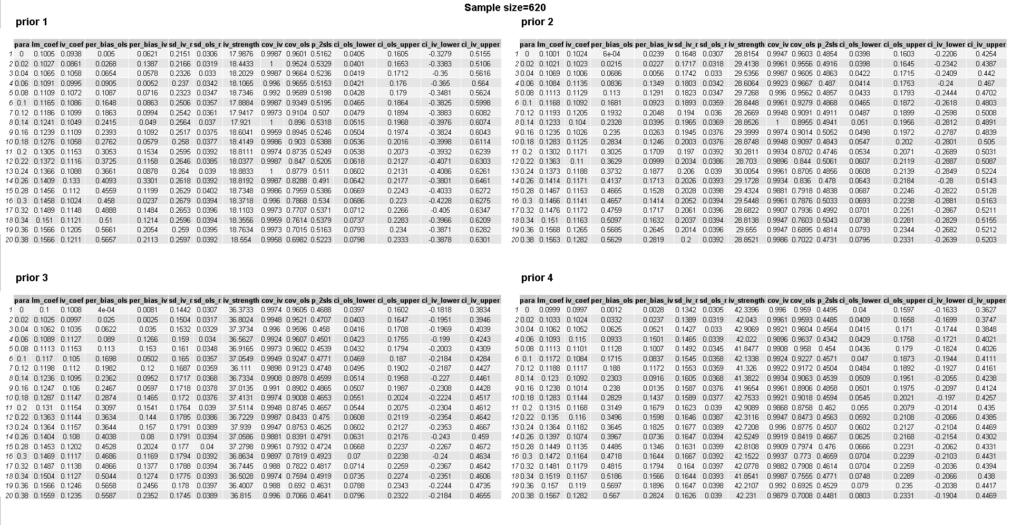
Figure 6. The performance of IV estimates and OLS estimates in the samples size of 620
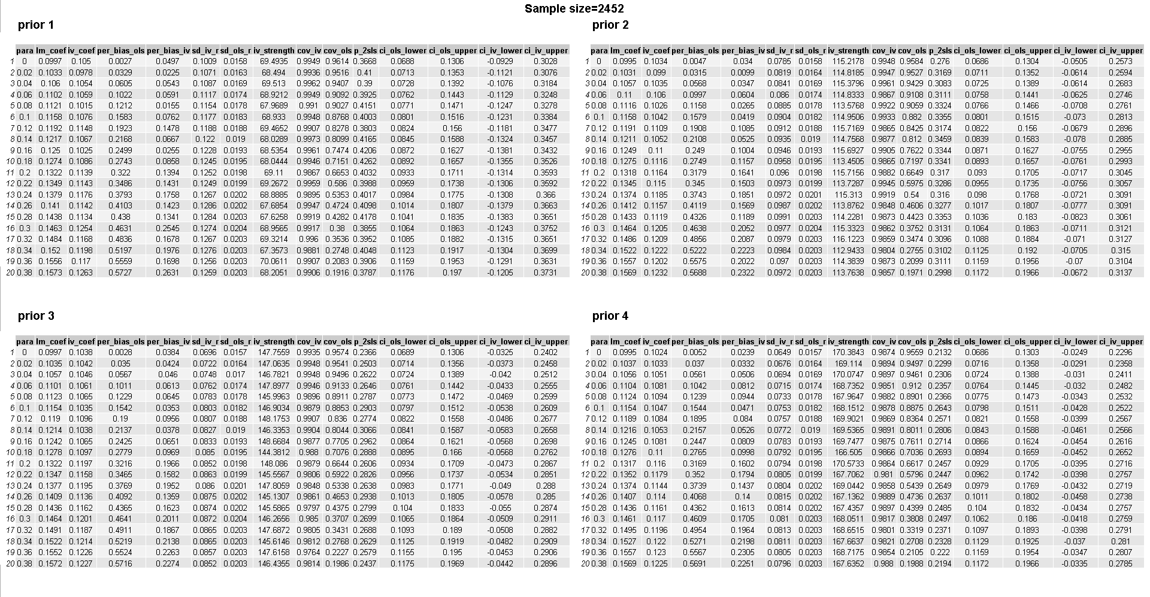
Figure 7. The performance of IV estimates and OLS estimates in the sample sizes of 2452

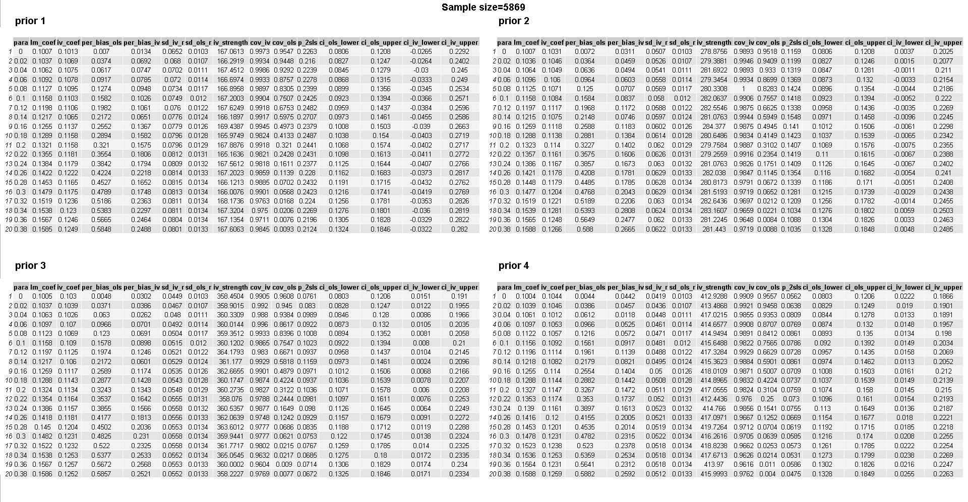
Figure 8. The performance of IV estimates and OLS estimates in the samples size of 5869

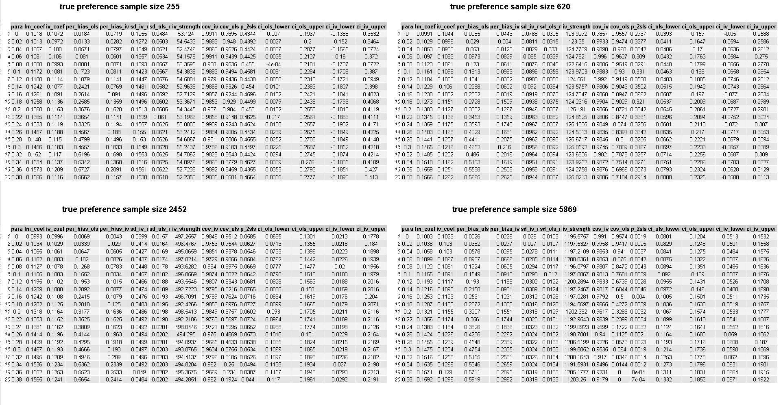
Figure 9 The performance of ‘true’ prescribing preference in four sample sizes
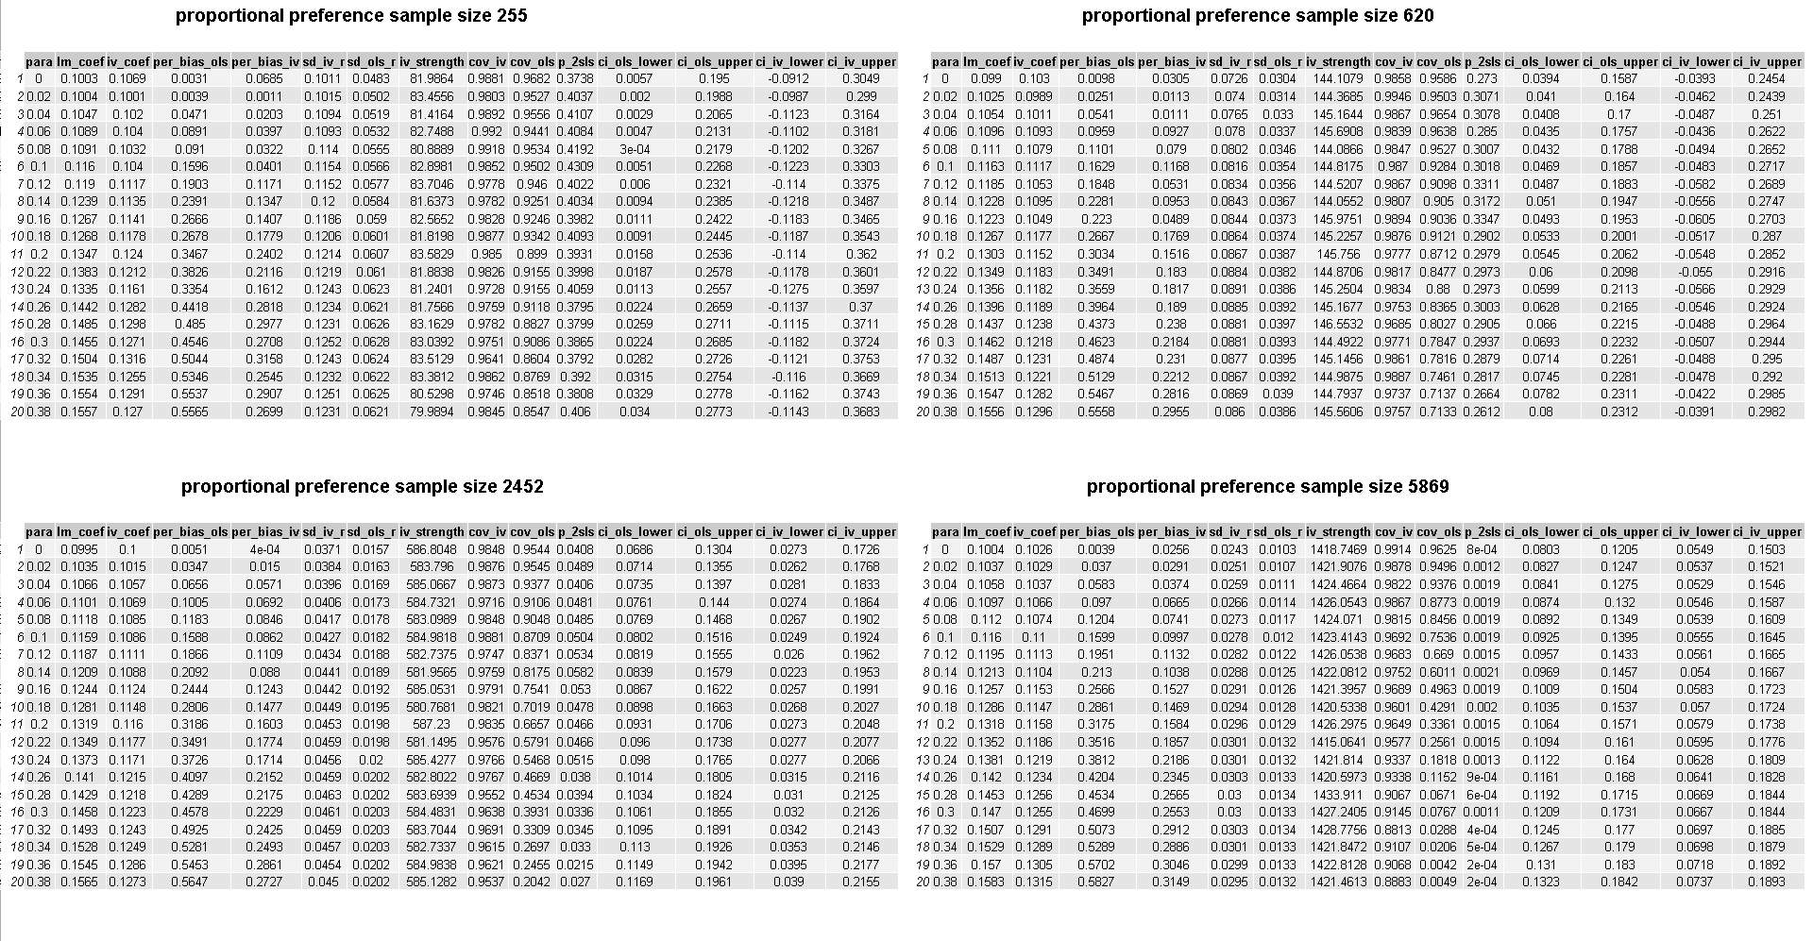
Figure 10 The performance of proportional preference in four sample sizes

