Supplementary Material
Manuscript title:
PG-FVEV: Petri-net-constrained genetic scheduling and offline virtual execution validation for a rail-mounted manipulator-CNC flexible manufacturing line

Supplementary Fig. S1. Overall Petri-net model
Supplementary Fig. S1 provides the complete labelled G2 engineering Petri-net model corresponding to Fig. 2(a)–(c) in the main text. It retains the process-flow, resource mutual-exclusion and q/g dispatch-control relationships used in PG-FVEV and provides the engineering-level detail underlying the simplified Petri-net subfigures.
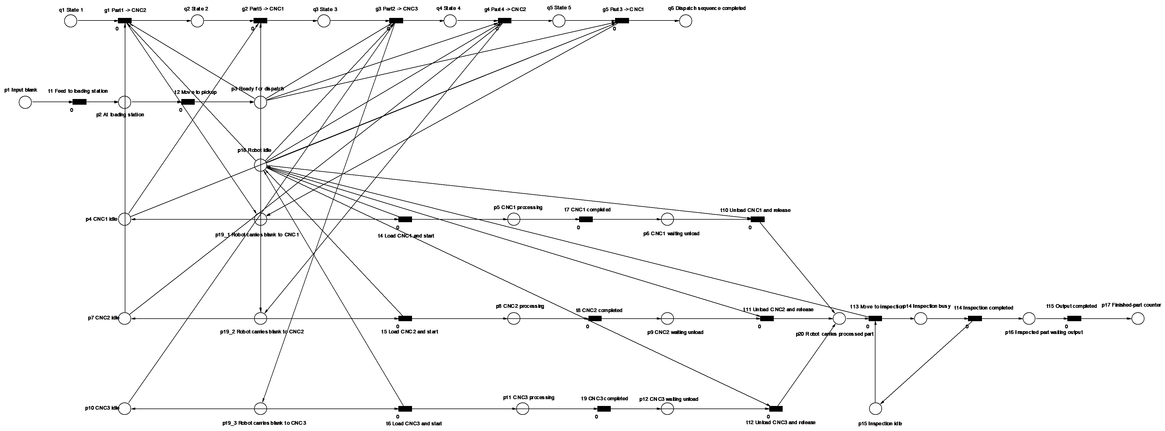
Supplementary Fig. S1. Overall Petri-net model used for the rail-mounted manipulator-CNC flexible manufacturing line.

Supplementary Text S1. MIoT.VC execution log excerpt and consistency evidence for the Case 1-b GA v3 schedule.
This supplementary text gives a representative MIoT.VC log excerpt for the Case 1-b GA v3 schedule, showing the dispatch order, CNC assignment and final rack-entry evidence used for offline validation.
[CONFIG] GA_ORDER = [1, 5, 2, 4, 3]
[CONFIG] ROUTE_MAP = {1: 'CNC2', 2: 'CNC3', 3: 'CNC1', 4: 'CNC2', 5: 'CNC1'}
START PART ROUTE | Part1 -> CNC2
[FINISH RACK] Part1 placed in FINISH_RACK slot
START PART ROUTE | Part5 -> CNC1
[FINISH RACK] Part5 placed in FINISH_RACK slot
START PART ROUTE | Part2 -> CNC3
[FINISH RACK] Part2 placed in FINISH_RACK slot
START PART ROUTE | Part4 -> CNC2
[FINISH RACK] Part4 placed in FINISH_RACK slot
START PART ROUTE | Part3 -> CNC1
[FINISH RACK] Part3 placed in FINISH_RACK slot
V17-R1 GA V3 ROUTE TEST END
ROUTE_MAP is stored by part index, whereas the actual dispatch order is determined by GA_ORDER. The excerpt supports only the consistency among the GA dispatch order, CNC route assignment and MIoT.VC recorded virtual execution sequence under deterministic offline virtual-case conditions.

