Supporting Information

Chemical Constituents with Inhibitory Activities of Proprotein Convertase Subtilisin/kexin Type 9 Expression from the Aerial Parts of Penthorum chinense

Pisey Pel,^{1,#} Hee-Sung Chae,^{1,#} Jinwoo Cho,¹ Young-Mi Kim,¹ Jungmoo Huh,¹ Young Hee Choi,² Jinwoong Kim,¹ Young-Won Chin^{1,}*
¹College of Pharmacy and Research Institute of Pharmaceutical Sciences, Seoul National University, Seoul 08826, Republic of Korea
²College of Pharmacy and Integrated Research Institute for Drug Development, Dongguk University-Seoul, Gyeonggi-do 10326, Republic of Korea
Email: pisey.1603@gmail.com (P.P.); chaeheesung83@gmail.com (H.-S.C.); jinu5709@donga.co.kr (J. C.); 0210121@hanmail.net (Y.-M.K.); jmhuh112@gmail.com (J. H); jwkim@snu.ac.kr (J. K.); choiyh@dongguk.edu (Y. H. C.); ywchin@snu.ar. kr (Y.-W.C.)
Contents
Figure legends
Fig. S1 CD and UV spectra of compound 1 -----------------------------------------------------1
Fig. S2. Mass spectrum of compound 1 -------------------------------------------------2
Fig. S3 IR spectrum of compound 1 -----------------------------------------------3
Fig. S4 ¹H-NMR (800Hz, CD₃OD) spectrum of compound 1 ---------------------------------3
Fig. S5 ¹³C-NMR (200Hz, CD₃OD) spectrum of compound 1 --------------------------------4
Fig. S6 COSY spectrum of compound 1 -------------------------------------------4
Fig. S7 HSQC spectrum of compound 1 -------------------------------------------------5
Fig. S8 HMBC spectrum of compound 1 --------------------------------------------------5
Fig. S9 NOESY spectrum of compound 1 --------------------------------------------------6
Fig. S10 Key NOE difference spectrum irradiated 3-OCH₃ of compound 1 --------------6
Fig. S11 DEPT spectrum of compound 1 ----------------------------------------------7
Fig. S12 CD and UV spectra of compound 2 ------------------------------------------------------8
Fig. S13 Mass spectrum of compound 2 ---------------------------------------------9
Fig. S14 IR spectrum of compound 2 ---------------------------------------------------10
Fig. S15 ¹H-NMR (800Hz, CD₃OD) spectrum of compound 2 ----------------------------10
Fig. S16 ¹³C-NMR (200Hz, CD₃OD) spectrum of compound 2 ------------------------------11
Fig. S17 COSY spectrum of compound 2 ----------------------------------------------------------11
Fig. S18 HSQC spectrum of compound 2 -------------------------------------------------12
Fig. S19 HMBC spectrum of compound 2 --------------------------------------------------12
Fig. S20 NOESY spectrum of compound 2 --------------------------------------------------13
Fig. S21 Key NOE difference spectrum irradiated H-5 of compound 2 --------------13
Fig. S22 DEPT spectrum of compound 2 --------------------------------------14
Fig. S23 Experimental and calculated ECD curves for compounds 1 and 2 -------------------14
Fig. S24 Mass spectrum of compound 20 ---------------------------------------------16
Fig. S25 ¹H-NMR (CD₃OD, 800Hz) spectrum of compound 20 --------------------------------17
Fig. S26 ¹³C-NMR (CD₃OD, 200Hz) spectrum of compound 20 -------------------------------17
Fig. S27 COSY spectrum of compound 20 ---------------------------------------------------------18
Fig. S28 HSQC spectrum of compound 20 -----------------------------------------------------18
Fig. S29 HMBC spectrum of compound 20 --------------------------------------------------19
Fig. S30 Sugar analysis of compound 20 ----------------------------------------------------------19
Fig. S31 Effect of compounds from P. chinense on PCSK9 and LDLR binding activity----20

Compound 1
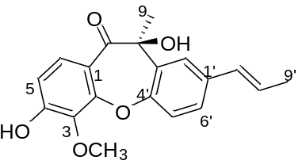
Appearance: purple powder
[α]_{D}²⁰= -18.11 (c 0.08, MeOH)
UV (MeOH) λ_{Max} (log ε): 212.5 (4.41)
ECD (MeOH) λ_{ma} 251 (-3.54), 317 (1.88)
FT-IR (ATR) v_{max} 3416, 2929, 1713, 1611, 1231 cm⁻¹
HRESIMS m/z [M+H]⁺ 327.1232 (calcd for C₁₉H₁₉O₅ 327.1232)

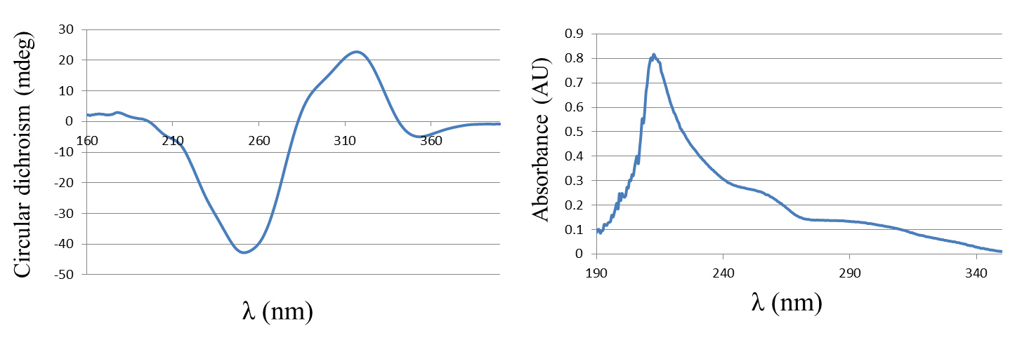
Fig. S1 CD and UV spectrum of compound 1

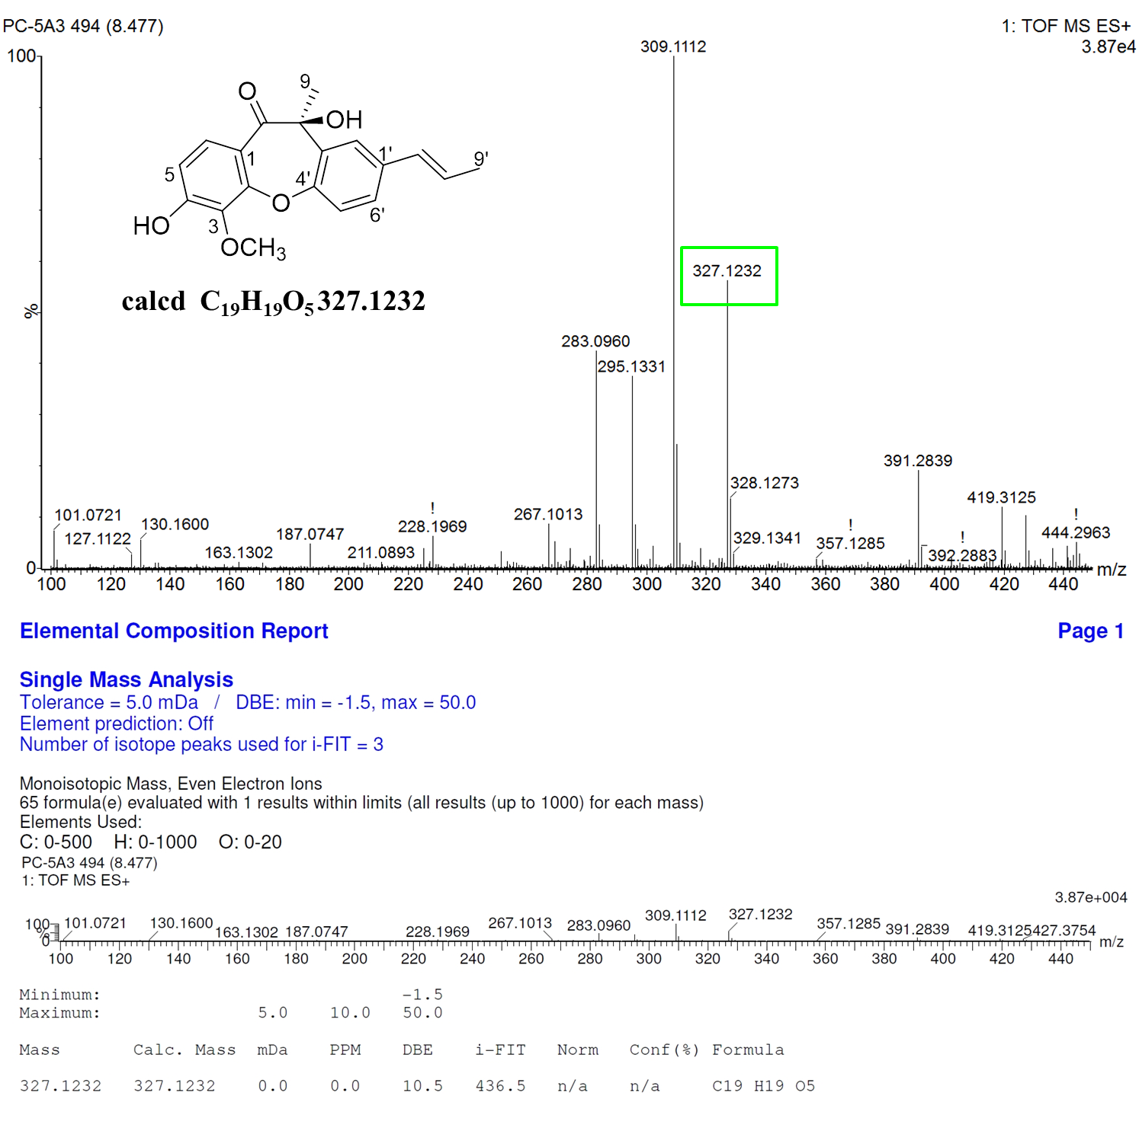
Fig. S2 HR-ESI-MS spectrum of compound 1
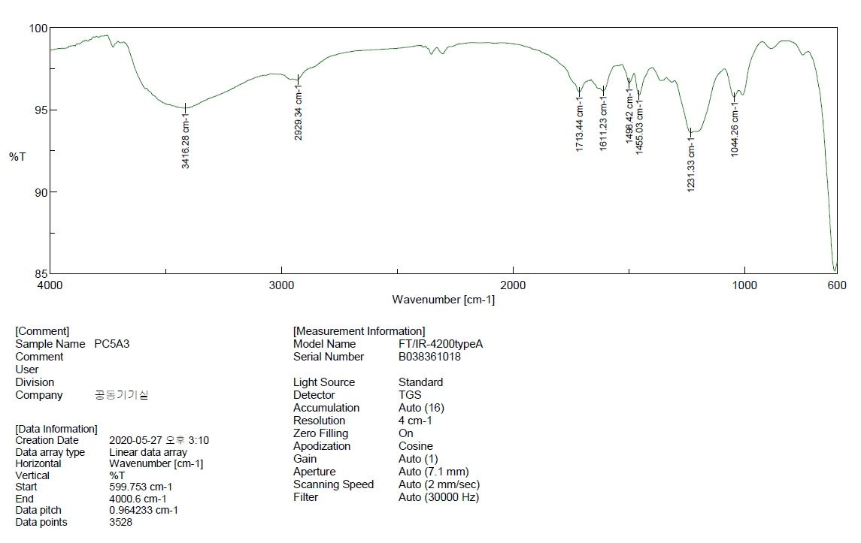
Fig. S3 IR spectrum of compound 1
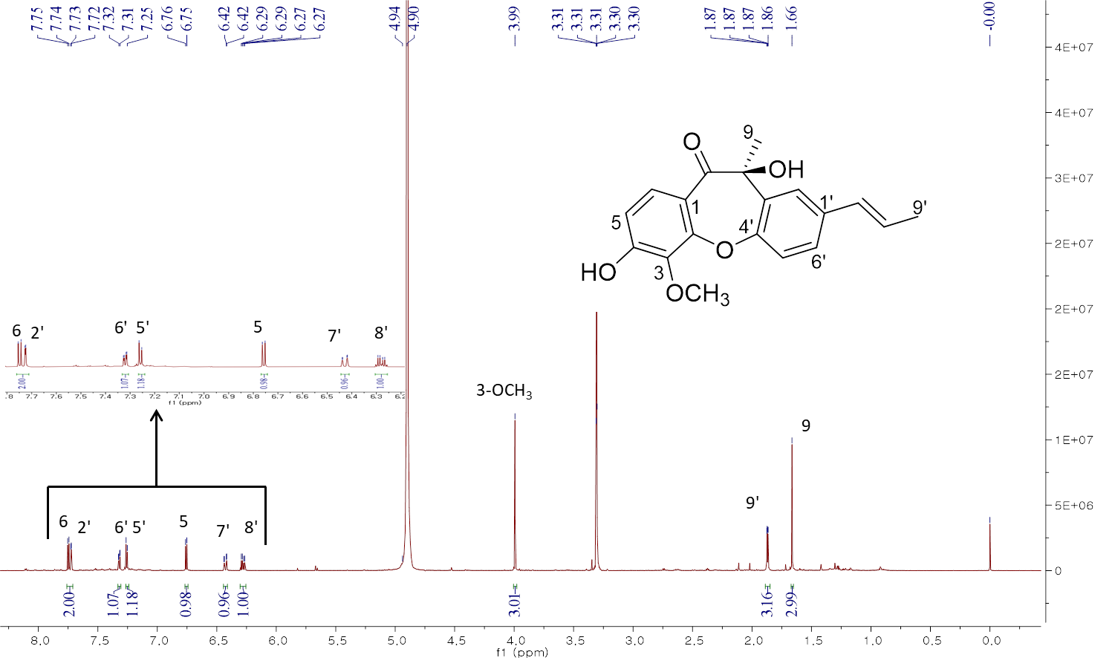
Fig. S4 ¹H-NMR spectrum (CD₃OD, 800MHz) of compound 1
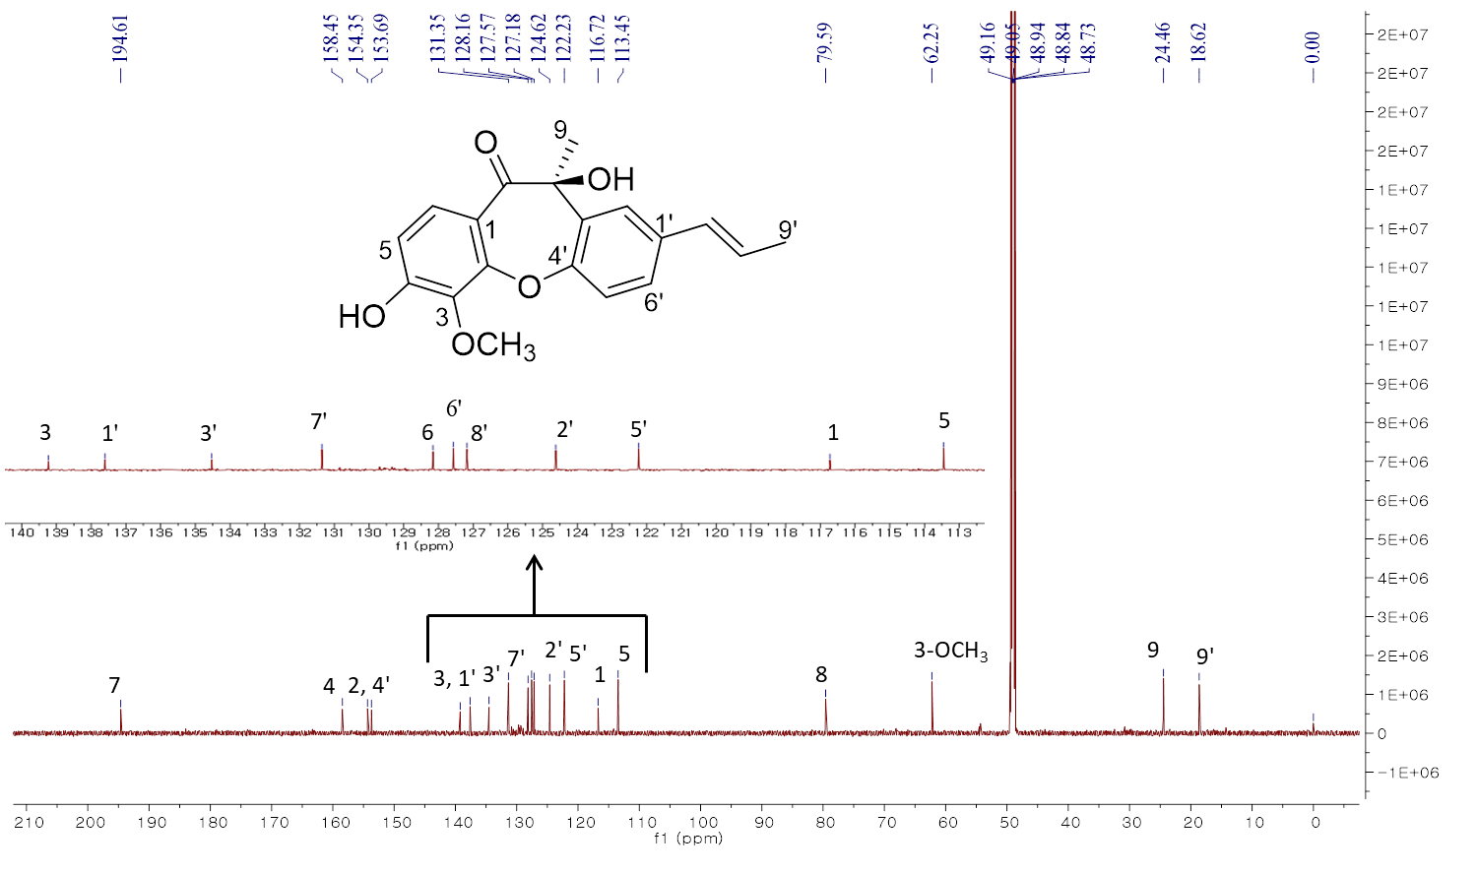
Fig. S5 ¹³C-NMR spectrum (CD₃OD, 200MHz) of compound 1
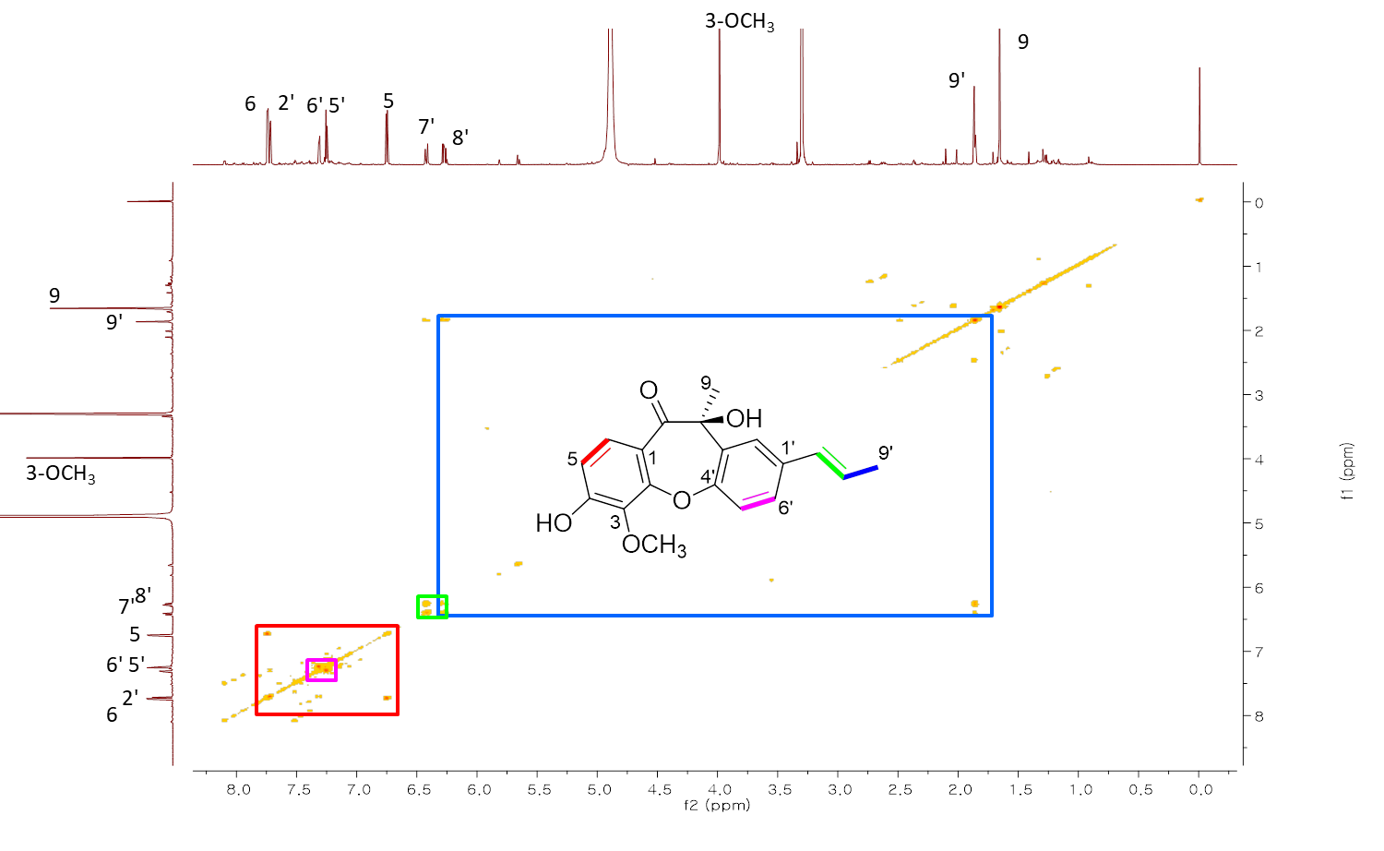Fig. S6 ¹H-¹H COSY spectrum (CD₃OD, 800MHz) of compound 1
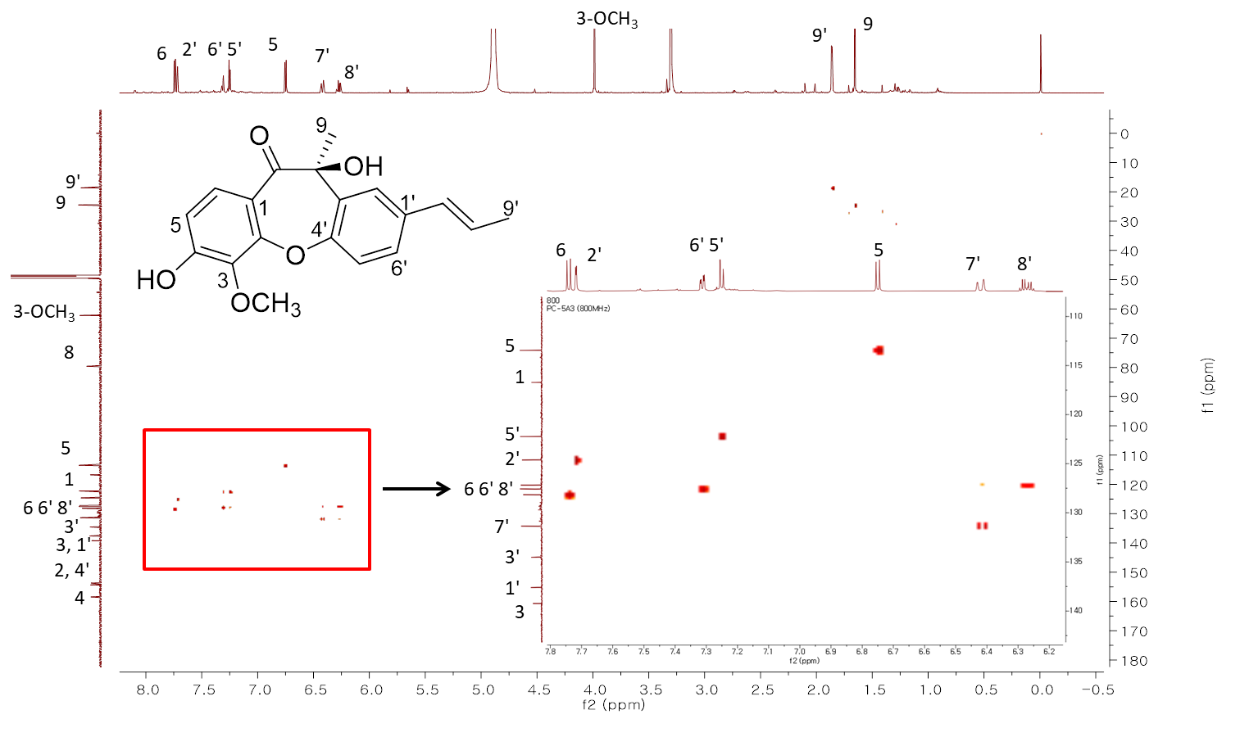
Fig. S7 HSQC spectrum (CD₃OD, 800MHz) of compound 1
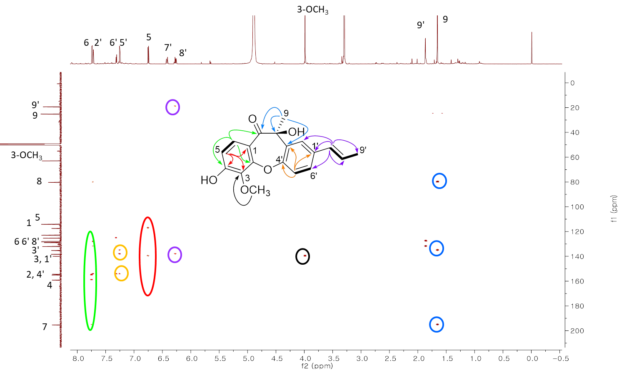
Fig. S8 HMBC spectrum (CD₃OD, 800MHz) of compound 1

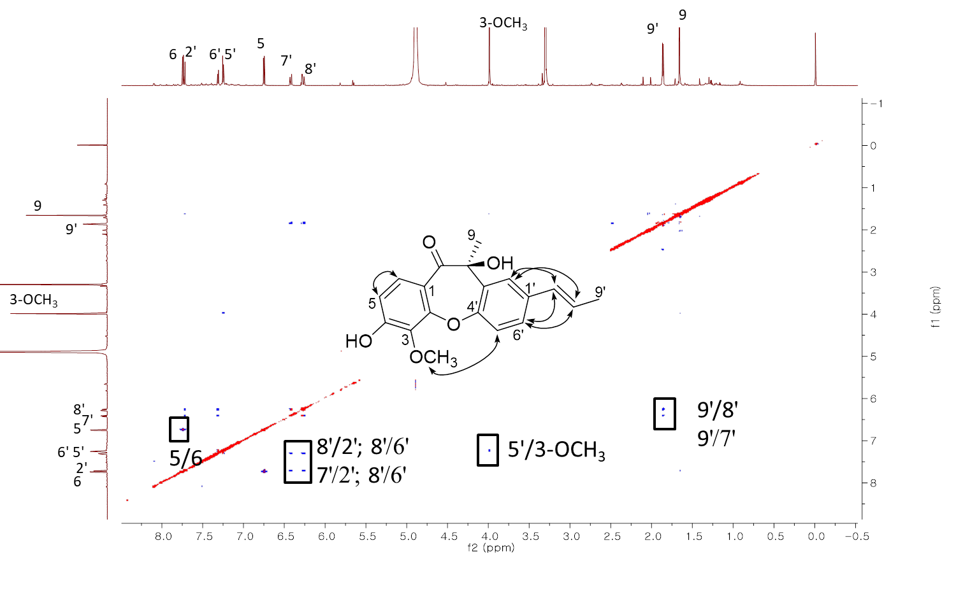Fig. S9 NOESY spectrum (CD₃OD, 800MHz) of compound 1
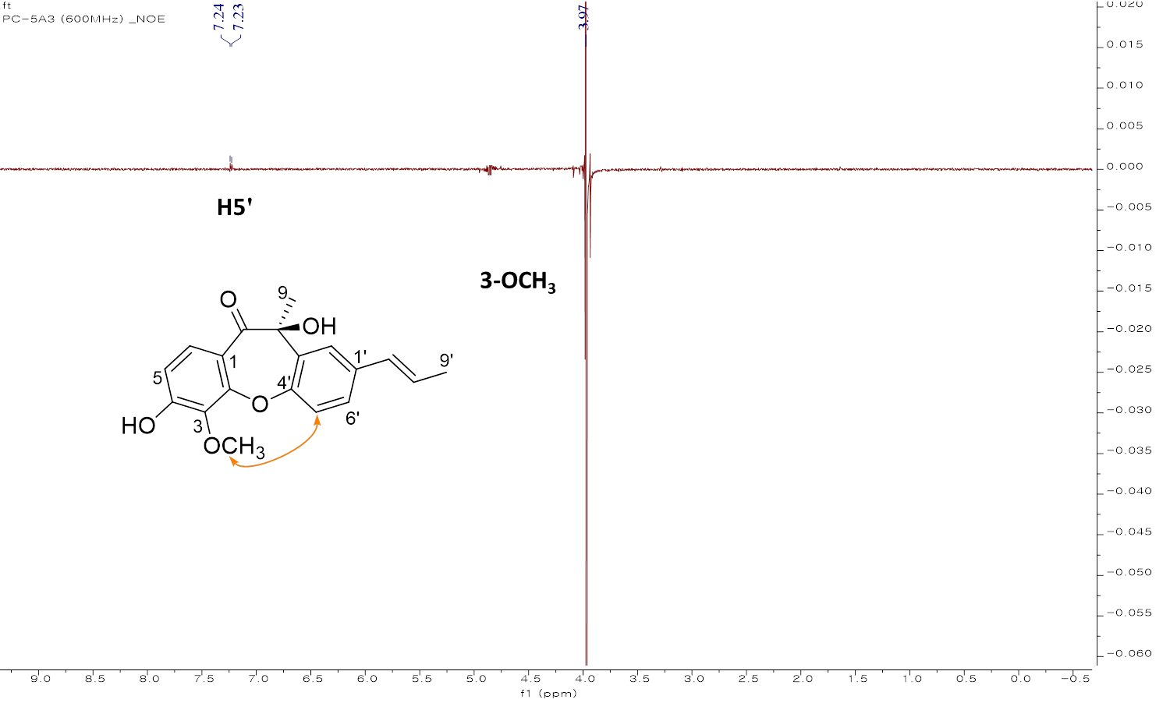
Fig. S10 Key NOE difference spectrum of compound 1 when 3-OCH₃ was irradiated.
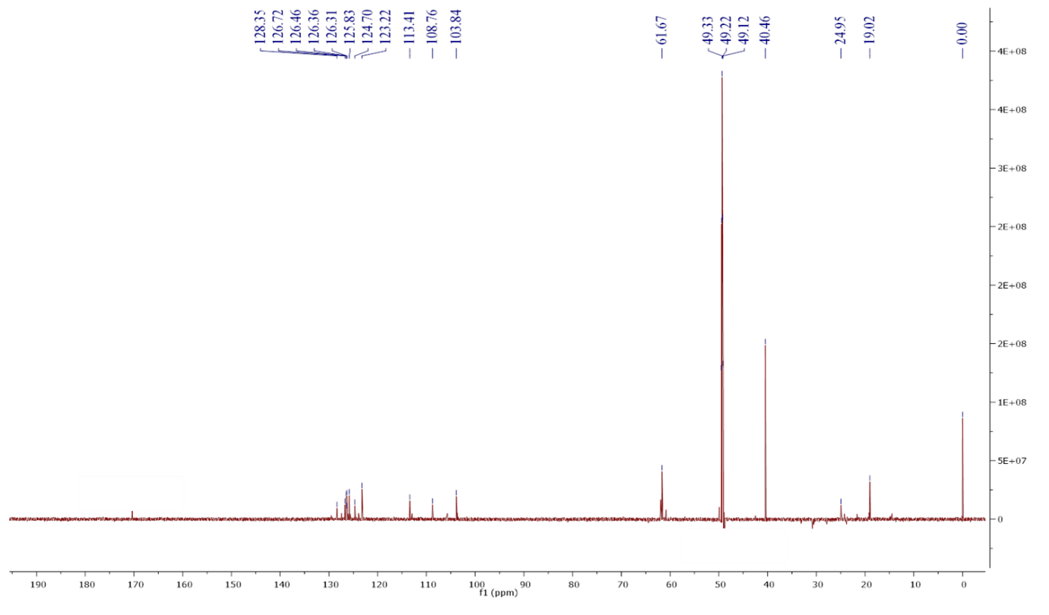
Fig. S11 DEPT spectrum (CD₃OD, 100MHz) of compound 1

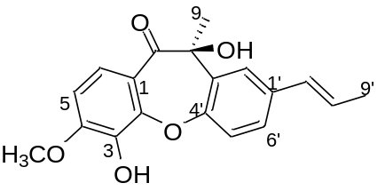
Compound 2

Appearance: purple powder
${[α]}_{D}^{20}$= -50.50 (c 0.44, MeOH)
UV (MeOH) λ_{Max} (log ε): 215.5 (4.27)
ECD (MeOH) λ_{max} 232 (-2.06), 324 (0.64)
FT-IR (ATR) v_{max} 3431, 2932, 1660, 1603, 1212 cm⁻¹
HRESIMS m/z [M+H]⁺ 327.1235 (calcd for C₁₉H₁₉O₅ 327.1232)

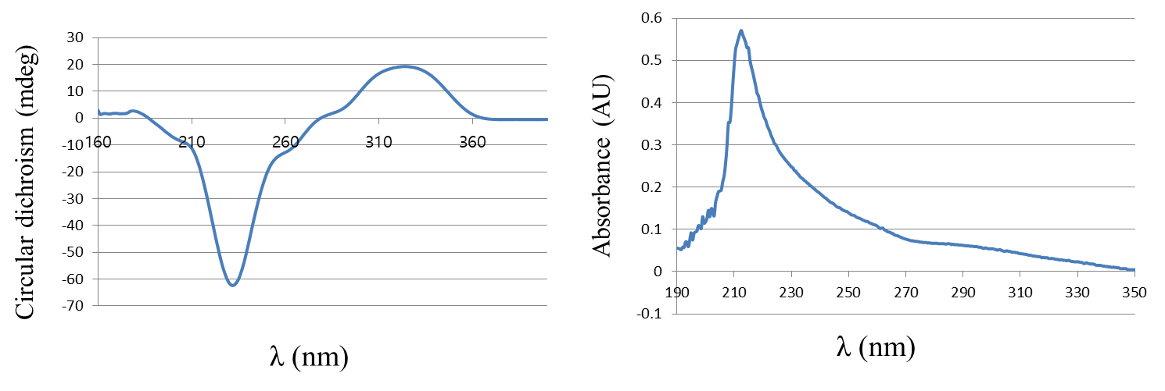
Fig. S12 CD and UV spectrum of compound 2

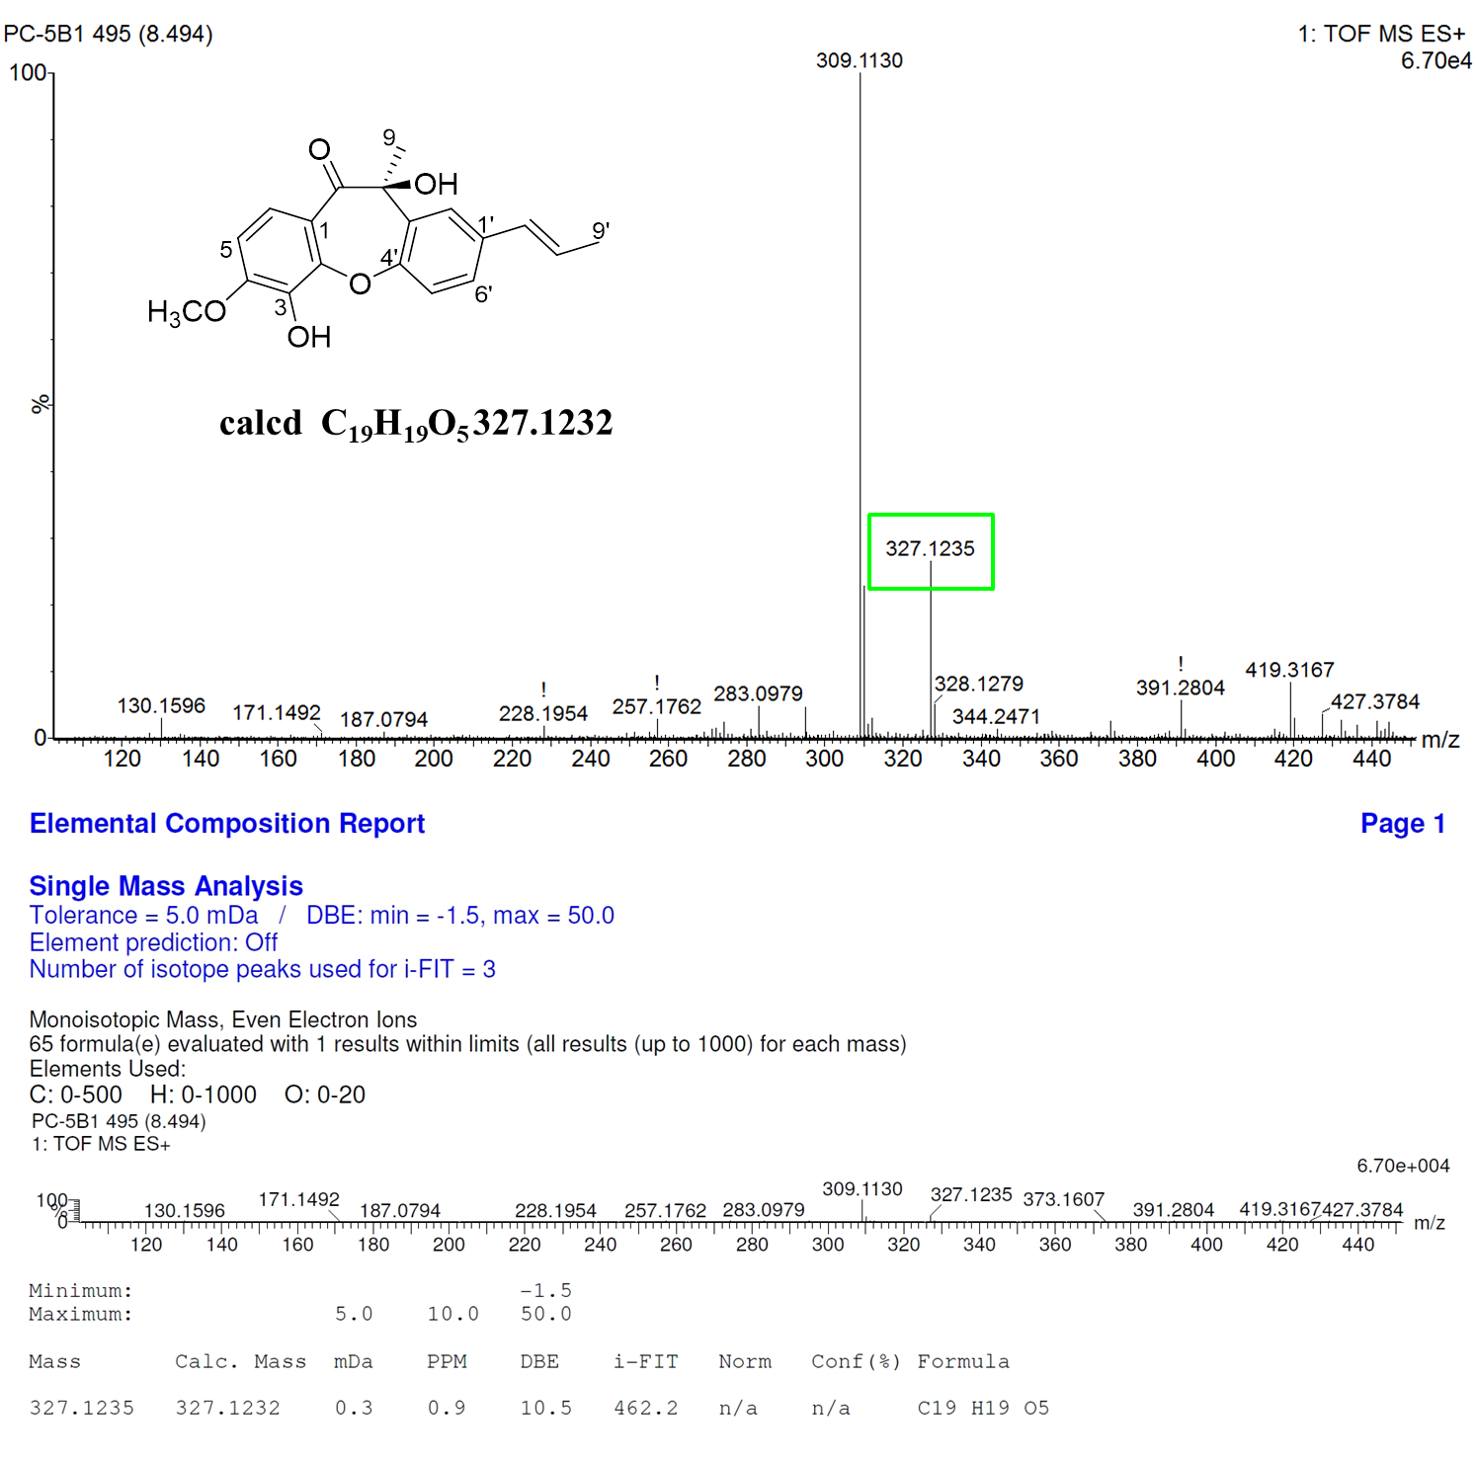
Fig. S13 HR-ESI-MS spectrum of compound 2
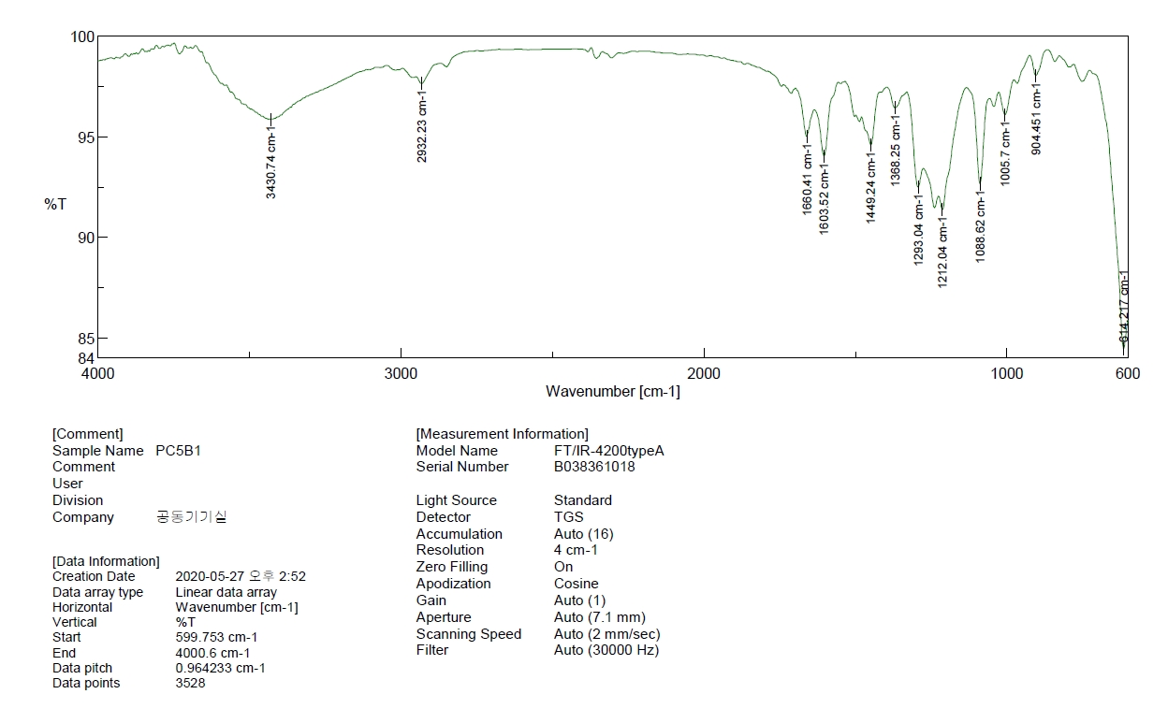
Fig. S14 IR spectrum of compound 2
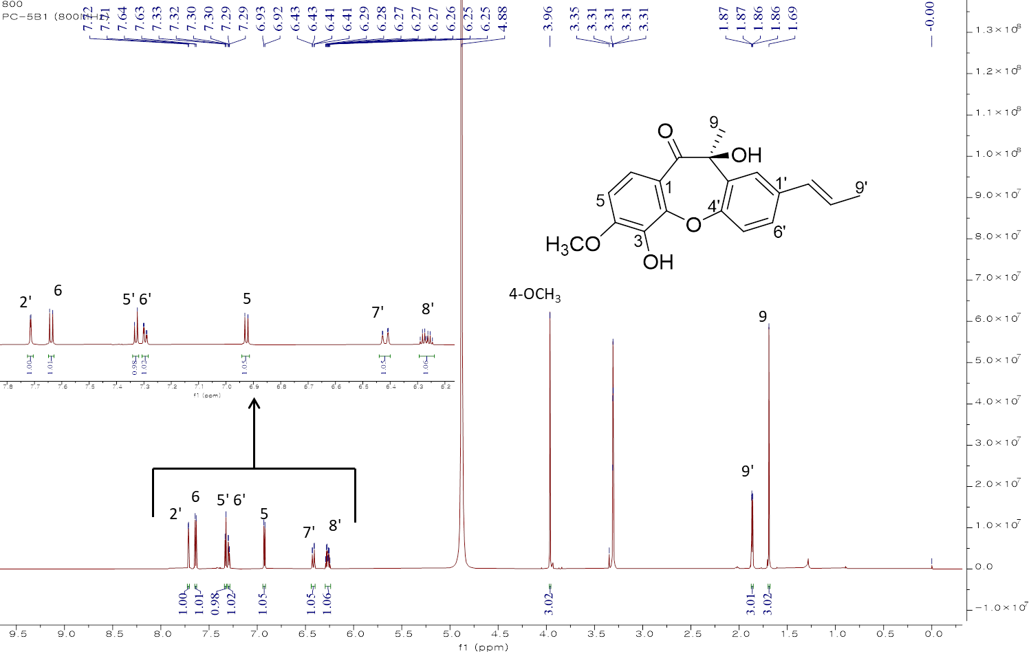
Fig. S15 ¹H-NMR spectrum (CD₃OD, 800MHz) of compound 2
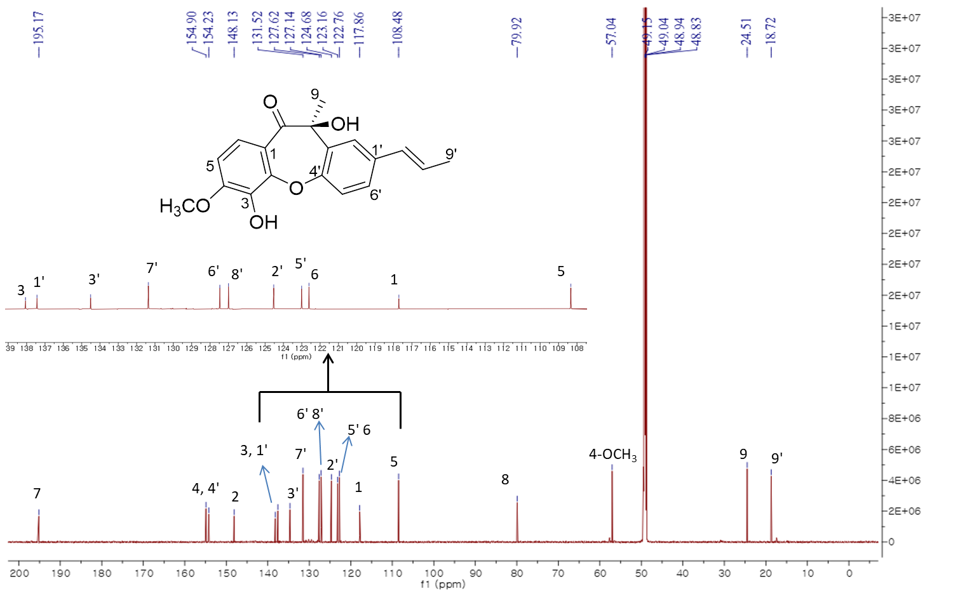
Fig. S16 ¹³C-NMR spectrum (CD₃OD, 200MHz) of compound 2
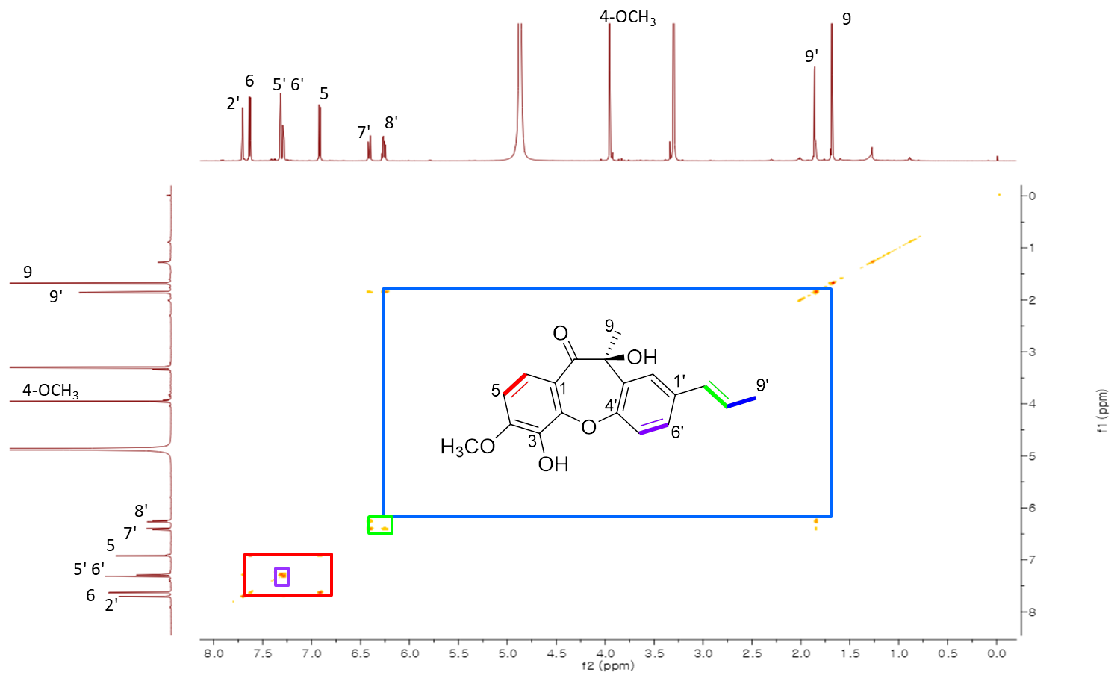Fig. S17 ¹H-¹H COSY (CD₃OD, 800MHz) spectrum of compound 2

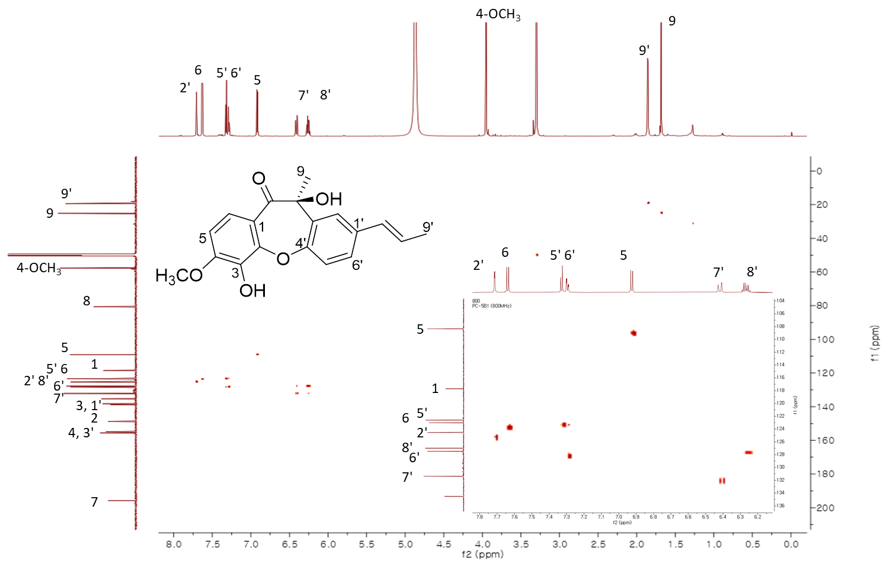Fig. S19 HSQC spectrum (CD₃OD, 800MHz) of compound 2
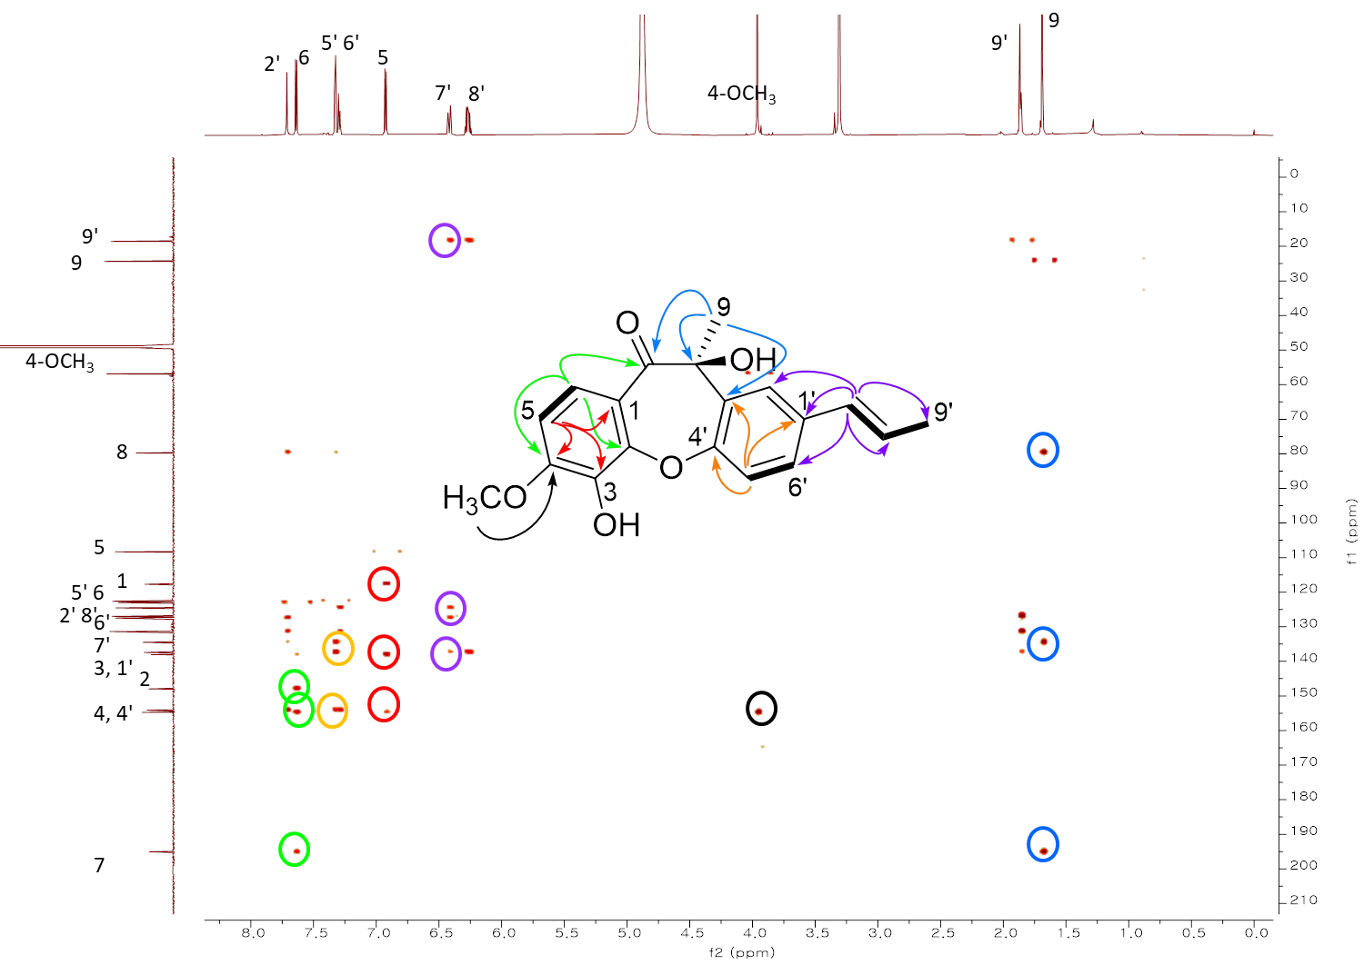
Fig. S19 HMBC spectrum (CD₃OD, 800MHz) of compound 2
Fig. S20 NOESY spectrum (CD₃OD, 800MHz) of compound 2

Fig. S21 Key NOE difference spectrum of compound 2 when H-5 was irradiated.

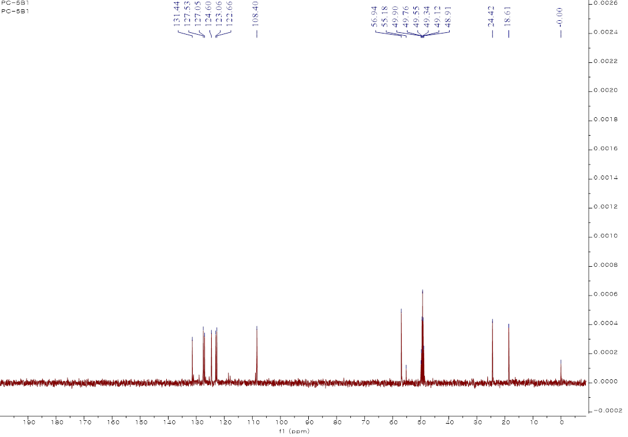Fig. S22 DEPT spectrum (CD₃OD, 100MHz) of compound 2

Fig. S23 Experimental and calculated ECD curves for compounds 1(A) and 2 (B). Experimental and calculated ECD curves after a UV correction for compound 1 (C).

Compound 20
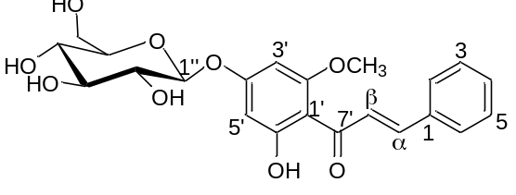

Appearance: purple powder
${[α]}_{D}^{20}$= -78.4 (c 0.10, MeOH)
UV (MeOH) λ_{Max} (log ε): 330 (3.14), 205 (3.35).
HRESIMS m/z [M-H]⁻ 431.1346 (calcd for C₂₂H₂₃O₉ 431.1342 ).
Fig. S24 HR-ESI-MS spectrum of compound 20

Fig. S25 ¹H-NMR spectrum (CD₃OD, 800MHz) of compound 20
Fig. S26 ¹³C-NMR spectrum (CD₃OD, 200MHz) of compound 20
Fig. S27 ¹H-¹H COSY (CD₃OD, 800MHz) spectrum of compound 20
Fig. S28 HSQC spectrum (CD₃OD, 800MHz) of compound 20
Fig. S29 HMBC spectrum (CD₃OD, 800MHz) of compound 20

Fig. S30 Sugar analysis of compound 20. The obtained results of the retention time of standard sugar derivatives were as follows; the acid hydrolysate of 20 at t_{R} 15.07 min were coincided with the thiocarbamoyl thiazolidine derivative of d-glucose at t_{R} 15.06 min, while the thiocarbamoyl thiazolidine derivative of L-glucose and d-galactose at t_{R} 13.70 min and 13.83 min
Fig. S31 Effect of compounds (50 μM) from P. chinense on PCSK9 and LDLR binding activity. Alirocumab, PCSK9 therapeutic antibody (A, 1 ng/mL), was used as a positive control..

