Additional file 1
Supplementary methods, figures, and tables
Developmental subgroups and co-occurring conditions among 5817 minimally speaking autistic youth: a latent class analysis of the SPARK cohort
Supplementary Methods 1. Intervention and service-use variables
Supplementary Methods 2. Latent class model selection
Supplementary Methods 3. Alternative unstratified model including age as an indicator
Supplementary Methods 4. Indicator-specific entropy
Supplementary Methods 5. Within-class developmental profiles
Figure S1 Participant flow
Figure S2 Model fit (BIC and ICL) for children (5–11 years) by covariance specification
Figure S3 Model fit (BIC and ICL) for adolescents (12–17 years) by covariance specification
Figure S4 Unstratified latent class model with age as an indicator
Table S1 Sociodemographic characteristics of the analytic sample, overall and by age group
Table S2 Comparison of included (analytic sample) and excluded participants
Table S3 Latent class indicator measures, coding, and justification
Table S4 Total SCQ-L scores by age group and class
Table S5 Model fit and class frequencies for the EVI age-stratified models
Table S6 Model fit and class frequencies for the age-unstratified models
Table S7 Indicator-specific entropy and omission diagnostics
Table S8 Within-class comparison of standardized developmental domain scores
Table S9 Pairwise within-class comparisons of developmental domains
Table S10 Sociodemographic characteristics by latent class and age group
Table S11 Post hoc pairwise comparisons between latent classes, within age group
Supplementary references

Supplementary Methods 1. Intervention and service-use variables
Service use was operationalized as the total number of distinct interventions a child was reported to have received. These were summed across school-based and private or community services reported on the Background and History Questionnaire-Child/Dependent (BHQ). Endorsement of an intervention was captured as 1. The total could range from 0 to 23:
School-based services (11 items) included early intervention or Birth-to-Three services, special education preschool, ancillary supports, 1:1 aide, speech-language therapy, occupational therapy, physical therapy, behavioral supports, social skills instruction, private autism school placement, and other school-based services.
Private or community services (12 items) included medication, biomedical treatment, intensive behavioral intervention, other developmental therapy, speech-language therapy, occupational therapy (sensory), occupational therapy (fine motor), physical therapy, recreational therapy, social skills training, counseling, and other private or community services.

Supplementary Methods 2. Latent class model selection
Class enumeration. The BIC was minimized at three classes in children (5–11 years) and at two classes in adolescents (12–17 years) (Table S5). Solutions with more classes did not lower the BIC, and solutions with five or more classes included classes below the 5% minimum size (e.g., the five-class child solution included a class with <1% of children). The three-class child solution was retained because it improved BIC by 72.3 units relative to two classes and described an intermediate developmental profile while keeping all classes above the 5% threshold. However, the two-class solution had better ICL and classification certainty. Co-occurring conditions and service use were examined after class enumeration and did not determine model selection.
Classification certainty. Classification certainty was first summarized directly from the saved clustMD posterior probabilities. For children, relative entropy was 0.690 for two classes and 0.502 for three classes, with mean maximum posterior probabilities of 0.906 and 0.747, respectively. For the retained two-class adolescent model, entropy was 0.535 and mean maximum posterior probability was 0.853. Separation was also assessed from the final class assignments using a post hoc local-independence classifier, with a Gaussian density for the continuous social-interaction indicator and category-specific probabilities for the three ordinal indicators. Class-conditional parameters were estimated from assigned members. Entropy and the average posterior probability of class membership are standard indices of classification quality in latent class analysis [1,2]. Using the same post hoc classifier for the child two- and three-class solutions yielded entropy of 0.747 and 0.635 and mean maximum posterior probabilities of 0.925 and 0.827, respectively. Corresponding adolescent two-class values were 0.651 and 0.897. Exploratory indicator-specific diagnostics using the final fitted parameters are reported separately in Supplementary Methods 4 and Table S7.
Robustness (split-sample). As a sensitivity analysis, each age band was randomly divided into two equal halves. Class-conditional profiles were estimated in one half and used to classify the other half (and vice versa), and agreement with the assigned classes was quantified using the adjusted Rand index. Agreement between held-out classifier assignments and the full-sample class assignments averaged adjusted Rand indices of 0.84 for children and 0.93 for adolescents.

Supplementary Methods 3. Alternative unstratified model including age as an indicator
We also fit a single unstratified model in which child age at registration was added to the four developmental indicators as an additional continuous clustering variable (VVI parameterization), comparing 2 to 14 classes. Models with 13 or more classes did not converge. Across all solutions, classes were distinguished primarily by age, partitioning the sample into approximately three age bands (5–7, 8–11, and 12–17 years) rather than by the developmental indicators (Table S6 and Figure S4). Between 66% and 88% of participants fell within their class’s modal age band, compared with 53% expected under independence (Cramér V, 0.63–0.85). In the nine-class solution, 78% fell within their class’s modal age band (Cramér V = 0.74), and three classes consisted of children aged 5 to 7 years. This alternative model was not retained. The primary models were stratified by age and used only the four developmental indicators.
Supplementary Methods 4. Indicator-specific entropy
We conducted exploratory univariate entropy analyses following Asparouhov and Muthén [3]. For each indicator j, posterior class probabilities were computed from that indicator alone, using the class proportions, means, variances, and ordinal thresholds of the retained EVI model. Relative entropy was calculated as 1 minus the average Shannon entropy of the individual posterior class distributions divided by log(K), where K is the number of classes. Larger values indicate clearer class discrimination. For the continuous indicator, we used normal densities, and for ordinal indicators we used probabilities between the clustMD thresholds. Class proportions were the column means of the saved posterior matrix. Parameters were held fixed and models were not refitted. We also calculated entropy using all indicators except one and subtracted it from the full-model value recomputed from the same final parameters (Table S7).

Supplementary Methods 5. Within-class developmental profiles
To further characterize each class profile, the four latent class indicators were standardized to z scores within age band (higher scores indicate greater difficulty on the measured indicators) and compared across the four developmental domains (social interaction, motor, spoken language, and nonverbal cognition) within each class. Differences among domains were tested with the Friedman test (Table S8), with the Kendall W coefficient of concordance as an effect size (higher values indicate more uneven profiles). Pairwise differences between domains were tested with Wilcoxon signed-rank tests, with Benjamini-Hochberg-adjusted P values and matched-pairs rank-biserial correlations as effect sizes (Table S9).

Figure S1 Participant flow.
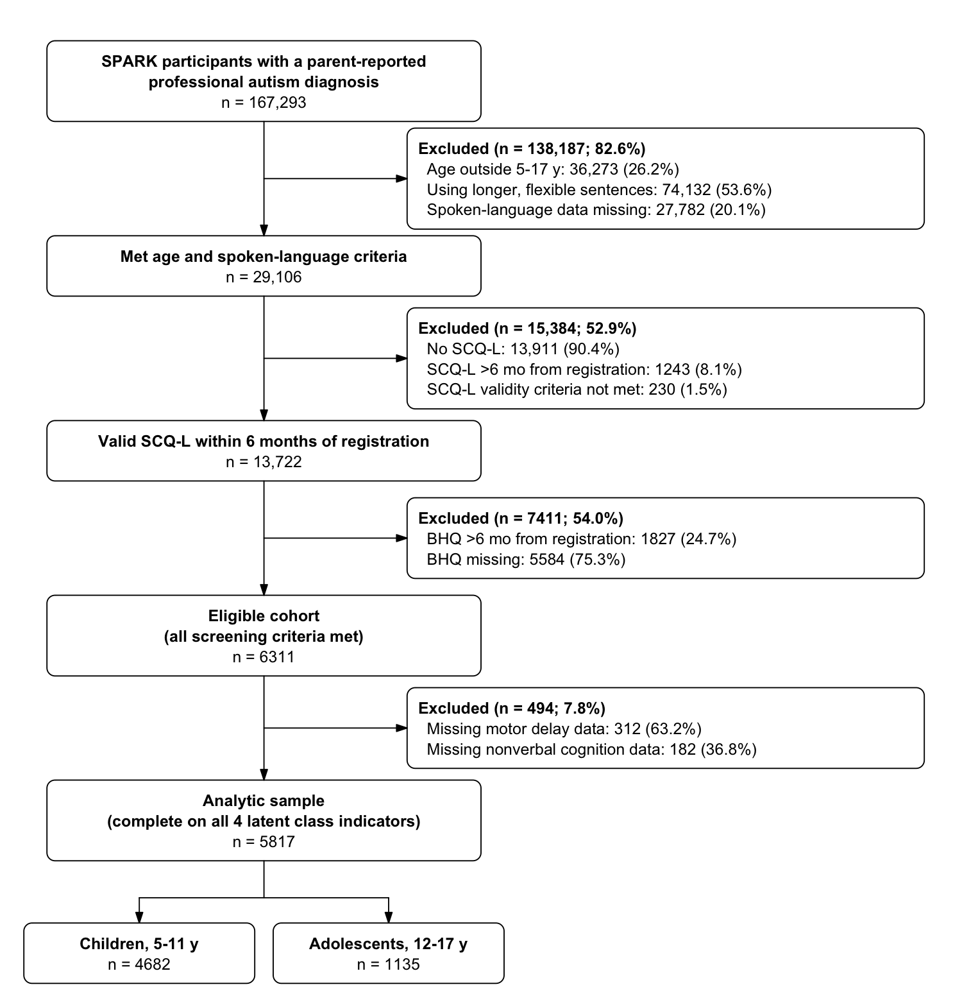
BHQ, Background and History Questionnaire-Child/Dependent; SCQ-L, Social Communication Questionnaire-Lifetime.
Participant flow from the SPARK cohort to the analytic sample. Co-occurring-condition data were available for 5802 of 5817 participants (99.7%) and intervention data for all 5817 (100%).

Figure S2 Model fit (BIC and ICL) for children (5–11 years) by covariance specification.
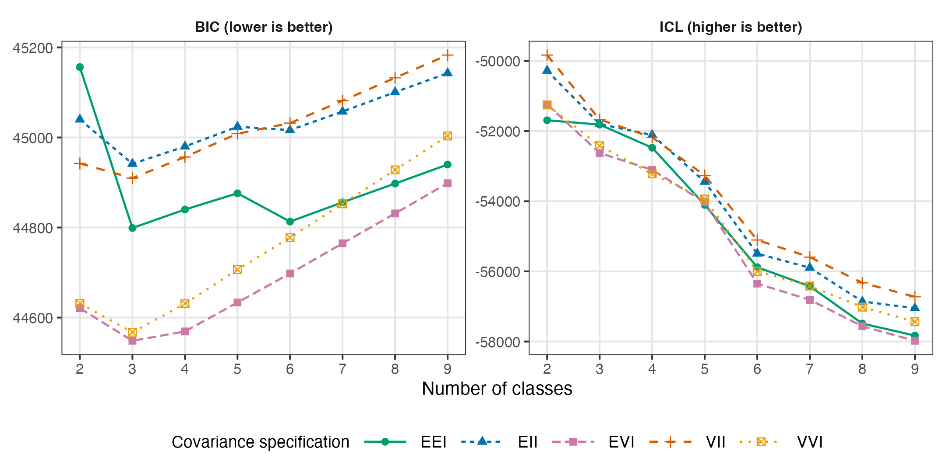
BIC, Bayesian information criterion; ICL, integrated completed likelihood; E, equal; V, varying; I, identity. Left panel, BIC; right panel, ICL. The horizontal axis is the number of classes. Lines and symbols identify covariance specifications. Lower BIC and higher ICL indicate better fit. BIC values are sign-reversed from the software output to match Table S5.

Figure S3 Model fit (BIC and ICL) for adolescents (12–17 years) by covariance specification.
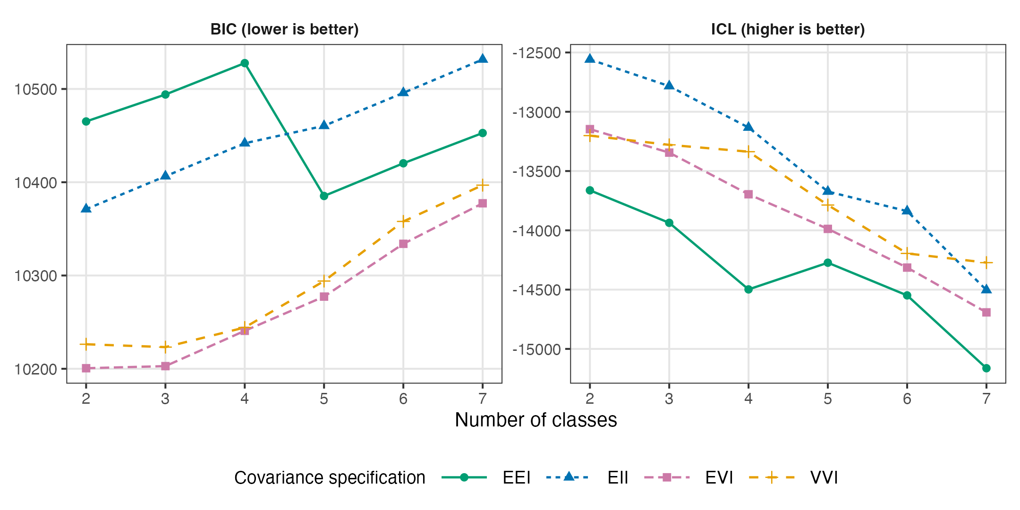
BIC, Bayesian information criterion; ICL, integrated completed likelihood. Left panel, BIC; right panel, ICL. The horizontal axis is the number of classes. Lines and symbols identify covariance specifications. Lower BIC and higher ICL indicate better fit. BIC values are sign-reversed from the software output to match Table S5. Only finite values in the final saved fit summaries are plotted. E, equal; V, varying; I, identity.

Figure S4 Unstratified latent class model with age as an indicator.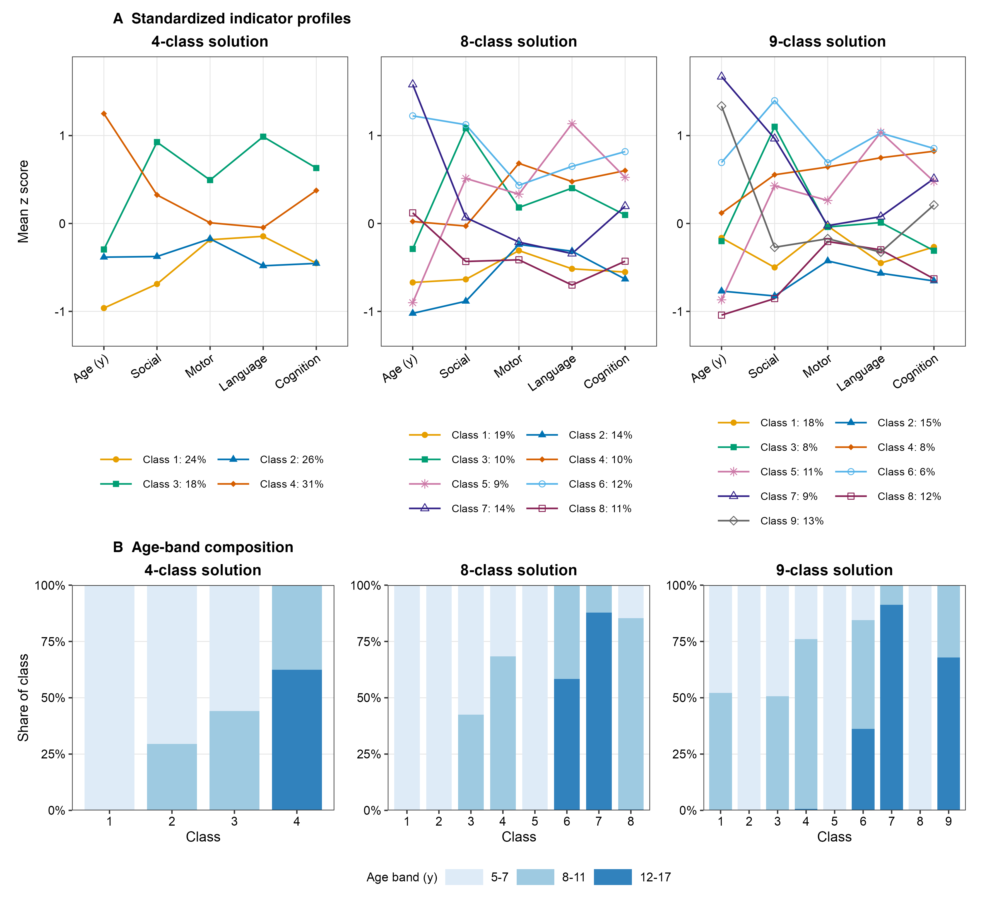
Unstratified latent class model with child age at registration entered as a second continuous clustering indicator (VVI parameterization, converged fits, tolerance 1×10⁻⁶). A, Standardized (z-score) class profiles for the 4-, 8-, and 9-class solutions (the 9-class solution is the BIC minimum). B, Age-band composition of each class. Classes aligned closely with age bands. For example, 3 classes in the 8- and 9-class solutions consisted almost exclusively (≥90%) of a single age band. Age (y) denotes age at registration.
Table S1 Sociodemographic characteristics of the analytic sample, overall and by age group
Characteristic | No. with data | Overall  (N = 5817) | 5–11 y  (n = 4682) | 12–17 y  (n = 1135) | P value
Age at registration, y | 5817 |  |  |  | <.001
Mean (SD) |  | 8.3 (3.4) | 7.0 (1.9) | 14.1 (1.6)
Median (IQR) |  | 7.0 (6.0–10.0) | 6.0 (5.0–8.0) | 14.0 (13.0–15.0)
Registration year | 5817 |  |  |  | <.001
2017–2019 |  | 3813 (65.5) | 3004 (64.2) | 809 (71.3)
2020–2022 |  | 1096 (18.8) | 885 (18.9) | 211 (18.6)
2023–2025 |  | 908 (15.6) | 793 (16.9) | 115 (10.1)
Sex | 5817 |  |  |  | .02
Female |  | 1351 (23.2) | 1118 (23.9) | 233 (20.5)
Male |  | 4466 (76.8) | 3564 (76.1) | 902 (79.5)
Race | 5325 |  |  |  | NA
Asian |  | 235 (4.4) | 196 (4.5) | 39 (3.9)
Black |  | 530 (10.0) | 429 (9.9) | 101 (10.0)
Multiracial |  | 639 (12.0) | 542 (12.6) | 97 (9.6)
American Indian or Alaska Native |  | 22 (0.4) | 15 (0.3) | 7 (0.7)
Native Hawaiian or Other Pacific Islander |  | 10 (0.2) | 9 (0.2) | 1 (0.1)
Other |  | 313 (5.9) | 255 (5.9) | 58 (5.7)
White |  | 3576 (67.2) | 2867 (66.5) | 709 (70.1)
Age at diagnosis, mo | 5817 |  |  |  | .01
Mean (SD) |  | 44.2 (24.2) | 43.4 (20.5) | 47.7 (35.3)
Median (IQR) |  | 37.0 (29.0–54.0) | 38.0 (29.0–54.0) | 36.0 (27.0–52.0)
Everyday spoken language | 5817 |  |  |  | .07
No words |  | 1292 (22.2) | 1014 (21.7) | 278 (24.5)
Single words |  | 1583 (27.2) | 1296 (27.7) | 287 (25.3)
Phrase speech |  | 2942 (50.6) | 2372 (50.7) | 570 (50.2)
Social interaction (SCQ-L score) | 5817 |  |  |  | <.001
Mean (SD) |  | 12.9 (4.8) | 12.4 (4.8) | 15.0 (4.0)
Median (IQR) |  | 14.0 (10.0–17.0) | 13.0 (9.0–16.0) | 16.0 (13.0–18.0)
Nonverbal cognition | 5817 |  |  |  | <.001
At or above age level |  | 1230 (21.1) | 1119 (23.9) | 111 (9.8)
Slightly below age level |  | 1510 (26.0) | 1314 (28.1) | 196 (17.3)
Significantly below age level |  | 3077 (52.9) | 2249 (48.0) | 828 (73.0)
No. of motor delays | 5817 |  |  |  | <.001
0 |  | 2659 (45.7) | 2093 (44.7) | 566 (49.9)
1 |  | 1581 (27.2) | 1347 (28.8) | 234 (20.6)
2 |  | 691 (11.9) | 573 (12.2) | 118 (10.4)
3 |  | 412 (7.1) | 303 (6.5) | 109 (9.6)
4 |  | 474 (8.1) | 366 (7.8) | 108 (9.5)
IQR, interquartile range; SCQ-L, Social Communication Questionnaire-Lifetime.
Data are presented as No. (%) unless otherwise indicated.
P values compare age groups (χ² or Fisher exact test for categorical variables, t test or Wilcoxon rank-sum test for continuous variables). Race was not formally tested across age groups (NA).
Percentages may not total 100 due to rounding.
All characteristics in this table were complete except race. Race was parent-reported. The 492 participants (8.5%) with missing race were excluded from the denominator for race percentages.
Registration year denotes the calendar year of SPARK enrollment. Age at registration is reported in completed years. Class-specific ages in Table 1 are calculated from months.

Table S2 Comparison of included (analytic sample) and excluded participants
Characteristic | Analytic sample (n = 5817) | Excluded for missing indicator (n = 494) | P value
Age at registration, y, mean (SD) | 8.3 (3.4) | 8.7 (3.4) | .01
Sex |  |  | .11
Female | 1351 (23.2) | 99 (20.0)
Male | 4466 (76.8) | 395 (80.0)
Everyday spoken language |  |  | .49
No words | 1292 (22.2) | 120 (24.3)
Single words | 1583 (27.2) | 136 (27.5)
Phrase speech | 2942 (50.6) | 238 (48.2)
Social interaction (SCQ-L score), mean (SD) | 12.9 (4.8) | 13.3 (4.5) | .05
Race |  |  | .02
Asian | 235 (4.4) | 14 (3.1)
Black | 530 (10.0) | 62 (13.9)
Multiracial | 639 (12.0) | 54 (12.1)
American Indian or Alaska Native | 22 (0.4) | 4 (0.9)
Native Hawaiian or Other Pacific Islander | 10 (0.2) | 1 (0.2)
Other | 313 (5.9) | 36 (8.1)
White | 3576 (67.2) | 274 (61.6)
Unknown | 492 | 49
SCQ-L, Social Communication Questionnaire-Lifetime.
Data are presented as No. (%) unless otherwise indicated. Participants with missing race were excluded from the denominators for race percentages.
Included and excluded participants were broadly similar, with small differences in age and racial distribution. Age at registration is reported in completed years.

Table S3 Latent class indicator measures, coding, and justification
Indicator | Source and item | Coding | Justification
Age | SPARK Registration (calculated age) | Continuous (years) | Used to define age strata (5–11 y, 12–17 y).
Spoken language | SPARK Registration: how the child’s everyday language is described | 3 ordered levels: no words, single words used meaningfully, 3-word phrases (longer flexible sentences excluded) | Polychoric correlation = 0.93 with the SCQ-L phrase/sentence item.
Social interaction | SCQ-L, 20-item Social Interaction subscale | Continuous (0–20, higher = greater difficulty) | Domain administered regardless of phrase speech. Captures historical and current or lifetime behaviors. Range 0–20. The SCQ total-score cutoff of 15 does not apply. Separate measurement does not imply statistical independence from spoken language.
Nonverbal cognition | BHQ: parent rating of nonverbal problem-solving relative to age | 3 ordered levels: at or above, slightly below, significantly below age or grade level | Used in place of the SPARK-derived cognitive score (heavily influenced by spoken language). Compared with clinical neuropsychological testing where available (n = 353 [6.1%], two-step polychoric correlation with clinical IQ below 70 = 0.48) and with parent-reported intellectual disability or developmental delay (two-step polychoric correlation = 0.52, n = 5802). External SPARK validation of the age-relative item found 70.9% agreement with average versus below-average full-scale IQ [4].
Motor delays | BHQ: ages of attaining sitting, crawling, walking, and self-feeding | Count of delayed milestones (0–4). Attainment after 8, 12, 16, and 24 months, respectively. “Not yet” coded as delayed | Associated with caregiver-reported professional motor disorder on Basic Medical Screening (two-step polychoric correlation = 0.52, n = 5802). Unselected motor-disorder checkboxes were coded absent only for completed medical forms, and 15 participants without a matching form were excluded from this correlation.
BHQ, Background and History Questionnaire-Child/Dependent; SCQ-L, Social Communication Questionnaire-Lifetime; SPARK, Simons Powering Autism Research for Knowledge; y, years.

Table S4 Model fit and class frequencies for the EVI age-stratified models
No. of classes | Children (EVI) BIC | Children ICL | Children class sizes, % | Adolescents (EVI) BIC | Adolescents ICL | Adolescents class sizes, %
2 | 44620.7 | -51239.8 | 24; 76 | 10200.6 | -13146.5 | 48; 52
3 | 44548.4 | -52626.6 | 19; 24; 57 | 10202.8 | -13344.6 | 10; 43; 47
4 | 44569.2 | -53106.1 | 6; 11; 25; 58 | 10240.7 | -13695.9 | 8; 11; 29; 52
5 | 44633.4 | -54030.9 | 0; 6; 14; 17; 63 | 10277.4 | -13987.6 | 0; 12; 16; 33; 40
6 | 44698.0 | -56348.2 | 0; 0; 6; 19; 21; 54 | 10334.0 | -14314.2 | 0; 7; 15; 16; 17; 46
7 | 44764.9 | -56811.1 | 0; 0; 1; 9; 14; 22; 54 | 10377.4 | -14691.9 | 0; 10; 15; 17; 18; 20; 20
8 | 44831.2 | -57563.1 | 0; 0; 2; 6; 9; 10; 16; 57 | NC | NC | NC
9 | 44898.4 | -57978.3 | 0; 0; 0; 0; 3; 10; 14; 15; 58 | NC | NC | NC
BIC, Bayesian information criterion; EVI, equal-volume varying-shape; ICL, integrated completed likelihood; NC, not converged. The EVI specification provided the best fit and was used for both age groups. Only the EVI fit indices are shown. A 3-class solution (children) and a 2-class solution (adolescents) were selected. Adolescent models did not converge beyond 7 classes. Class percentages are sorted in ascending order and rounded. Zero entries include empty hard-assignment classes and classes smaller than 0.5%.

Table S5 Model fit and class frequencies for the age-unstratified models
No. of classes | BIC | ICL | Class sizes, %
2 | 69193.9 | -75665.9 | 42; 58
3 | 68659.1 | -74943.0 | 18; 38; 44
4 | 68027.1 | -74784.2 | 18; 24; 26; 31
5 | 67664.3 | -75035.9 | 14; 20; 20; 21; 25
6 | 67618.9 | -74205.8 | 10; 11; 14; 18; 23; 23
7 | 67522.0 | -74997.5 | 8; 12; 13; 13; 15; 16; 23
8 | 67533.9 | -74669.1 | 9; 10; 10; 11; 12; 14; 14; 19
9 | 67508.7 | -73851.4 | 6; 8; 8; 9; 11; 12; 13; 15; 18
10 | 67570.9 | -74223.2 | 5; 5; 8; 9; 9; 10; 10; 11; 14; 18
11 | 67533.5 | -74648.7 | 3; 5; 5; 8; 8; 9; 9; 10; 12; 14; 17
12 | 67593.7 | -74845.3 | 3; 4; 5; 5; 7; 7; 8; 10; 10; 11; 14; 16
13 | NC | NC | NC
14 | NC | NC | NC
BIC, Bayesian information criterion; ICL, integrated completed likelihood; NC, not converged; VVI, varying-volume varying-shape.
In this alternative model (VVI parameterization), child age at registration was entered as an additional continuous clustering indicator alongside the 4 developmental indicators. Lower BIC and higher ICL indicate better fit. The BIC reached a minimum at 9 classes. Across all solutions, classes separated participants primarily into 3 age bands (ages 5–7, 8–11, and 12–17 years) rather than by developmental profile (Figure S4). Because age dominated class formation regardless of the number of classes specified, the age-stratified models were retained.

Table S6 Indicator-specific entropy and omission diagnostics
Age group | Indicator | Univariate entropy | Entropy with indicator omitted | Entropy reduction when omitted
Children | Social interaction | 0.386 | 0.331 | 0.178
Children | Motor delays | 0.139 | 0.493 | 0.016
Children | Spoken language | 0.221 | 0.452 | 0.056
Children | Nonverbal cognition | 0.193 | 0.466 | 0.043
Adolescents | Social interaction | 0.481 | 0.172 | 0.370
Adolescents | Motor delays | 0.033 | 0.534 | 0.008
Adolescents | Spoken language | 0.075 | 0.511 | 0.031
Adolescents | Nonverbal cognition | 0.066 | 0.516 | 0.026
Children: n = 4682, 3 classes. Adolescents: n = 1135, 2 classes. Full-model entropy recomputed from the final parameter estimates was 0.509 and 0.541, respectively. The last column subtracts omission entropy from this recomputed full-model value, not from the entropy of the stored posterior matrix (0.502 and 0.535). Larger univariate entropy indicates greater class discrimination from that indicator alone. Larger omission reductions indicate greater incremental discrimination conditional on the remaining indicators.

Table S7 Within-class comparison of standardized developmental domain scores
Class | No. | Social | Motor | Language | Cognition | Friedman χ² (df = 3) | P value | Kendall W
C1 | 1116 | +0.38 | +0.30 | +0.45 | +0.51 | 128 | <.001 | 0.04
C2 | 2692 | -0.54 | -0.28 | -0.50 | -0.45 | 424 | <.001 | 0.05
C3 | 874 | +1.18 | +0.48 | +0.97 | +0.75 | 428 | <.001 | 0.16
A1 | 543 | +0.76 | +0.21 | +0.36 | +0.36 | 114 | <.001 | 0.07
A2 | 592 | -0.69 | -0.20 | -0.33 | -0.33 | 98 | <.001 | 0.06
Values are mean within-band z scores (higher = greater difficulty, lower = relative strength). The Friedman test compared the 4 domains within each class. Kendall W indexes profile unevenness (0 = even across domains). Within every class the domains differed (P < .001). The most uneven profile was child class 3. Class codes: C1–C3, child classes 1–3; A1–A2, adolescent classes 1–2. Pairwise comparisons are reported in Table S9. Relative-skill labels: C1 = intermediate, C2 = higher, C3 = lower; A1 = lower, A2 = higher.

Table S8 Pairwise within-class comparisons of developmental domains
Class | Comparison | Mean z difference | Rank-biserial r | Adjusted P value
C1 | Social vs Motor | +0.08 | +0.13 | <.001
C1 | Social vs Language | -0.07 | -0.08 | .02
C1 | Social vs Cognition | -0.12 | -0.23 | <.001
C1 | Motor vs Language | -0.15 | -0.10 | .006
C1 | Motor vs Cognition | -0.21 | -0.21 | <.001
C1 | Language vs Cognition | -0.06 | +0.14 | <.001
C2 | Social vs Motor | -0.26 | -0.18 | <.001
C2 | Social vs Language | -0.04 | -0.04 | .11
C2 | Social vs Cognition | -0.09 | -0.07 | .004
C2 | Motor vs Language | +0.22 | +0.37 | <.001
C2 | Motor vs Cognition | +0.17 | +0.18 | <.001
C2 | Language vs Cognition | -0.05 | +0.21 | <.001
C3 | Social vs Motor | +0.70 | +0.56 | <.001
C3 | Social vs Language | +0.22 | +0.10 | .01
C3 | Social vs Cognition | +0.43 | +0.86 | <.001
C3 | Motor vs Language | -0.48 | -0.36 | <.001
C3 | Motor vs Cognition | -0.26 | -0.28 | <.001
C3 | Language vs Cognition | +0.22 | +0.42 | <.001
A1 | Social vs Motor | +0.54 | +0.50 | <.001
A1 | Social vs Language | +0.39 | +0.38 | <.001
A1 | Social vs Cognition | +0.40 | +0.65 | <.001
A1 | Motor vs Language | -0.15 | -0.20 | <.001
A1 | Motor vs Cognition | -0.14 | -0.13 | .01
A1 | Language vs Cognition | +0.00 | -0.10 | .05
A2 | Social vs Motor | -0.50 | -0.35 | <.001
A2 | Social vs Language | -0.36 | -0.20 | <.001
A2 | Social vs Cognition | -0.37 | -0.29 | <.001
A2 | Motor vs Language | +0.14 | +0.22 | <.001
A2 | Motor vs Cognition | +0.13 | +0.13 | .01
A2 | Language vs Cognition | -0.00 | -0.06 | .21
C, Children; A, Adolescents. Wilcoxon signed-rank tests, with P values Benjamini-Hochberg-adjusted within class. A positive mean z difference (first minus second domain) indicates greater difficulty in the first domain (i.e., a relative strength in the second). The rank-biserial r is the matched-pairs effect size. The mean z difference and the rank-biserial r can differ in sign when difference scores are skewed or take few distinct values, as for language vs cognition in classes C1, C2, and A1. Relative-skill labels: C1 = intermediate, C2 = higher, C3 = lower; A1 = lower, A2 = higher.

Table S9 Sociodemographic characteristics by latent class and age group
Characteristic | Children: Class 1  (n = 1116) | Children: Class 2  (n = 2692) | Children: Class 3  (n = 874) | Children: P value | Children: q value | Adolescents: Class 1  (n = 543) | Adolescents: Class 2  (n = 592) | Adolescents: P value | Adolescents: q value
Age at registration, mo | 91.3 (23.4) | 84.7 (21.1) | 97.2 (23.6) | <.001 | <.001 | 175.0 (20.7) | 173.1 (19.2) | .12 | .29
Age at diagnosis, mo | 42.8 (21.9) | 45.2 (20.1) | 38.6 (19.4) | <.001 | <.001 | 41.6 (28.1) | 53.4 (40.1) | <.001 | <.001
Sex |  |  |  | .12 | .19 |  |  | .51 | .85
Female | 244 (22) | 671 (25) | 203 (23) |  |  | 107 (20) | 126 (21)
Male | 872 (78) | 2021 (75) | 671 (77) |  |  | 436 (80) | 466 (79)
Race |  |  |  | .02 | .04 |  |  | .03 | .11
Asian | 51 (5.0) | 101 (4.0) | 44 (5.5) |  |  | 16 (3.4) | 23 (4.3)
Black | 98 (9.6) | 266 (11) | 65 (8.2) |  |  | 35 (7.4) | 66 (12)
Multiracial | 121 (12) | 338 (14) | 83 (10) |  |  | 39 (8.2) | 58 (11)
Other | 67 (6.6) | 146 (5.8) | 66 (8.3) |  |  | 31 (6.6) | 35 (6.5)
White | 682 (67) | 1650 (66) | 535 (67) |  |  | 352 (74) | 357 (66)
Missing | 97 | 191 | 81 |  |  | 70 | 53
Ethnicity |  |  |  | .65 | .65 |  |  | .02 | .11
Hispanic | 248 (22) | 635 (24) | 200 (23) |  |  | 84 (15) | 122 (21)
Non-Hispanic | 868 (78) | 2057 (76) | 674 (77) |  |  | 459 (85) | 470 (79)
Annual household income |  |  |  | .29 | .42 |  |  | .33 | .65
< $51,000 | 551 (50) | 1216 (46) | 402 (47) |  |  | 213 (40) | 256 (44)
$51,000–$100,000 | 320 (29) | 825 (31) | 266 (31) |  |  | 171 (32) | 169 (29)
> $100,000 | 229 (21) | 591 (22) | 181 (21) |  |  | 148 (28) | 151 (26)
Missing | 16 | 60 | 25 |  |  | 11 | 16
Mother’s highest education |  |  |  | .01 | .03 |  |  | .98 | .98
Less than high school | 45 (4.0) | 104 (3.9) | 46 (5.3) |  |  | 23 (4.2) | 25 (4.2)
High school | 220 (20) | 466 (17) | 188 (22) |  |  | 82 (15) | 87 (15)
More than high school | 849 (76) | 2120 (79) | 639 (73) |  |  | 438 (81) | 479 (81)
Missing | 2 | 2 | 1 |  |  | 0 | 1
Mother’s occupation |  |  |  | <.001 | <.001 |  |  | .69 | .85
Unemployed or part-time | 218 (20) | 485 (18) | 156 (18) |  |  | 110 (20) | 127 (22)
Full-time employment | 418 (38) | 1184 (44) | 306 (35) |  |  | 241 (45) | 269 (46)
Full-time care provider | 474 (43) | 1004 (38) | 405 (47) |  |  | 190 (35) | 193 (33)
Missing | 6 | 19 | 7 |  |  | 2 | 3
Father’s highest education |  |  |  | .43 | .54 |  |  | .71 | .85
Less than high school | 98 (9.0) | 237 (9.0) | 77 (9.0) |  |  | 44 (8.3) | 42 (7.2)
High school | 327 (30) | 779 (29) | 280 (33) |  |  | 141 (27) | 164 (28)
More than high school | 660 (61) | 1630 (62) | 495 (58) |  |  | 345 (65) | 378 (65)
Missing | 31 | 46 | 22 |  |  | 13 | 8
Father’s occupation |  |  |  | .52 | .58 |  |  | .77 | .85
Unemployed or part-time | 173 (16) | 363 (14) | 121 (15) |  |  | 82 (16) | 94 (17)
Full-time employment | 833 (78) | 2072 (80) | 662 (79) |  |  | 418 (80) | 446 (79)
Full-time care provider | 59 (5.5) | 157 (6.1) | 50 (6.0) |  |  | 21 (4.0) | 27 (4.8)
Missing | 51 | 100 | 41 |  |  | 22 | 25
FDR, false discovery rate.
Data are presented as No. (%) unless otherwise indicated (age variables, mean [SD]). Household income was grouped as low (up to $50,000), middle ($51,000–$100,000), or high ($101,000 or more). Comparisons were conducted across classes within each age group. P values are from Pearson χ² tests (categorical) and Welch one-way analysis of variance (continuous). q values are Benjamini-Hochberg FDR-adjusted P values. Effect sizes (η² for continuous, bias-corrected Cramér V for categorical) were small throughout (η² < 0.05, bias-corrected Cramér V < 0.09) and are therefore omitted from the table. For race, Other combines Other, American Indian or Alaska Native, and Native Hawaiian or Other Pacific Islander responses. Relative-skill labels: Children: Class 1 = intermediate, Class 2 = higher, Class 3 = lower; Adolescents: Class 1 = lower, Class 2 = higher.
Table S10 Post hoc pairwise comparisons between latent classes, within age group
Children (5–11 y, classes 1–3):
Outcome | Comparison | Estimate (95% CI) | Adjusted P value | Effect size (95% CI)
Macro- or microcephaly | Class 2 vs 1 | 0.41 (0.30 to 0.57) | <.001 | 0.09 (0.05 to 0.13)
 | Class 3 vs 1 | 1.04 (0.74 to 1.46) | .87 | 0.00 (0.00 to 0.05)
 | Class 3 vs 2 | 2.51 (1.79 to 3.51) | <.001 | 0.10 (0.05 to 0.13)
Seizures or epilepsy | Class 2 vs 1 | 0.43 (0.32 to 0.57) | <.001 | 0.10 (0.06 to 0.13)
 | Class 3 vs 1 | 1.17 (0.86 to 1.59) | .32 | 0.01 (0.00 to 0.06)
 | Class 3 vs 2 | 2.74 (2.03 to 3.68) | <.001 | 0.12 (0.08 to 0.16)
Birth defect | Class 2 vs 1 | 0.53 (0.35 to 0.82) | .006 | 0.05 (0.00 to 0.08)
 | Class 3 vs 1 | 1.03 (0.63 to 1.68) | .91 | 0.00 (0.00 to 0.05)
 | Class 3 vs 2 | 1.94 (1.22 to 3.05) | .006 | 0.05 (0.00 to 0.09)
Tics | Class 2 vs 1 | 0.98 (0.47 to 2.20) | 1.00 | 0.00 (0.00 to 0.03)
 | Class 3 vs 1 | 1.40 (0.56 to 3.51) | .79 | 0.00 (0.00 to 0.06)
 | Class 3 vs 2 | 1.42 (0.65 to 2.94) | .79 | 0.00 (0.00 to 0.05)
Obsessive-compulsive disorder | Class 2 vs 1 | 0.61 (0.44 to 0.84) | .003 | 0.05 (0.01 to 0.09)
 | Class 3 vs 1 | 1.24 (0.87 to 1.77) | .22 | 0.02 (0.00 to 0.07)
 | Class 3 vs 2 | 2.05 (1.47 to 2.82) | <.001 | 0.07 (0.03 to 0.11)
Depression | Class 2 vs 1 | 0.78 (0.44 to 1.43) | .72 | 0.00 (0.00 to 0.05)
 | Class 3 vs 1 | 0.76 (0.34 to 1.65) | .72 | 0.00 (0.00 to 0.05)
 | Class 3 vs 2 | 0.97 (0.46 to 1.91) | 1.00 | 0.00 (0.00 to 0.03)
Anxiety | Class 2 vs 1 | 0.77 (0.60 to 0.99) | .11 | 0.03 (0.00 to 0.07)
 | Class 3 vs 1 | 0.94 (0.69 to 1.28) | .76 | 0.00 (0.00 to 0.05)
 | Class 3 vs 2 | 1.23 (0.93 to 1.60) | .21 | 0.02 (0.00 to 0.06)
Attention-deficit/hyperactivity disorder | Class 2 vs 1 | 0.88 (0.76 to 1.03) | .34 | 0.02 (0.00 to 0.06)
 | Class 3 vs 1 | 0.94 (0.77 to 1.15) | .55 | 0.00 (0.00 to 0.05)
 | Class 3 vs 2 | 1.06 (0.89 to 1.26) | .55 | 0.00 (0.00 to 0.04)
Conduct disorder or aggression | Class 2 vs 1 | 0.90 (0.67 to 1.23) | .85 | 0.00 (0.00 to 0.04)
 | Class 3 vs 1 | 0.95 (0.64 to 1.41) | .85 | 0.00 (0.00 to 0.05)
 | Class 3 vs 2 | 1.05 (0.74 to 1.48) | .85 | 0.00 (0.00 to 0.03)
Feeding or eating disorder | Class 2 vs 1 | 0.54 (0.45 to 0.64) | <.001 | 0.12 (0.08 to 0.15)
 | Class 3 vs 1 | 1.25 (1.02 to 1.52) | .03 | 0.04 (0.00 to 0.09)
 | Class 3 vs 2 | 2.31 (1.93 to 2.77) | <.001 | 0.16 (0.12 to 0.19)
Sleep disorder | Class 2 vs 1 | 0.54 (0.46 to 0.63) | <.001 | 0.12 (0.09 to 0.16)
 | Class 3 vs 1 | 1.29 (1.07 to 1.57) | .007 | 0.06 (0.00 to 0.10)
 | Class 3 vs 2 | 2.42 (2.04 to 2.87) | <.001 | 0.17 (0.14 to 0.21)
Total No. of interventions | Class 2 vs 1 | -1.03 (-1.29 to -0.77) | <.001 | —
 | Class 3 vs 1 | 0.90 (0.57 to 1.24) | <.001 | —
 | Class 3 vs 2 | 1.94 (1.65 to 2.22) | <.001 | —
Adolescents (12–17 y, classes 1–2):
Outcome | Comparison | Estimate (95% CI) | P value | Effect size (95% CI)
Macro- or microcephaly | Class 2 vs 1 | 0.91 (0.55 to 1.53) | .81 | 0.00 (0.00 to 0.06)
Seizures or epilepsy | Class 2 vs 1 | 0.83 (0.60 to 1.17) | .29 | 0.01 (0.00 to 0.09)
Birth defect | Class 2 vs 1 | 0.81 (0.38 to 1.71) | .60 | 0.00 (0.00 to 0.07)
Tics | Class 2 vs 1 | 1.15 (0.56 to 2.41) | .74 | 0.00 (0.00 to 0.06)
Obsessive-compulsive disorder | Class 2 vs 1 | 0.76 (0.53 to 1.08) | .12 | 0.04 (0.00 to 0.10)
Depression | Class 2 vs 1 | 1.68 (0.92 to 3.17) | .09 | 0.04 (0.00 to 0.10)
Anxiety | Class 2 vs 1 | 1.15 (0.85 to 1.56) | .37 | 0.00 (0.00 to 0.08)
Attention-deficit/hyperactivity disorder | Class 2 vs 1 | 1.20 (0.93 to 1.55) | .15 | 0.03 (0.00 to 0.10)
Conduct disorder or aggression | Class 2 vs 1 | 0.77 (0.50 to 1.18) | .22 | 0.02 (0.00 to 0.09)
Feeding or eating disorder | Class 2 vs 1 | 0.68 (0.50 to 0.92) | .01 | 0.07 (0.00 to 0.13)
Sleep disorder | Class 2 vs 1 | 0.62 (0.47 to 0.81) | <.001 | 0.10 (0.04 to 0.17)
Total No. of interventions | Class 2 vs 1 | -0.73 (-1.22 to -0.25) | .003 | —
CI, confidence interval; OR, odds ratio.
Because the latent classes were estimated separately within each age group, pairwise comparisons were conducted only between classes in the same age group. Child and adolescent classes were not compared. For co-occurring conditions, the estimate is an OR (odds in the first-named class relative to the second) and the effect size is the bias-corrected Cramér V. For total interventions, the estimate is the mean difference between classes (first-named minus second-named class mean, so a positive value indicates more interventions in the first-named class) and the effect size is the mean difference with its 95% confidence interval, shown in the Estimate column. Dashes in the Effect size column indicate that Cramér V does not apply to intervention counts. Odds ratios were derived from pairwise Fisher exact tests and mean differences from pairwise Welch t tests. Adjusted P (q) values were computed with the Benjamini-Hochberg false-discovery-rate procedure applied to the three class comparisons for each outcome in children. In the adolescent group, each outcome involved a single comparison, so P values are unadjusted. Relative-skill labels: Children: Class 1 = intermediate, Class 2 = higher, Class 3 = lower; Adolescents: Class 1 = lower, Class 2 = higher.

Supplementary references
1. Nylund-Gibson K, Choi AY. Ten frequently asked questions about latent class analysis. Translational Issues in Psychological Science. 2018;4:440–61. https://doi.org/10.1037/tps0000176
2. Celeux G, Soromenho G. An entropy criterion for assessing the number of clusters in a mixture model. Journal of Classification. 1996;13:195–212. https://doi.org/10.1007/BF01246098
3. Asparouhov T, Muthén B. Variable-specific entropy contribution. 2018 Jun 19. https://www.statmodel.com/download/UnivariateEntropy.pdf
4. Lee CM, Green Snyder L, Carpenter LA, Harris J, Kanne S, Taylor CM, et al. Agreement of parent-reported cognitive level with standardized measures among children with autism spectrum disorder. Autism Research. 2023;16:1210–24. https://doi.org/10.1002/aur.2934

