Online Resource 1: Supplementary Information
International Journal of Thermophysics
Effect of temperature and composition on density, viscosity, surface tension and refractive index for 2-HEAA + CPAc, 2-HEAA + HEAPe, and CPAc + HEAPe binary mixtures at atmospheric pressure

Francisco M. T. Pereira Filhoᵃ, Vitor J. Policarpoᵃ, Lorena M. Alexandre e Silvaᵇ, Kirley M. Canutoᵇ, Filipe X. Feitosaᵃ, Hosiberto B. de Sant’Anaᵃ,*

ᵃ Grupo de Pesquisa em Termofluidodinâmica Aplicada, Department of Chemical Engineering, Universidade Federal do Ceará, Fortaleza, CE, Brazil
ᵇ Empresa Brasileira de Pesquisa Agropecuária (Embrapa), Fortaleza, CE, Brazil
*Corresponding author: Hosiberto B. de Sant’Ana · hbs@ufc.br
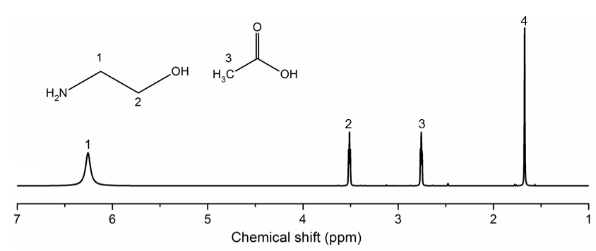
Figure S1. ¹H NMR spectrum for the protic ionic liquid 2-HEAA. Experimental relative peak areas (peak 1 =36.72 %, peak 2= 5.80 %, peak 3= 14.51 %, peak 4= 42.97%)

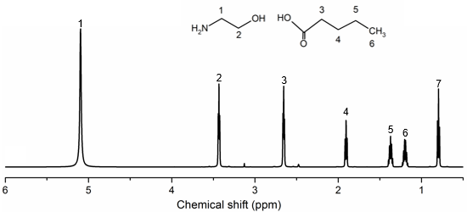
Figure S2. ¹H NMR spectrum for the ionic liquid HEAPe. Relative integrated areas, normalized to the sum of the numbered signals: peak 1 = 12.4 %, peak 2 = 24.5 %, peak 3 = 17.1 %, peak 4 = 5.9 %, peak 5 = 12.0 %, peak 6 = 13.7 %, peak 7 = 14.2 %.

Figure S3. ¹H NMR spectrum for the ionic liquid CPAc. Relative integrated areas, normalized to the sum of the listed signals: unnumbered signal near 10 ppm = 3.9 %, peak 1 = 5.9 %, peak 2 = 17.3 %, peak 3 = 16.0 %, peak 4 = 39.0 %, peak 5 = 17.9 %.

Table S1. Excess volume data relative to molar fraction of 2-HEAA (1) + CPAc (2), 2-HEAA (1) + HEAPe (2) and CPAc (1) + HEAPe (2) mixtures at T = (293.15 to 373.15) K and atmospheric pressure (P = 101.3 kPa)ª.
$V^{E}$ / cm³·mol⁻¹
x₁ | T / K
x₁ | 293.15 | 303.15 | 313.15 | 323.15 | 333.15 | 343.15 | 353.15 | 363.15 | 373.15
2-HEAA (1) + CPAc (2)
1.000 | 0 | 0 | 0 | 0 | 0 | 0 | 0 | 0 | 0
0.857 | -0.855 | -0.890 | -0.909 | -0.977 | -1.018 | -1.081 | -1.139 | -1.164 | -1.196
0.730 | -1.269 | -1.324 | -1.319 | -1.449 | -1.489 | -1.618 | -1.696 | -1.750 | -1.812
0.615 | -1.368 | -1.420 | -1.434 | -1.591 | -1.633 | -1.767 | -1.877 | -1.984 | -2.079
0.505 | -1.314 | -1.377 | -1.397 | -1.547 | -1.570 | -1.749 | -1.846 | -1.938 | -1.981
0.423 | -0.612 | -0.666 | -0.651 | -0.805 | -0.792 | -0.963 | -1.050 | -1.143 | -1.124
0.312 | -0.585 | -0.659 | -0.631 | -0.794 | -0.754 | -0.950 | -0.984 | -1.051 | -1.079
0.225 | -0.215 | -0.153 | -0.057 | -0.236 | -0.154 | -0.293 | -0.325 | -0.361 | -0.363
0.147 | 0.893 | 0.895 | 1.015 | 0.894 | 1.032 | 0.909 | 0.923 | 1.033 | 1.104
0.071 | 0.515 | 0.539 | 0.710 | 0.586 | 0.763 | 0.636 | 0.662 | 0.687 | 0.742
0.000 | 0 | 0 | 0 | 0 | 0 | 0 | 0 | 0 | 0
2-HEAA (1) + HEAPe (2)
1.000 | 0 | 0 | 0 | 0 | 0 | 0 | 0 | 0 | 0
0.841 | -0.935 | -0.932 | -0.947 | -0.967 | -0.995 | -0.983 | -1.017 | -1.028 | -1.027
0.705 | -1.620 | -1.637 | -1.661 | -1.683 | -1.723 | -1.723 | -1.752 | -1.776 | -1.797
0.577 | -1.783 | -1.801 | -1.826 | -1.853 | -1.885 | -1.879 | -1.914 | -1.967 | -1.966
0.467 | -1.901 | -1.942 | -1.977 | -2.004 | -2.048 | -2.034 | -2.084 | -2.127 | -2.137
0.373 | -1.948 | -1.972 | -2.002 | -2.050 | -2.104 | -2.079 | -2.154 | -2.234 | -2.320
0.285 | -1.661 | -1.689 | -1.708 | -1.735 | -1.766 | -1.724 | -1.778 | -1.794 | -1.828
0.202 | -1.343 | -1.360 | -1.380 | -1.397 | -1.429 | -1.398 | -1.443 | -1.462 | -1.468
0.126 | -0.807 | -0.809 | -0.813 | -0.814 | -0.831 | -0.778 | -0.793 | -0.810 | -0.813
0.000 | 0 | 0 | 0 | 0 | 0 | 0 | 0 | 0 | 0
CPAc (1) + HEAPe (2)
1.000 | 0 | 0 | 0 | 0 | 0 | 0 | 0 | 0 | 0
0.949 | -0.252 | -0.257 | -0.113 | -0.272 | -0.124 | -0.266 | -0.259 | -0.251 | -0.248
0.882 | -0.756 | -0.829 | -0.702 | -0.890 | -0.778 | -0.945 | -0.967 | -1.006 | -0.970
0.775 | -0.668 | -0.695 | -0.618 | -0.776 | -0.701 | -0.828 | -0.890 | -0.921 | -0.901
0.671 | -0.411 | -0.467 | -0.391 | -0.519 | -0.447 | -0.598 | -0.617 | -0.669 | -0.682
0.578 | -0.214 | -0.241 | -0.184 | -0.318 | -0.283 | -0.383 | -0.427 | -0.471 | -0.551
0.467 | -0.155 | -0.197 | -0.190 | -0.309 | -0.295 | -0.370 | -0.420 | -0.455 | -0.501
0.320 | -0.145 | -0.161 | -0.167 | -0.303 | -0.323 | -0.369 | -0.450 | -0.500 | -0.523
0.179 | -0.037 | -0.043 | -0.048 | -0.139 | -0.174 | -0.160 | -0.221 | -0.234 | -0.282
0.113 | -0.060 | -0.062 | -0.060 | -0.140 | -0.168 | -0.119 | -0.164 | -0.160 | -0.197
0.000 | 0 | 0 | 0 | 0 | 0 | 0 | 0 | 0 | 0
a Standard uncertainties: u(x₁) = 0.00029, u(T) = 0.05 K, u_{c}(ρ) = 0.0014 g·cm⁻³. Propagated u(Vᴱ) = 0.18–0.34 cm³·mol⁻¹.

Table S2. Viscosity Deviation Data with respect to molar fraction of 2-HEAA (1) + CPAc (2), 2-HEAA (1) + HEAPe (2) and CPAc (1) + HEAPe (2) mixtures at T = (293.15 to 373.15) K and atmospheric pressure (P = 101.3 kPa) ª.
$Δη$ / mPa·s
x₁ | T / K
x₁ | 293.15 | 303.15 | 313.15 | 323.15 | 333.15 | 343.15 | 353.15 | 363.15 | 373.15
2-HEAA (1) + CPAc (2)
1.000 | 0 | 0 | 0 | 0 | 0 | 0 | 0 | 0 | 0
0.857 | 315.7 | 134.4 | 65.62 | 34.49 | 19.76 | 12.52 | 7.945 | 5.181 | 3.498
0.730 | -289.3 | -112.0 | -45.45 | -19.84 | -8.655 | -3.260 | -1.204 | -0.354 | 0.033
0.615 | -528.8 | -209.5 | -90.59 | -41.92 | -20.40 | -9.931 | -5.098 | -3.915 | -2.206
0.505 | -696.5 | -283.7 | -126.5 | -61.02 | -31.39 | -16.74 | -9.451 | -5.532 | -3.319
0.423 | -694.6 | -284.4 | -128.5 | -62.95 | -32.93 | -17.93 | -10.32 | -6.117 | -3.604
0.312 | -595.1 | -247.4 | -113.8 | -56.82 | -30.38 | -17.00 | -10.08 | -6.221 | -3.956
0.225 | -470.9 | -198.2 | -92.30 | -46.78 | -25.43 | -14.52 | -8.790 | -5.544 | -3.613
0.147 | -336.1 | -143.6 | -68.03 | -35.15 | -19.51 | -11.42 | -7.076 | -4.573 | -3.021
0.071 | -171.9 | -74.41 | -35.81 | -18.83 | -10.67 | -6.386 | -4.054 | -2.687 | -1.833
0.000 | 0 | 0 | 0 | 0 | 0 | 0 | 0 | 0 | 0
2-HEAA (1) + HEAPe (2)
1.000 | 0 | 0 | 0 | 0 | 0 | 0 | 0 | 0 | 0
0.874 | 138.1 | 54.87 | 40.43 | 20.76 | 11.50 | 7.502 | 4.679 | 3.026 | 2.061
0.798 | 156.1 | 81.72 | 43.80 | 24.45 | 14.25 | 9.388 | 5.992 | 4.025 | 2.541
0.715 | 145.2 | 79.75 | 44.78 | 25.50 | 15.04 | 9.960 | 6.382 | 4.175 | 2.862
0.627 | 129.1 | 73.20 | 40.73 | 23.21 | 13.71 | 9.231 | 5.827 | 3.711 | 2.460
0.533 | 45.86 | 38.03 | 25.79 | 16.38 | 10.32 | 7.509 | 4.988 | 3.421 | 2.551
0.423 | 6.558 | 19.79 | 14.23 | 11.39 | 7.151 | 5.480 | 3.590 | 2.323 | 1.484
0.295 | -33.50 | 0.921 | 6.586 | 5.908 | 3.951 | 4.122 | 2.868 | 2.055 | 1.649
0.159 | -118.8 | -48.39 | -22.65 | -11.43 | -6.383 | -2.619 | -1.588 | -1.151 | -0.717
0.000 | 0 | 0 | 0 | 0 | 0 | 0 | 0 | 0 | 0
CPAc (1) + HEAPe (2)
1.000 | 0 | 0 | 0 | 0 | 0 | 0 | 0 | 0 | 0
0.949 | -111.1 | -52.45 | -26.94 | -14.72 | -8.453 | -4.994 | -3.086 | -1.954 | -1.259
0.882 | -239.4 | -114.5 | -59.15 | -32.46 | -18.71 | -11.08 | -6.860 | -4.363 | -2.829
0.775 | -476.5 | -227.7 | -117.3 | -64.23 | -37.00 | -21.94 | -13.62 | -8.689 | -5.650
0.671 | -668.6 | -318.4 | -163.3 | -89.03 | -50.98 | -30.00 | -18.45 | -11.84 | -7.484
0.578 | -839.2 | -398.6 | -203.9 | -110.8 | -63.26 | -37.08 | -22.73 | -14.30 | -9.145
0.467 | -989.2 | -467.5 | -237.8 | -128.4 | -72.81 | -42.28 | -25.69 | -16.02 | -10.15
0.320 | -1083 | -506.6 | -255.0 | -136.1 | -76.23 | -43.54 | -26.07 | -16.12 | -10.05
0.179 | -1117 | -516.7 | -257.5 | -136.3 | -75.89 | -42.73 | -25.76 | -15.89 | -9.976
0.113 | -1031 | -476.3 | -236.8 | -125.3 | -69.77 | -39.47 | -23.68 | -14.67 | -9.252
0.000 | 0 | 0 | 0 | 0 | 0 | 0 | 0 | 0 | 0
a Standard uncertainties: u(x₁) = 0.00029, u(T) = 0.05 K, u_{c}(η) = 0.015η. Propagated u(Δη) = 0.06–48.8 mPa·s over the interior measured compositions.

Table S3. Surface Tension Deviation data in relation to molar fraction of 2-HEAA (1) + CPAc (2), 2-HEAA (1) + HEAPe (2) and CPAc (1) + HEAPe (2) mixtures at T = (293.15 to 343.15) K and atmospheric pressure (P = 101.3 kPa) ª.
$Δσ$ / mN·m⁻¹
x₁ | T / K
x₁ | 293.15 | 303.15 | 313.15 | 323.15 | 333.15 | 343.15
2-HEAA (1) + CPAc (2)
1.000 | 0 | 0 | 0 | 0 | 0 | 0
0.857 | -4.92 | -4.71 | -4.34 | -4.06 | -3.87 | -3.78
0.730 | -5.69 | -5.82 | -5.67 | -5.46 | -5.37 | -5.42
0.615 | -4.97 | -5.36 | -5.05 | -5.36 | -5.06 | -5.58
0.505 | -3.87 | -4.20 | -4.13 | -4.26 | -4.09 | -4.33
0.423 | -3.02 | -3.38 | -3.18 | -3.36 | -3.32 | -3.46
0.312 | -1.36 | -1.76 | -1.55 | -1.89 | -1.89 | -1.84
0.225 | 0.03 | -0.39 | -0.31 | -0.81 | -0.83 | -0.79
0.147 | 1.32 | 0.87 | 0.92 | 0.73 | 0.48 | 0.72
0.071 | 2.13 | 1.68 | 1.66 | 0.64 | 0.44 | 0.93
0.000 | 0 | 0 | 0 | 0 | 0 | 0
2-HEAA (1) + HEAPe (2)
1.000 | 0 | 0 | 0 | 0 | 0 | 0
0.841 | -5.93 | -5.64 | -5.42 | -5.00 | -4.91 | -4.66
0.705 | -8.06 | -7.96 | -7.51 | -7.47 | -7.66 | -8.24
0.577 | -6.90 | -6.82 | -6.58 | -6.20 | -6.13 | -6.37
0.467 | -5.50 | -5.54 | -5.29 | -5.09 | -5.09 | -5.44
0.373 | -4.49 | -4.67 | -4.49 | -4.29 | -4.14 | -4.12
0.285 | -3.92 | -3.86 | -3.86 | -3.92 | -3.47 | -3.64
0.202 | -2.74 | -2.56 | -2.61 | -2.72 | -2.73 | -2.84
0.126 | -2.17 | -2.20 | -2.29 | -2.39 | -2.39 | -2.68
0.000 | 0 | 0 | 0 | 0 | 0 | 0
CPAc (1) + HEAPe (2)
1.000 | 0.00 | 0.00 | 0.00 | 0.00 | 0.00 | 0.00
0.949 | 5.12 | 5.12 | 5.20 | 5.58 | 5.01 | 5.32
0.882 | 9.34 | 9.33 | 9.34 | 9.52 | 8.93 | 9.27
0.775 | 11.92 | 11.91 | 11.71 | 11.18 | 11.11 | 11.19
0.671 | 11.78 | 11.74 | 11.46 | 10.70 | 10.93 | 10.78
0.578 | 11.01 | 10.94 | 10.71 | 10.24 | 10.37 | 10.19
0.467 | 10.49 | 10.37 | 10.32 | 10.35 | 10.16 | 10.11
0.320 | 10.98 | 10.85 | 10.92 | 10.78 | 10.66 | 10.74
0.179 | 10.70 | 10.60 | 10.51 | 9.07 | 9.84 | 9.76
0.113 | 8.86 | 8.79 | 8.62 | 6.77 | 7.87 | 7.68
0.000 | 0.00 | 0.00 | 0.00 | 0.00 | 0.00 | 0.00
a Standard uncertainties: u(x₁) = 0.00029, u(T) = 0.05 K, uc(σ) = 0.25 mN·m⁻¹. Propagated u(Δσ) = 0.31–0.34 mN·m⁻¹ over the interior measured compositions.

BINARY MIXTURES 2-HEAA (1) + CPAc (2)

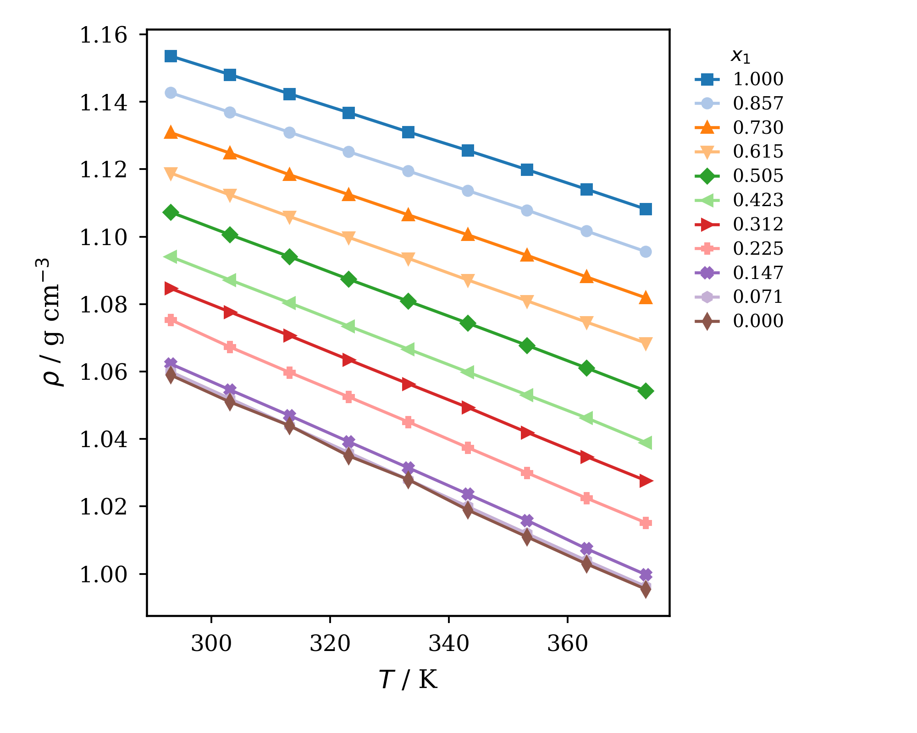
Figure S4. Densities of pure components and binary mixtures at different temperatures and compositions of 2-HEAA (1) + CPAc (2): mole fractions are labeled in the figure.

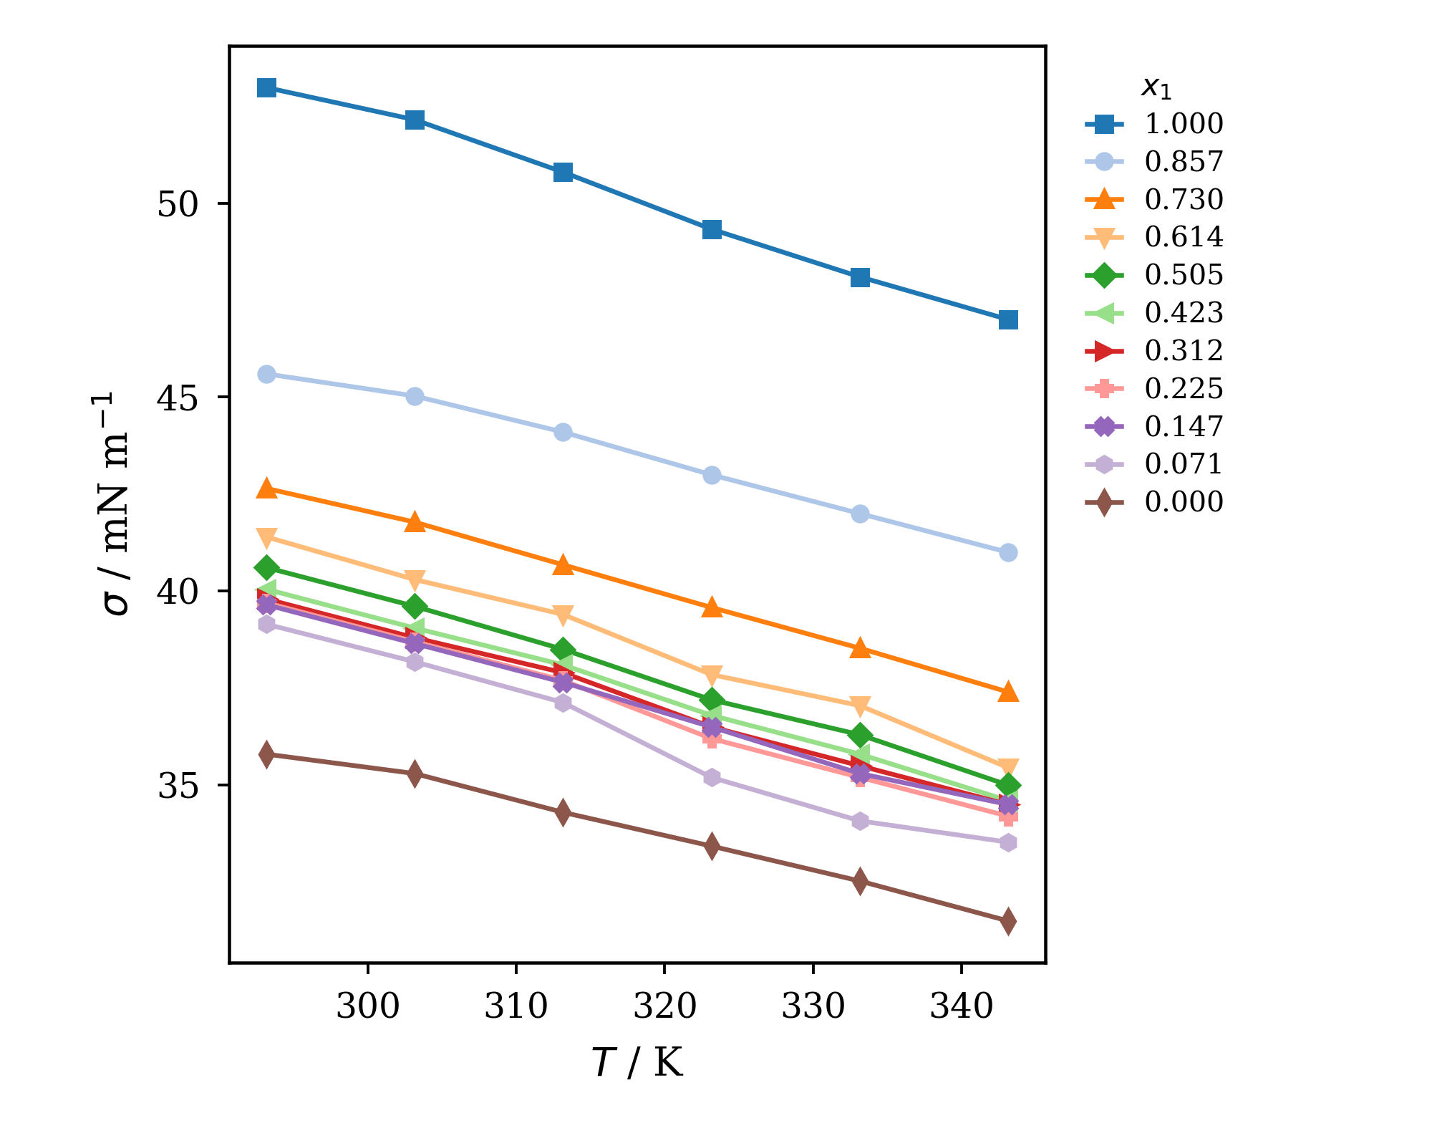
Figure S5. Surface tension of pure components and binary mixtures at different temperatures and compositions of 2-HEAA (1) + CPAc (2): mole fractions are labeled in the figure.
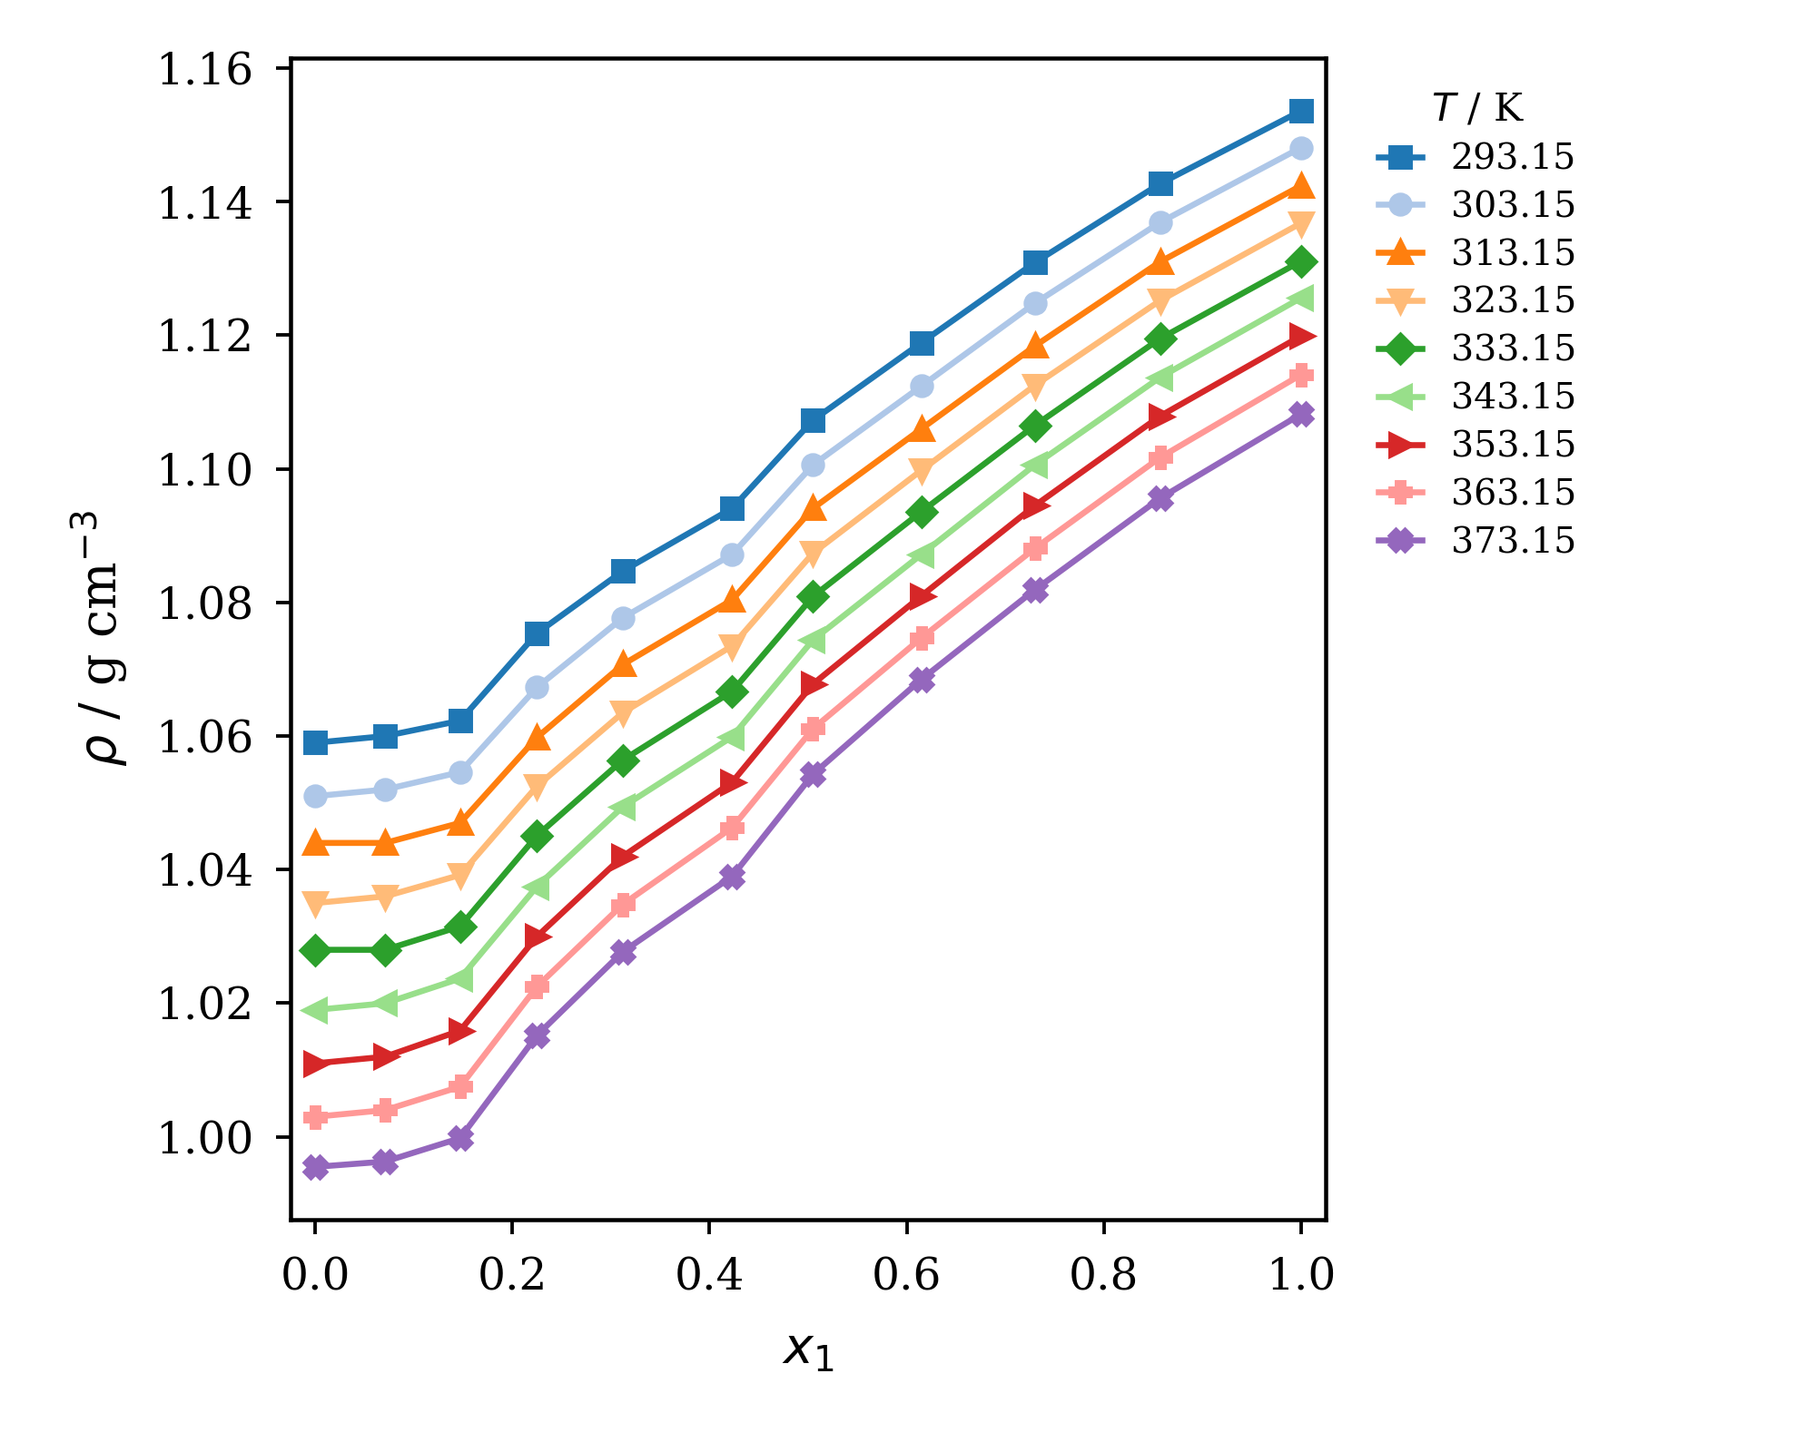
Figure S6. Influence of temperature on the density of a binary mixture of 2-HEAA (1) + CPAc (2). Temperatures are labeled in the figure.

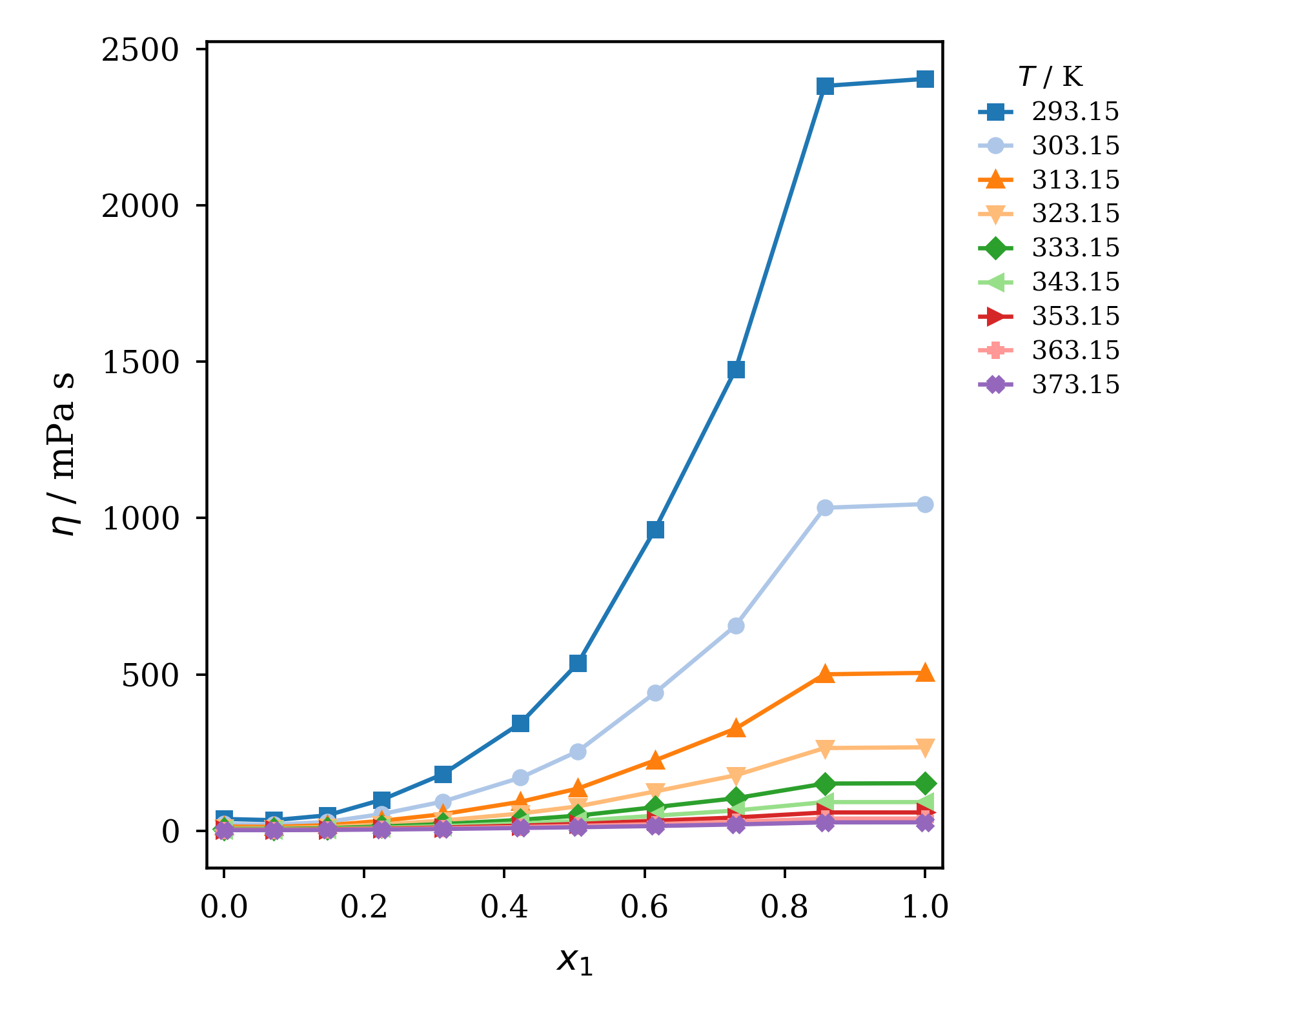
Figure S7. Influence of temperature on viscosity of a binary mixture of 2-HEAA (1) + CPAc (2). Temperatures are labeled in the figure.
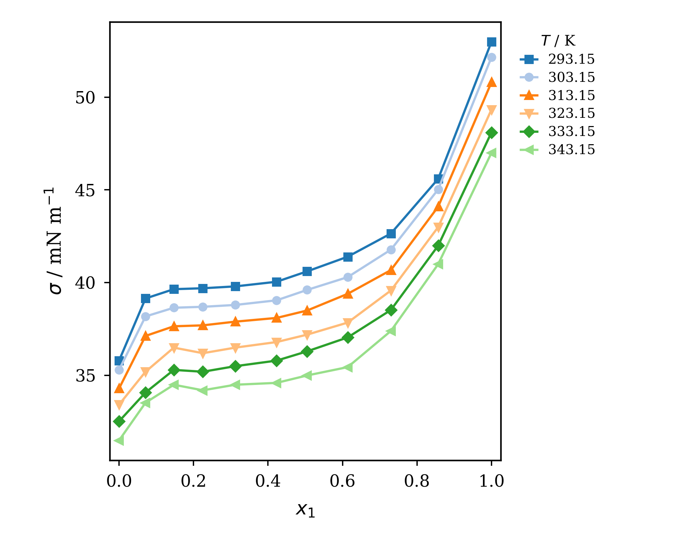
Figure S8. Influence of temperature on the surface tension of a binary mixture of 2-HEAA (1) + CPAc (2). Temperatures are labeled in the figure.

Table S4. Redlich−Kister parameters, from Equation 5, and standard deviations for the excess molar volume, the viscosity deviation and the surface tension deviation of the binary system 2-HEAA (1) + CPAc (2).
 | 2-HEAA (1) + CPAc (2)
VE / cm³·mol⁻¹ | A | B | C | D | R² | s | T / K
VE / cm³·mol⁻¹ | -4.8515 | 3.9122 | 6.4718 | 8.8050 | 0.91502 | 0.29716 | 293.15
VE / cm³·mol⁻¹ | -5.1071 | 3.9728 | 6.8988 | 9.3811 | 0.92775 | 0.28471 | 303.15
VE / cm³·mol⁻¹ | -5.1722 | 3.8537 | 8.0263 | 11.5395 | 0.93662 | 0.28716 | 313.15
VE / cm³·mol⁻¹ | -5.7986 | 3.8699 | 7.5044 | 10.6079 | 0.93199 | 0.29882 | 323.15
VE / cm³·mol⁻¹ | -5.9083 | 4.0120 | 8.5258 | 12.6558 | 0.93835 | 0.30911 | 333.15
VE / cm³·mol⁻¹ | -6.5824 | 3.8742 | 8.2248 | 12.0476 | 0.93782 | 0.31269 | 343.15
VE / cm³·mol⁻¹ | -6.9760 | 4.1087 | 8.6576 | 12.3345 | 0.94286 | 0.31344 | 353.15
VE / cm³·mol⁻¹ | -7.4145 | 4.0290 | 9.7009 | 13.3628 | 0.93989 | 0.34065 | 363.15
VE / cm³·mol⁻¹ | -7.6169 | 4.3983 | 10.1332 | 13.6495 | 0.93404 | 0.37302 | 373.15
Δη / mPa·s | A | B | C | D | R² | s | T / K
Δη / mPa·s | -2885.193 | -568.607 | 5111.641 | -5568.275 | 0.98065 | 56.09863 | 293.15
Δη / mPa·s | -1171.211 | -300.633 | 2068.350 | -2267.813 | 0.98062 | 23.19730 | 303.15
Δη / mPa·s | -522.429 | -177.193 | 935.821 | -1032.278 | 0.98130 | 10.52361 | 313.15
Δη / mPa·s | -251.963 | -109.295 | 454.614 | -506.786 | 0.98120 | 5.28740 | 323.15
Δη / mPa·s | -129.441 | -71.379 | 238.039 | -268.479 | 0.98178 | 2.82218 | 333.15
Δη / mPa·s | -68.904 | -49.341 | 134.013 | -153.449 | 0.98245 | 1.61419 | 343.15
Δη / mPa·s | -38.767 | -34.014 | 77.174 | -90.935 | 0.98293 | 0.96798 | 353.15
Δη / mPa·s | -24.017 | -17.768 | 49.012 | -69.264 | 0.99009 | 0.46582 | 363.15
Δη / mPa·s | -14.289 | -12.502 | 29.666 | -45.426 | 0.98921 | 0.31574 | 373.15
Δσ / mN·m⁻¹ | A | B | C | D | R² | s | T / K
Δσ / mN·m⁻¹ | -15.9696 | 19.0807 | 2.7952 | 36.9796 | 0.99412 | 0.28172 | 293.15
Δσ / mN·m⁻¹ | -17.4786 | 19.6278 | 3.5155 | 27.9947 | 0.99414 | 0.26859 | 303.15
Δσ / mN·m⁻¹ | -16.8049 | 19.9449 | 5.1424 | 23.9990 | 0.99304 | 0.28342 | 313.15
Δσ / mN·m⁻¹ | -17.5161 | 20.7786 | 4.6071 | 10.8574 | 0.99406 | 0.23513 | 323.15
Δσ / mN·m⁻¹ | -16.8424 | 20.0372 | 2.9616 | 8.2438 | 0.99473 | 0.20642 | 333.15
Δσ / mN·m⁻¹ | -18.1556 | 21.3213 | 8.7920 | 8.3895 | 0.99283 | 0.26592 | 343.15

Table S5. Linear Arrhenius parameters fitted to nine measured viscosity temperatures. A quadratic function of 1/T is favored by corrected AIC > 2 for all 11 tabulated series. The listed E_{η} values are apparent parameters over the measured interval, not temperature-independent activation energies; extrapolation is not supported.
η / mPa·s | ln(η∞/mPa·s) | $E_{η}$ / J·mol⁻¹ | R² | s | x₁
η / mPa·s | -13.10373 | 50507.51 | 0.99549 | 0.10926 | 1.000
η / mPa·s | -13.05957 | 50371.44 | 0.99545 | 0.10945 | 0.857
η / mPa·s | -12.57993 | 48022.94 | 0.99475 | 0.11213 | 0.730
η / mPa·s | -12.29498 | 46318.27 | 0.99540 | 0.10121 | 0.615
η / mPa·s | -11.47752 | 42866.33 | 0.99350 | 0.11149 | 0.505
η / mPa·s | -10.92027 | 40435.78 | 0.99260 | 0.11221 | 0.423
η / mPa·s | -10.36325 | 37535.60 | 0.99258 | 0.10432 | 0.312
η / mPa·s | -9.72377 | 34543.38 | 0.99233 | 0.09759 | 0.225
η / mPa·s | -8.84618 | 30754.52 | 0.99179 | 0.08993 | 0.147
η / mPa·s | -8.60785 | 29275.43 | 0.99167 | 0.08627 | 0.071
η / mPa·s | -8.88241 | 30184.38 | 0.99093 | 0.09283 | 0.000

BINARY MIXTURE 2-HEAA (1) + HEAPe (2)

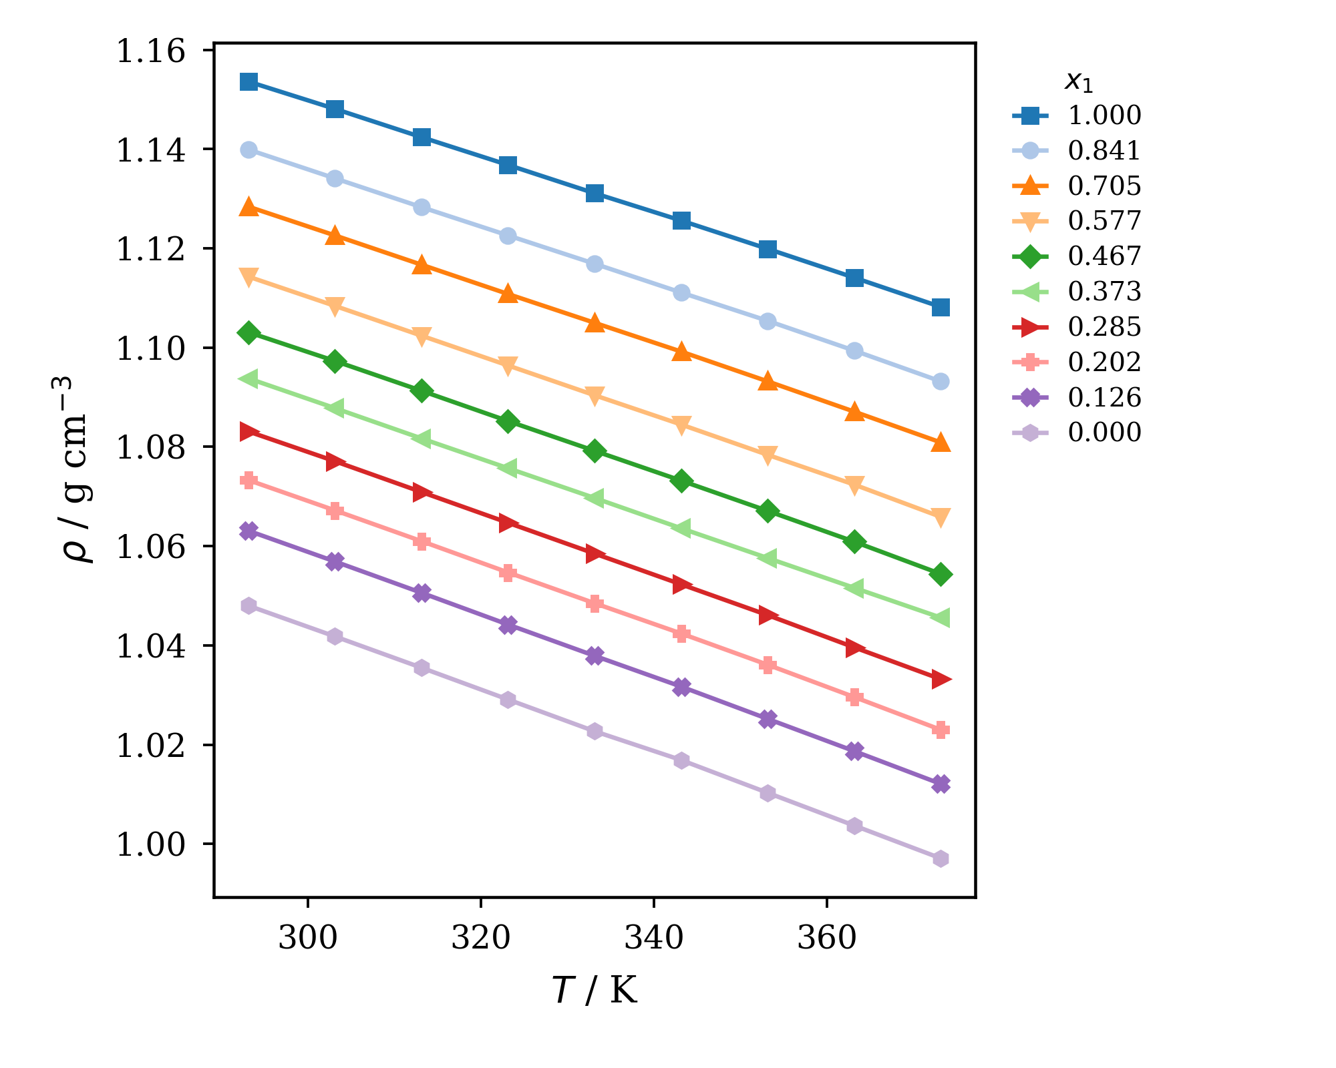
Figure S9. Densities of pure components and binary mixtures at different temperatures and compositions of 2-HEAA (1) + HEAPe (2): mole fractions are labeled in the figure.

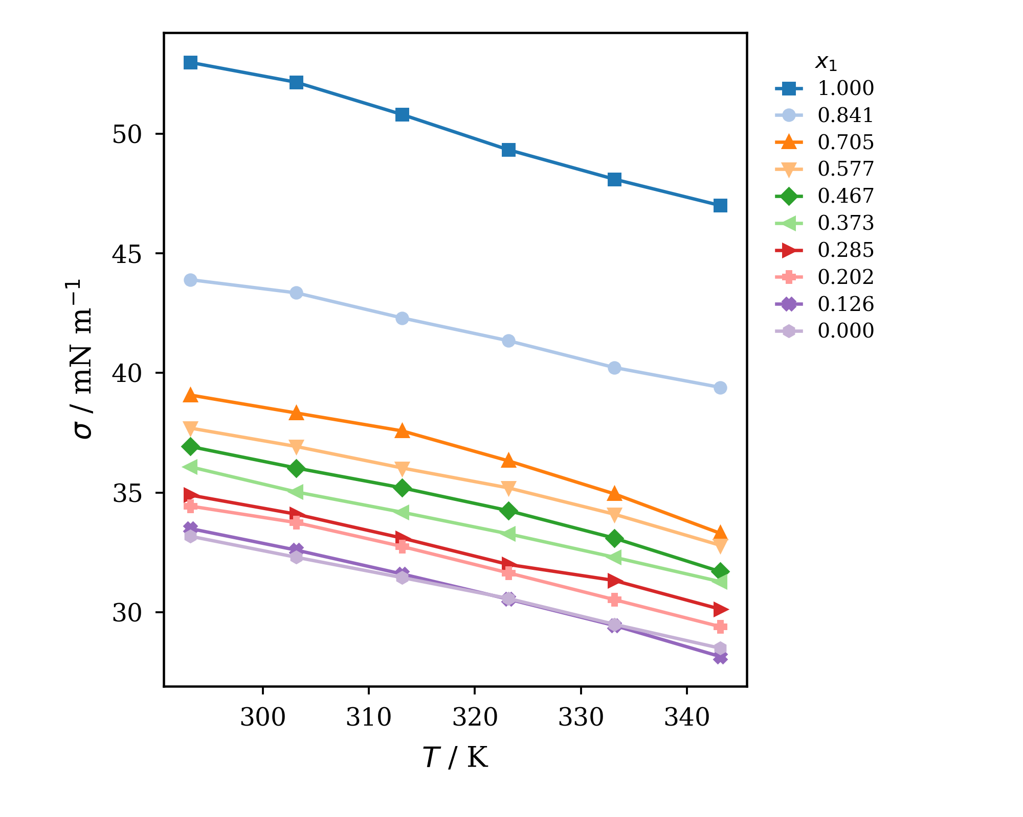
Figure S10. Surface tension of pure components and binary mixtures at different temperatures and compositions of 2-HEAA (1) + HEAPe (2): mole fractions are labeled in the figure.

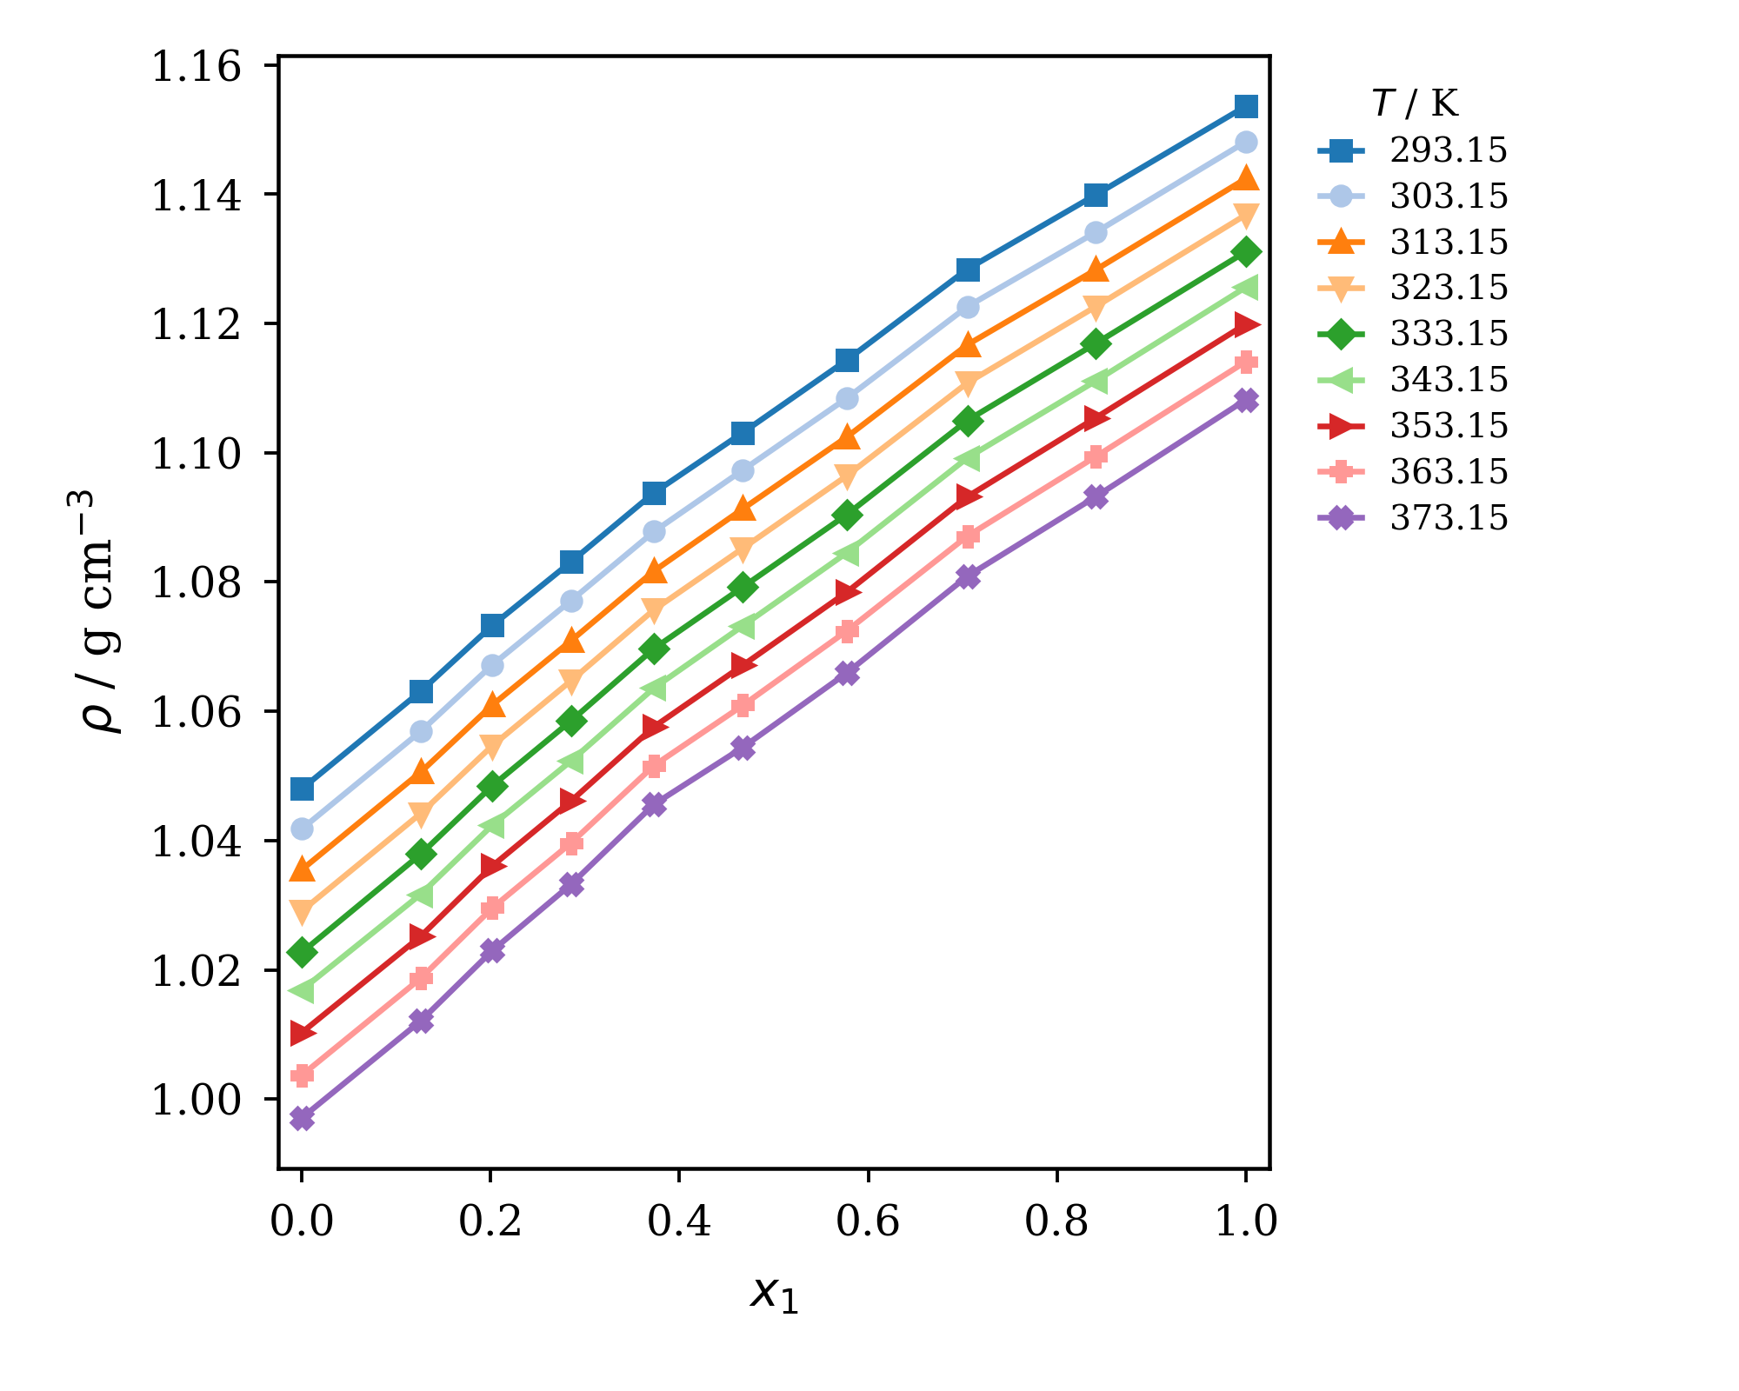
Figure S11. Influence of temperature on the density of a binary mixture of 2-HEAA (1) + HEAPe (2). Temperatures are labeled in the figure.

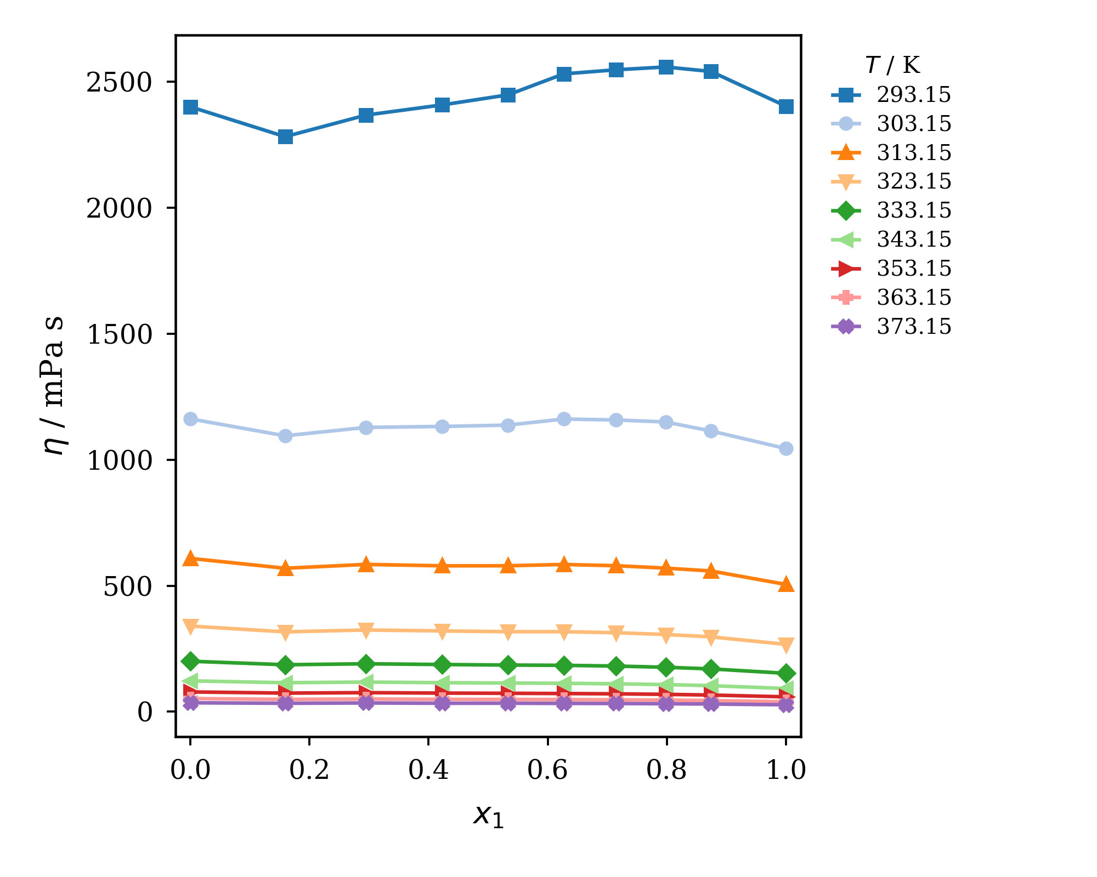
Figure S12. Influence of temperature on the dynamic viscosity of a binary mixture of 2-HEAA (1) + HEAPe (2). Temperatures are labeled in the figure.

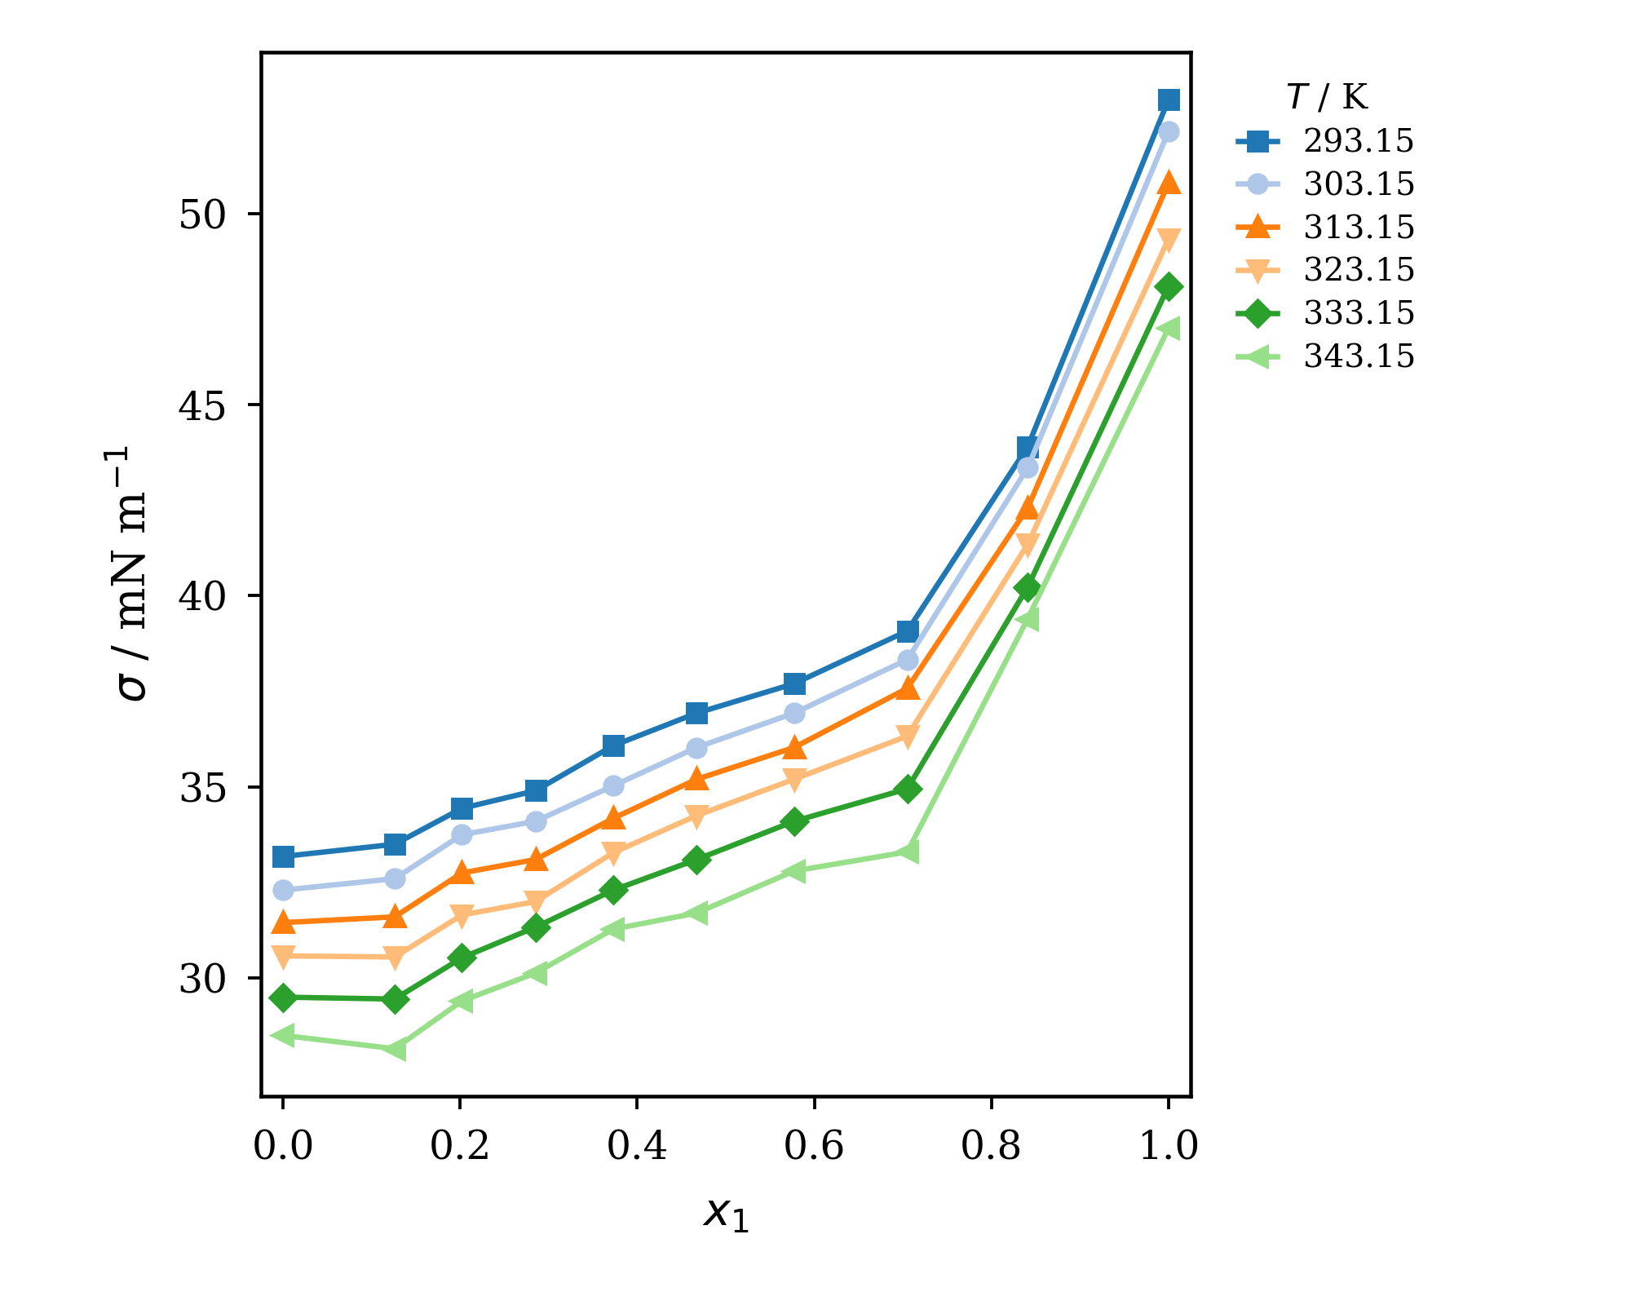
Figure S13. Influence of temperature on the Surface tension of a binary mixture of 2-HEAA (1) + HEAPe (2). Temperatures are labeled in the figure.

Table S6. Redlich–Kister parameters and residual standard deviations for 2-HEAA (1) + HEAPe (2), refitted to Tables S1–S3. The reported composition grid for viscosity differs from that for density and surface tension.
 | 2-HEAA (1) + HEAPe (2)
VE / cm³·mol⁻¹ | A | B | C | D | R² | s | T / K
VE / cm³·mol⁻¹ | -7.7685 | -1.4476 | 0.2373 | 2.2347 | 0.97883 | 0.08312 | 293.15
VE / cm³·mol⁻¹ | -7.8951 | -1.5519 | 0.4470 | 2.3405 | 0.97924 | 0.08466 | 303.15
VE / cm³·mol⁻¹ | -8.0172 | -1.5899 | 0.5100 | 2.4922 | 0.97911 | 0.08658 | 313.15
VE / cm³·mol⁻¹ | -8.1492 | -1.7590 | 0.5570 | 3.0196 | 0.97812 | 0.09070 | 323.15
VE / cm³·mol⁻¹ | -8.3203 | -1.8364 | 0.4966 | 3.2721 | 0.97624 | 0.09640 | 333.15
VE / cm³·mol⁻¹ | -8.2830 | -1.6625 | 0.8615 | 3.3191 | 0.97403 | 0.10249 | 343.15
VE / cm³·mol⁻¹ | -8.4811 | -2.0242 | 0.7812 | 4.1929 | 0.97303 | 0.10730 | 353.15
VE / cm³·mol⁻¹ | -8.7007 | -2.1022 | 1.0795 | 4.3004 | 0.97221 | 0.11289 | 363.15
VE / cm³·mol⁻¹ | -8.8171 | -2.5220 | 1.2051 | 5.2388 | 0.96240 | 0.13569 | 373.15
Δη / mPa·s | A | B | C | D | R² | s | T / K
Δη / mPa·s | 212.537 | -965.363 | -80.817 | -1008.281 | 0.97715 | 20.15422 | 293.15
Δη / mPa·s | 172.461 | -461.827 | -130.614 | -323.279 | 0.95957 | 12.04188 | 303.15
Δη / mPa·s | 106.067 | -190.309 | -29.155 | -340.965 | 0.97313 | 5.15225 | 313.15
Δη / mPa·s | 69.100 | -92.442 | -36.221 | -193.666 | 0.97377 | 2.67921 | 323.15
Δη / mPa·s | 42.728 | -53.341 | -26.822 | -106.129 | 0.97278 | 1.56278 | 333.15
Δη / mPa·s | 30.709 | -28.036 | -10.754 | -65.576 | 0.96315 | 1.04866 | 343.15
Δη / mPa·s | 20.114 | -16.653 | -7.557 | -42.555 | 0.95722 | 0.70921 | 353.15
Δη / mPa·s | 13.432 | -9.761 | -5.826 | -31.416 | 0.94212 | 0.55085 | 363.15
Δη / mPa·s | 9.421 | -5.572 | -4.359 | -21.588 | 0.90103 | 0.47631 | 373.15
Δσ / mN·m⁻¹ | A | B | C | D | R² | s | T / K
Δσ / mN·m⁻¹ | -24.3419 | 21.7925 | -17.9801 |  | 0.97851 | 0.35061 | 293.15
Δσ / mN·m⁻¹ | -24.5225 | 20.8195 | -14.8204 |  | 0.97284 | 0.38962 | 303.15
Δσ / mN·m⁻¹ | -23.4214 | 18.9518 | -15.7143 |  | 0.97197 | 0.36091 | 313.15
Δσ / mN·m⁻¹ | -22.5074 | 17.1342 | -16.5447 |  | 0.93974 | 0.49265 | 323.15
Δσ / mN·m⁻¹ | -22.1917 | 18.2261 | -16.7449 |  | 0.92405 | 0.57699 | 333.15
Δσ / mN·m⁻¹ | -23.3223 | 18.2134 | -15.7381 |  | 0.85706 | 0.84343 | 343.15

Table S7. Linear Arrhenius parameters fitted to nine measured viscosity temperatures. A quadratic function of 1/T is favored by corrected AIC > 2 for all 10 tabulated series.
η / mPa·s | ln(η∞/mPa·s) | $E_{η}$ / J·mol⁻¹ | R² | s | x₁
η / mPa·s | -13.10373 | 50507.51 | 0.99549 | 0.10926 | 1.000
η / mPa·s | -12.79105 | 49916.14 | 0.99637 | 0.09679 | 0.874
η / mPa·s | -12.64647 | 49605.24 | 0.99667 | 0.09221 | 0.798
η / mPa·s | -12.49811 | 49252.28 | 0.99699 | 0.08692 | 0.715
η / mPa·s | -12.42198 | 49070.32 | 0.99735 | 0.08135 | 0.627
η / mPa·s | -12.19332 | 48443.79 | 0.99748 | 0.07823 | 0.533
η / mPa·s | -12.13089 | 48278.34 | 0.99798 | 0.06985 | 0.423
η / mPa·s | -11.93037 | 47764.07 | 0.99811 | 0.06690 | 0.295
η / mPa·s | -11.95226 | 47747.60 | 0.99845 | 0.06055 | 0.159
η / mPa·s | -11.87490 | 47706.68 | 0.99875 | 0.05416 | 0.000

BINARY MIXTURES CPAc (1) + HEAPe (2)
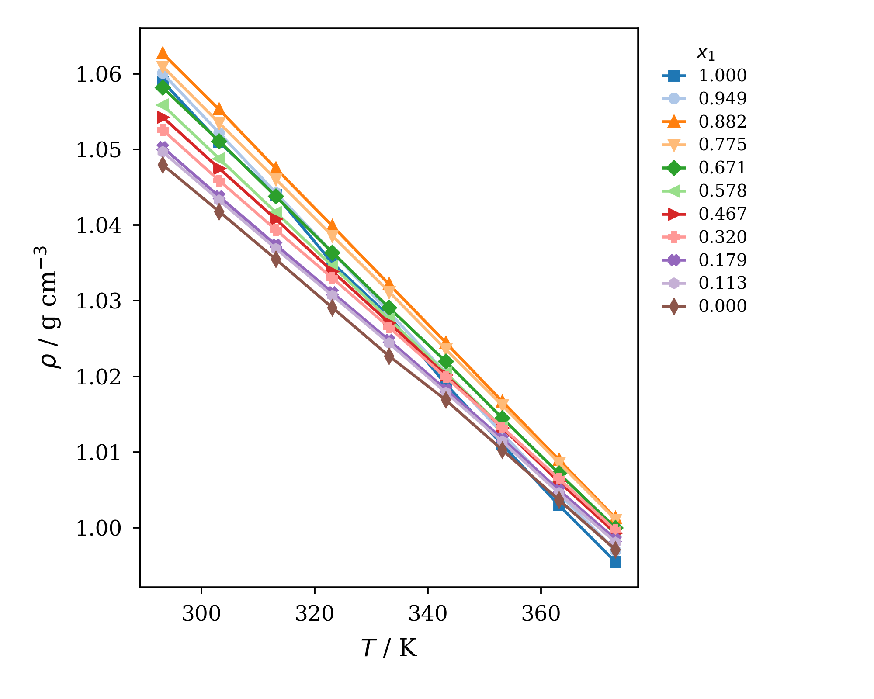
Figure S14. Densities of pure components and binary mixtures at different temperatures and compositions of CPAc (1) + HEAPe (2): mole fractions are labeled in the figure.

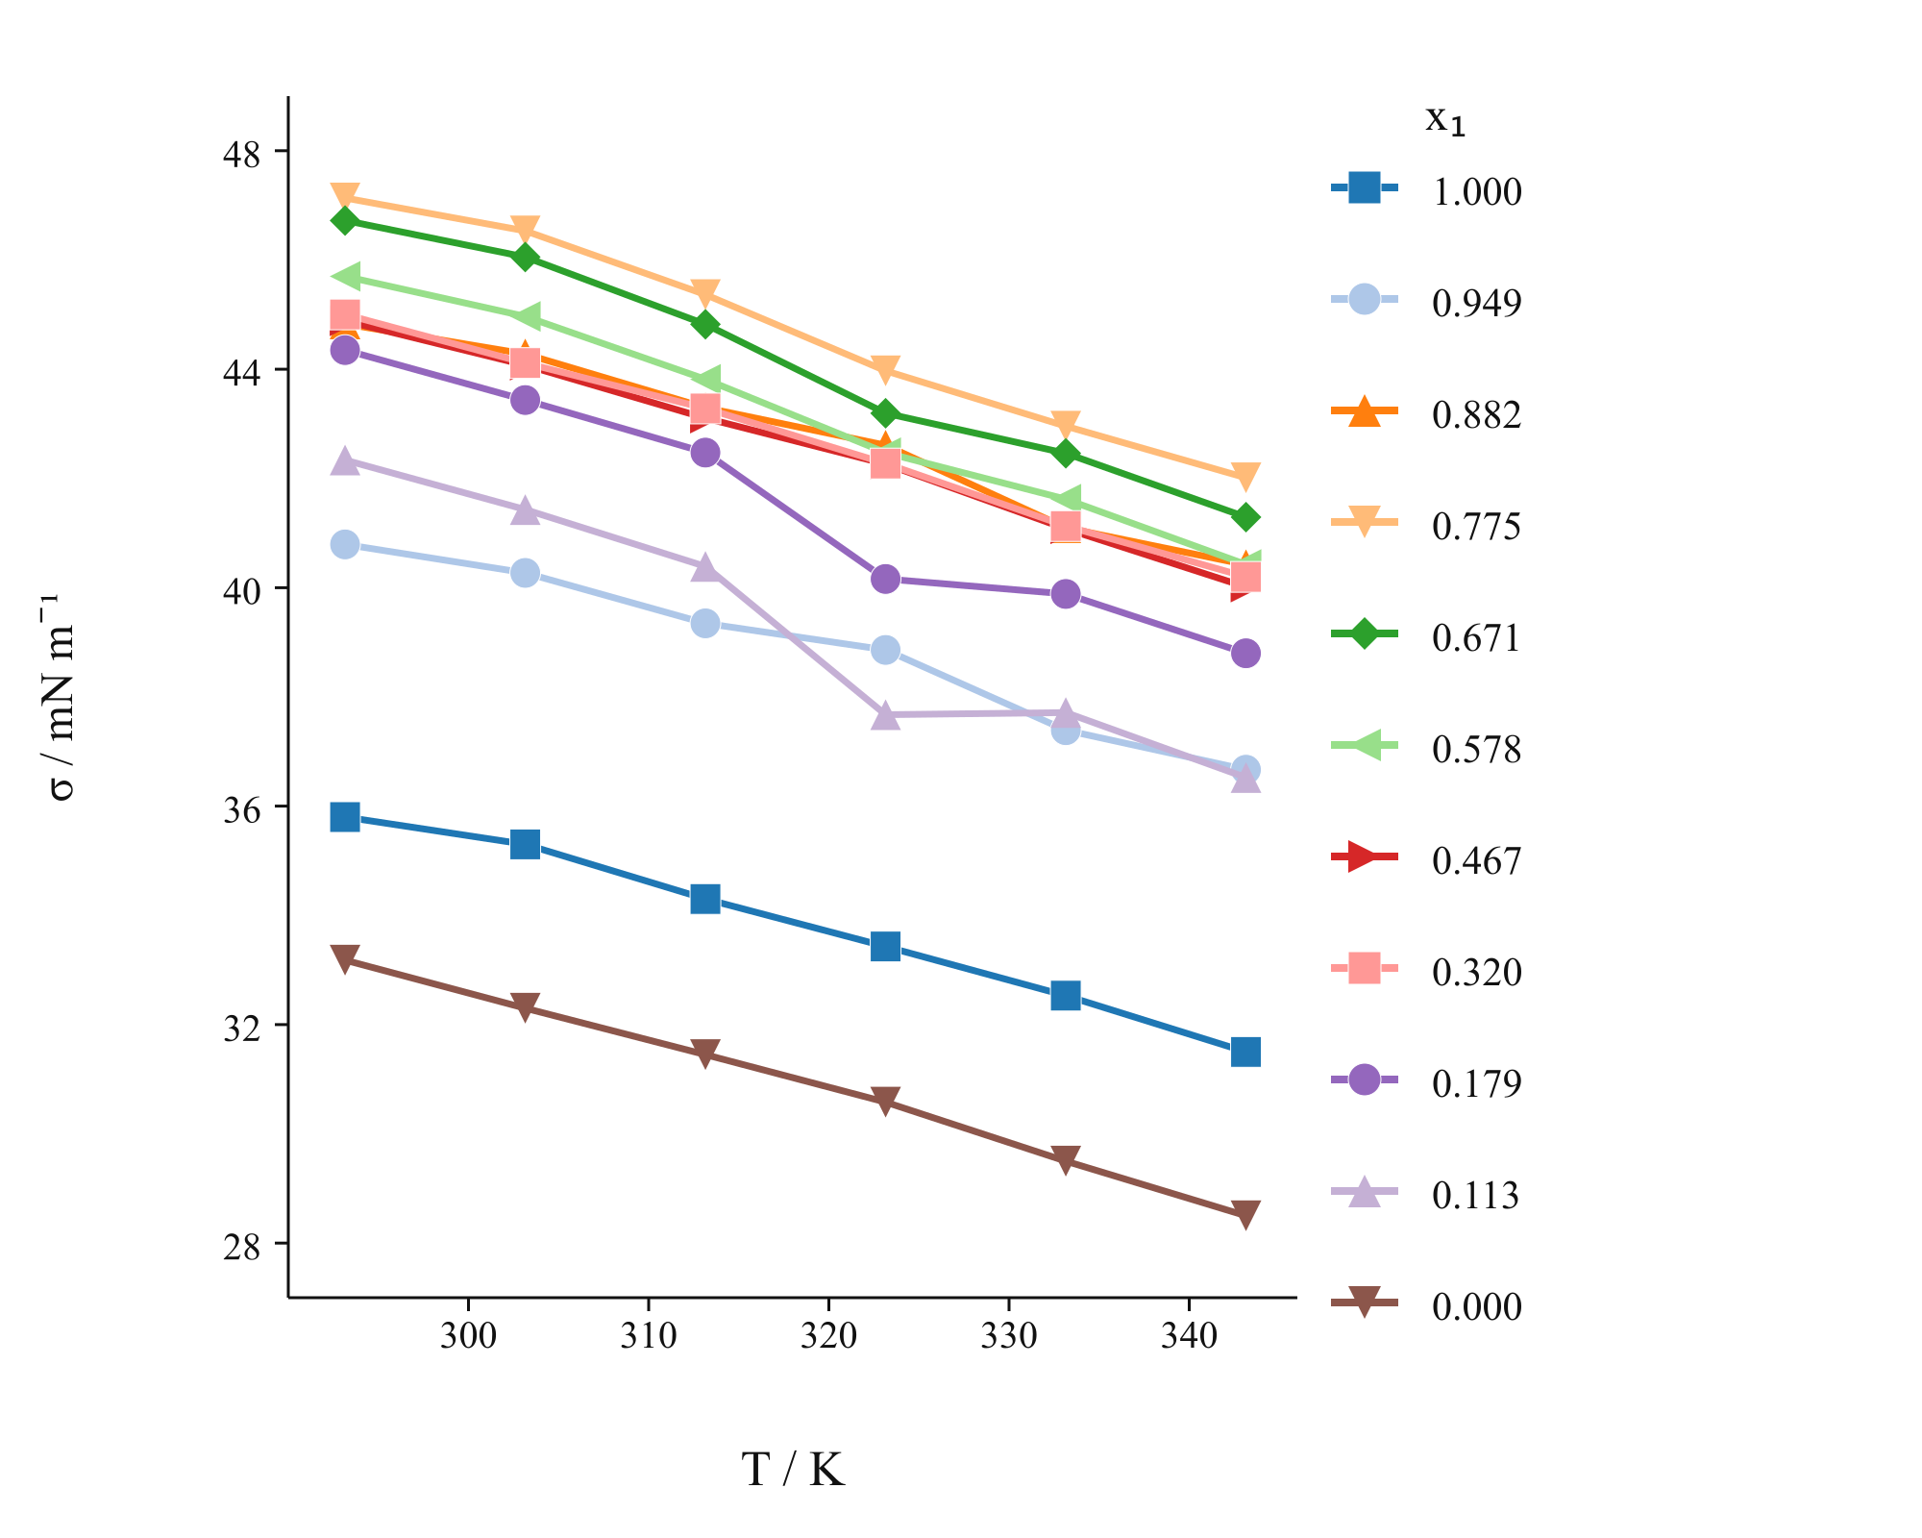
Figure S15. Surface tension of pure components and binary mixtures at different temperatures and compositions of CPAc (1) + HEAPe (2): mole fractions are labeled in the figure.

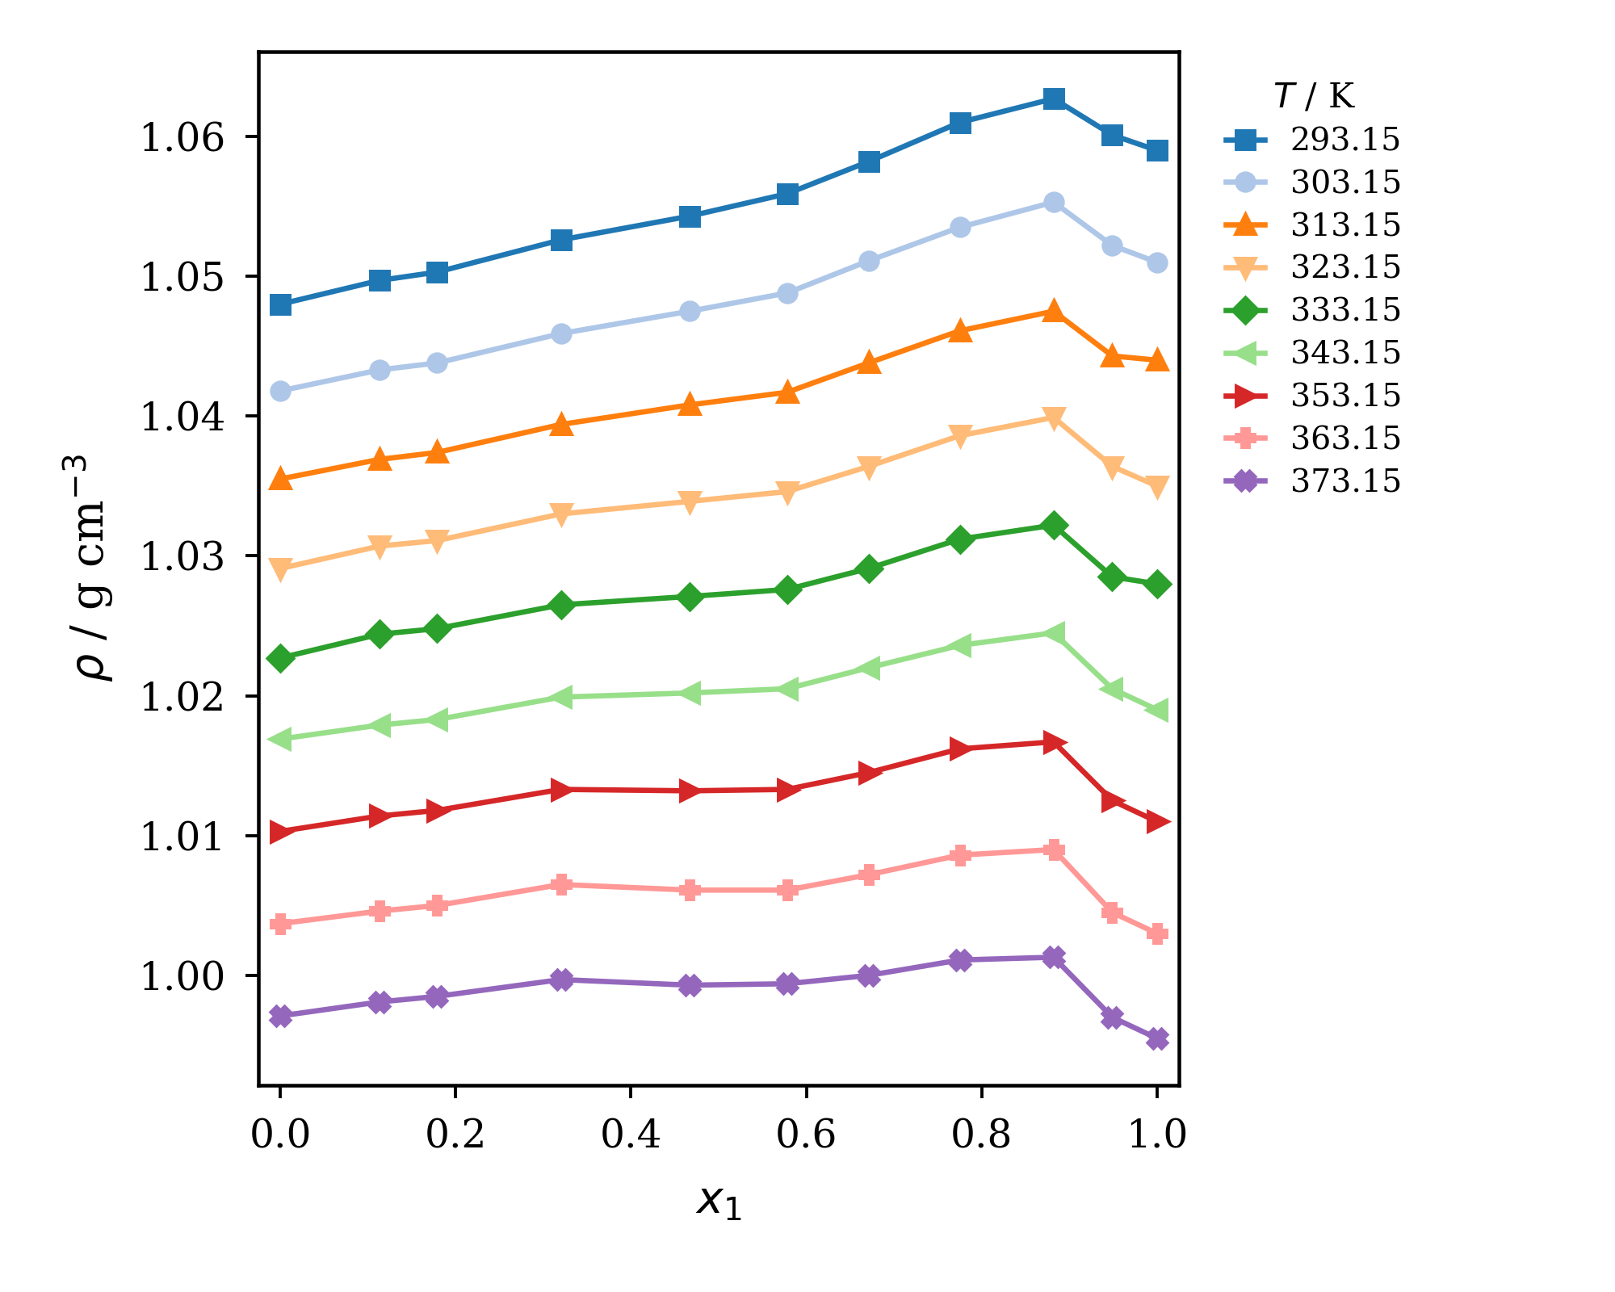
Figure S16. Influence of temperature on the density of a binary mixture of CPAc (1) + HEAPe (2). Temperatures are labeled in the figure.

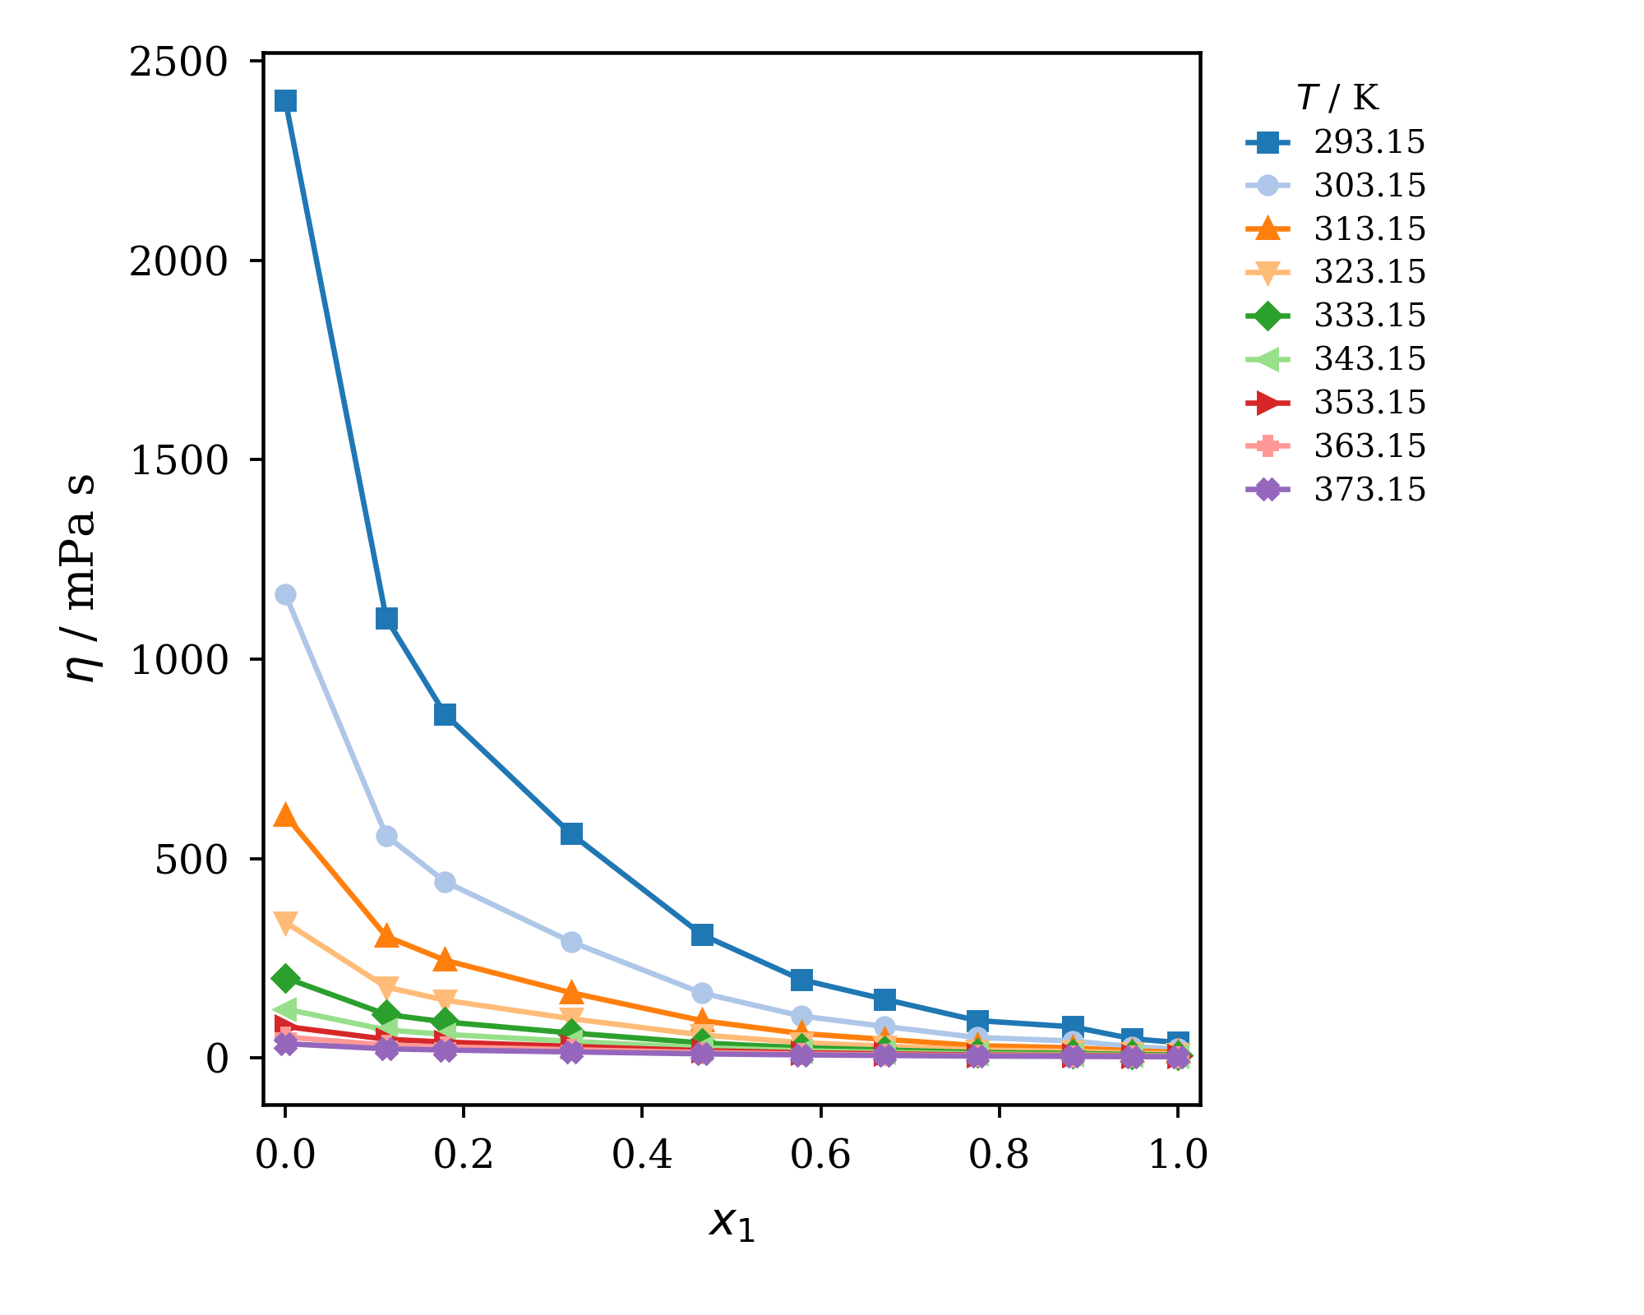
Figure S17. Influence of temperature on the dynamic viscosity of a binary mixture of CPAc (1) + HEAPe (2). Temperatures are labeled in the figure.

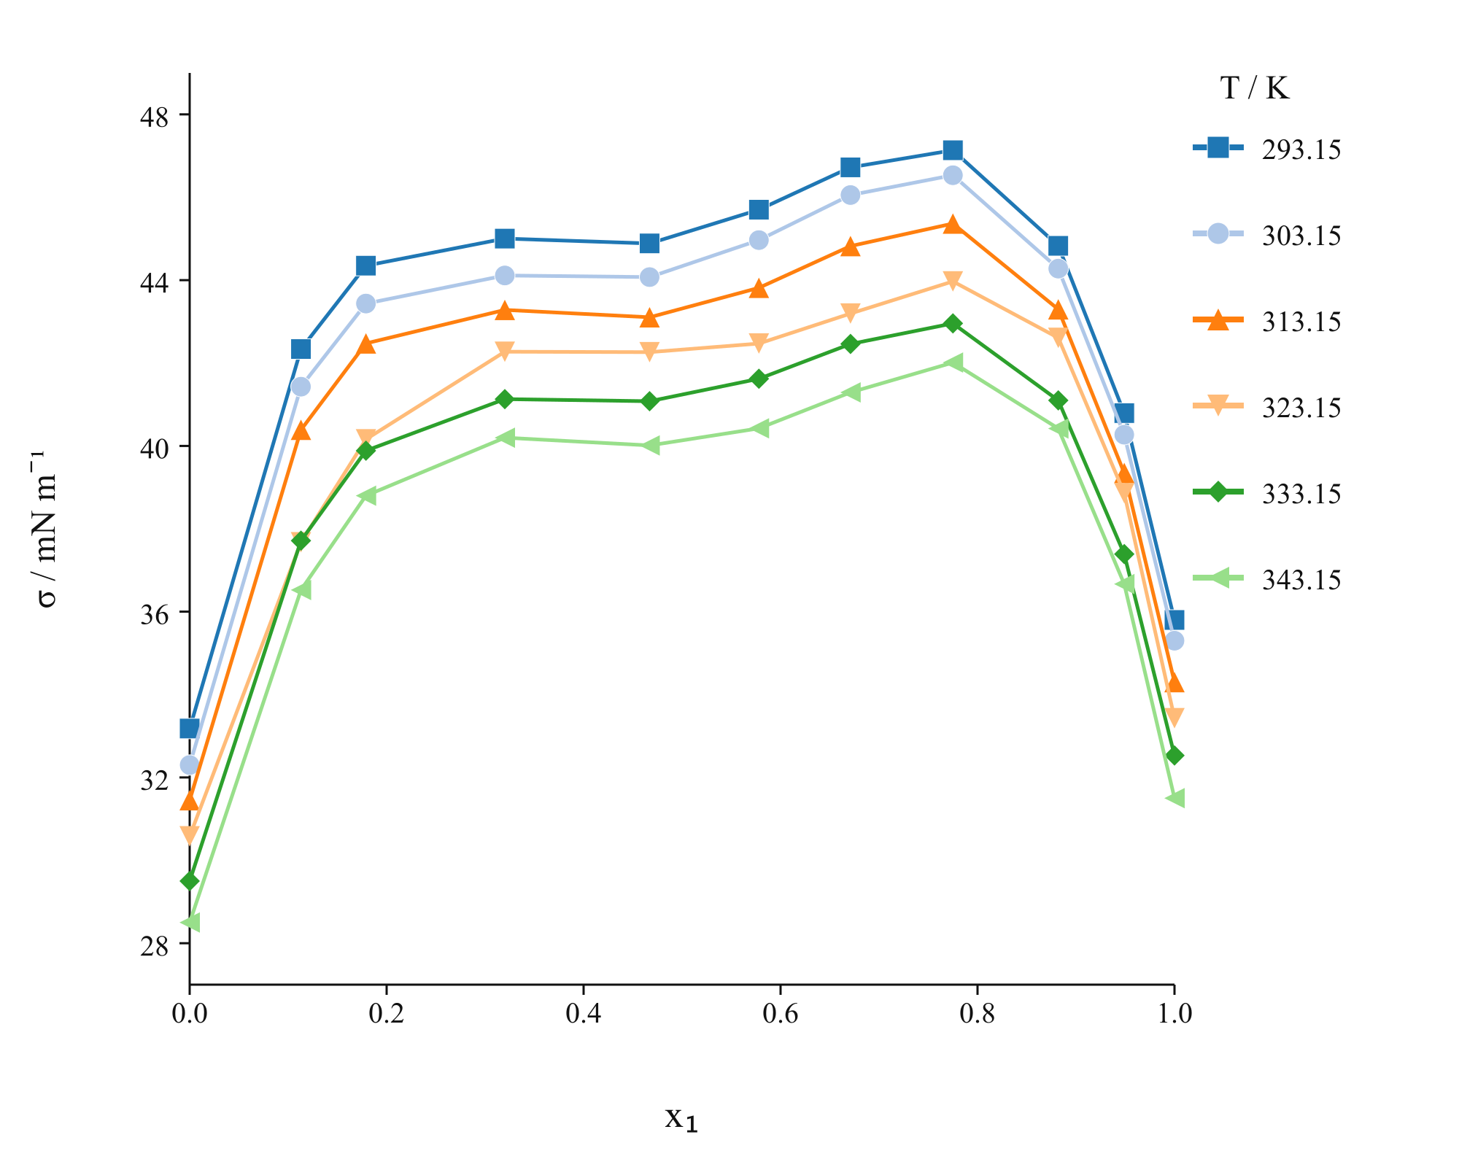
Figure S18. Influence of temperature on the surface tension of a binary mixture of CPAc (1) + HEAPe (2). Temperatures are labeled in the figure.

Table S8. Redlich–Kister parameters and residual standard deviations for CPAc (1) + HEAPe (2). Four coefficients were fitted to Δσ calculated from the x₁ and σ values reported in Table 6; s uses n−p degrees of freedom for the interior mixtures.
 | CPAc (1) + HEAPe (2)
VE / cm³·mol⁻¹ | A | B | C | D | R² | s | T / K
VE / cm³·mol⁻¹ | -0.6667 | 1.7289 | -4.6847 | 3.6182 | 0.91824 | 0.09376 | 293.15
VE / cm³·mol⁻¹ | -0.7993 | 1.8238 | -4.8163 | 3.9314 | 0.90650 | 0.10714 | 303.15
VE / cm³·mol⁻¹ | -0.7399 | 1.5890 | -3.8797 | 2.7449 | 0.80562 | 0.13432 | 313.15
VE / cm³·mol⁻¹ | -1.2065 | 1.2953 | -5.2078 | 4.6279 | 0.87562 | 0.11925 | 323.15
VE / cm³·mol⁻¹ | -1.1612 | 1.0923 | -4.5456 | 3.1057 | 0.74793 | 0.14845 | 333.15
VE / cm³·mol⁻¹ | -1.5064 | 1.3145 | -4.9869 | 5.0694 | 0.86615 | 0.13244 | 343.15
VE / cm³·mol⁻¹ | -1.7143 | 1.0971 | -5.2480 | 5.1669 | 0.84175 | 0.14311 | 353.15
VE / cm³·mol⁻¹ | -1.9091 | 1.1012 | -5.1481 | 5.3931 | 0.83186 | 0.15450 | 363.15
VE / cm³·mol⁻¹ | -2.1075 | 1.1054 | -4.8196 | 4.6343 | 0.83989 | 0.13946 | 373.15
Δη / mPa·s | A | B | C | D | R² | s | T / K
Δη / mPa·s | -3631.541 | -2210.074 | -3917.218 | -4467.954 | 0.99092 | 45.40722 | 293.15
Δη / mPa·s | -1720.388 | -999.803 | -1764.210 | -2056.336 | 0.99083 | 21.14323 | 303.15
Δη / mPa·s | -877.337 | -485.235 | -856.701 | -1018.762 | 0.99072 | 10.60478 | 313.15
Δη / mPa·s | -474.783 | -247.406 | -443.213 | -541.308 | 0.99034 | 5.72899 | 323.15
Δη / mPa·s | -269.584 | -130.861 | -242.475 | -305.818 | 0.98982 | 3.27214 | 333.15
Δη / mPa·s | -156.967 | -68.510 | -132.396 | -175.547 | 0.98872 | 1.94823 | 343.15
Δη / mPa·s | -95.471 | -37.573 | -79.430 | -109.584 | 0.98843 | 1.18172 | 353.15
Δη / mPa·s | -59.801 | -20.286 | -49.050 | -71.608 | 0.98870 | 0.71926 | 363.15
Δη / mPa·s | -37.809 | -11.402 | -31.203 | -46.498 | 0.98643 | 0.49220 | 373.15
Δσ / mN·m⁻¹ | A | B | C | D | R² | s | T / K
Δσ / mN·m⁻¹ | 42.2002 | -6.5765 | 79.1628 | 8.3679 | 0.9999985 | 0.00329 | 293.15
Δσ / mN·m⁻¹ | 41.7924 | -7.2182 | 79.2416 | 8.7300 | 0.9999983 | 0.00346 | 303.15
Δσ / mN·m⁻¹ | 41.3822 | -4.0662 | 78.5695 | 1.4256 | 0.9999994 | 0.00194 | 313.15
Δσ / mN·m⁻¹ | 40.9914 | 4.7055 | 65.5825 | -35.3188 | 0.9999992 | 0.00213 | 323.15
Δσ / mN·m⁻¹ | 40.6045 | -1.0916 | 70.3468 | -7.3612 | 0.9999995 | 0.00173 | 333.15
Δσ / mN·m⁻¹ | 40.1954 | 1.6655 | 72.4362 | -17.7494 | 0.9999995 | 0.00166 | 343.15

Table S9. Linear Arrhenius parameters fitted to nine measured viscosity temperatures. A quadratic function of 1/T is favored by corrected AIC > 2 for all 11 tabulated series.
η / mPa·s | ln(η∞/mPa·s) | $E_{η}$ / J·mol⁻¹ | R² | s | x₁
η / mPa·s | -8.88241 | 30184.38 | 0.99093 | 0.09283 | 1.000
η / mPa·s | -9.03159 | 31114.86 | 0.99231 | 0.08806 | 0.949
η / mPa·s | -9.91142 | 34378.11 | 0.99118 | 0.10425 | 0.882
η / mPa·s | -9.76485 | 34497.79 | 0.99263 | 0.09556 | 0.775
η / mPa·s | -10.02752 | 36257.89 | 0.99375 | 0.09243 | 0.671
η / mPa·s | -10.05634 | 37043.09 | 0.99445 | 0.08898 | 0.578
η / mPa·s | -10.27194 | 38693.72 | 0.99562 | 0.08248 | 0.467
η / mPa·s | -10.59012 | 40969.41 | 0.99703 | 0.07190 | 0.320
η / mPa·s | -10.86651 | 42723.51 | 0.99805 | 0.06077 | 0.179
η / mPa·s | -11.13347 | 43983.49 | 0.99826 | 0.05896 | 0.113
η / mPa·s | -11.87490 | 47706.68 | 0.99875 | 0.05416 | 0.000

Table S10. Redlich–Kister parameters and residual standard deviations for refractive-index deviation at T = (293.15 to 353.15) K.
ΔnD | A | B | C | D | R² | s | T / K
2-HEAA (1) + CPAc (2)
 | 0.018306 | 0.010511 | 0.008147 | 0.002930 | 0.95949 | 0.000317 | 293.15
 | 0.019092 | 0.009668 | 0.007188 | 0.004275 | 0.96030 | 0.000325 | 303.15
 | 0.020128 | 0.009497 | 0.007849 | 0.004541 | 0.96163 | 0.000334 | 313.15
 | 0.021374 | 0.009201 | 0.008084 | 0.005708 | 0.96860 | 0.000315 | 323.15
 | 0.022507 | 0.009772 | 0.008426 | 0.004620 | 0.97159 | 0.000316 | 333.15
 | 0.023684 | 0.010516 | 0.009773 | 0.003257 | 0.97985 | 0.000277 | 343.15
 | 0.024713 | 0.010209 | 0.013445 | 0.007497 | 0.99840 | 0.000075 | 353.15
2-HEAA (1) + HEAPe (2)
 | 0.002568 | 0.003302 | -0.004999 | -0.007060 | 0.99324 | 0.000044 | 293.15
 | 0.002791 | 0.003879 | -0.004531 | -0.006702 | 0.99884 | 0.000018 | 303.15
 | 0.002962 | 0.004345 | -0.004421 | -0.007763 | 0.97956 | 0.000084 | 313.15
 | 0.003279 | 0.004623 | -0.004016 | -0.009313 | 0.97574 | 0.000099 | 323.15
 | 0.003315 | 0.005483 | -0.003412 | -0.010398 | 0.96662 | 0.000118 | 333.15
 | 0.003453 | 0.004868 | -0.002957 | -0.010306 | 0.96894 | 0.000114 | 343.15
 | 0.003701 | 0.005393 | -0.003037 | -0.010526 | 0.98253 | 0.000089 | 353.15
CPAc (1) + HEAPe (2)
 | 0.035180 | -0.065315 | 0.069380 |  | 0.91422 | 0.001802 | 293.15
 | 0.035579 | -0.065730 | 0.069944 |  | 0.91555 | 0.001798 | 303.15
 | 0.036166 | -0.065946 | 0.070566 |  | 0.91624 | 0.001797 | 313.15
 | 0.037118 | -0.066625 | 0.071505 |  | 0.91437 | 0.001838 | 323.15
 | 0.037861 | -0.067285 | 0.072679 |  | 0.91121 | 0.001895 | 333.15
 | 0.038716 | -0.068152 | 0.074032 |  | 0.90098 | 0.002037 | 343.15
 | 0.039601 | -0.068628 | 0.074251 |  | 0.89540 | 0.002117 | 353.15

Table S11. Refractive-index deviations for 2-HEAA (1) + CPAc (2), 2-HEAA (1) + HEAPe (2), and CPAc (1) + HEAPe (2) at T = (293.15 to 353.15) K. Standard uncertainties: u(x₁) = 0.00029, u(T) = 0.05 K, and u_{c}(nD) = 0.00012.
x1 | T / K
x1 | 293.15 | 303.15 | 313.15 | 323.15 | 333.15 | 343.15 | 353.15
2-HEAA (1) + CPAc (2)
1.000 | 0 | 0 | 0 | 0 | 0 | 0 | 0
0.814 | 0.00219 | 0.00225 | 0.00243 | 0.00261 | 0.00278 | 0.00305 | 0.00331
0.652 | 0.00347 | 0.00376 | 0.00408 | 0.00440 | 0.00463 | 0.00481 | 0.00510
0.532 | 0.00448 | 0.00464 | 0.00484 | 0.00514 | 0.00544 | 0.00580 | 0.00605
0.421 | 0.00500 | 0.00511 | 0.00538 | 0.00565 | 0.00592 | 0.00623 | 0.00644
0.330 | 0.00490 | 0.00504 | 0.00525 | 0.00555 | 0.00586 | 0.00619 | 0.00673
0.245 | 0.00508 | 0.00514 | 0.00537 | 0.00560 | 0.00583 | 0.00609 | 0.00635
0.181 | 0.00392 | 0.00396 | 0.00419 | 0.00442 | 0.00465 | 0.00500 | 0.00564
0.109 | 0.00362 | 0.00367 | 0.00381 | 0.00394 | 0.00408 | 0.00423 | 0.00437
0.053 | 0.00159 | 0.00152 | 0.00154 | 0.00166 | 0.00168 | 0.00181 | 0.00253
0.000 | 0 | 0 | 0 | 0 | 0 | 0 | 0
2-HEAA (1) + HEAPe (2)
1.000 | 0 | 0 | 0 | 0 | 0 | 0 | 0
0.832 | 0.00002 | 0.00002 | 0.00002 | 0.00012 | 0.00013 | 0.00023 | 0.00023
0.687 | 0.00025 | 0.00023 | 0.00032 | 0.00041 | 0.00040 | 0.00048 | 0.00047
0.562 | 0.00048 | 0.00055 | 0.00051 | 0.00057 | 0.00053 | 0.00060 | 0.00066
0.352 | 0.00069 | 0.00078 | 0.00086 | 0.00095 | 0.00104 | 0.00103 | 0.00112
0.121 | -0.00012 | 0.00001 | 0.00003 | 0.00006 | 0.00009 | 0.00012 | 0.00014
0.059 | -0.00015 | -0.00009 | -0.00012 | -0.00016 | -0.00010 | -0.00013 | -0.00007
0.000 | 0 | 0 | 0 | 0 | 0 | 0 | 0
CPAc (1) + HEAPe (2)
1.000 | 0 | 0 | 0 | 0 | 0 | 0 | 0
0.887 | 0.01582 | 0.01593 | 0.01603 | 0.01633 | 0.01663 | 0.01714 | 0.01745
0.776 | 0.01478 | 0.01490 | 0.01510 | 0.01530 | 0.01550 | 0.01562 | 0.01564
0.664 | 0.01262 | 0.01275 | 0.01285 | 0.01315 | 0.01335 | 0.01358 | 0.01391
0.562 | 0.01063 | 0.01078 | 0.01098 | 0.01119 | 0.01140 | 0.01155 | 0.01170
0.468 | 0.00837 | 0.00844 | 0.00856 | 0.00889 | 0.00911 | 0.00948 | 0.00976
0.369 | 0.00663 | 0.00672 | 0.00685 | 0.00698 | 0.00712 | 0.00731 | 0.00751
0.276 | 0.00458 | 0.00460 | 0.00475 | 0.00500 | 0.00515 | 0.00527 | 0.00539
0.198 | 0.00289 | 0.00295 | 0.00302 | 0.00310 | 0.00328 | 0.00344 | 0.00360
0.091 | 0.00061 | 0.00068 | 0.00077 | 0.00085 | 0.00083 | 0.00080 | 0.00077
0.000 | 0 | 0 | 0 | 0 | 0 | 0 | 0

