Supporting Information

A Real-Time Recombinase Polymerase Amplification Platform for Rapid and Field-Deployable Detection of Major DNA and RNA Viruses in Sweetpotato

A. Abdul Kader Jailani, Andrea Gilliard, Christie V. Almeyda, Phillip Wadl, Ming Li Wang, Jon Y. Suzuki, Ainong Shi, and Kai-Shu Ling

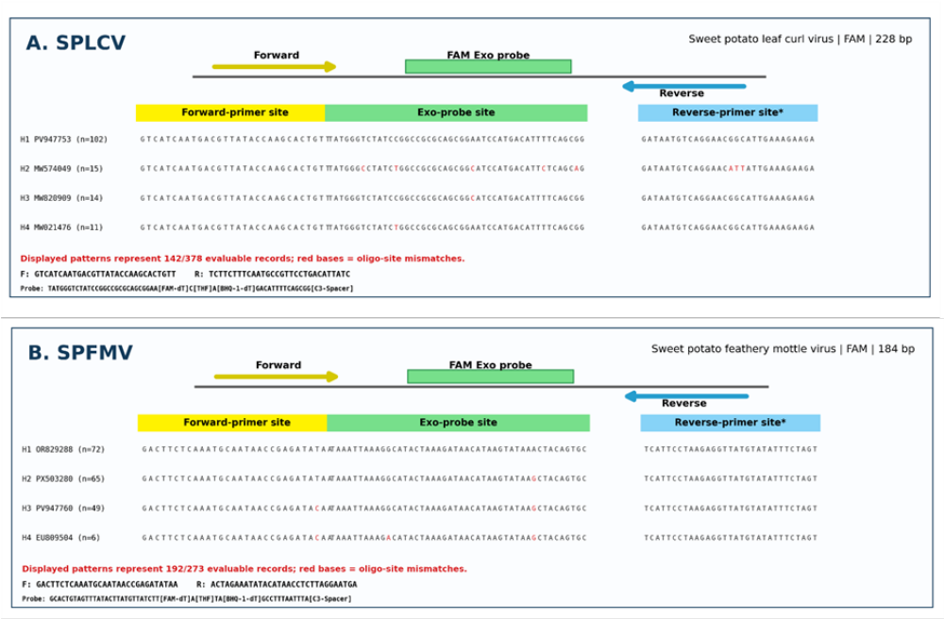
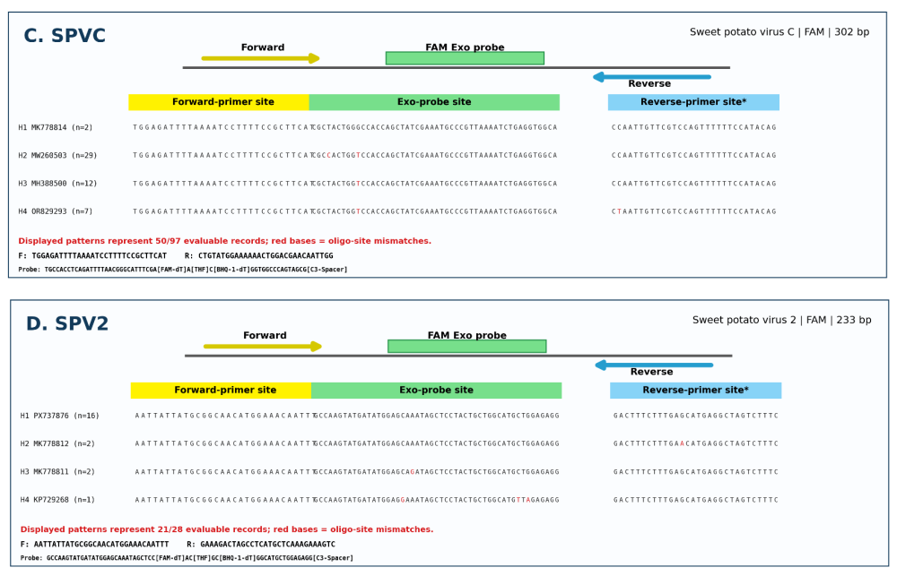
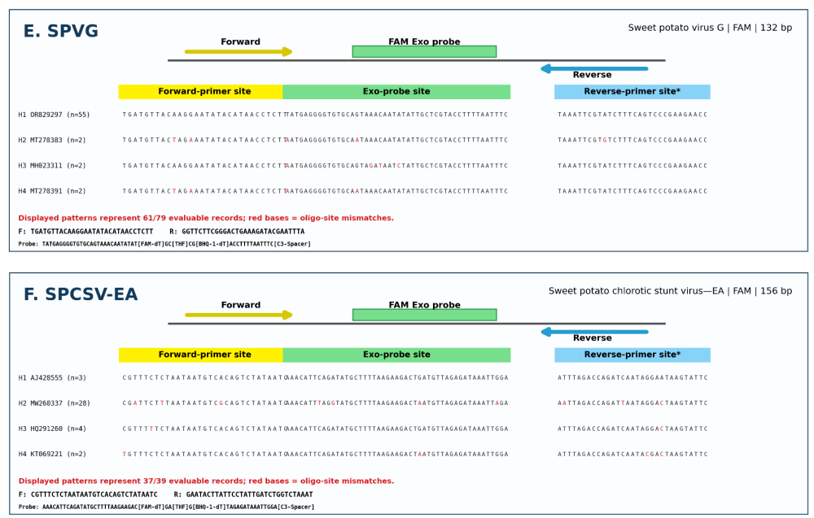
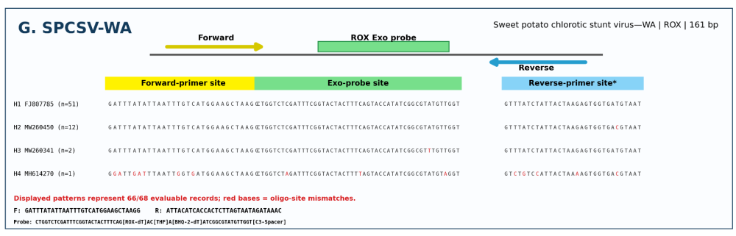
Supplementary Figure S1. Worldwide sequence comparison of RPA primer- and Exo-probe-binding regions for seven sweetpotato virus targets. Representative alignments are shown for (A) SPLCV, (B) SPFMV, (C) SPVC, (D) SPV2, (E) SPVG, (F) SPCSV-EA, and (G) SPCSV-WA. Forward-primer, Exo-probe, and reverse-primer sites are indicated for each singleplex assay. Red nucleotides denote differences from the corresponding assay oligonucleotide. FAM-labeled Exo probes were used for SPLCV, SPFMV, SPVC, SPV2, SPVG, and SPCSV-EA, whereas a ROX-labeled Exo probe was used for SPCSV-WA.

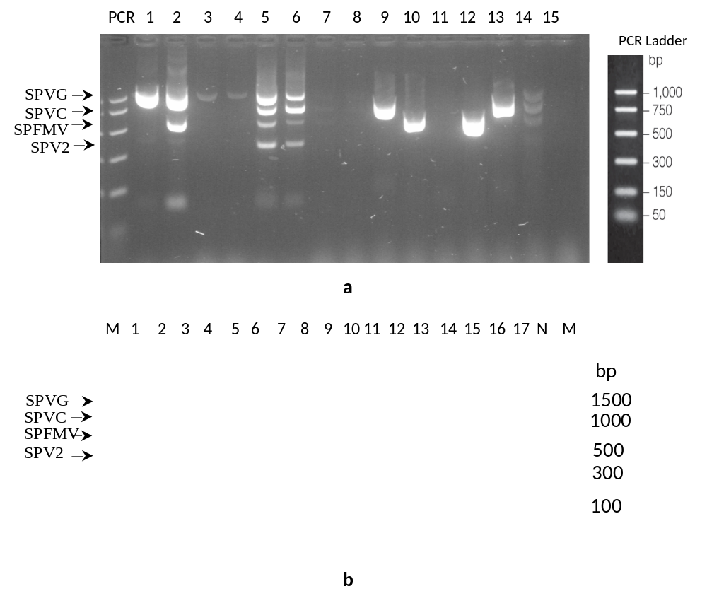

Supplementary Figure S2. Multiplex one-step RT-PCR detection of sweetpotato-infecting potyviruses in (a) 15 North Carolina virus culture samples and (b) 17 South Carolina field samples. Agarose-gel electrophoresis shows the diagnostic products for SPVG (1,191 bp), SPVC (836 bp), SPFMV (589 bp), and SPV2 (369 bp), with their positions indicated on the left. Lanes 1–15 in panel (a) and lanes 1–17 in panel (b) represent the individual sweetpotato samples. The DNA size marker and corresponding fragment sizes (bp) are shown on the right and left. Note: In two field samples; V26-96 (Lane 15) and V26-98 (Lane 17), each contained four potyviruses in mixed infection, however the conventional multiplex RT-PCR detected only two viruses (SPV2 and SPVG) in V26-96 (lane 15) and one virus (SPV2) in V26-98 (lane 17).

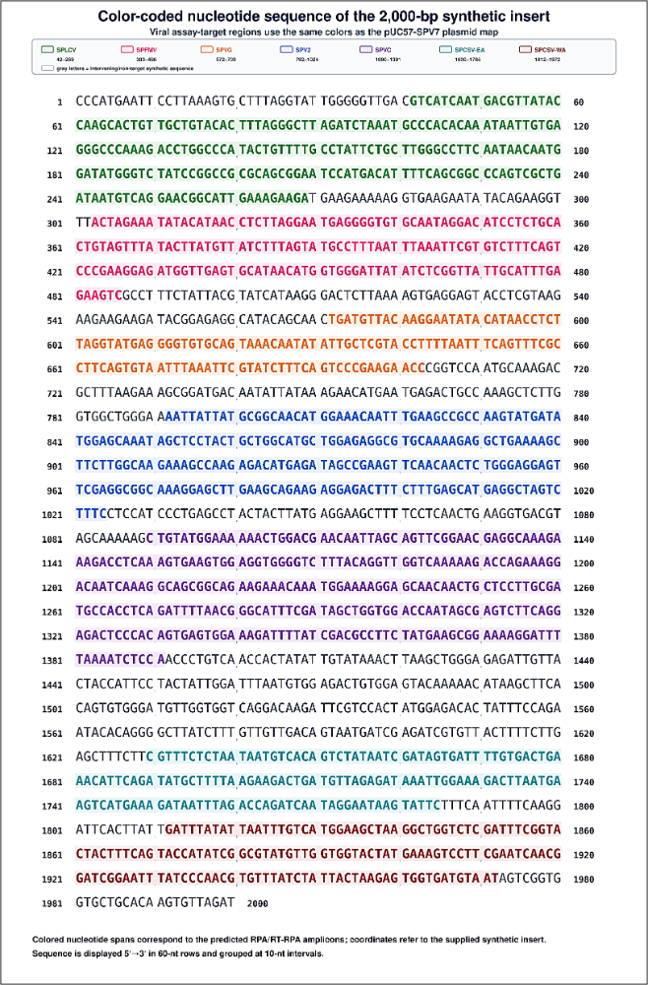

Supplementary Figure S3. Organization and color-coded nucleotide sequence of the 2,000-bp synthetic insert in the pUC57-SPV7 artificial positive-control plasmid. The insert contains Exo RPA/RT-RPA assay-target regions from SPLCV, SPFMV, SPVG, SPV2, SPVC, SPCSV-EA, and SPCSV-WA. Virus-specific target regions are highlighted using the color scheme of the pUC57-SPV7 plasmid map, whereas intervening non-target sequences are shown in gray.

