Supplementary Table 1 Detection of csPCa according to PI-RADS score in the development cohort.

PI-RADS score | Number of cases (n) | csPCa detection, n (%)
1 | 0 | 0 (0)
2 | 18 | 1 (5.6)
3 | 212 | 45 (21.2)
4 | 507 | 282 (55.6)
5 | 206 | 173 (84.0)

Supplementary Table 2 Logistic regression analysis for developing COR-PM1 and COR-PM2.
Predictive variable | COR-PM1 |  | p Value | COR-PM2 |  | p Value
Predictive variable | Coefficient | Odds ratio (95% CI) | p Value | Coefficient | Odds ratio (95% CI) | p Value
Intercept | -2.389 | - | - | -2.526 | - | -
Age, Ref. year | 0.102 | 1.107 (1.083-1.132) | <0.001 | 0.090 | 1.094 (1.069-1.119) | <0.001
Prior negative biopsy, Ref. no | -1.051 | 0.349 (0.247-0.493) | <0.001 | -0.966 | 0.381 (0.271-0.619) | <0.001
DRE findings, Ref. normal | 0.768 | 2.155 (1.260-3.686) | =0.005 | 0.393 | 1.482 (1.014-2.563) | =0.047
Serum PSA, Ref. ng/mL | 0.056 | 1.058 (1.025-1.093) | <0.001 | 0.049 | 1.050 (1.017-1.084) | <0.002
Intermediate DRE- PV, Ref. small | -1.025 | 0.359 (0.277-0.465) | <0.001 | - | - | -
Large DRE- PV, Ref. small | -2.071 | 0.126 (0.070–0.226) | <0.001 | - | - | -
MRI-PV, Ref. mL | - | - | - | -0.019 | 0.981 (0.975-0.987) | <0.001
PI-RADS 3, Ref. 2 | - | - | - | 1.550 | 4.713 (0.564-39.397) | =0.152
PI-RADS 4, Ref. 2 | - | - | - | 2.936 | 18.836 (2.304-154.019) | =0.006
PI-RADS 5, Ref. 2 | - | - | - | 3.980 | 53.500 (6.378-448.750) | <0.001
*Small for COR-PM1, and mL for COR-PM2

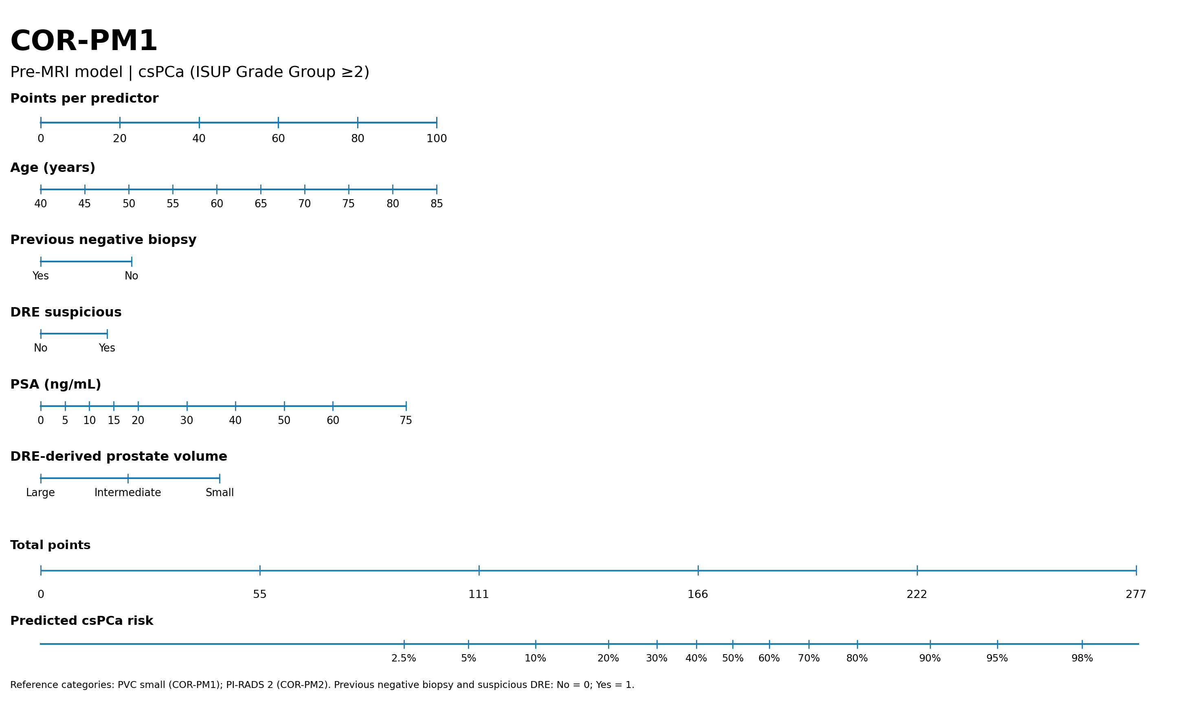
Supplementary Fig. 1 Nomogram of COR-PM1.

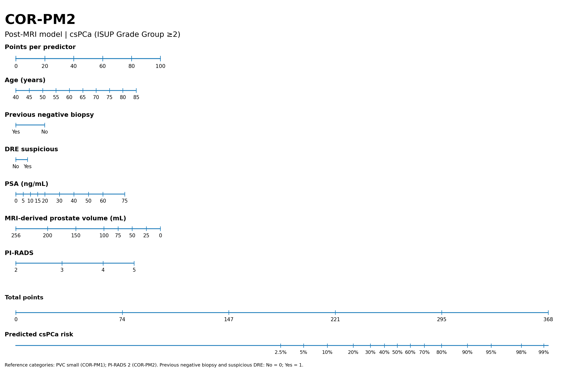
Supplementary Fig. 2 Nomogram of COR-PM2.

Supplementary Table 3 Clinical performance of COR-PM2 according to PI-RADS score at the threshold corresponding to an overall sensitivity of 95% for csPCa.
Statistic | PI-RADS 2 | PI-RADS 3 | PI-RADS 4 | PI-RADS 5
csPCa/All cases, n (%) | 1/18 (5.6) | 45/212 (21.2) | 282/507 (55.6) | 173/206 (84.0)
Risk threshold, % | 22.7 | 22.7 | 22.7 | 22.7
Sensitivity, % (95% CI) | 0.0 (0.0-97.5) | 66.7 (51.0-80.0) | 96.8 (94.0-98.5) | 100.0 (97.9-100.0)
Specificity, % (95% CI) | 94.1 (71.3-99.9) | 70.7 (63.1-77.4) | 9.3 (5.9-13.9) | 0.0 (0.0-10.6)
Positive predictive value, % (95% CI) | 0.0 (0.0-97.5) | 38.0 (27.3-49.6) | 57.2 (52.7-61.7) | 84.0 (78.2-88.7)
Negative predictive value, % (95% CI) | 94.1 (71.3-99.9) | 88.7 (82.1-93.5) | 70.0 (50.6-85.3) | -
Odds ratio (95% CI) | 3.67 (0.10-135.66) | 4.82 (2.38-9.73) | 3.12 (1.40-6.96) | 5.18 (0.10-265.61)
Accuracy, % (95% CI) | 88.9 (65.3-98.6) | 69.8 (63.1-75.9) | 58.0 (53.6-62.3) | 84.0 (78.2-88.7)
Avoided biopsies, n (%; 95% CI) | 17 (94.4; 74.2-99.9) | 133 (62.7; 56.1-69.0) | 30 (5.9; 4.2-8.3) | 0 (0.0; 0.0-1.8)
Missed csPCa, n (%) | 1 (100.0) | 15 (33.3) | 9 (3.2) | 0 (0.0)

