The emerging role of drought as a regulator of dissolved organic carbon in the boreal landscapes

*Tejshree Tiwari¹, Ryan A. Sponseller², and Hjalmar Laudon¹.

¹Department of Forest Ecology and Management, Swedish University of Agricultural Sciences, SE-901 83 Umea, Sweden
²Department of Ecology and Environmental Sciences, Umea University, 901 87 Umea, Sweden.

Supplementary Figures

Contents of this file
Figures S1
Tables S1

Introduction
The Figure S1 presents relationship between stream water DOC concentrations and groundwater DOC concentrations. Description of each catchment landscape type and scales are found in Table S1.

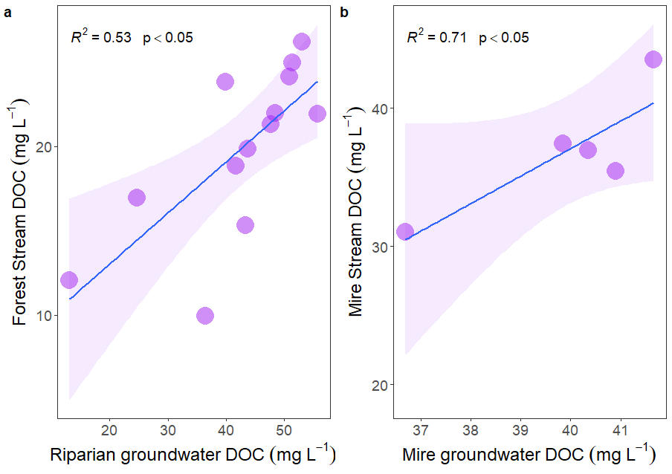
Figure S 1. Predicting the DOC concentrations in the streams in the forest (C2) and the mire (C4) using riparian zone groundwater (GW) DOC concentrations (a) and mire groundwater DOC concentrations (b).

Table S1. Areal coverage and landscape description of the 13 catchments used in this study.
Catchments | Area (km²) | Peat | Forest
1 | 0.48 | 0.00 | 97.95
2 | 0.12 | 0.00 | 99.92
4 | 0.18 | 51.06 | 55.88
5 | 0.65 | 47.76 | 53.98
6 | 1.1 | 28.66 | 71.36
7 | 0.47 | 19.41 | 81.95
9 | 2.88 | 15.16 | 84.36
10 | 3.36 | 28.84 | 73.84
12 | 5.44 | 19.16 | 82.57
13 | 7 | 11.81 | 88.19
14 | 14.1 | 6.64 | 90.13
15 | 20.13 | 14.50 | 81.57
16 | 67 | 9.40 | 87.20

