Plasmonic anchoring boosts mechanoluminescence via mechano-electro-optical cascade
Yutao Qin¹, Jiaxiang He¹, Guoyan Dong¹*, Haonan Shi^{2,3}, Xueli Sun¹, Zheng Zhu¹, Wengao Tang¹, Tianzhuo Zhao^{1,4}*, and Ji Zhou^{2,3}*
¹School of Optoelectronics, University of Chinese Academy of Sciences (UCAS), Beijing 101408, China
²State Key Laboratory of New Ceramic Materials, Tsinghua University, Beijing 100084, China
³School of Materials Science and Engineering, Tsinghua University, Beijing 100084, China
⁴Aerospace Information Research Institute, Chinese Academy of Sciences, No. 9 Dengzhuang South Road, Haidian District, Beijing 100094, China
These authors contributed equally: Yutao Qin and Jiaxiang He
*Correspondence: Guoyan Dong (gydong@ucas.ac.cn) or Tianzhuo Zhao (zhaotianzhuo@ucas.ac.cn) or Ji Zhou (zhouji@tsinghua.edu.cn)

Supplementary Note 1: Theoretical Derivation and Numerical Simulation of LSPR Evanescent Field Decay Length
S1.1 Analytical Baseline in the Quasi-Static Limit
For a spherical Au nanoparticle (NP) of radius R (~70 nm) embedded in a dielectric medium, the localized surface plasmon resonance (LSPR) near-field can be approximated by an induced electric dipole when R ≪ λ. Along the polarization axis, the exact intensity profile at a distance z from the NP surface follows a power-law decay:
|E(z)|² = |E₀|² (1 + z/R)⁻⁶ (S1)
In plasmon-enhanced luminescence studies, the distance-dependent Purcell factor is conventionally modeled as an exponential decay F_{P}(z) ∝ |E(z)|² ∝ e^{-2z/d [Ref.1]}, where d is the characteristic decay length. Matching the 1/e² intensity point of Eq. (S1) yields:
(1 + d₀/R)⁻⁶ = e⁻² → d₀ ≈ 0.396R (S2)
For R = 35 nm (70 nm diameter), the quasi-static, lossless baseline gives d₀ ≈ 13.9 nm, which serves as a lower bound for the near-field penetration depth.
This quasi-static estimate is independent of the dielectric environment because the normalized field profile (1 + z/R)⁻⁶ cancels the polarizability factor α(ε_{m}, ε_{d}) upon normalization. However, this invariance holds only in the quasi-static limit. Beyond R/λ ~ 0.05, retardation and radiative damping, both strongly dependent on the host refractive index, broaden the near-field distribution, as confirmed by the FDTD result (d_{sim} = 24 nm) in S1.2, which explicitly incorporates the ZnS:Cu (n ~ 2.37) / PDMS (n ~ 1.41) dielectric environment.

S1.2 Full-Wave FDTD Simulation
To accurately capture the near-field distribution beyond the quasi-static dipole limit, we performed finite-difference time-domain (FDTD) simulations of a 70 nm Au NP anchoring on a ZnS:Cu/PDMS matrix excited by a plane wave at the mechanoluminescence (ML) emission wavelength of 510 nm. The simulated |E(z)|² profile along the polarization Y axis was extracted and fitted to the exponential model |E(z)|² = |E₀|²e^{-2z/d} over the range z = -60–60 nm. The fitting yields a characteristic decay length of:
d_{sim} = 24 ± 1 nm (S3)
This value is consistently reproduced across multiple mesh resolutions (0.2 nm grid size) and boundary conditions, confirming numerical convergence.
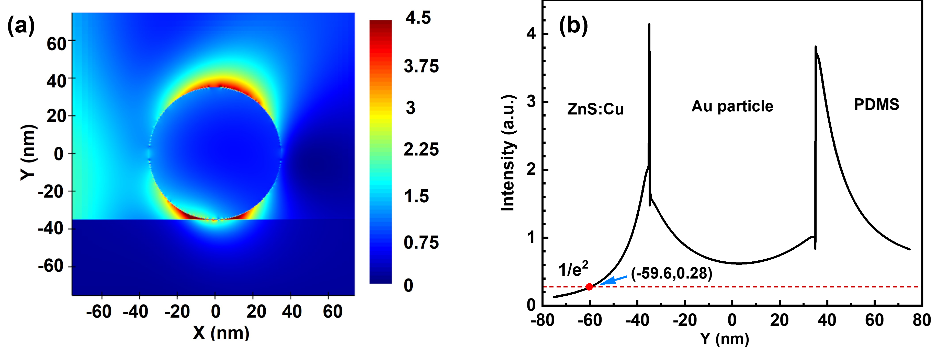
Fig. S1 FDTD simulation of the LSPR near-field distribution. ​(a)​ Spatial map of the normalized electric field intensity (|E|²) surrounding a 70 nm Au nanoparticle embedded in PDMS matrix anchored on the ZnS:Cu surface at the ML emission wavelength (510 nm) with Y-axis polarization. The field is strongly confined to the particle–matrix interface, exhibiting a characteristic dipolar distribution. ​(b)​ Normalized field intensity profile extracted along the central cross-section (Y-axis) as a function of distance from the Au surface. The simulation data displays a characteristic decay length of d ≈ 24 nm at the exponential value 1/e². This extended decay length, which exceeds the quasi-static dipole estimate, quantitatively confirms the role of retardation effects in broadening the plasmonic near-field and defines the effective spatial window for Purcell enhancement.
The simulated decay length (d_{sim} = 24 nm) exceeds the analytical dipole estimate (d₀ ∼ 14 nm) primarily due to retardation effects. At R/λ ≈ 0.07, the quasi-static approximation breaks down as phase retardation across the particle volume modifies the effective polarizability. Dynamic depolarization and radiative reaction terms broaden the near-field distribution beyond the static 1/r⁶ profile, a well-documented phenomenon for plasmonic nanoparticles in the 60–90 nm regime².
S1.3 Connection to the Experimental Coupling Window
Despite d_{sim}=24 nm, the effective Purcell enhancement remains concentrated within the experimentally observed ~10–30 nm range. Using |E(z)|²/|E₀|² = e^{-2z/24}, the experimental coupling window (~10–30 nm) corresponds to the region where the local field retains significant (>10% of surface maximum). Beyond 40 nm, the intensity drops below the threshold required to measurably accelerate radiative recombination. This spatial confinement aligns with the single-exponential ML decay kinetics and the saturation of the enhancement factor at optimal Au loading, confirming that the plasmonic near-field selectively couples to the triboelectrically activated surface shell.
S1.4 Effect of ZnS:Cu Optical Loss on the Decay Length
The derivation above assumes a lossless dielectric. To assess the impact of ZnS:Cu absorption, we consider its complex refractive index ñ = n + ik at 510 nm. Given the wide bandgap of ZnS (E_{g} ≈ 3.6 eV), the material is optically transparent at the ML emission wavelength, with an extinction coefficient k ≈ 0.005–0.02 arising from Cu-related defect states³. The corresponding absorption length L_{abs} = λ/(4πk) ranges from 2 to 8 μm, exceeding the LSPR near-field range by two orders of magnitude.
Incorporating the imaginary part of the permittivity into the intensity decay model yields a corrected length:
1/d_{lossy} ≈ 1/d_{sim} + 2πk/λ ≈ 0.04179 (S4)
Substituting k = 0.01 and λ = 510 nm yields a correction term of ~0.00012 nm⁻¹, resulting in d_{lossy} ≈ 23.9 nm. This <0.5% reduction is negligible compared to FDTD discretization uncertainty and experimental lifetime fitting errors. Consequently, bulk ZnS:Cu absorption does not measurably alter the near-field spatial profile, and the lossless approximation for d is rigorously justified.

Table S1 Reagents used during the fabrication of ZnS:Cu/PDMS/Au composite
Mass fraction of ZnS:Cu (wt%) | Weight of ZnS:Cu(g) | PDMS(g) | Curing (g) | HAuCl₄ (7.8 μmol/L) (uL)
0.2 | 0.03 | 0.12 | 0.012 | 3.9
0.28 | 0.047 | 0.12 | 0.012 | 6.1
0.37 | 0.059 | 0.1 | 0.01 | 7.7
0.40 | 0.06 | 0.09 | 0.009 | 7.8
0.50 | 0.07 | 0.07 | 0.007 | 9.1
0.60 | 0.1 | 0.067 | 0.0067 | 13.0
0.67 | 0.12 | 0.06 | 0.006 | 15.5

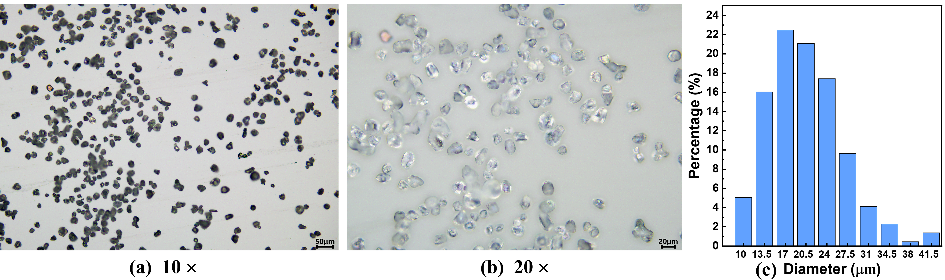
Fig. S2 Morphological characterization and size distribution of ZnS:Cu phosphor particles. (a) Optical micrograph at 10× magnification showing the overall particle ensemble. (b) Corresponding 20× magnification image revealing surface morphology and individual particle boundaries. (c) Statistical particle size distribution histogram derived from image analysis, indicating a mean diameter of ~20 μm. The polydisperse nature is typical of commercial phosphor powders employed in elastomeric mechanoluminescent composites.

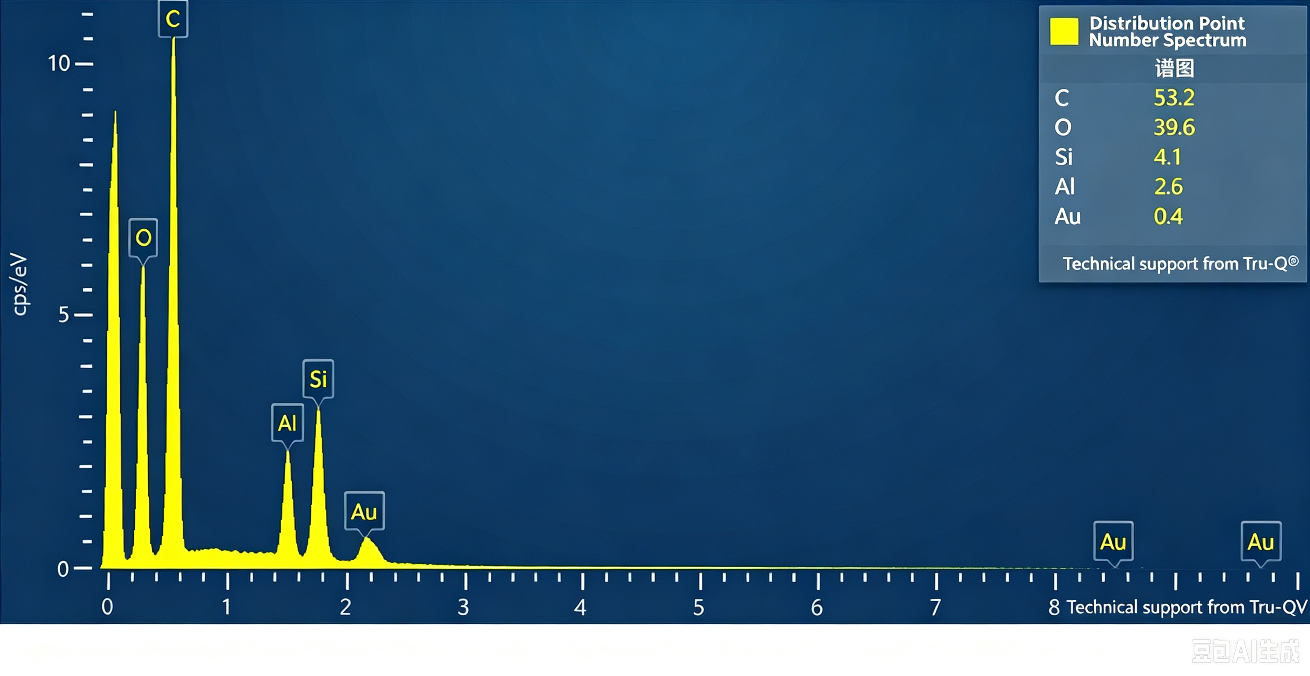Fig. S3 Energy-dispersive X-ray spectroscopy (EDS) spectrum of the sample. The spectrum reveals the elemental composition with C (53.2 at%) and O (39.6 at%) dominating, consistent with the PDMS elastomeric matrix. Si (4.1 at%) originates from the PDMS backbone rather than substrate material. Minor amounts of Si (4.1 at%) and Al (2.6 at%) suggest the presence of substrate material or trace inorganic impurities. The trace Au peak (0.4 at%) originates from the sputter-coating layer applied for SEM analysis. Au L-lines (~9.7 keV) and Au M-lines (~2.2 keV) are both detected. The spectrum was acquired using Tru-Q® software for automated peak identification and quantification.
At%

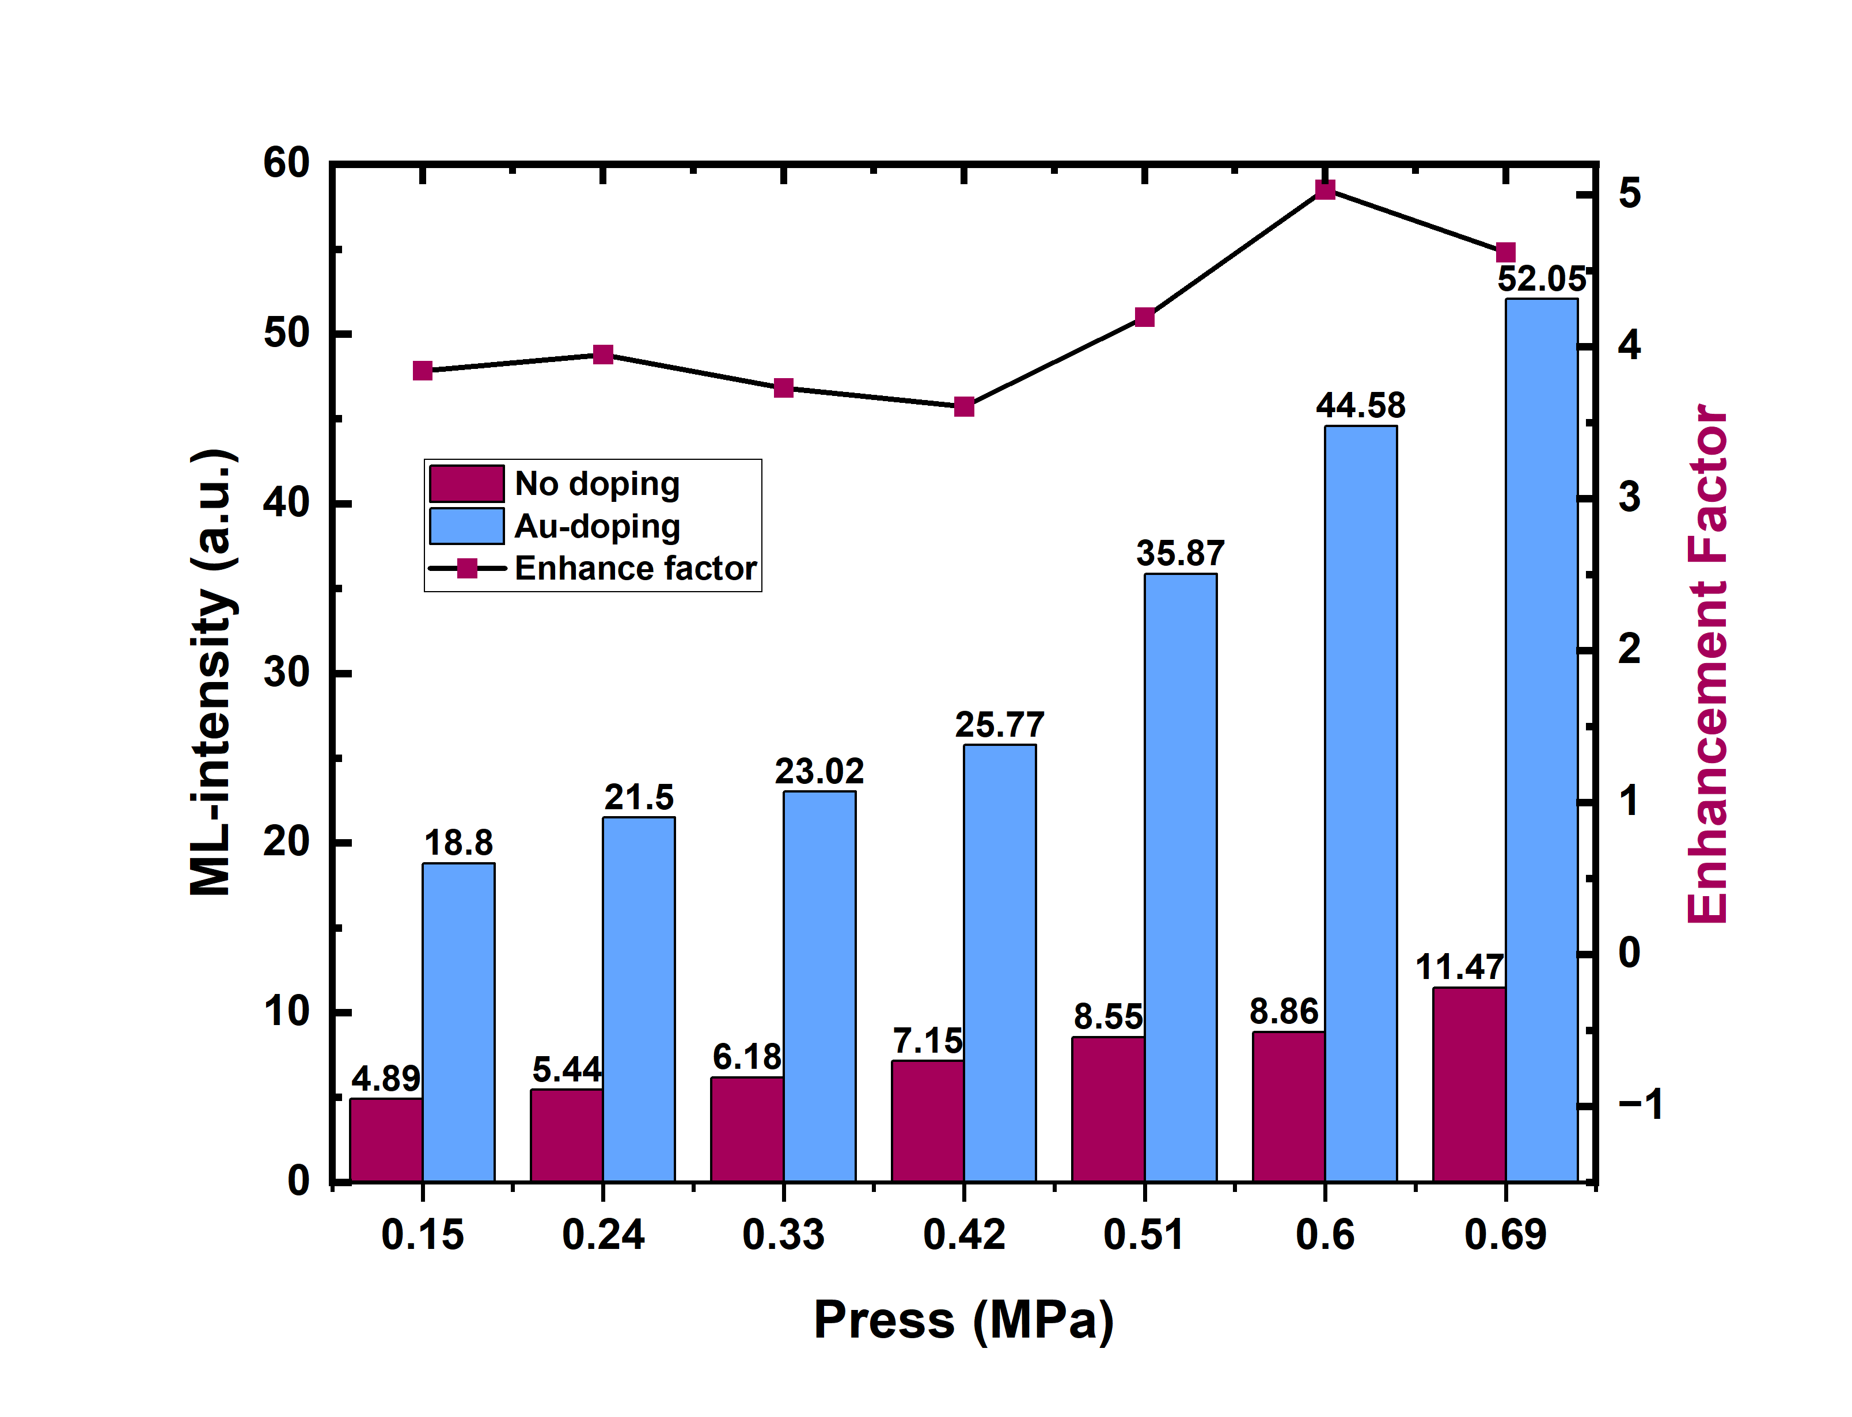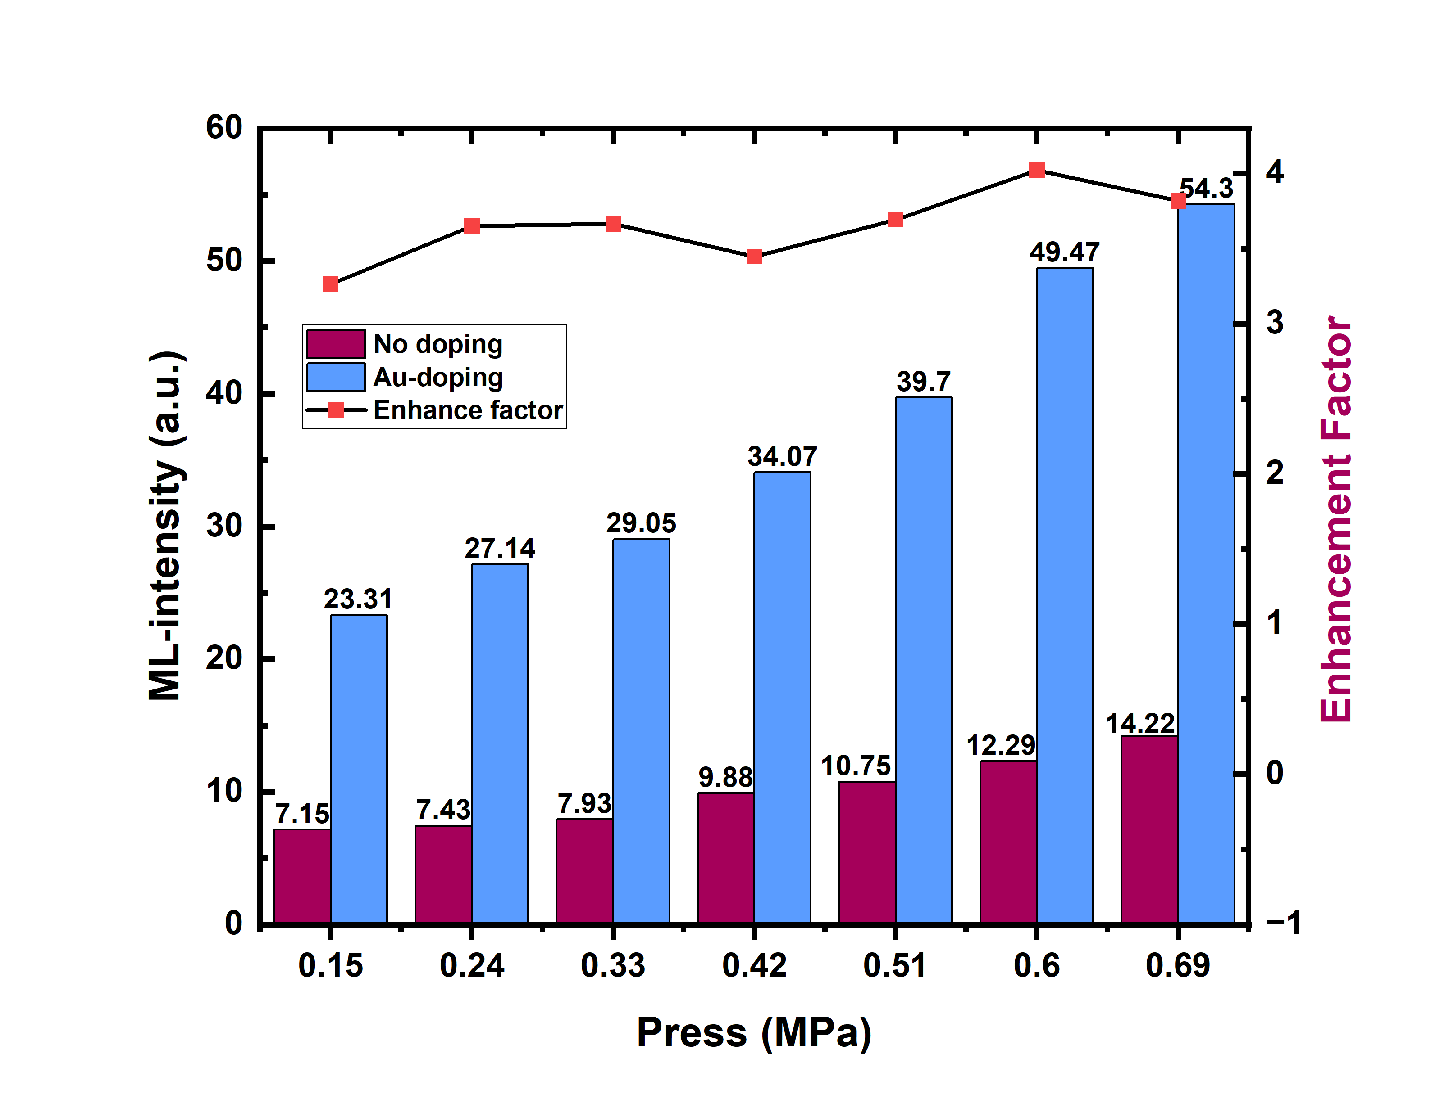
(a)
(b)
Fig. S4 Comparison of the mechanoluminescence (ML) intensity and enhancement factor of pristine and Au-doped (7.8 μmol L⁻¹ HAuCl₄) ZnS:Cu/PDMS (20 wt%) samples, under different mechanical force stimuli at (a) 25 Hz, and (b) 30 Hz. The Au-doped composite consistently outperforms the pristine control by a factor of 3.3–5.0 in ML intensity across the entire stress range (0.15–0.69 MPa). Linear regression yields mechano-optical sensitivities of 12.19 vs 61.57 a.u./MPa at 25 Hz (5.05-fold improvement) and 13.09 vs 57.39 a.u./MPa at 30 Hz (4.38-fold improvement), confirming that Au incorporation substantially enhances both ML brightness and pressure-sensing sensitivity. The enhancement factor peaks near 0.60 MPa in both panels and remains stable across the full stress window, demonstrating robust Purcell-enhanced radiative recombination over a wide pressure range.

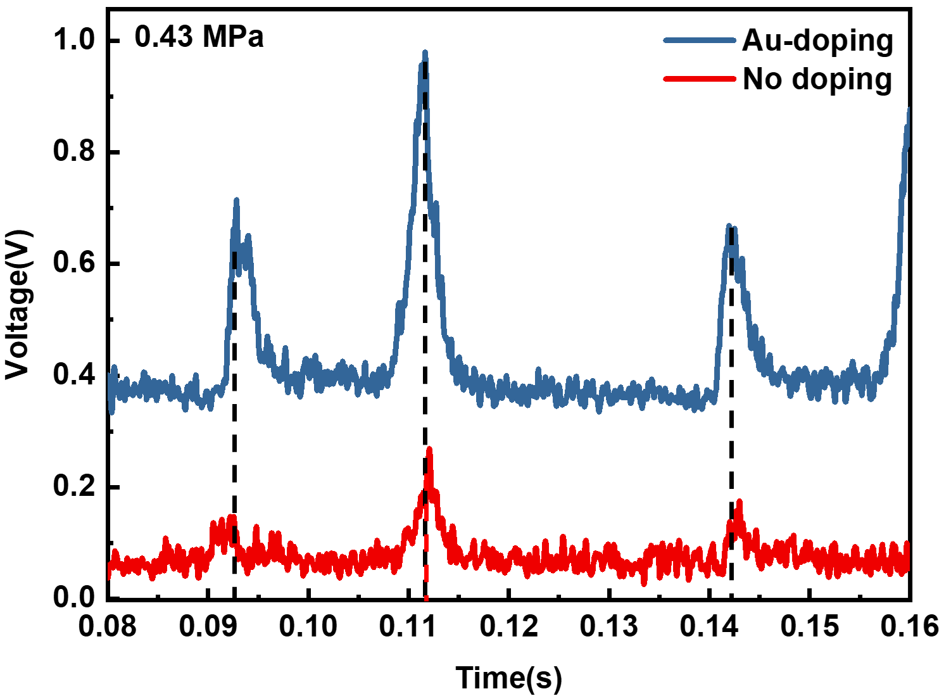
Fig. S5 Enlarged response profiles during a single compression–release cycle under the compressive stress of 0.43 MPa.

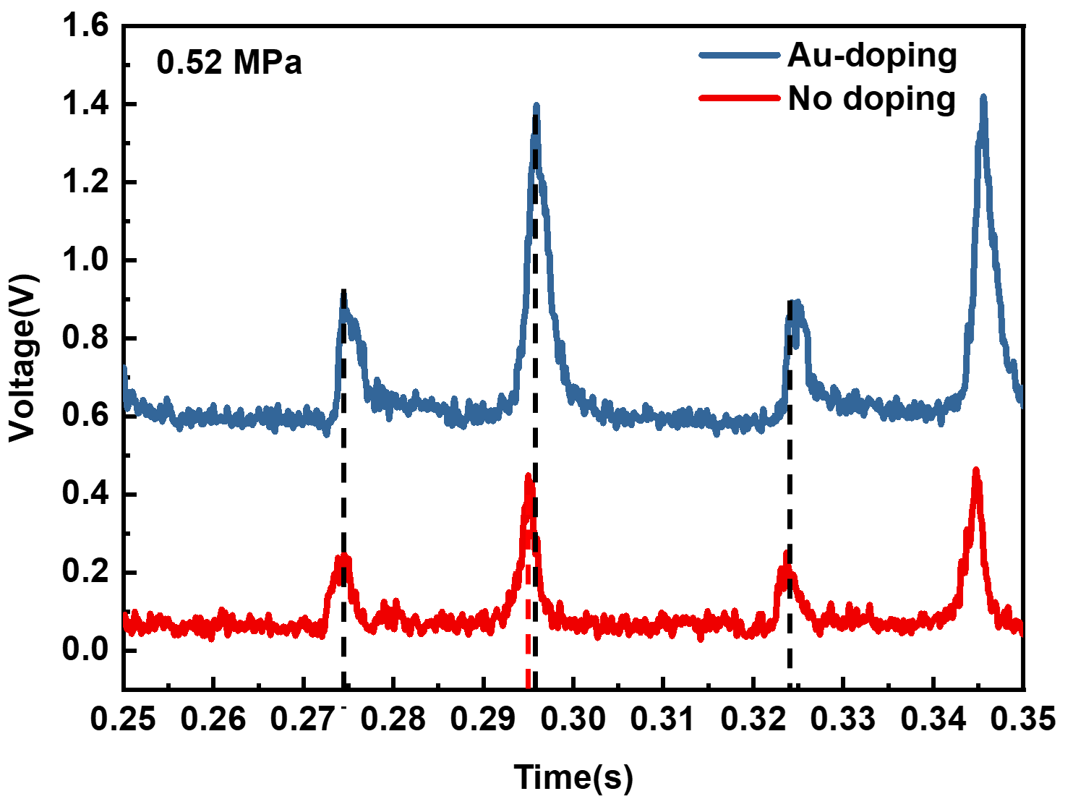
Fig. S6 Enlarged response profiles during a single compression–release cycle under the compressive stress of 0.52 MPa, with a tiny delay of 0.86 ms in the release process.

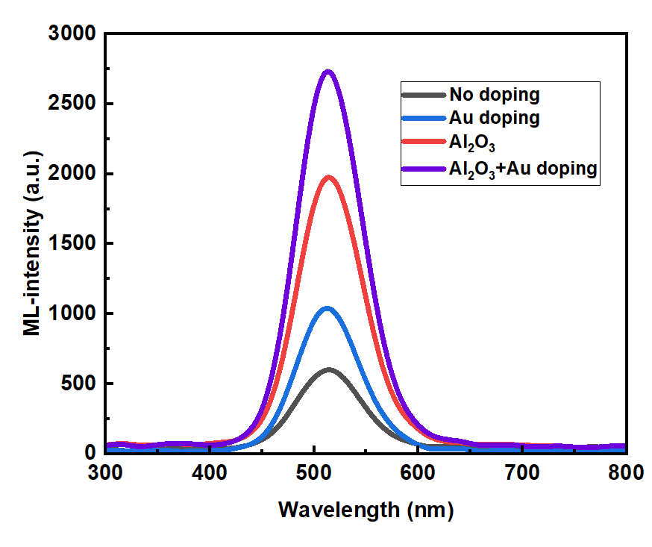
Fig. S7 ML emission spectra under compressive loading for hybrid discs prepared with pristine, Au-doping, Al₂O₃-doping and Al₂O₃+Au doping 67 wt% ZnS:Cu sheets.
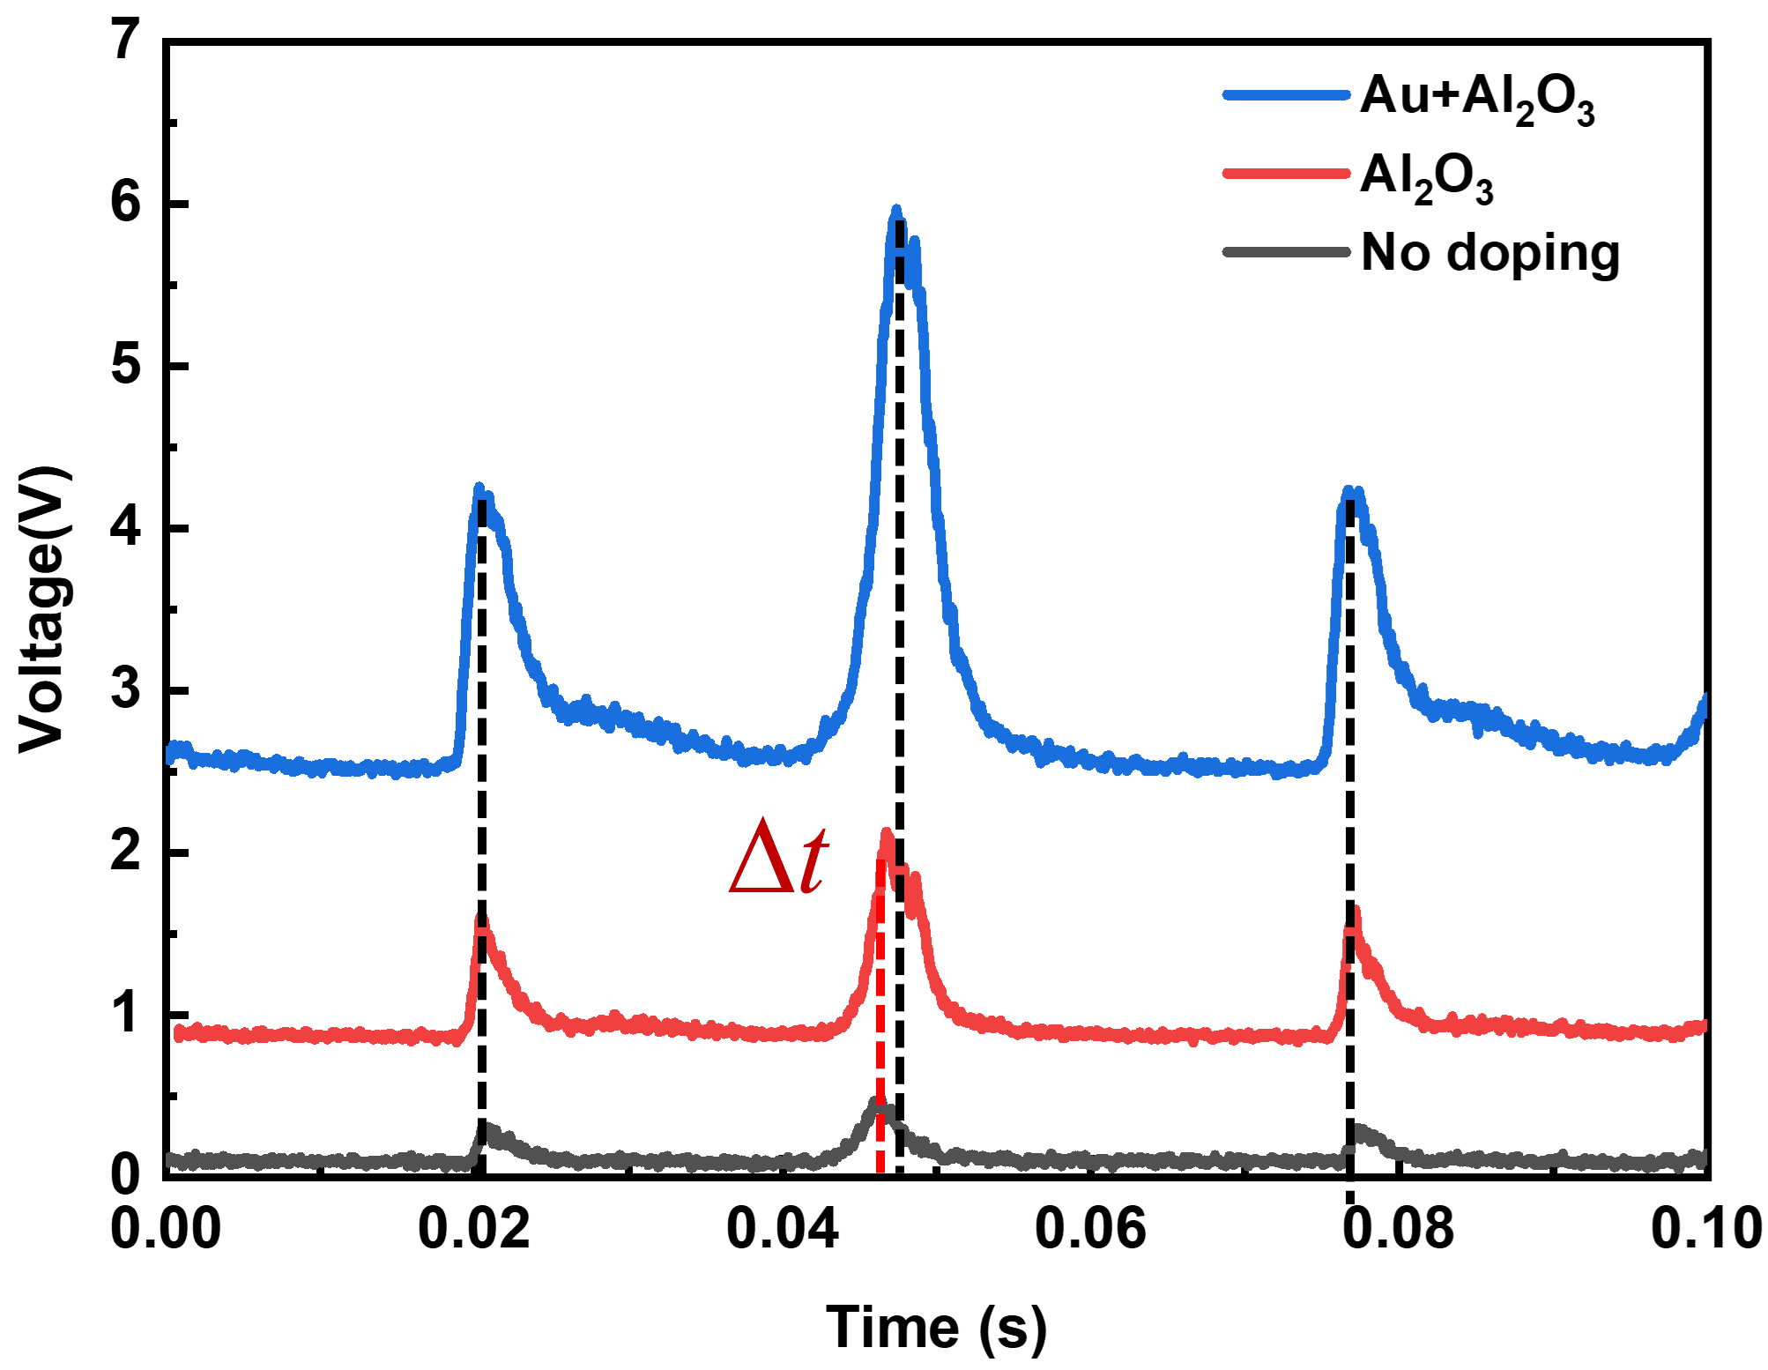
Fig. S8. Transient ML unloading kinetics of dual-filler co-modified elastomers. Expanded time-resolved profiles at 0.61 MPa reveal that Al₂O₃ incorporation alone exerts negligible influence on the peak delay, whereas the addition of Au NPs further extends the unloading relaxation time by ~1.5 ms. This kinetic signature confirms that covalent Au–S anchoring deepens interfacial trap states, gating the carrier release process without compromising the mechanical stress-concentration effect of Al₂O₃.

References
1 Anger, P., Bharadwaj, P. & Novotny, L. Enhancement and Quenching of Single-Molecule Fluorescence. Phys. Rev. Lett. 96, 113002, doi:10.1103/PhysRevLett.96.113002 (2006).
2 Kelly, K. L., Coronado, E., Zhao, L. L. & Schatz, G. C. The Optical Properties of Metal Nanoparticles: The Influence of Size, Shape, and Dielectric Environment. The Journal of Physical Chemistry B 107, 668-677, doi:10.1021/jp026731y (2003).
3 Palik, E. D. Handbook of Optical Constants of Solids, Five-Volume Set. (Elsevier/Academic Press, 1998).

