Crop domestication reduces root volatile organic compounds diversity and abundance across species
Jordi Cercós-Tuset, Joan Llusià, Laura Márquez, Josep Peñuelas, Erik Verbruggen, Ana María Yáñez-Serrano, Catherine Preece

Supplementary information
Table S1 Number of final replicates of each crop and domestication status due to removal for aphid and mite infestation during the growing season, with each corresponding accessions obtained from the IPK Liebniz-Institut (GBIS, last updated August 13, 2025) and USDA Germplasm Resources Information Network (GRIN, last updated February 24, 2025) seed banks.
Crop | Domestication status | Number of replicates | Accession ID
Barley | CWR | 6 | HOR 10977
Barley | CWR | 6 | HOR 9751
Barley | CWR | 6 | HOR 10404
Barley | CWR | 6 | HOR 2826
Barley | CWR | 6 | HOR 2693
Barley | Dom | 7 | HOR 16220
Barley |  |  | HOR 16215
Barley |  |  | HOR 20912
Barley |  |  | HOR 14337
Beet | CWR | 5 | BETA 1079
Beet | CWR | 5 | BETA 1129
Beet | CWR | 5 | BETA 194
Beet | Dom | 6 | BETA 3817
 |  |  | BETA 154
 |  |  | BETA 1244
 |  |  | BETA 290
Broad bean | CWR | 9 | NAR 2
Broad bean | CWR | 9 | NAR 20
Broad bean | CWR | 9 | NAR 1
Broad bean | CWR | 9 | NAR 154
Broad bean | CWR | 9 | NAR 30
Broad bean | Dom | 4 | FAB 6175
 |  |  | FAB 6176
 |  |  | FAB 6611
Cucumber | CWR | 6 | 462369
Cucumber | CWR | 6 | 215589
Cucumber | CWR | 6 | 214155
Cucumber | Dom | 4 | CUS 677
 |  |  | CUS 127
 |  |  | CUS 510
 |  |  | CUS 454
Sunflower | CWR | 6 | HEL 505
Sunflower | CWR | 6 | HEL 733
Sunflower | CWR | 6 | HEL 702
Sunflower | CWR | 6 | HEL 708
Sunflower | Dom | 4 | HEL 160
 |  |  | HEL 682
 |  |  | HEL 218
Tomato | CWR | 5 | LYC 2
Tomato | CWR | 5 | LYC 2286
Tomato | CWR | 5 | LYC 1
Tomato | CWR | 5 | LYC 2671
Tomato | Dom | 5 | BGV 12843
 |  |  | LYC 1014
 |  |  | LYC 15
 |  |  | BGV 5553

Table S2 Averaged time difference among treatments with p values obtained from standard t-tests.
Crop | Domestication status | Grow time (days) | SD | P value
Barley | Dom | 98 | 7.48 | <0.0001
 | CWR | 116 | 5.72
Beet | Dom | 113 | 7.34 | 0.3091
 | CWR | 108 | 10.26
Broad bean | Dom | 85 | 3.50 | 0.4649
 | CWR | 82 | 3.50
Cucumber | Dom | 105 | 7.00 | <0.0001
 | CWR | 79 | 8.57
Sunflower | Dom | 113 | 3.50 | 0.0804
 | CWR | 120 | 8.48
Tomato | Dom | 123 | 0.00 | 0.3184
 | CWR | 119 | 6.26

Table S3 List of all included compounds from the original dataset obtained from the GC-MS analyses, classified by their chemical class.
Chemical family |  |  |  | Compounds
Aliphatic hydrocarbons
 | 2,2,4,6,6-pentamethyl-Heptane
 | 7-methyl-tetracyclo[4.1.0.0(2,4).0(3,5)]heptane
 | Dodecane
 | Hexadecane
 | Hexane
 | Pentane
 | Tridecane
Aromatic compounds
 | 2,6-bis(1,1-dimethylethyl)-4-(1-methylpropyl)-Phenol
 | 7-Amino-1,2,3,4-tetrahydro-1,1,4,4,6-pentamethyl-5-nitronaphthalene
 | m-Xylene
 | o-tert-butyl-Phenol
 | o-xylene
 | p-Benzoquinone
 | Phenol
 | TBHQ
 | Toluene
Fatty acid derivatives
 | 2-ethyl-1-Hexanol
 | [2-[(4-methylphenyl)sulfonyl]ethylidene]-dimethyl ester Propanedioic acid
 | 1-methyl-6-(1-oxoethyl)-3-oxo-4-prop-2-ylidenecyclononene
 | 3-(2,2-dimethylpropylidene)bicyclo[3.3.1]nonane-2,4-dione
 | Cyclohexanone
 | Isopropyl Myristate
 | N-Decanal
 | Nonanal
 | Salicylaldehyde
Halogenated compounds
 | 1,1,2-Trifluoro-2,5-bis(trifluoromethyl)hexane
 | 5,5'-Dicarboxy-3'-(2-chloroethyl)-4-(2-acetoxyethyl)-3,4'-dimethylpyrromethane
 | Bromoform
Heterocyclic compounds
 | 1-Acetyl-6-(acetylamino)-5-methyl-1H-indazole
 | 2-methoxy[1]benzothieno[2,3-c]quinolin-6(5H)-one
 | 2-methyl-6-β-d-ribofuranosylimidazo[1,2-c]pyrimidin-5(6H)-one
 | 4-(benzoyloxy)-2H-pyran-3-one
 | 5,5'-Dicarboxy-3'-(2-chloroethyl)-4-(2-acetoxyethyl)-3,4'-dImethylpyrromethane
 | 5,7-dimethoxy-2,2-dimethyl-2H-chromene
 | 6-Acetyl-5,8-dimethoxy-2,2-dimethyl-2H-chromene
 | 7,8-Dimethoxy-1,2,4,5,10a,10b-hexahydrobenzo(de)-pyrrolo(3,2,1-ij)quinoline
 | Benzothiazole
 | N-methyl-N,N-di[2-(4-pyridyl)ethyl]-(2-pyridyl)ethylamine
Terpenoids
 | 15-methyltricyclo[6.5.2(13,14).0(7,15)]pentadecα-1,3,5,7,9,11,13-heptene
 | 1R-α-Pinene
 | Aristolen
 | CIS-α-Bisabolene
 | l-α-Pinene
 | Trans-α-Bisabolene
 | Unknown from lime oil
 | α-curcumene
 | β-Bisabolene
 | β-Cadinene
 | β-Gurjunene
 | β-Ionone epoxide
 | β-Maaliene
 | β-Sesquiphellandrene
 | δ-Cadinene
 | 2,2,4,6,6-pentamethyl-Heptane
 | 7-methyl-tetracyclo[4.1.0.0(2,4).0(3,5)]heptane
Excluded potentially pollutant compounds
Hexamethyl cyclotrisiloxane
1,2-Benzenedicarboxylic acid, bis(2-methylpropyl) ester
Diethyl Phthalate
Dibutyl phthalate
Argon
Octamethyl cyclotetrasiloxane
1,2-Benzenedicarboxylic acid, diethyl ester
1,2-Benzenedicarboxylic acid, dibutyl ester
1,2-Benzenedicarboxylic acid, diisooctyl ester

Table S4. Species predicted emission values per root gram and soil litre for crop wild relatives (CWR) and domesticates obtained from the GLM following a gamma distribution. As the interaction term was found non-significant, it is just noted for the general domestication effect.
Crop | CWR |  | Domesticated
 | Predicted emission (μg g⁻¹ root L⁻¹ soil) | SE | Predicted emission  (μg g⁻¹ root L⁻¹ soil) | SE | P value
Barley | 0.0185 | 0.0080 | 0.0056 | 0.0030
Beet | 0.15102 | 0.0761 | 0.0453 | 0.0231
Broad bean | 0.1100 | 0.0504 | 0.0330 | 0.0162
Cucumber | 0.1644 | 0.0837 | 0.0493 | 0.0271
Sunflower | 0.0954 | 0.0574 | 0.0286 | 0.0140
Tomato | 0.0277 | 0.0144 | 0.0083 | 0.0045
Average | 0.0715 | 0.0192 | 0.0215 | 0.0062 | 0.0034

Table S5. Species predicted net depletion values per root gram and soil litre for crop wild relatives (CWR) and domesticates obtained from the GLM following a gamma Distribution.
CROP | CWR |  | Domesticated
 | Predicted depletion  (μg g⁻¹ root L⁻¹ soil) | SE |  | Predicted depletion  (μg g⁻¹ root L⁻¹ soil) | SE | P value
Barley | 0.0340 | 0.0126 |  | 0.0054 | 0.0023
Beet | 0.0836 | 0.0360 |  | 0.0134 | 0.0055
Broad bean | 0.1016 | 0.0360 |  | 0.0163 | 0.0066
Cucumber | 0.2245 | 0.1020 |  | 0.0360 | 0.0153
Sunflower | 0.0828 | 0.0376 |  | 0.0133 | 0.0056
Tomato | 0.0159 | 0.0065 |  | 0.0026 | 0.0012
Average | 0.0663 | 0.0144 |  | 0.0106 | 0.0025 | <0.0001

Table S6. Species predicted Shannon diversity (H) of emitted VOCs for crop wild relatives (CWR) and domesticates obtained from the linear model. As the interaction term was found non-significant, it is just noted for the general domestication effect.
Crop | CWR |  | Domesticated
 | H | SE | H | SE | P value
Barley | 0.679 | 0.177 | 0.358 | 0.173
Beet | 1.281 | 0.190 | 0.960 | 0.185
Broad bean | 1.048 | 0.166 | 0.727 | 0.188
Cucumber | 1.069 | 0.191 | 0.748 | 0.201
Sunflower | 1.309 | 0.191 | 0.988 | 0.201
Tomato | 2.205 | 0.196 | 1.883 | 0.196
Average | 1.265 | 0.096 | 0.944 | 0.106 | 0.0292

Table S7. Species predicted Shannon diversity (H) of net depleted VOCs for crop wild relatives (CWR) and domesticates obtained from the linear model.
Crop | CWR |  | Domesticated
 | H | SE | H | SE | P value
Barley | 1.992 | 0.170 | 0.902 | 0.157 | <0.0001
Beet | 1.512 | 0.186 | 2.033 | 0.170 | 0.0428
Broad bean | 0.839 | 0.138 | 0.634 | 0.218 | 0.4152
Cucumber | 1.802 | 0.170 | 1.982 | 0.208 | 0.5062
Sunflower | 1.955 | 0.170 | 2.068 | 0.208 | 0.6744
Tomato | 1.778 | 0.186 | 1.656 | 0.186 | 0.6447
Average | 1.650 | 0.0696 | 1.550 | 0.0777 | 0.0292

Table S8 Model parameters for temperature and humidity correlation with VOC emissions and net depletion
Model |  | AIC | BIC | Delta R2 | Residuals
Emissions
 | Temp^2 | -339.7 | -330.9 | 0.4790 | Significant deviation
 | Temp^2 + Hum | -338.2 | -327.2 | 0.4800 | Significant deviation
 | Temp^2 + Hum + Temp:Hum | -340.9 | -331.0 | 0.4600 | n.s.
Net depletion
 | Temp^2 | -380.2 | -371.4 | 0.7425 | Significant deviation
 | Temp^2 + Hum | -379.1 | -368.0 | 0.7443 | Significant deviation
 | Temp^2 + Hum + Temp:Hum | -381.4 | -368.2 | 0.7499 | n.s.

Table S9 Mean of R2 across sampling days of the calibration curves obtained for the seven standard compounds. Response factor (RF) plus their standard deviation were averaged from those obtained for all sampling dates by multiplying the slope and a reference area value.
Group | Compound | Range (µg) |  | Slope | R2 ± sd | RF ± sd
Not terpene | 3-hexen-1-ol |  | 0.8401-0.0014 | 0.00000003 | 0.9912 ± 0.0069 | 0.2785 ± 0.2641
Monoterpenes | myrcene |  | 0.7885-0.0013 | 0.000000004 | 0.9932 ± 0.009 | 0.0621 ± 0.0903
 | 3-carene |  | 0.8540-0.0014 | 0.000000007 | 0.9892 ± 0.0121 | 0.1192 ± 0.0918
 | limonene |  | 0.8352-0.0014 | 0.00000001 | 0.9907 ± 0.0094 | 0.0744 ± 0.0846
 | a-pinene |  | 0.8520-0.0014 | 0.00000003 | 0.9953 ± 0.0041 | 0.0801 ± 0.0848
 | mt mean |  |  |  |  | 0.0809 ± 0.076
(not terpene) | dodecane |  | 0.7537-0.0012 | 0.000000006 | 0.9941 ± 0.0061 | 0.0687 ± 0.0547
Other terpenes | a-humulene |  | 0.8798-0.0015 | 0.000000009 | 0.9951 ± 0.004 | 0.1013 ± 0.0952
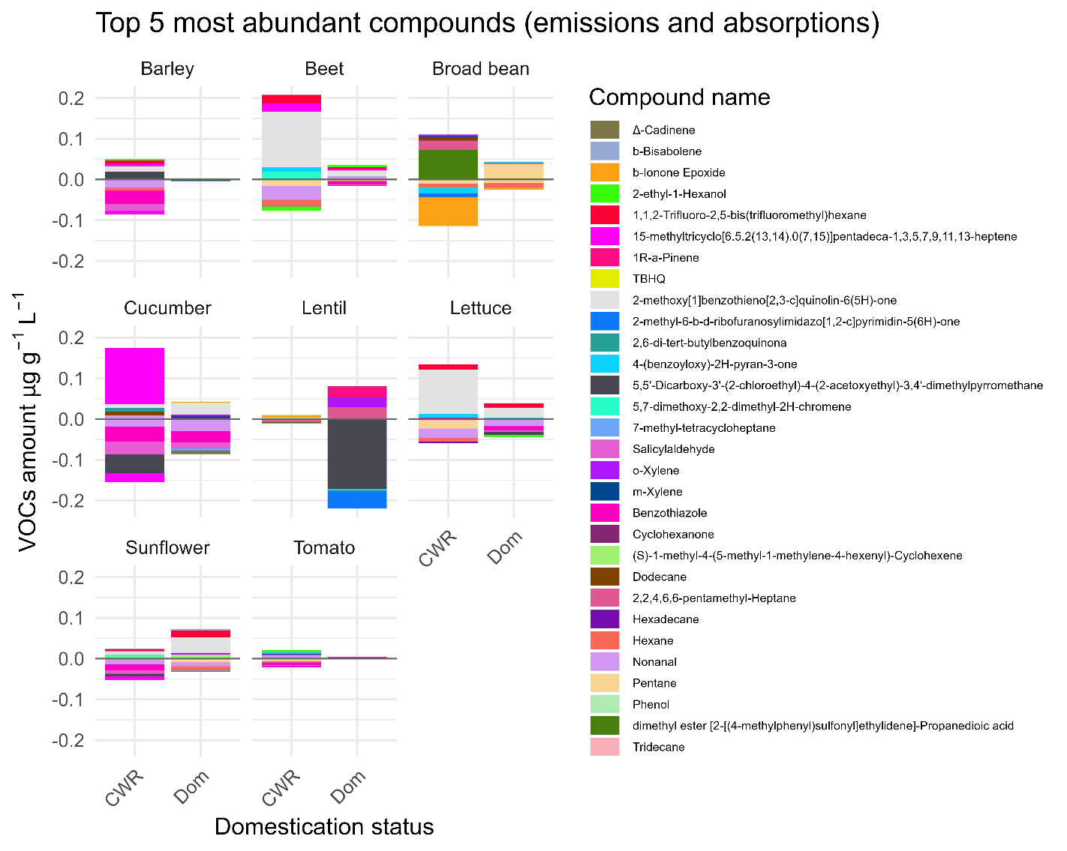
Figure S1. Mean of the five most abundant emitted and net depleted compounds per root gram and soil litre for each species and domestication status. Each compound is represented by a coloured bar as listed in the legend on the right side.

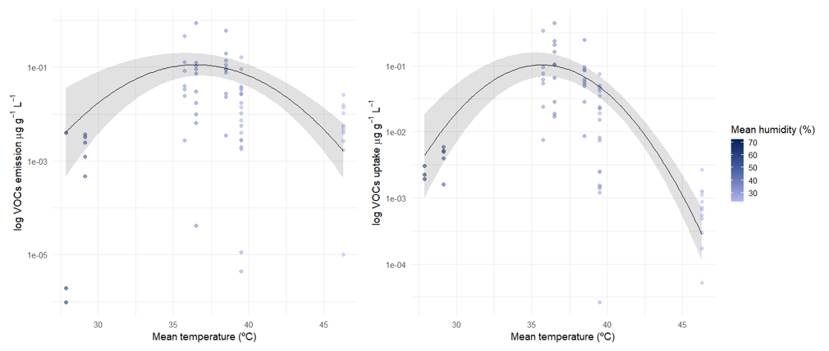
Figure S2. Temperature effect on VOC emissions (a) and net depletion (b) for root gram and soil litre (natural log scale) in a humidity gradient. Each point represents a plant plot. Dark line and shadow represent a quadratic model including just temperature as a response factor. This model did not meet quantile deviation requirements.
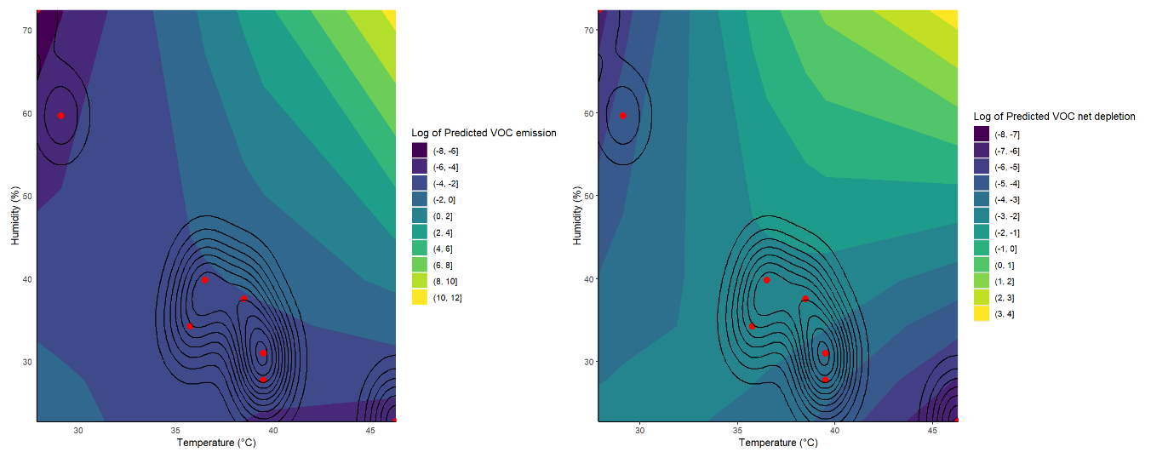
Figure S3. Heatmap of predicted VOC emission and net depletion in a log scale in response to temperature (x axis) and humidity (y axis). Data points are shown in red, exposing that the density of sampling occurred just in low temperature-high humidity: high temperature – low humidity gradient (pearson’s correlation -0.94; p < 0.001).

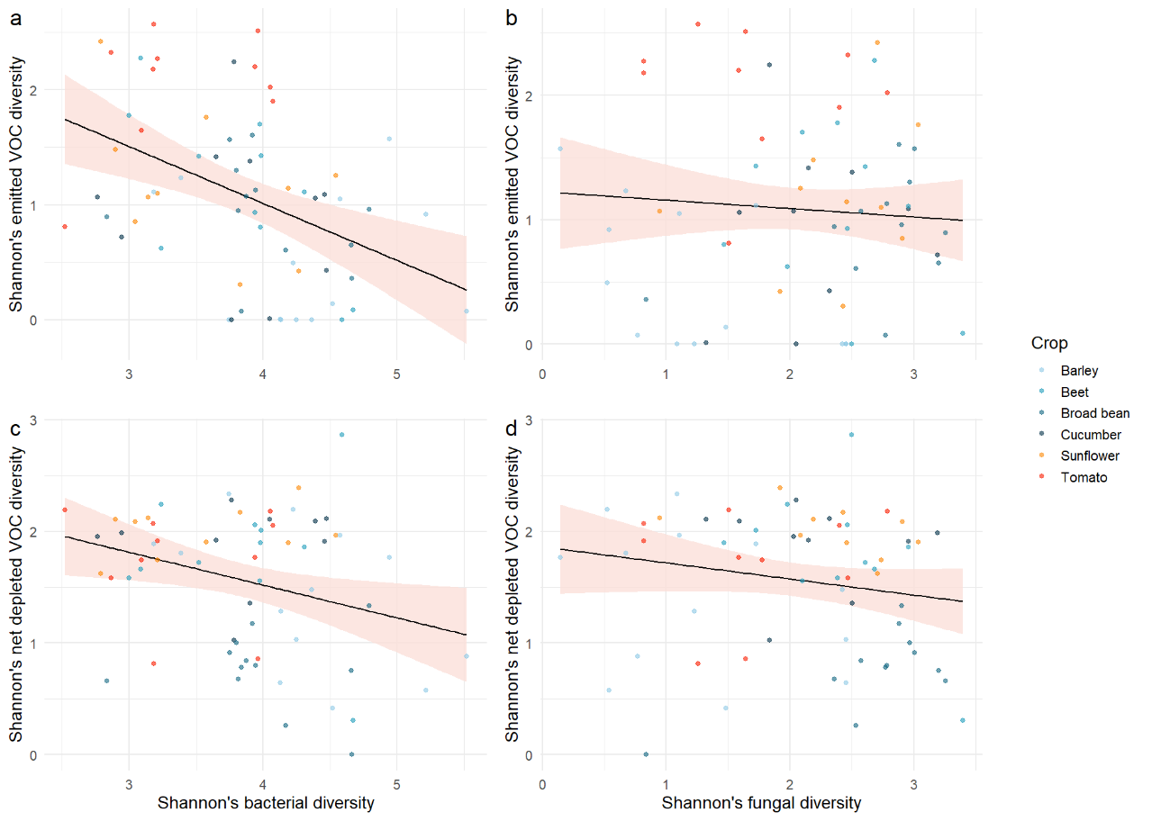
Figure S3. Alpha diversity of VOCs in Shannon index in relation to microbial alpha diversity. Each point represents a plant pot (n = 66). Correlation from the linear model is represented with a line and a shade for the 95% IC. Plots represent emitted VOC diversity contrasted with bacterial diversity (a) and fungal diversity (b) and net depleted VOC diversity contrasted with bacterial (c) and fungal (d) diversity.

Figure S4. Rarefaction curves of bacterial (a) and fungal (b) samples, showing the number of species within each pot (lines) by increasing sample size.
Figure S5. NMDS of bacterial (a) and fungal (b) composition of samples. Points represent the mean composition of each factor, with their standard errors as whiskers. Crop species are indicated by colours and domestication status by shape.

